作业2：SBERT编码、相似度计算

一、如何使用bert 进行文本编码
from sentence_transformers import SentenceTransformer
import numpy as np
from typing import List

class SBERTEncoder:
"""SBERT文本编码器"""

def __init__(self, model_name: str = "moka-ai/m3e-base"):
"""
初始化编码器

Args:
model_name: 模型名称
- moka-ai/m3e-base: 中文优化，768维
- paraphrase-multilingual-MiniLM-L12-v2: 多语言，384维
"""
self.model = SentenceTransformer(model_name)
self.embedding_dim = self.model.get_sentence_embedding_dimension()
print(f"模型加载成功，输出维度：{self.embedding_dim}")

def encode_single(self, text: str) -> np.ndarray:
"""
编码单个文本

Args:
text: 输入文本

Returns:
向量，shape: (embedding_dim,)
"""
embedding = self.model.encode(
[text],
normalize_embeddings=True, # L2归一化，用于余弦相似度
convert_to_numpy=True
)[0]

return embedding

def encode_batch(self, texts: List[str], batch_size: int = 32) -> np.ndarray:
"""
批量编码文本

Args:
texts: 文本列表
batch_size: 批处理大小

Returns:
向量矩阵，shape: (n, embedding_dim)
"""
embeddings = self.model.encode(
texts,
batch_size=batch_size,
normalize_embeddings=True,
convert_to_numpy=True,
show_progress_bar=True
)

return embeddings

二、使用bert 进行相似度计算
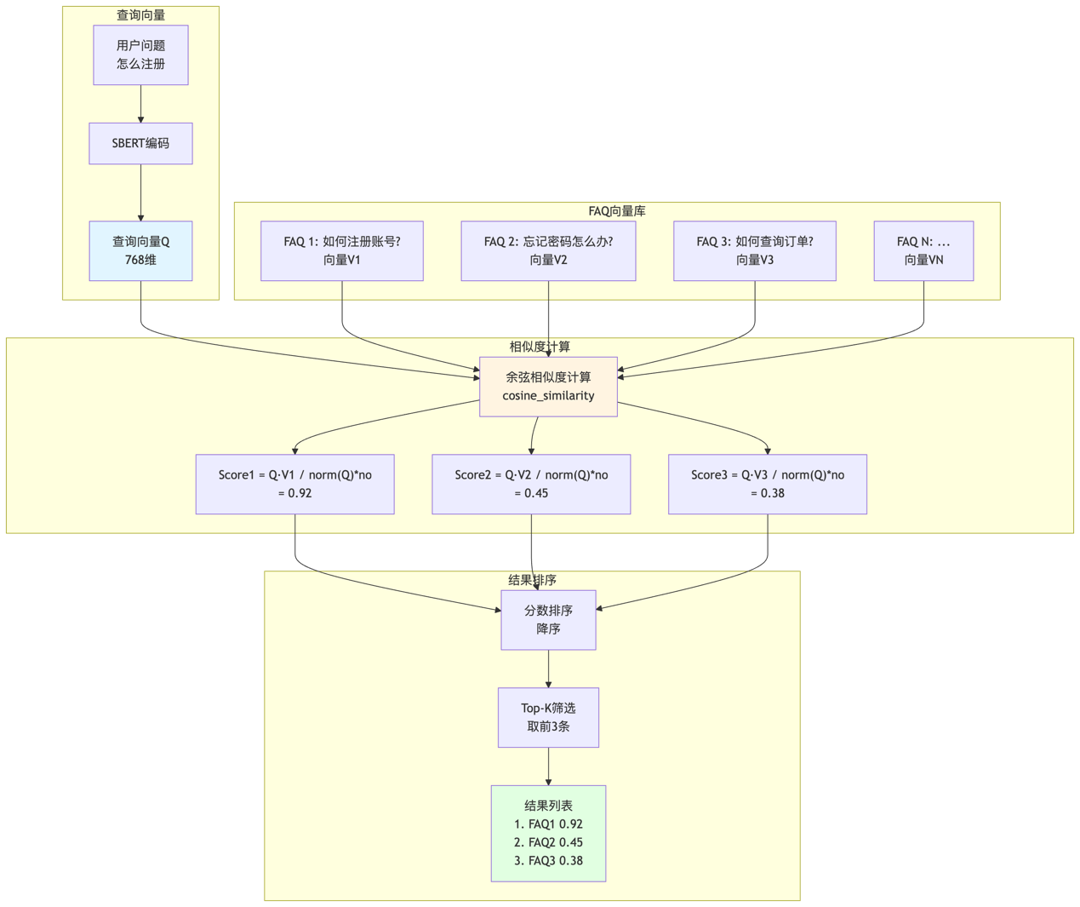
from sentence_transformers import util

def compute_similarity_util(query_vector: np.ndarray,
faq_vectors: np.ndarray,
k: int = 5) -> List[Tuple[int, float]]:
"""
使用sentence-transformers内置工具计算相似度

Args:
query_vector: 查询向量
faq_vectors: FAQ向量矩阵
k: Top-K

Returns:
Top-K结果
"""
# 计算余弦相似度
scores = util.cos_sim(query_vector, faq_vectors)[0]

# 转为NumPy并排序
scores = scores.cpu().numpy()
top_k_indices = np.argsort(scores)[::-1][:k]

results = [(int(idx), float(scores[idx])) for idx in top_k_indices]

return results

