Problem 1: Find the total number of crimes recorded in the crime table.

%sql select count(*) from CRIME22

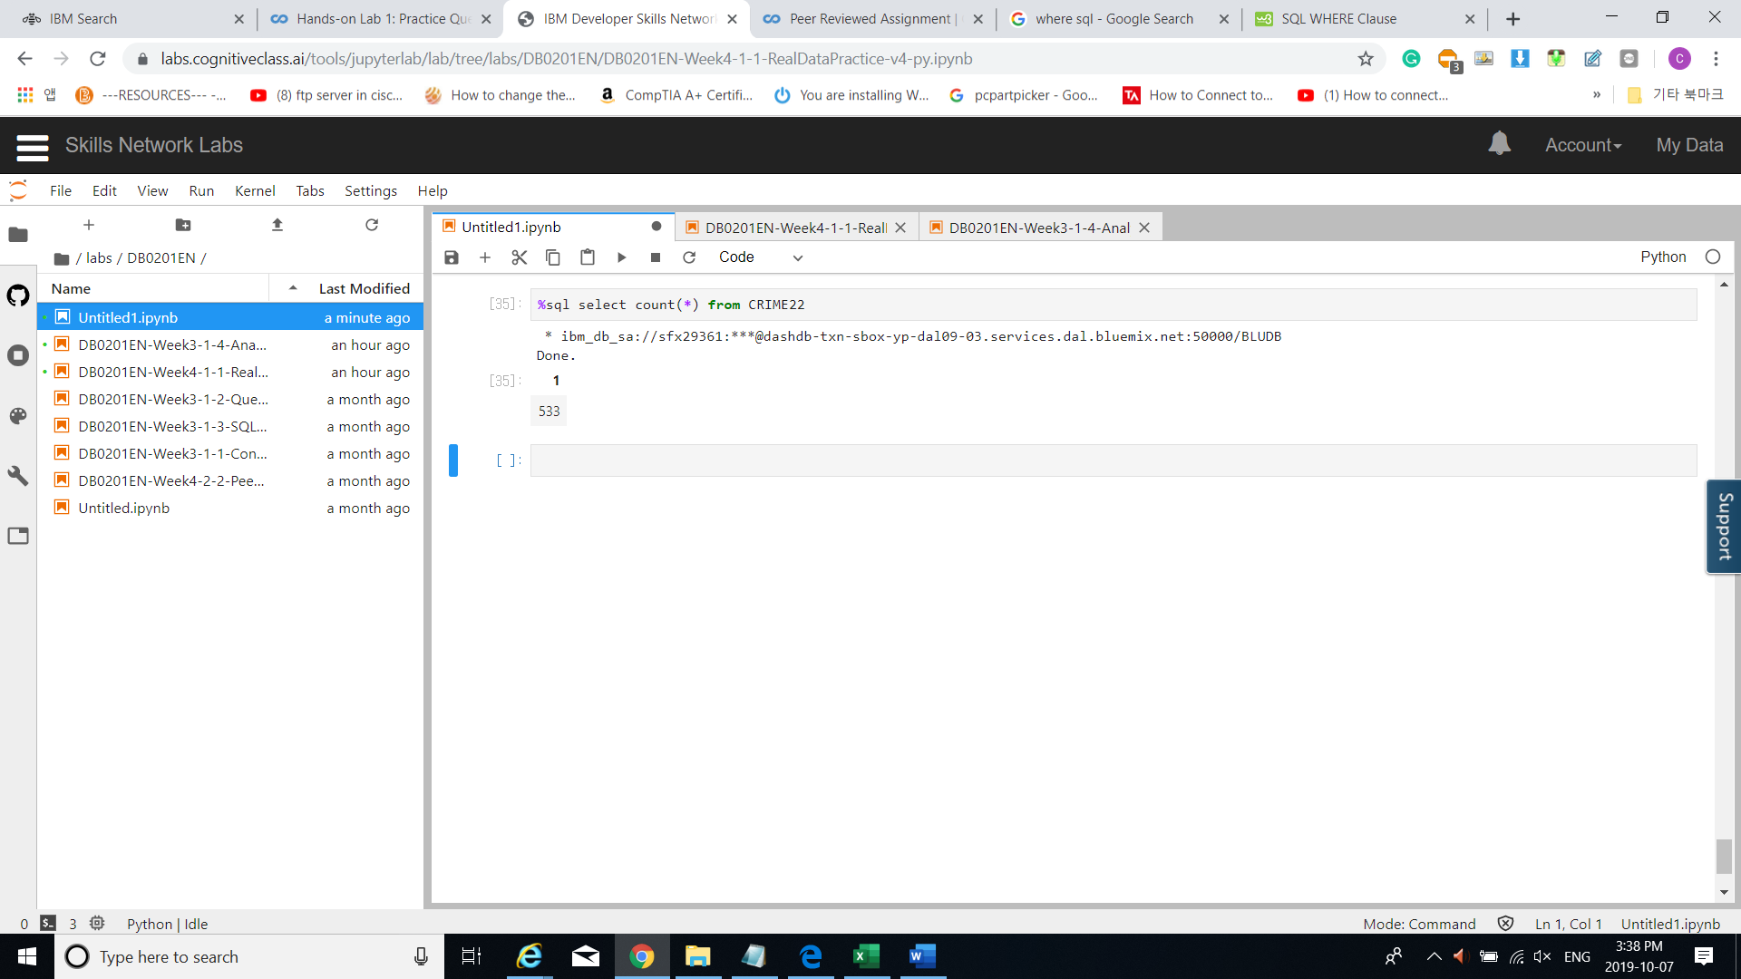

Problem 2: Retrieve first 10 rows from the CRIME table.

%sql select * from CRIME22 fetch first 10 rows only

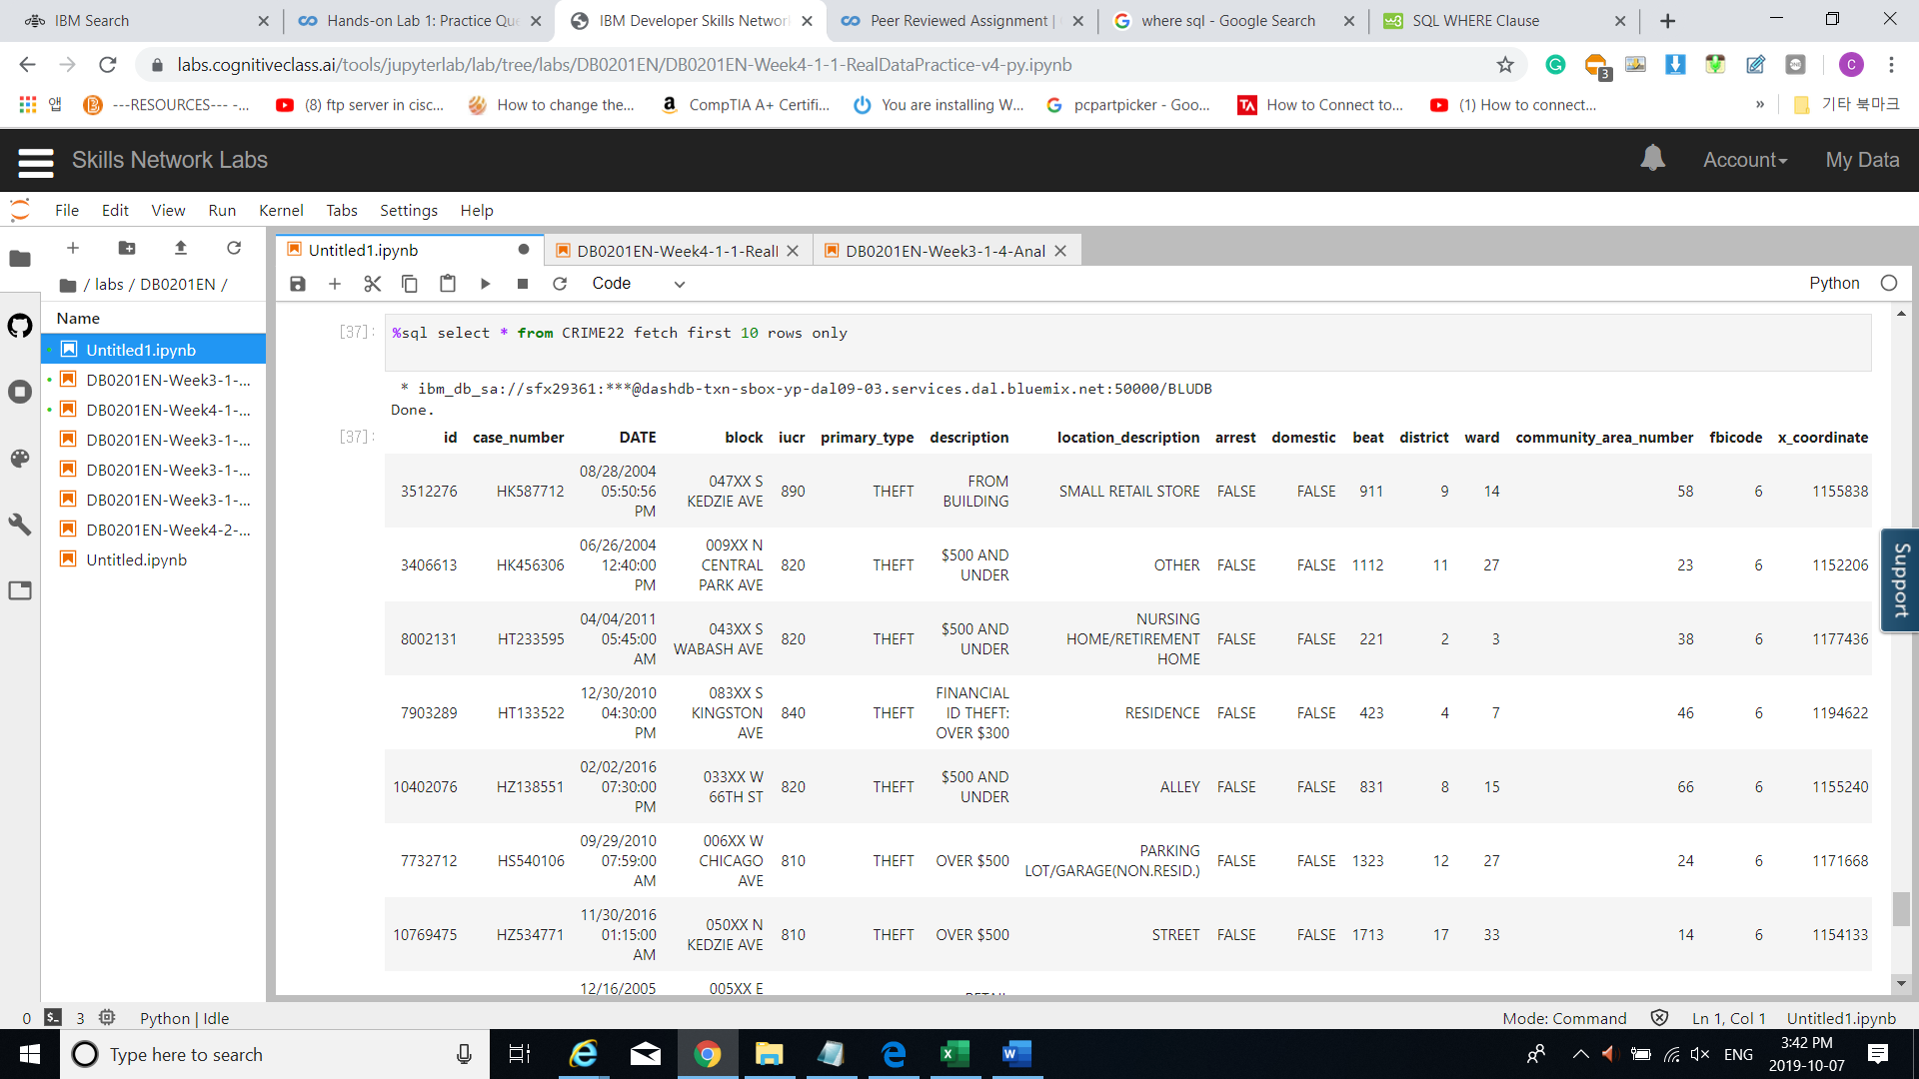

Problem 3: How many crimes involve an arrest.

%sql select count(*) from CRIME22 where ARREST = TRUE

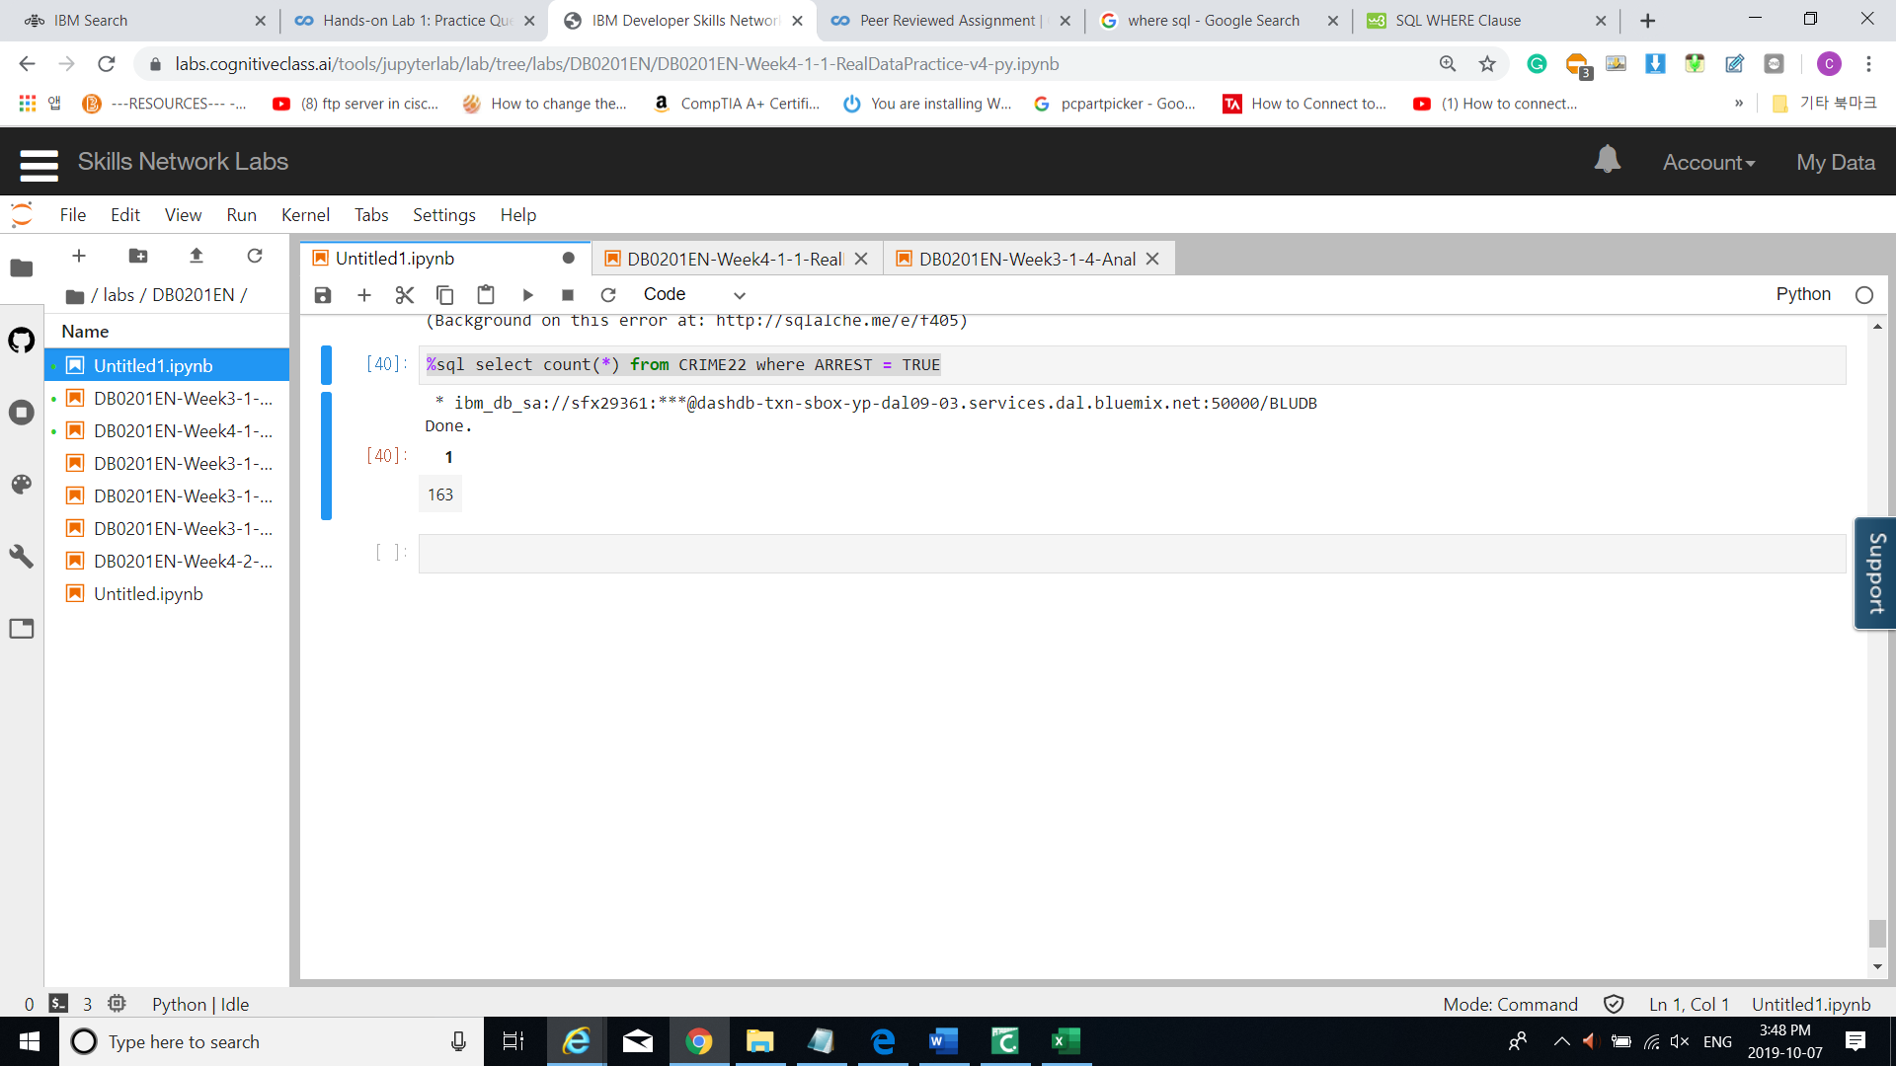

Problem 4: Which unique types of crimes (e.g. THEFT) have been recorded at a GAS STATION locations?

%sql select distinct primary_type from CRIME22 where location_description = 'GAS STATION'

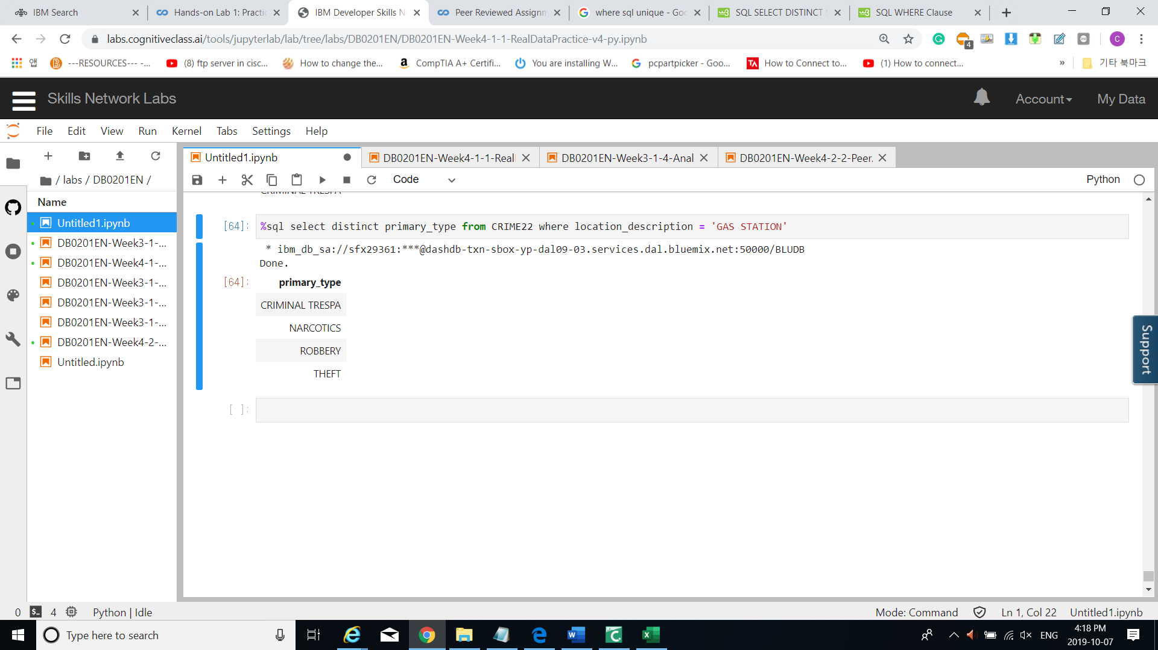

Problem 5: In the CENUS_DATA table list all community areas whose names start with the letter ‘B’.

%sql select * from CENSUS11 where COMMUNITY_AREA_NAME like 'B%'

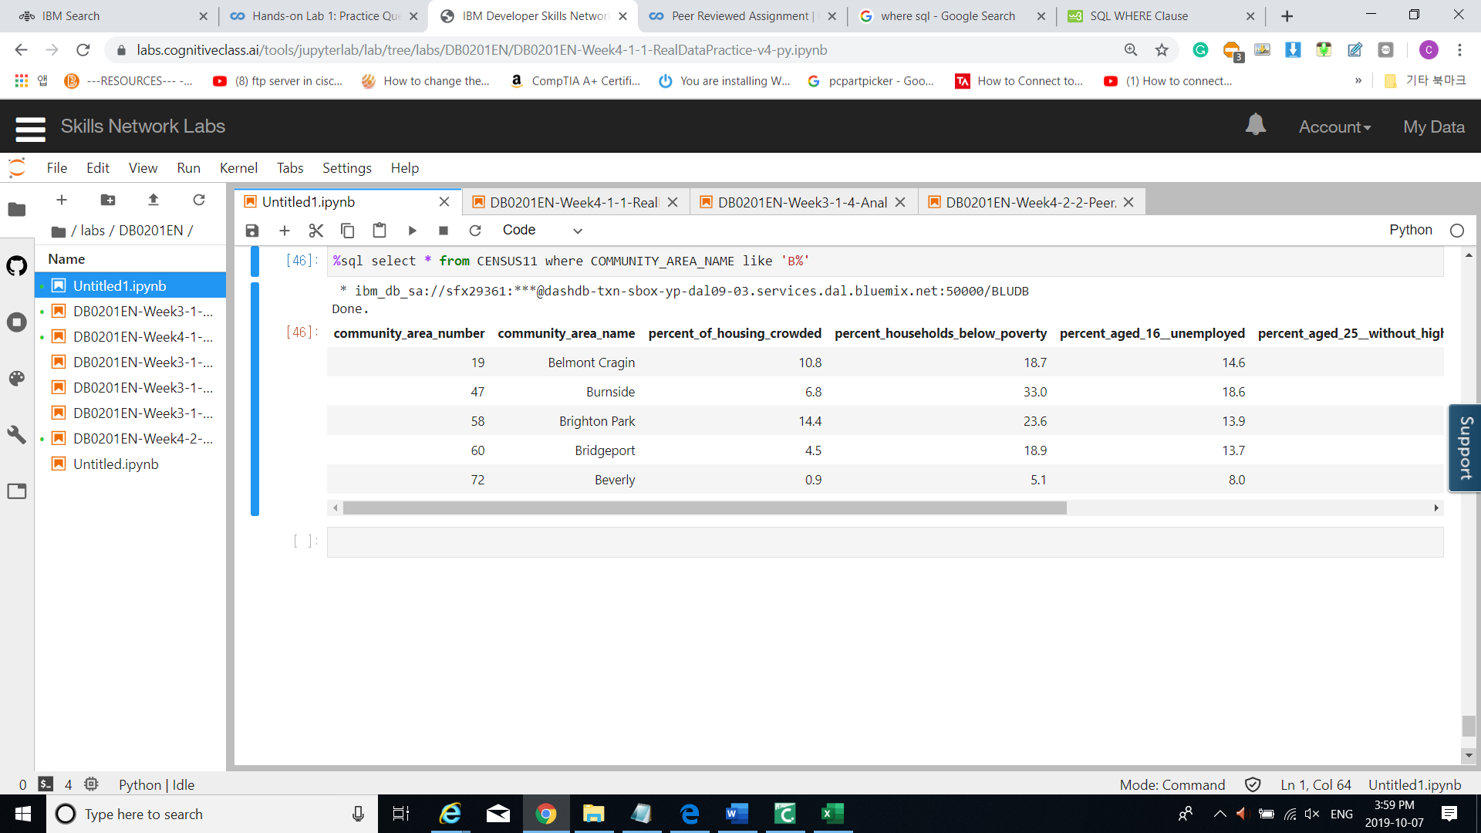

Problem 6: List the schools in community areas 10 to 15 that are healthy school certified.

%sql select * from PUBLIC11 where HEALTHY_SCHOOL_CERTIFIED = 'Yes' and COMMUNITY_AREA_NUMBER in (10,11,12,13,14,15)

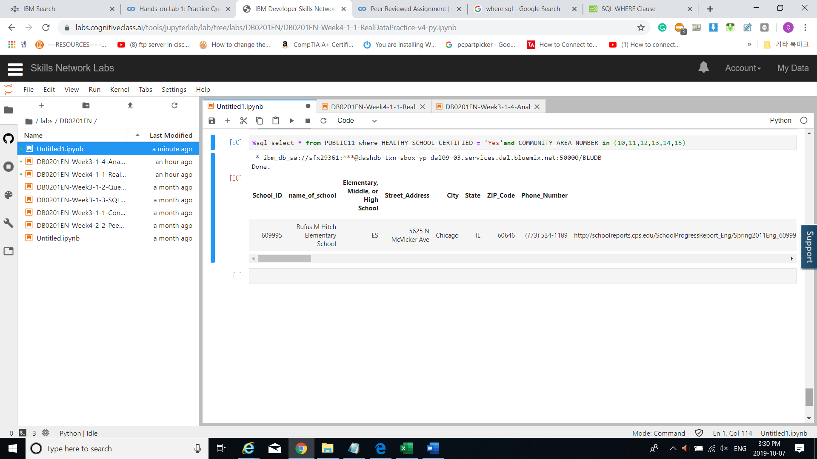

Problem 7: What is the average school Safety Score?

%sql select avg(Safety_Score) from PUBLIC11

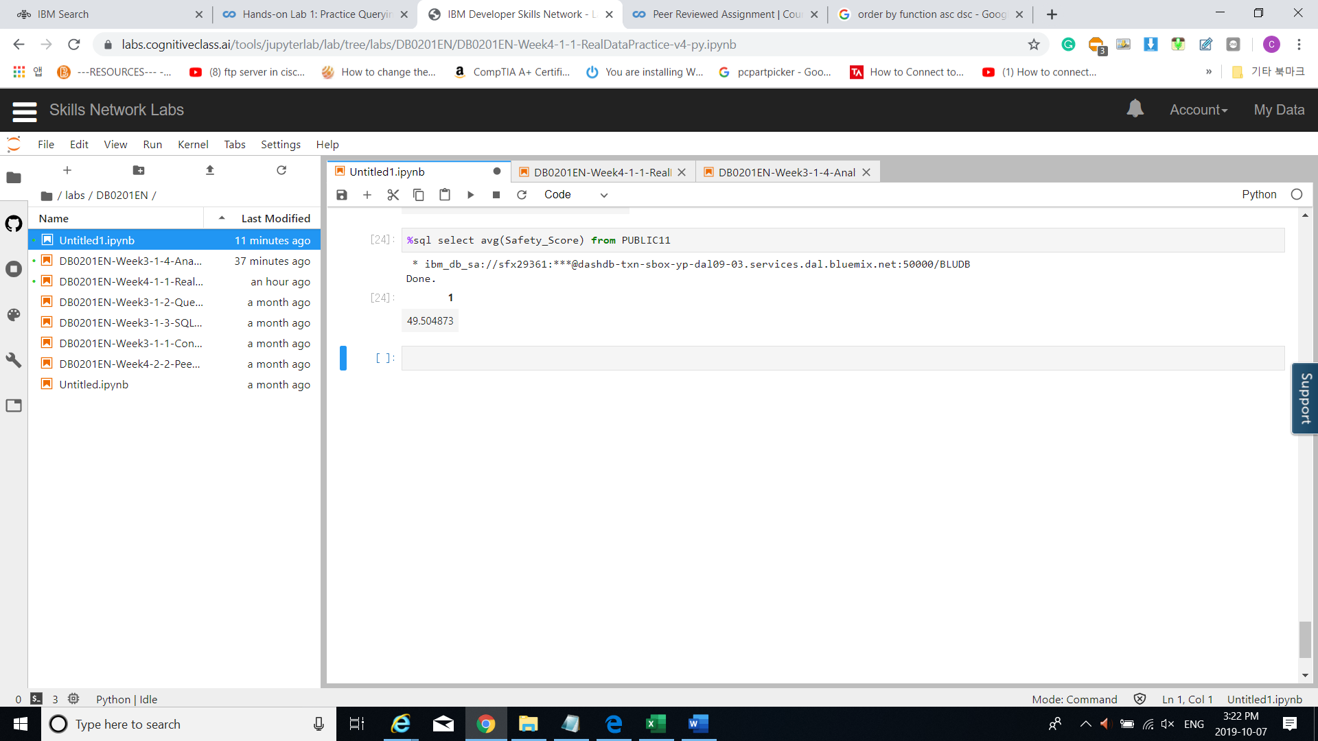

Problem 8: Find the top 5 Community Areas by average College Enrollment [number of students].

%sql select Community_Area_Name, avg(College_Enrollment) AS AVERAGE_ENROLLMENT \

from PUBLIC11 \

group by Community_Area_Name \

order by AVERAGE_ENROLLMENT desc \

fetch first 5 rows only

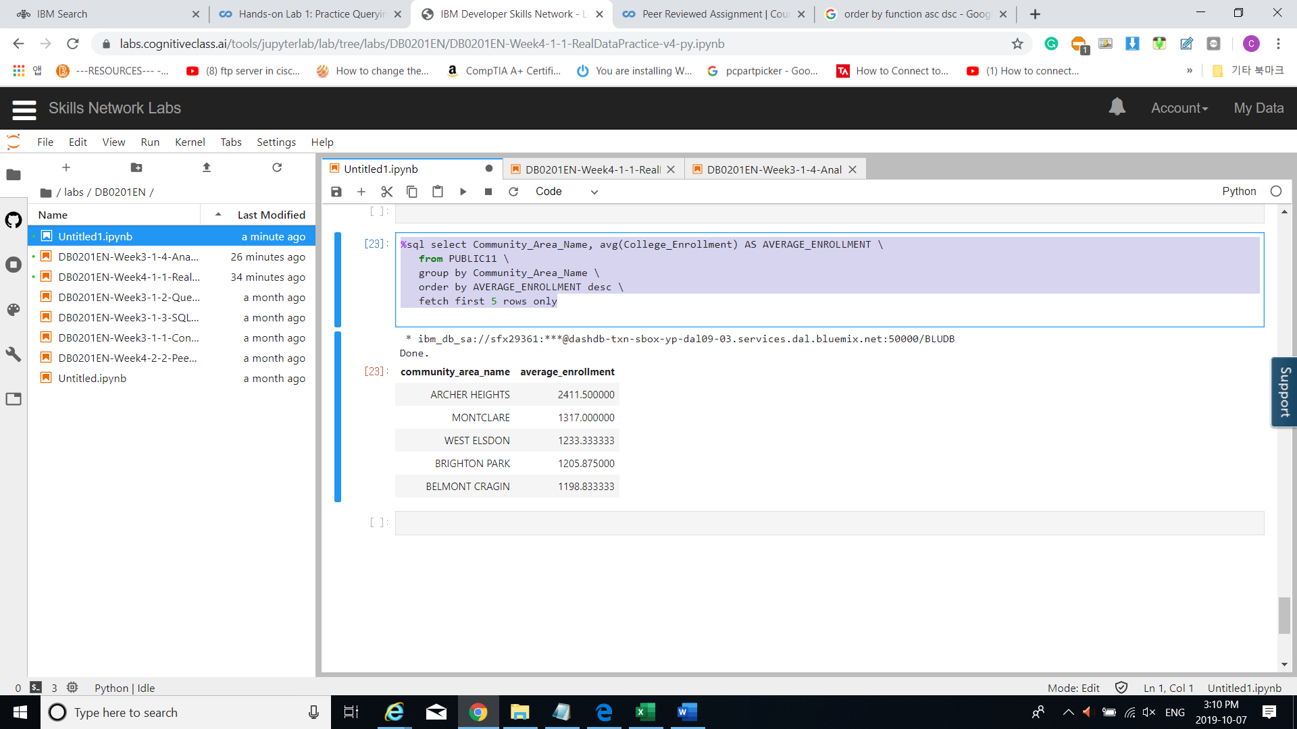

Problem 9: Use a sub-query to determine which Community Area has the least value for school Safety Score.

%sql select Community_Area_Name, Safety_score \

from PUBLIC11 \

order by Safety_score asc

fetch first 5 rows only

%sql select community_area_name from PUBLIC11 where safety_score< 20

%sql select distinct primary_type from CRIME22

\ where (select from PUBLIC11 where safety_score< 90)

Problem 10: [Without using an explicit JOIN operator] Find the Per Capita Income of the Community Area which has a school Safety Score of 1.

1. **SELECT column-names**
2. **FROM table-name1**
3. **WHERE value IN (SELECT column-name**
4. **FROM table-name2**
5. **WHERE condition)**

%sql select communy_area_name, per_capita_income

from CENSUS11

where community_area_name in ( select community_area_name \

from PUBLIC11 \

where safey_score = 1 )