

Intelligent Enterprise Systems
Year 2 (2025/26), Semester 3

SCHOOL OF INFOCOMM TECHNOLOGY
Diploma in Data Science

ASSIGNMENT 2

Weightage: | 40 %
Individual/Team/Both: | Individual
Format: | Font Arial  Font Size 11, 1.5 spacing
Deadline: | 31 Jul 2025, 2359hrs  Softcopy via Brightspace Assessment

Penalty for late submission:
10 marks per day (including Sunday and public holiday).
No report will be accepted after 07 Aug 2025, 2359hrs.

Intelligent Enterprise Systems
Year 2 (2025/26), Semester 3

SCHOOL OF INFOCOMM TECHNOLOGY
Diploma in Data Science

ASSIGNMENT 2

Tutorial Group | : | DS03
Student Name | : | Cheong Wei En
Student Number | : | S10268377E

E-Learning:
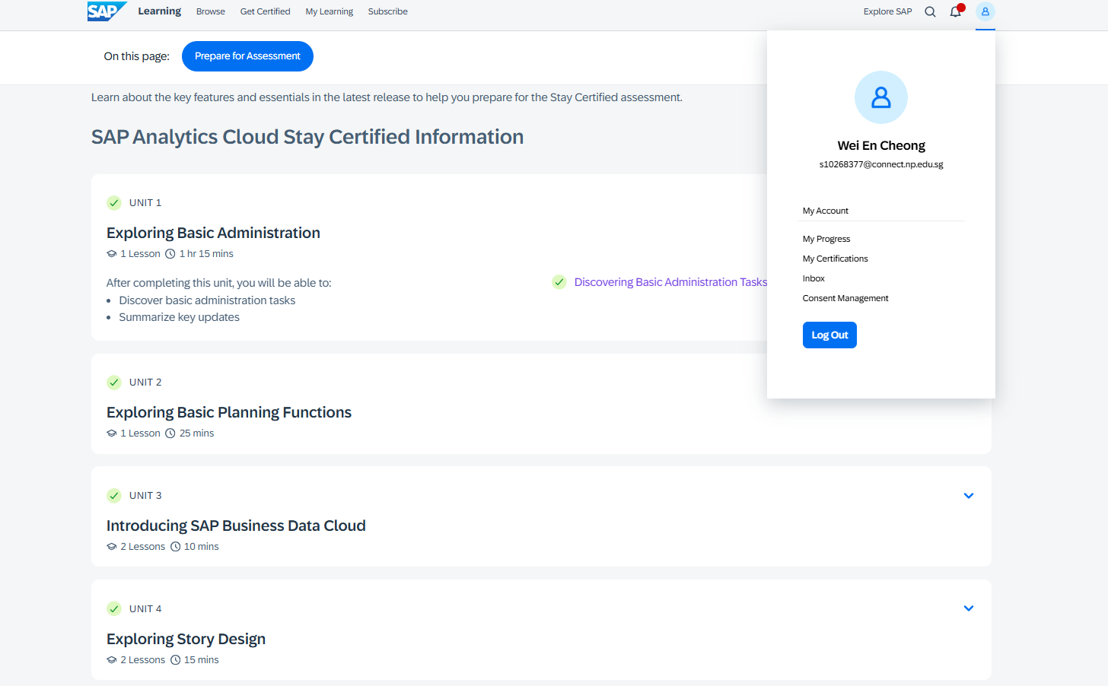
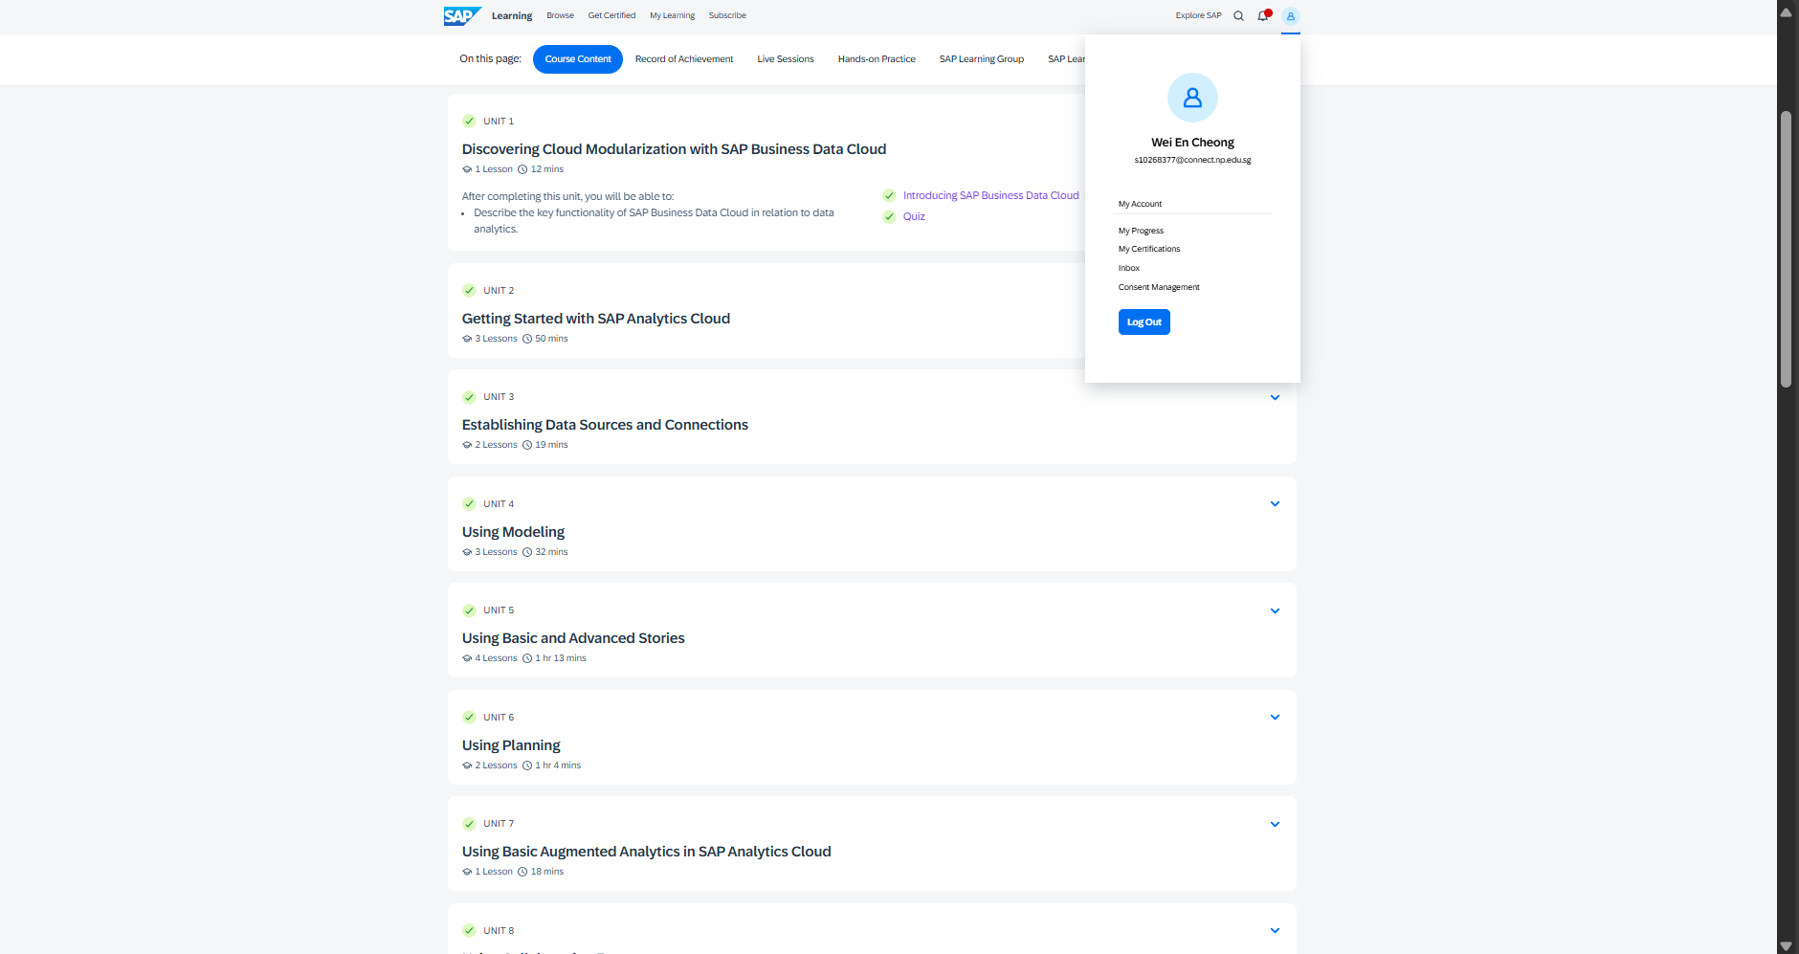
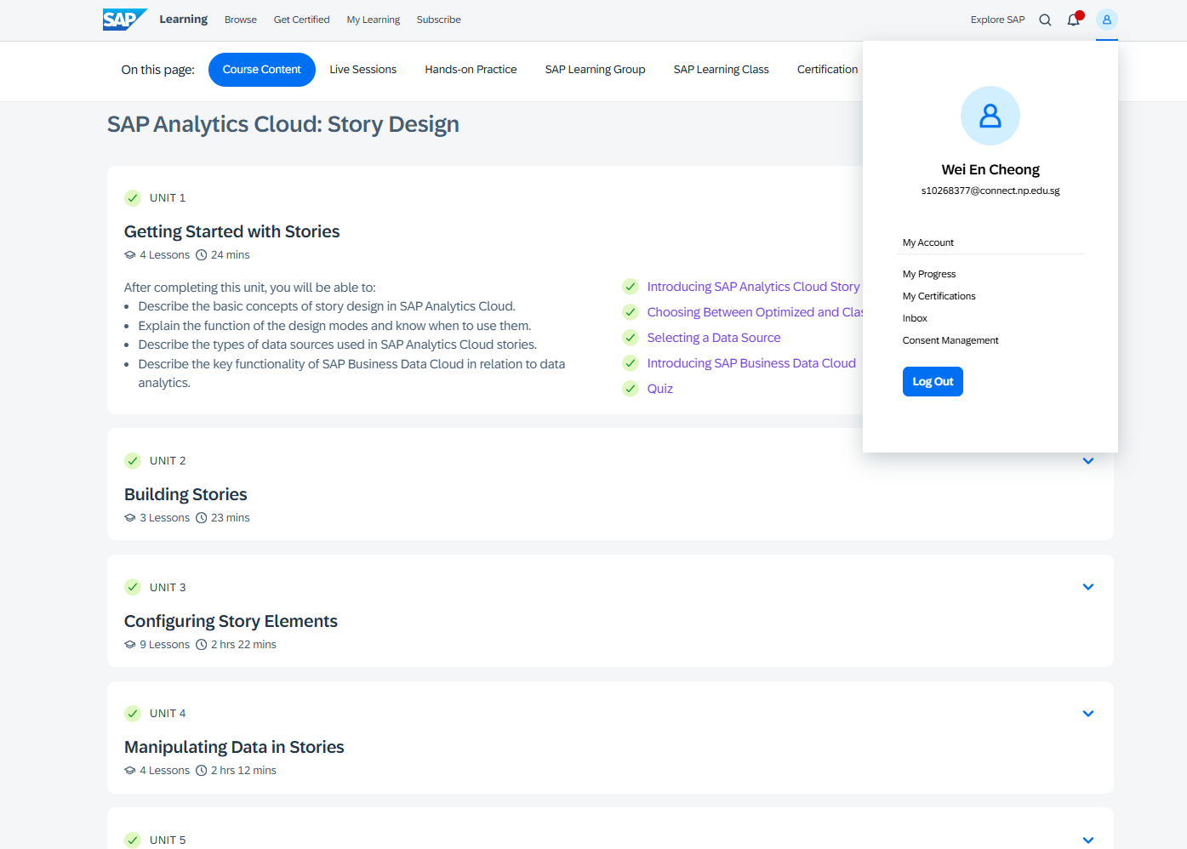
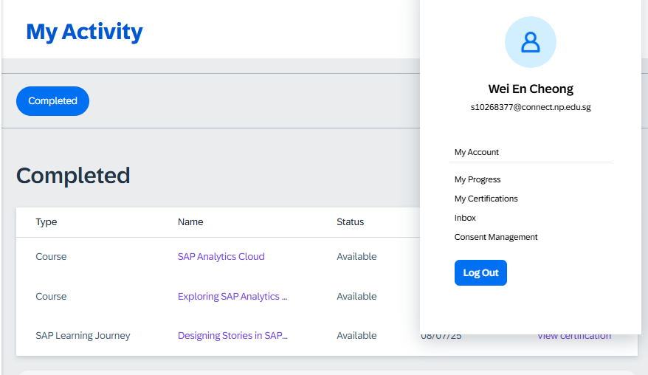

Contents
SCHOOL OF INFOCOMM TECHNOLOGY 1
SCHOOL OF INFOCOMM TECHNOLOGY 2
E-Learning: 3
Introduction: 6
Background of Dataset: 6
Exploratory Questions 6
Visualisations: 7
Geographic Performance: 7
Product Performance: 10
Customer Insights: 15
Time-Based Trends: 18
Logistics Insights: 22
Dash Boards: 24
Geographic Performance Dashboard: 24
Product Performance and Profitability Dashboard 25
Customer Insights Dashboard 27
Time-Based Trends Dashboard 29
Logistics Dashboard 31
Reflection 33

Introduction:
For companies, it is important for data to drive decision making in companies to maintain a competitive edge. This report helps to explore the usage of visualisations and analysis using the Retailer Dataset provided to us. By creating such visualisations and dashboards, I hope to be able to improve the company’s operational efficiency, identify profitable markets and improve customer targeting.

Background of Dataset:
The data set provided to us represents a retailer that has records of columns like profits, sales, regions as well as external costs etc. The data set does not require any cleaning done which made the pre preparation of data to be of ease.

This flow of analysis helps key stakeholders to understand where to grow, what to improve and how to better serve customers.

Key target stakeholders: Marketing Director

Exploratory Questions
- Global Sales and Profit Dashboard
  - Which are the top 10 most profitable countries (with Sales)? (Bar Chart)
  - What is the Regional Distribution of units sold? (Geo Chart)
  - What is the distribution of discounts across regions (with profits)? (Combination of line and bar chart)
- Product Performance and Profitability Dashboard
  - Which is the bestselling subcategory? (Tree diagram)
  - What is the profit margin per subcategory (Bar Chart)
  - What is the Quantity and profit by Subcategory)? (Combination of line and bar chart)
  - What is the breakdown of costs across subcategory? (Stacked Bar Chart)
  - What is the discount distribution and Profit by subcategory? (Combination of line and bar chart)
- Customer Insights
  - Which customers have the highest profits?
  - Which 10 customers receive the highest discounts? (Table)
  - Who buys from the company the most? (Pie Chart)
- Time-Based Trends
  - How is the profit over time (Time series Chart)
  - How are the sales over time (Time series Chart)
  - How are the Profit and Total costs over time (Time series Chart)
- Logistics Dashboard
  - Which Shipping mode has the highest quantity of items? (Bar Chart)
  - What is the profit distribution across the Shipping modes (Table)

Visualisations:

Geographic Performance:

Which are the top 10 most profitable countries (with Sales)?
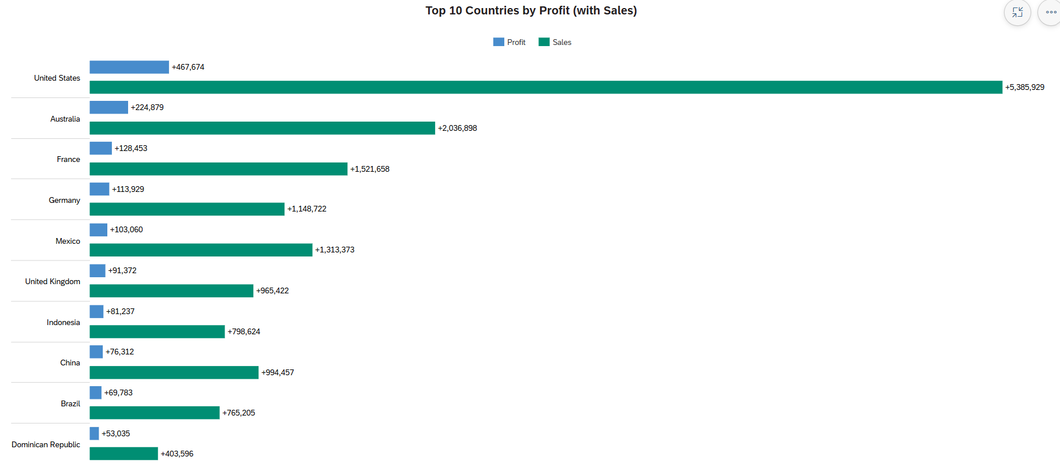
Analysis:
From the bar chart above, the company has the highest market presence and profitability in the US compared to any other country.

Moreover, we can see that some countries have higher sales than others but making less profit than the other (e.g. Germany VS Mexico, Indonesia VS China). This shows that there could be some underlying causes like high operational causes as to why certain countries are having higher sales but lower profits than other countries.

Suggestion/Insights:
This provides us with valuable information such as places like the US (where it is very profitable) to conduct marketing campaigns.
It also helps to identify potential markets like Australia and Europe that could benefit from targeted marketing strategies to grow market share.

This can also help us track the sales and profits from top performing countries to better guide expansion plans so as to boost profitability.

What is the Regional Distribution of units sold? (Geo Chart)
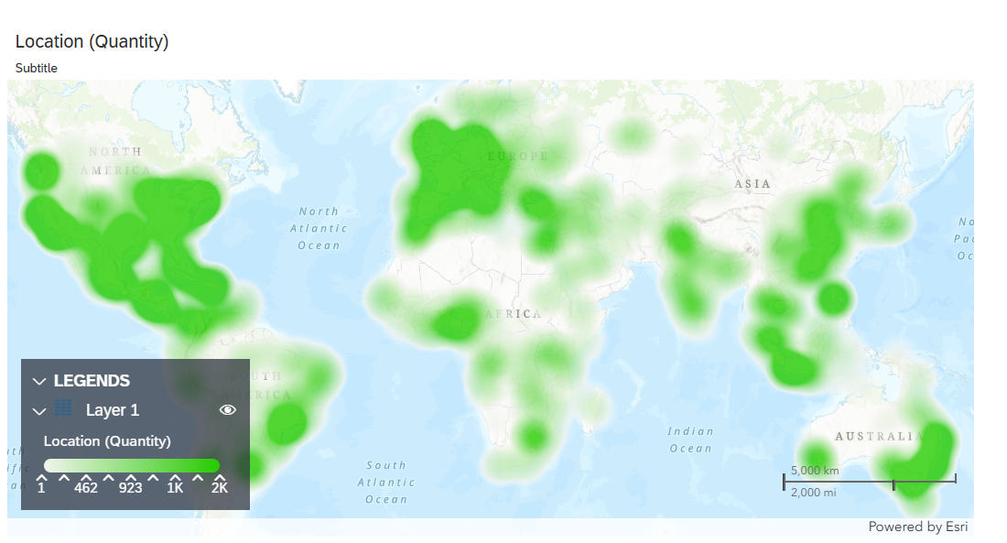
Analysis:
From the Geo Chart above, it shows that places like Europe and North America purchase the highest quantities. This helps to guide inventory planning and increase efficiency in storage across key regions.

Suggestion/Insights:
This chart indicates that places like North America and Europe have high volume of items sold, so building hubs there would decrease the costs spend on shipping, shorten delivery time and improve overall supply chain performance.

What is the distribution of discounts and profits across regions? (Bar chart & Line Chart)
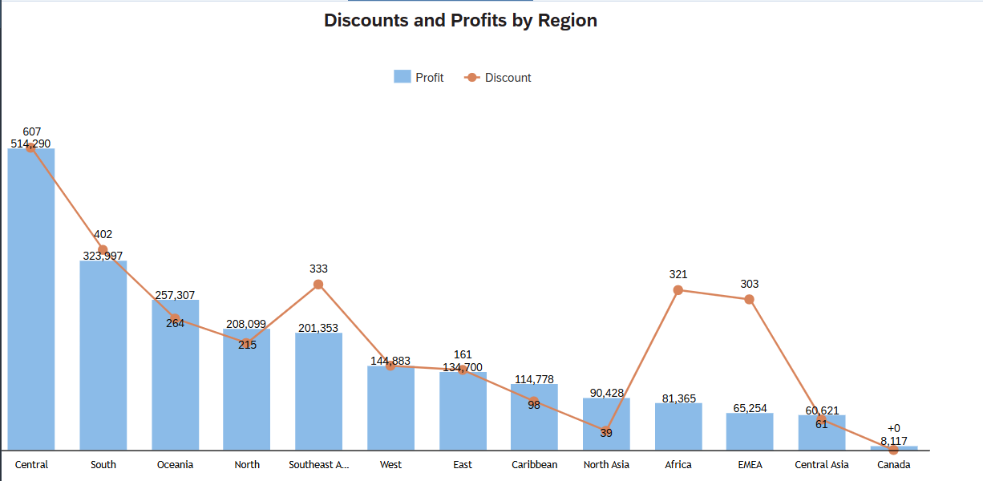
Analysis:
Compared to the rest of the regions, Africa and EMEA regions have one of the lowest profit values but are given a high number of discounts.

Similarly, The Southeast Asia Region also has the same similar trend where higher discounts do not correlate with higher profits.

Suggestion/Insights:
Discounts in these regions like Africa and EMEA are not effectively driving higher sales. The company should reconsider discount distribution in these regions to improve overall profitability.

Product Performance:
Which is the bestselling subcategory? (Tree diagram)
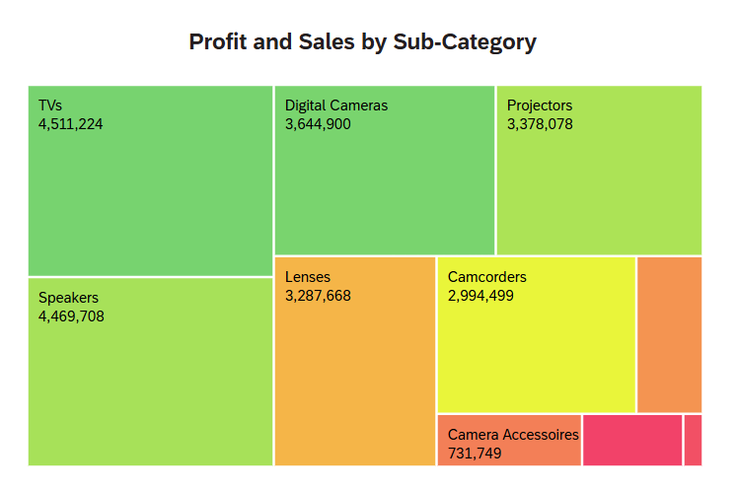
The tree diagram shows subcategory sales by block size and uses a green-to-red gradient to showcase and represent the different profit levels. (Green for high, red for low)

TVs dominate both sales and profit while Speakers also show strong sales and good profit, making them top-performing subcategories.

However, Camera Accessories have decent sales but yet it is shaded in red which indicates that the profit is low or negative.

Suggestion/Insights:
This may be due to the company over-discounting or facing high costs in that area which calls for further analysis.

Overall, this visualisation helps to identify which products drive revenue and profits while highlighting subcategories that need more reviewing like Camera Accessories.
Company can also make use of high-performing products for targeted marketing.

Smart Discovery Chart: Profit by country and category
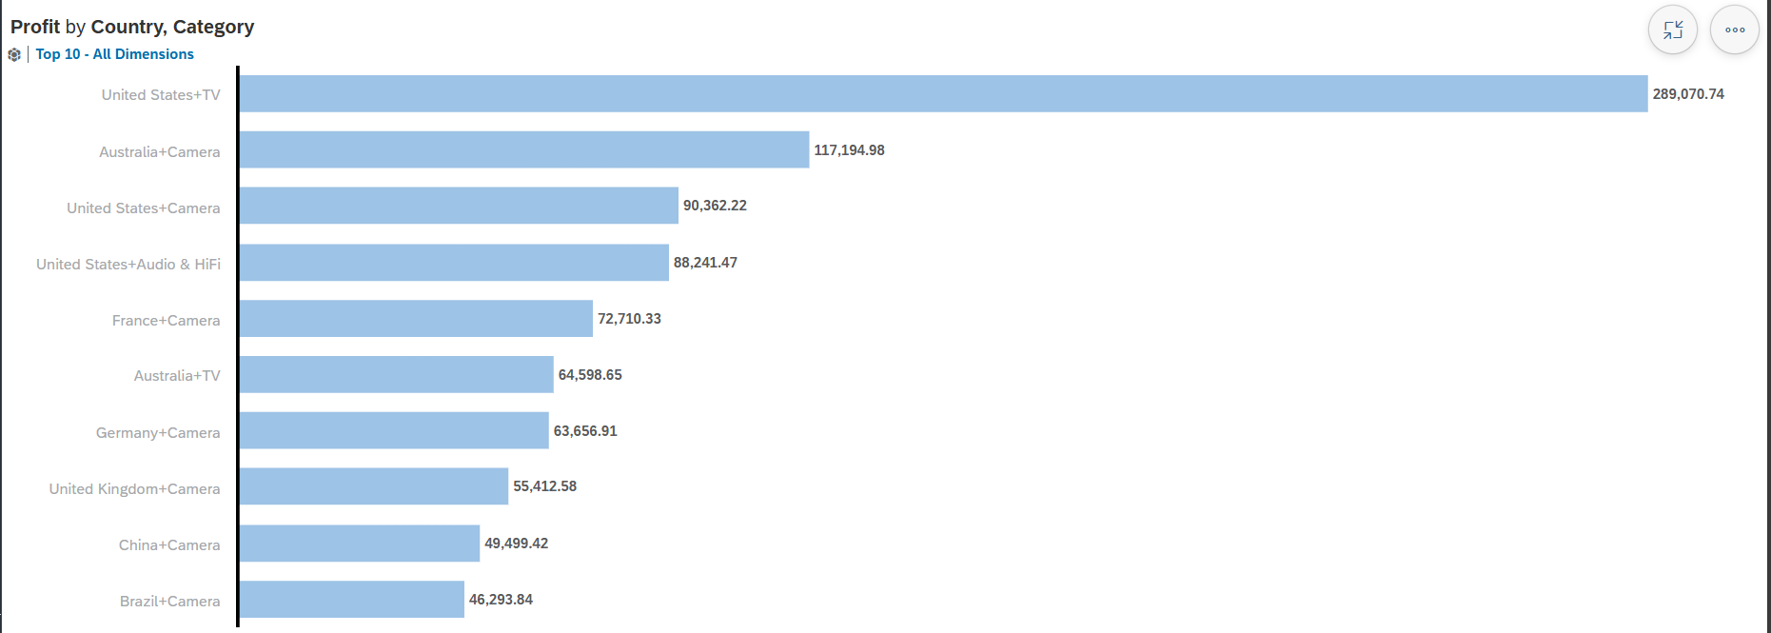
This chart highlights which countries and categories drive the most profit which helps company to align with supply chain and focus marketing efforts on high-performing areas.

For instance, in the US, company should promote TVs and have strategic targeted marketing in order to boosts profit. Alternatively, company can consider having seasonal promotions in specific regions for certain categories of item to increase profit.

What is the profit margin per subcategory (Bar Chart)
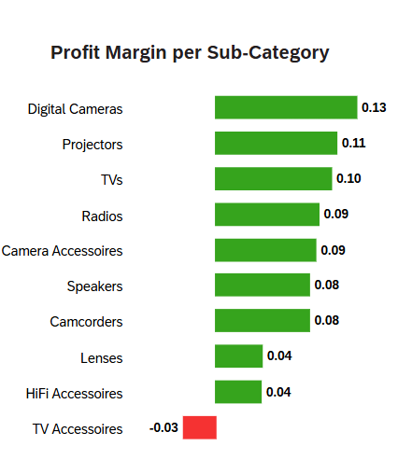
This chart highlights products with higher profit regardless of sale volume.

From the bar chart above, Digital cameras have the highest profit margin (0.13). All subcategories bring in profit except TV Accessories (-0.03) which may be losing money on each sale.

Suggestion/ Insights:
Further analysis is needed to find out if high costs, low sales volume or discounting distribution caused the negative margin.

What is the Quantity and profit VS Subcategory (Bar and Line Chart)
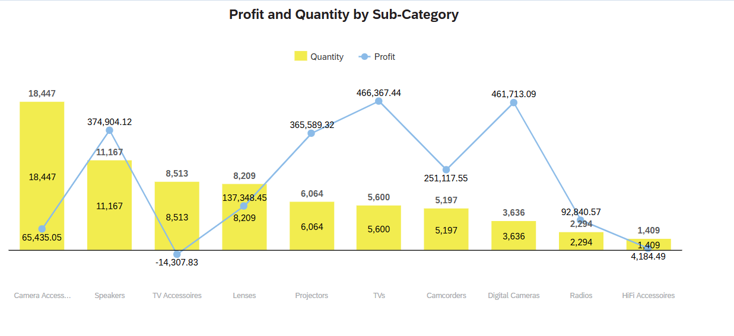
Camera accessories have highest quantity items sold yet one of the lowest profits.

Suggestion/Insights:
Despite high sales volume, it may have suffered from high costs or high discounts which requires further analysis.

What is the breakdown of costs across subcategory products? (Stacked Bar Chart)
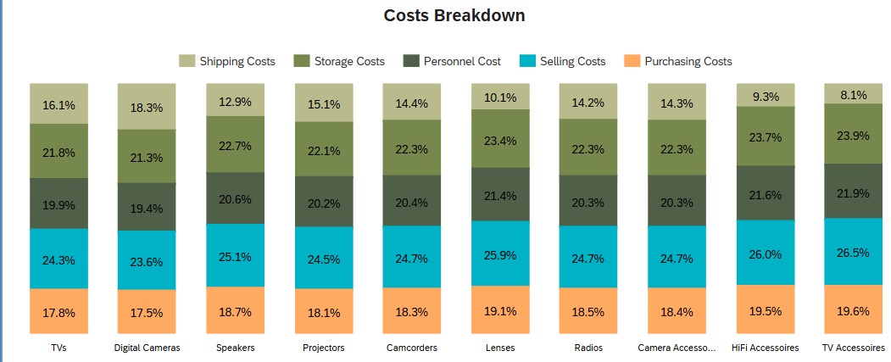
Analysis:
This chart would enable us to compare the proportions of the costs in the different subcategories regardless of its sales volume.

TVs and Digital Cameras have a more balanced cost structure which might contribute to their higher profitability.

Hifi Accessories and TV accessories have highest selling and storage costs which might have explained why their profits are low or have negative profit margins.

Suggestion/Insights:
High storage or even selling costs bring about inefficiencies in inventory or marketing.
Further analysis of discounting and profit alignment is needed.

What is the discount distribution given to each subcategory given their profits? (Combination of line and bar chart)
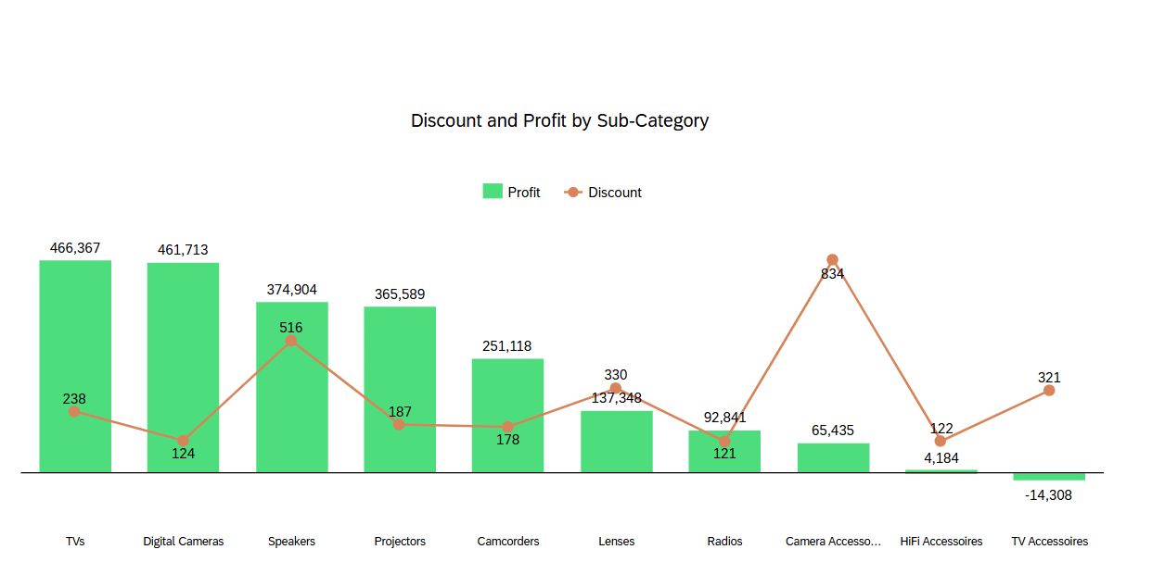

Analysis:
Lenses, Camera, HiFi and TV Accessories are given a high number of discounts, which could be the main reason why the profits for those categories are lower.

Suggestion/Insights:
Since Camera Accessories have a high volume of sold items but making less profit due to high amount of discounts, the company should remove discounts on certain best-selling items for Camera Accessories.
For slow moving camera Accessories, companies can conduct bundling discounts or even loss-leader strategies to clear out slow moving inventory while still managing profitability. E.g Free HDMI cable when TV purchase.

Customer Insights:
Which customers are the most valuable to the business (Table)

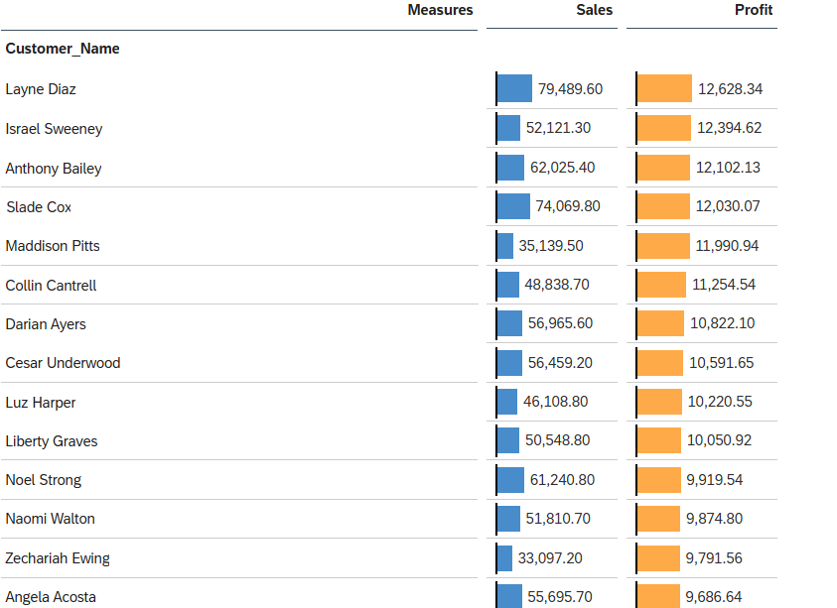
The table above shows the top 20 customers with the highest profits.

Analysis:
This table would enable the company to easily identify the top valuable customers in terms of profitability.

Suggestion/Insights:
By recognising these high-profit customers, the company can then consider rewarding them by giving them exclusive discounts or even loyalty rewards so that they will continue buying from the company and strengthen the customer relationships.

What is the discount distribution across customers? (Table)
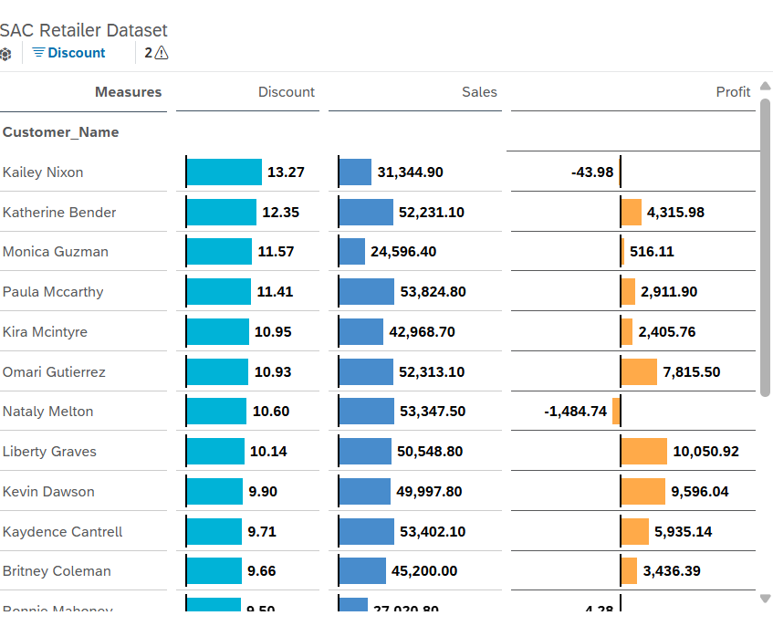
While the previous table helps identify who our best customers are, this table helps ensure and monitors whether discounts are appropriately allocated across the customer base.

Analysis:
From the table above, the highest discount given to customers has negative or low profits for the company.

Suggestion/Insight:
The company may want to relook at discount distribution and provide and allocate discounts to customers that bring in the most profit and value. This can not only strengthen customer relations but also bring in more profits.

Who buys from the company the most (Pie Chart)
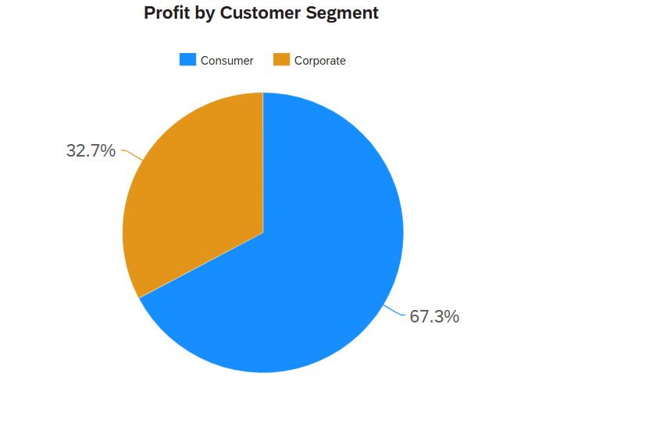

Pie Chart: Profit Distribution across Customer Segments
The pie chart shows more than 2/3 of the profit comes from Consumer (67.3%) as compared to corporate (32.7%) making it the company’s main profit driver.

Suggestions/Insights:
This suggests that marketing strategies that are more focused on individual consumers could prove to be effective. For example, adding loyalty programs or even personalised offers can boost profitability from Consumers.

At the same time, the company can explore ways to increase profitability among the corporate segment such as offering bundled items.

Time-Based Trends:
How is the profit over time? (Time series Chart)
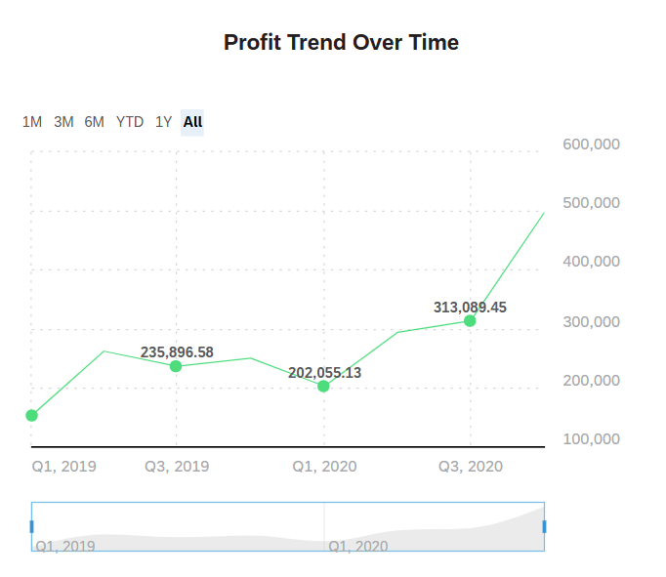Analysis:
The chart above displays the profits across order data. Overall, there seems to be a growth of profit which indicates business growth.

Suggestion/Insights:
This allows stakeholders to track their financial performance over time and identify seasonal patterns or even assess the impact of marketing strategies or other business decisions.

There seems to be a dip in profit between Q3 2019 and Q1 2020. More investigations can be done to find out what happened during that time which caused a dip in profit.

Overall, the business is growing well in terms of profit.

How are the sales over time (Time series Chart)
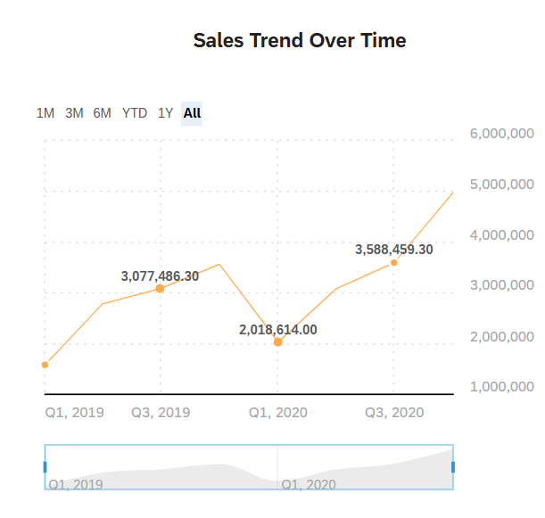
Analysis:
The chart above displays the sales across order date. Overall, there seems to be a growth of profit which indicates business growth.

Suggestion/Insights:
This allows stakeholders to track their sales over time and identify buying trends which supports better inventory planning.

There seems to also be a correlation between sales and profit which is a good sign as it shows operational efficiencies.

Sales and Total costs overtime (Time series Chart)
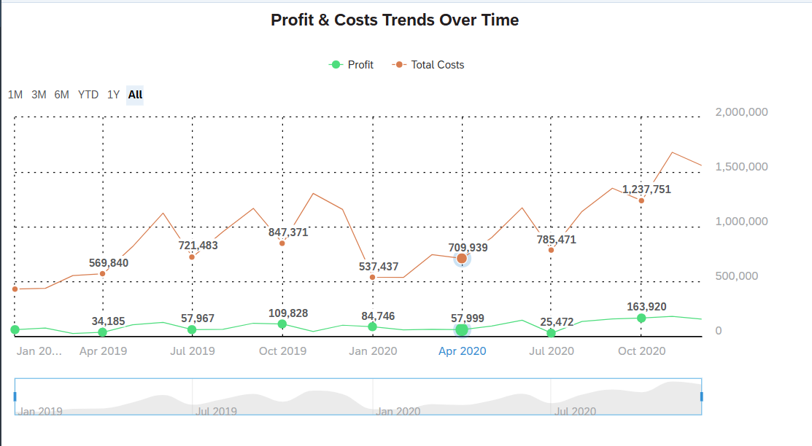
Analysis:
The chart above displays profit and total costs overtime, which shows how efficiently the company is in generating profits relative to its expenses and costs.

Suggestion/Insights:
Monitoring both costs and profits helps to detect cost spikes and assess whether an increase in sales means higher profitability. It also supports strategic cost control and pricing decisions.

Smart Discover Chart (Sales Forecast):
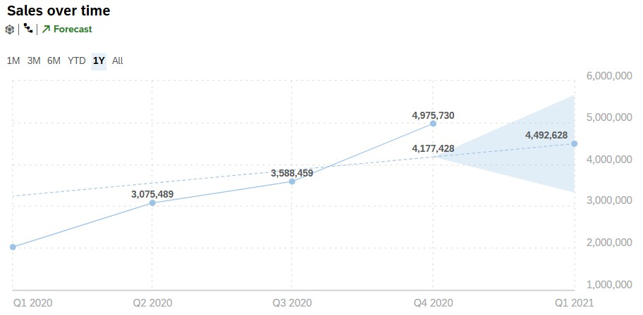

Analysis:
This chart shows the forecasted and predicted Sales for the next quarter. This helps the stakeholders to anticipate future performance and make informed planning decisions.
Moreover, the company can use the forecasted sales to gauge if future marketing plans are effective by comparing actual sales to the forecasted sales.

Smart Discover Chart (Profit Forecast):
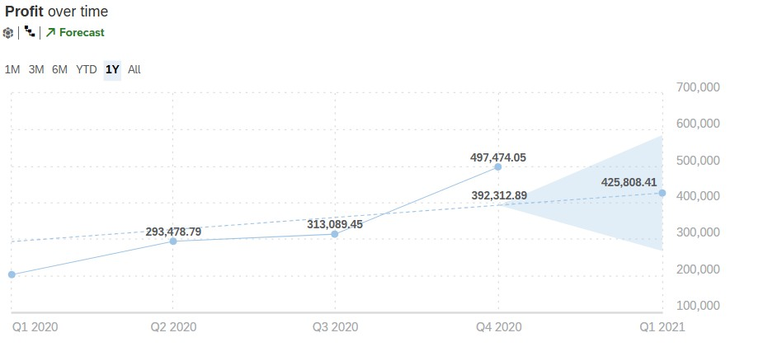

Analysis:
This chart uses predictive analytics to forecast profits for the next quarter. This enables stakeholders to anticipate financial performance and evaluate the impact of current or planned marketing and operational strategies by comparing actual profits to the forecasted one.

Logistics Insights:
Which shipping mode is most preferred?
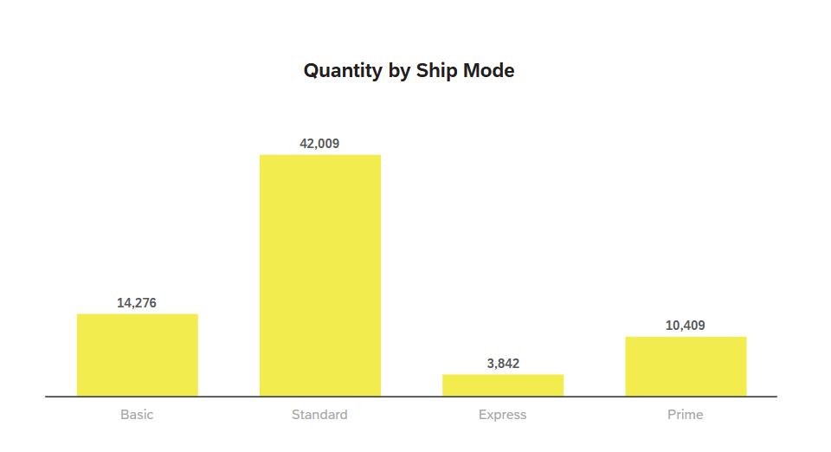Analysis:
The chart shows that customers seem to prefer shipping modes in the order of Standard, Basic, Prime then express.

The sharp drop between standard and other shipping modes suggests that customers either find it most cost-effective between speed and cost or it may be defaulted during checkout.

Further analysis to find out why customers prefer Standard shipping over the others and find out why fewer customers prefer Express. This can be due to high costs, lack of value for the price paid or the customers not interested in faster options.

Suggestion/Insights:
The company can see if customer feedback is related to shipping preferences and also compare shipping duration across different modes.

Smart Insights (Quantity Sold per country)
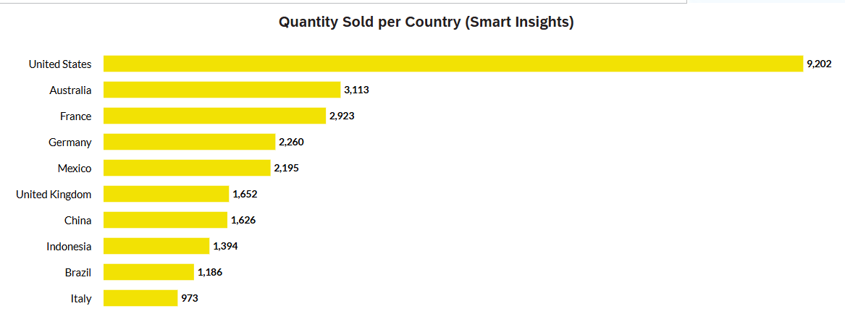
Analysis:
This chart expands on the information as to where high volumes of purchases are at. This also shows us where companies can consider opening the logistics hub and warehouses with this chart, which can help better respond to customer needs.

Suggestion/Insights:
Building a hub can reduce reliance on long-haul international shipping which is more expensive and prone to delays.
The company can analyse this and optimize delivery routes and explore bulk shipping strategies in key places like US and Europe.

Dash Boards:

Geographic Performance Dashboard:
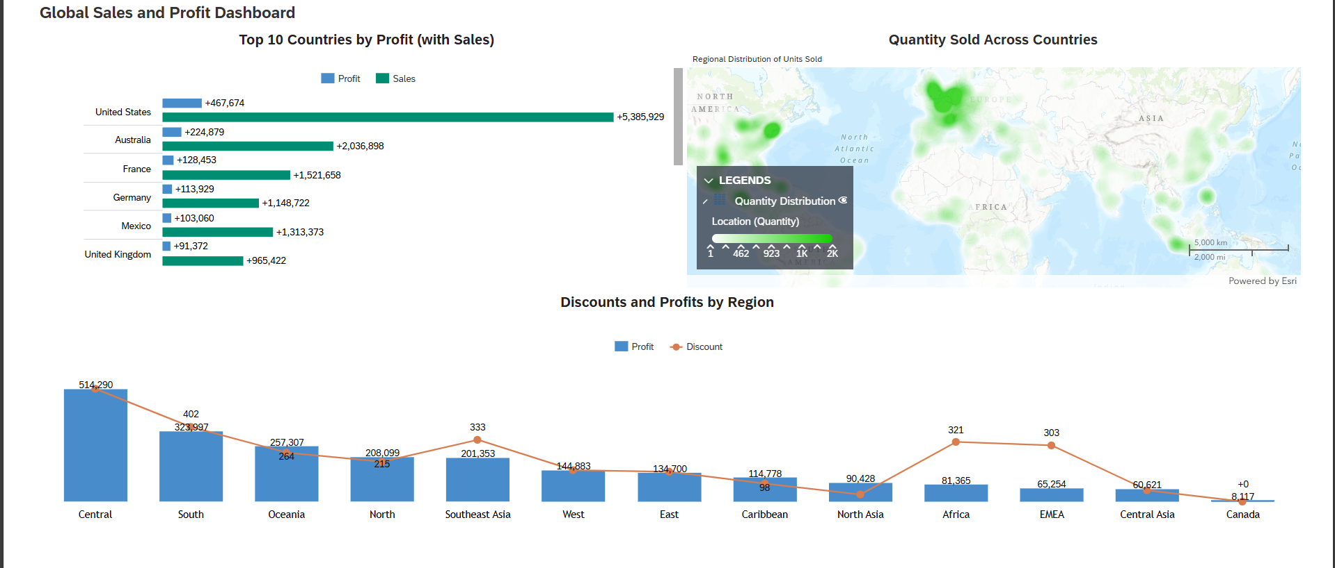

The dashboard above helps to identify market dominance and profitability.

Bar Chart: Top 10 Countries by Profit (with Sales)
Key Usage: Point out profit makers and market expansion opportunities
Actionable Insights:
- Conduct marketing campaigns (localised ads, warehouse expansions or even exclusive promotions) in areas like US to boost profit even more and attract more buyers
- Can consider conducting marketing campaigns in areas like Australia and Europe areas to expand market size and presence
- Use profit to sales ratio to see if some countries have higher sales but low profit margins, indicating a need to adjust operational costs

Geo Chart: Quantity Sold by Country
Key Usage: Map demand density to help optimise logistics
Actionable Insights:
- Negotiate for bulk shipping rates in Europe and America to decrease shipping costs
- Can consider conducting marketing campaigns in Africa and EMEA such as local influencer partnerships on popular platforms like Tik Tok
- Expand inventory warehouses in places like US and Europe

Combo Chart: Discounts vs Profits by Regions
Key Usage: Exposes discount inefficiencies
Actionable Insights:
- Reduce discounts in Africa and EMDA and monitor the profits for 2-3 months
- Alternatively, can consider replacing discounts with bundled deals such as free shipping after minimum spending

Product Performance and Profitability Dashboard
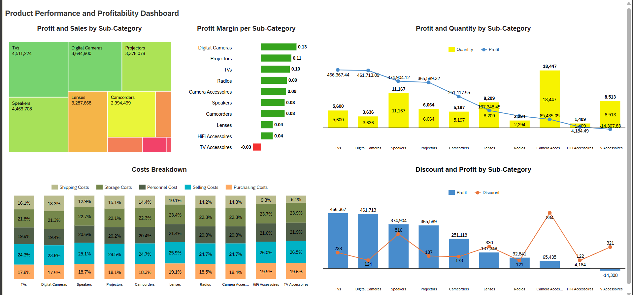

This dashboard helps provide an overall overview of the product performances across areas like subcategories, sales, profit, cost structures as well as effectiveness of discounts.

Tree Diagram: Bestselling subcategories

Key Usage: Identifies top-performing and underperforming subcategories
Actionable insights:
- For TVs and Speakers (High sales and profit)
  - Conduct targeted upsell campaigns such as premium bundles
  - Consider featuring products in seasonal promotions to further boost the performances

Bar Chart: Profit Margin Per Sub-Category

Key Usage: Identifies most and least profitable subcategories
Actionable insights:
- For Digital cameras (High profit margin)
  - Expand successful pricing strategies to other similar subcategories
  - Increase the inventory stock as it is high in demand
- For TV Accessories (low profit margin)
  - Considering conducting Loss leader Strategy, free accessories with TV Purchase (e.g. Free HDMI Cable with each TV Purchase)

Bar and Line Chart: Quantity and Profit by subcategory

Key Usage: Displays the sales volume to profit correlation
Actionable insights:
- For Camera Accessories
  - Consider exploring strategic opportunities such as only discounting slow moving products
  - Sell top-selling accessories at full price to increase profits

Stacked Bar Chart: Costs breakdown

Key Usage: Displays costs distribution across subcategories
Actionable insights:
- For camera and TV Accessories
  - Consider loss leader strategy to drive the sales of high-margin products
- For HiFi and TV Accessories,
  - Company can consider negotiating better warehouse rates or find another warehouse which has lower rates
- Company can also identify 2-3 cost saving priorities per quarter/semester

Bar and Line Chart: Discount and Profit by subcategory

Key Usage: Displays and evaluates discount effectiveness
Actionable insights:
- For over-discounted subcategories, add value bundles (e.g. Camera and Lens package deal)
- Limited time offers instead of discounts without permanently lowering prices (e.g. 24-hour flash sales)

Customer Insights Dashboard
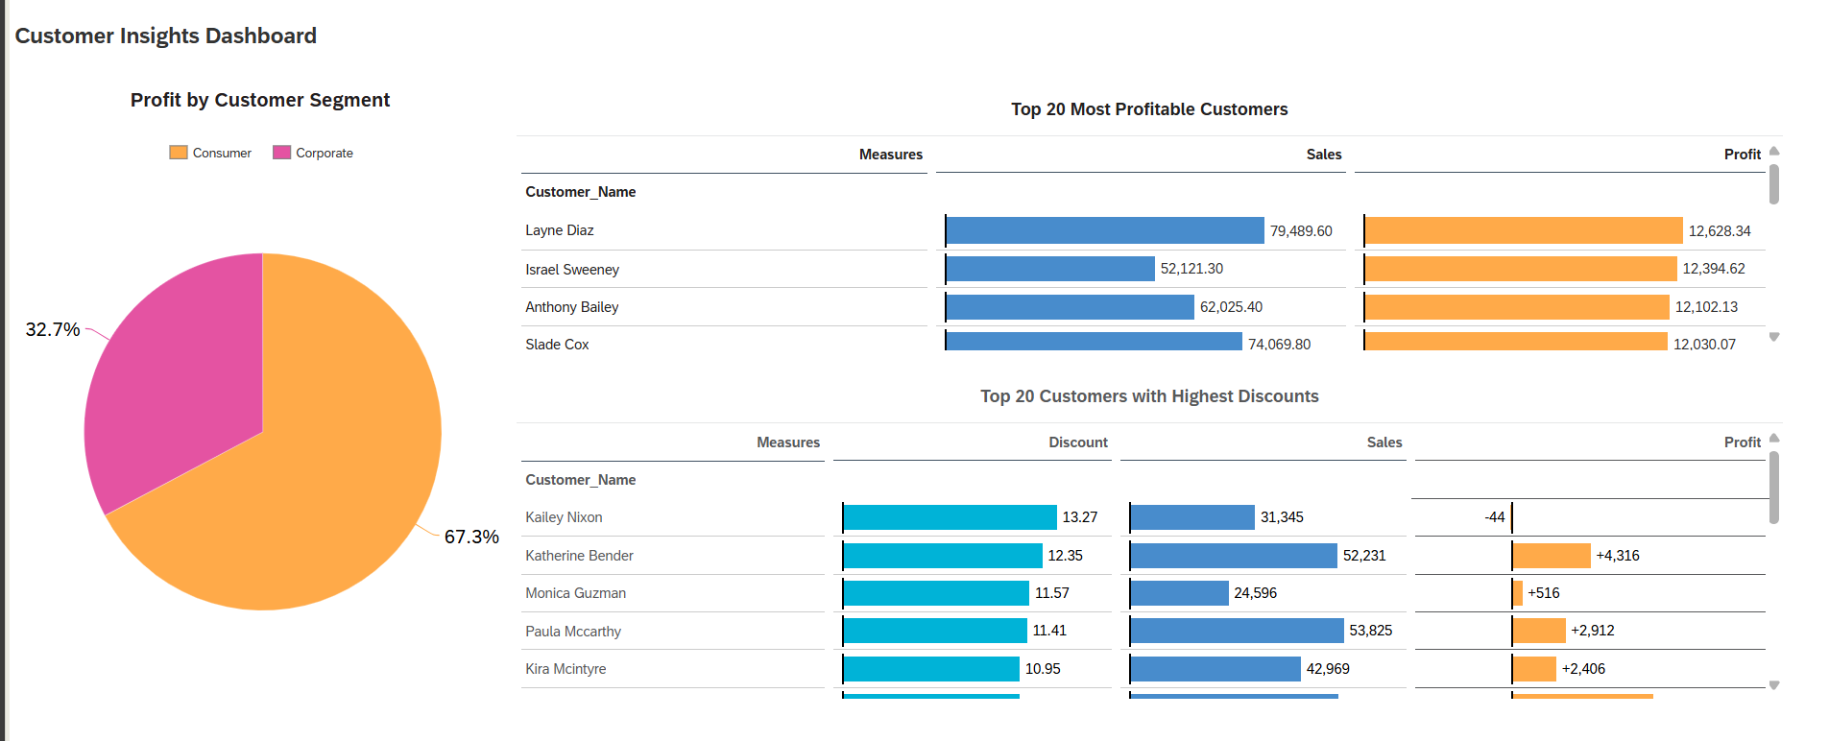

This dashboard forces on increasing and managing customer relationships through monitoring of profits and discounts.

Table: Top 20 most profitable customers

Key Usage: Used to identify and maintain loyalty with high-value customers
Actionable Insights:
- For top 3 customers
  - Offer exclusive premium perks like early access to newly launched items
  - Can also consider assigning dedicated account managers for an even more personalised service if possible
- For all customers
  - Offer exclusive premium perks such as free shipping so customers can continue buying more from company due to benefits

Table: Top 20 Discounted Customers

Key Usage: Monitor discount effectiveness
Actionable Insights:
- For loss making customers (Kallery Nixon),
  - Reduce discounts from 13.27% to 5% immediately
  - Replace with other incentives like loyalty points
- For profitable customers (e.g. Katherine Bender, Paula McCarthy),
  - Increase discounts by a bit (from 12.35% to maybe around 15%) to encourage them to have larger orders from company to boost profits from them

Pie chart: Profit by Segment

Key Usage: Proportion of Customer segments
Actionable Insights:
- Consumer Segment (Large proportion)
  - Launch referral program such as getting vouchers/cash back each time customer refers someone else
  - Create personalised marketing to target this group of customers like product recommendations
- Corporate Segment
  - Offer yearly contracts with volume discounts, this encourages more partnerships with the company

Time-Based Trends Dashboard
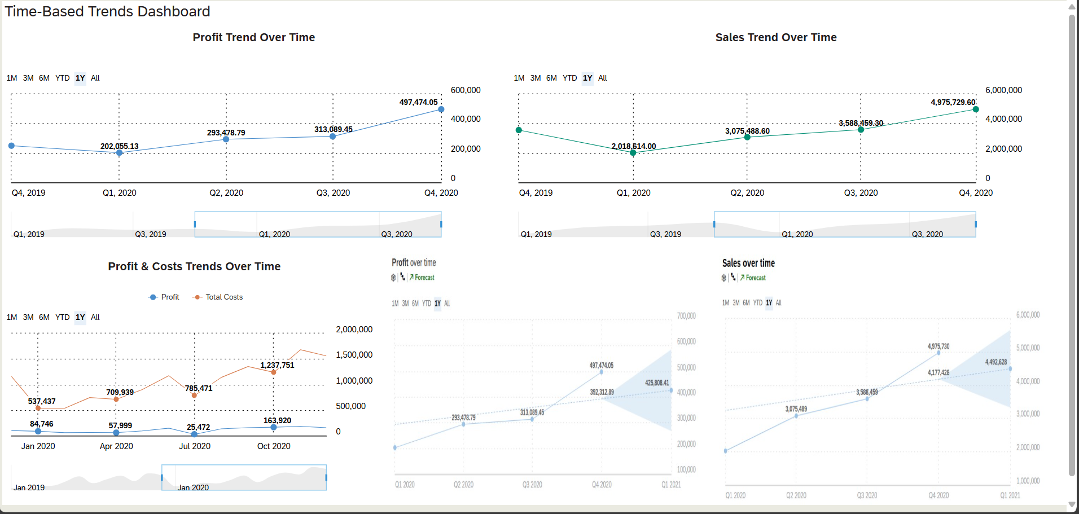

This dashboard provides important time-based Profits, costs, sales and forecasted revenue to help drive decision making.

Time series Chart: Profit over time
Key Usage: Track and monitor financial performance and potential growth trends
Actionable Insights:
- Growth opportunities
  - Since there is a spike in Q4 (Holiday season), increasing inventory and marketing 2 months before can help maximise sales and profits
  - Test out limited time promotions in slow quarters like Q2 to keep sales going
- Risk Monitoring
  - Analyse and investigate any sudden decrease in profit(e.g. potential supply chain issues or shipping issues)

Time series Chart: Sales overtime
Key Usage: Identify buying patterns and inventory needs
Actionable Insights:
- Inventory planning
  - Stock up 20% more top selling products before peak months like October to December
- Marketing Planning
  - Increase marketing campaigns during high profit periods

Chart Time series: Profits and costs overtime
Key Usage: Track and monitor operational efficiencies
Actionable Insights:
- Risk Monitoring
  - Monitoring costs closely and investigating if any sudden costs rise
- Monitoring costs
  - Track if there is any sudden cost rise, if there is then can be used to review costs breakdown

Smart Discovery Chart: Forecasted Profit
Key Usage: Future planning
Actionable Insights:
- If positive trend:
  - Consider increasing stock for top selling products and expand on promotional activities for high-performing products
- If negative trend:
  - Reducing any non-essential costs
- Use it to evaluate effectiveness of marketing plans by comparing if actual profit is higher than forecasted profit

Smart Discovery Chart: Forecasted Sales
Key Usage: Future planning

Actionable Insights:
- If positive trend:
  - Consider increasing stock for top selling products
- If negative trend
  - Review of marketing effectiveness and operational costs
- Use it to evaluate marketing plans of current profit is higher than forecasted sales and inventory planning

Logistics Dashboard
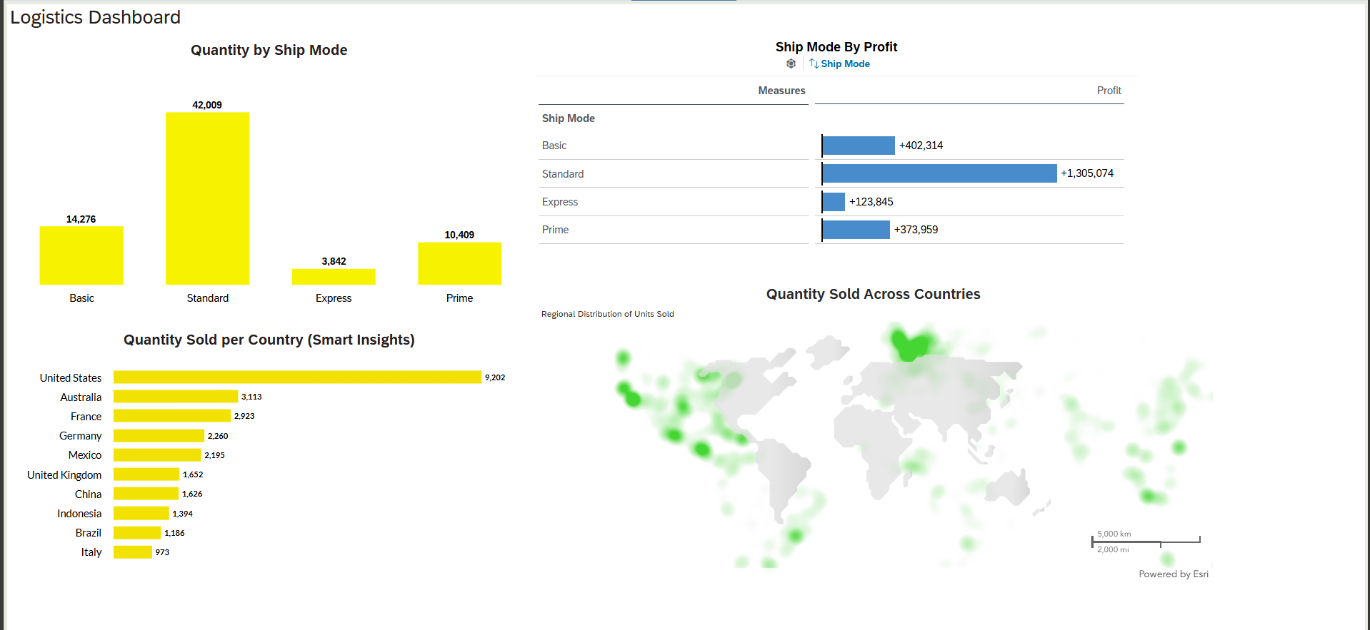

This dashboard provides a clearer overview on the logistics side such as shipping preferences, global demand and opportunities to expand warehouse and delivery strategies.

Bar Chart: Quantity shipped per shipping mode
Key Usage: Helps to understand the customer shipping preferences and optimise options
Actionable insights:
- For standard shipping (most popular),
  - Promote option as “Best Value” option in checkout pages to encourage continued selection
  - Consider setting it as a default option
- For lower-used mode like express
  - Investigate why less customers do not prefer this mode (e.g. Feedback survey from customers)
  - Offer limited time-based express upgrade to promote trial and to gather feedback

Table: Profit per shipping mode
Key Usage: Analyse if profitability of customers influences shipping mode
Actionable insights:
- For high profit shipping mode like Standard
  - The Company can negotiate better rates with delivery companies
- For low profit shipping mode like Express
  - The company can explore bundled pricing for high-value orders to cover the extra costs

Bar Chart: Smart insight (Quantity sold Country)
Key Usage: Identify which countries have high volumes of purchases for allocation of warehouses
Actionable insights:
- Prioritise countries with high volumes of purchases to set up regional logistic hub
- Plan inventory distribution (e.g. US can have more/larger hubs as they have higher demand)

Geo Chart: Quantity sold across countries
Key Usage: Easily visualize spread of product demand to further support international logistics strategy and distribution coverage
Actionable insights:
- Identify under-served but are growing regions that may require logistics upgrade like Australia
- Use chart to further pinpoint which area is the best area to place hub

Overall
These are my suggestions and insights I have found throughout the datasets through visualisations and analysis. Hopefully, these insights will inform the company about their own performance as well as how they can further improve company performance by driving sales and decreasing operating costs.

Reflection
Overall impression of SAC:
When I first started exploring and using SAC, I initially thought that it would be quite similar to Tableau. However, SAC uses AI to create smart discoveries and insights which we can use to our benefits to enrich our visualization. I also thought that SAC would be quite easy to use like Tableau, but I think it is much more complex than Tableau. Starting from importing data where there seems to be many complex functions to transform the dataset and I feared pressing a function as I didn’t know what most of the function do so it is kind of like a trial and error. But, while I think SAC is harder to use, I think it allows for more opportunities to create complex charts and more unique ones.

Aspects of SAC I found most useful or enjoyable:
After using it for a week or so, I find that SAC is useful in terms of flexibility. I enjoyed how we can just copy charts over to another file when connected to the same model so we can segregate the different parts of the assignment. For example, one file for folder and one file for dashboards so not every part is squeezed into one file. Even though it may be quite confusing to use this platform, I liked how they have additional functions like add on reference line which is quite useful since we do not have to do it manually. The many functions also allow us to create more interesting and complex charts which some platform may not be able to do.
Moreover, I liked how to smart insights not only provided insights for us but also created the chart to refer to and use. These functions are hardly found it most software as most software relies mainly on manual work. I also liked how they can verify our dataset before we use it so there would be no future errors such as missing dataset values or unknown dataset values which I think is super useful.

What stood out to me during my hands-on experience
I liked how customisable each chart is. For instance, I can not only change the colour of certain bar charts but also adjust the size of the line, how we want the values to be displayed, how many decimal places etc. I think these are all small but very important functions when creating charts as they can help us create more concise, neat and consistent charts which allows people to easily understand what your charts are displaying. So I think that standardizing how you want your charts to be displayed can make a very crucial difference as to how people would perceive it.

I also like how we can choose to allow different y axis to merge. For example, using a bar and line chart. There is an option that allows us to choose whether we want the y axis to merge and that allows us to compare different measures that may have big differences like discount and profits, which are significantly different in terms of values. But merging the y axis allows us to compare these two measures in proportion which I find quite amazing.

Comparisons with other visualisations tools I have used such as Power BI or Tableau

Both Power BI and Tableau are apps on their own while SAC is on the cloud. So that means that when we use SAC, if we forget to save our work and session is up, we will lose our work progress which can be frustrating at times as there was this one time I created 2-3 charts but got deleted as I forgot to save my work. However, for Tableau and Power BI, there is no time frame for session hence we just have to remember to save our work at times, but lost progress can be retrieved.

I also personally think data transformation is easier on SAC as compared to the others as we can easily manipulate our data values.

Key takeaways from SAP Experience Centre visit and talk by SAP and Abeam Consulting

I was informed about the many certifications and qualifications that we can participate in for free. This can help boost our profile as an even more qualified user of the SAP enterprise systems which companies may look out for.

I also learned about communication between different stakeholders and how it applies to our school life since we also have group projects which require us to effectively communicate well with others. I also learned about the importance of communication between people and how good communication can lead to an overall success of a project. It is also important for me to work on my own communication skills before pointing out others’ faults.

I also learned about the overall steps taken to conquer a project which is prepare, explore realize, deploy and then run which provides me guidelines as to how a project usually goes. This provides me with knowledge and informs me about the different skillsets needed for future work and employment opportunities. One example would be how AI and Big data are in demand so I should familiarise myself with these topics to keep myself informed as I do not want to be inexperienced in these areas.

What have I learnt from this module and why do I feel it is useful
I have learnt more about the business operating systems and the different steps behind purchasing items from a company. I did not know about things like Sales and Purchase orders as what invoices are even though I see them often.

I think learning how businesses operate and how to use the SAP system to create an order is a unique skillset that not everyone has. Moreover, it is useful to learn about these systems so that in future, we can easily track the company’s sales and profit and know which processes are automated and which are not automated. Maybe in the future, when AI is used in these systems, then at least we can be there to support the AI in these systems as we have an idea on how these systems operate.

Where can I apply the new knowledge and experience gained from this module
I think I can apply it in my future internship experiences as usually big companies would value these skillsets since they are high in demand. I can also apply this new knowledge when I buy things. Moreover, having important skills like in SAP SAC creating dashboards and generating interesting smart insights. I can also learn to communicate well with different stakeholders, using my skills to make communication more effective as well.

What surprised me most during the module
I think I didn’t expect the enterprise systems to contain many steps as I just assumed its order then pay but I didn’t realise that it was a very systematic process which surprised me.

If I could redo the practicals or assignments, what would I do differently and why
Maybe for my practical, instead of just blindly following steps, I should learn to understand the rationale for each step first before doing the step. This would allow me to be more familiar with the platform and not just memorise the steps.

During my assignment 1, I made quite a few mistakes which took me a good while to find out how to reverse the mistakes. Hence, I would also like to do my practical more than once, but I chose not too as it was quite time consuming. But looking back, I feel that if I did it, then I will do my assignment practicals even faster or even know how to reverse my mistakes and be more familiar with the platform. I would probably also feel less intimidated with the many functions since I have played around with it.

What might have helped improve my learning process?
Watching videos of people using the SAP system. I watched a few videos before doing my assignment 2 to get a better understanding of how the app functions which gave me a lift as to how I approached my creation of visualisations. Moreover, YouTube tutorials always provide extra information that we usually might miss or even explain certain functions of the app which we usually might not know how to use.

How does the topic of enterprise systems relate to other modules I have taken so far?
I think the SAP system is closely linked to the module database and data visualizations as each time a new order comes in, everything is tracked all the way from time to time and quantity. This is all captured into the database which then is manipulated by a sequence of code like SQL. After which we can create visualisation to analyse how efficient the process is and to further enhance the system if needed.

References for the Analysis on SAC Retailier:
References: OpenAI. (2025). ChatGPT (GPT-4o) [Large language model]. Retrieved July 30, 2025, from https://chat.openai.com/chat

