# <오전>

## 커리어 멘토링 진행

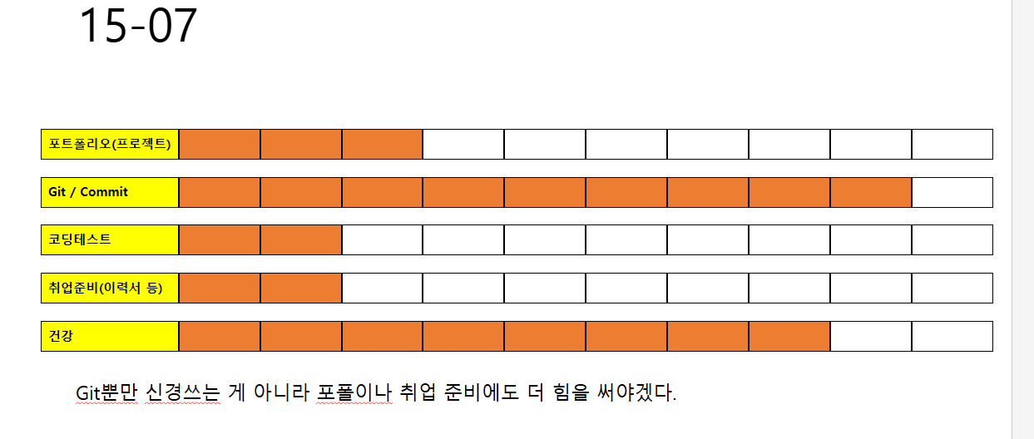

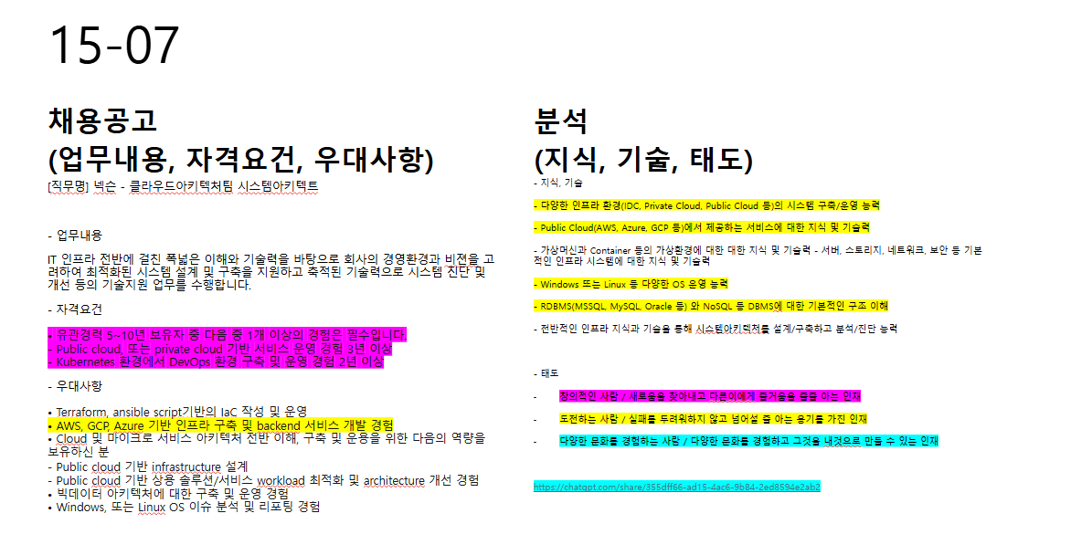

<https://padlet.com/ckohoon/padlet-8rrg23outecd5p62>

<https://ncs.go.kr/unity/th03/ncsSearchMain.do?tabNo=1>

# <오후>

<https://chatgpt.com/share/355dff66-ad15-4ac6-9b84-2ed8594e2ab2>

