Github Link: https://github.com/Cheonny/Sunway_Assessment

Challenge 1: Traffic Analysis
The detection model used is Yolov5n. In the first video streaming, there is a busy road on three lanes. The code snippet allows detecting, counting of vehicles each lane and estimating their moving speed. Based on the average of estimated speed, analysis of lane occupancy and traffic congestion can be conducted. For future work, it should be able to detect emergency and non-emergency vehicles and track the abnormal scenarios. For instance, a vehicle moves with abnormal speed (extremely slow or fast), broken, or accidents so that the parties can respond to it immediately.
Busy Road Screenshot:
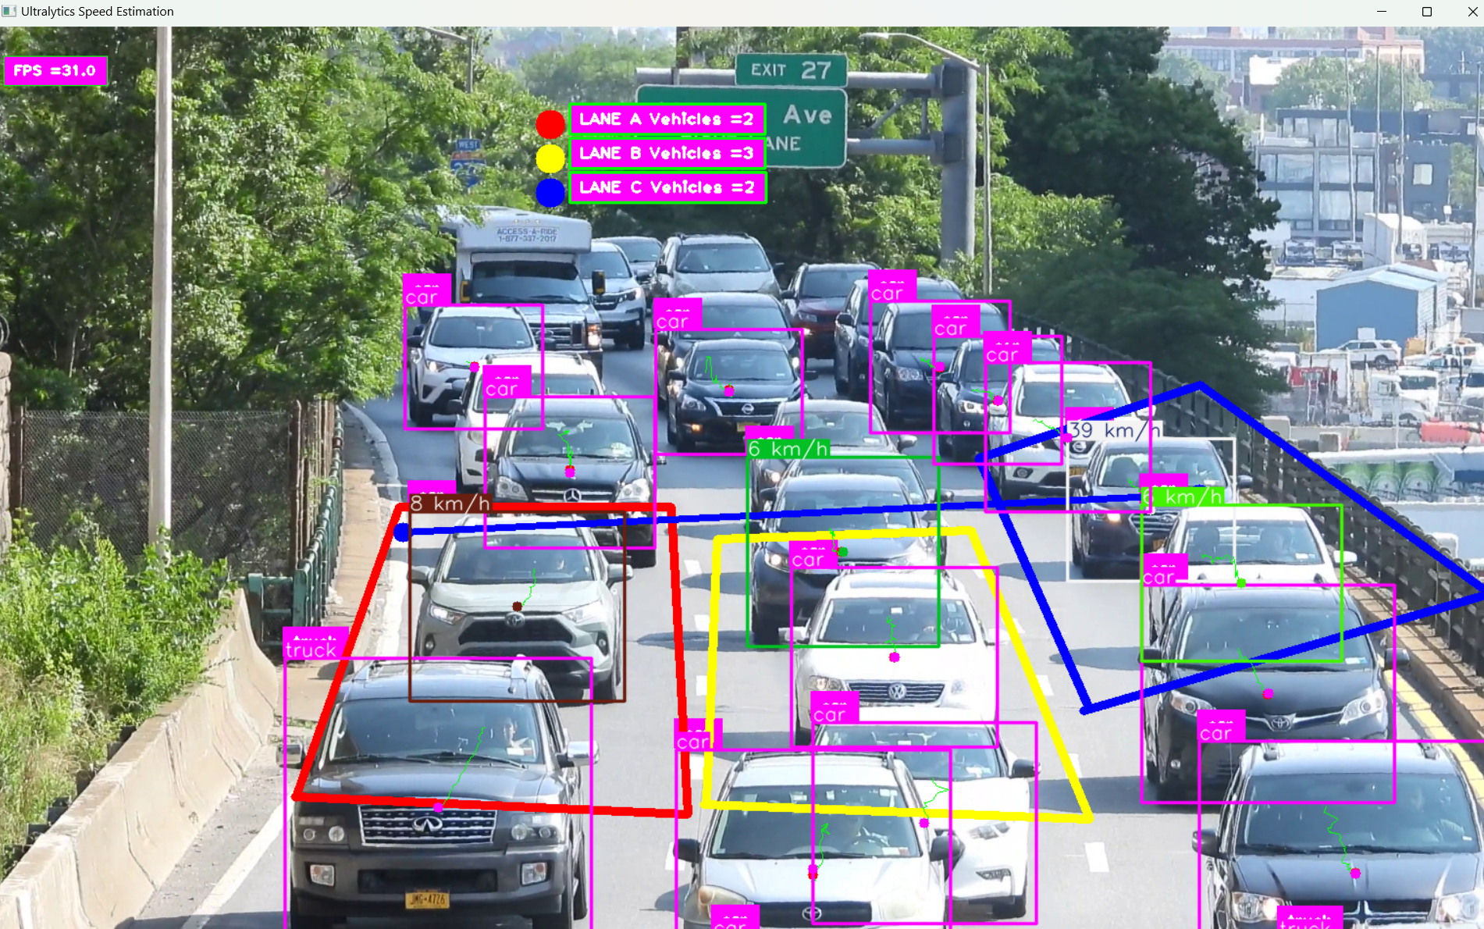
The detection model successfully detects the type of vehicles and count the vehicles passed through the drawn region. Other than that, the speed estimator allows the program to estimate the speed of vehicles accurately.
By using Yolov5s model, the fps rate is low (16fps) which lead to some delays. Yolov5n and Yolov8n (31fps) performs well in terms of inference speed.

Highway Video
Another scenario of detecting and tracking vehicles is on the highway. In this video streaming, the inference speed is more near to the real time inference especially using Yolov5n and Yolov8n model. Compared to Yolov5s, they demonstrate better performance in inference speed and FPS rate.
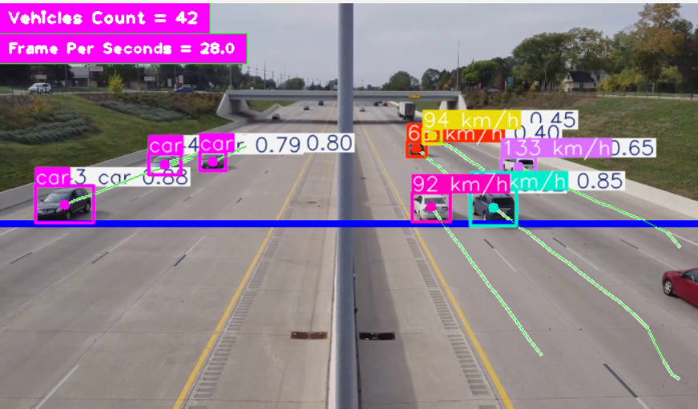
The speed of the vehicles are estimated accurately, where they moves approximately 60km/h and above on the highway road.
 | Highway Road Video |  |  | Busy Road Video
Performance | Yolov5s | Yolov5n | Yolov8n | Yolov5s | Yolov5n | Yolov8n
Frame Per Seconds | 16-20 | 24-30 | 22-33 | 16-19 | 28-33 | 27-33
The higher the FPS rate, the lower the inference speed (faster). Yolov8n performs the best among these YOLO models. FPS formula:
$$fps=\frac{1000ms}{inference speed (ms)}$$
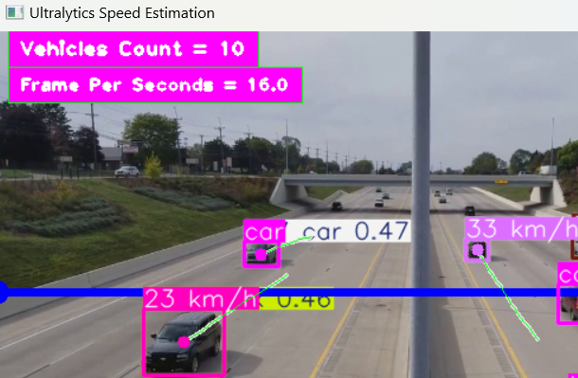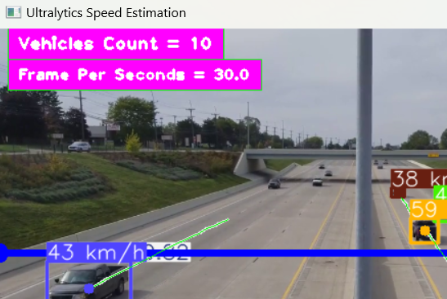
Yolov5s Yolov5n
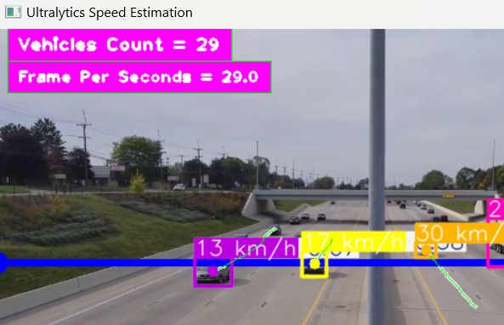
Yolov8n
Some screenshots of code snippet:
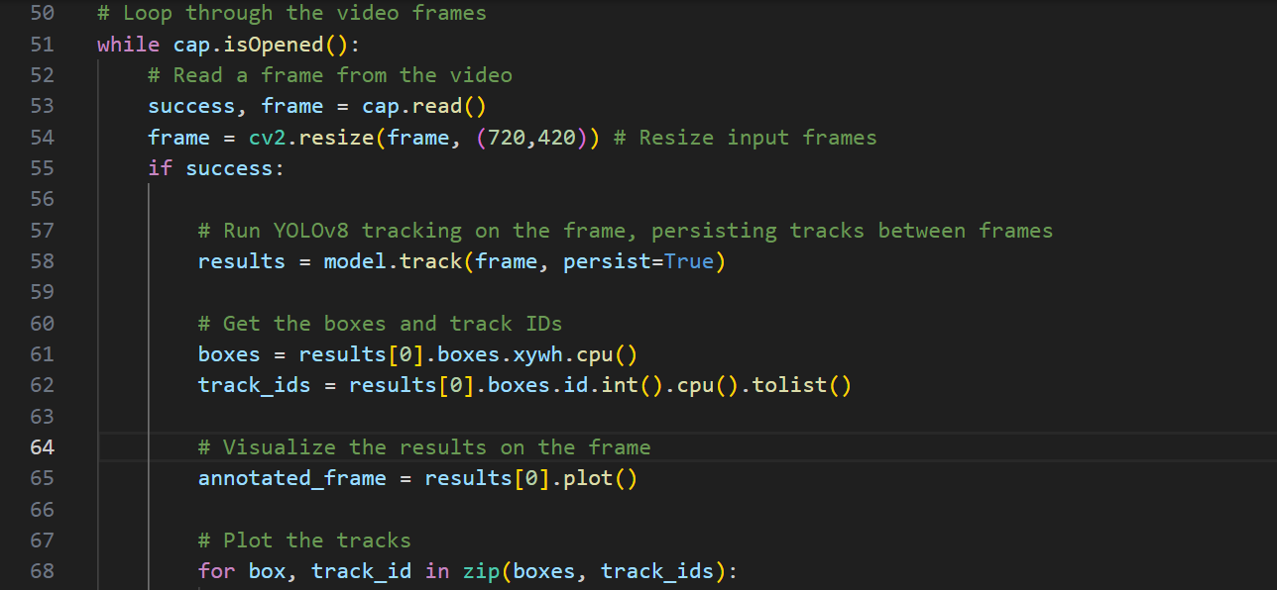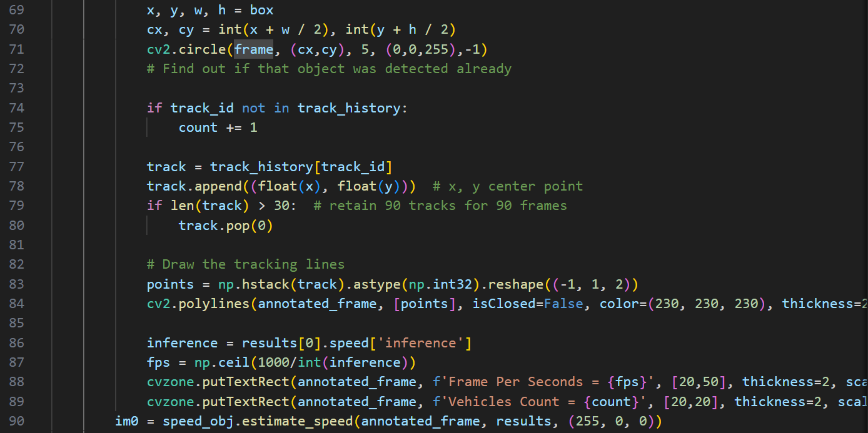

Challenge 2: Image Processing
The images chosen in this challenge are grainy. The purpose of the code snippet below is improving the quality of image using denoising, smoothing, and sharpening techniques.
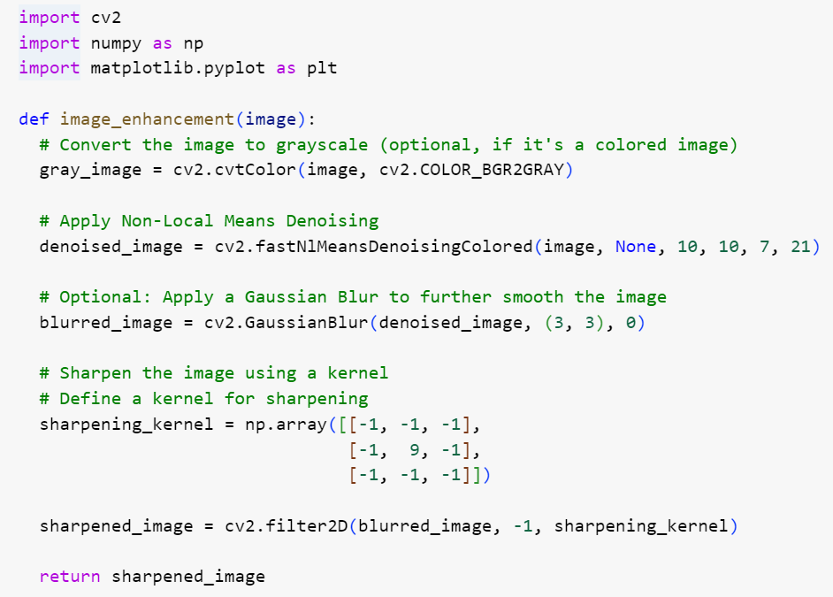The code provided in the image performs image enhancement. The image is converted into grayscale and is performed non-local means denoising method to reduce noise. Other than that, gaussian blur is applied for smoothing and lastly sharpening kernel is applied on the image.

Result:
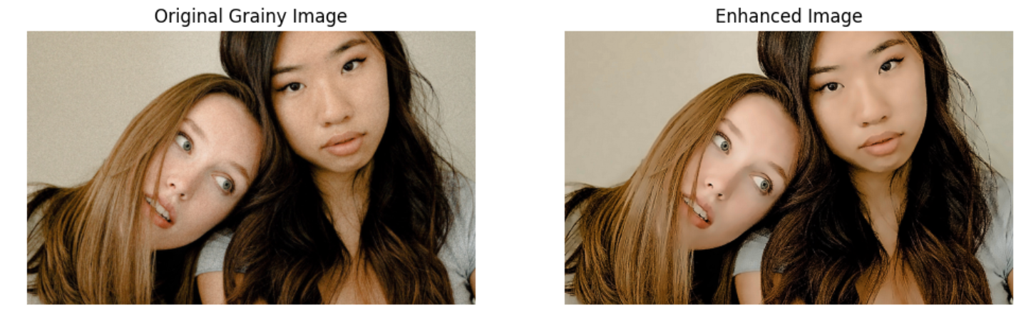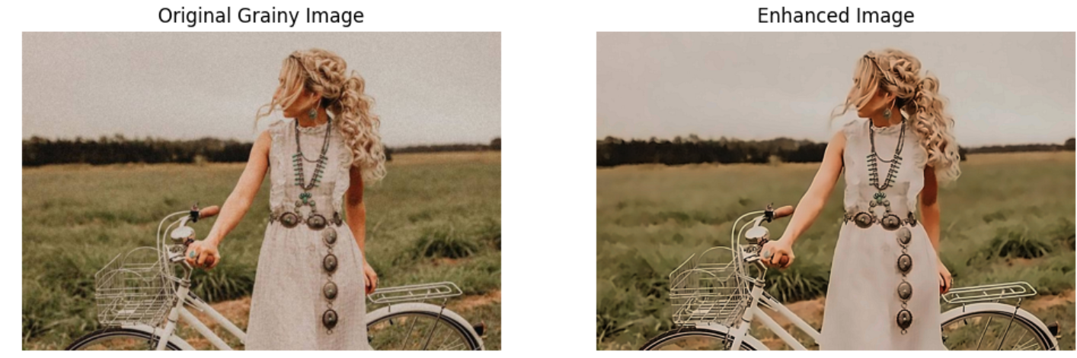
Two grainy images are tested. Both processed images show a significant enhancement of image quality. However, there are some lost details on the second image (e.g. over-smoothed grass background and white dresses).

Challenge 3: RAG Chatbot
Integrating Retrieval-Augmented Generation (RAG) allows for the customization of language models to meet specific needs by combining document retrieval with text generation. This chatbot serves as personalized chatbot based on the information fed (website links or file upload). One key use case is that the chatbot serves as an assistant for organizational knowledge, enhancing both the efficiency and accuracy of retrieving information within the organization.
The chatbot user interface is programmed using Streamlit and backend is programmed integrating with LangChain, Ollama, and Chroma. The program retrieves the relevant documents from the source and splits the text into chunks for retrieval. Vector embeddings are used to represent the documents. Chroma is used as the vector database to store and retrieve document embeddings while the local embedding model, ‘nomic-embed-text’ is used to provide embeddings for the documents, enhancing the retrieval process.
Document Retrieval and Vector Representation
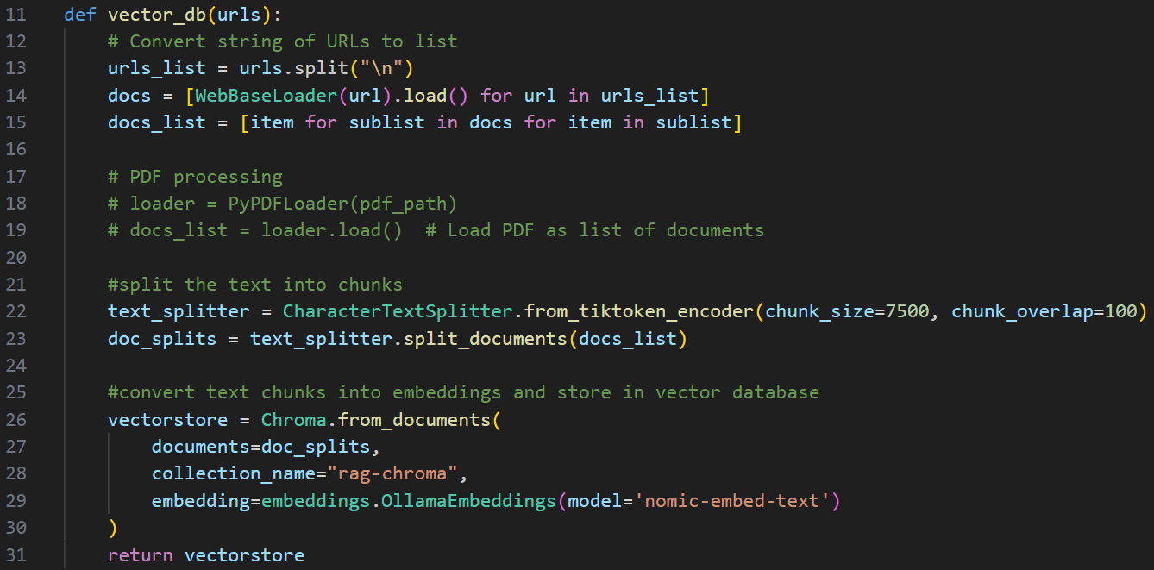
RAG is then performed using model “Mistral” and retrieved vectors based on the user prompt.
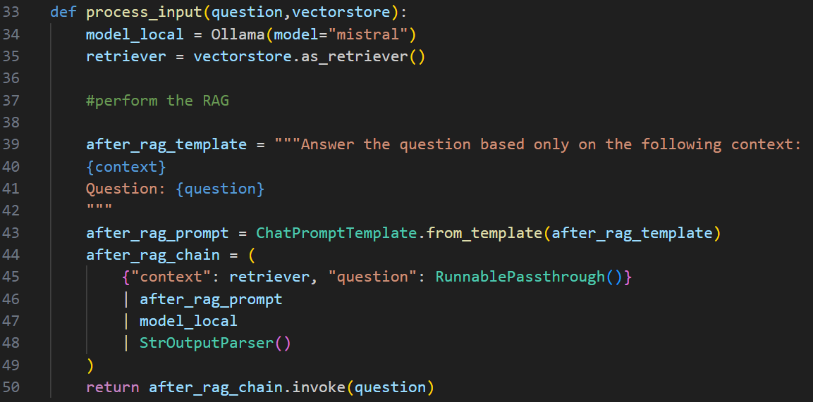
Screenshots of User Interface:
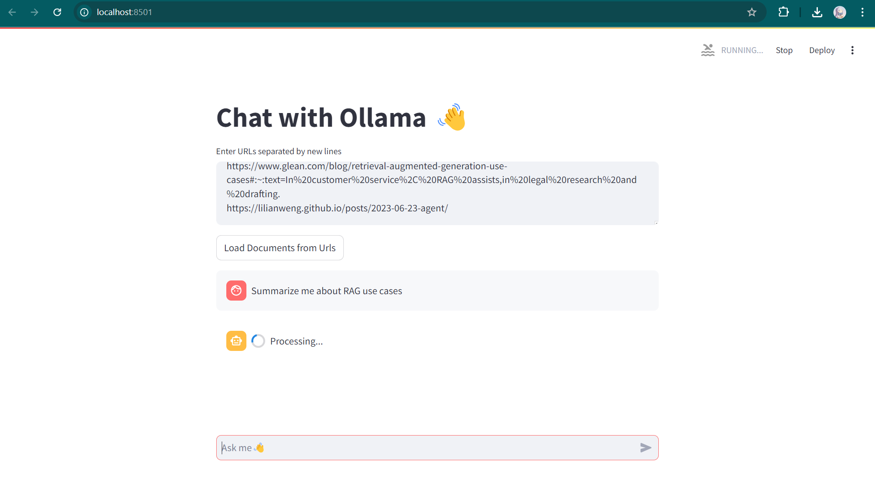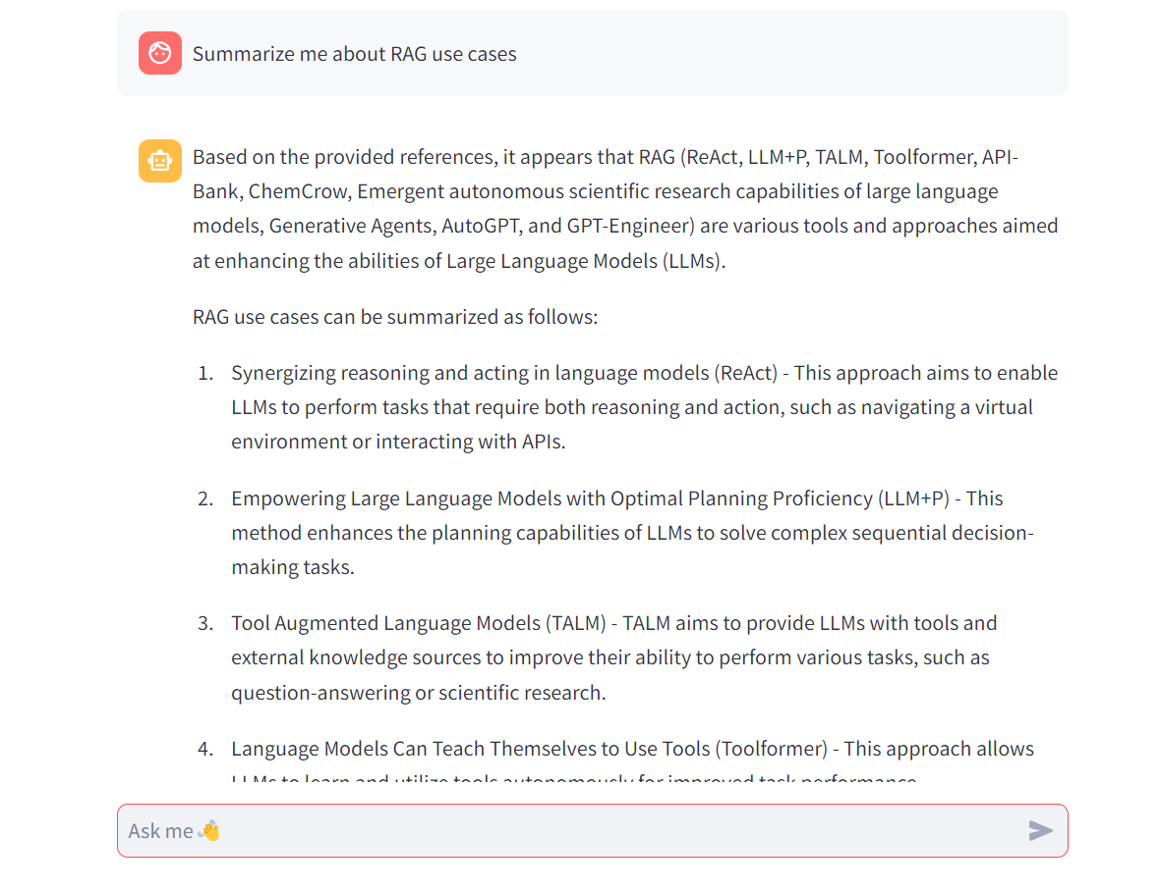
The response shows that the summarized the data from these two links but mostly retrieved from one link which is more informative.

Bonus challenge:
Idea: Install adaptive traffic lights within Sunway City region to adjust their timings based on emergency vehicle priority. Integration between traffic signals, emergency services, and traffic management systems to allow ambulance transports faster. Ambulances equipped with GPS and real-time adjustments of traffic signals.

