AI-BASED EMAIL PHISHING DETECTION SYSTEM

NAME: RAHAB CHEPCHIRCHIR

REG NO: SCT222-0741/2022

SUPERVISOR: FRANCIS THIONG’O

A Research Proposal Submitted to the Department of Information Technology in the School of Computing and Information Technology in Partial Fulfillment of the Requirements for the Award of the Degree of Bachelor of Science in Business Computing,
Jomo Kenyatta University of Agriculture and Technology.

May 2025

DECLARATION
Candidate’s Declaration
This proposal/research project is my original work and has not been presented for a degree in any other University.
……………………………………….. …………………………
Signature Date
Supervisor’s Declaration
This proposal/research project has been submitted for examination with my approval as University Supervisor.
……………………………………….. …………………………
Signature Date

ABSTRACT

Phishing remains one of the most persistent and damaging cybersecurity threats affecting individuals, organizations, and financial institutions worldwide. Despite the presence of spam filters in popular email platforms such as Gmail and Outlook, attackers continue to bypass existing defenses by crafting deceptive messages that imitate legitimate communication. These attacks lead to financial loss, identity theft, data breaches, and compromised organizational systems. In Kenya, the rise of digital communication and online services has further increased the vulnerability of users to phishing attacks, highlighting the need for more intelligent email security solutions.
This study proposes the development of an Artificial Intelligence (AI)-based phishing email detection system designed to enhance accuracy, reduce false positives, and identify sophisticated phishing techniques. The system applies machine learning techniques to analyze email body content, linguistic structure, metadata, and sender characteristics. Using the CRISP-DM methodology, the research follows a structured approach from problem definition and data collection to modeling, evaluation, and deployment. The proposed solution aims to complement existing email filtering mechanisms by introducing a more adaptive and context-aware detection approach.
The results from this research are expected to demonstrate improved detection performance compared to traditional rule-based filters, particularly in identifying zero-day phishing emails and reducing the misclassification of legitimate messages as spam. The study contributes to ongoing cybersecurity efforts by offering a practical, locally relevant, and academically grounded solution to the growing threat of phishing emails.
Table of Contents
DECLARATION i
ABSTRACT ii
CHAPTER 1 9
INTRODUCTION 9
1.1 Background of the Study 9
1.2 Project Overview 10
1.3 Statement of the Problem 10
1.4 Proposed Solution 11
1.5 Objectives 12
General Objective 12
1.6 Research Questions 12
1.7 Justification of the Study 12
1.8 Proposed System Methodology 13
1.9 Scope of the Study 14
CHAPTER 2 16
LITERATURE REVIEW 16
2.1 Introduction 16
2.2 Theoretical Review 16
2.2.1 Key Concepts in Machine Learning for Email Classification 16
2.2.2 Schools of Thought in Phishing Email Detection 17
2.3 Case Study Review 17
2.3.1 ML-Based Phishing Detection Systems 18
2.3.2 NLP-Driven and Deep Learning Approaches 18
2.3.3 Comparative Studies 18
2.4 Integration and Architecture 18
2.4.1 Client-Side Integration 19
2.4.2 Server-Side Integration 19
2.4.3 Hybrid Integration Architecture 20
2.4.4 Detection and Design Frameworks 20
2.5 Summary 21
2.6 Research Gaps 23
CHAPTER 3: SYSTEM ANALYSIS AND DESIGN 1
3.1 Introduction 1
3.2 Systems Development Methodology 2
3.2.1 Business Understanding 3
3.2.2 Data Understanding 3
3.2.3 Data Preparation 3
3.2.4 Modeling 4
3.2.5 Evaluation 4
3.2.6 Deployment 6
3.3 Feasibility Study 7
3.3.1 Technical Feasibility 7
3.3.2 Economic Feasibility 8
3.3.3 Operational Feasibility 9
3.3.4 Schedule Feasibility 9
3.4 Requirements Elicitation 10
3.5 Data Analysis 11
3.6 System Specification 12
3.6.1 Functional Requirements 12
3.6.2 Non-Functional Requirements 14
3.6.3 System Constraints 14
3.7 Requirements Analysis and Modeling 15
3.7.1 Use Case Diagram 15
3.7.2 Data Flow Diagram (DFD) 17
DFD Level 0 – Context Diagram 17
DFD Level 1 18
3.7.3 Activity Diagram 20
3.7.4 Sequence Diagram 23
3.7.5 Summary of Modeling 24
3.8 Logical Design 25
3.8.1 System Architecture 25
3.8.2 Control Flow and Process Design 28
3.8.3 Design for Non-Functional Requirements 31
3.9 Summary of Logical Design 33
3.10 Physical Design 33
3.10.1 Hardware Requirements 33
3.10.2 Software Environment 34
3.10.3 Model and File Storage Design 35
3.10.4 Dataset Description and Storage 36
3.10.5 System Directory Structure 39
3.10.6 Deployment Approach 40
3.10.7 Security and Privacy Considerations 40
Summary of Physical Design 41
CHAPTER 4 43
SYSTEM IMPLEMENTATION AND TESTING, CONCLUSIONS AND RECOMMENDATIONS 43
4.1 Introduction 43
4.2 Environment and Tools 44
4.2.1 Backend Environment 44
4.2.2 Frontend Environment 45
4.2.3 Development Environment 45
4.3 System Code Generation 46
4.3.1 Data Loading and Feature–Label Separation 47
4.3.2 Data Splitting and Stratification 48
4.3.3 Email Preprocessing and Normalization Pipeline 49
4.3.4 Feature Engineering Using TF-IDF and Engineered Metadata Features 50
4.3.5 Model Training Using Logistic Regression and Hybrid Analysis 52
4.3.6 Model Evaluation and Validation 53
4.3.7 Model Serialization and Persistence 54
4.3.8 Prediction Workflow During Deployment 55
4.3.9 Explainability Mechanism 56
4.4 Testing 57
4.4.1 Introduction 58
4.4.2 Testing Objectives 59
4.4.3 Testing Scope 59
4.4.4 Testing Approaches 61
4.4.5 Model Performance Evaluation 64
4.4.6 Test Case Design 66
4.4.7 Summary of Testing Results 69
4.5 User Guide 70
4.5.1 System Setup and Installation 70
4.5.2 Launching the System 71
4.5.3 Using the System 72
4.5.4 Understanding the Output 73
4.5.5 Help and Error Handling 75
4.5.6 Deployment Scope 76
4.6 Conclusions 76
4.6.1 Extent to Which the Problem Was Solved 76
4.6.2 Most Significant Accomplishments 77
4.6.3 System Limitations 78
4.6.4 Challenges Encountered 79
4.7 Recommendations 80
4.7.1 Enhancement of Live Email Integration 80
4.7.2 Expansion of Dataset Diversity 80
4.7.3 Implementation of Advanced Machine Learning Architectures 81
4.7.4 Cloud and Distributed Deployment 81
4.7.5 Enhanced Explainability and Threat Intelligence 81
4.7.6 Continuous Learning and Adaptive Retraining 82
4.7.7 Advanced Security and Attachment Analysis 82
4.7.8 Improved Dashboard Visualization and Alerting 82
REFERENCES 84
APPENDICES 86
A. Hardware Requirements 86
B. Software Requirements 86
C. Dataset Requirements 86
Project schedule 87

Table of figures
Figure 1 conceptual model 14
Figure 4 Use case diagram 17
Figure 5 DFD level 0 diagram 18
Figure 6 DFD level 1 diagram 20
Figure 7 Activity diagram 23
Figure 8 sequence diagram 24
Figure 9 control flow diagram 31
Figure 11 physical design dashboard 42
Figure 12 Data Splitting and Stratification 48
Figure 13 TF-IDF vectorizer 51
Figure 14 Model Evaluation 54
Figure 15 Model Serialization 54
Figure 16 model evaluation 66
Figure 17 Explainability Output 75
Figure 18. Dashboard Statistics 75
Tables
Table 1 study methods summary 22
Table 2 Comparative Analysis of Proposed and Baseline Models 6
Table 3comprehensive dataset characteristics table 39
Table 4Test Case Table 69
Table 5Project Budget 87

CHAPTER 1

INTRODUCTION

1.1 Background of the Study
Email remains one of the most widely used communication tools worldwide, supporting personal, organizational, and institutional communication. Its ubiquity has made it an essential tool for businesses, universities, and government agencies. However, the widespread use of email has also made it the primary target for cybercriminals, particularly through phishing attacks. Phishing attacks involve deceiving users into revealing sensitive information by impersonating trusted entities. Globally, phishing remains responsible for over ninety percent of successful cyberattacks, resulting in significant financial losses and compromised data security. According to the Anti-Phishing Working Group (APWG, 2024), phishing attacks have evolved from simple spam messages to highly sophisticated context-aware emails that bypass traditional security mechanisms.
Existing email platforms such as Gmail, Outlook, and Yahoo Mail largely rely on rule-based filtering, blacklists, sender reputation systems, and known threat signatures. While these methods are effective against simple spam, they struggle to detect zero-day phishing emails, contextually manipulated messages, and emails with spoofed sender identities that contain no obvious malicious links or attachments. This limitation results not only in phishing emails bypassing security filters but also in legitimate emails being incorrectly classified as spam, commonly referred to as false positives.
In Kenya, the cyber threat landscape is increasingly concerning. The Communications Authority of Kenya reported over 200 million detected cyber threat incidents in 2024, with email phishing representing a significant proportion. Many local institutions, including universities, small and medium-sized enterprises, and financial organizations, rely on global email platforms, whose filters are not specifically tailored to local phishing patterns. As a result, organizations remain vulnerable to phishing attacks that exploit social engineering techniques. This situation highlights the urgent need for an intelligent, adaptive, and context-aware system that can accurately detect phishing emails while minimizing false positives.

1.2 Project Overview
This project seeks to develop an AI-Based Email Phishing Detection System that leverages artificial intelligence techniques, including machine learning and natural language processing, to classify emails as either phishing or legitimate. Unlike traditional filters that rely on predefined rules, the system analyzes email text, subject lines, sender metadata, and linguistic patterns to identify potential phishing attempts.
Globally, machine learning models such as Logistic Regression, Random Forest, Support Vector Machines, and advanced deep learning architectures like BERT have demonstrated superior performance in detecting phishing emails. These models can recognize complex patterns, detect social engineering cues, and adapt to evolving attack methods. In Kenya, the adoption of machine learning-based phishing detection remains limited, with most organizations relying on default spam filters that are insufficient for modern threats. This project therefore introduces a localized, intelligent system capable of addressing gaps in existing email security mechanisms.
The system will also incorporate Explainable AI (XAI) to provide transparency, showing users why a particular email has been flagged as suspicious. The project will be structured using the CRISP-DM methodology, ensuring a systematic and iterative approach from data collection and preprocessing to model training, evaluation, and prototype implementation.

1.3 Statement of the Problem
Despite the presence of built-in spam filters, phishing emails continue to infiltrate users’ inboxes. Current systems, such as those provided by Gmail, rely heavily on rules, keywords, and historical threat signatures, which are inadequate against modern phishing techniques. Sophisticated phishing attacks increasingly involve context-aware messages, impersonation of trusted entities, and social engineering tactics that exploit human behavior rather than relying solely on malicious links or attachments.
Additionally, existing filters frequently produce false positives, misclassifying legitimate emails as spam and disrupting important communications. This problem is particularly pronounced in Kenyan institutions, where universities, SMEs, and financial organizations report growing incidents of email impersonation, credential theft, and fraudulent instructions sent via email. Globally, research indicates that more than seventy percent of successful phishing attacks bypass traditional email filters, demonstrating the inadequacy of conventional systems.
The research problem, therefore, is the inability of existing email filtering systems to accurately detect phishing emails while minimizing false positives, leaving users and organizations exposed to financial, operational, and reputational risks. This study addresses this gap by developing an AI-based system capable of intelligently identifying by phishing emails through content and contextual analysis.

1.4 Proposed Solution
This research proposes the development of an AI-Based Email Phishing Detection System designed to retrieve, analyze, monitor, and classify emails as either phishing or legitimate using a hybrid machine learning and heuristic analysis approach. The system analyzes email subject content, body text, sender information, metadata, suspicious URLs, and structural phishing indicators to identify potentially malicious emails within synchronized inbox environments.
The proposed solution leverages machine learning models trained on labeled phishing email datasets together with Natural Language Processing (NLP), TF-IDF feature extraction, heuristic forensic analysis, engineered phishing indicators, and probability calibration mechanisms to improve phishing detection accuracy and reduce false positives. The system further incorporates suspicious URL analysis, sender-domain verification, urgency detection, and explainability mechanisms to strengthen phishing identification and improve transparency during classification.
The proposed system also integrates Explainable AI (XAI) techniques to provide users with understandable phishing indicators, suspicious feature summaries, confidence scores, and reasoning behind classification decisions. Unlike traditional rule-based spam filters, the implemented platform combines machine learning classification, heuristic analysis, inbox synchronization, and real-time dashboard monitoring to provide a more adaptive and intelligent phishing detection environment.
An interactive phishing monitoring and analysis platform will be implemented using a React frontend dashboard and FastAPI backend architecture within a controlled academic environment. The platform will support inbox synchronization, phishing monitoring, suspicious email categorization, explainability visualization, and phishing risk analysis while minimizing false positives and improving phishing detection reliability.

1.5 Objectives

General Objective
To develop an AI-powered phishing email monitoring and detection system capable of retrieving, analyzing, classifying, and monitoring phishing emails in real time.
Specific Objectives
- To analyze phishing characteristics using NLP and machine learning techniques.
- To design and develop an AI-based model for classifying phishing emails.
- To implement a real-time detection and alerting system for emails.
- To test and evaluate the system’s performance in detecting phishing threats.

1.6 Research Questions
- What features of phishing emails can be effectively analyzed using AI and NLP techniques?
- How can machine learning models be designed to classify phishing threats accurately?
- What system architecture is suitable for real-time detection of phishing emails?
- How effective is the developed system in detecting phishing threats compared to existing methods?

1.7 Justification of the Study
Phishing attacks remain a significant threat worldwide and locally. Traditional spam filters are insufficient for detecting modern, context-aware phishing emails, resulting in financial losses, data breaches, and disrupted communication. Developing an AI-based detection system will provide a more intelligent and adaptive solution that can evolve with emerging threats.
This research benefits organizations, educational institutions, and individual users by improving email security and reducing false positives. It also contributes to the academic and practical knowledge in AI-based cybersecurity systems, offering a locally relevant solution that addresses the gap between global AI research and its application in Kenya.

1.8 Proposed System Methodology
The project will adopt the CRISP-DM methodology, which provides a structured and iterative approach to data-driven system development. The methodology includes understanding the business problem, exploring and preparing email datasets, designing and training AI models, evaluating model performance, and implementing a functional prototype. CRISP-DM is particularly suitable for AI and machine learning projects because it ensures systematic progress, continuous evaluation, and flexibility for iterative improvement.

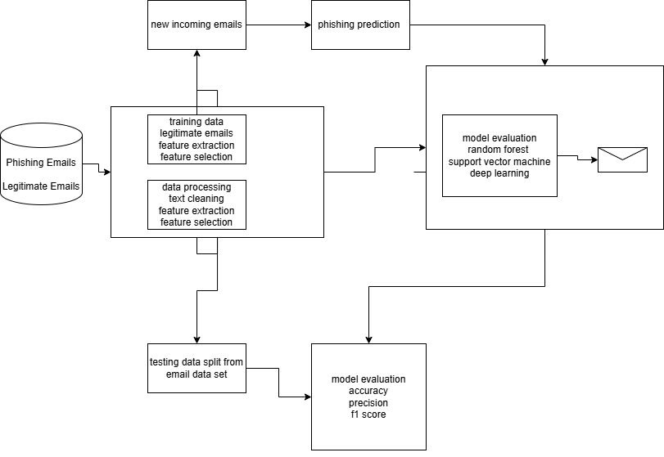
Figure 1 conceptual model

1.9 Scope of the Study
The study focuses on developing an AI-based phishing email monitoring and detection system within a controlled academic testing environment. The geographical focus is primarily Kenya, with datasets supplemented by global phishing email repositories and publicly available cybersecurity datasets. The research focuses on analyzing email content including subject lines, body text, sender metadata, suspicious URLs, linguistic patterns, and heuristic phishing indicators to classify emails as phishing or legitimate.
The implemented system incorporates machine learning classification, TF-IDF feature extraction, heuristic forensic analysis, suspicious URL detection, explainability mechanisms, and inbox synchronization through IMAP integration for phishing monitoring and analysis. The study is limited to email-based phishing detection and does not include broader cyber-forensics investigations, malware reverse engineering, network intrusion detection, or mobile application threat analysis.
The deployment environment remains within a controlled local academic setup and does not include enterprise-scale cloud deployment or large-scale distributed phishing monitoring infrastructure. Time, computational resources, and dataset availability may limit the scale of experimentation and evaluation. Nevertheless, the study aims to produce a functional, tested, and explainable phishing monitoring platform capable of accurately detecting phishing emails, analyzing suspicious indicators, and minimizing false positive classifications.

CHAPTER 2

LITERATURE REVIEW

2.1 Introduction
This chapter reviews existing literature related to phishing email detection and the application of Artificial Intelligence (AI) and Machine Learning (ML) techniques in cybersecurity. Email continues to be the most widely exploited communication channel for malicious activities, with phishing attacks increasing in frequency and sophistication globally. The growing use of AI-driven tools in cyber defense has motivated researchers and organizations to adopt ML models capable of identifying deceptive patterns in emails more effectively than traditional rule-based systems (Abraham & George, 2022).
The purpose of this literature review is to evaluate relevant theories, concepts, existing models, and implementation approaches pertaining to AI-based phishing email detection. This chapter also examines the gaps in current research and highlights the technological limitations that the proposed study seeks to address.

2.2 Theoretical Review

2.2.1 Key Concepts in Machine Learning for Email Classification
Machine Learning models rely on structured components such as datasets, features, labels, algorithms, training, and evaluation. In phishing detection, features are extracted from email content, metadata, and linguistic cues (Mittal et al., 2022). Labels categorize emails as either phishing or legitimate. Models are trained using supervised learning techniques, where algorithms learn patterns from annotated datasets (Altwaijry et al., 2024).
Key concepts include:
Natural Language Processing (NLP): Used to analyze text semantics, detect suspicious intent, and identify manipulative language.
Feature Engineering: Extraction of structural, lexical, and semantic indicators associated with phishing (Chavan et al., 2024).
Classification Algorithms: Logistic Regression, Naïve Bayes, SVM, Random Forest, and deep-learning models like LSTMs or Transformers.
Model Evaluation: Precision, recall, and F1-score determine how effectively a model detects phishing while minimizing false positives.

2.2.2 Schools of Thought in Phishing Email Detection
There are three major theoretical divisions:

Rule-Based Detection
This approach relies on predefined patterns, keyword lists, and blacklists.
Advantages: Simple and fast.
Limitations: Ineffective against zero-day attacks and sophisticated phishing emails that mimic legitimate communication (Ahmed et al., 2021).

Traditional Machine Learning Models
These methods use statistical and lexical features to classify emails.
Advantages: Good accuracy, interpretable models.
Limitations: Struggle with context, sarcasm, psychological manipulation, and evolving language (Khan et al., 2023).

Deep Learning and Transformer-Based Models
These models learn semantic meaning and context from large training datasets. Techniques include CNNs, LSTMs, and BERT-based models.
Advantages: High accuracy, effective against modern phishing, detects sophisticated writing patterns.
Limitations: Data-intensive and computationally expensive (Alhuzali et al., 2025; Altwaijry et al., 2024).
Deep learning models are currently considered the leading theoretical approach due to their ability to capture linguistic subtleties and social engineering patterns.

2.3 Case Study Review
Several research studies demonstrate the application of ML and NLP techniques in email phishing detection:

2.3.1 ML-Based Phishing Detection Systems
Abraham and George (2022) reviewed multiple ML techniques and found that Random Forest and SVM perform strongly in detecting phishing due to their ability to handle structured textual data. However, these systems still produced false positives when emails contained marketing-like language.
Brioua et al. (2025) proposed a hybrid model combining ML and novel feature engineering. Their system improved classification accuracy but required large-scale feature extraction, increasing computational overhead.

2.3.2 NLP-Driven and Deep Learning Approaches
Mittal et al. (2022) demonstrated that NLP combined with ML could effectively detect phishing intent from syntax, grammar, and semantics. Their model improved accuracy but struggled with multilingual phishing emails.
A systematic review by Various Authors (2023) reported that deep-learning methods, particularly transformers, outperform traditional ML models in detecting socially engineered emails.
Kulal et al. (2025) presented an advanced ML model capable of detecting LLM-generated phishing messages. This is important because attackers increasingly use AI to produce highly convincing emails.

2.3.3 Comparative Studies
Comparative analyses such as those by Altwaijry et al. (2024) and Machine Learning-Based Phishing Detection (2024) highlighted that deep learning models outperform older techniques but require more data and specialized tuning.
These case studies emphasize that while current systems are improving, challenges persist—especially false positives, spoofed senders, zero-day attacks, and context manipulation.

2.4 Integration and Architecture
AI-based phishing detection systems can be integrated into email environments using different architectural approaches depending on operational requirements, processing capabilities, scalability needs, and deployment environments.

2.4.1 Client-Side Integration
In client-side integration, phishing detection models are embedded within user-facing email applications or dashboard interfaces to analyze email content before or during user interaction.
Advantages:
• Real-time phishing monitoring and analysis
• Immediate feedback and phishing alerts
• Improved user interaction and explainability visualization
Limitations:
• Limited computational resources on client devices
• Reduced scalability for large-scale phishing analysis
• Dependence on lightweight processing architectures
Client-side approaches are suitable for interactive phishing monitoring systems where users require immediate visibility into suspicious emails and phishing risk indicators.

2.4.2 Server-Side Integration
In server-side integration, phishing analysis and classification are performed on backend servers before or during inbox synchronization operations. Backend services retrieve emails, preprocess content, perform machine learning and heuristic analysis, and return phishing classification results to frontend interfaces.
Advantages:
• Higher processing capability for machine learning operations
• Centralized phishing analysis and model management
• Better support for heuristic analysis and explainability generation
Limitations:
• Increased backend resource requirements
• Potential synchronization delays during high-volume analysis
• Additional security and privacy considerations for email handling
The implemented system primarily adopts server-side processing architecture using a FastAPI backend for phishing analysis and classification operations.

2.4.3 Hybrid Integration Architecture
Hybrid architecture combines frontend dashboard interfaces with back-end phishing analysis services. This approach supports separation of concerns between user interaction, synchronization operations, machine learning processing, heuristic analysis, and dashboard visualization.
The implemented system adopts hybrid architecture consisting of:
• React frontend dashboard interface
• FastAPI backend services
• IMAP inbox synchronization mechanisms
• machine learning phishing classification modules
• heuristic forensic analysis components
• explainability and risk scoring layers
This architecture enables real-time phishing monitoring, suspicious email categorization, phishing risk analysis, and dashboard-based visualization while maintaining modularity, scalability, and maintainability.
Advantages:
• Improved scalability and modularity
• Better separation between frontend and backend services
• Support for real-time dashboard monitoring
• Easier integration of additional phishing analysis modules
• Improved maintainability and extensibility
Limitations:
• Increased implementation complexity
• Requirement for reliable API communication between components

2.4.4 Detection and Design Frameworks
Modern phishing detection systems commonly combine Natural Language Processing (NLP), machine learning, heuristic analysis, metadata evaluation, and explainability mechanisms to improve phishing detection reliability.
Typical phishing detection frameworks include:
• Email collection and synchronization
• Text preprocessing and normalization
• Feature extraction and engineered phishing indicators
• Machine learning training and evaluation
• Heuristic forensic analysis
• Probability calibration and risk scoring
• Real-time phishing inference and monitoring
• Explainability and dashboard visualization
Advanced deep learning architectures such as CNNs, RNNs, LSTMs, and transformer-based models are widely adopted in phishing detection research because of their ability to capture semantic and contextual phishing patterns. However, lightweight supervised learning models such as Logistic Regression remain effective for high-dimensional textual phishing datasets due to their interpretability, computational efficiency, and strong classification performance.
The implemented system adopts a hybrid NLP and machine learning framework using TF-IDF vectorization, Logistic Regression classification, heuristic forensic analysis, suspicious URL detection, engineered metadata features, explainability mechanisms, and dashboard-based phishing monitoring to support intelligent and transparent phishing email detection.

2.5 Summary
This chapter explored theoretical foundations, key ML concepts, and research studies relevant to phishing email detection. Rule-based systems provide baseline filtering but lack adaptability. Traditional ML models improve accuracy but struggle with deep contextual understanding. Deep learning and transformer-based models achieve state-of-the-art performance but require large datasets and computational resources. Existing case studies demonstrate progress yet highlight persistent gaps such as false positives, spoofed email attacks, and multilingual phishing threats. These findings justify the need for an enhanced, context-aware AI-based phishing detection model.
Table 1 study methods summary
Study | Method(s) Used | Key Contribution | Limitations (Including False Positives)
Ahmed et al. (2021) | Rule-Based Filters, Blacklists | Early detection of known phishing patterns | High false positives for new senders; ineffective against zero-day phishing
Abraham & George (2022) | Random Forest, SVM | Improved phishing classification accuracy | Legitimate marketing and transactional emails often misclassified
Mittal et al. (2022) | NLP + Traditional ML | Detection of linguistic phishing cues | Context ambiguity leads to false positives in academic and corporate emails
Almomani et al. (2022) | ML Feature-Based Models | Comprehensive survey of phishing filters | Persistent false positives reduce user trust
Hossain et al. (2023) | Hybrid Deep Learning Models | Enhanced detection of complex phishing emails | Computationally expensive; still flags urgent legitimate emails
Altwaijry et al. (2024) | ML vs Deep Learning Comparison | Demonstrated higher recall using DL models | Precision drops due to increased false positives
Kulal et al. (2025) | Transformer-Based Models (BERT) | Detection of AI-generated phishing emails | Requires large datasets; limited explainability
Proposed Study (2025) | TF-IDF + Logistic Regression + Heuristic Analysis + Explainable AI | Hybrid phishing monitoring and detection using ML, heuristic analysis, explainability, and inbox synchronization with reduced false positives | Performance depends on dataset diversity, metadata quality, and evolving phishing patterns

2.6 Research Gaps
Despite advancements in AI-based phishing detection, several gaps remain evident:
High False Positive Rates: Many systems misclassify legitimate emails with promotional or urgent language (Abraham & George, 2022). The proposed study seeks to design a model that reduces false positives through advanced NLP techniques.
Weak Detection of Social Engineering Tactics: Most ML models fail to capture psychological manipulation, tone, and intent (Mittal et al., 2022). This gap will be addressed using semantic and sentiment-based analysis.
Spoofed Sender Weaknesses: Existing systems struggle with identity spoofing, where attackers mimic trusted names (Ahmed et al., 2021). The proposed research will integrate metadata analysis to identify sender anomalies.
Limited Localized Research in Kenya: There is minimal academic research on phishing detection tailored to the Kenyan context. This study contributes by evaluating global methods on Kenyan datasets and usage patterns.
Inadequate Detection of AI-Generated Phishing: Recent attacks use generative AI to craft realistic emails (Kulal et al., 2025). The proposed system aims to incorporate transformers capable of identifying such patterns.

CHAPTER 3

SYSTEM ANALYSIS AND DESIGN

3.1 Introduction
This chapter presents the system analysis and design of the proposed AI-Based Email Phishing Detection System. It translates the research problem and objectives discussed in the previous chapters into a structured technical framework that guides system implementation. The chapter describes the systems development methodology adopted, feasibility analysis, requirements elicitation and analysis, system specifications, and the logical and physical design of the system. The purpose of this chapter is to provide a detailed architectural and functional blueprint that supports the successful implementation of the proposed phishing detection solution.
Phishing remains one of the most significant cybersecurity threats globally, with attackers continuously developing sophisticated social engineering techniques capable of bypassing conventional rule-based security filters. Traditional spam filtering approaches struggle to detect modern phishing attacks because many phishing emails closely resemble legitimate business communication and frequently exploit urgency, impersonation, and deceptive links to manipulate users. In Kenya, the increasing number of reported cyber threat incidents further demonstrates the need for adaptive and intelligent email security systems capable of improving phishing detection accuracy while minimizing false positives.
The proposed system addresses these challenges through a hybrid intelligence architecture that combines machine learning classification with heuristic forensic analysis and Explainable AI (XAI) mechanisms. Unlike traditional text-only phishing detectors, the enhanced system performs both textual and structural email analysis by examining phishing indicators such as suspicious URLs, urgency-related language, redirect-based links, uppercase character patterns, sender-link inconsistencies, and abnormal domain structures. These mechanisms improve the system’s ability to identify sophisticated phishing attempts while reducing the incorrect classification of legitimate emails.
The system utilizes supervised machine learning techniques together with engineered metadata features to improve phishing detection reliability. Textual email content is transformed into numerical representations using Term Frequency-Inverse Document Frequency (TF-IDF) vectorization, while additional structural features such as URL density, suspicious link indicators, and sender-domain relationships are incorporated into the detection process. The system also integrates probability calibration mechanisms and heuristic risk analysis to generate more reliable prediction confidence scores.
To improve transparency and user trust, the system incorporates Explainable AI mechanisms that identify influential words and structural indicators contributing to prediction outcomes. This enables users to understand why an email has been classified as phishing or legitimate instead of relying solely on opaque prediction results. The system architecture further separates frontend and backend services using a FastAPI backend and React frontend structure, allowing modular processing, scalability, and efficient interaction between detection components.
The overall design emphasizes accuracy, explainability, scalability, and operational efficiency in phishing email detection. By integrating machine learning, heuristic analysis, and explainability mechanisms within a unified architecture, the proposed system provides a more advanced and reliable approach for detecting phishing attacks in modern email communication environments.

3.2 Systems Development Methodology
The development of the AI-Based Email Phishing Detection System follows the Cross-Industry Standard Process for Data Mining (CRISP-DM) methodology. CRISP-DM was selected because the proposed solution is data-driven and relies heavily on machine learning, heuristic analysis, and predictive modeling techniques for phishing email classification. The methodology provides a structured and iterative framework that supports systematic data understanding, preprocessing, feature engineering, model development, evaluation, and deployment of intelligent cybersecurity systems.
The CRISP-DM methodology is appropriate for this project because phishing detection involves continuous analysis of large volumes of textual and structural email data. The methodology supports iterative refinement of machine learning models and allows integration of additional analytical mechanisms such as heuristic forensic analysis, probability calibration, and Explainable AI components. This flexibility is important because phishing attacks continuously evolve and detection systems must adapt to new attack patterns and techniques.
CRISP-DM consists of six interrelated phases: Business Understanding, Data Understanding, Data Preparation, Modeling, Evaluation, and Deployment. These phases ensure that the system development process remains aligned with the project objectives while supporting systematic improvement and validation of the phishing detection architecture.
The methodology also supports experimental comparison of different machine learning approaches, feature extraction methods, and heuristic detection strategies before final deployment. This enables the development of a more accurate, scalable, and reliable phishing detection system capable of analyzing both textual and structural characteristics of suspicious emails.

3.2.1 Business Understanding
This phase focuses on defining the problem domain and objectives of the proposed AI-Based Email Phishing Detection System. The main problem addressed in this study is the inability of conventional rule-based email filters to accurately detect sophisticated phishing attacks while minimizing false positives. The objective of the project is therefore to develop a hybrid phishing detection system that combines machine learning and heuristic forensic analysis to identify phishing emails based on both textual and structural characteristics such as suspicious URLs, urgency indicators, and sender-link inconsistencies.

3.2.2 Data Understanding
In this phase, phishing and legitimate email datasets will be collected and analyzed to understand their structure, distribution, and characteristics. The datasets will be examined to identify important phishing indicators such as email content, embedded links, sender metadata, urgency-related language, suspicious URLs, and domain inconsistencies. Exploratory data analysis will also be conducted to assess class balance, identify missing values, detect inconsistencies, and understand common phishing patterns within the dataset.

3.2.3 Data Preparation
Data preparation involves cleaning and transforming raw email data into a suitable format for machine learning and heuristic analysis. This process includes removing duplicates, eliminating HTML tags and special characters, tokenization, stop-word removal, and lemmatization. Textual data will be converted into numerical representations using TF-IDF vectorization. Additional engineered features such as URL count, suspicious URL indicators, uppercase character frequency, urgency patterns, and sender-link relationships will also be extracted to improve phishing detection accuracy.

3.2.4 Modeling
In the modeling phase, supervised learning techniques will be applied to classify emails as phishing or legitimate. The system utilizes a hybrid and ensemble-based detection approach that combines Logistic Regression classification with heuristic forensic analysis and engineered metadata features to improve phishing detection accuracy, interpretability, and reduction of false positives. Logistic Regression is selected as the primary classification algorithm due to its effectiveness in binary text classification tasks, interpretability, and computational efficiency.
The dataset will be divided into training and testing subsets to ensure unbiased performance evaluation. The model will be trained using TF-IDF feature representations derived from email text content together with additional engineered features such as suspicious URLs, urgency indicators, uppercase character frequency, redirect patterns, and sender-link inconsistencies. Hyperparameter tuning and probability calibration techniques will be conducted to optimize model performance while minimizing overfitting. Parameters such as regularization strength and maximum iterations will be adjusted using validation techniques to ensure optimal model convergence, prediction reliability, and performance.
Logistic Regression is particularly suitable for high-dimensional sparse data generated through TF-IDF vectorization, making it appropriate for phishing detection tasks. The integration of heuristic analysis and engineered structural features further strengthens the system’s ability to identify sophisticated phishing attacks that resemble legitimate business communication.

3.2.5 Evaluation
The trained models will be evaluated using performance metrics including accuracy, precision, recall, F1-score, and confusion matrix analysis. These metrics will be used to assess the effectiveness of the hybrid phishing detection system in distinguishing phishing emails from legitimate emails. Special emphasis will be placed on minimizing false positive rates to improve usability and reduce the likelihood of legitimate business emails being incorrectly classified as phishing. The evaluation process will also assess the effectiveness of heuristic forensic analysis, engineered metadata features, and probability calibration mechanisms in improving prediction reliability.
The dataset will be divided into training and testing subsets using an 80:20 train-test split with stratified sampling to preserve class distribution across both datasets. Model validation will also be performed using cross-validation techniques to improve the reliability and consistency of performance estimates. Additional stress testing will be conducted using legitimate business emails and adversarial phishing samples to evaluate the system’s resistance against sophisticated phishing techniques.
Accuracy will measure the overall proportion of correctly classified emails, while precision will evaluate the proportion of emails classified as phishing that are truly phishing emails. Recall will measure the system’s ability to correctly identify phishing emails, and the F1-score will provide a balanced evaluation of precision and recall. Confusion matrix analysis will further assist in identifying false positives and false negatives generated during prediction.
The performance of the proposed hybrid Logistic Regression and heuristic analysis model will be compared against selected baseline classifiers including Naive Bayes, Linear Support Vector Machine (SVM), Random Forest, and Dummy Classifier. Comparative evaluation will help determine the most suitable phishing detection approach based on classification performance, computational efficiency, interpretability, and false positive reduction.
Since the dataset is relatively balanced, no oversampling or under sampling techniques will be required during model training and evaluation.
Model | Type | Strengths | Weaknesses | Reason in Study
Hybrid Logistic Regression + Heuristic Analysis | Proposed Model | High interpretability, improved phishing detection, reduced false positives, supports explainable AI | Increased architectural complexity | Selected as the main phishing detection architecture
Logistic Regression | Baseline Model | Fast, interpretable, works well with TF-IDF text data | Limited with complex nonlinear patterns | Used as the primary machine learning benchmark
Naive Bayes | Baseline Model | Fast and effective for text classification | Assumes feature independence | Used as a standard text classification benchmark
Linear SVM | Baseline Model | High accuracy with high-dimensional data | Less interpretable and slower training | Used to compare classification performance
Random Forest | Baseline Model | Handles complex patterns well | Higher computational cost | Used to compare ensemble learning performance
Dummy Classifier | Baseline Reference | Simple benchmark model | No actual learning capability | Used to measure minimum baseline performance
Table 2 Comparative Analysis of Proposed and Baseline Models

3.2.6 Deployment
The deployment phase involves integrating the trained phishing detection models and heuristic analysis components into a web-based application for real-time email analysis and academic demonstration. The system is deployed using a decoupled FastAPI backend and React frontend architecture running within a controlled environment. The backend handles preprocessing, feature extraction, heuristic forensic analysis, probability calibration, and machine learning inference, while the frontend provides interactive visualization of prediction results and explainability indicators.
The trained Logistic Regression model, TF-IDF vectorizer, calibrated classifiers, and heuristic analysis configurations are stored as serialized files and loaded by the backend during runtime. Users can analyze email content either by pasting email text into the interface or through inbox scanning functionality integrated using IMAP services. The system then generates phishing predictions together with probability confidence scores, heuristic risk indicators, suspicious URL analysis, and Explainable AI outputs showing influential phishing features contributing to the final classification result.
The deployment environment remains controlled for academic evaluation and testing purposes. The system incorporates header-first deduplication mechanisms to prevent repeated analysis of previously scanned emails, improving performance efficiency and scalability during inbox analysis.

3.3 Feasibility Study
A feasibility study was conducted to determine whether the proposed AI-Based Email Phishing Detection System can be successfully developed within the available technical, financial, operational, and time constraints. This evaluation ensures that the project is realistic, achievable, and sustainable before proceeding to full implementation. The feasibility assessment considers technical, economic, operational, and schedule factors relevant to the successful development of the system.

3.3.1 Technical Feasibility
Technical feasibility evaluates whether the required hardware, software tools, programming skills, and computational resources are available to implement the proposed system effectively.
The system will be developed using the Python programming language together with relevant machine learning, web development, and heuristic analysis libraries suitable for phishing email detection tasks. Python provides a flexible and efficient environment for implementing data preprocessing, feature extraction, model training, heuristic forensic analysis, probability calibration, and evaluation processes. The selected tools support iterative experimentation, testing, and optimization of the hybrid phishing detection architecture while maintaining compatibility with standard computing environments.
The primary technologies and libraries to be used include:
• Scikit-learn for Logistic Regression, TF-IDF vectorization, probability calibration, and machine learning evaluation
• Pandas and NumPy for data manipulation and numerical operations
• NLTK and Regex libraries for text preprocessing and heuristic forensic analysis
• FastAPI for backend service implementation
• React.js for frontend user interface development
• Matplotlib and Seaborn for visualization of results
The selected hybrid phishing detection architecture is computationally efficient and suitable for high-dimensional text classification tasks. Logistic Regression combined with TF-IDF vectorization performs efficiently even with sparse textual datasets, while heuristic analysis modules and engineered feature extraction mechanisms require minimal computational overhead. Unlike deep learning approaches, the proposed system does not require specialized GPUs or advanced computing infrastructure.
The project will be developed using a standard laptop with 16 GB RAM and sufficient storage capacity. The dataset size and additional heuristic analysis processes are manageable within these hardware specifications. Therefore, no specialized computing infrastructure is required for successful system implementation and deployment.

3.3.2 Economic Feasibility
Economic feasibility assesses whether the project can be completed within the available financial resources.
The estimated total project budget is 40,000 KES, covering internet access, consultations, printing and binding costs, testing expenses, and contingency requirements. Since the primary development technologies including Python, Scikit-learn, FastAPI, React.js, Pandas, and other supporting libraries are open-source and freely available, there are no software licensing costs involved.
The project does not require specialized hardware, paid machine learning platforms, or expensive cloud infrastructure. System development, model training, heuristic analysis, and deployment can be performed locally using existing computing equipment or free cloud-based platforms such as Google Colab when additional computational resources are required.
The hybrid phishing detection architecture is computationally lightweight and does not depend on resource-intensive deep learning infrastructure, reducing operational and hardware expenses. Given the limited financial requirements and reliance on open-source technologies, the project is economically feasible within the allocated budget.

3.3.3 Operational Feasibility
Operational feasibility examines whether the proposed system will function effectively within its intended environment and whether users will be able to utilize it without difficulty.
The system will initially be developed and tested within a controlled research environment using a FastAPI backend and React frontend interface for user interaction and phishing analysis. The operational process involves either submitting email text manually or scanning inbox emails through IMAP integration, after which the system analyzes the content, performs heuristic forensic analysis, and returns a classification result indicating whether the email is phishing or legitimate together with probability confidence scores and explainability indicators.
The system is designed to be simple, interactive, and user-friendly. Users are not required to possess advanced technical knowledge to operate the system. The interface presents clear phishing predictions, suspicious URL indicators, and explainable AI outputs to improve usability and user trust. Additionally, the system does not permanently store user-submitted email content, thereby minimizing privacy and security concerns.
Since the system performs phishing analysis without modifying existing email infrastructure or interfering with email delivery processes, it does not disrupt normal operational workflows. The hybrid detection architecture, explainability mechanisms, and lightweight deployment structure further support reliable and efficient operation within the intended environment. Therefore, the project is operationally feasible.

3.3.4 Schedule Feasibility
Schedule feasibility evaluates whether the project can be completed within the allocated academic timeframe.
The project development timeline is structured into manageable phases as follows:
• Weeks 1-2: Dataset collection, exploratory data analysis, and preprocessing
• Weeks 3-4: TF-IDF feature extraction, heuristic feature engineering, and model training
• Weeks 5-6: Model evaluation, probability calibration, tuning, validation, and heuristic analysis integration
• Weeks 7-8: Backend and frontend integration, testing, visualization of results, documentation, and preparation for system demonstration
The tasks involved, including data preprocessing, feature engineering, machine learning modeling, heuristic forensic analysis, backend and frontend development, and evaluation, are well-defined and achievable within the allocated period. The selected hybrid detection architecture is computationally efficient and does not require resource-intensive infrastructure, reducing training and deployment time.
Based on the defined project scope, available tools, structured development phases, and manageable system requirements, the project is feasible within the academic schedule.

3.4 Requirements Elicitation
Requirements elicitation involves identifying and documenting the functional and non-functional needs that the proposed system must satisfy. For the AI-Based Email Phishing Detection System, requirements were derived from secondary sources to ensure alignment with established cybersecurity research, phishing detection practices, and modern intelligent security systems.
Secondary data sources included peer-reviewed journal articles, industry cybersecurity reports, and publicly available phishing email datasets. These sources provided insights into phishing characteristics, structural attack patterns, system performance expectations, and limitations of existing phishing detection approaches. Modern phishing attacks frequently rely on urgency cues, impersonation, suspicious URLs, redirect links, and deceptive domain structures to manipulate users, highlighting the need for intelligent and adaptive phishing detection systems.
The elicitation process focused on identifying functional requirements such as email content analysis, suspicious URL detection, heuristic forensic analysis, phishing classification, probability scoring, inbox scanning, and explainable AI output generation. Non-functional requirements such as accuracy, reliability, response time, scalability, privacy protection, and interpretability were also identified to ensure efficient and trustworthy system performance.
Public phishing datasets were further analyzed to identify recurring indicators such as malicious URLs, urgency-related language, sender-link inconsistencies, redirect obfuscation, and suspicious top-level domains. These indicators informed the development of engineered features and heuristic analysis mechanisms integrated into the system architecture.
The requirements derived from this process provide a structured foundation for defining system specifications, guiding architectural design, and ensuring alignment with the project objectives and current phishing detection challenges.

3.5 Data Analysis
The data used in this study was analyzed to identify patterns and characteristics relevant to phishing email detection. The analysis focused on understanding the structure, quality, and distribution of the dataset before model training and evaluation. Since the proposed system relies on machine learning and heuristic forensic analysis techniques, data analysis was necessary to ensure that the dataset was suitable for preprocessing, feature engineering, phishing detection, and classification tasks.
The phishing email dataset obtained from Kaggle was examined using exploratory data analysis (EDA) techniques. The analysis involved checking class distribution, identifying missing values, examining textual and structural email characteristics, and evaluating the overall consistency of the dataset. This process helped ensure that the dataset was reliable and appropriate for supervised machine learning and phishing analysis.
The dataset contains two classes:
• Phishing emails (Class 1)
• Legitimate emails (Class 0)
Analysis of class distribution showed that the dataset is relatively balanced, with approximately 52% phishing emails and 48% legitimate emails. This balanced distribution reduces the risk of model bias toward a single class and improves the reliability of evaluation metrics such as precision, recall, and F1-score.
Textual and structural analysis was conducted to examine common indicators associated with phishing emails. Features such as urgency-related terms, suspicious wording, malicious URLs, redirect links, abnormal sender patterns, uppercase character frequency, suspicious domain structures, and deceptive language patterns were identified as useful phishing indicators. These findings informed the preprocessing, heuristic analysis, and feature engineering stages of the system.
Data quality analysis was also performed to identify inconsistencies such as duplicate records, missing values, HTML tags, special characters, and noisy text elements. Cleaning procedures including lowercasing, tokenization, stop-word removal, lemmatization, URL extraction, and regex-based forensic analysis were applied to standardize the dataset before model training.
After preprocessing, the textual data was transformed into numerical representations using Term Frequency–Inverse Document Frequency (TF-IDF) vectorization. TF-IDF was selected because it effectively measures the importance of words within email content while reducing the influence of commonly occurring terms. Additional engineered features such as URL count, urgency indicators, suspicious URL flags, and sender-link inconsistencies were also extracted to improve phishing detection performance.
The analysis further examined the dimensionality and sparsity of the TF-IDF feature matrix. Since email text data produces high-dimensional sparse representations, Logistic Regression was selected because of its efficiency and strong performance with sparse textual datasets. The system also incorporated heuristic forensic analysis and probability calibration mechanisms to strengthen prediction reliability and reduce false positives.
The findings from the data analysis process informed the selection of preprocessing techniques, feature extraction methods, heuristic analysis strategies, and classification models used in the proposed AI-Based Email Phishing Detection System. This ensured that the developed system was based on structured, reliable, and machine learning-ready data.

3.6 System Specification
System specification defines the detailed functional and non-functional requirements that the proposed AI-Based Email Phishing Detection System must satisfy. These specifications are derived from the requirements elicitation process, system analysis findings, and existing phishing detection practices. Clearly defining system specifications ensures that the developed system aligns with the project objectives and effectively addresses modern phishing detection challenges through machine learning, heuristic forensic analysis, engineered feature extraction, and explainable AI mechanisms.

3.6.1 Functional Requirements
Functional requirements describe the specific operations and tasks that the system must perform.
The proposed system shall:
- Accept email text input from the user for phishing analysis.
- Retrieve and scan emails through IMAP inbox integration.
- Preprocess email content by cleaning text, removing stop words, tokenizing words, and extracting URLs.
- Convert textual data into numerical format using TF-IDF vectorization.
- Extract engineered features such as suspicious URLs, urgency indicators, uppercase character frequency, redirect patterns, and sender-link inconsistencies.
- Perform heuristic forensic analysis to identify suspicious phishing indicators and malicious patterns.
- Apply Logistic Regression classification together with heuristic analysis to determine whether the email is phishing or legitimate.
- Generate probability confidence scores for phishing predictions using probability calibration mechanisms.
- Display phishing classification results clearly to the user (Phishing / Legitimate).
- Display suspicious URL indicators, heuristic risk analysis results, and explainability outputs.
- Highlight influential words and structural indicators contributing to the classification decision.
- Prevent repeated analysis of previously scanned emails using header-first deduplication mechanisms.
- Allow repeated analysis of multiple email inputs within the same session.
These functional requirements ensure that the system performs the essential operations necessary for intelligent phishing detection while maintaining usability, explainability, and operational efficiency.

3.6.2 Non-Functional Requirements
Non-functional requirements define the quality attributes and performance expectations of the system.
The system shall:
- Provide phishing classification results within a short response time.
- Ensure data privacy by not permanently storing user-submitted email content.
- Operate reliably without system crashes during normal usage.
- Maintain high classification accuracy consistent with evaluation metrics such as precision, recall, and F1-score.
- Minimize false positive classifications for legitimate business emails.
- Provide clear and understandable outputs including probability scores, suspicious indicators, and explainability results to enhance user trust and transparency.
- Support scalable backend processing using FastAPI services and modular system architecture.
- Be compatible with standard computing environments using Python-based technologies and web-based interfaces.
- Support efficient inbox scanning and deduplication during repeated email analysis.
- Maintain secure processing of email content and phishing analysis operations.
- Non-functional aspects such as performance efficiency, reliability, scalability, explainability, and false positive reduction are important because unclear system decisions and inaccurate predictions can reduce user trust in automated phishing detection systems.

3.6.3 System Constraints
The system is subject to the following constraints:
• The system will initially operate within a controlled research and academic environment.
• The dataset size is limited to publicly available phishing and legitimate email datasets.
• The system primarily focuses on textual and URL-based phishing analysis and does not currently perform attachment malware scanning or sandbox-based behavioral analysis.
• Computational resources are limited to standard laptop specifications with 16 GB RAM.
• IMAP integration depends on user email provider configurations and internet connectivity.
• The system relies on existing phishing datasets, which may not fully represent all real-world phishing variations and emerging attack techniques.
These constraints define the boundaries of the project scope and ensure that system development and deployment remain feasible within the available academic timeframe and resources.

3.7 Requirements Analysis and Modeling
Requirements analysis involves examining the gathered functional and non-functional requirements to structure them into logical system components, workflows, and detection processes. The purpose of modeling is to visually represent how the AI-Based Email Phishing Detection System operates, how phishing analysis is performed, how data flows through the system, and how users interact with the detection platform. Modeling improves system clarity, reduces ambiguity, and ensures consistency between system requirements, architecture, and implementation.
For this project, system modeling is presented using:
• Use Case Diagram
• Data Flow Diagram (Level 0 and Level 1)
• Activity Diagram
Sequence Diagram
These models collectively illustrate user interaction, phishing detection workflows, heuristic and machine learning processing logic, system control flow, and explainability operations within the proposed hybrid phishing detection architecture.

3.7.1 Use Case Diagram
The Use Case Diagram (Figure 3.1) illustrates the interaction between the user and the proposed AI-Based Email Phishing Detection System. The primary actor in this system is the email user who interacts with the system to monitor inbox activity, scan emails, and review phishing detection results.
The user performs the following actions
• Sync Emails
• Scan Inbox Emails
• View Dashboard Statistics
• View Safe Emails
• View Spam or Phishing Emails
• View Risk Scores
• View Explainability Results
• Reclassify Emails
Internally, the system executes the following processes:
• Retrieve Emails through IMAP Integration
• Preprocess Email Content
• Extract URLs and Engineered Features
• Perform Heuristic Forensic Analysis
• Apply TF-IDF Vectorization
• Classify Emails Using Logistic Regression and Heuristic Analysis
• Generate Probability Confidence Scores
• Generate Explainable AI Indicators
• Update Dashboard Statistics
The diagram demonstrates that the user initiates the phishing analysis process by synchronizing inbox emails through the system interface. The system then retrieves email content, performs preprocessing, heuristic analysis, feature extraction, and machine learning classification before displaying phishing detection results, risk scores, and explainability outputs on the dashboard. This interaction structure supports automated, scalable, and user-centered phishing email detection.

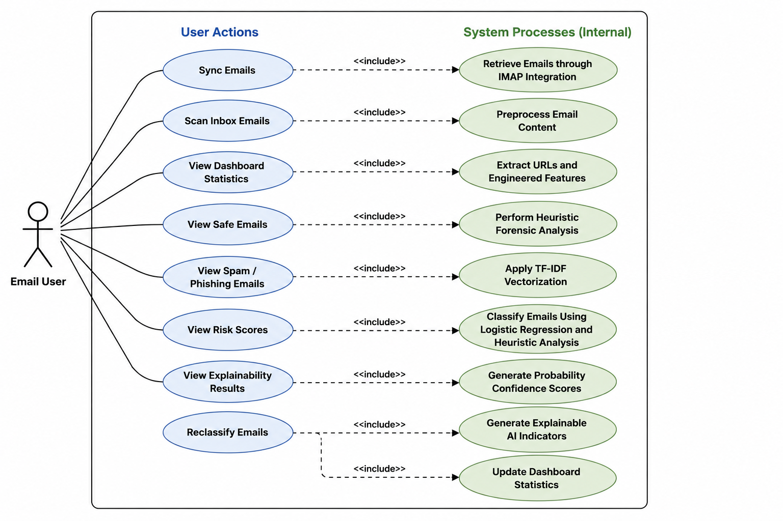
Figure 4 Use case diagram

3.7.2 Data Flow Diagram (DFD)

DFD Level 0
The DFD Level 0 (Figure 3.2) presents the AI-Based Email Phishing Detection System as a single high-level process interacting with the external entity, which is the email user. The user initiates phishing analysis by synchronizing inbox emails or requesting email scanning through the system interface. The system then retrieves email data, performs phishing analysis, and returns classification results, risk scores, and phishing indicators as output.
This diagram provides an overview of the system boundaries and demonstrates that the phishing detection system operates as an independent analytical platform responsible for retrieving, processing, analyzing, and classifying emails using machine learning and heuristic forensic analysis techniques.

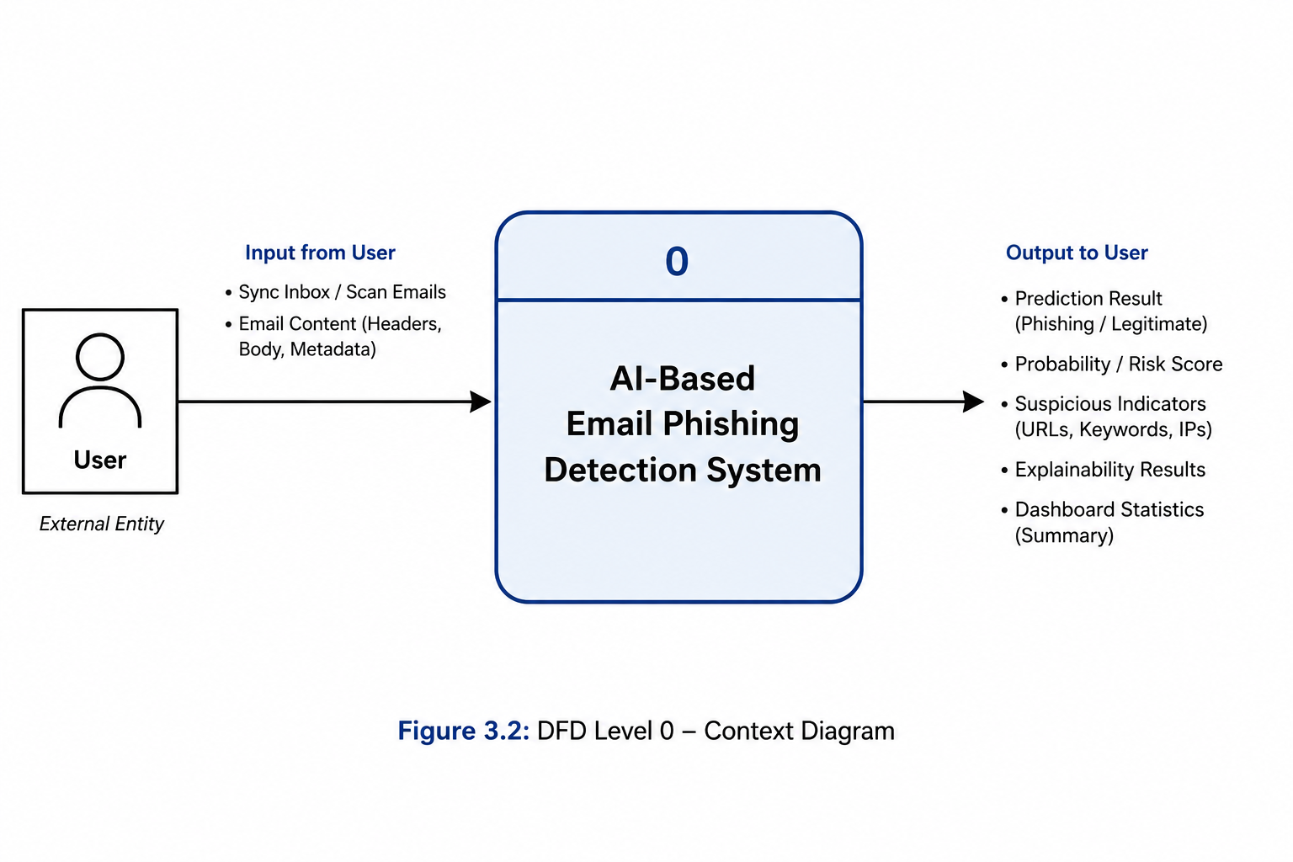
Figure 5 DFD level 0 diagram

DFD Level 1
DFD Level 1 (Figure 3.3) expands the internal processes of the AI-Based Email Phishing Detection System to show how email data is processed and transformed at each stage of phishing analysis.
The system consists of the following sequential processes:
- Retrieve and Receive Email Data
- Email Preprocessing and Cleaning
- URL and Engineered Feature Extraction
- Heuristic Forensic Analysis
- TF-IDF Feature Vectorization
- Logistic Regression Classification
- Probability Calibration and Risk Scoring
- Explainability Generation
- Displaying Classification Results and Dashboard Statistics
Several data stores support the phishing analysis process:
• TF-IDF Vocabulary
• Trained Logistic Regression Model
• Heuristic Rules Database
• Suspicious URL and Domain Patterns
• Processed Email Records
The data flows sequentially from email retrieval to phishing classification and output generation. Retrieved email content is cleaned, tokenized, and analyzed to extract structural phishing indicators such as suspicious URLs, urgency patterns, uppercase character frequency, and sender-link inconsistencies. The processed text is then transformed into numerical feature vectors using TF-IDF vectorization before being analyzed by the trained Logistic Regression model together with heuristic forensic analysis mechanisms. The system then generates phishing predictions, probability confidence scores, suspicious indicators, and explainability results, which are displayed to the user through the dashboard interface.
This structured process ensures logical dependency, efficient phishing analysis, and consistency within the hybrid phishing detection architecture.

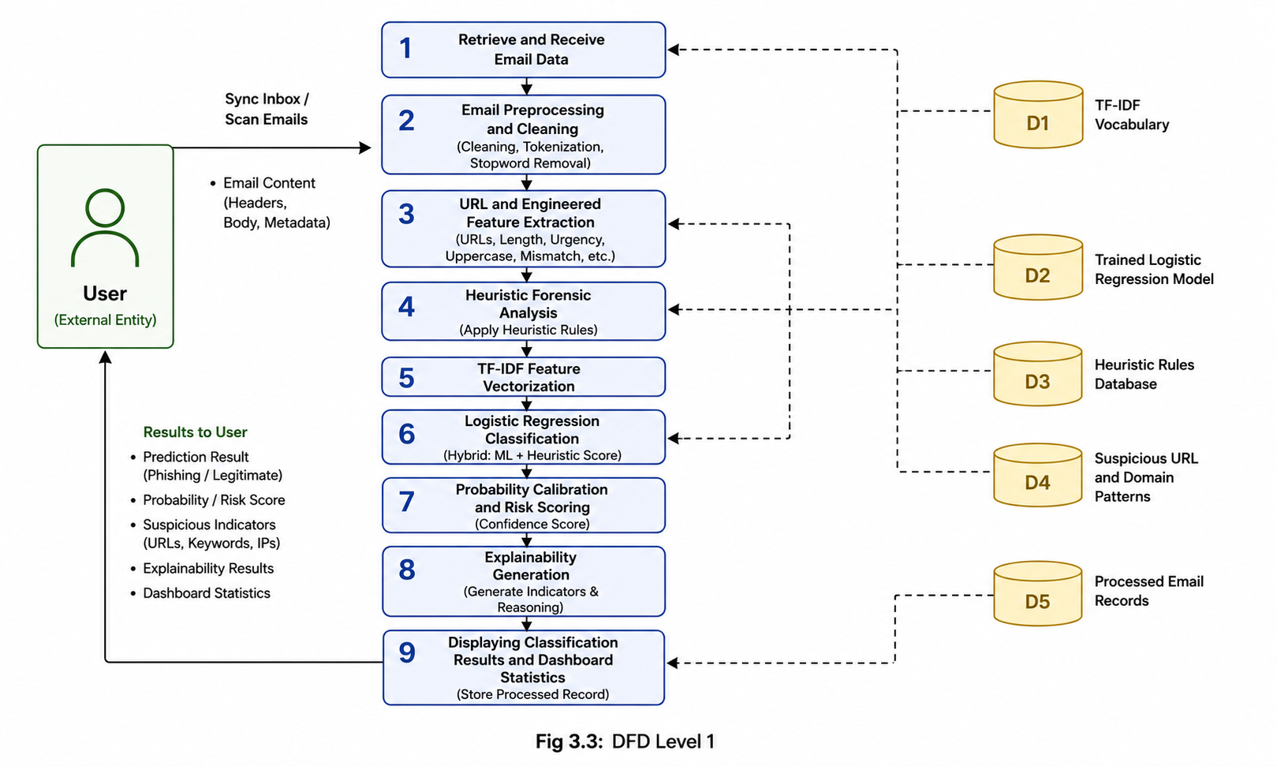
Figure 6 DFD level 1 diagram

3.7.3 Activity Diagram
The Activity Diagram (Figure 3.4) represents the control flow of operations within the AI-Based Email Phishing Detection System. It describes the step-by-step process executed when the user synchronizes inbox emails or initiates phishing analysis through the system interface.
The process begins when the user starts email synchronization or inbox scanning. The system retrieves email content and metadata through IMAP integration before performing preprocessing operations such as text cleaning, tokenization, URL extraction, and feature engineering. The system then performs heuristic forensic analysis to identify suspicious phishing indicators including malicious URLs, urgency patterns, redirect links, uppercase character frequency, and sender-link inconsistencies.
After preprocessing and heuristic analysis, the textual content is transformed into numerical feature vectors using TF-IDF vectorization. The transformed data together with engineered features is passed to the Logistic Regression classification model for phishing prediction. The system then applies probability calibration and risk scoring mechanisms to evaluate prediction confidence levels.
A decision node evaluates whether the phishing probability score exceeds the predefined classification threshold. If the probability exceeds the threshold, the email is classified as phishing. Otherwise, the email is classified as legitimate. The system then generates explainability indicators and displays phishing classification results, suspicious indicators, probability scores, and dashboard statistics to the user.
The activity flow ensures a structured, deterministic, and transparent phishing detection process within the proposed hybrid system architecture.

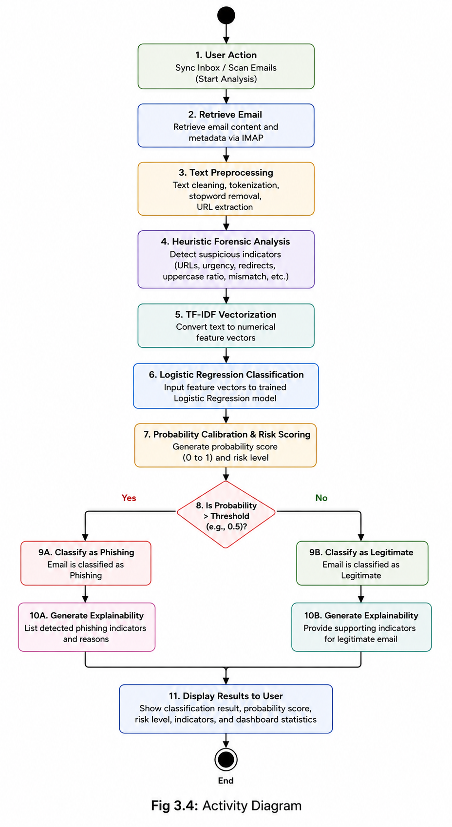
Figure 7 Activity diagram

3.7.4 Sequence Diagram
The Sequence Diagram (Figure 3.5) illustrates the interaction between the user and the major components of the AI-Based Email Phishing Detection System during phishing analysis. The diagram shows the chronological sequence of messages exchanged among the frontend interface, backend services, preprocessing modules, heuristic analysis components, machine learning models, and result display mechanisms.
The sequence of operations is as follows:
The user initiates inbox synchronization or email scanning through the system interface.
The frontend sends the email retrieval request to the backend system.
The backend retrieves email content and metadata through IMAP integration.
The preprocessing module cleans and tokenizes the email content.
The system extracts URLs and engineered phishing features from the email.
The heuristic forensic analysis module evaluates suspicious indicators such as malicious URLs, urgency patterns, redirect links, and sender-link inconsistencies.
The TF-IDF vectorizer converts the processed text into numerical feature vectors.
The feature vectors and heuristic analysis results are passed to the Logistic Regression classification model for prediction.
The model returns phishing probability scores and classification predictions.
The system applies probability calibration and determines whether the email is phishing or legitimate based on the predefined threshold.
Explainability indicators and suspicious feature analysis results are generated.
The backend sends the phishing classification result, probability score, and explainability output to the frontend dashboard.
The results are displayed to the user through the dashboard interface.
This sequence ensures an organized, transparent, and deterministic interaction among the system components, supporting accurate phishing detection, explainability, and efficient dashboard-based email monitoring.
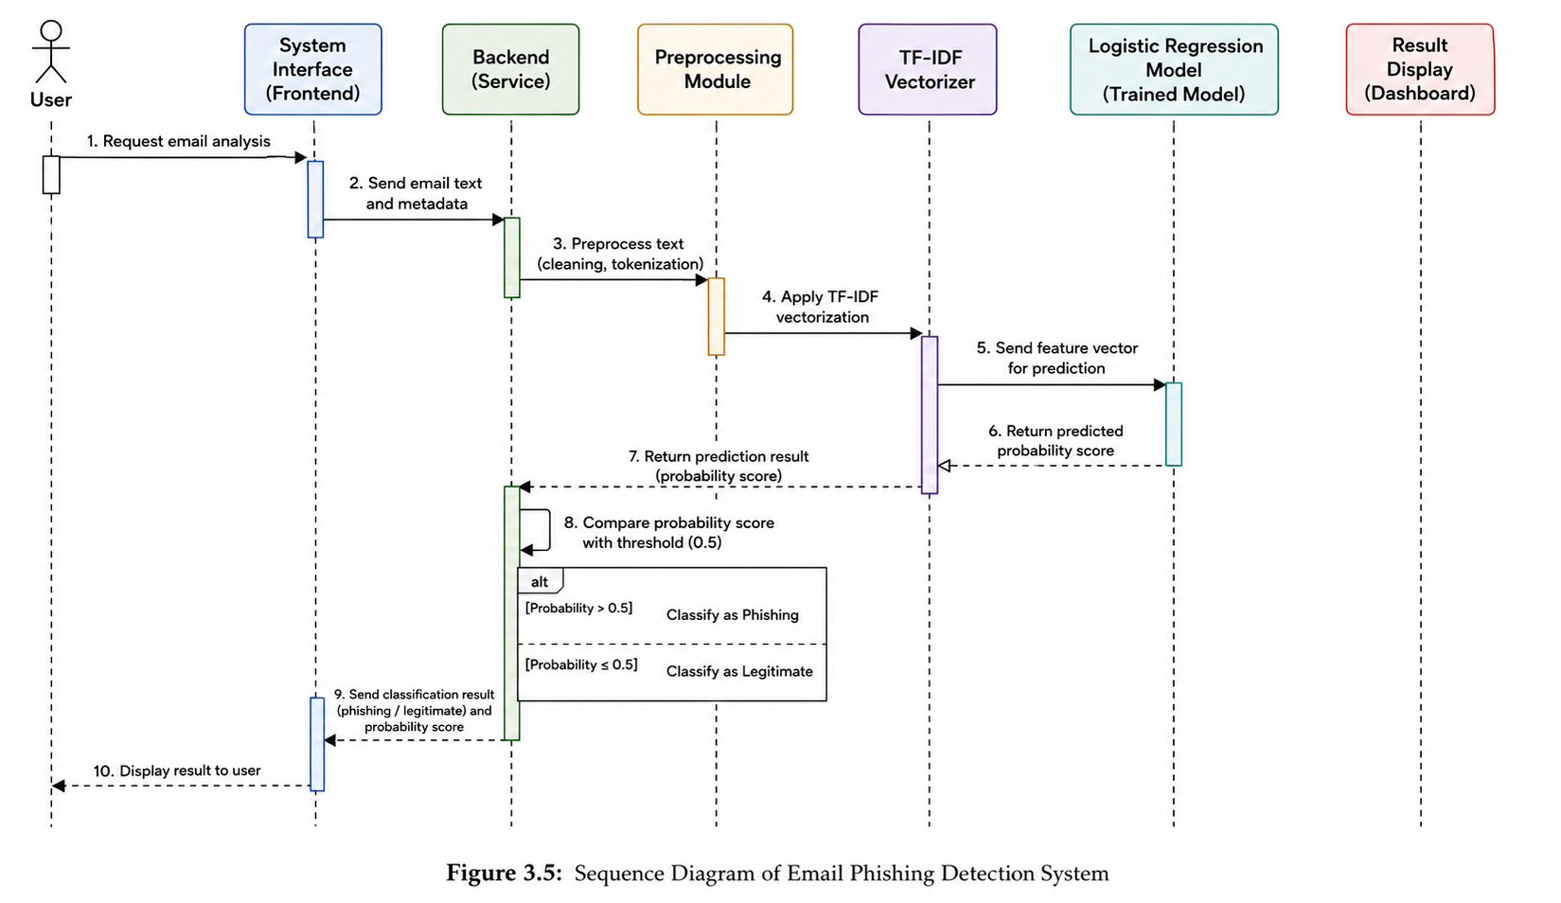
Figure 8 sequence diagram

3.7.5 Summary of Modeling
The modeling artifacts presented in this section clarify system interaction, data transformation, processing workflows, and decision-making logic within the proposed AI-Based Email Phishing Detection System. The Use Case Diagram defines user interaction with the phishing detection platform, the Data Flow Diagrams illustrate the flow of email data and phishing analysis processes, the Activity Diagram represents the operational control flow during phishing detection, and the Sequence Diagram illustrates the interaction and communication among frontend services, backend components, preprocessing modules, heuristic analysis mechanisms, and machine learning models.
Together, these models provide a comprehensive representation of how the proposed hybrid phishing detection system retrieves, processes, analyzes, classifies, and displays phishing detection results within the integrated dashboard environment.

3.8 Logical Design
Logical design provides a high-level conceptual representation of the structure, behavior, and functionality of the proposed AI-Based Email Phishing Detection System. It defines how the major system components are organized and how they interact to support phishing email retrieval, preprocessing, heuristic forensic analysis, machine learning classification, explainability generation, and dashboard visualization.
The logical design focuses on the interaction between the React frontend, FastAPI backend services, preprocessing modules, TF-IDF vectorization mechanisms, heuristic analysis components, Logistic Regression classification model, probability calibration processes, and explainability modules. It also defines the control flow and processing sequence involved during inbox synchronization, phishing detection, risk scoring, and result presentation.
The proposed architecture adopts a modular and decoupled design approach to improve scalability, maintainability, reliability, and efficient processing of email analysis tasks. The logical design further incorporates mechanisms such as IMAP-based email retrieval, engineered feature extraction, deduplication handling, and suspicious indicator analysis to strengthen phishing detection accuracy and system performance.

3.8.1 System Architecture
The proposed AI-Based Email Phishing Detection System adopts a modular and decoupled architecture consisting of frontend, backend, preprocessing, heuristic analysis, machine learning, and output management components. The architecture is designed to support scalable phishing analysis, efficient email processing, explainability generation, and interactive dashboard visualization.
Presentation Layer
This component provides the user interface through a React-based dashboard where users can synchronize inbox emails, scan email records, monitor phishing statistics, and view phishing analysis results. The presentation layer displays outputs such as phishing classification labels, probability confidence scores, suspicious indicators, risk levels, explainability results, and dashboard statistics. It manages user interaction but does not directly perform phishing analysis operations.
Backend Service Layer
This layer is implemented using FastAPI and acts as the core communication and processing engine of the system. It handles email retrieval requests, inbox synchronization, preprocessing coordination, phishing analysis execution, probability scoring, explainability generation, and communication between all internal modules.
Processing and Preprocessing Layer
This component performs preprocessing and standardization of retrieved email content before analysis. The operations include:
• Lowercasing
• Removal of special characters and HTML tags
• Stop-word removal
• Tokenization
• URL extraction
• Metadata normalization
The preprocessing layer ensures that raw email data is transformed into a clean and machine learning-ready format.
Feature Extraction and Heuristic Analysis Component
This module performs TF-IDF vectorization together with engineered feature extraction and heuristic forensic analysis. The system extracts phishing indicators such as suspicious URLs, urgency patterns, uppercase character frequency, redirect links, domain mismatches, and sender-link inconsistencies. The module relies on pre-trained TF-IDF vocabulary data and heuristic rule sets generated during the training and analysis phases.
Classification Component
This component contains the trained Logistic Regression model together with probability calibration mechanisms. The classification engine computes phishing probability scores and determines whether an email belongs to the phishing or legitimate class based on extracted textual and structural features.
Explainability and Output Component
This module generates explainability indicators, suspicious feature summaries, phishing risk scores, and dashboard statistics before presenting the final results to the user through the frontend interface.

Architectural Relationships
The system follows a modular layered architecture as follows:
Presentation Layer
↓
Backend Service Layer
↓
Processing and Preprocessing Layer
↓
Feature Extraction and Heuristic Analysis Layer
↓
Classification Layer
↓
Explainability and Output Layer
Each layer performs a specialized responsibility and communicates with adjacent layers through defined interfaces, improving modularity, maintainability, scalability, and system reliability.
Component Structure
The component structure of the system consists of:
• React Frontend Dashboard
• FastAPI Backend Service
• Email Retrieval and IMAP Module
• Preprocessing Module
• TF-IDF Vectorization Module
• Heuristic Forensic Analysis Module
• Logistic Regression Classification Module
• Probability Calibration Module
• Explainability Module
• Dashboard Output Module
Each module performs a distinct responsibility within the phishing detection pipeline and communicates through structured input-output interactions.

3.8.2 Control Flow and Process Design
Control flow defines how tasks are sequenced and how the system transitions between phishing analysis operations within the proposed architecture.
The overall process follows these steps:
- The user initiates inbox synchronization or email scanning through the dashboard interface.
- The backend service retrieves email content and metadata through IMAP integration.
- The system validates and organizes retrieved email data.
- Text preprocessing operations such as cleaning, tokenization, stop-word removal, and URL extraction are executed.
- Engineered phishing features and suspicious indicators are extracted from the email content and metadata.
- Heuristic forensic analysis is performed to identify suspicious URLs, urgency patterns, redirect links, uppercase character frequency, and sender-link inconsistencies.
- TF-IDF vectorization is applied to convert textual content into numerical feature vectors.
- The Logistic Regression classification model computes phishing prediction probabilities using textual and engineered features.
- Probability calibration and risk scoring mechanisms evaluate prediction confidence levels.
- The phishing probability score is compared against the predefined classification threshold.
- The system determines whether the email is phishing or legitimate.
- Explainability indicators and suspicious feature summaries are generated.
- Classification results, probability scores, suspicious indicators, and dashboard statistics are displayed to the user.
This control flow ensures organized sequencing of operations, efficient phishing analysis, consistent decision-making, and transparent presentation of phishing detection results within the system.

3.8.2.1Key Processes Explained
a) Text Preprocessing
This process prepares retrieved email content for phishing analysis by removing irrelevant elements and standardizing the input data. Operations performed include lowercasing, removal of special characters and HTML tags, tokenization, stop-word removal, metadata normalization, and URL extraction. The preprocessing stage ensures that email data is clean, structured, and suitable for machine learning and heuristic analysis.
b) Feature Extraction and Heuristic Analysis
This process transforms processed email content into machine learning-ready features. TF-IDF vectorization converts textual tokens into numerical feature vectors representing word importance within the dataset. In addition, engineered phishing indicators such as suspicious URLs, urgency patterns, redirect links, uppercase character frequency, suspicious domains, and sender-link inconsistencies are extracted through heuristic forensic analysis to strengthen phishing detection accuracy.
c) Classification and Probability Scoring
The Logistic Regression classification model analyzes the extracted textual and structural features to compute phishing prediction probabilities.
$$P(\text{Phishing}∣\text{Email})$$
The system then applies probability calibration and compares the resulting phishing probability score against the predefined classification threshold. If the probability exceeds the threshold value, the email is classified as phishing. Otherwise, the email is classified as legitimate. The system further generates explainability indicators and suspicious feature summaries before displaying the final result to the user.

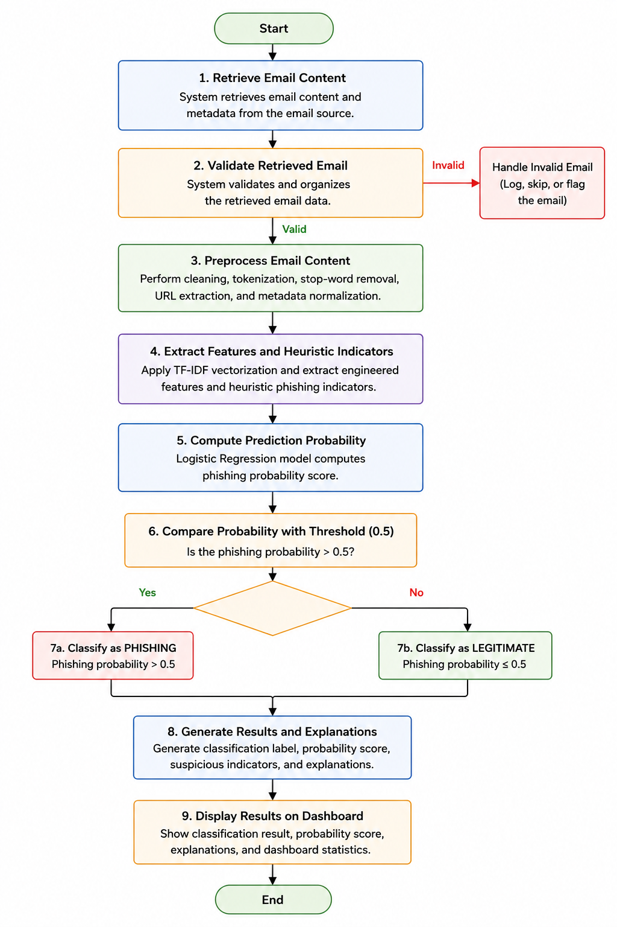
Figure 9 control flow diagram

3.8.3 Design for Non-Functional Requirements
The system incorporates mechanisms to address security, reliability, efficiency, scalability, explainability, and usability requirements within the phishing detection environment.
- Security Strategies
• Retrieved email content is processed securely during phishing analysis operations.
• The system minimizes permanent storage of sensitive email content to reduce privacy risks.
• IMAP authentication credentials are handled securely during inbox synchronization.
• The trained Logistic Regression model, TF-IDF vocabulary, heuristic rule sets, and calibration data are securely stored as serialized files.
• Input validation and backend request handling mechanisms reduce the risk of malicious script injection and invalid processing requests.
• Suspicious email analysis operates independently without modifying existing email infrastructure.
These measures reduce exposure to data leakage, unauthorized access, and insecure processing operations.
- Error and Exception Handling
The system incorporates the following reliability strategies:
• Validation of retrieved email data and metadata
• Exception handling during IMAP synchronization and backend communication
• Controlled handling of missing or corrupted model files
• Error logging and controlled processing termination during critical failures
• Duplicate email detection and handling mechanisms
• Dashboard notifications for invalid synchronization or analysis operations
These mechanisms improve operational stability, consistency, and reliability during phishing analysis.
- Performance and Efficiency
• Logistic Regression provides fast phishing prediction and efficient processing of sparse textual data.
• TF-IDF vectorization and heuristic analysis mechanisms are computationally efficient.
• Pre-trained machine learning models and vocabularies are loaded during system startup to reduce prediction latency.
• Backend services process phishing analysis requests using lightweight modular operations.
• Deduplication handling reduces repeated email processing and unnecessary computation.
These strategies improve system responsiveness, scalability, and operational efficiency.
- Maintainability and Scalability
• The modular architecture allows independent modification of frontend, backend, preprocessing, heuristic analysis, and classification components.
• Additional machine learning models and heuristic detection rules can be integrated without redesigning the entire system.
• Feature extraction and explainability mechanisms can be extended in future versions of the platform.
• The separation of frontend and backend services supports easier maintenance and scalability.
These strategies improve adaptability, extensibility, and long-term system maintenance.
- Usability and Explainability Enhancement
• The dashboard interface provides simple and organized interaction for phishing monitoring and analysis.
• Clear phishing classification labels and probability scores improve interpretability.
• Suspicious indicators and explainability outputs improve user trust and transparency.
• Dashboard statistics and risk summaries improve monitoring and decision-making.
• Automated inbox synchronization improves usability by reducing manual interaction requirements.
These mechanisms improve user experience, transparency, and trust in the phishing detection process.

3.9 Summary of Logical Design
The logical design defines the structured organization of the AI-Based Email Phishing Detection System using a modular layered architecture. It specifies component relationships, control flow sequencing, phishing analysis logic, backend and frontend interactions, and integration of non-functional requirements such as security, reliability, explainability, scalability, and performance efficiency.
The logical design further defines how the system retrieves emails through IMAP integration, preprocesses and analyzes email content, performs heuristic forensic analysis and machine learning classification, generates phishing risk scores and explainability outputs, and presents phishing analysis results through the interactive dashboard environment. This structured blueprint ensures clarity, consistency, and architectural readiness before proceeding to physical implementation and system deployment.

3.10 Physical Design
Physical design describes the actual implementation environment, hardware configuration, software technologies, storage mechanisms, backend services, frontend structure, and deployment environment of the AI-Based Email Phishing Detection System. While logical design defines the conceptual structure and operational workflow of the system, the physical design specifies the real-world technologies, frameworks, and computing resources used to implement the phishing detection platform.

3.10.1 Hardware Requirements
The system will be developed and tested using a standard personal computer with the following minimum specifications:
• Processor: Intel Core i7
• RAM: Minimum 16 GB
• Storage: Minimum 512 GB SSD
• Operating System: Windows 11
• Internet Connectivity: Required for IMAP email synchronization and dashboard communication
The proposed hybrid phishing detection architecture combines TF-IDF vectorization, heuristic forensic analysis, and Logistic Regression classification, which are computationally efficient and suitable for high-dimensional textual analysis without requiring specialized hardware such as GPUs or dedicated machine learning servers.
Since the dataset size is moderate and the system uses lightweight backend and frontend technologies, phishing analysis, email synchronization, heuristic processing, and dashboard operations can execute efficiently within standard academic computing environments. The modular FastAPI backend and React frontend architecture further support efficient local deployment and testing without advanced infrastructure requirements.
Therefore, no specialized computing infrastructure is required for system implementation and evaluation.

3.10.2 Software Environment
The system will be implemented using the following software components:
• Programming Language: Python 3.11
• Frontend Framework: React.js
• Backend Framework: FastAPI
• Machine Learning Library: Scikit-learn
• Data Processing Libraries: Pandas and NumPy
• Text Processing Libraries: NLTK and Regular Expressions (Regex)
• Visualization and Dashboard Libraries: React UI Components and Chart Libraries
• Development Environment: Visual Studio Code and Jupyter Notebook
• Version Control: Git and GitHub
• API Testing Tools: Postman
• Email Retrieval Protocol: IMAP
The system is implemented using Python-based backend technologies and a React frontend architecture that supports modular development, interactive dashboard visualization, machine learning integration, and scalable phishing analysis operations. FastAPI provides lightweight and high-performance backend services for handling phishing analysis requests, email synchronization, preprocessing operations, heuristic forensic analysis, and communication between system components.
Scikit-learn provides robust implementations of Logistic Regression classification, TF-IDF vectorization, probability calibration, and machine learning utilities suitable for phishing email detection tasks. Pandas and NumPy support efficient data manipulation, feature engineering, and numerical computation during preprocessing and model evaluation stages.
NLTK and Regex-based preprocessing mechanisms support tokenization, stop-word removal, URL extraction, metadata normalization, and suspicious pattern analysis. React.js provides an interactive and responsive dashboard interface for displaying phishing classification results, suspicious indicators, risk scores, explainability outputs, and monitoring statistics.
The selected technologies support efficient local deployment, modular scalability, iterative experimentation, and systematic evaluation of machine learning and heuristic phishing detection mechanisms within the proposed system architecture.

3.10.3 Model and File Storage Design
The trained Logistic Regression model, TF-IDF vectorizer, heuristic analysis configurations, and probability calibration components are serialized and stored locally using Python serialization mechanisms such as Pickle and Joblib. Model persistence enables reuse of trained parameters and preprocessing configurations without repeated retraining, improving operational efficiency, startup performance, and deployment readiness.
The following files are generated and stored within the backend environment:
• logistic_model.pkl – stores the trained Logistic Regression classification model
• tfidf_vectorizer.pkl – stores the trained TF-IDF vocabulary and vectorization configuration
• calibration_model.pkl – stores probability calibration parameters used for phishing confidence scoring
• heuristic_rules.json – stores heuristic phishing indicators, suspicious domain patterns, and forensic analysis rules
• processed_email_cache.json – stores temporary deduplication and synchronization tracking information
The system does not rely on a traditional relational database management system (RDBMS) for permanent storage of email content. Retrieved emails are processed temporarily during phishing analysis operations and are not permanently stored within the application environment, supporting privacy, confidentiality, and secure handling of user email data.
Temporary synchronization metadata and deduplication information may be maintained locally to support inbox scanning efficiency and prevent repeated phishing analysis of previously processed emails. The lightweight local storage structure improves deployment simplicity, processing efficiency, and maintainability within the academic implementation environment.

3.10.4 Dataset Description and Storage
The dataset used in this study was obtained from a publicly available phishing email detection dataset associated with the work of Al-Subaiey et al. (2024). The selected dataset consists of labeled email samples categorized as phishing (1) and legitimate (0).
The dataset contains 82,486 email samples, comprising:
- 42,891 phishing emails (Class 1)
- 39,595 legitimate emails (Class 0)
The class distribution is relatively balanced, with approximately 52% phishing emails and 48% legitimate emails. This near-balanced distribution reduces the risk of classification bias and improves the reliability of performance evaluation metrics such as precision, recall, and F1-score.
Each record in the dataset includes:
- text_combined – the email body content
- label – binary classification (0 = legitimate, 1 = phishing)
The dataset was selected for the following reasons:
- Large sample size sufficient for robust training and evaluation
- Clear binary labeling suitable for supervised learning
- Realistic phishing and legitimate email patterns
- Compatibility with text-based feature extraction methods such as TF-IDF
Exploratory data analysis was conducted to examine class distribution, missing values, and structural consistency. Since the dataset was nearly balanced, stratified sampling was applied during train-test splitting to preserve class proportions in both training and testing subsets. This approach ensures unbiased performance evaluation and prevents skewed classification results.
Although the dataset provides a strong foundation for model training, it represents secondary data and may not fully capture region-specific phishing patterns within Kenya. This limitation is acknowledged in the system evaluation and recommendations for future research.
comprehensive dataset characteristics table
Characteristic | Description | Implementation in my Project | Why It Matters
Dataset Source | Public dataset from Kaggle | Imported as CSV (phishing_email.csv) into Python using Pandas | Ensures reliability, accessibility, and reproducibility of results
Dataset Size | 82,486 email samples | Loaded into a DataFrame for preprocessing and modeling | Large size improves model generalization and reduces overfitting
Class Labels | Binary classification (0 = Legitimate, 1 = Phishing) | Used as target variable (label) in supervised learning | Enables Logistic Regression to perform classification
Class Distribution | 42,891 phishing (52%), 39,595 legitimate (48%) | Stratified train-test split applied | Balanced dataset prevents bias toward one class
Feature Type | Textual data (email content) | Stored in text combined column | Core input for NLP and feature extraction
Data Type | Unstructured text | Converted into structured numerical vectors using TF-IDF | ML models require numerical input
Feature Extraction Method | TF-IDF (Term Frequency–Inverse Document Frequency) | Implemented using Scikit-learn TF-IDF Vectorizer | Captures importance of words in emails
Dimensionality | High-dimensional sparse matrix | Output of TF-IDF transformation | Handles large vocabulary typical in email text
Missing Values | Minimal or none (clean dataset) | Verified during EDA and handled if present | Ensures model accuracy and stability
Noise Level | Contains HTML tags, special characters, stop words | Cleaned during preprocessing (tokenization, stop word removal) | Improves model performance
Data Preprocessing Steps | Cleaning, tokenization, stop word removal, lemmatization | Implemented using NLTK and regex | Standardizes input for better learning
Train-Test Split | Typically, 80:20 ratio | Stratified splitting used | Maintains class balance in both sets
Target Variable | Email classification label | Used to train Logistic Regression model | Enables prediction of phishing vs legitimate
Data Storage Format | CSV file | Stored locally and loaded into Pandas DataFrame | Easy handling and portability
Data Nature | Secondary data | Used directly without primary collection | Saves time and resources
Data Limitation | May not reflect Kenyan-specific phishing patterns | Acknowledged in project limitations | Affects real-world applicability
Scalability | Moderate dataset size (82k rows) | Processed on standard laptop (16GB RAM) | No need for high-end hardware
Table 3comprehensive dataset characteristics table

3.10.5 System Directory Structure
The physical organization of system files follows a modular directory structure to improve maintainability, scalability, readability, and separation of responsibilities within the phishing detection platform.
The frontend directory contains the React dashboard interface, reusable user interface components, API communication services, and visualization resources. The backend directory contains FastAPI services, phishing detection models, preprocessing modules, heuristic forensic analysis components, explainability mechanisms, and backend utility functions.
The data directory stores datasets and processed training data used during experimentation and evaluation. The saved model’s directory contains serialized machine learning models, TF-IDF vocabularies, calibration configurations, and heuristic analysis rule sets required during phishing detection operations.
This structured organization supports modular development, efficient maintenance, scalability, and separation of concerns while aligning recommended software engineering practices for modern web-based machine learning systems.

3.10.6 Deployment Approach
The system is deployed locally using a decoupled React frontend and FastAPI backend architecture running on a standard personal computer within a controlled academic environment. The backend services handle email retrieval, preprocessing, heuristic forensic analysis, TF-IDF vectorization, machine learning classification, probability calibration, explainability generation, and dashboard data management, while the React frontend provides interactive visualization and phishing monitoring capabilities.
The trained Logistic Regression model, TF-IDF vectorizer, calibration configurations, and heuristic analysis rules are loaded from serialized files during backend startup. When the user initiates inbox synchronization or phishing analysis through the dashboard interface, the backend retrieves email content and metadata through IMAP integration before executing preprocessing, feature extraction, heuristic analysis, and phishing classification processes.
The deployment environment supports phishing prediction generation, suspicious indicator analysis, probability confidence scoring, explainability outputs, and dashboard statistics visualization in real time. Header-first deduplication mechanisms are also implemented to reduce repeated processing of previously analyzed emails and improve operational efficiency.
The deployment remains within a controlled academic environment for research, testing, and demonstration purposes. Although the system integrates with email inboxes through IMAP synchronization, it does not modify existing email infrastructure or perform direct intervention within external mail server operations.

3.10.7 Security and Privacy Considerations
The physical design incorporates several security and privacy measures to support secure phishing analysis operations and protect user email information.
• Retrieved email content is processed securely during phishing analysis and unnecessary permanent storage of email content is minimized.
• IMAP authentication credentials are handled securely during inbox synchronization processes.
• Trained machine learning models, TF-IDF vocabularies, calibration configurations, and heuristic rule files are stored locally within the backend environment.
• Backend request validation mechanisms reduce the risk of malicious input processing and unauthorized requests.
• The system performs phishing analysis without modifying existing email infrastructure or mail server configurations.
• Header-first deduplication mechanisms reduce repeated processing of previously scanned emails and improve operational efficiency.
• Suspicious URL analysis and sender-domain verification mechanisms improve phishing detection reliability while reducing false positives.
• The deployment environment operates within a controlled academic setting to minimize exposure to external security threats.
These strategies reduce attack surfaces, improve secure processing operations, and support privacy-preserving system behavior during phishing analysis and dashboard interaction.

Summary of Physical Design
The physical design defines the computing environment, hardware requirements, software technologies, backend and frontend architecture, file organization, storage mechanisms, deployment structure, and security considerations of the AI-Based Email Phishing Detection System.
The system utilizes lightweight machine learning algorithms, heuristic forensic analysis mechanisms, FastAPI backend services, react frontend interfaces, and modular file organization to support efficient phishing analysis, explainability generation, and interactive dashboard monitoring. The use of open-source technologies, serialized model persistence, structured deployment architecture, and secure processing mechanisms ensures that the system remains scalable, maintainable, resource-efficient, and suitable for academic implementation and evaluation.
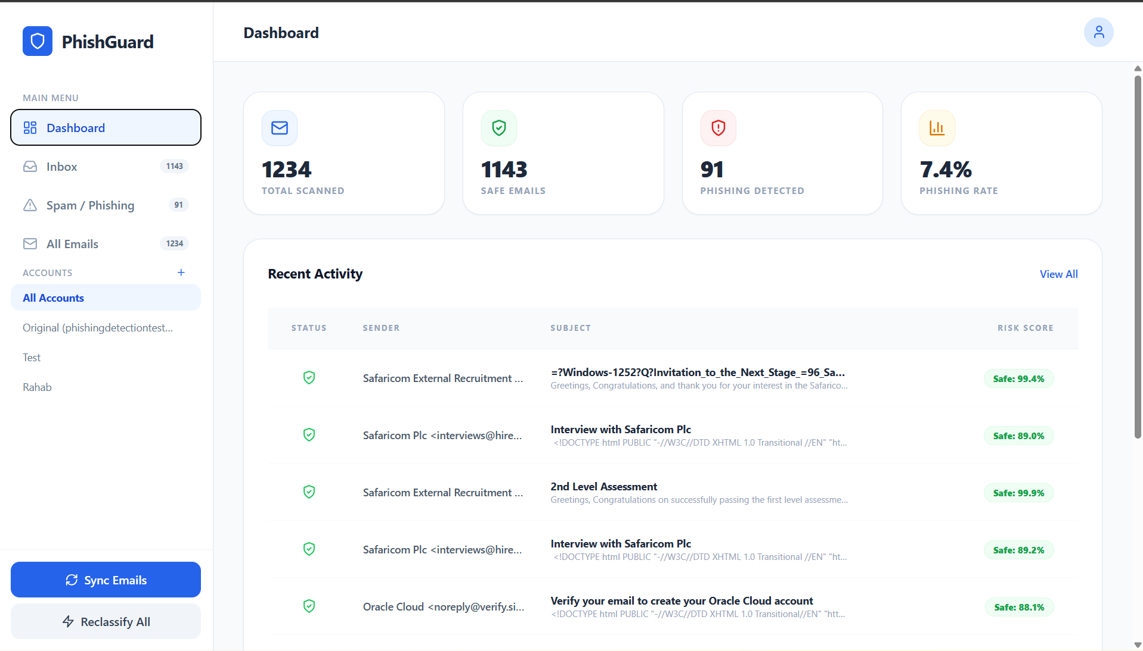
Figure 11 physical design dashboard

CHAPTER 4

SYSTEM IMPLEMENTATION AND TESTING, CONCLUSIONS AND RECOMMENDATIONS

4.1 Introduction
This chapter presents the implementation, testing, and evaluation of the AI-Based Email Phishing Detection System proposed and designed in Chapter 3. While the previous chapter focused on system analysis, requirements specification, logical design, and physical design, this chapter translates those specifications into a functional phishing detection and email monitoring platform.
The system was implemented using Python-based backend technologies and a React frontend architecture within a controlled academic environment. The phishing detection engine was developed following the CRISP-DM methodology to support structured data preparation, feature engineering, machine learning modeling, evaluation, and deployment processes. The implemented system combines TF-IDF vectorization, Logistic Regression classification, heuristic forensic analysis, engineered metadata features, probability calibration, and explainable AI mechanisms to improve phishing detection accuracy and reduce false positives.
The deployed prototype utilizes a decoupled FastAPI backend and React dashboard interface to support real-time inbox synchronization, phishing analysis, suspicious URL detection, risk scoring, and explainability visualization. Through IMAP integration, the system retrieves inbox emails, preprocesses email content, performs heuristic and machine learning analysis, and generates phishing classification results together with probability confidence scores and suspicious indicator summaries.
This chapter further describes the implementation environment, technologies used, backend and frontend integration, core phishing analysis processes, system testing strategies, and evaluation procedures employed to validate system functionality, usability, performance, and reliability. The chapter also presents the system user guide, implementation outcomes, identified limitations, conclusions, and recommendations for future improvement.

4.2 Environment and Tools
The AI-Based Email Phishing Detection System was implemented using Python-based backend technologies, machine learning frameworks, heuristic forensic analysis mechanisms, and a React frontend interface suitable for real-time phishing detection and inbox monitoring. The implementation environment was structured into backend services, frontend interaction, machine learning processing, and supporting development tools.

4.2.1 Backend Environment
The backend of the system was developed using Python 3.11 and FastAPI. Python was selected because of its extensive ecosystem for artificial intelligence, machine learning, cybersecurity analysis, and data processing applications. FastAPI was selected to provide lightweight and high-performance backend services for phishing analysis, inbox synchronization, preprocessing operations, and communication between frontend and backend components.
The following core libraries and frameworks were utilized:
• Scikit-learn: Used for implementing Logistic Regression classification, TF-IDF vectorization, probability calibration, and machine learning evaluation operations.
• Pandas: Used for dataset loading, preprocessing, manipulation, and structured email analysis operations.
• NumPy: Used for numerical computations and matrix operations required during feature extraction and classification.
• NLTK (Natural Language Toolkit): Used for tokenization, stop-word removal, and preprocessing operations.
• Regular Expressions (Regex): Used for suspicious URL detection, pattern matching, redirect analysis, and heuristic forensic analysis.
• Fast API :Used for backend API development, phishing analysis routing, inbox synchronization handling, and dashboard communication.
• IMAP Libraries: Used for retrieving inbox emails and metadata from email servers during synchronization operations.
• Pickle and Joblib: Used for serialization and persistence of trained models, TF-IDF vocabularies, calibration models, and heuristic analysis configurations.
The backend incorporates engineered feature extraction mechanisms, heuristic forensic analysis modules, probability calibration components, deduplication handling mechanisms, and explainable AI processing layers to improve phishing detection reliability and transparency.

4.2.2 Frontend Environment
The user interface layer was implemented using React.js to provide a responsive and interactive phishing monitoring dashboard. The frontend communicates with the FastAPI backend through API requests and displays phishing analysis results, suspicious indicators, probability confidence scores, explainability summaries, and monitoring statistics in real time.
The dashboard provides:
• Inbox synchronization and scanning functionality
• Real-time phishing analysis results
• Safe and phishing email categorization
• Probability confidence scores and risk levels
• Suspicious URL and forensic indicator visualization
• Explainability summaries and phishing feature indicators
• Dashboard statistics and monitoring panels
• Reclassification and email analysis interaction mechanisms
The front end and backend operate as decoupled system components, improving scalability, maintainability, modularity, and system responsiveness within the phishing detection architecture.

4.2.3 Development Environment
Model development, feature engineering, heuristic analysis experimentation, training, and evaluation were conducted using Jupyter Notebook and Visual Studio Code. These environments support interactive experimentation, incremental code execution, backend and frontend integration, debugging, API testing, and visualization of machine learning performance metrics. The development environment was suitable for implementing the CRISP-DM methodology phases, particularly data understanding, preprocessing, feature engineering, modeling, evaluation, and deployment preparation.
Version control and project management operations were supported using Git and GitHub to maintain modular source code organization and track implementation changes throughout development. Postman was additionally used for backend API testing and verification of communication between the FastAPI backend services and the React frontend interface.
The system was executed on a standard personal computer within a Windows 11 operating system environment. The implementation and deployment environment remained within a controlled academic setup for research, experimentation, testing, and demonstration purposes. Although the system integrates with live inboxes through IMAP synchronization, no external cloud infrastructure or production deployment services were used during implementation and evaluation.

4.3 System Code Generation
This section explains how the logical system design described in Chapter 3 was translated into executable program components within the implemented AI-Based Email Phishing Detection System. The implementation follows a modular hybrid architecture in which retrieved inbox emails flow through synchronization, preprocessing, heuristic forensic analysis, feature extraction, machine learning classification, probability calibration, explainability generation, and dashboard visualization stages before phishing detection results are produced.
The system was implemented using a decoupled frontend and backend structure to ensure separation of concerns between email retrieval, preprocessing, feature engineering, heuristic analysis, machine learning operations, explainability mechanisms, and dashboard presentation logic. The FastAPI backend handles phishing analysis operations and communication with machine learning components, while the React frontend manages user interaction, inbox monitoring, visualization, and dashboard rendering.
The implementation pipeline combines TF-IDF vectorization, engineered phishing feature extraction, Logistic Regression classification, heuristic forensic analysis, suspicious URL detection, probability calibration, and explainable AI processing to improve phishing detection reliability and reduce false positive classifications.
The system processes retrieved emails through the following major stages:
- Inbox synchronization and email retrieval through IMAP integration
- Email preprocessing and normalization
- URL extraction and engineered phishing feature generation
- Heuristic forensic analysis and suspicious pattern detection
- TF-IDF feature vectorization
- Logistic Regression classification and probability scoring
- Probability calibration and risk assessment
- Explainability generation and suspicious indicator analysis
- Dashboard visualization and phishing monitoring output
The modular implementation structure improves maintainability, scalability, debugging, testing, and future enhancement of the phishing detection platform.

4.3.1 Data Loading and Feature–Label Separation
The first step in implementation involved importing phishing and legitimate email datasets into the system using the Pandas library. The datasets contain email textual content together with phishing classification labels used for supervised machine learning training and evaluation.
The primary dataset attributes include:
• text_combined: Combined email subject and body content
• label – Binary classification label (0 = legitimate, 1 = phishing)
Additional engineered metadata and heuristic indicators were also generated during preprocessing and feature engineering stages to strengthen phishing detection accuracy.
The dataset was loaded and separated into input features and classification labels as follows:
data = pd.read_csv("phishing_legit_dataset.csv")
X = data["text_combined"]
y = data["label"]
This separation enables machine learning models to learn relationships between textual content, engineered phishing indicators, and classification labels during training.
The implementation further supports engineered phishing feature extraction including:
• URL count analysis
• Uppercase character frequency
• Suspicious URL indicators
• Sender-domain inconsistencies
• Urgency keyword detection
• Redirect pattern analysis
These engineered features were later integrated with TF-IDF textual features to support hybrid phishing detection and heuristic forensic analysis.

4.3.2 Data Splitting and Stratification
To ensure unbiased evaluation and reliable performance estimation, the dataset was divided into training and testing subsets using an 80:20 ratio.
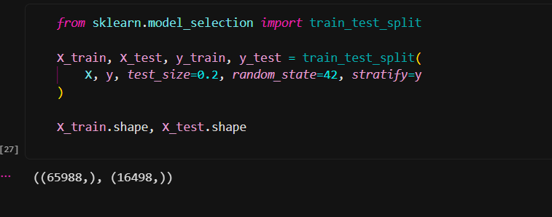
Figure 12 Data Splitting and Stratification
Stratification was applied to preserve the original class distribution of phishing and legitimate emails across both datasets. This prevents skewed evaluation results and ensures balanced exposure to phishing and legitimate samples during model training and testing.
The dataset splitting process also supports:
• unbiased model evaluation
• prevention of training bias
• improved reliability of performance metrics
• consistent phishing detection validation
Without stratification, class imbalance could negatively affect phishing detection reliability and increase the likelihood of misleading evaluation outcomes.

4.3.3 Email Preprocessing and Normalization Pipeline
Raw email content contains multiple noisy and inconsistent elements that may negatively affect phishing analysis and machine learning performance. These include:
• URLs and embedded links
• HTML tags and formatting artifacts
• punctuation and special characters
• uppercase variations
• stopwords
• tracking parameters and redirect structures
The preprocessing pipeline was designed to clean, normalize, and standardize email content before heuristic analysis and feature extraction operations.
The preprocessing stage performs:
- Lowercasing and normalization
- URL extraction and suspicious link preservation
- Removal of non-alphabetic characters and HTML artifacts
- Stop-word filtering
- Tokenization and text cleaning
- Metadata normalization
The preprocessing implementation is represented as follows:
def clean_text(text):
text = str(text).lower()
extracted_urls = re.findall(
r"http\S+|www\S+|https\S+",
text
)
text = re.sub(
r"http\S+|www\S+|https\S+",
"",
text
)
text = re.sub(r"[^a-z\s]", " ", text)
words = [
w for w in text.split()
if w not in stop_words
]
cleaned_text = " ".join(words)
return cleaned_text, extracted_urls
Unlike the earlier implementation, the current preprocessing pipeline preserves extracted URLs before text cleaning to support heuristic forensic analysis and suspicious link evaluation during phishing detection.
The same preprocessing logic is reused during deployment and inbox synchronization operations to ensure consistency between model training, phishing analysis, and real-time prediction stages.

4.3.4 Feature Engineering Using TF-IDF and Engineered Metadata Features
Machine learning algorithms cannot directly process raw textual email content. Therefore, email text must be transformed into numerical representations suitable for phishing classification and heuristic analysis.
TF-IDF (Term Frequency - Inverse Document Frequency) vectorization was used to:
• Measure word importance within each email
• Reduce the influence of overly common terms
• Capture discriminative phishing-related vocabulary
• Generate sparse numerical feature vectors suitable for machine learning classification
The TF-IDF vectorizer was implemented as follows:
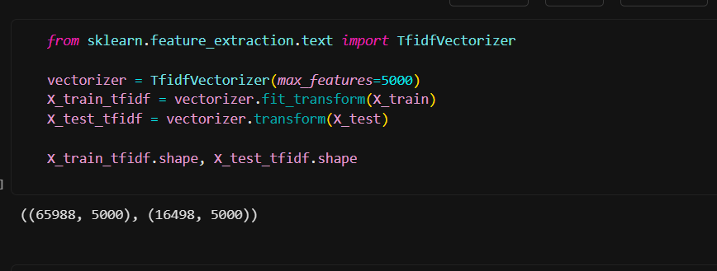
Figure 13 TF-IDF vectorizer
The vectorizer was fitted only on the training dataset to prevent data leakage and ensure unbiased model evaluation.
In addition to TF-IDF textual features, the implemented system incorporates engineered phishing metadata features and heuristic indicators including:
• URL count analysis
• Uppercase character frequency
• Suspicious URL detection
• Redirect pattern indicators
• Sender-domain inconsistencies
• Urgency keyword indicators
• Suspicious domain pattern detection
These engineered features strengthen phishing detection accuracy by combining textual analysis with forensic structural analysis of email content.
The resulting TF-IDF vectors and engineered features form high-dimensional sparse representations where each feature contributes to phishing probability estimation and heuristic risk evaluation.

4.3.5 Model Training Using Logistic Regression and Hybrid Analysis
Logistic Regression was selected as the primary classification algorithm because of:
• suitability for binary classification
• interpretability and explainability support
• efficient handling of sparse textual data
• probabilistic output generation
• fast training and prediction performance
The model was trained using TF-IDF textual vectors together with engineered phishing indicators generated during preprocessing and heuristic analysis stages.
model = LogisticRegression(
max_iter=1000
)
model.fit(X_train_tfidf, y_train)
The Logistic Regression model learns weighted coefficients for phishing-related textual and structural features. Positive coefficients increase phishing probability while negative coefficients increase legitimacy probability.
The current implementation further incorporates:
• heuristic forensic analysis
• suspicious URL evaluation
• probability calibration
• non-linear heuristic scaling
• explainable AI feature analysis
These additional mechanisms improve phishing detection reliability and reduce false positive classifications commonly observed in purely keyword-based detection systems.
The optimization process minimizes classification error while improving probabilistic confidence estimation and phishing detection consistency.

4.3.6 Model Evaluation and Validation
After model training, phishing predictions were generated using the unseen testing dataset.
y_pred = model.predict(X_test_tfidf)
The implemented phishing detection system was evaluated using:
• Accuracy
• Precision
• Recall
• F1-score
• Confusion Matrix
• Probability calibration performance
• False positive analysis
• False negative analysis
These evaluation metrics ensure that the model generalizes effectively to unseen phishing and legitimate emails while maintaining reliable phishing detection performance.
Additional validation was performed on:
• suspicious URL detection
• heuristic analysis consistency
• phishing risk scoring reliability
• explainability output generation
• dashboard prediction synchronization
The implemented hybrid phishing detection architecture demonstrated strong performance in identifying phishing patterns while reducing unnecessary false alerts on legitimate business emails.
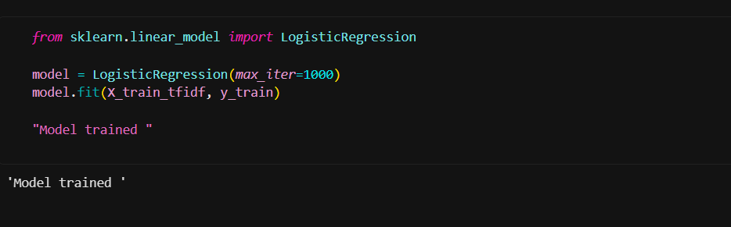
Figure 14 Model Evaluation

4.3.7 Model Serialization and Persistence
To support deployment within the FastAPI backend environment, the trained models, vectorizers, calibration configurations, and heuristic analysis rules were serialized and stored locally.
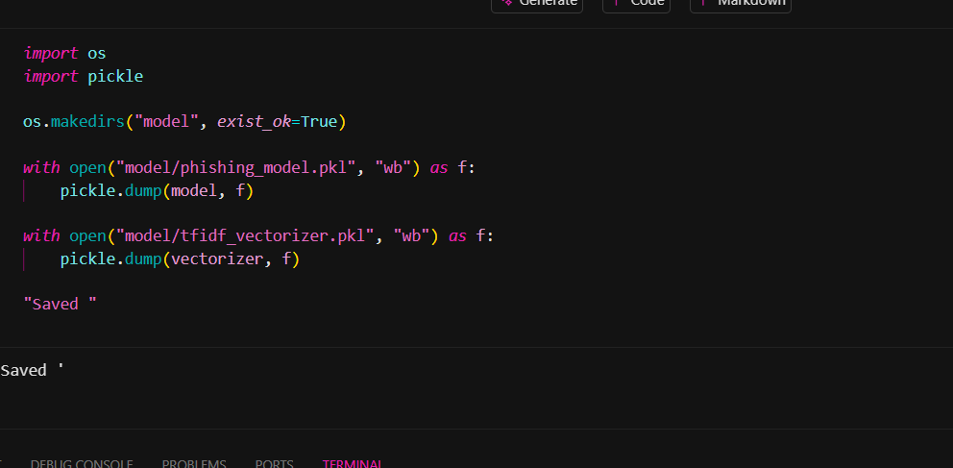
Figure 15 Model Serialization
Additional serialized artifacts include:
• TF-IDF vocabulary and vectorizer configurations
• probability calibration models
• heuristic rule sets
• suspicious domain patterns
• engineered feature configurations
Model serialization prevents repeated retraining during application startup and improves deployment efficiency, backend responsiveness, and phishing analysis scalability.

4.3.8 Prediction Workflow During Deployment
During deployment, phishing analysis is performed automatically when inbox emails are synchronized through IMAP integration or scanned through the dashboard interface.
The prediction workflow performs the following operations:
- Retrieve email content and metadata through IMAP synchronization
- Clean and preprocess email content
- Extract URLs and engineered phishing indicators
- Perform heuristic forensic analysis
- Transform processed text using TF-IDF vectorization
- Generate phishing prediction probabilities using Logistic Regression
- Apply probability calibration and heuristic scaling
- Generate explainability indicators and suspicious feature summaries
- Display phishing analysis results on the dashboard
The prediction process is implemented as follows:
def predict_email(email_text):
cleaned_text, extracted_urls = clean_text(
email_text
)
vect = vectorizer.transform(
[cleaned_text]
)
prediction = model.predict(vect)[0]
probability = model.predict_proba(vect)[0][1]
heuristic_score = analyze_urls(
extracted_urls
)
final_score = calibrate_probability(
probability,
heuristic_score
)
return prediction, final_score
The final phishing probability score represents the combined output of machine learning classification and heuristic forensic analysis. This hybrid approach improves transparency, phishing detection reliability, and confidence estimation during real-time inbox monitoring and phishing analysis.

4.3.9 Explainability Mechanism
To improve transparency and interpretability, the system incorporates an Explainable AI (XAI) mechanism that identifies the major textual and structural features influencing phishing classification decisions. The explainability layer analyzes model coefficients, TF-IDF feature importance values, engineered phishing indicators, and heuristic forensic analysis outputs to generate human-readable explanations for each prediction.
For textual analysis, word-level contribution scores are approximated using:
\text{TF-IDF Value} \times \text{Model Coefficient}
Words with high positive contribution values increase phishing likelihood, while words with negative contribution values strengthen legitimacy classification. The explainability mechanism filters irrelevant stopwords and low-impact terms before displaying the most influential phishing indicators to the user.
In addition to textual contributions, the current implementation also incorporates:
• suspicious URL indicators
• urgency pattern detection
• redirect analysis results
• sender-domain inconsistencies
• uppercase character frequency analysis
• heuristic forensic risk indicators
The dashboard displays the most significant phishing indicators, suspicious features, and risk contributors to improve transparency, user trust, and understanding of phishing classification decisions.

4.4 Testing
Testing is a critical phase in the system development life cycle aimed at verifying that the implemented phishing detection platform functions correctly, reliably, securely, and according to the specified requirements. In the context of the AI-Based Email Phishing Detection System, testing was conducted to ensure that inbox synchronization, preprocessing mechanisms, heuristic forensic analysis, machine learning classification, explainability generation, backend services, and dashboard interfaces operated cohesively and accurately.
The testing phase validated both the internal logic of the phishing detection architecture and the external interaction between the system and users. Since the system integrates IMAP synchronization, heuristic forensic analysis, TF-IDF feature extraction, Logistic Regression classification, probability calibration, explainable AI mechanisms, and real-time dashboard visualization, comprehensive testing was necessary to confirm correctness, reliability, and performance across all functional layers.
Both verification and validation strategies were applied throughout testing. Verification focused on confirming that backend services, preprocessing operations, heuristic analysis mechanisms, and classification workflows were implemented correctly according to system specifications. Validation focused on ensuring that the phishing detection platform satisfied user expectations, operational requirements, and project objectives.

4.4.1 Introduction
This section outlines the testing strategies adopted to evaluate the functionality, reliability, usability, performance, explainability, and stability of the AI-Based Email Phishing Detection System. The system was subjected to multiple categories of testing to assess its behavior under normal operating conditions, boundary scenarios, synchronization conditions, and stress environments.
Testing was conducted after the complete integration of:
• FastAPI backend services
• React frontend dashboard
• IMAP synchronization modules
• preprocessing pipelines
• heuristic forensic analysis mechanisms
• TF-IDF feature extraction modules
• Logistic Regression classification models
• probability calibration mechanisms
• explainability generation modules
The testing process ensured seamless operation from inbox synchronization and phishing analysis to dashboard visualization and explainability presentation.
The testing strategy was structured to:
• confirm correctness of phishing classification results
• validate preprocessing and heuristic analysis consistency
• assess phishing probability calibration reliability
• evaluate suspicious URL detection accuracy
• verify explainability output generation
• ensure dashboard responsiveness and frontend interaction
• examine backend stability during repeated synchronization operations
• evaluate system performance under high-volume email analysis conditions

4.4.2 Testing Objectives
The testing phase was guided by the following objectives:
- To verify correctness of the preprocessing and normalization modules, ensuring that text cleaning, tokenization, URL extraction, and stop-word filtering operate consistently during training and deployment.
- To validate heuristic forensic analysis mechanisms, ensuring suspicious URLs, redirect patterns, urgency indicators, sender-domain inconsistencies, and phishing-related structural patterns are correctly detected.
- To validate feature extraction integrity, ensuring that the TF-IDF vectorizer correctly transforms processed email content into numerical feature representations consistent with the training phase.
- To evaluate phishing classification accuracy, ensuring that the Logistic Regression model and hybrid heuristic analysis mechanisms generate reliable predictions and calibrated probability scores for phishing and legitimate emails.
- To confirm explainability consistency, ensuring that textual and structural phishing indicators are correctly identified and displayed to users.
- To assess frontend dashboard functionality, ensuring that inbox synchronization, phishing monitoring, email categorization, dashboard updates, and visualization outputs operate correctly.
- To evaluate backend service stability and API communication reliability during repeated synchronization and phishing analysis operations.
- To assess overall system responsiveness, scalability, and operational performance under repeated and high-volume inbox scanning conditions.

4.4.3 Testing Scope
The scope of testing covered all major functional modules and operational components of the phishing detection platform. The following modules were subjected to structured testing:
- Email Synchronization Module
Responsible for retrieving inbox emails and metadata through IMAP integration.
- Data Preprocessing and Normalization Module
Responsible for cleaning, tokenizing, normalizing, and preparing retrieved email content for phishing analysis.
- Feature Extraction and Heuristic Analysis Module
Responsible for TF-IDF vectorization, suspicious URL detection, urgency analysis, redirect analysis, and engineered phishing feature generation.
- Classification and Probability Calibration Module
Responsible for phishing prediction generation, heuristic scaling, probability calibration, and phishing risk scoring.
- Explainability Module
Responsible for calculating and displaying influential phishing indicators, suspicious features, and explainability summaries.
- Frontend Dashboard Module
Responsible for inbox monitoring, phishing visualization, synchronization interaction, dashboard updates, and display of phishing analysis results.
- Backend API and Communication Module
Responsible for communication between frontend services, phishing analysis components, synchronization modules, and machine learning services.
The testing scope focused on the integrated phishing detection platform operating within the controlled academic deployment environment. Although the system supports IMAP inbox synchronization, cloud deployment and production-scale enterprise infrastructure were not included within the testing scope.
The datasets used for evaluation included unseen testing samples together with synchronized inbox emails analyzed during deployment testing to ensure reliable and unbiased phishing detection evaluation.

4.4.4 Testing Approaches
To ensure comprehensive evaluation of the phishing detection platform, multiple testing approaches were adopted. These approaches included verification and validation techniques designed to evaluate preprocessing operations, heuristic forensic analysis, phishing classification accuracy, explainability consistency, backend services, dashboard interaction, synchronization reliability, and overall system stability.

4.4.4.1 Unit Testing (Verification)
Unit testing was conducted on individual modules and functions to confirm that each component performed its intended operation independently before full system integration.
Examples of unit testing included:
• Testing the clean_text() preprocessing function with controlled inputs
• Testing URL extraction and suspicious link detection functions
• Testing TF-IDF transformation consistency
• Testing heuristic forensic analysis rules
• Testing phishing probability calculation
• Testing probability calibration mechanisms
• Testing explainability contribution calculations
• Testing deduplication and synchronization handling logic
Unit testing ensured that preprocessing, heuristic analysis, machine learning operations, and explainability mechanisms operated correctly and consistently before integrated deployment.

4.4.4.2 Functional Testing (Black-Box Testing)
Functional testing was conducted without examining internal implementation details. Various phishing and legitimate email samples were synchronized, scanned, and analyzed through the dashboard interface, and the generated outputs were compared against expected phishing detection results.
This approach validated:
• Correct phishing prediction generation
• Proper phishing probability computation
• Accurate suspicious URL detection
• Correct dashboard updates and visualization
• Proper explainability output generation
• Accurate inbox categorization into safe and phishing emails
Black-box testing focused on validating system behavior from the user’s perspective without considering internal implementation logic.

4.4.4.3 White-Box Testing (Verification of Internal Logic)
White-box testing involved examining the internal execution flow of the phishing detection architecture to ensure that processing operations followed the designed workflow sequence:
Inbox Synchronization → Preprocessing → URL Extraction → Heuristic Analysis → TF-IDF Vectorization → Logistic Regression Classification → Probability Calibration → Explainability Generation → Dashboard Visualization
The internal logic was validated against the designed architectural workflow to confirm correct interaction between backend services, heuristic analysis modules, machine learning components, and dashboard interfaces.

4.4.4.4 GUI and Dashboard Testing
Graphical User Interface and dashboard testing were conducted to ensure proper frontend interaction and visualization behavior.
Testing included:
• Inbox synchronization functionality
• Dashboard navigation and responsiveness
• Email categorization visualization
• Risk score rendering and updates
• Suspicious indicator display
• Explainability panel updates
• Reclassification interaction behavior
• Dynamic dashboard statistics rendering
• Error notification and alert handling
The sequencing of frontend interaction and backend responses was evaluated to ensure smooth and reliable phishing monitoring operations.

4.4.4.5 API and Backend Communication Testing
Backend communication testing was conducted to validate reliable interaction between the React frontend and FastAPI backend services.
Testing focused on:
• API request handling
• synchronization request processing
• phishing analysis response generation
• JSON response consistency
• backend exception handling
• response latency and reliability
• communication stability during repeated operations
This test ensured stable communication between frontend dashboard services and phishing analysis components.

4.4.4.6 Performance Testing
Performance testing evaluated system responsiveness during repeated inbox synchronization operations, phishing analysis execution, and high-volume email scanning conditions.
The evaluation focused on:
• phishing analysis response time
• synchronization speed
• dashboard update latency
• backend processing efficiency
• deduplication efficiency
• memory and CPU utilization during scanning operations
The system maintained stable response times and responsive dashboard interaction under normal operating conditions on standard academic hardware.

4.4.4.7 Stress Testing
Stress testing was conducted using:
• unusually long email content
• repeated inbox synchronization operations
• rapid consecutive phishing scans
• large batches of synchronized emails
• multiple suspicious URL patterns
The system remained operational without freezing, crashing, or generating critical synchronization failures during stress conditions, demonstrating stability and robustness within the defined prototype scope.

4.4.4.8 Usability Testing
Informal usability testing was conducted with peers to evaluate:
• ease of dashboard navigation
• clarity of phishing classification outputs
• understandability of probability confidence scores
• usefulness of suspicious indicators
• transparency of explainability outputs
• readability of phishing monitoring statistics
• responsiveness of inbox synchronization operations
Feedback indicated that the dashboard interface was understandable, responsive, and effective for phishing monitoring and analysis tasks.

4.4.5 Model Performance Evaluation
The performance of the implemented hybrid phishing detection architecture was evaluated using unseen testing datasets together with synchronized inbox email samples analyzed during deployment testing. The evaluation metrics were selected to provide a comprehensive assessment of phishing classification effectiveness, probability reliability, and false positive reduction performance.
The following evaluation metrics were computed:
• Accuracy
• Precision
• Recall
• F1-Score
• Confusion Matrix
• False Positive Rate
• False Negative Rate
• Probability Calibration Consistency
Accuracy measures the proportion of correctly classified phishing and legitimate emails relative to the total number of evaluated samples. Since phishing detection involves risk-sensitive binary classification, precision and recall were also evaluated to measure the system’s ability to correctly identify phishing emails while minimizing false positive classifications of legitimate emails.
Precision evaluates the proportion of emails predicted as phishing that were truly phishing emails, while recall measures the proportion of actual phishing emails correctly identified by the system. The F1-score provides a balanced evaluation of precision and recall performance.
The confusion matrix was used to visualize classification performance through:
• True Positives (TP)
• True Negatives (TN)
• False Positives (FP)
• False Negatives (FN)
Additional evaluation was conducted on:
• suspicious URL detection reliability
• heuristic forensic analysis consistency
• phishing risk scoring stability
• explainability generation accuracy
• probability calibration effectiveness
The implemented hybrid phishing detection system achieved high classification accuracy and demonstrated strong generalization capability during phishing analysis, heuristic detection, and inbox synchronization operations within the academic deployment environment.
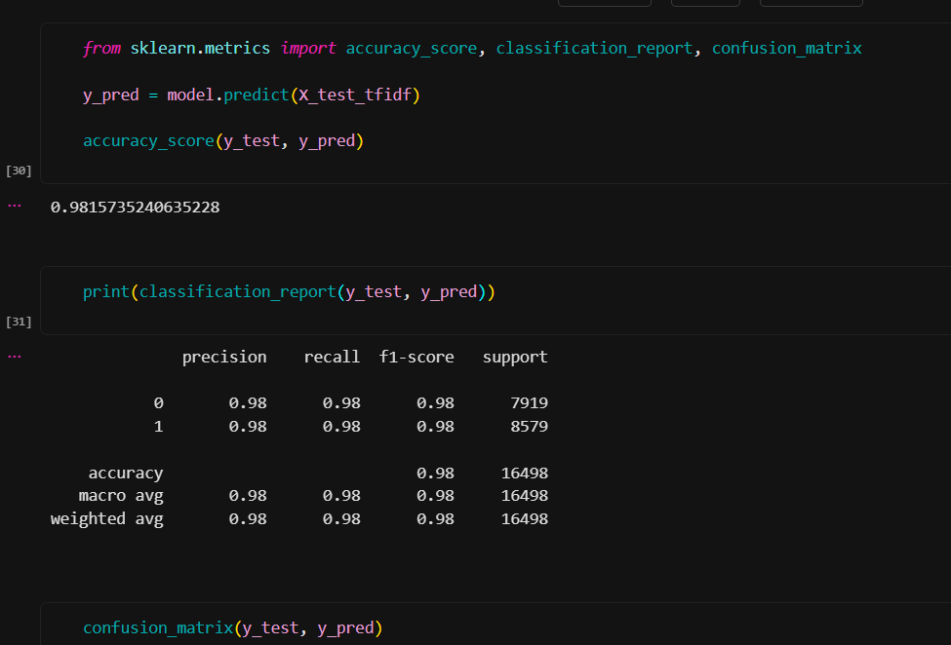
Figure 16 model evaluation

4.4.6 Test Case Design
A test case is defined as a structured set of input conditions, expected outputs, and evaluation criteria used to determine whether a system behaves according to the specified requirements. Structured test cases were developed to evaluate all major modules of the implemented AI-Based Email Phishing Detection System.
Each test case included:
• Test Case ID
• Module Tested
• Test Condition
• Expected Result
• Actual Result
• Status (Pass/Fail)
The test cases were designed to:
• cover normal phishing analysis operations
• evaluate boundary and abnormal conditions
• validate synchronization and preprocessing behavior
• confirm backend and frontend communication
• verify phishing prediction correctness
• assess suspicious URL detection
• validate explainability generation
• evaluate dashboard interaction and responsiveness
• test performance and stress stability
A minimum of four structured test cases were applied to each major module to ensure comprehensive functional coverage across the phishing detection architecture.
Test Case Table
Test Case ID | Module | Test Condition | Expected Result | Actual Result | Status
TC01 | Preprocessing | Email contains suspicious URL | URL extracted and analyzed | URL analyzed | Pass
TC02 | Preprocessing | Mixed uppercase phishing text | Text normalized to lowercase | Converted | Pass
TC03 | Preprocessing | Email contains HTML tags and punctuation | HTML and punctuation removed | Removed | Pass
TC04 | Preprocessing | Email contains stop words | Stop words filtered correctly | Filtered | Pass
TC05 | Feature Extraction | Clean phishing email input | TF-IDF vectors generated | Generated | Pass
TC06 | Feature Extraction | Email contains unseen vocabulary | Handled without processing failure | Handled | Pass
TC07 | Feature Extraction | Empty email content | Validation warning generated | Warning shown | Pass
TC08 | Feature Extraction | Long email content | Feature vectors generated successfully | Generated | Pass
TC09 | Classification | Known phishing email sample | Classified as phishing | Phishing | Pass
TC10 | Classification | Known legitimate business email | Classified as legitimate | Legitimate | Pass
TC11 | Classification | Ambiguous suspicious email | Moderate phishing probability generated | Generated | Pass
TC12 | Classification | Email containing multiple suspicious URLs | High phishing probability generated | Generated | Pass
TC13 | Heuristic Analysis | Suspicious redirect link detected | Redirect warning generated | Generated | Pass
TC14 | Heuristic Analysis | Sender-link domain mismatch | Mismatch indicator displayed | Displayed | Pass
TC15 | Heuristic Analysis | Email with urgency keywords | Urgency indicators detected | Detected | Pass
TC16 | Explainability | High phishing probability email | Influential phishing indicators displayed | Displayed | Pass
TC17 | Explainability | Legitimate email prediction | Legitimate indicators displayed | Displayed | Pass
TC18 | Dashboard GUI | Inbox synchronization initiated | Emails synchronized successfully | Synchronized | Pass
TC19 | Dashboard GUI | Multiple rapid dashboard refresh operations | System remains responsive | Responsive | Pass
TC20 | Performance | High-volume email synchronization | Stable phishing analysis performance | Stable | Pass
Table 4Test Case Table

4.4.7 Summary of Testing Results
The testing phase confirmed that all major functional modules operated according to the defined system specifications and architectural design requirements. Unit testing verified correctness of preprocessing functions, heuristic forensic analysis modules, probability calculations, and explainability generation mechanisms, while functional and black-box testing validated phishing prediction accuracy, synchronization behavior, and dashboard interaction reliability.
Frontend and dashboard testing confirmed that inbox synchronization, phishing visualization, suspicious indicator rendering, and explainability outputs responded correctly during user interaction. API and backend communication testing further verified reliable interaction between the React frontend and FastAPI backend services during phishing analysis operations.
Performance and stress testing demonstrated stable system behavior during repeated inbox synchronization operations, high-volume email analysis, rapid dashboard interaction, and long email processing conditions. No critical crashes, synchronization failures, or major operational instability were observed during testing.
The implemented hybrid phishing detection architecture demonstrated strong phishing classification performance through the combination of TF-IDF vectorization, Logistic Regression classification, heuristic forensic analysis, suspicious URL evaluation, and probability calibration mechanisms. Although some linguistically ambiguous emails generated moderate phishing probability scores, the explainability layer and heuristic indicators improved transparency and supported interpretation of classification outcomes.
Overall, the system satisfied the defined functional, usability, performance, explainability, and reliability requirements within the scope of the academic phishing detection prototype.

4.5 User Guide
This section provides instructions for installing, launching, configuring, and operating the AI-Based Email Phishing Detection System. The system is implemented as a hybrid phishing monitoring and detection platform consisting of a React frontend dashboard and a FastAPI backend integrated with machine learning and heuristic forensic analysis mechanisms.
The user guide enables users to correctly configure the environment, synchronize inbox emails, monitor phishing activity, and interpret phishing analysis results through the dashboard interface.

4.5.1 System Setup and Installation
Before running the system, the following requirements must be satisfied.
Software Requirements
• Python 3.11
• Node.js and npm
• FastAPI
• React.js
• Scikit-learn
• Pandas
• NumPy
• NLTK
• IMAP-enabled email account
• Visual Studio Code or compatible development environment
Backend Installation Steps
- Install Python 3.11 if not already installed.
- Open Command Prompt or terminal.
- Navigate to the backend project directory.
- Install the required backend libraries:
pip install -r requirements.txt
- Ensure that the following files are available:
• logistic_model.pkl
• tfidf_vectorizer.pkl
• calibration_model.pkl
• heuristic_rules.json
• main.py
Frontend Installation Steps
- Navigate to the frontend project directory.
- Install required frontend dependencies:
npm install
- Ensure that the front-end source files and dashboard components are available before launching the application.
Once these components are properly configured, the system is ready for execution.

4.5.2 Launching the System
The phishing detection platform requires both backend and frontend services to run simultaneously.
Backend Launch Procedure
- Open Command Prompt or terminal.
- Navigate to the backend project directory.
- Execute:
uvicorn main:app --reload
- The FastAPI backend service starts locally and becomes available for phishing analysis operations and API communication.
Frontend Launch Procedure
- Open another terminal window.
- Navigate to the frontend project directory.
- Execute:
npm start
- The React dashboard automatically launches in the default web browser.
The dashboard operates locally within the academic deployment environment and communicates directly with the FastAPI backend services.

4.5.3 Using the System
Once the dashboard is launched, the following operations can be performed:
- Configure IMAP synchronization credentials if required.
- Initiate inbox synchronization through the dashboard interface.
- The system retrieves inbox emails and metadata for phishing analysis.
- Retrieved emails are automatically processed through preprocessing, heuristic forensic analysis, TF-IDF vectorization, and machine learning classification stages.
- The dashboard displays:
• phishing and legitimate email classifications
• phishing probability confidence scores
• suspicious URL indicators
• phishing risk levels
• explainability summaries
• dashboard monitoring statistics
- Users can refresh synchronization results and monitor newly analyzed emails within the same session.

4.5.4 Understanding the Output
The system provides several phishing analysis outputs.
1. Classification Result
Indicates whether the analyzed email is:
• Phishing
• Legitimate
2. Probability Confidence Score
Displays the phishing probability generated by the hybrid detection architecture. Higher values indicate stronger confidence in phishing classification.
3. Suspicious Indicators
Displays detected phishing-related indicators such as:
• suspicious URLs
• urgency phrases
• redirect patterns
• sender-domain inconsistencies
• suspicious metadata features
4. Explainability Output
Displays influential textual and structural features contributing to the phishing prediction. This improves transparency and interpretability of the classification process.
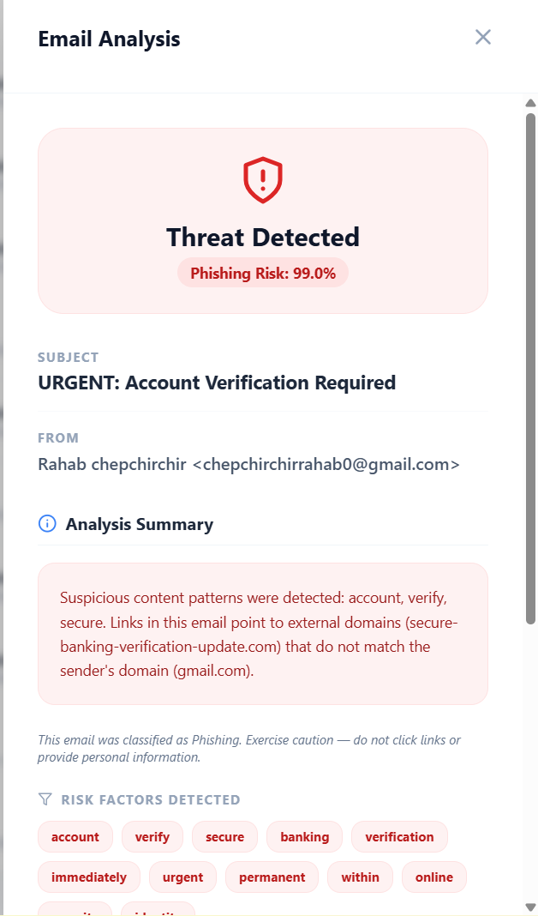
Figure 17 Explainability Output
5. Dashboard Statistics
Provides summarized monitoring information including:
• total analyzed emails
• phishing detection counts
• safe email counts
• synchronization statistics
• risk distribution summaries

Figure 18. Dashboard Statistics

4.5.5 Help and Error Handling
The system incorporates several validation and error-handling mechanisms to improve usability and operational reliability.
• Invalid synchronization requests generate warning notifications.
• Empty or corrupted email content is handled safely during preprocessing.
• Long email content is processed without system failure.
• Duplicate synchronized emails are automatically filtered through deduplication mechanisms.
• Backend communication failures generate controlled error responses.
• Invalid characters and unsupported formatting are cleaned automatically during preprocessing.
These mechanisms reduce runtime failures and improve system stability during phishing analysis operations.

4.5.6 Deployment Scope
The system operates within a controlled local academic deployment environment for research, demonstration, and evaluation purposes. The platform integrates with inbox email services through IMAP synchronization to retrieve and analyze email content during phishing detection operations.
The deployment architecture combines:
• React frontend dashboard services
• FastAPI backend services
• machine learning phishing analysis modules
• heuristic forensic analysis mechanisms
• explainability and risk scoring components
The system does not modify external email infrastructure or perform automated intervention on external mail servers. All phishing analysis operations are performed within the local deployment environment for academic evaluation and controlled experimentation purposes.

4.6 Conclusions
This study aimed to design, implement, and evaluate an AI-Based Email Phishing Detection System capable of detecting and classifying phishing emails using machine learning techniques, heuristic forensic analysis, engineered phishing indicators, and explainable AI mechanisms. Based on the implementation and evaluation results obtained during testing, the system successfully achieved its primary objectives within the defined academic scope.

4.6.1 Extent to Which the Problem Was Solved
The implemented system effectively addresses the challenge of phishing email detection by providing an automated phishing monitoring and analysis platform capable of retrieving inbox emails, analyzing suspicious indicators, and classifying emails as phishing or legitimate using hybrid detection architecture.
The combination of TF-IDF vectorization, Logistic Regression classification, heuristic forensic analysis, suspicious URL detection, engineered metadata features, probability calibration, and explainability mechanisms significantly improved phishing detection reliability and transparency. The system demonstrated strong phishing classification performance and maintained high predictive accuracy during evaluation and deployment testing.
Unlike earlier standalone text-classification approaches, the implemented system supports automated inbox synchronization through IMAP integration and real-time phishing monitoring through an interactive dashboard environment. The platform enables users to monitor synchronized emails, view phishing risk scores, examine suspicious indicators, and understand the reasoning behind phishing predictions through explainability outputs.
Although the deployment environment remained within a controlled academic scope, the system successfully demonstrated the feasibility of combining machine learning and heuristic forensic analysis techniques for intelligent phishing detection and monitoring operations.

4.6.2 Most Significant Accomplishments
The major accomplishments of this study include:
- Successful implementation of a hybrid phishing detection architecture combining machine learning and heuristic forensic analysis mechanisms.
- Development of a high-performing phishing detection model using TF-IDF vectorization, Logistic Regression classification, engineered phishing indicators, and probability calibration mechanisms.
- Implementation of automated inbox synchronization using IMAP integration for real-time phishing monitoring and analysis.
- Development of a decoupled React frontend and FastAPI backend architecture supporting scalable phishing detection operations.
- Integration of explainability mechanisms capable of identifying influential phishing indicators, suspicious URLs, and structural risk factors contributing to classification decisions.
- Implementation of dashboard visualization features for phishing monitoring, risk analysis, suspicious indicator display, and synchronization management.
- Comprehensive testing covering preprocessing validation, heuristic analysis evaluation, classification testing, backend communication testing, GUI testing, performance testing, stress testing, and usability testing.
- Achievement of high phishing detection accuracy while maintaining transparency, interpretability, and operational efficiency.
The integration of explainable AI mechanisms, heuristic forensic analysis, and automated inbox synchronization significantly improved the transparency, practicality, and reliability of the implemented phishing detection platform within the academic deployment environment.

4.6.3 System Limitations
Despite its strengths and successful implementation, the system has several limitations within the current academic deployment scope:
- The machine learning model was trained primarily using publicly available phishing datasets, which may not fully represent all real-world phishing variations, organization-specific attack patterns, or region-specific phishing techniques.
- Although the system integrates with inbox email services through IMAP synchronization, the deployment environment remains limited to controlled local execution and does not support enterprise-scale distributed deployment.
- The current implementation focuses mainly on textual content, metadata analysis, and suspicious URL evaluation. Advanced attachment scanning and malware behavior analysis are not fully implemented.
- Some borderline or linguistically ambiguous emails may still generate moderate phishing probability scores because of similarities between legitimate business communication and sophisticated phishing messages.
- The heuristic forensic analysis layer relies on predefined suspicious indicators and rule patterns, which may require periodic updates to adapt to newly emerging phishing strategies.
- The system currently uses lightweight Logistic Regression classification architecture and does not fully incorporate advanced transformer-based deep learning models that may improve contextual understanding of complex phishing content.
- Cloud-native deployment, distributed synchronization infrastructure, and large-scale enterprise integration mechanisms were not included within the current implementation scope.
These limitations are consistent with the defined academic objectives and do not undermine the core phishing detection functionality achieved by the implemented system.

4.6.4 Challenges Encountered
Several technical and operational challenges were encountered during system development and implementation:
- Backend and Frontend Integration Challenges
Ensuring stable communication between the React frontend dashboard and FastAPI backend services required careful API configuration, routing management, and synchronization handling.
- Preprocessing and Feature Consistency Challenges
Maintaining consistency between training-stage preprocessing and deployment-stage phishing analysis required careful implementation to prevent feature mismatch and prediction inconsistencies.
- Heuristic Analysis Design Challenges
Developing reliable heuristic forensic analysis mechanisms for suspicious URL detection, redirect analysis, urgency detection, and sender-domain verification required iterative experimentation and refinement.
- Model Optimization and Calibration Challenges
Selecting suitable model parameters, reducing false positives, calibrating phishing probability scores, and balancing heuristic influence required repeated experimentation and validation.
- Explainability Implementation Challenges
Generating meaningful explainability outputs combining TF-IDF contributions, suspicious indicators, and heuristic analysis results required additional processing logic beyond standard machine learning classification.
- Synchronization and Deduplication Challenges
Handling repeated inbox synchronization operations while preventing duplicate phishing analysis required implementation of deduplication and email tracking mechanisms.
- Resource and Infrastructure Constraints
Although the system was developed using adequate academic hardware, limited access to large-scale cloud computing infrastructure restricted experimentation with computationally intensive deep learning and distributed phishing analysis architectures.
- Dataset Dependence Challenges
Reliance on publicly available phishing datasets limited exposure to organization-specific and geographically localized phishing variations.

4.7 Recommendations
Based on the implementation findings, evaluation results, and identified limitations, several recommendations are proposed to improve the scalability, robustness, usability, and practical applicability of the AI-Based Email Phishing Detection System in future work.

4.7.1 Enhancement of Live Email Integration
The current system already supports inbox synchronization through IMAP integration. Future improvements should focus on expanding compatibility with enterprise-grade email platforms, secure authentication mechanisms, and large-scale email synchronization architectures to support broader real-world deployment.
Additional integration with email provider APIs and automated phishing alert systems would further improve operational effectiveness and real-time threat monitoring capabilities.

4.7.2 Expansion of Dataset Diversity
Future studies should incorporate:
• region-specific phishing datasets
• organization-specific phishing campaigns
• multilingual phishing emails
• emerging phishing attack samples
• real-world enterprise email datasets
Expanding dataset diversity would improve contextual relevance, phishing adaptability, and generalization capability against evolving phishing threats.

4.7.3 Implementation of Advanced Machine Learning Architectures
Although the implemented Logistic Regression and heuristic hybrid architecture achieved strong phishing detection performance, future research may explore:
• transformer-based deep learning models
• LSTM and recurrent neural network architectures
• ensemble learning mechanisms
• hybrid deep learning and heuristic architectures
• graph-based phishing relationship analysis
These advanced approaches may improve contextual understanding and detection of sophisticated phishing attacks.

4.7.4 Cloud and Distributed Deployment
The current implementation operates within a controlled local academic environment. Future deployment may involve:
• cloud-native deployment architectures
• distributed phishing analysis services
• scalable backend infrastructure
• containerized deployment using Docker and Kubernetes
• enterprise-scale synchronization services
Cloud deployment would improve scalability, accessibility, and performance under large-scale operational conditions.

4.7.5 Enhanced Explainability and Threat Intelligence
Future improvements may integrate:
• SHAP-based explainability mechanisms
• advanced feature attribution models
• phishing threat intelligence feeds
• domain reputation services
• behavioral phishing analytics
These enhancements would improve transparency, forensic visibility, and interpretability of phishing detection decisions.

4.7.6 Continuous Learning and Adaptive Retraining
Phishing strategies evolve continuously. Future implementations should incorporate:
• automated dataset updates
• adaptive retraining pipelines
• online learning mechanisms
• continuous model evaluation
• dynamic heuristic rule updates
Continuous learning would improve long-term phishing detection accuracy and adaptability against newly emerging phishing attacks.

4.7.7 Advanced Security and Attachment Analysis
Future development should incorporate:
• attachment scanning and malware analysis
• sandbox-based suspicious file execution
• QR-code phishing detection
• advanced URL reputation analysis
• DNS and domain intelligence evaluation
• real-time threat correlation mechanisms
These additions would strengthen the forensic capabilities and security coverage of the phishing detection platform.

4.7.8 Improved Dashboard Visualization and Alerting
Future user interface improvements may include:
• advanced phishing risk visualization
• color-coded threat severity indicators
• real-time phishing alerts
• historical phishing trend analytics
• customizable dashboard monitoring panels
• organization-level reporting capabilities
• interactive forensic investigation views
These improvements would enhance user experience, decision-making efficiency, and phishing monitoring effectiveness within operational environments.

REFERENCES
Almomani, A., Gupta, B., Atawneh, S., Meulenberg, A., & Almomani, E. (2022). A survey of phishing email filtering techniques based on machine learning algorithms. Neural Computing and Applications, 34(5), 3487–3510.
Alsharnouby, M., Alaca, F., & Chiasson, S. (2020). Why phishing still works: User strategies for combating phishing attacks. International Journal of Human–Computer Studies, 139, 1–15.
Al-Subaiey, A., Al-Thani, M., Alam, N. A., Antora, K. F., Khandakar, A., & Zaman, S. A. U. (2024, May 19). Novel interpretable and robust web-based AI platform for phishing email detection. ArXiv.org. https://arxiv.org/abs/2405.11619
Basit, A., Zafar, M., Anwar, S., & Hussain, S. (2021). A hybrid approach for phishing detection using deep learning and blacklist features. IEEE Access, 9, 109230–109245.
Bulatov, V., & Nikiforov, V. (2022). URL-based detection of malicious websites using machine learning and feature selection. Journal of Information Security and Cybercrimes Research, 5(1), 22–31.
CAK. (2023). Cybersecurity incident report 2022/2023. Communications Authority of Kenya.
Chiew, K., Yong, K., & Tan, C. (2020). A survey of phishing attacks and detection methods. Computers & Security, 88, 1–20.
Google AI. (2021). Machine learning for enhanced email security. Google Research.
Google Security. (2021). Spam and phishing protection with Google AI. Google Security Blog.
Hossain, M., Rahman, T., & Karim, M. (2023). Deep learning-based hybrid models for phishing detection. Journal of Cybersecurity Research, 11(2), 45–60.
IBM Security. (2022). IBM X-Force threat intelligence index 2022. IBM Corporation.
Kumar, A., & Rao, P. (2021). Natural language processing approaches for phishing email detection. International Journal of Information Security Studies, 9(1), 14–28.
Kumar, S., & Garg, P. (2022). Phishing site prediction using deep learning-based URL classification. Expert Systems with Applications, 198, 116800.
Microsoft Threat Report. (2022). Digital defense report: Email and phishing threats. Microsoft Corporation.
Mohammad, R., McCluskey, T., & Thabtah, F. (2020). Predicting phishing websites using machine learning techniques. Applied Computing and Informatics, 16(1/2), 165–176.
Symantec. (2022). Internet security threat report: Phishing and email fraud. Symantec Enterprise Security.
Verizon. (2023). 2023 data breach investigations report. Verizon Enterprise.
Verma, A., & Das, S. (2022). URL feature analysis techniques for detecting phishing websites. Cyber Technology Review, 7(3), 112–130.
Zhang, L., & Gupta, R. (2021). Machine learning techniques for phishing email classification. ACM Computing Surveys, 54(8), 1–35.

APPENDICES

A. Hardware Requirements
• Laptop or Desktop Computer
• Intel Core i7 Processor
• Minimum 16GB RAM
• Minimum 512GB SSD Storage
• Stable Internet Connection
• Windows 11 Operating System

B. Software Requirements
• Python 3.11
• Node.js and npm
• Visual Studio Code or Jupyter Notebook
• FastAPI
• React.js
• Libraries: Scikit-learn, Pandas, NumPy, NLTK, Matplotlib, Seaborn
• Uvicorn Server for FastAPI Backend Execution
• Git and GitHub for Version Control

C. Dataset Requirements
• Kaggle Phishing Email Dataset
• Public Phishing Email Repositories
• Legitimate Email Samples for Binary Classification
• Email Metadata and Header Information
• Public Cybersecurity Threat Intelligence Sources
• Suspicious URL and Domain Indicators for Heuristic Analysis
Project Budget
Item | Description | Cost (KES)
Laptop (Existing) | Development and Testing Environment | 0
Internet Bundles | Research, Dataset Downloads, API Testing | 12,500
Software Tools | Open-source Development Tools and Libraries | 0
Printing and Binding | Final Project Documentation | 3,500
Miscellaneous | Transport, Contingency, Testing Expenses | 10,000
Total Estimated Cost |  | 25,500
Table 5Project Budget

Project schedule
Project Timeline (12 Weeks)
Task | W1–2 | W3–4 | W5–6 | W7–8 | W9–10 | W11–12
Topic Selection & Approval | ███
Proposal Writing | ███ | ███
Literature Review |  | ███ | ███
Data Collection |  |  | ███
Model Development |  |  | ███ | ███
System Prototype |  |  |  | ███ | ███
Testing & Evaluation |  |  |  |  | ███
Report Writing |  |  |  |  | ███ | ███
Presentation Preparation |  |  |  |  |  | ███

