COMP5310 — Project Stage 2
Develop and Evaluate Data-Driven Analytical Models
Group: Lab_05_Group_10
Dataset: Hotel Bookings (Dataset C)
Task: Binary Classification — Predict booking cancellation
Student 1: 550606798 / xlyu0883
Student 2: 550574947 / hgar0964

Section 1. Topic Selection and Problem Definition

1.1 Dataset Choice and Rationale
For Stage 2 we chose Dataset C (Hotel Bookings) over the two alternatives considered in Stage 1. The decision was driven directly by what our Stage 1 exploratory analysis revealed about the signal-to-noise ratio of each dataset:
- Dataset A (NSW Train Occupancy) produced near-zero numerical correlations with the target Occupancy_Encoded (Node.Seq.Order = −0.02, Hour = −0.03, Dwell_Seconds = 0.01). This does not make the dataset unusable, but it means the Stage 2 supervised modelling story would depend more heavily on categorical context and non-linear structure, with less direct numerical signal from the Stage 1 analysis.
- Dataset B (Air Travel Delay) had the opposite problem. The strongest correlation with is_delayed came from DepDelay at 0.71, but DepDelay is itself part of the delay being predicted and is not observable at the time of a genuine pre-departure decision. Once DepDelay is excluded, the remaining reservation-time features showed substantially weaker correlations, leaving a weaker modelling problem.
- Dataset C (Hotel Bookings) sits between these extremes. The target is moderately balanced (37.07% positive), several reservation-time features have meaningful correlations with cancellation (lead_time +0.27, total_of_special_requests −0.23, booking_changes −0.14), and deposit_type shows a sharp association with cancellation (Non Refund ≈ 99% cancellation vs. ≤ 28% for the other two categories).
Comparing the three: A lacks strong numerical signal for supervised modelling, B's strongest signal is unavailable for genuine pre-departure prediction, and C offers moderately balanced classes with several genuinely predictive reservation-time features. Dataset C therefore provides the cleanest signal-to-noise ratio for Stage 2 supervised modelling.

1.2 Research Question

In Stage 1, we framed Dataset C as a hotel revenue-management problem: predicting booking cancellation so hotels can manage overbooking, pricing, staffing, and guest experience more effectively.

For Stage 2, we refine the Stage 1 problem statement to emphasise that all features must be available at the time of reservation, ensuring no target leakage:
Using only information available at the time of reservation, can we predict whether a hotel booking will be cancelled? Which booking characteristics are the strongest predictors, and how do different modelling approaches trade off accuracy against interpretability for hotel revenue management?
This refinement is necessary because Stage 1's framing was looser. By making the no-leakage constraint explicit, we ensure that the Stage 2 results are operationally defensible — the model can be applied to a fresh booking at the moment it arrives, not only after the outcome is observed.

1.3 Stakeholders and Benefits
- Hotel revenue managers — early cancellation predictions enable smarter overbooking decisions, inventory control, and targeted retention actions for high-risk bookings.
- Front desk and operations staff — predicted cancellations help plan staffing, room preparation, and resource allocation ahead of peak periods, reducing last-minute scrambling.
- Guests — better cancellation management reduces instances where confirmed bookings are denied due to overbooking, leading to a more reliable guest experience.

Section 2. Data Description

2.1 Dataset Overview and Stage 1 Recap
The raw Hotel Bookings dataset contains 119,987 instances and 32 attributes, with each row representing a single booking at either a City Hotel or a Resort Hotel for arrivals between 2015 and 2017. The target variable is is_canceled (1 = cancelled, 0 = not cancelled), and the raw cancellation rate (before cleaning) is 37.04%. Stage 1 EDA identified three particularly strong predictors — lead_time (r = +0.27), total_of_special_requests (r = −0.23) and deposit_type (Non Refund cancels at ≈ 99%) — and confirmed that the class balance is mild enough not to require resampling for Stage 2 modelling.
Stage 1 inspection also identified the main data-quality issues that shaped the Stage 2 cleaning pipeline: company had 94.3% missing values, agent/country/children had smaller missingness, several categorical fields contained inconsistent labels, and logically invalid zero-guest bookings plus ADR/adults outliers required removal.

2.2 Data Cleaning Summary (Stage 1 + Stage 2 Updates)
All Stage 1 cleaning steps are preserved. For Stage 2, three additional steps were applied to make the data modelling-ready:
- Stricter categorical standardisation — additional case and typo fixes for hotel, market_segment, meal, customer_type and distribution_channel after Stage 1 inspection surfaced edge cases (e.g., "CityHotel" → "City Hotel", "Direc" → "Direct", "Online Ta" → "Online TA", "UNDEFINED" meal → "SC").
- Removal of leakage columns — reservation_status and reservation_status_date are both recorded after the booking outcome is known and would inflate model performance artificially. Both are dropped before modelling.
- Five engineered features (described in Section 2.5) — all derived from columns available at booking time.

Cleaning pipeline summary
Step | Action | Result (rows × cols)
Raw | Loaded hotel_bookings.csv | 119,987 × 32
Categorical | Whitespace, case, typo fixes incl. hotel, market_segment, meal, customer_type, distribution_channel | 119,987 × 32
Missing values | Filled children/agent with 0, country with 'Unknown', and categorical fields with mode | 119,987 × 32
High-missing column | Dropped company because 94.3% of values are missing | 119,987 × 31
Date type | Converted reservation_status_date to datetime before later leakage removal | 119,987 × 31
Outliers | Removed zero-guest rows, adults > 10, and invalid ADR | 119,793 × 31
Leakage removal | Dropped reservation_status and reservation_status_date entirely | 119,793 × 29
Feature engineering | Added 5 engineered features | 119,793 × 34

2.3 Challenges and Caveats
- Mild class imbalance (37% positive) — handled through a stratified train/test split and a mix of evaluation metrics: recall and F1 capture threshold-level performance on cancellations, while ROC-AUC measures ranking performance independently of a fixed threshold.
- Non Refund cancellation pattern (≈ 99% cancellation) — this is initially surprising because non-refundable bookings appear financially committed, but non-refundable does not mean non-cancellable. It means the guest may not recover the payment after cancellation. Therefore, we retain deposit_type as a strong reservation-time predictor, while interpreting it as an association with booking context rather than direct evidence that the deposit policy causes cancellation.
- Temporal coverage limited to 2015–2017 — travel behaviour, booking channels, and hotel cancellation policies may have changed since the data was collected, so the model should be revalidated on more recent data before deployment.
- No price-discount or guest-demographic features — limits the depth of behavioural interpretation; the model can predict who will cancel but cannot directly attribute it to a discount strategy or loyalty tier.

2.4 Variable Selection
Target variable: is_canceled (binary, 1 = cancelled, 0 = not cancelled).

Feature variables
Feature selection followed two principles: (i) only columns available at booking time were retained, and (ii) Stage 1 EDA findings guided which variables to prioritise. Columns excluded from the modelling set include the two leakage columns and high-cardinality or redundant fields such as country, agent, and detailed arrival-date columns.
Group | Features | Justification
Numerical (14) | lead_time, total_of_special_requests, booking_changes, previous_cancellations, previous_bookings_not_canceled, adults, children, babies, adr, stays_in_weekend_nights, stays_in_week_nights, days_in_waiting_list, required_car_parking_spaces, is_repeated_guest | Stage 1 EDA showed 3 of these (lead_time, total_of_special_requests, booking_changes) have |r| > 0.14 with the target
Categorical (8) | hotel, deposit_type, market_segment, customer_type, meal, distribution_channel, arrival_date_month, reserved_room_type | Stage 1 EDA showed deposit_type and hotel are highly discriminating; market_segment also showed strong differences (Groups highest at 61.1%, Direct much lower at 15.3%), and arrival_date_month captures the observed seasonal pattern such as June's 41.5% cancellation rate.
Engineered (5) | total_nights, total_guests, has_special_request, is_summer_arrival, prev_cancel_rate | See Section 2.5 for derivations and rationale
Excluded from modelling | reservation_status, reservation_status_date; country, agent; arrival_date_year / week_number / day_of_month | reservation_status and reservation_status_date were removed entirely because they leak the outcome. country, agent, and detailed arrival-date fields remain in the cleaned CSV but are excluded from the model feature set due to high cardinality, lower interpretability, or redundancy; arrival_date_month captures the main seasonality signal.
The final modelling feature set contains 27 reservation-time input columns; Section 4 describes the encoding and scaling steps used before model fitting.

2.5 Derived (Engineered) Features
Five new features were engineered from existing columns. All are computable at booking time.
Feature | Definition | Rationale
total_nights | stays_in_weekend_nights + stays_in_week_nights | Captures total stay length in one variable
total_guests | adults + children + babies | Captures party size; larger parties may have different cancellation patterns and room/resource requirements.
has_special_request | 1 if total_of_special_requests > 0, else 0 | Binary version of an already strong predictor; useful as a non-linear signal
is_summer_arrival | 1 if arrival_date_month in {June, July, August}, else 0 | Stage 1 EDA: June peaks at 41.5% cancellation rate
prev_cancel_rate | previous_cancellations / (previous_cancellations + previous_bookings_not_canceled + 1) | Smoothed historical cancel rate per guest; +1 in denominator avoids division by zero for first-time guests

These five engineered features expand the numerical feature set from 14 original numerical columns to 19 numerical/engineered columns.

Section 3. Modelling and Analysis
We apply three analytical techniques: two supervised classifiers (Logistic Regression and Random Forest) and one unsupervised clustering method (K-Means). The three are mathematically distinct — linear vs. ensemble vs. distance-based — and serve complementary roles: an interpretable baseline, a high-performance ensemble, and a customer-segmentation lens that uses no labels.

3.1 Method 1 — Logistic Regression

3.1.1 Method Description
Logistic Regression estimates the probability of a binary outcome, such as whether or not a hotel booking is canceled, by fitting a linear model of the input features to a log-odds scale. This linear combination is then passed through the logistic sigmoid function to produce a probability value between 0 and 1:

P(y = 1|X) = $\frac{1}{1+ e^{-(β_{0+ }β_{1}x_{1}+…+ β_{n}x_{n})} }$

The pipeline uses a grid search (GridSearchCV) with 5-fold stratified cross-validation to tune the regularization strength (C) and penalty types (L1 and L2) to find the optimal decision boundary, optimizing the Area Under the Receiver Operating Characteristic curve (ROC-AUC).
Key assumptions:
- Linearity of Log-Odds: The model assumes a strict linear relationship between the continuous independent features and the log-odds (logit transformation) of the dependent variable (y = is_canceled). The relationship between the features and the raw probability is non-linear (sigmoidal). Any non-linear patterns of the continuous variables (e.g., skewed distribution profiles in variables such as lead time or average daily rate) need to be properly handled in the pre-processing step to avoid underfitting of the model.
- Independence of Observations: Logistic Regression assumes that observations are independent. In this dataset, this assumption may be imperfect because group bookings, repeat guests, or bookings made through the same agent/channel may create correlated cancellation behaviour. We treat each booking as one observation, but this limitation should be considered when interpreting coefficient estimates and standard predictive performance.
- Multicollinearity Constraints: The predictor variables should not be highly correlated among themselves. High correlation between independent variables (e.g. strong relation between the type of room assigned and the average daily rate) increases the variance of the coefficient estimates (β_n). This makes the model very sensitive to small changes in the data, which masks the true individual effect of each feature on the likelihood of cancellation.
Strengths and limitations:
- Strengths:
- High Interpretability: The model is a transparent white box. The sign and magnitude of each feature coefficient (β) can be directly interpreted. Management can then interpret the particular odds ratio for each driver (for example, how much each additional day of lead time increases or decreases the odds of cancellation) by calculating the exponentiated coefficient (e^β).
- Probability Outputs: Logistic Regression produces interpretable probability estimates, which are useful for ranking bookings by cancellation risk. However, these probabilities should still be checked with calibration diagnostics before being used for operational thresholds.
- Efficiency and Baseline Robustness: The algorithm is computationally inexpensive and incredibly fast to train, even with extensive hyperparameter tuning (GridSearchCV). This efficiency makes it a robust, industry-standard baseline against which more complex machine learning models can be benchmarked.
- Limitations:
- Inability to Capture Complex Non-Linear Interactions: Logistic Regression assumes a linear decision boundary on the log-odds scale by default. It cannot learn complex interactions involving multiple variables (e.g., a particular combination of room type and distribution channel leads to a spike in cancellations) unless such interaction terms are hand crafted a priori.
- Sensitivity to Extreme Values: Very large values in variables such as lead_time or ADR can still influence the fitted decision boundary and coefficient estimates. Standardisation and regularisation reduce this risk, but they do not remove it entirely.
- Strict Feature Scaling Requirements: The pipeline includes regularization (either L1 or L2 penalties, using the liblinear solver) making the model very sensitive to the scale of the inputs. Without a robust pre-processing step to standardize continuous features (e.g. StandardScaler), features with bigger numerical ranges would unfairly dominate the regularization penalty.

3.1.2 Justification of Use
There are three alignment factors between the business problem and the mathematical profile of the algorithm that led us to select Logistic Regression as the basic framework for this predictive pipeline:
- Direct Binary Classification Alignment: The main task of forecasting hotel booking behavior is, of course, binary (y ∈ {0, 1}), a booking is either fulfilled or canceled. Logistic Regression is a natural choice to model this outcome because it is mathematically optimized to directly map continuous and discrete inputs to a bounded [0,1] probability range.
- Seamless Handling of Mixed Feature Types: Hotel booking data usually consist of a heterogeneous collection of both numerical indicators (e.g., lead time, average daily rate, or number of special requests) as well as categorical identifiers (e.g., customer type, distribution channel, or deposit type). The model integrates your preprocessor pipeline (standardizing numerical scales and encoding categorical levels) with Logistic Regression, enabling it to handle these mixed inputs seamlessly, without sacrificing mathematical stability.
- Operational Interpretability for Stakeholders: In revenue management, predictive accuracy is not sufficient on its own. Hotel operators and revenue managers often require more than a black-box prediction; they need to understand which booking characteristics are associated with higher cancellation risk. Logistic Regression supports this by providing interpretable coefficients that can help managers identify major risk drivers, refine overbooking strategies, and review cancellation policies using empirical evidence.

3.1.3 Application Plan
The Logistic Regression pipeline implementation methodology is designed to ensure consistent preprocessing, systematic hyperparameter optimisation, and fair comparison with alternative models.

- Automated Preprocessing via ColumnTransformer: To avoid data leakage and deal with mixed data types, a solid preprocessing pipeline is constructed with scikit-learn’s ColumnTransformer. All numerical features like lead time and average daily rate are standardized with StandardScaler to get zero mean and unit variance. This is to remove scale bias from the regularization step. Meanwhile categorical features are transformed into a sparse numeric format with the help of OneHotEncoder, that creates independent binary flags for every categorical level.
- Systematic Hyperparameter Tuning: The model configuration is optimized by an automated grid search (GridSearchCV) and is evaluated against the Area Under Receiver Operating Characteristic curve (scoring=‘roc_auc’). A 5-fold StratifiedKFold cross-validation strategy (k=5) with a fixed random seed is adopted to preserve the class balances in the subsets. The grid exhaustively explores combinations over the following parameter space:
Regularization Strength (C) ∈ {0.01, 0.1, 1, 10}
Penalty Type ∈ {L1, L2}
The liblinear solver is used because it supports both L1 and L2 penalties and is efficient for this medium-sized binary classification task.
- Controlled Evaluation Baseline: The Logistic Regression pipeline is scored on the same train/test splits (X_train, y_train, and X_test, y_test) as the Random Forest model to compare the models in an unbiased way. This controlled setting makes the LR/RF comparison fairer because both models are evaluated on the same data split and feature set.

3.2 Method 2 — Random Forest

3.2.1 Method Description
Random Forest Classifier is an ensemble learning technique that builds many decision trees during training. It uses bagging (bootstrap aggregating) to train each tree on a random subset of the data and also selects a random subset of features at each split to ensure diversity among the trees. For classification tasks, the final prediction is obtained by majority voting, which reduces variance and lowers the risk of overfitting compared with individual decision trees.
Key assumptions:
- Non-Parametric Nature: Random Forest makes few distributional assumptions and does not require normality, homoscedasticity, or linearity. This makes it suitable for mixed hotel-booking features and non-linear cancellation patterns, although noisy labels and extreme values can still affect tree splits.
- Tree Decorrelation: Bootstrap samples and random feature subsets reduce correlation among individual trees. Averaging many less-correlated trees usually reduces variance compared with a single decision tree, improving generalisation.
Strengths and limitations:

- Strengths
- Non-Linearity and Feature Interactions: It naturally captures high-order interactions and non-linear relationships between variables without the need for explicit polynomial feature engineering.
  - Robustness: By averaging many trees, Random Forest is less sensitive than a single decision tree to individual noisy splits or outlying observations. However, irrelevant or sparse encoded features can still add noise and should be monitored through validation performance and feature-importance analysis.
  - No Feature Scaling Required: Random Forest itself does not require numerical features to be standardised or normalised, although scaling was retained in our shared preprocessing pipeline for consistency with Logistic Regression.
  - Inherent Interpretability Tools: Random Forest provides global feature-importance measures, which help identify influential predictors. However, impurity-based importance can be biased toward variables with more split opportunities, so it should be interpreted as a broad ranking rather than causal evidence.
- Limitations
  - Reduced Local Interpretability: Unlike simple models such as Logistic Regression (LR), Random Forest is mostly a “black box” at the level of individual prediction, where it becomes difficult to trace or mathematically explain the specific row-by-row decision.
  - Computational Overhead: Training and optimisation have a higher computational cost because multiple deep decision trees need to be built; in this pipeline, this is partly mitigated by using n_jobs=-1.
- Risk of Overfitting: Individual trees can overfit when grown deeply. In this study, this risk is managed through bootstrap aggregation, cross-validated hyperparameter selection, and monitoring held-out performance; nevertheless, Random Forest remains less transparent than Logistic Regression.

3.2.2 Justification of Use
The selection of a Random Forest framework for this particular dataset is based on three structural alignment factors:
- Heterogeneous Data Handling: After categorical variables are one-hot encoded and numerical variables are passed through the shared preprocessing pipeline, Random Forest can model both numerical thresholds and categorical-level splits effectively.
- Capturing Non-Linear Threshold Effects: Random Forest can capture threshold effects and interactions that are difficult for a purely linear log-odds model to represent without manual interaction terms. For example, the very high cancellation rate for Non Refund bookings can be isolated through tree splits and combined with other booking conditions such as lead_time or market_segment.
- Establishing a Strong Predictive Benchmark: Random Forest provides a strong non-linear benchmark against Logistic Regression because it can model interactions and threshold effects while remaining relatively robust through bagging.

3.2.3 Application Plan

The execution pipeline is systematically engineered to ensure consistency, reproducibility, and optimal configuration selection through the following structured phases:

Pipeline Integrated Preprocessing: Data transformations are consistently processed by the same upstream ColumnTransformer. Tree algorithms do not require scaling, but the same upstream ColumnTransformer is retained for implementation consistency with the supervised-model pipeline. This keeps the LR and RF workflows comparable while avoiding separate preprocessing code paths.

Grid Search & Hyperparameter Optimization: Hyperparameter tuning is done with GridSearchCV using ROC-AUC as the selection metric. A 5-fold StratifiedKFold cross-validation strategy is applied to preserve class balance across folds while testing the following parameter space:

rf__n_estimators: [100, 200] (Ensemble size for variance minimization)

rf__max_depth: [10, 20, None] (limits for tree-depth for complexity control)

rf__min_samples_split: [2, 10] (Node split limits to prevent overfitting)

rf__class_weight: None, ‘balanced’ (Cost-sensitive weights for class representation)

Post-Estimation Feature Extraction: Following pipeline optimization, the feature importances are directly pulled from the best-fitted forest object. These are aligned back with the encoded post-preprocessed columns to generate a ranking of global predictive drivers for analytical transparency.

3.3 Method 3 — K-Means Clustering

3.3.1 Method Description
K-Means is an unsupervised clustering method. It partitions observations into k clusters by repeatedly assigning each booking to the nearest centroid and then updating each centroid as the mean of the assigned observations. The algorithm minimises within-cluster sum of squared distances, also known as inertia.
Unlike Logistic Regression and Random Forest, K-Means does not use the target variable is_canceled during fitting. Instead, it groups bookings based only on reservation-time characteristics. After the clusters are formed, we compare the observed cancellation rate within each cluster to understand whether different booking profiles have different cancellation behaviour.
Key assumptions:
- Comparable feature scales: K-Means relies on Euclidean distance, so numerical features must be standardised before clustering. Without scaling, large-range variables such as lead_time or ADR would dominate the distance calculation.
- Cluster geometry: K-Means works best when clusters are relatively compact and separable around centroids. This is a limitation for hotel-booking data, where customer groups may overlap rather than form clearly separated natural clusters.
- Choice of k and initialisation: The number of clusters must be chosen before fitting, and different initial centroids can produce slightly different solutions. We therefore test k values from 2 to 8 using inertia and silhouette score, and use repeated initialisation through n_init to improve stability.
Strengths and limitations:
- Strengths: K-Means is simple, scalable, and useful for exploratory customer segmentation. Because it does not use is_canceled during fitting, it can reveal booking profiles independently of the cancellation label and then compare their observed cancellation rates afterward. This makes it useful for revenue managers who need segment-level patterns rather than only booking-level predictions.
- Limitations: K-Means is sensitive to feature scaling, the selected value of k, and the way categorical variables are encoded. Because one-hot encoded categorical variables are treated as Euclidean dimensions, distance interpretation is only approximate. The low silhouette scores also mean the clusters should be interpreted as broad managerial profiles, not sharply separated natural customer types.

3.3.2 Justification of Use
K-Means was selected as the third technique because it is an unsupervised clustering method introduced in the Week 08 clustering material and is appropriate for exploratory customer segmentation. The research problem is not only about predicting whether a single booking will cancel, but also about understanding groups of bookings with similar reservation profiles.
Stage 1 showed that cancellation rates differ across hotel type, deposit type, market segment, lead_time, and special request behaviour. K-Means provides a way to combine these variables into broader customer segments.
This method therefore complements the supervised models. Logistic Regression and Random Forest answer “will this booking cancel?”, while K-Means answers “what kinds of bookings exist, and which segments have higher observed cancellation rates?” This is useful for revenue managers because segment-level insights can support targeted retention strategies, overbooking policies, and follow-up rules.
Although the feature set is mixed-type, K-Means remains appropriate at this exploratory stage because the goal is segment-level profiling rather than precise distance-based prediction. Alternative methods such as K-Prototypes may be more suitable for mixed-type data, but K-Means was retained for consistency with the unit material and ease of interpretation.

3.3.3 Application Plan
- Apply an equivalent preprocessing pipeline to the full feature matrix: StandardScaler for numerical features and OneHotEncoder for categorical features.
- Fit K-Means on the full feature matrix without using is_canceled as an input; because clustering is unsupervised and the cancellation rates per cluster are reported descriptively (not as out-of-sample predictions), no train/test split is required.
- Test k values from 2 to 8 using inertia and silhouette score.
- Use n_init = 10 and a fixed random_state to reduce sensitivity to random centroid initialisation and improve reproducibility.
- Select k based on both quantitative diagnostics and interpretability.
- Profile each cluster using size, cancellation rate, mean values of key numerical variables, and dominant categorical values.

Section 4. Experimental Setup and Results

4.1 Experimental Setup

4.1.1 Data Preprocessing
- ColumnTransformer combining StandardScaler (19 numerical features, including the five engineered variables from Section 2.5) and OneHotEncoder with handle_unknown='ignore' (8 categorical features).
- Encoding produces 64 features fed to the models from the original 27 input columns.
- For supervised models, preprocessing is fitted inside each CV fold via Pipeline to prevent train-validation leakage; the held-out test set is transformed only through preprocessors fitted on the training data.

4.1.2 Train/Test Split
Stratified 80/20 split with random_state = 42. Training set: 95,834 rows; test set: 23,959 rows. Class balance is preserved exactly in both splits (62.93% / 37.07%).

4.1.3 Validation Strategy
For supervised models, 5-fold stratified cross-validation on the training set is used for hyperparameter selection. ROC-AUC is the selection metric because it evaluates ranking performance without fixing a probability threshold and is suitable for the mildly imbalanced cancellation class. K-Means is fitted on the full preprocessed feature matrix because it is not predicting is_canceled; k is selected using inertia, silhouette score, and interpretability of the resulting customer segments.

4.1.4 Final Hyperparameters

Model | Hyperparameter | Selected value
Logistic Regression | C | 1
 | penalty | L1 (Lasso)
 | solver | liblinear
 | Best CV ROC-AUC | 0.8545
Random Forest | n_estimators | 200
 | max_depth | None
 | min_samples_split | 10
 | class_weight | balanced
 | Best CV ROC-AUC | 0.9224
K-Means | k (number of clusters) | 4 (elbow + silhouette + interpretability)
 | n_init | 10

4.2 Results — Logistic Regression

4.2.1 Performance metrics on test set
Metric | Value
Accuracy | 0.8053
Precision (cancelled) | 0.8230
Recall (cancelled) | 0.6050
F1 (cancelled) | 0.6974
ROC-AUC | 0.8510
On the held-out test set, Logistic Regression achieves an ROC-AUC of 0.851, indicating good discrimination between cancellations and non-cancellations. Its precision on the cancelled class (0.823) is high, meaning that when LR flags a booking as a cancellation it is usually right. However, its recall (0.605) is the model's weakest metric: roughly 40% of actual cancellations are missed. This precision-recall asymmetry is consistent with LR's linear log-odds structure, which may miss some non-linear interactions among variables such as deposit_type, lead_time, and market_segment.

4.2.2 Top coefficients
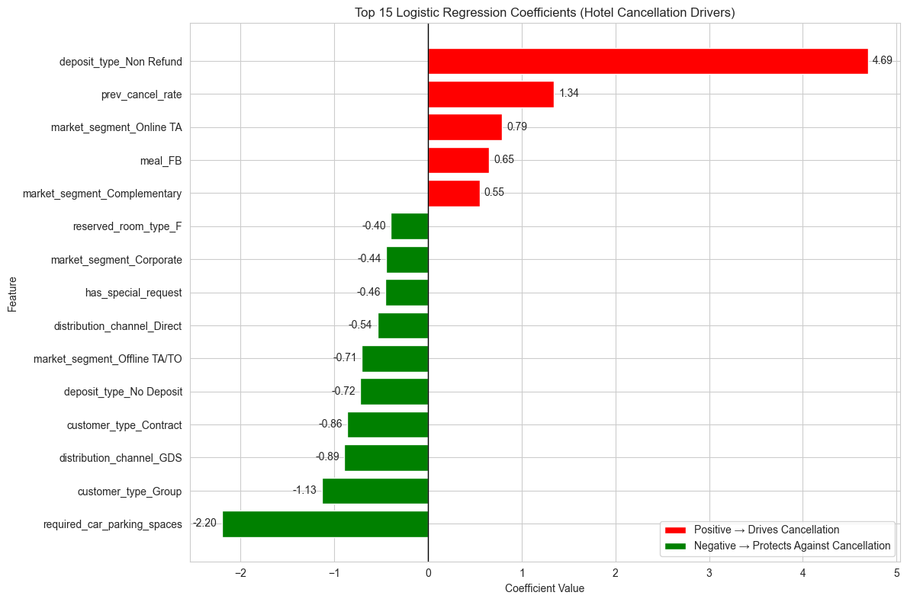
Figure 1. Top 15 Logistic Regression coefficients (red = drives cancellation; green = protects against cancellation).
The three largest positive coefficients are deposit_type_Non Refund (+4.69), prev_cancel_rate (+1.34) and market_segment_Online TA (+0.79) — bookings carrying a non-refundable rate type, guests with a history of cancelling, and online travel-agent bookings all push the predicted probability upward, consistent with the Stage 1 EDA. The three strongest negative coefficients are required_car_parking_spaces (−2.20), customer_type_Group (−1.13) and deposit_type_No Deposit (−0.72). The protective role of customer_type_Group should not be confused with the high-risk market_segment_Groups pattern: they are different variables, and LR coefficients are partial effects after controlling for other predictors. K-Means, by contrast, describes full booking profiles rather than isolated variable effects.

4.3 Results — Random Forest

4.3.1 Performance metrics on test set
Metric | Value
Accuracy | 0.8537
Precision (cancelled) | 0.8231
Recall (cancelled) | 0.7711
F1 (cancelled) | 0.7963
ROC-AUC | 0.9251
Random Forest performs better than Logistic Regression on the main test-set metrics, with the largest operational gain in recall on the cancelled class: RF recovers 77.1% of true cancellations against LR's 60.5%, while keeping precision essentially unchanged (0.823). The ROC-AUC of 0.925 indicates strong discrimination, and the F1 of 0.796 confirms that the recall improvement is not simply achieved by flagging many more false positives.

4.3.2 Feature importance
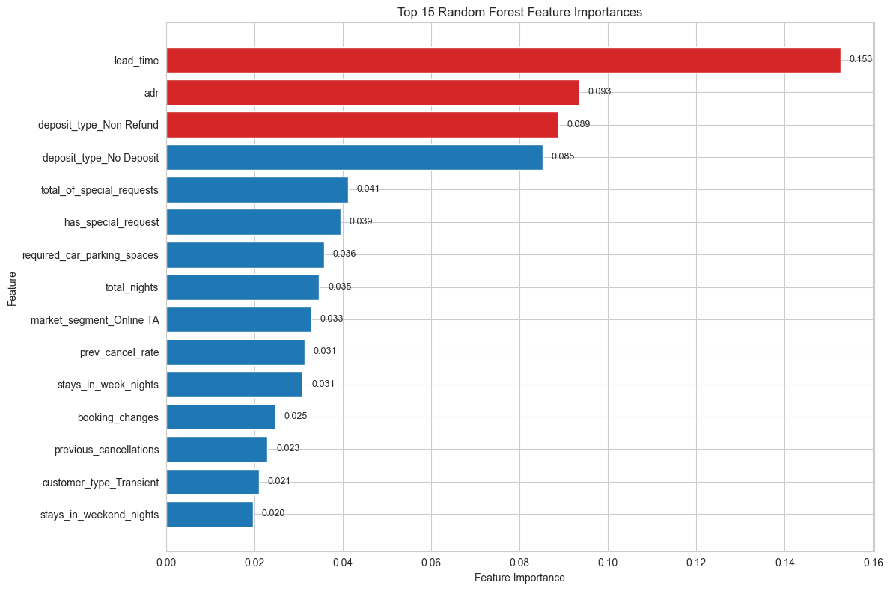
Figure 2. Top 15 Random Forest feature importances (Gini-based; interpreted as global importance, not direction of effect).
The Random Forest feature importance plot reinforces the Stage 1 story without simply repeating it: cancellation risk is shaped by timing, price, booking commitment, deposit type, and channel context. Its overlap with LR coefficients increases confidence in the main predictors, while differences such as the stronger role of adr show why a non-linear model adds value. These are predictive associations, not causal claims; in particular, deposit_type_Non Refund should be read as a strong contextual signal rather than proof that the deposit policy itself causes cancellation.

4.4 Results — K-Means Clustering

4.4.1 Selection of k
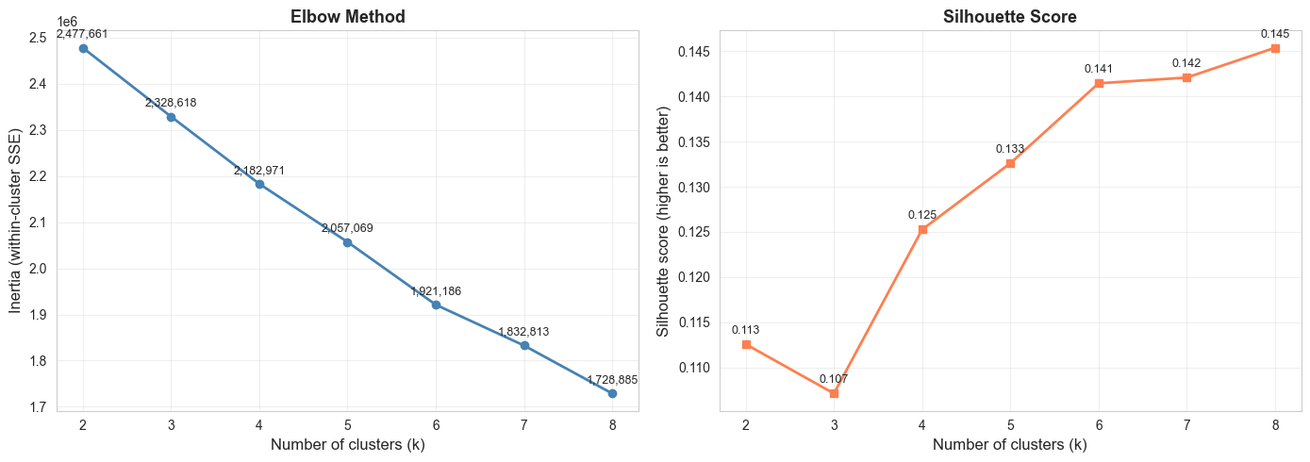
Figure 3. Elbow method (inertia) and silhouette score for k ∈ {2, …, 8}.
K-Means results are evaluated against two criteria: internal clustering quality (inertia, silhouette) and managerial usefulness (whether clusters reveal distinct cancellation profiles).
The silhouette score is relatively flat across the tested range of k (from 0.107 at k = 3 up to 0.145 at k = 8), and the inertia curve shows a gentle bend rather than a sharp elbow. Because no single k stands out statistically, we favoured interpretability and chose k = 4 — large enough to capture the main reservation profiles (corporate short-stay, online leisure, resort vacation, group bookings) yet small enough that each cluster has a clear business narrative. The silhouette at k = 4 (0.1253) is within 0.02 of the maximum at k = 8. The low silhouette values also mean the clusters should not be interpreted as sharply separated natural customer groups; their value is exploratory and managerial, summarising broad booking profiles with different observed cancellation rates.

4.4.2 Cluster profiles
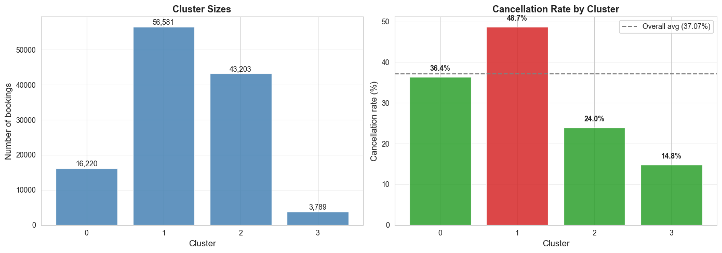
Figure 4. Cluster sizes and observed cancellation rate per cluster (dashed line: overall 37.07%).
Cluster | Size | Cancel  rate | Mean lead time | Total nights | Guests | ADR | Special  requests | Market  segment | Hotel
3 | 3,789 | 14.83% | 32.3 | 1.78 | 1.43 | 65.21 | 0.62 | Corporate | City Hotel
2 | 43,203 | 24.00% | 83.7 | 2.90 | 2.24 | 121.30 | 1.28 | Online TA | City Hotel
0 | 16,220 | 36.42% | 141.9 | 8.16 | 2.16 | 110.69 | 0.60 | Online TA | Resort Hotel
1 | 56,581 | 48.73% | 118.1 | 2.58 | 1.74 | 89.16 | 0.02 | Groups | City Hotel
Clusters are ordered by observed cancellation rate (lowest to highest) for ease of comparison; the cluster IDs themselves are arbitrary labels from K-Means.
The profile table shows a clear 33.9 percentage-point spread between the lowest-risk and highest-risk clusters. This supports the value of K-Means as a managerial segmentation tool, even though the internal clustering scores are modest.
The four clusters summarise bookings into operationally interpretable risk profiles. Cluster 3 (Low risk — corporate short-stay business travel) is the smallest but the cleanest: short lead time, City Hotel, Corporate market segment, and a 14.83% cancellation rate — less than half the dataset average. Cluster 2 (Below-average risk — Online TA city leisure) is the second-largest, with moderate lead time and a 24.0% cancellation rate. Cluster 0 (Near-average risk — Resort vacation long-stay) gathers the longer-stay, longer-lead-time resort bookings at 36.42%, close to the overall rate. Cluster 1 (High risk — Group bookings) is the largest segment (56,581 bookings) and cancels at 48.73%, well above average; it is also characterised by very few special requests (mean 0.02 vs. ≥ 0.6 in the other clusters).

4.5 Comparative Analysis

4.5.1 Quantitative Comparison (LR vs. RF)
Metric | Logistic Regression | Random Forest | Δ (RF − LR)
Accuracy | 0.8053 | 0.8537 | +0.0484
Precision (cancelled) | 0.8230 | 0.8231 | +0.0001
Recall (cancelled) | 0.6050 | 0.7711 | +0.1661
F1 (cancelled) | 0.6974 | 0.7963 | +0.0989
ROC-AUC | 0.8510 | 0.9251 | +0.0741
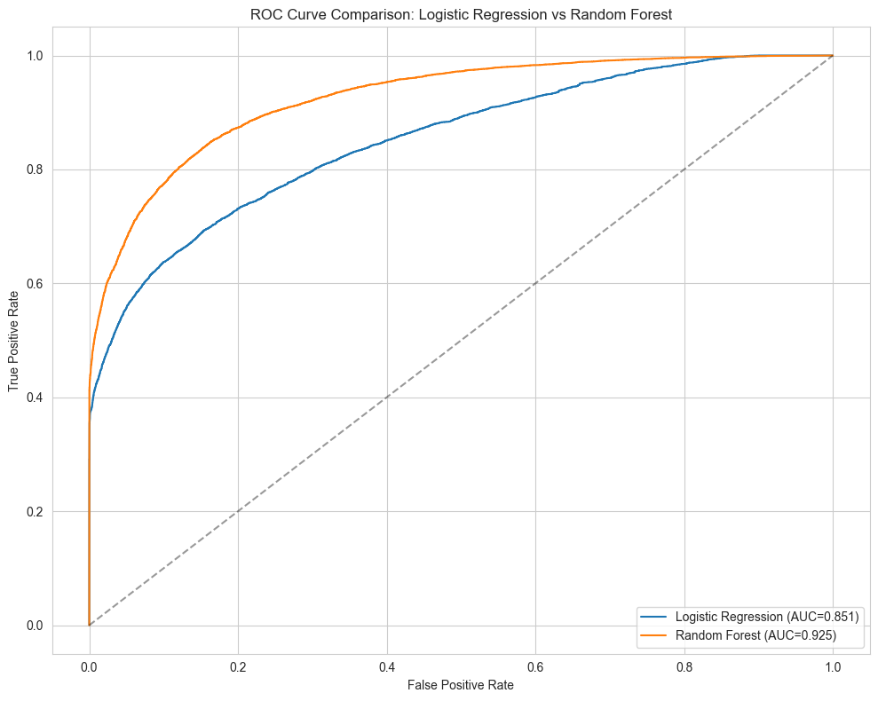
Figure 5. ROC curves on the test set — Logistic Regression vs. Random Forest.
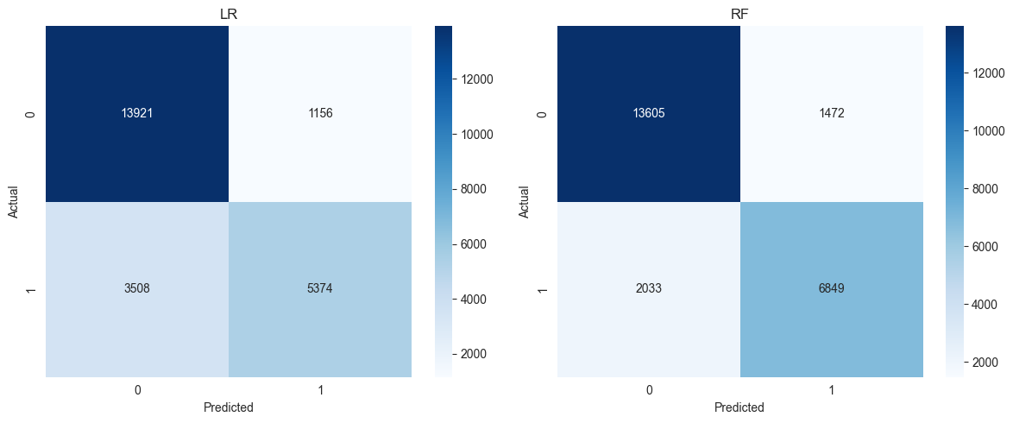
Figure 6. Confusion matrices (test set, default 0.5 threshold).
Random Forest's ROC curve dominates Logistic Regression's across nearly the entire false-positive-rate range, consistent with the +0.074 ROC-AUC gap. The confusion matrices make the recall difference concrete: LR misses 3,508 of 8,882 actual cancellations (false negatives), while RF misses 2,033 — recovering an additional 1,475 true cancellations at almost no precision cost. For a hotel revenue manager, a missed cancellation is more costly than a false alarm (it may leave rooms protected for bookings that later cancel, reducing opportunities for controlled overbooking or earlier resale), so RF's recall advantage is operationally meaningful.

4.5.2 Insight-Based Comparison (K-Means vs. Supervised)
The supervised models and K-Means answer different but complementary questions. Logistic Regression and Random Forest predict whether an individual booking is likely to be cancelled, so they are most useful when the hotel needs a booking-level risk score for overbooking, pricing, or intervention decisions. K-Means does not optimise prediction accuracy and does not use the target label during fitting; instead, it groups bookings with similar reservation profiles and then allows us to compare the observed cancellation rate across those groups.
This segmentation revealed patterns that are less visible from LR/RF metrics alone. The four clusters have cancellation rates ranging from 14.83% to 48.73%, a 33.9 percentage-point gap between the lowest-risk and highest-risk profiles. The lowest-risk cluster is dominated by short-lead corporate City Hotel bookings (cluster size 3,789, ≈ 3.2% of bookings), while the highest-risk cluster is dominated by group bookings with very few special requests (cluster size 56,581). These are not just important variables; they are operationally meaningful customer segments.
For revenue management, this means K-Means is useful even without producing a per-booking prediction. A revenue manager can design segment-level actions — different confirmation timing, targeted retention offers, stricter follow-up for high-risk group bookings, or more conservative overbooking assumptions for segments with historically high cancellation. In contrast, the supervised models are better suited to booking-level decisions. The most practical approach is therefore to use Random Forest for risk scoring, Logistic Regression for explainable drivers, and K-Means for segment-level strategy.

4.6 Discussion
Random Forest was the strongest predictive model overall on the held-out test set. It achieved the highest ROC-AUC (0.9251 vs. 0.8510 for Logistic Regression), recall for cancelled bookings (0.7711 vs. 0.6050), and F1 score (0.7963 vs. 0.6974), while maintaining almost identical precision (0.8231 vs. 0.8230). This is operationally important because the hotel revenue-management problem is more affected by missed cancellations than by small differences in overall accuracy.
Logistic Regression remains useful because it is easier to interpret. It communicates the direction of major risk drivers — for example, non-refundable deposits (coefficient +4.69) and higher prior cancellation rates (+1.34) push cancellation probability up, while required car parking spaces (−2.20), customer_type_Contract (−0.86), and customer_type_Group (−1.13) push it down. Random Forest captures more complex non-linear effects and interactions but does not expose these directions as transparently.
K-Means should not be compared with LR and RF as a predictive classifier, because it does not predict is_canceled. Its value is complementary: it converts the same booking features into customer segments with clearly different observed cancellation profiles, from 14.83% in the low-risk corporate short-stay cluster to 48.73% in the high-risk group-booking cluster. This segment-level view is operationally useful because revenue-management actions are typically applied to booking groups, not individual reservations.
The recommended workflow is therefore combined rather than model-exclusive: use Random Forest for operational cancellation-risk scoring, Logistic Regression to communicate the main risk drivers, and K-Means to design segment-level revenue-management actions such as differentiated follow-up, capacity planning, and booking policy review.

Section 5. Conclusions and Limitations

5.1 Summary of Key Findings (Stage 1 + Stage 2)
Across both stages, a consistent picture of hotel cancellation behaviour emerged. Stage 1 identified strong reservation-time signals such as deposit_type, lead_time, market_segment, hotel, and special requests; Stage 2 confirmed that these signals remain useful in multivariate predictive models while adding a segmentation perspective.
- Random Forest was the strongest supervised model, achieving 0.7963 F1 and 0.9251 ROC-AUC on the held-out test set after hyperparameter tuning.
- Logistic Regression remains a valuable companion model because its coefficients provide a transparent explanation of the main cancellation drivers.
- K-Means revealed four broad booking segments with cancellation rates from 14.83% to 48.73%, showing that segmentation can support targeted operational strategies even without booking-level predictions.
- Together, the three methods answer the research question from different angles: reservation-time information can support useful cancellation prediction, explanation, and customer-segment analysis.

5.2 Limitations
- Temporal coverage. The data covers bookings from 2015–2017. Travel behaviour, booking channels, and hotel cancellation policies may have changed since then, limiting the external validity of the models unless they are revalidated on more recent data.
- Missing behavioural features. No price-discount, loyalty programme, or guest-demographic information is available, which limits both the predictive ceiling and the explanatory depth of the analysis.
- Interpretation of deposit_type. The ≈ 99% cancellation rate for Non Refund bookings is highly predictive but should be treated as an association with booking context rather than a causal lever (see Section 2.3). A deployed model should validate operational use across channels before justifying policy changes.
- High-cardinality columns excluded from modelling. country and agent were retained in the cleaned CSV but excluded from the modelling feature set to avoid sparse, hard-to-interpret one-hot encodings. Future work could group countries into broader source-market regions and group agents by booking-volume tier to test whether this information adds signal.
- Single train/test split. Final performance was evaluated on a single 80/20 held-out split with a fixed random seed. Although hyperparameters were selected using 5-fold cross-validation on the training set, repeated splits or nested cross-validation would provide a stronger estimate of metric stability.
- Threshold and calibration. The reported classification metrics use the default 0.5 probability threshold, and probability calibration was not formally tested. A deployed revenue-management system should tune the decision threshold and check calibration before using predicted probabilities operationally.

- K-Means modelling assumptions. K-Means assumes spherical clusters and Euclidean distance, which is only an approximation for one-hot-encoded categorical features. Alternative algorithms (e.g., k-prototypes, hierarchical clustering with Gower distance) might produce more faithful segments. The low silhouette values confirm that K-Means is best treated as exploratory segmentation rather than a definitive taxonomy of hotel guests.

5.3 Future Work
- Apply Gradient Boosting methods such as XGBoost or LightGBM to test whether more flexible supervised models can improve recall and ROC-AUC beyond Random Forest.
- Test calibration of predicted probabilities (e.g., Brier score, reliability diagrams) — important for revenue-management decisions, not just classification accuracy.
- Augment with more recent booking data to validate model stability over time, and to test whether the cluster structure persists or changes under newer travel and booking conditions.
- Apply k-prototypes or hierarchical clustering with Gower distance to handle mixed-type features more faithfully, and compare resulting customer segments against the K-Means baseline.

Section 6. Contribution Statements

Member A — 550606798 / xlyu0883
- Led the data-cleaning notebook: extended Stage 1 cleaning with stricter categorical standardisation, removed the two leakage columns, engineered five new features (total_nights, total_guests, has_special_request, is_summer_arrival, prev_cancel_rate), and exported the final cleaned CSV used by the modelling notebook.
- Wrote and organised Sections 1, 2, 3, 6, 7.4, and 8 of the modelling notebook, covering notebook setup, data loading/checks, feature preparation context, K-Means clustering, insight comparison, and discussion.
- Implemented and analysed K-Means clustering: k selection via elbow and silhouette analysis, fitted the final k = 4 model, built the cluster profiles, and interpreted the customer segments.
- Drafted and revised report Sections 1, 2, 3.3, 4.4, 5, and 6; integrated and substantially revised Sections 4.2, 4.3, 4.5, and 4.6 for consistency with the model outputs; and completed final formatting.

Member B — 550574947 / hgar0964
- Implemented the Logistic Regression and Random Forest modelling workflow, including GridSearchCV and 5-fold stratified cross-validation.
- Wrote and organised Sections 4, 5, 7.1, 7.2, and 7.3 of the modelling notebook, covering Logistic Regression, Random Forest, supervised-model evaluation, ROC curves, confusion matrices, and LR/RF comparison.
- Provided the initial LR/RF result outputs and draft content for report Sections 3.1, 3.2, 4.2, 4.3, 4.5, and 4.6.

AI Tool Usage Declaration
Tools used: Claude (Anthropic), Codex (OpenAI)
Dates used: 9 May – 17 May 2026
How AI was used:
- Drafting outlines and improving wording, grammar, and report structure.
- Reviewing notebook code for correctness, reproducibility, and possible leakage issues.
- Suggesting plotting templates and code-organisation improvements, which we checked, implemented, and customised.
- Cross-checking written interpretations against actual model outputs to ensure reported numbers and qualitative claims matched the notebooks.
Declaration: All analytical decisions, model choices, hyperparameter selections, result interpretations, and conclusions presented in this report are our own. AI tools were used for language refinement, code review, and structural assistance.

