**Dilla University Employee Schedule Management System**

**By:**

1. Cherinet Afewerk
2. Natnael Tsedeke
3. Robel Wondwesen
4. Hermela Kidane
5. Haymanot Derbe

**Introduction**

The **Dilla University Employee Schedule Management System** is a smart, centralized platform tailored to meet the scheduling and administrative needs of non-academic staff, including **café employees, campus police, and cleaning staff**.  
This system is designed to:

* **Automate work schedules** for each employee group based on shifts, availability, and department need.
* **Notify employees and managers** instantly about shift changes, overtime, and special assignments
* **Track daily attendance** using check-in/check-out systems with timestamps
* **Provide access control** for coordinators, field-specific managers, and higher-level administrators
* **Generate real-time reports** on employee performance, absences, and scheduling conflicts
* **Enable mobile-friendly access**, so users can view schedules or receive notifications on the go

With this platform, Dilla University can significantly reduce manual scheduling work, minimize errors, and ensure better coordination across departments—ultimately contributing to a more efficient and responsive working environment.

### **General Objective**

The general objective of this project is to design and develop an **Integrated Employee Schedule Management System** that serves all relevant administrative departments within **Dilla University**.

### **Specific Objectives**

1. **To develop a user-friendly dashboard** for coordinators, field managers, and administrators to manage staff schedules, attendance, and daily reports.
2. **To implement an automated scheduling system** that assigns work shifts based on employee availability, departmental needs, and workload balance.
3. **To integrate real-time notification features** that alert employees about new shifts, changes in their schedules, or urgent tasks via SMS, email, or in-app messages.
4. **To track and record employee attendance** using check-in/check-out mechanisms, with timestamps and location logging for on-campus validation.
5. **To allow coordinators and managers to monitor performance** by generating reports on attendance trends, punctuality, shift fulfillment, and task completion.
6. **To create role-based access controls** so that each user (e.g., café manager, police coordinator, cleaning supervisor) can only access and manage their respective group.
7. **To ensure data security and backup**, utilizing cloud storage solutions like Firebase for real-time syncing and recovery.
8. **To provide a mobile-responsive interface** so that both staff and administrators can interact with the system using smartphones, tablets, or computers.
9. **To support leave management features**, enabling employees to request time off and coordinators to approve or decline those requests within the system.
10. **To build a scalable architecture** that can later support additional departments or be adapted by other campuses within the university system.

### **Problem Statement**

Dilla University currently faces significant challenges in managing the work schedules and attendance of non-academic staff, including café workers, campus police, and cleaning personnel. These challenges include:

* **Manual scheduling processes** that are time-consuming, error-prone, and difficult to update
* **Poor communication** between coordinators, managers, and employees, leading to misunderstandings and missed shifts
* **Lack of real-time data** on attendance and employee performance
* **No centralized system** for managing staff duties, approvals, and shift changes
* **Inflexible systems** that cannot adapt quickly to staff availability, emergencies, or workload changes
* **Inefficient record-keeping** and reporting that makes it hard to track and evaluate staff performance

These issues lead to **mismanagement, low staff satisfaction, reduced productivity**, and a **lack of transparency** in daily operations.

### **Proposed Solutions**

To address the above challenges, this project proposes the development of an **Integrated Employee Schedule Management System** that will:

* **Digitize staff scheduling** with automated shift assignment based on employee roles, availability, and workload.
* **Enable instant notifications** via SMS, email, or app alerts to keep staff informed about schedules, updates, or emergencies.
* **Implement real-time attendance tracking** with check-in/check-out and timestamp features.
* **Introduce role-based dashboards** for coordinators, field managers, and higher admins to simplify operations and monitoring.
* **Generate insightful reports** on attendance, shift coverage, and staff productivity to help managers make informed decisions.
* **Ensure data privacy and access control**, protecting sensitive employee information while allowing authorized users to manage their teams.
* **Provide mobile and web access**, so users can interact with the system anytime, anywhere.
* **Offer flexible leave management** to handle time-off requests and scheduling adjustments in real-time.
* **Use cloud-based storage (e.g., Firebase)** for secure, scalable, and backed-up data handling.
* **Support future scalability**, allowing the system to adapt as the university grows or adds new departments.

**For more information, please visit our official website:**  
[https://duems.vercel.app/](https://duems.vercel.app/" \t "_new)

**Welcome Page**

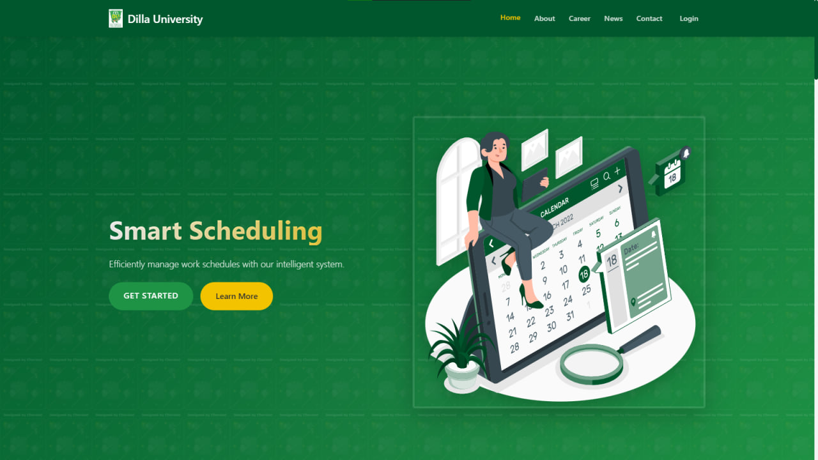

**Real Time Notifications**

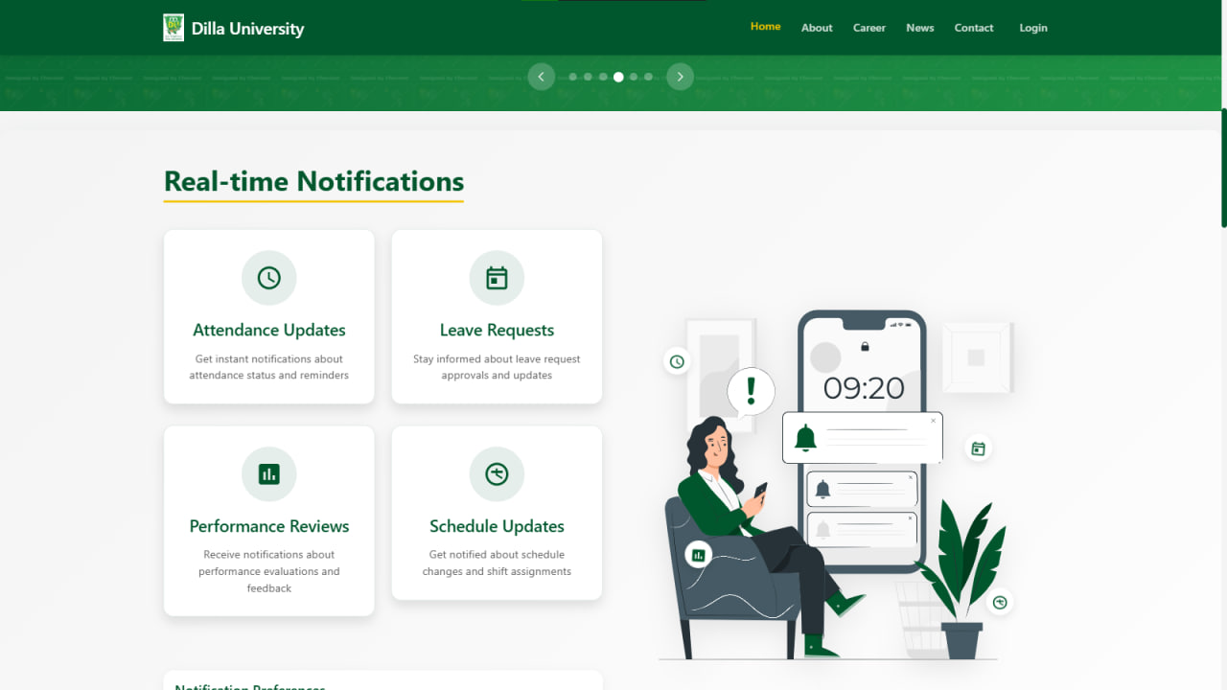

**FEATURES**

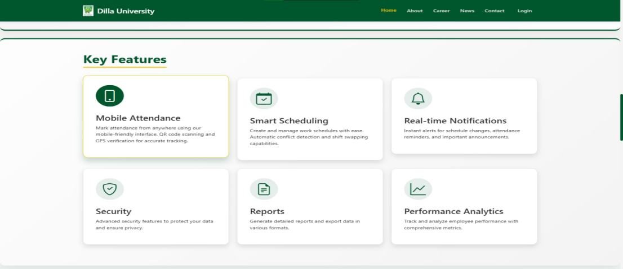

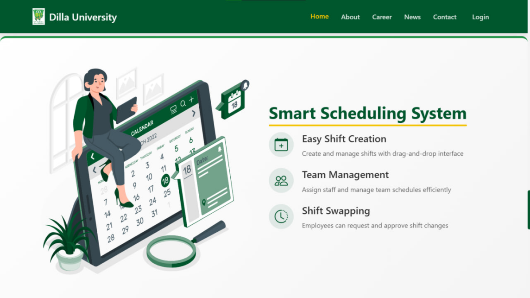

**Login (Credentials)**

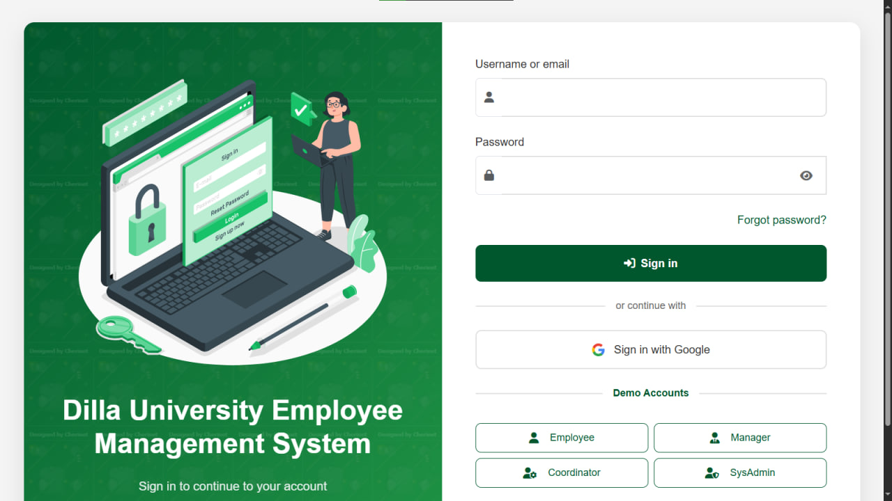

**Employee Portal Dashboard**

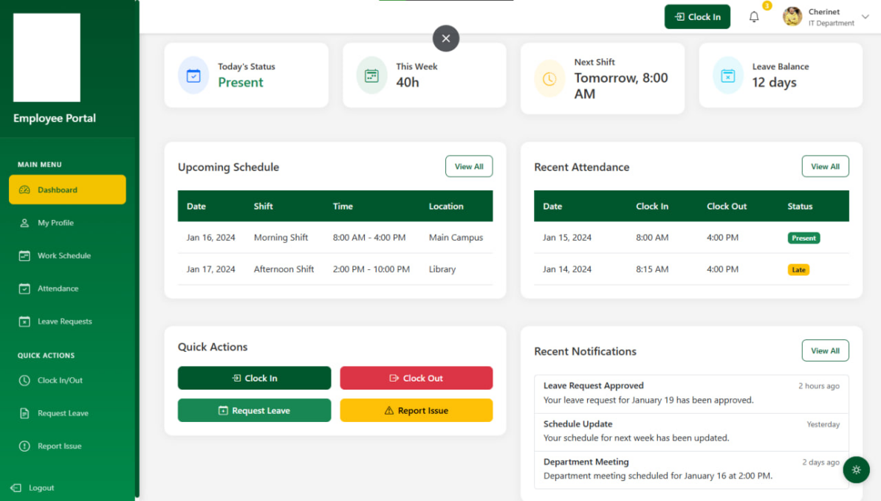

**Employee Portal Attendance Page**

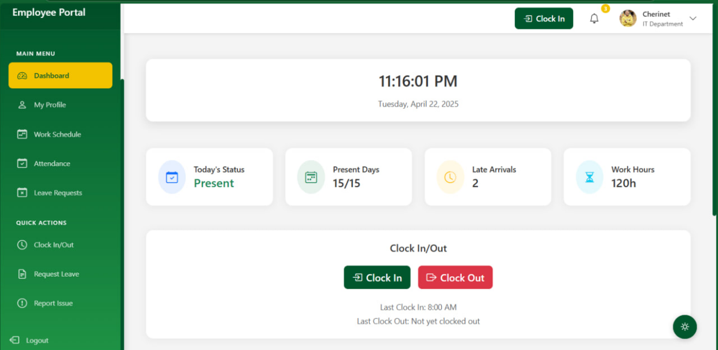

Employee Portal Schedule Page

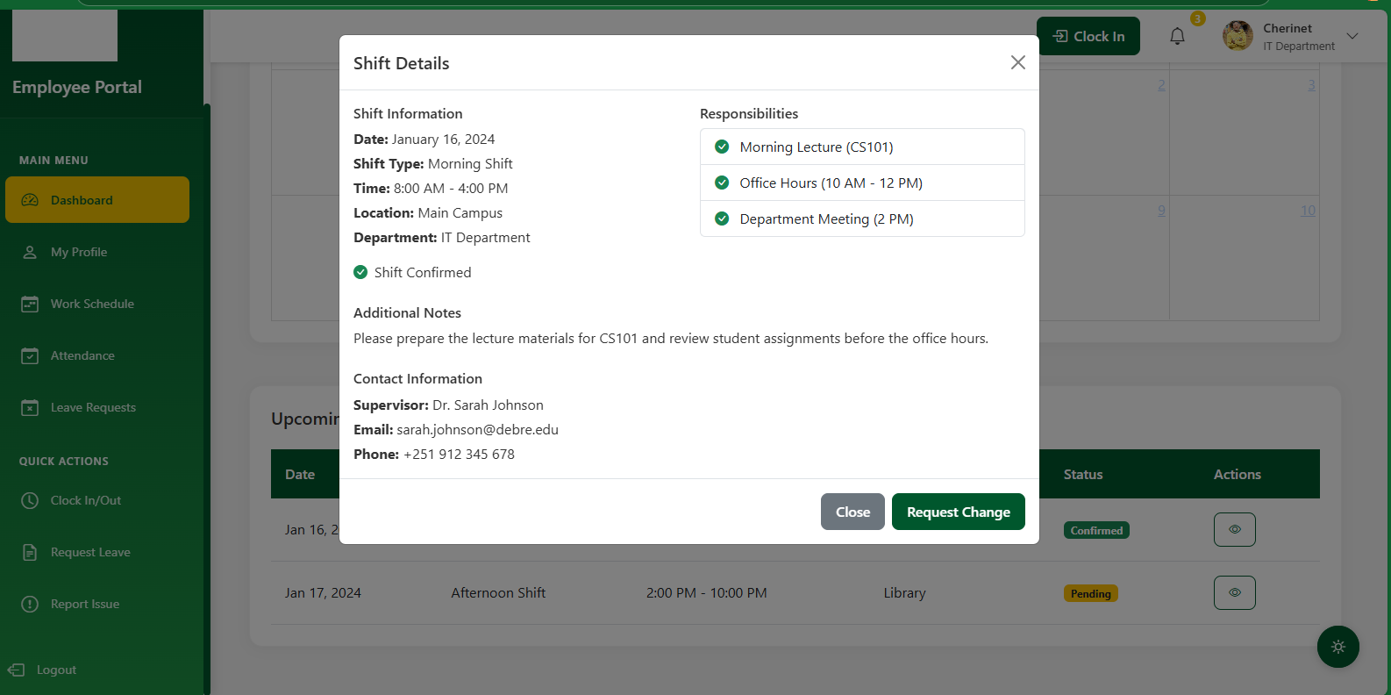

**Coordinator Employee detail**

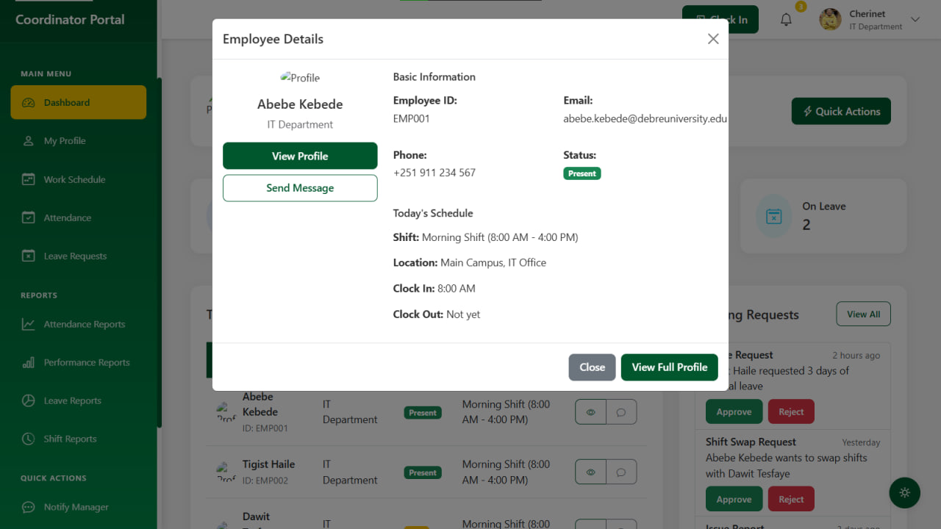



**Coordinator Mark to Attendance**

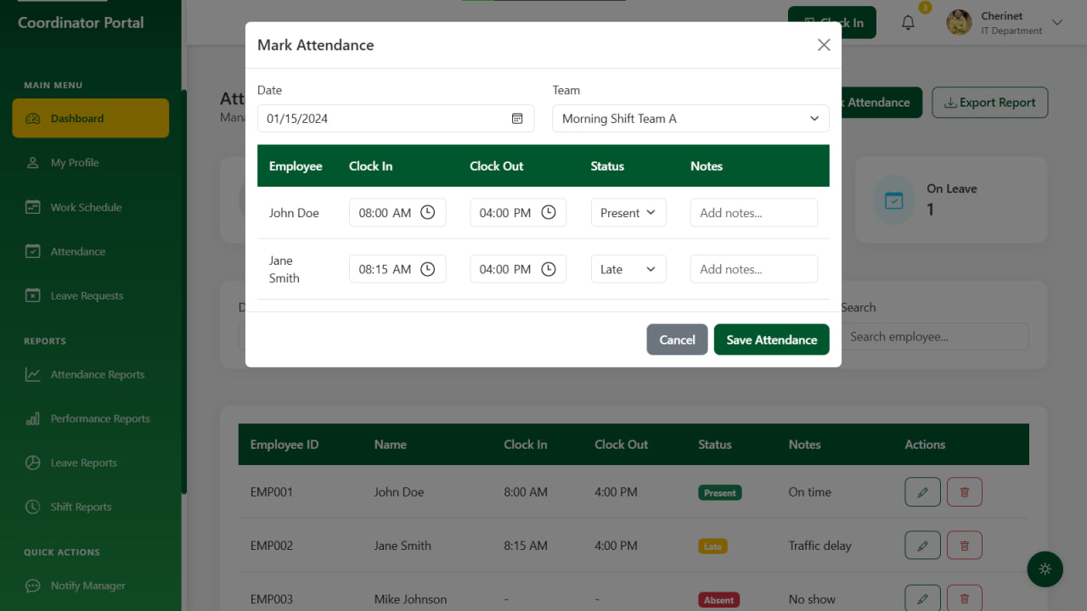

Coordinator Report Page

