ReactJS HOL 10 - Office Space Rental App (JSX)

Aim
Create an Office Space Rental React application using JSX, objects, arrays and inline CSS.

Procedure
- 1. Create project: npx create-react-app officespacerentalapp
- 2. Open project in VS Code.
- 3. Replace src/App.js with the code below.
- 4. Create an office object and an array of office objects.
- 5. Display heading, image, office details and list using JSX.
- 6. Apply inline CSS: rent < 60000 in red, otherwise green.
- 7. Run: npm start
- 8. Open http://localhost:3000

File: src/App.js
const offices=[
{name:'DBS',rent:50000,address:'Chennai',image:'office.jpg'},
{name:'Regus',rent:75000,address:'Bangalore',image:'office.jpg'}
];
function App(){
return(
<div>
<h1>Office Space, at Affordable Range</h1>
{offices.map(o=>(
<div key={o.name}>
<img src={o.image} width='25%' alt='Office'/>
<h2>Name: {o.name}</h2>
<h3 style={{color:o.rent<60000?'red':'green'}}>
Rent: Rs. {o.rent}
</h3>
<h3>Address: {o.address}</h3>
</div>
))}
</div>
)}
export default App;

Expected Output
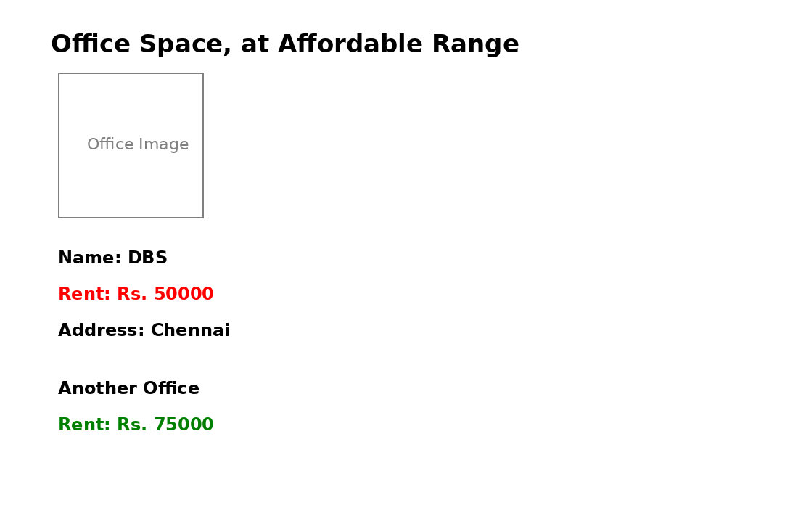
The page displays office details with rent shown in red if below Rs.60000 and green otherwise.

