ReactJS HOL 11 - Event Examples App

Aim
Create an eventexamplesapp demonstrating React event handling, synthetic events, multiple event handlers and a currency converter.

Procedure
- 1. Create project: npx create-react-app eventexamplesapp
- 2. Open in VS Code.
- 3. Create Counter component with Increment and Decrement buttons.
- 4. Increment button should increment counter and call sayHello().
- 5. Add 'Say Welcome' button passing 'Welcome' as argument.
- 6. Add 'OnPress' button displaying 'I was clicked'.
- 7. Create CurrencyConvertor component.
- 8. Convert INR to Euro on button click.
- 9. Import components in App.js.
- 10. Run using npm start.

File: src/App.js
function App(){
return(
<>
<Counter/>
<CurrencyConvertor/>
</>
);
}

File: src/Counter.js
const [count,setCount]=useState(0);
const inc=()=>setCount(count+1);
const hello=()=>alert('Hello React');
<button onClick={()=>{inc();hello();}}>Increment</button>
<button onClick={()=>setCount(count-1)}>Decrement</button>
<button onClick={()=>welcome('Welcome')}>Say Welcome</button>
<button onClick={()=>alert('I was clicked')}>OnPress</button>

File: src/CurrencyConvertor.js
const convert=()=>setEuro((inr/89.2).toFixed(2));
<input .../>
<button onClick={convert}>Convert</button>

Expected Output
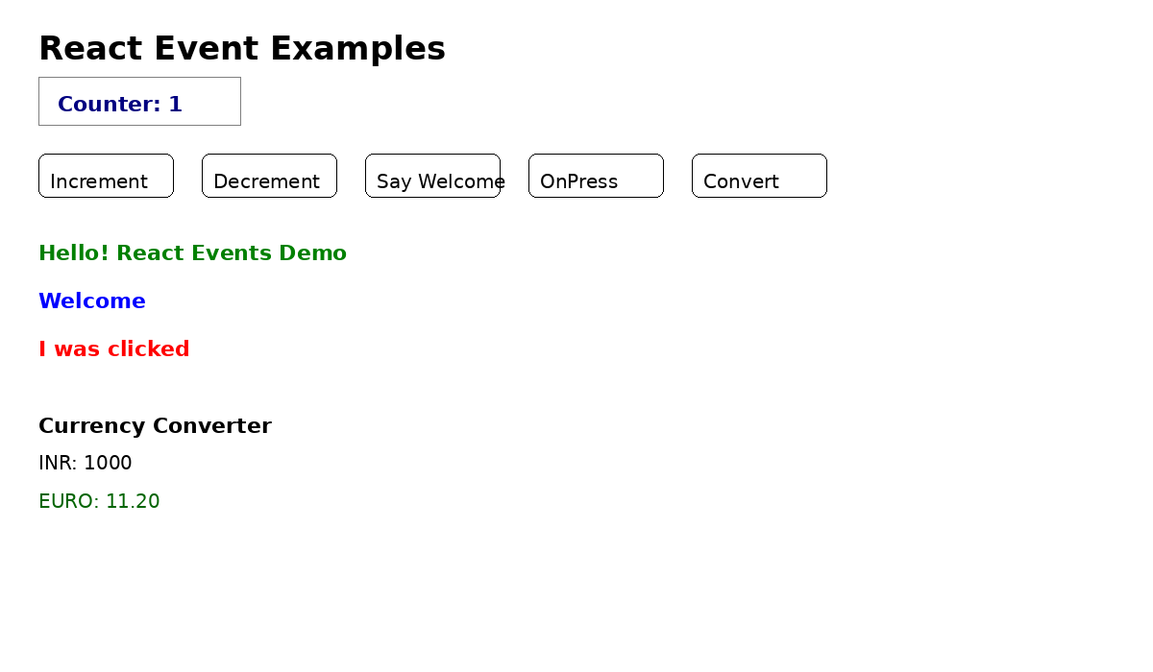
The page shows buttons for event handling and a currency converter section.

