ReactJS HOL 12 - Ticket Booking App

Aim
Implement conditional rendering using Login and Logout buttons.

Procedure
- 1. Create project: npx create-react-app ticketbookingapp
- 2. Open project in VS Code.
- 3. Create LoginButton.js, LogoutButton.js and Greeting.js.
- 4. Create GuestGreeting and UserGreeting components.
- 5. Use state variable isLoggedIn.
- 6. Render Guest page when logged out.
- 7. Render User page when logged in.
- 8. Run using npm start.

LoginButton.js
function LoginButton(props){return <button onClick={props.onClick}>Login</button>;}

LogoutButton.js
function LogoutButton(props){return <button onClick={props.onClick}>Logout</button>;}

Greeting.js
function Greeting(props){return props.isLoggedIn?<UserGreeting/>:<GuestGreeting/>;}

App.js
const [isLoggedIn,setIsLoggedIn]=useState(false);

Expected Output
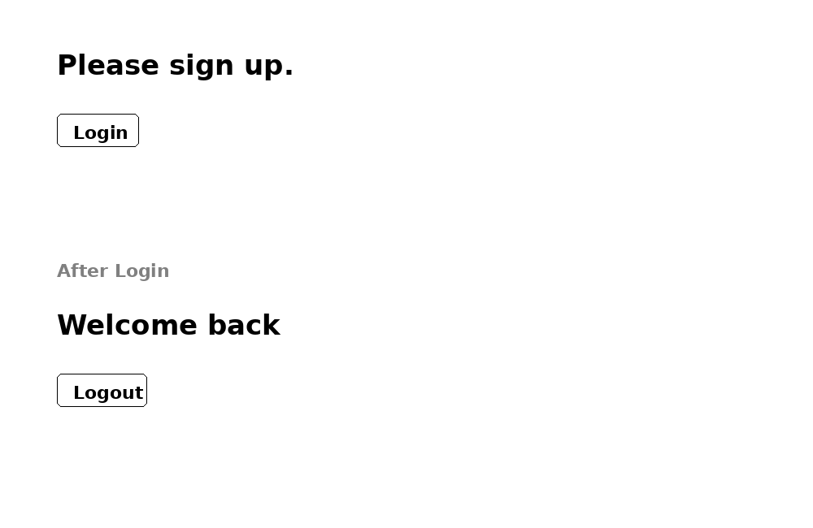
Initially 'Please sign up' with Login button is shown. After login, 'Welcome back' with Logout button appears.

