ReactJS Hands-on Lab 9 - Cricket App (ES6 Features)

Aim
Create a React application named cricketapp demonstrating ES6 map(), arrow functions, destructuring and merge features.

Procedure
- 1. Create the project: npx create-react-app cricketapp
- 2. Open the project in VS Code.
- 3. Create ListofPlayers.js component.
- 4. Create IndianPlayers.js component.
- 5. In ListofPlayers, declare an array of 11 players and display using map().
- 6. Filter players with score below 70 using an arrow function.
- 7. In IndianPlayers, use destructuring to separate odd/even team players.
- 8. Merge T20Players and RanjiPlayers arrays using the spread (...) operator.
- 9. In App.js use a flag variable with if/else to display the required component.
- 10. Run using npm start and open http://localhost:3000.

File: src/ListofPlayers.js
const players=[{name:'Virat',score:95},{name:'Rahul',score:68}];
players.map(p=><p>{p.name} {p.score}</p>);
const low=players.filter(p=>p.score<70);

File: src/IndianPlayers.js
const [p1,p2,p3,p4,p5,p6]=players;
const odd=[p1,p3,p5];
const even=[p2,p4,p6];
const merged=[...T20Players,...RanjiPlayers];

File: src/App.js
const flag=true;
return flag?<ListofPlayers/>:<IndianPlayers/>;

Expected Output
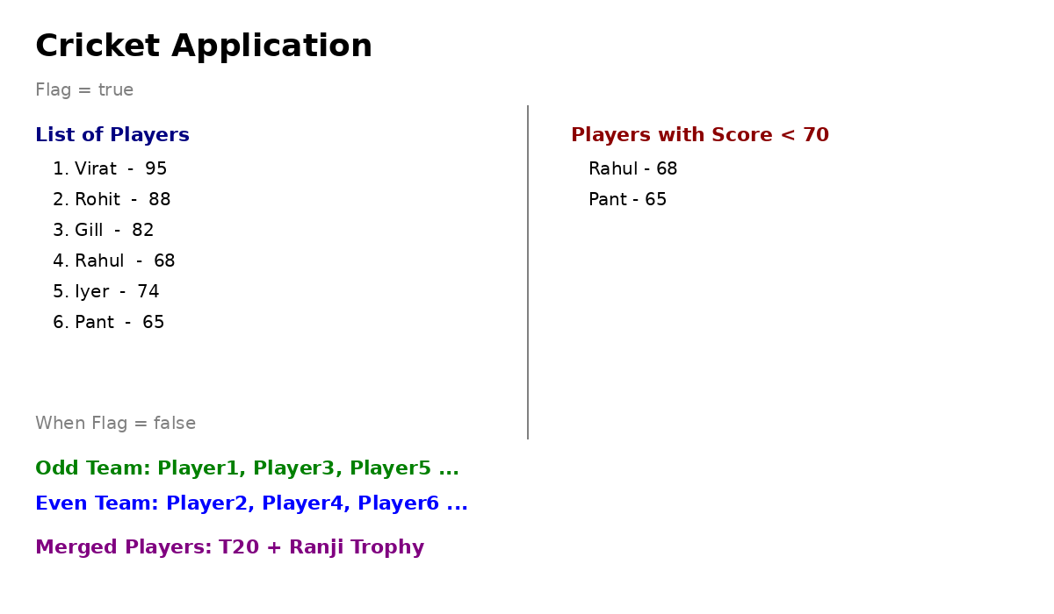
When flag=true, player list and filtered players are displayed. When flag=false, odd/even team players and merged players are displayed.

