ReactJS Hands-on Lab: Create Your First React Application
This document explains how to create a React application named myfirstreact and display the heading 'Welcome to the first session of React'.

Step 1: Install Node.js
Download and install the LTS version of Node.js from https://nodejs.org/en/download/.

Step 2: Verify Installation
Open Command Prompt and run:
node -v
npm -v

Step 3: Install Create React App
Run:
npm install -g create-react-app

Step 4: Create the React Project
Run:
npx create-react-app myfirstreact

Step 5: Open the Project
Run:
cd myfirstreact
code .

Step 6: Edit App.js
Open src/App.js, delete its contents and replace with:
function App() {
return (
<h1>Welcome to the first session of React</h1>
);
}
export default App;

Step 7: Run the Application
Run:
npm start

Step 8: View Output
Open http://localhost:3000 if it doesn't open automatically.

Expected Output
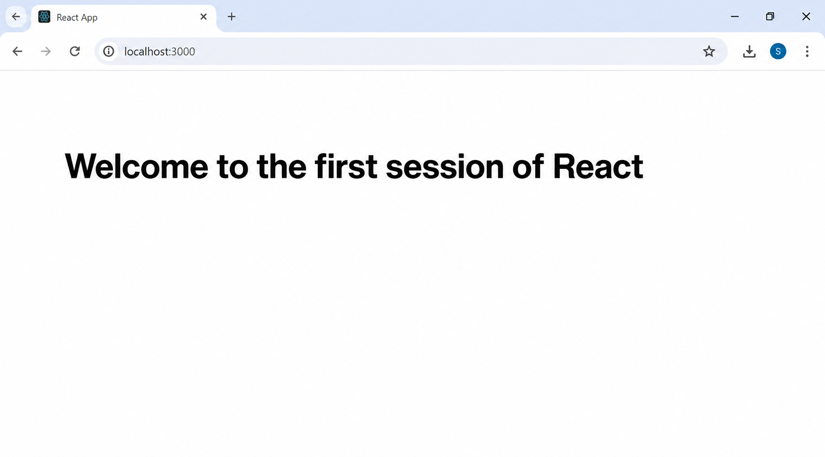
The browser displays a white page with the heading 'Welcome to the first session of React'.

