ReactJS Hands-on Lab 3 - Score Calculator App
Prepared from the uploaded lab document.

Procedure
- 1. Create the React project:
npx create-react-app scorecalculatorapp
- 2. Open the project:
cd scorecalculatorapp
code .
- 3. Inside src create a folder named Components.
- 4. Create CalculateScore.js inside Components.
- 5. Inside src create a folder named Stylesheets and create mystyle.css.
- 6. Replace App.js with the code shown below.
- 7. Run the application using npm start.
- 8. Open http://localhost:3000 in your browser.

File: src/Components/CalculateScore.js
import '../Stylesheets/mystyle.css';
const percentToDecimal=(d)=> (d.toFixed(2)+' %');
const calcScore=(total,goal)=> percentToDecimal((total/goal));
export const CalculateScore=({Name,School,total,goal})=>(
<div className='formatstyle'>
<h1>Student Details:</h1>
<p><b>Name:</b> <span className='Name'>{Name}</span></p>
<p><b>School:</b> <span className='School'>{School}</span></p>
<p><b>Total:</b> <span className='Total'>{total} Marks</span></p>
<p><b>Score:</b> <span className='Score'>{calcScore(total,goal)}</span></p>
</div>
);

File: src/Stylesheets/mystyle.css
.Name{color:blue;}
.School{color:crimson;}
.Total{color:darkmagenta;}
.Score{color:forestgreen;}
.formatstyle{text-align:center;font-size:large;}

File: src/App.js
import {CalculateScore} from './Components/CalculateScore';
function App(){
return(
<div>
<CalculateScore
Name='Steve'
School='DNV Public School'
total={284}
goal={3}
/>
</div>
);
}
export default App;

Expected Output
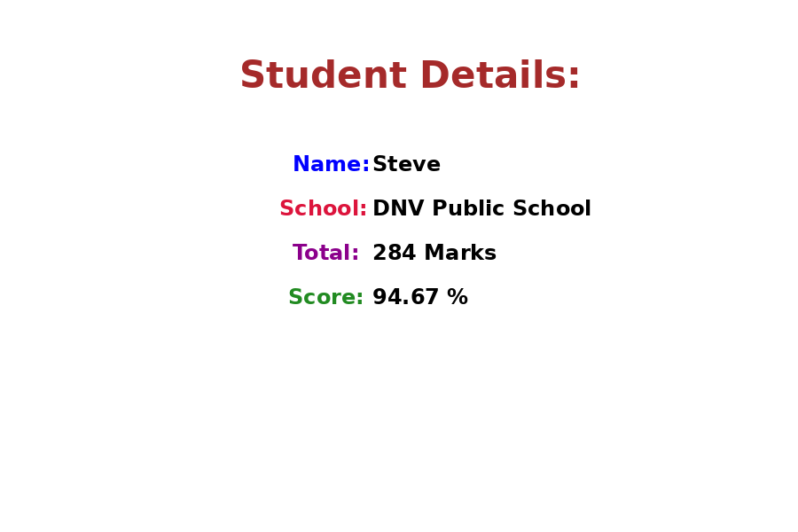
After running npm start and opening http://localhost:3000, the page will look similar to the image above.

