ReactJS Hands-on Lab 5 - Styling React Components (Cohorts Dashboard)

Aim
Style the Cohorts Dashboard React application using CSS Modules and conditional styling.

Procedure
- 1. Download and unzip the cohorttracker React application.
- 2. Open Command Prompt and navigate to the project folder.
- 3. Install dependencies using: npm install
- 4. Open the project in Visual Studio Code.
- 5. Create CohortDetails.module.css inside the component folder.
- 6. Add the required CSS styles.
- 7. Import the CSS module into CohortDetails.js.
- 8. Apply the 'box' class to the container div.
- 9. Make the heading green when status is 'Ongoing' and blue otherwise.
- 10. Run the application using: npm start
- 11. Open http://localhost:3000

File: CohortDetails.module.css
.box{
width:300px;
display:inline-block;
margin:10px;
padding:10px 20px;
border:1px solid black;
border-radius:10px;
}
dt{
font-weight:500;
}

File: CohortDetails.js (changes)
import styles from './CohortDetails.module.css';
<div className={styles.box}>
<h3 style={{color: cohort.currentStatus==='Ongoing'?'green':'blue'}}>
{cohort.cohortCode}
</h3>
...
</div>

Expected Output
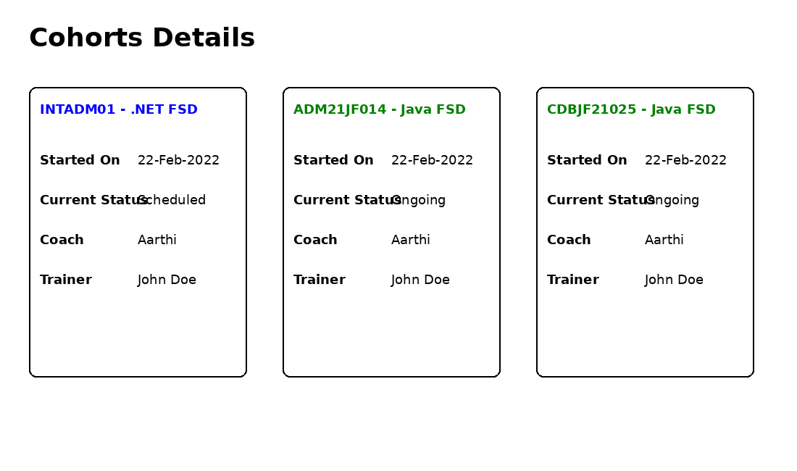
The dashboard displays styled cohort cards similar to the lab manual.

