Singleton:

using System;
class Logger
{
private static Logger instance;
private Logger()
{
Console.WriteLine("Logger instance created");
}
public static Logger GetInstance()
{
if (instance == null)
{
instance = new Logger();
}
return instance;
}
public void Log(string message)
{
Console.WriteLine("LOG: " + message);
}
}
class Program{
static void Main()
{
Logger logger1 = Logger.GetInstance();
Logger logger2 = Logger.GetInstance();
logger1.Log("Application started");
logger2.Log("User logged in");
if (logger1 == logger2)
{
Console.WriteLine("Only one Logger instance exists.");
}
else
{
Console.WriteLine("Multiple Logger instances exist.");
}
}}
Output:
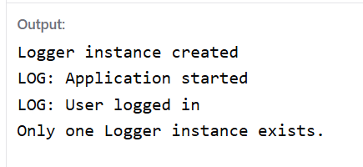

FactoryMethodTest:

using System;
interface IDocument
{
void Open();
}
class WordDocument : IDocument
{
public void Open()
{
Console.WriteLine("Opening Word Document");
}
}
class PdfDocument : IDocument
{
public void Open()
{
Console.WriteLine("Opening PDF Document");
}
}
class ExcelDocument : IDocument
{
public void Open()
{
Console.WriteLine("Opening Excel Document");
}
}
class DocumentFactory
{
public static IDocument CreateDocument(string type)
{
if (type == "WORD")
return new WordDocument();

else if (type == "PDF")
return new PdfDocument();

else if (type == "EXCEL")
return new ExcelDocument();

return null;
}
}
class Program
{
static void Main()
{
IDocument doc1 = DocumentFactory.CreateDocument("WORD");
doc1.Open();

IDocument doc2 = DocumentFactory.CreateDocument("PDF");
doc2.Open();

IDocument doc3 = DocumentFactory.CreateDocument("EXCEL");
doc3.Open();
}
}

Output:
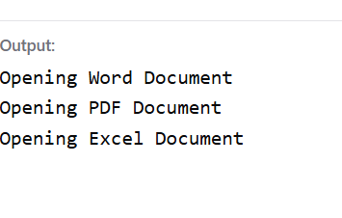
E-Commerce Search Function:
using System;
using System.Collections.Generic;

class Product
{
public int Id;
public string Name;

public Product(int id, string name)
{
Id = id;
Name = name;
}
}

class Program
{
static void Main()
{
List<Product> products = new List<Product>()
{
new Product(1, "Laptop"),
new Product(2, "Mouse"),
new Product(3, "Keyboard"),
new Product(4, "Laptop Bag")
};

string search = Console.ReadLine();

bool found = false;

foreach (Product p in products)
{
if (p.Name.ToLower().Contains(search.ToLower()))
{
Console.WriteLine(p.Id + " " + p.Name);
found = true;
}
}

if (!found)
{
Console.WriteLine("Product not found");
}
}
}
Output:



