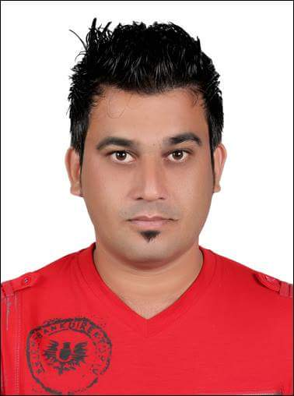AQEEL

Marital Status Single

Nationality Pakistan

Year of Birth 1982

Passport Number NV1157302

Position Driver Cum Messenger

Email address [aqeel.33181@2reemail.com](mailto:aqeel.33181@2reemail.com)

EDUCATION AND PROFESSIONAL STATUS

F.A. from Post Graduate College Haripur Pakistan in 2005.

Previous Experience: Company; Auto Rent LLC

Present working with Al-Nabooda Automobiles LLC

EXPERIENCE RECORD

Responsibilities included:

* Customer Handling
* Car Receiving from Customer
* Deliver Car to Customer
* Customer Pick/Drop
* Parts Transferring from Branch to Branch
* Parts Transferring from Warehouse to Store room
* Parts Receiving from Port
* PDI Cars Receiving from Port
* PDI Cars deliver to Service Centre as per their Request(Logistics)
* Car Registration/ Renewal of Registration/Passing Of Vehicle

I am well aware with Automobile Industry. Exclusively know about all the pre requisites for Logistics.

I have total 7 year experience of driver but more than 4 Year I have spend in Logistics field and currently working in most competitive group Al-Nabooda Automobiles. As a responsible candidate I am ensuring timely delivery of tools, parts, cars and other automobile item to predetermined sides and customer on specific routes, reviewing orders prior to delivery. Although I am well familiar with complete UAE routes.

**2007 – 2009 Light Vehicle Driver**

**Location Islamabad Pakistan**

Having 2 years experience of driving in Islamabad Pakistan from 2007 to 2009.

**Jan. 2004 – June 2007 National Power Construction Company Saudi Arabia**

**Location Makkah Saudi Arabia**

**Designation Light Vehicle Driver**

Having 4 years of experience as a Driver in National Power Construction Company Saudi Arabia.

LANGUAGE CAPABILITY

English : Fluent

Arabic : Good

Urdu : Fluent

**Reference: To be furnished on demand.**