# **Your Challenge PART 1: On the Solving Problem Process**

**Step 1: Understand and Define the Problem (Analyse)**

**Problem statement:**

A local animal shelter is seeking a low-cost and programmable automated pet feeder system which is designed to dispense food for animals at the scheduled times during the day, monitor whether the food dispensed has been consumed, monitor the amount of food that has been consumed, and has the ability to display an alert to staff if there is an issue with the feeder, such as no food dispensed or food not eaten. The objective is to design and simulate the logic and behaviour of the automated pet feeder system.

**Aspects of system:**

**Features:** automated, programmable, able to dispense food, servo motor, sensor system, alert system

**Inputs:** feeding times, food, amount of food to be dispensed

**Outputs:** dispense food, display alerts (food not dispensed, food not eaten, dispenser empty, etc)

**Assumptions:** sensors are reliable (can determine if food not eaten, how much food was eaten), servo meter responds to controlled inputs, ability to determine capacity and monitor levels (if dispenser full or empty)

**Expected outcomes:** dispenses food at programmed times, system keeps track of food levels

**Block diagram:** Power 🡪 User interface/Inputs (display food level, enter food dispense times) 🡪 Logic (display alerts, how much food eaten, food not eaten, food dispensed at feeding times) 🡪 Output (food)

Please see figure 1 below for drawing of block diagram.

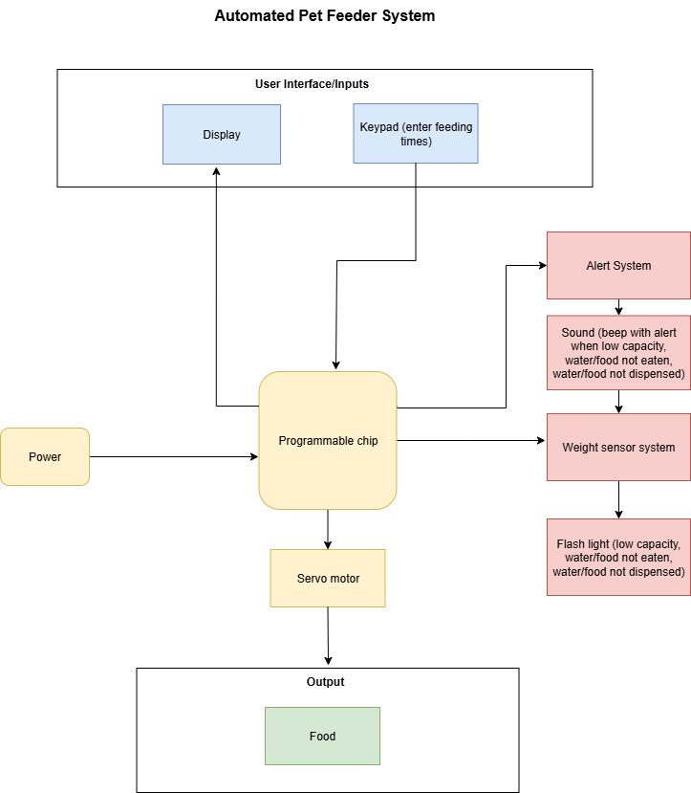

Figure 1: Image of block diagram created for automated pet feeder system, template from Wondershare Edraw, 2021.

**Step 2: Organise and Describe the Data**

**Data table with inputs/outputs and operation parameters:**

|  |  |  |
| --- | --- | --- |
| **Parameter** | **Type** | **Example value** |
| Max capacity – Food | Constant | 10kg |
| Low Capacity – Food | Constant | 0.15kg |
| Is food dispensed? | Decision | Yes/No |
| Has food been eaten? | Decision | Yes/No |
| Display available | Output | Current food level |
| Alert | Output | Sound on/off |
| Sensor | Output | Light on/off |
| Dispense food | Output | Dispense food to tray/bowl |
| Put food into dispenser | Input | 5kg |
| Feeding times | Input | 8:00AM |
| Feeding amounts | Input | 0.2kg per feeding time |
| Set system time | Input | 5:00PM |

**Step 3: Plan the Solution (Design the Algorithm)**

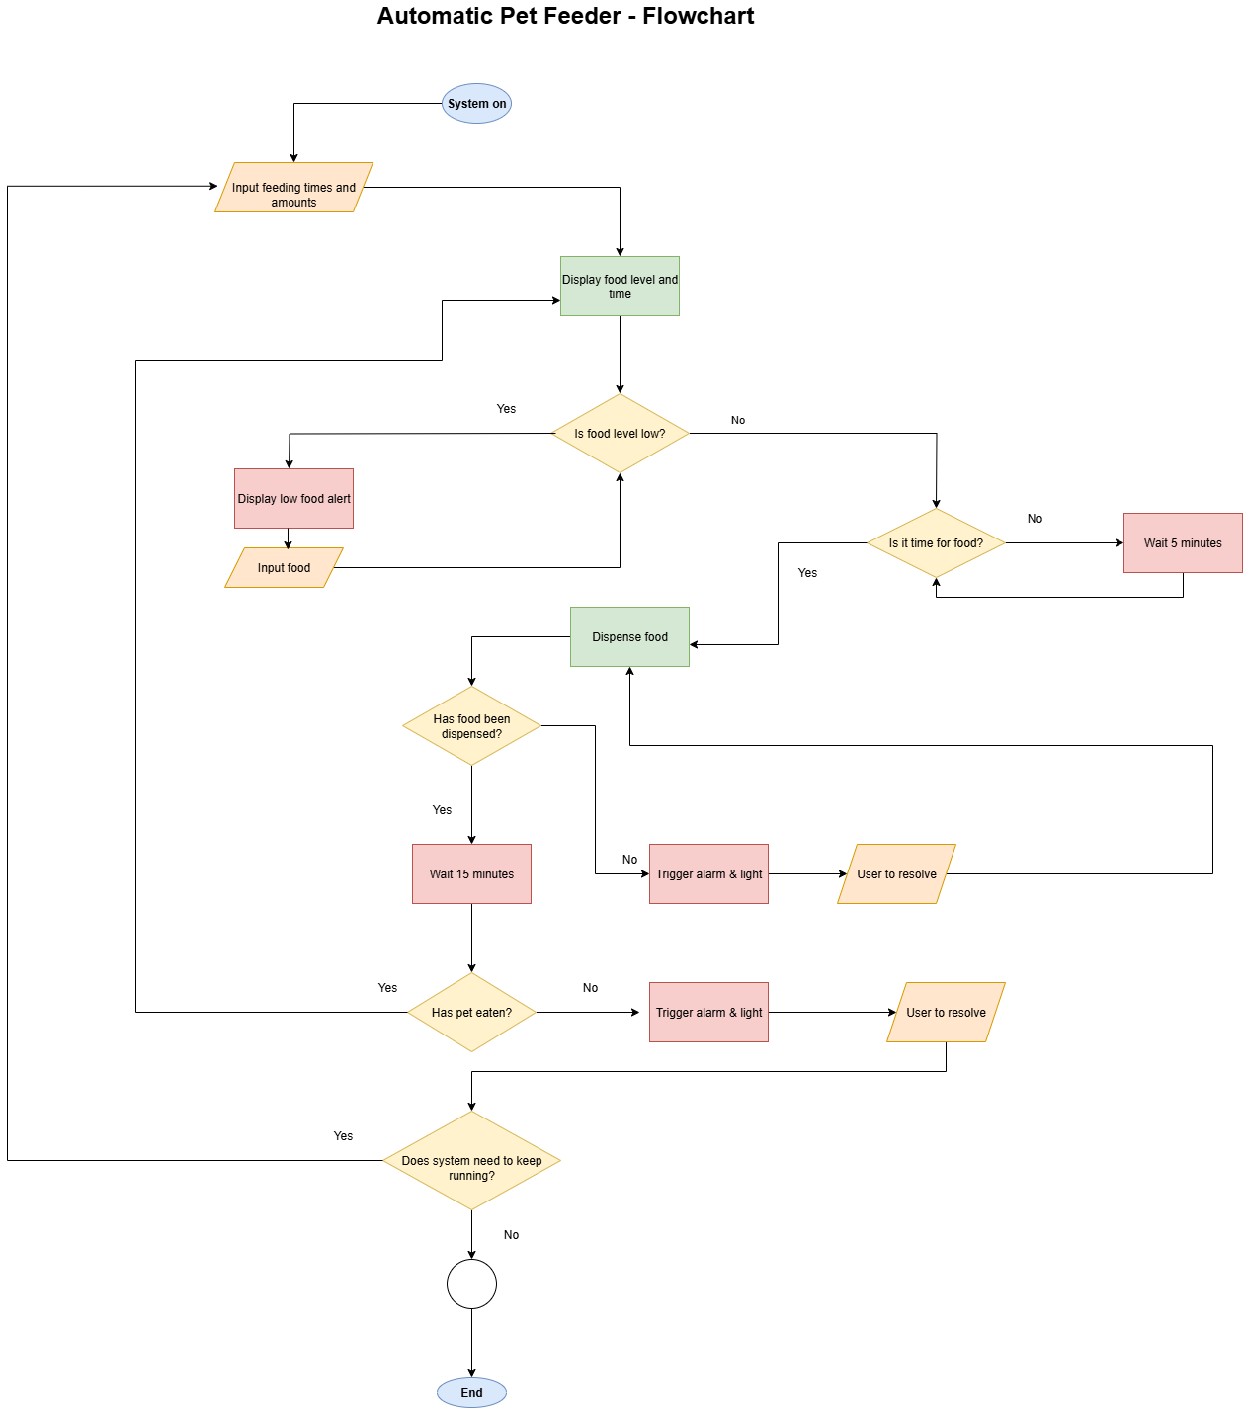

Figure 2: Flowchart showing algorithm design of automated pet feeder system.

**Step 4: Implement the Solution (Word Coding)**

**Word code/pseudocode:**

1. Program system time
2. Set feeding times and food amounts to be dispensed
3. Display the current food level and time
4. If food levels are low, display “food level low” and trigger alert
5. Else, check if feeding time
6. If feeding time, dispense food
7. If not feeding time wait 5 minutes, check again
8. Dispense food
9. If food not dispensed, display “dispense failure” and trigger alert
10. Else, wait 15 minutes using weight sensor to detect if pet has eaten
11. If pet has eaten, return to step 3
12. If pet has not eaten, display “food not eaten” and trigger alert
13. Check if system needs to keep running
14. If system needs to keep running, return to step 2
15. Else, end program

**Step 5: Test and Refine the Solution (Debug and Verify)**

**Test outputs:**

1. Pet has eaten, with food level 100g 🡪 display food level, with food level low alert
2. Pet has eaten, with food level 2kg 🡪 display food level, without alert
3. Pet has not eaten, with weight sensor reading 200g in bowl 🡪 trigger alarm and lights
4. Food/kibble size too large for dispenser 🡪 trigger alarm and lights

**Expectations of system:**

1. Max capacity of dispenser allowed: 10kg
2. Dispenser is updated: actual food level is displayed
3. Food is dispensed at feeding times
4. Alarms and lights are triggered if pet has not eaten or food levels are low

**Suggested improvements:**

1. Adding features for dispenser to retract food if pet not eaten
2. Ability to monitor system levels remotely, i.e. from mobile app or website dashboard
3. Ability to also dispense water for pets and monitor water levels accurately

# **Your Challenge PART 2: On the Use of Technology. To promote professional reporting and personal development practices, you are now required to use GitHub to manage your project files and collaborate efficiently when needed.**

**Petfeeder Github Respitory Link:**

<https://github.com/CheriseKellmanUC/IIT-Semester-2-Assignment1-PetFeederProject>

# **Your Challenge PART 3: On AI Agent Integration**

In this part of the assignment, you will explore how Artificial Intelligence (AI) can assist in solving problems, refining logic, and enhancing your assignment’s documentation. You are encouraged to use an AI agent such as Microsoft Copilot to support your work.

Use Copilot to assist with at least two or more of the following:

1. Refine your logic or Word Code: Ask Copilot to review your Step 4 implementation and suggest improvements or identify potential issues.

2. Generate alternative solutions: Prompt Copilot to propose different ways to solve the problem or enhance your flowchart logic.

3. Explore real-world implementation: Use Copilot to discuss how your system could be built using actual hardware (e.g., Arduino, Raspberry Pi).

4. Improve documentation: Ask Copilot to help you write a professional README.md file or summarize your project for presentation.

5. Reflect on ethics and limitations: Use Copilot to explore the ethical implications of using AI in automated pet care or discuss the reliability of AI-generated suggestions.

**1. Generate alternative solutions: Prompt Copilot to propose different ways to solve the problem or enhance your flowchart logic.**

- Student prompt to Copilot:

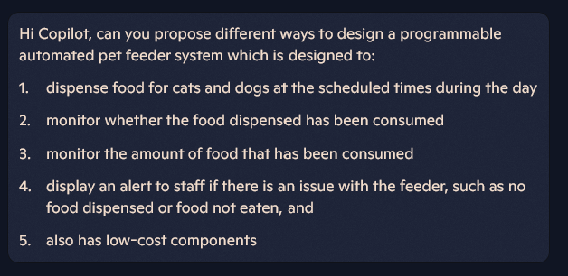

- Copilot’s response:

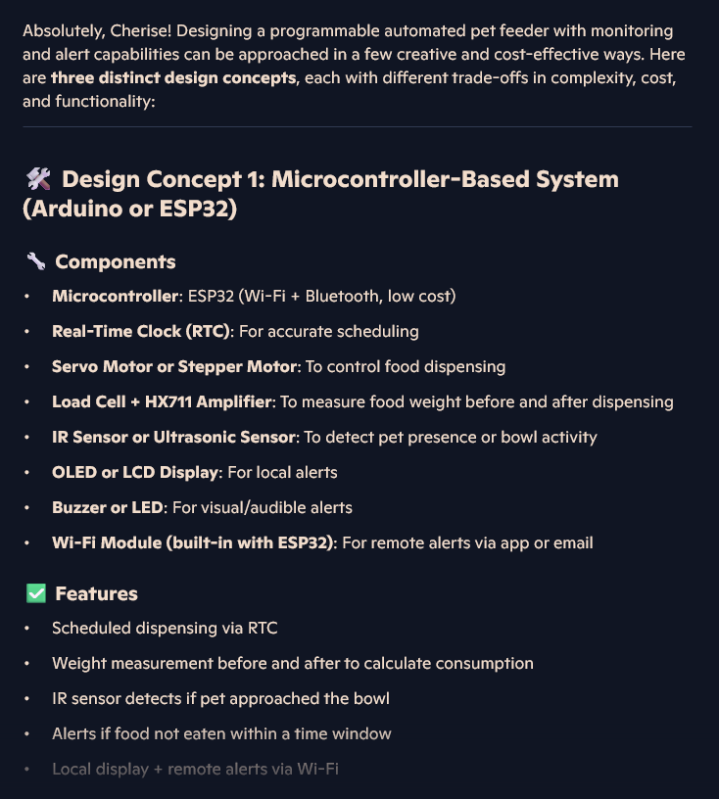

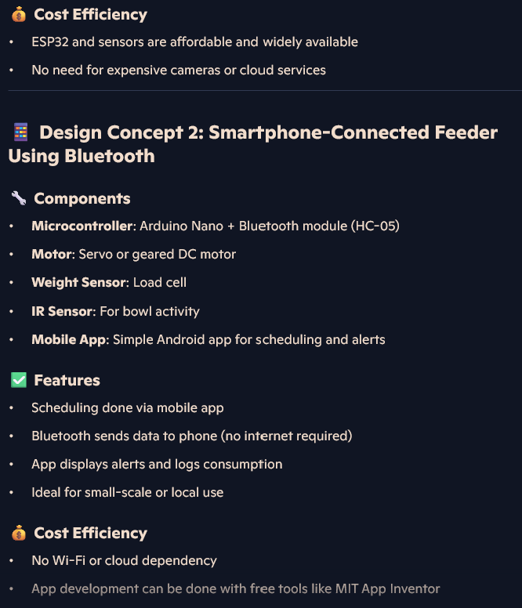

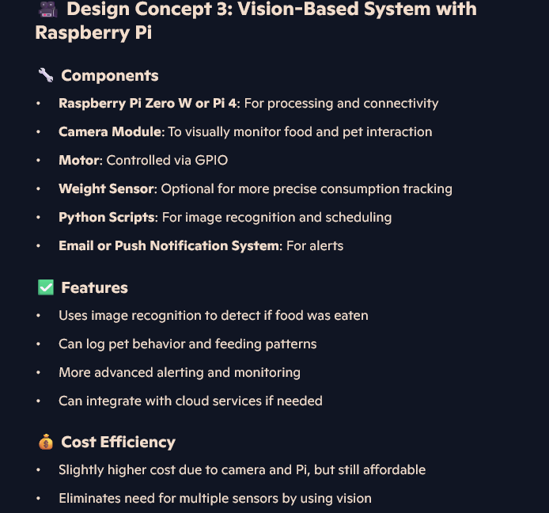

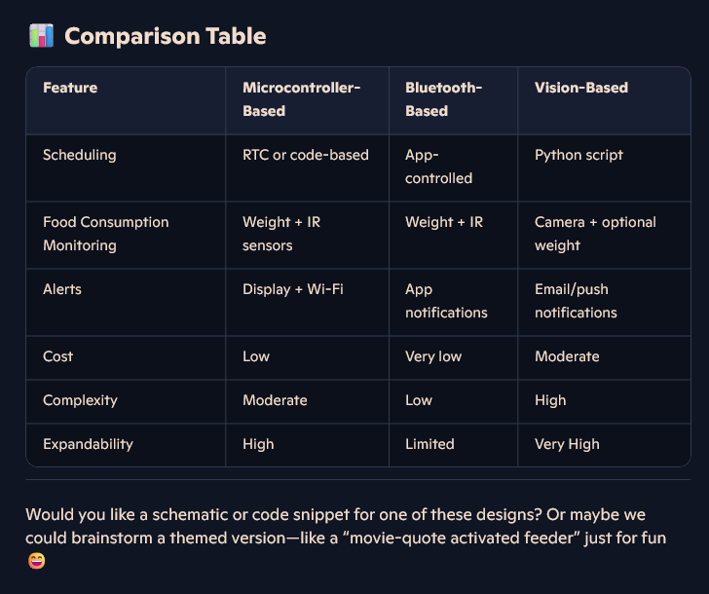

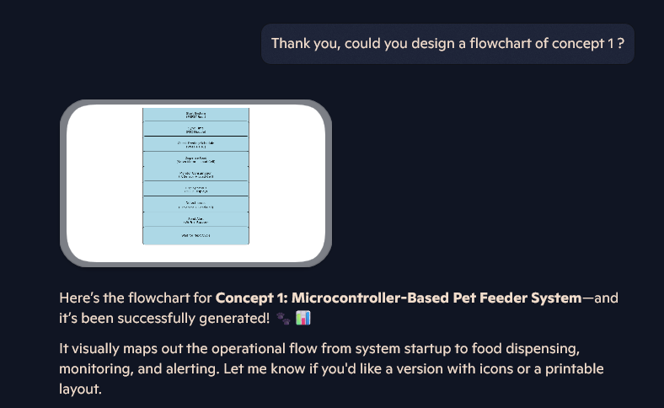

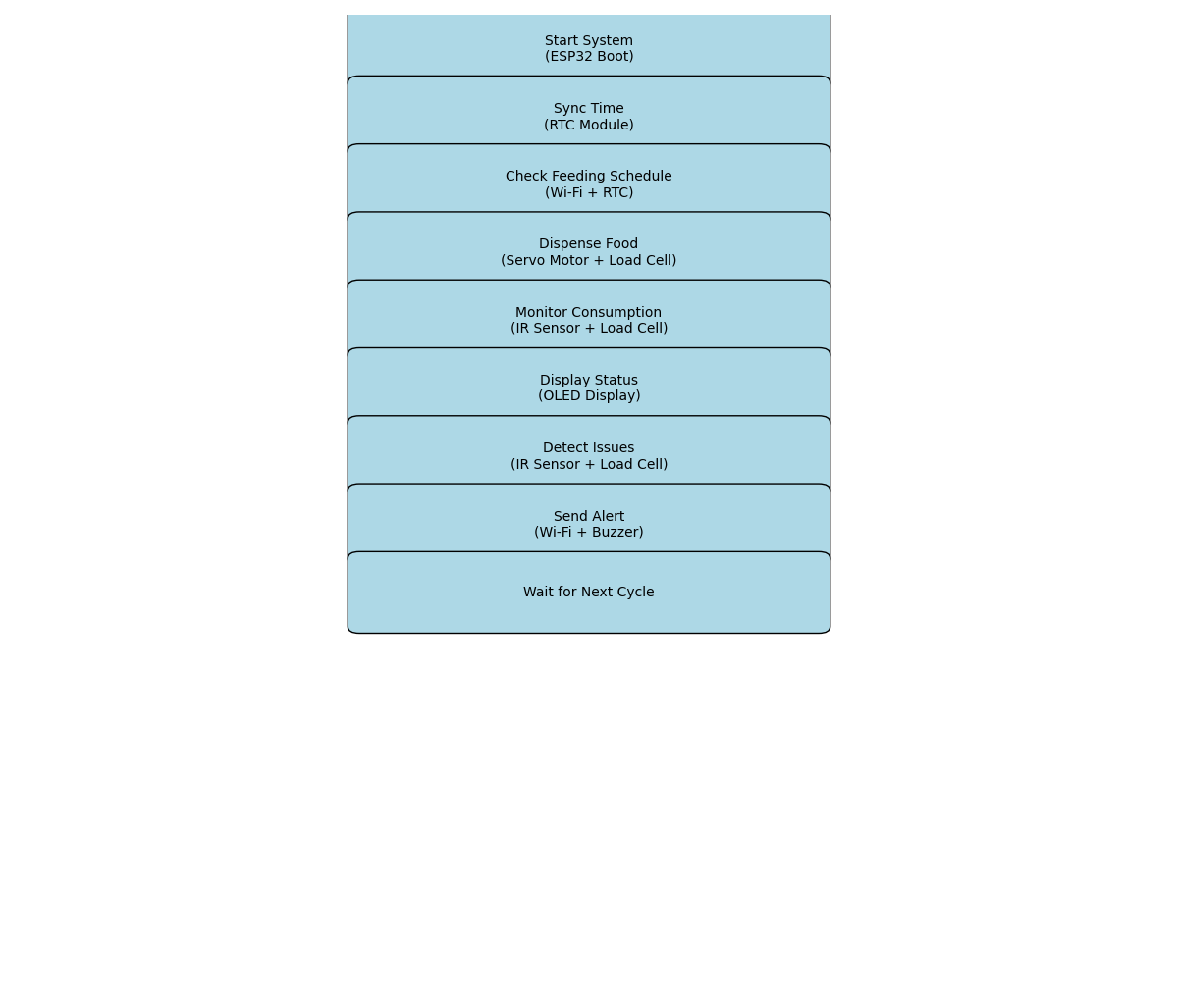  
Figure 3: Generated image

* Student reflection:

While I was working on my assignment, I only thought to envision a design concept which was simple and straightforward. However, Copilot presented three different concepts. I think that concept 1 is most similar to my own, and this gave me confidence in my design because I felt like I was on the right track with my ideas. I feel like concept 2 from Copilot would probably be more user friendly as it gives the ability to use the pet feeder remotely from a smartphone, and I think that would be very helpful for an animal shelter, because any adjustments to the feeding times or food monitoring could be done from anywhere. The user could also be alerted on their phone of any issues as well which means errors with the food dispenser could be fixed quicker. I was very interested to see how Copilot would put this into a flowchart so I asked it to design one for concept 1.

While the flowchart was clear in the steps it would take to dispense food, it also had a lot of errors such as no arrows or decision steps. However, I was surprised to see that it included the monitoring system, sensors and food dispensing mechanisms. In the flowchart I created, there is the assumption that these features are included from the different decision processes highlighted. I learnt that while Copilot might be useful for brainstorming, it could not produce a detailed, step by step flowchart.

**2. Reflect on ethics and limitations: Use Copilot to explore the ethical implications of using AI in automated pet care or discuss the reliability of AI-generated suggestions.**

* Student prompt:

**

* Copilot response:

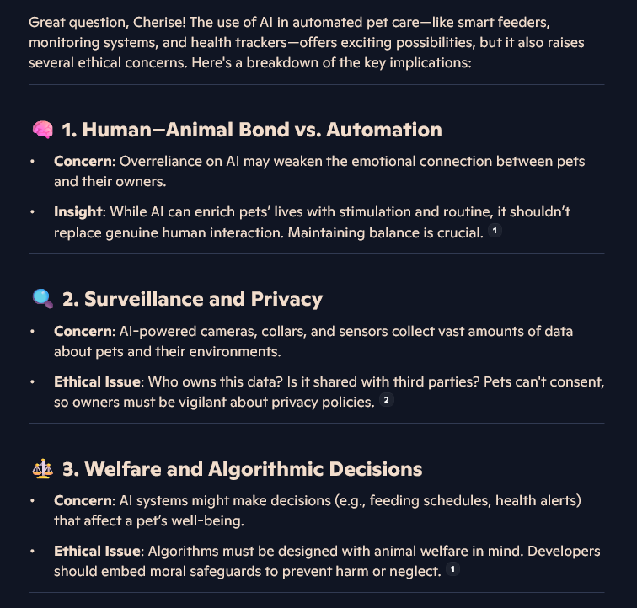

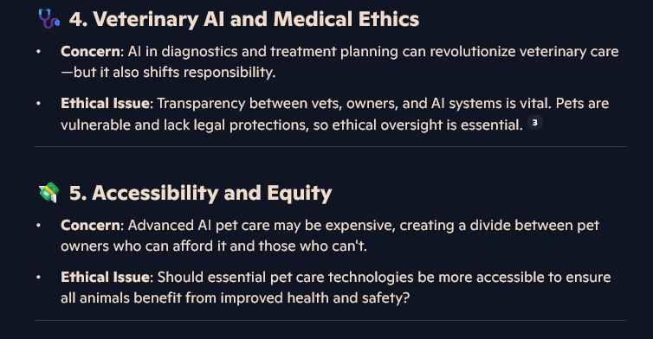

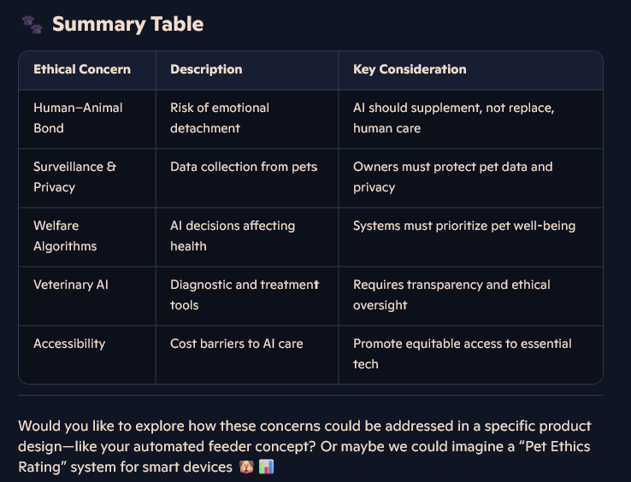

* Student reflection:

I believe that AI in pet care in general could be very useful to pet owners and professionals in the pet care industry, in the areas of automating feeding, pet monitoring (motion camera’s, pet camera’s, etc), but I don’t think that AI should take a bigger role beyond that. I agreed with Copilot when it said that AI should not replace genuine human interaction, it should just make caring for our pets more efficient. I feel like AI in pet care could give us peace of mind when comes to monitoring our pet’s activity and even their vital signs, this could help us detect when our pets are sick in a quicker way, however Copilot made good points about privacy, while it could alert us to issues faster, there is an ethical issue with how our information might be stored, as large amounts of data would be collected when we use these tools. I often use an automated water fountain for my dog, so this also reminded me that while the fountain is useful for having water readily available to my dog, I really don’t know how any data collected is stored and used. I will be very mindful of how I use automated pet care items in the future.

# **References:**

Wondershare Edraw. (2021, December 18). How to Draw Block Diagram | Explain with Examples [Video]. Youtube.<https://www.youtube.com/watch?v=iggvA8-Or1w>

Academic Skills, The University of Melbourne. (2017, June 2). Reflective writing [Video].Youtube.<https://www.youtube.com/watch?v=SntBj0FIApw&t=31s>

Learn Fast Make Things. (2022, May 4). How To Write a USEFUL README On Github[Video]. YouTube. <https://www.youtube.com/watch?v=E6NO0rgFub4&t=306s>

# **Appendix**

## README.md

#Automated Pet Feeder

This is an automated pet feeder which dispenses food at specified times throughout the day.

The automated pet feeder is programmed to dispense food through the day at times specified by the user. The pet feeder has an alert system which will notify the user if the pet has not eaten, food has not been dispensed or if the food level is currently low.

The system also has a servo motor which will rotate to open position to dispense food and rotate to the closed position after food is dispensed.

#How this pet feeder works:

Link to flowchart here

#Instructions to user:

1. Turn pet feeder on.
2. Display to turn on and ask user to input current time/set system time
3. Display will then ask user to enter the scheduled times they would like food to be dispensed to pets.
4. Put kibble/biscuits into feeder.

#Troubleshooting:

System will alert user if any issues occur where the pet has not eaten or food level is low. The user is to read the alert on the display to resolve issue.