RECORD

Course: | Full Stack Web Development | Course Code: | 23CM4121
Experiment No.: | 3 | Date: | 30-08-2026
Student Name: | V Cherishma | Roll No.: | A24126552126

TITLE
Write a Program Using JavaScript (Arrays, Functions)

AIM
To write and execute JavaScript programs that demonstrate the use of arrays and functions, including adding and removing elements from an array and finding the largest element in an array using a user-defined function.

OBJECTIVE
  - To understand how arrays are declared and manipulated in JavaScript.
  - To use array methods such as push(), unshift(), and shift().
  - To use the spread operator to combine and extend arrays.
  - To define and use functions that accept arrays as parameters.
  - To write a function that iterates through an array to find the largest element.
  - To display the results of array operations using console.log().

THEORY
An array in JavaScript is an ordered collection of elements that can hold multiple values in a single variable. Arrays support several built-in methods to add, remove, or modify elements.
  - push(): Adds an element to the end of the array.
  - unshift(): Adds an element to the beginning of the array.
  - shift(): Removes the first element of the array.
  - Spread operator (...): Used to expand array elements, commonly used to merge or extend arrays.
A function in JavaScript is a reusable block of code designed to perform a particular task. Functions can accept parameters (such as an array) and return a value. In this experiment, a function is used to accept an array of numbers and iterate through it using a loop to determine the largest element.
The basic flow of the program is:
Array Declaration → Function Definition → Function Call → Processing → Output Display

ALGORITHM / PROCEDURE
- Declare an array (shoppingList) with initial string elements.
- Define a function addItem() that adds a new item to the array using push().
- Call addItem() to add new elements and display the updated array.
- Declare another array (food) and display its initial contents.
- Use push() and unshift() to add elements at the end and beginning of the array.
- Use shift() to remove the first element from the array.
- Use the spread operator to create a new extended array with additional elements.
- Declare a numeric array (numbers) with a set of values.
- Define a function findLargest(arr) that uses a for loop to find the largest element.
- Call the function and store the result in a variable.
- Display the array and the largest element using console.log().
- Run the program using Node.js and verify the output in the terminal/debug console.

PROGRAM

function.js (Array Manipulation)
let shoppingList = ["Milk", "Bread", "Eggs"];

function addItem(newItem) { shoppingList.push(newItem);
}
console.log("Initial List:", shoppingList); addItem("Bananas");
addItem("Cheese");

console.log("Updated List:", shoppingList);

const food=["pizza","burger","kfc","frenchfries"]; console.log(food);
food.push("tandori"); food.unshift("biriyani"); console.log("modified array is: ",food); food.shift();
console.log(" array is: ",food);
const extend=[...food,"chicken curry","pulav"]; console.log(extend);

array.js (Finding the Largest Element)
let numbers = [12, 45, 7, 89, 34]; function findLargest(arr) {
let largest = arr[0];

for (let i = 1; i < arr.length; i++) {

if (arr[i] > largest) { largest = arr[i];
}
}

return largest;
}

let result = findLargest(numbers);
console.log("Array Elements:", numbers); console.log("Largest Element:", result);

CODE EXPLANATION

Code | Explanation
push() | Adds one or more elements to the end of an array.
unshift() | Adds one or more elements to the beginning of an array.
shift() | Removes the first element from an array and returns it.
...(spread operator) | Expands an array's elements, used here to create a new extended array.
function findLargest(arr) | A user-defined function that accepts an array and returns its largest element.
for loop | Iterates through the array elements to compare and find the largest value.
console.log() | Displays the array contents and results in the console.

TEST CASES AND EXECUTION DATA

Test Case | File | Input | Expected Result | Status
TC-01 | function.js | addItem("Bananas"), addItem("Cheese") | List grows from 3 to 5 items | Pass
TC-02 | function.js | push, unshift, shift, spread on food array | Array correctly modified and extended to 7 items | Pass
TC-03 | array.js | findLargest([12,45,7,89,3 4]) | Returns 89 as the largest element | Pass

OUTPUT

Output 1: function.js — Array Manipulation

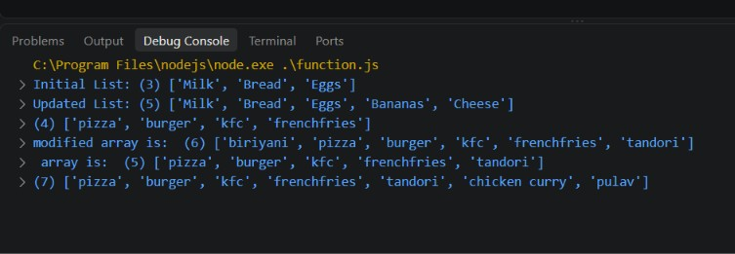
Shopping list updated with push(), and the food array modified using push(), unshift(), shift(), and the spread operator.

Output 2: array.js — Finding the Largest Element
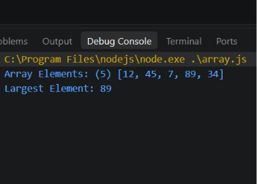

RESULT
findLargest() correctly identifies 89 as the largest element in the array.

Thus, JavaScript programs demonstrating the use of arrays and functions were successfully written and executed. Array elements were added, removed, and extended using push(), unshift(), shift(), and the spread operator, and a user-defined function was used to correctly find the largest element in an array.

