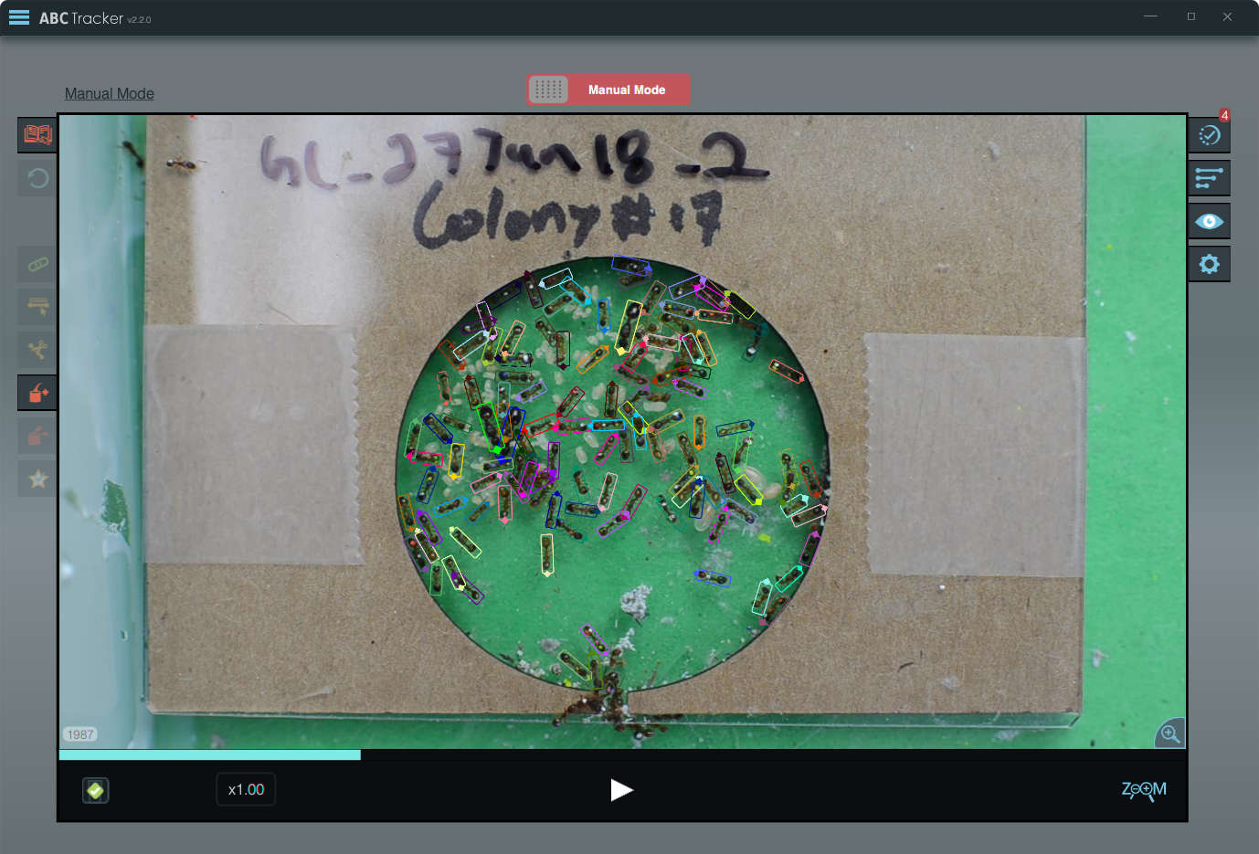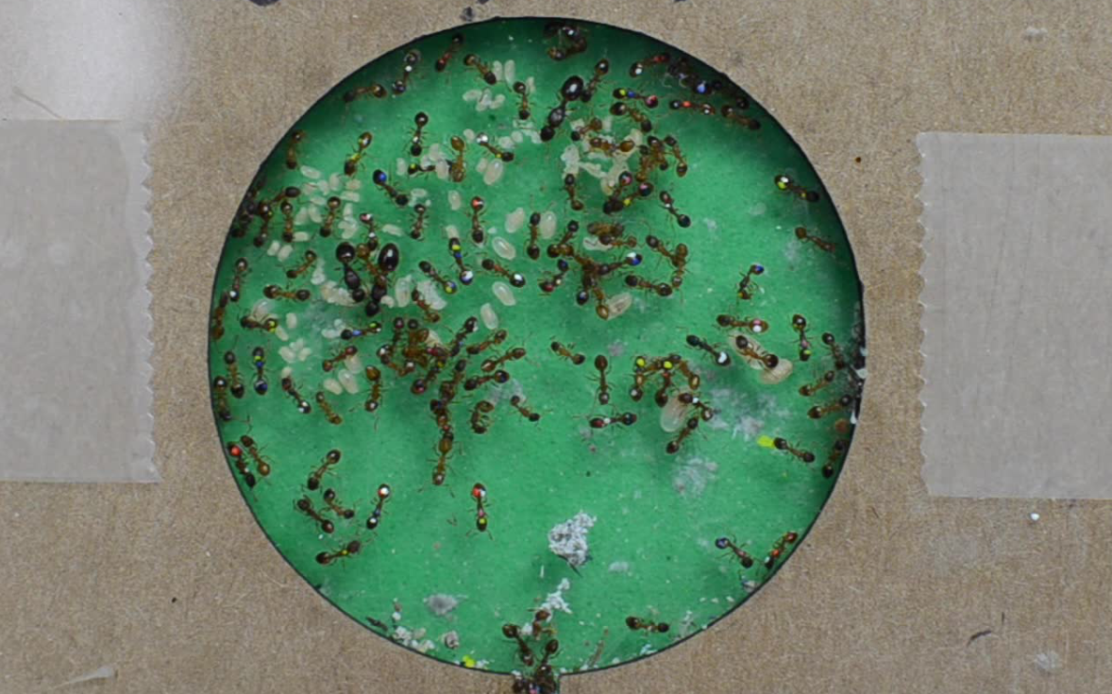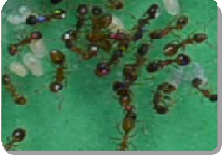

**#1 Mark**

Object marks gathered in step #1 are used to tune all tracking and correction parameters.

Object marks are specified with three mouse clicks.

**#2 Track**

Minimal system requirements due to computation being performed on server.

Long video sequences are automatically chunked, tracked individually, and assembled by the system.

Tracking algorithm design avoids errors that require greater correction effort.

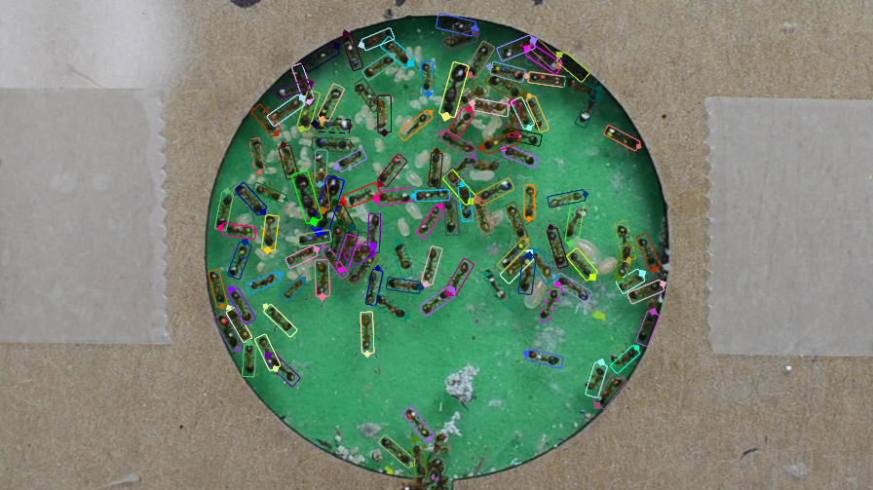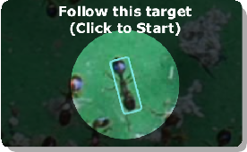

**#3 Correct**

Manual correction mode contains visualization and correction tools to identify and address tracking errors.

Guided correction

mode identifies potential errors and directs the user through fixing them.