哈尔滨工业大学计算学部
实验报告

课程名称：数据结构与算法
课程类型：专业基础（必修）
实验项目：树形结构及其应用
实验题目：哈夫曼编码与译码方法
实验日期：2023/10/11

班级：2203901
学号：2022111009
姓名：周天宇

设计成绩 | 报告成绩 | 指导老师
 |  | 翟德明

一、实验目的
通过哈夫曼编码的实现，加深对树形结构的理解和运用，同时掌握一种压缩数据的方式，对编码和译码的过程有初步的了解
二、实验要求及实验环境
实验要求：
1. 从文件中读入任意一篇英文文本文件，分别统计英文文本文件中各字符（包
括标点符号和空格）的使用频率；
2. 根据已统计的字符使用频率构造哈夫曼编码树，并给出每个字符的哈夫曼编
码（字符集的哈夫曼编码表）；
3. 将文本文件利用哈夫曼树进行编码，存储成压缩文件（哈夫曼编码文件）；
4. 计算哈夫曼编码文件的压缩率；
5. 将哈夫曼编码文件译码为文本文件，并与原文件进行比较。

实验环境：VS Code
三、设计思想（本程序中的用到的所有数据类型的定义，主程序的流程图及各程序模块之间的调用关系、核心算法的主要步骤）
1．逻辑结构 树形结构（二叉树）
2．存储结构 静态链表、结构体、vector容器
1）数据类型定义：
Huffman树的节点：
struct Node{
int frequency;
int left;
int right;
int parents;
bool isSelect;
Node():left(-1),right(-1),parents(-1),frequency(0),isSelect(false){};
};
Huffman表的节点：
struct code{
char ch;
string a;
};
主函数数据类型的定义：
char raw_symbols[20000];
char saved_symbols[300]={0};
int count[300]={0};
int raw_symbols_len;
float frequrncy[300];
vector<char> sorted_symbols;
vector<int> sorted_count;
bool isSymbolValid[300] = { false };
int validCount = 0;
Node HTree[200];
code Huffmantable[200];
double compressionRate；

2）主程序的流程图：
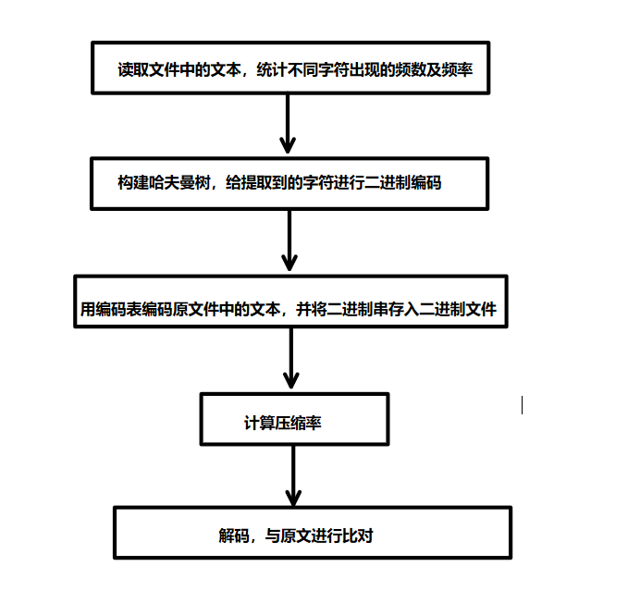

3）各程序模块之间的调用关系：
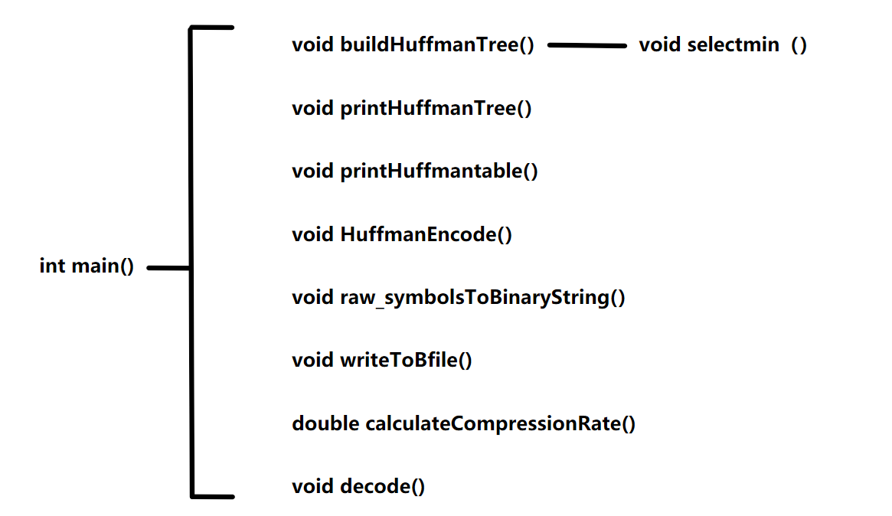

4）核心算法的主要步骤：
a.建立哈夫曼树：
首先将每节点建树，形成森林；然后找出频率最小的两棵树形成一棵新树，其根节点的权值为它们的频率之和，左右孩子指向这两棵树/节点，以此类推，直到只剩下一棵树，即为哈夫曼树。
找出最小的两棵树，这里用了两次遍历，分别找出第一小和第二小。

b.编码：
这里采用由根节点递归的方式，每往左遍历，编码+“0”；每往右遍历，编码+“1”,直到遍历到叶节点。

c. 将二进制文本写入二进制文件：
用按位打包的方式进行。对已经形成好的二进制字符串，每次读一位，若是零，将当前字节左移一位；若是一，当前字节左移一位，同时将最低位改为1。每读8位压到vector中。若剩余的字符不足8位，则将当前字节左移（8-bitcount）位，bitcount是当前该字节已读的位数，这样有效的bit会被移至字节顶部，后面自动补0，再压入vector。

四、测试结果
1）测试文本数据：（共三段，合为成一段）
Exactly 50 years ago, two authors of this commentary raced out of Yom Kippur prayer services to cover the last surprise attack on Israel for news radio. Now we see Israel taken by surprise once again. The radical Palestinians of Hamas, governing the Gaza Strip since Israel’s withdrawal in 2005, managed to carry out an unprecedented and unprovoked attack by land, sea, and air—and the results that prompted Israel to declare all-out war included massacres of hundreds of innocent civilians of all ages in their homes, at children’s parties, and at concerts. Scores more were taken hostage. President Biden and leading U.S. Republican voices alike are vowing to stand strongly behind Israel.History again echoes, as the predicate for Hamas’ attack had less to do with anything that the Israeli Prime Minister Benjamin Netanyahu may have done—now is not the moment to blame the victim. Rather, the trigger to the attack was likely that the prospect of a wider Mideast peace was almost at hand through an impending deal between Israel and Saudi Arabia. Hamas’ sabotage parallels the disruption of the prospective Israeli-Palestinian peace plan in 2000 on the heels of a Camp David Summit when the devastation of the Second Intifada ruined any dreams of normalization and resulted in the deaths of thousands of civilians.This time, by all accounts, Israel, Saudi Arabia, and the United States were inching closer towards a transformative three-way deal, which would have seen Israel and Saudi formally recognize each other within a security, defense, and economic partnership with the U.S. Just a week ago, Saudi Crown Prince Mohammed Bin Salman said that “every day we get closer” to a deal, while Netanyahu similarly stated that he was confident of forging “a historic peace” between his country and Saudi Arabia, with Israeli cabinet ministers already landing in Riyadh to “nurture blossoming ties.”

2）测试结果：

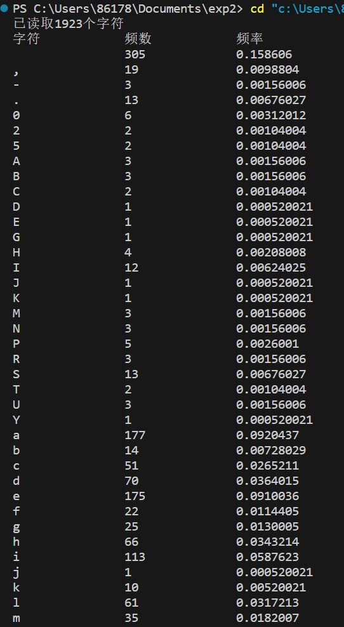
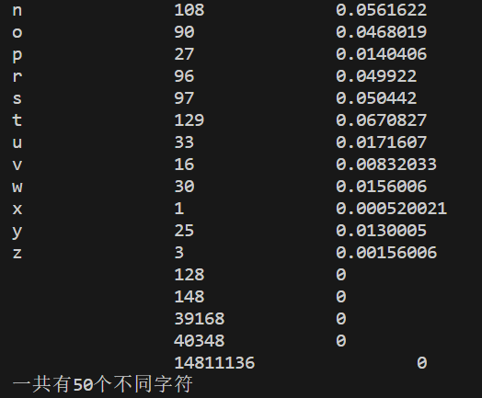

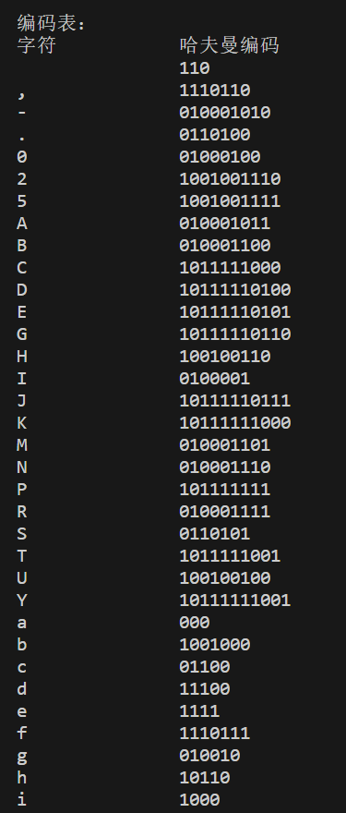
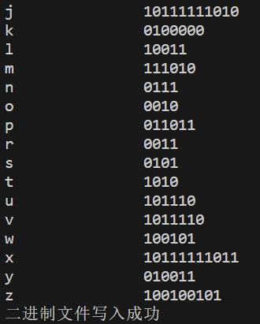

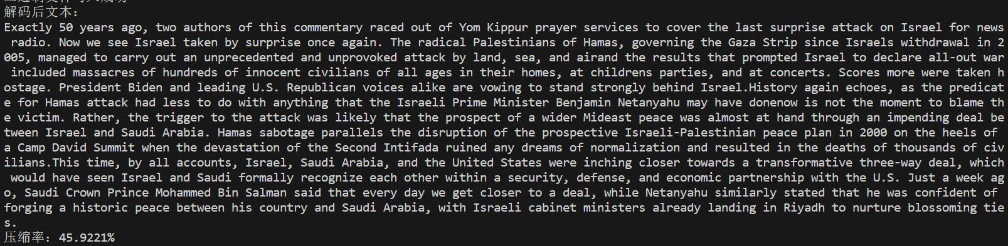

注：压缩率：45.922%

算法的时间复杂度分析：
a.建立哈夫曼树：先将频率存入树节点，一次遍历为O（n）；再遍历静态链表，其中含有selectmin（）函数，为O（n*2n），共为O（n^2+n）.
b.编码：递归遍历一遍所有节点，时间复杂度为O（n）.
c.将二进制文本写入二进制文件：遍历一次二进制串，时间复杂度为O（n）.

五、经验体会与不足
1.在统计字符及频率时，字符和频率是依照ASCII码“散落”在数组中的，要进行后续操作还要新开数组，将它们依次不留空地排好，这样子比较麻烦。其实可以用map减少代码量。
2.建树模块还是卡了我很久，虽然理解了逻辑，但是真正写的时候总会有疏忽或是卡住的地方，这体现了自己对C++的不熟悉。
3.写入二进制的操作用按位打包既方便又好理解，以后可以运用。
六、附录：源代码（带注释）
- #include <fstream>
- #include <iostream>
- #include <map>
- #include <math.h>
- #include <queue>
- #include <stack>
- #include <string>
- #include <vector>
- using namespace std;

- class TreeNode {
- public:
- char ch;
- int count;
- bool isChar;
- TreeNode* left;
- TreeNode* right;

- // 构造函数
- TreeNode(char ch, int count, bool isChar)
- : ch(ch)
- , count(count)
- , isChar(isChar)
- , left(nullptr)
- , right(nullptr) {};
- TreeNode() { }
- };

- class BTree {
- private:
- TreeNode* root;

- public:
- BTree()
- {
- // root = new TreeNode('#');
- root = nullptr;
- }
- void destroy(TreeNode* node)
- {
- if (node != nullptr) {
- destroy(node->left);
- destroy(node->right);
- delete node;
- }
- }
- ~BTree()
- {
- destroy(root);
- }

- TreeNode* getroot()
- {
- return root;
- }
- };

- void Huffman_str(TreeNode* curr, string str, map<char, string>& m)
- {
- if (curr == nullptr) {
- return;
- }
- if (curr->isChar) {
- m[curr->ch] = str;
- }
- Huffman_str(curr->left, str + '0', m);
- Huffman_str(curr->right, str + '1', m);
- }

- void PrintTree(TreeNode* n, bool left, string const& indent)
- {
- if (n->right) {
- PrintTree(n->right, false, indent + (left ? "| " : " "));
- }
- cout << indent;
- // 判断当前节点为左节点还是右节点。然后使用/或者\表示左右节点
- cout << (left ? '\\' : '/');
- // 打印一个当前节点的数据 一定是序号换行的
- cout << "-----" << n->ch << endl;
- if (n->left) {
- PrintTree(n->left, true, indent + (left ? " " : "| "));
- }
- }

- void PrintTree(TreeNode* root)
- {
- cout << "图形化打印二叉树" << endl;
- cout << "________________\n"
- << endl;
- if (root->right) {
- PrintTree(root->right, false, "");
- }
- cout << root->ch << endl;
- if (root->left) {
- PrintTree(root->left, true, "");
- }
- cout << "________________\n"
- << endl;
- }
- void PrintTree(TreeNode* root, int indent = 0)
- {
- if (root == nullptr) {
- return;
- }

- // 增加缩进，以表示树的层级结构
- indent += 4;

- // 递归打印右子树
- PrintTree(root->right, indent);

- // 打印当前节点，带有缩进
- for (int i = 4; i < indent; i++) {
- std::cout << " ";
- }
- std::cout << root->count << std::endl;

- // 递归打印左子树
- PrintTree(root->left, indent);
- }

- void readfile(string filename, string& content)
- {
- ifstream file(filename); // 打开文件

- if (!file.is_open()) {
- cerr << "无法打开文件" << endl;
- }

- string line;

- // 读取第一行内容
- if (getline(file, line)) {
- content = line;
- // cout << "第一行内容: " << line << endl;
- } else {
- // cerr << "文件为空" << endl;
- }

- file.close(); // 关闭文件
- }
- void readBfile(string filename, string& content)
- {
- std::ifstream file(filename, std::ios::binary);
- if (!file.is_open()) {
- cerr << "无法打开文件" << endl;
- }

- string line = "";

- // 读取第一行内容
- char bit;
- while (file.get(bit)) {
- for (int i = 7; i >= 0; --i) {
- // 使用位运算检查并提取每个位的值
- char t = (bit & (1 << i)) ? '1' : '0';
- line += t;
- }
- }
- file.close(); // 关闭文件
- int NULLCount=0;
- string last8Characters = line.substr(line.length() - 8);
- int binaryBase = 1; // 二进制的基数每次乘2

- // 从右到左遍历二进制字符串
- for (int i = last8Characters.length() - 1; i >= 0; --i) {
- if (last8Characters[i] == '1') {
- NULLCount += binaryBase;
- }
- binaryBase *= 2; // 更新二进制的基数
- }

- NULLCount+=8;
- content=line.substr(0, line.length() - NULLCount);
- }
- int getarrcnt(TreeNode* chars[], int size)
- {
- int cnt = 0;
- for (int i = 0; i < size; i++) {
- if (chars[i] != nullptr) {
- cnt++;
- }
- }
- return cnt;
- }

- void getmin(TreeNode* chars[], int size, TreeNode*& min1, TreeNode*& min2)
- {
- for (int i = 0; i < size; i++) {

- if (chars[i] == nullptr) {
- continue;
- }
- if (min1 == nullptr) {
- min1 = chars[i];
- } else if (chars[i]->count < min1->count) {
- min1 = chars[i];
- }
- }
- for (int i = 0; i < size; i++) {
- if (chars[i] == nullptr) {
- continue;
- }
- if (min2 == nullptr && chars[i] != min1) {
- min2 = chars[i];
- } else if (chars[i]->count < min2->count && chars[i] != min1) {
- min2 = chars[i];
- }
- }
- }

- string decode(string archive, TreeNode* root)
- {
- string content = "";
- TreeNode* curr = root;
- for (auto i : archive) {
- if (i == '0') {
- curr = curr->left;
- } else {
- curr = curr->right;
- }
- if (curr->isChar) {
- content += curr->ch;
- curr = root;
- continue;
- }
- }

- return content;
- }

- void write_into_Bfile(const string& filename, const string& archive)
- {
- ofstream binaryFile(filename, ios::binary | ios::out | ios::trunc); // 打开二进制文件并清空
- if (binaryFile.is_open()) {
- vector<char> packedData; // 用于存储打包后的数据

- char currentByte = 0; // 当前字节
- int bitCount = 0; // 记录当前字节中已经写入的位数

- for (size_t i = 0; i < archive.length(); i++) {
- char bit = archive[i];
- if (bit == '0') {
- currentByte <<= 1; // 将当前字节左移一位
- } else if (bit == '1') {
- currentByte = currentByte << 1;
- currentByte = currentByte | 1; // 在当前字节最低位置1
- } else {
- cerr << "无效的字符：" << bit << endl;
- return; // 退出函数以避免写入无效数据
- }

- bitCount++;

- // 如果当前字节已经装满8位，则将其添加到容器并重置
- if (bitCount == 8) {
- packedData.push_back(currentByte);
- currentByte = 0;
- bitCount = 0;
- }
- }

- // 如果还有未装满的字节，将其添加到容器
- if (bitCount > 0) {
- currentByte <<= (8 - bitCount);
- packedData.push_back(currentByte);
- }
- packedData.push_back(8-bitCount);

- // 将打包后的数据写入二进制文件
- binaryFile.write(packedData.data(), packedData.size());
- binaryFile.close();
- cout << "二进制文件写入成功" << endl;
- } else {
- cerr << "无法打开文件" << endl;
- }
- }

- double calculateCompressionRate(const string& filename, const string& archive)
- {
- // 打开原始文件
- ifstream originalFile(filename, ios::binary | ios::ate);
- if (!originalFile.is_open()) {
- cerr << "无法打开原始文件" << endl;
- return -1.0;
- }

- // 获取原始文件的大小
- streampos originalFileSize = originalFile.tellg();
- originalFile.close();

- // 打开压缩后的文件
- ifstream compressedFile(archive, ios::binary | ios::ate);
- if (!compressedFile.is_open()) {
- cerr << "无法打开压缩后的文件" << endl;
- return -1.0;
- }

- // 获取压缩后文件的大小
- streampos compressedFileSize = compressedFile.tellg();
- compressedFile.close();

- // 计算压缩率（百分比）
- double compressionRate = (1.0 - static_cast<double>(compressedFileSize) / static_cast<double>(originalFileSize)) * 100.0;

- return compressionRate;
- }

- int main()
- {

- string content;
- readfile("article.txt", content);
- cout << "源文本：" << endl
- << content << endl;
- cout << endl;
- map<char, int> charCount;
- for (char c : content) {
- // 如果字符已经在map中，增加计数，
- //否则添加新字符并初始化计数为1
- if (charCount.find(c) != charCount.end()) {
- charCount[c]++;
- } else {
- charCount[c] = 1;
- }
- }

- // 打印每个字符和对应的计数
- for (const auto& pair : charCount) {
- cout << "字符 '" << pair.first << "' 出现了 " << pair.second << " 次" << std::endl;
- }
- cout << endl;

- int size = charCount.size();
- TreeNode* chars[size];
- int i = 0;
- for (const auto& pair : charCount) {
- TreeNode* curr = new TreeNode(pair.first, pair.second, 1);
- chars[i] = curr;
- i++;
- }

- TreeNode* examplemin = new TreeNode(-1, 99999999, 0);
- TreeNode* min1;
- TreeNode* min2;
- TreeNode* Huffman = nullptr;

- while (1) {
- if (getarrcnt(chars, size) == 1) {
- for (int i; i < size; i++) {
- if (chars[i] != nullptr) {
- Huffman = chars[i];
- break;
- }
- }
- break;
- }
- min1 = examplemin;
- min2 = examplemin;
- getmin(chars, size, min1, min2);
- TreeNode* curr = new TreeNode(-1, (min1->count + min2->count), 0);
- curr->left = min1;
- curr->right = min2;
- for (int i = 0; i < size; i++) {
- if (chars[i] == min1) {
- chars[i] = curr;
- } else if (chars[i] == min2) {
- chars[i] = nullptr;
- }
- }
- }
- // PrintTree(Huffman, 0);

- map<char, string> Huffmanmap;

- Huffman_str(Huffman, "", Huffmanmap);

- for (const auto& pair : Huffmanmap) {
- cout << "字符 '" << pair.first << "' 编码：" << pair.second << std::endl;
- }
- cout << endl;

- string archive = "";
- for (auto i : content) {
- archive += Huffmanmap[i];
- }
- cout << "哈夫曼编码：" << endl
- << archive << endl;

- write_into_Bfile("archive.bin", archive);
- cout << endl;
- string readfromBfile;
- readBfile("archive.bin", readfromBfile);
- // cout<<readfromBfile<<endl;

- // string txt = decode(archive, Huffman);
- string txt = decode(readfromBfile, Huffman);
- cout << "解码后源文件：" << endl
- << txt << endl;
- cout << endl;
- double compressionRate = calculateCompressionRate("content.txt", "archive.bin");
- if (compressionRate >= 0.0) {
- std::cout << "压缩率为: " << compressionRate << "%" << std::endl;
- }
- return 0;
- }

