1. **LPP** - Max z = 7x1 + 10x2

Subject to

c1 = 5x1 + 6x2 <= 3600

c2 = x1 +2x2 <= 960

c3 = x1 <= 500

c4 = x2 <= 500

x1, x2 >= 0

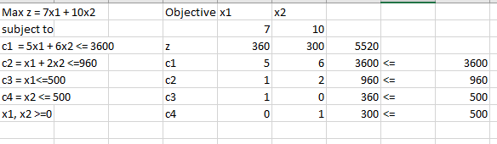

**Sensitivity Analysis Report**-

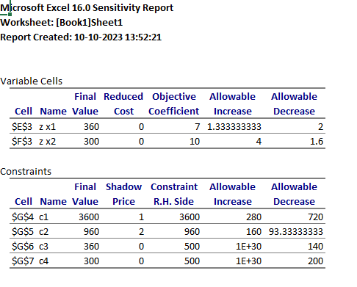

b.) Cost efficient sensitivity analysis –

The cost of Baseball can be increased by $1.333333333 and has an allowable decrease of $2.

And the cost of Softball can be increased by $4 and it has an allowable decrease of $1.6.

c.) Right hand side sensitivity analysis –

Out of 500 Baseballs, we are manufacturing only 360 balls. Hence, the allowable decrease is 140.

Out of 500 Softballs, we are manufacturing only 300 balls. Therefore, the allowable decrease is 200.

We are utilizing all the cowhide (3600 sq. feet), and there’s an allowable increase of 280, and can be decreased by 720. It has a shadow price of $1.

We are utilizing all the time (960 minutes), and there’s an allowable increase of 160, and can be decreased by 93.33333333. It has a shadow price of $2.

2.

