**Risk Factors for different asset classes**

We selected our equity universe to consist equities in different countries including CAD, AUD, EUR, JPY, USD. For each country’s equity, we are using Fama-French 5 factors issued in each country and the fx exchange rate between it’s currency and USD as the risk factor. For ETF:fixed income and the index of Dow Jones average industry index we are choosing the following factors:

|  |
| --- |
| **ticker** |
| SP500 |
| US Large Cap |
| US Small Cap |
| US Mid Cap |
| TSX |
| Europe |
| EM |
| US/CAD |
| US Treasury |
| US Corp High Yield |
| US IG 5-10 yr |
| CGOV 10y |
| CGOV 5y |
| CGOV 2y |
| Gold |
| Crude Oil |
| US Real Estate |
| CAN Real Estate |
| Toronto Real Estate |
| VIX |

Then for implied volatility, we are using 5 US Fama-French 5 factor model and VIX as the risk factors.

**Backtesting**

Here we showed the prediction power on 90 days return based on 5 year’s historical data.

**ETF: fixed income**

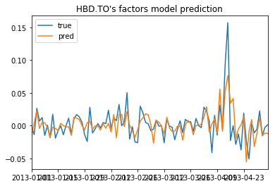

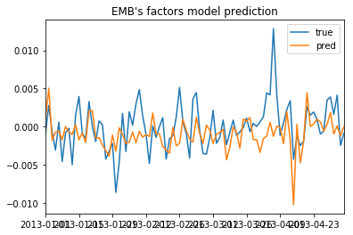

**Index:**

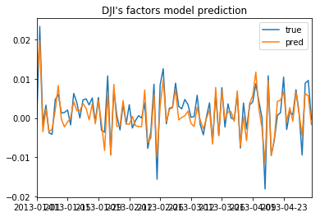

**Implied vol:**

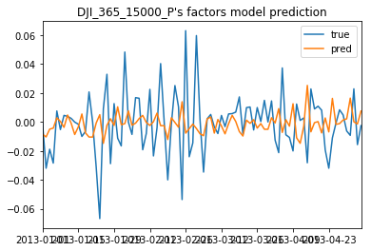

**Equity:CAD**

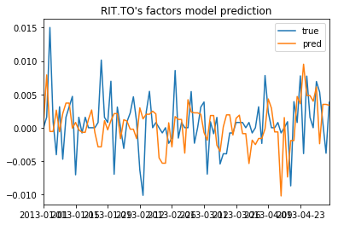

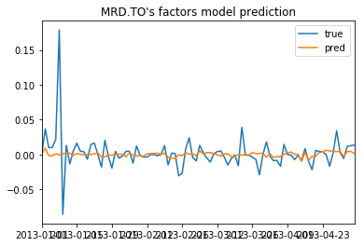

**Equity:USD**

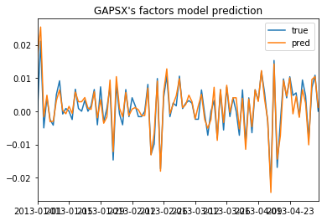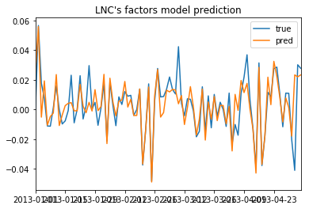

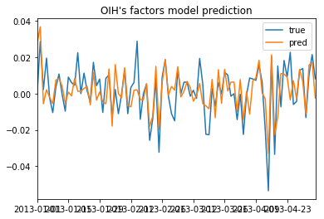

**Equity:EUR**

