**1、如何备份和还原交换机和路由器的IOS**

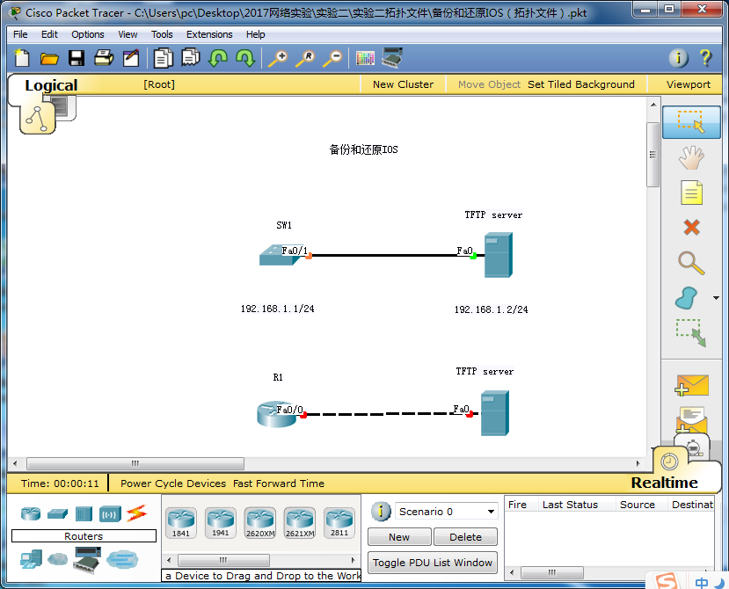

**备份和还原交换机的IOS**

步骤：

打开文件名为：备份和还原IOS（拓扑文件）.pkt的文件

1. 建立交换机和TFTP服务器的连接

Switch>en

Switch#conf t

Configuring from terminal, memory, or network [terminal]?

Enter configuration commands, one per line. End with CNTL/Z.

Switch(config)#hostname SW1

SW1(config)#interface vlan 1

SW1(config-if)#ip address 192.168.1.1 255.255.255.0

SW1(config-if)#no shutdown

1. 配置TFTP服务器的地址为：192.168.1.2 255.255.255.0
2. 测试交换机与TFTP服务器之间的连接。

SW1#ping 192.168.1.2

只有交换机与TFTP服务器是联通的状态下才能进行下面操作。

1. 备份交换机的ios

SW1#copy flash: tftp:

//输入源文件名称

Source filename [ ]? c2960-lanbase-mz.122-25.FX.bin

//输入服务器IP地址

Address or name of remote host [ ]? 192.168.1.2

//输入新的文件名称

Destination filename [c2960-lanbase-mz.122-25.FX.bin]? c2960-text.bin

Writing

c2960-lanbase-mz.122-5.FX.bin....!!!!!!!!!!!!!!!!!!!!!!!!!!!!!!!!!!!!!!!!!!!!!!!!!!!!!!!!!!!!!!!!!!!!!!!!!!!!!!!!!!!!!!!!

[OK - 4414921 bytes]

4414921 bytes copied in 3.05 secs (1447000 bytes/sec)

查看TFTP服务器文件如下：

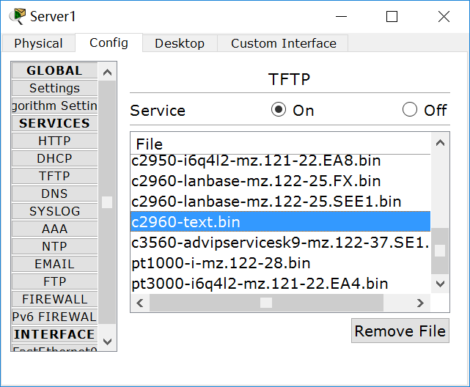

1. 还原交换机的ios

SW1#copy tftp: flash:

Address or name of remote host []? 192.168.1.2

Source filename []? c2960-text.bin

Destination filename [c2960-text.bin]?

Accessing tftp://192.168.1.2/c2960-text.bin...

Loading c2960-text.bin from 192.168.1.2: !!!!!!!!!!!!!!!!!!!!!!!!!!!!!!!!!!!!!!!!!!!!!!!!!!!!!!!!!!!!!!!!!!!!!!!!!!!!!!!!!!!!!!!

[OK - 4414921 bytes]

4414921 bytes copied in 0.045 secs (2665637 bytes/sec)

查看flash文件可以看到2个文件，其中名为c2960-text.bin的文件是从TFTP服务器中还原的文件。

SW1#show flash:

Directory of flash:/

1 -rw- 4414921 <no date> c2960-lanbase-mz.122-25.FX.bin

2 -rw- 4414921 <no date> c2960-text.bin

64016384 bytes total (55186542 bytes free)

1. 可以选择从flash中的哪个文件加载系统

SW1(config)#boot system flash: c2960-text.bin

SW1(config)#reload

1. 删除flash中的文件

SW1#delete flash:

Delete filename []?c2960-text.bin

Delete flash:/c2960-text.bin? [confirm]

SW1#show flash:

Directory of flash:/

1 -rw- 4414921 <no date> c2960-lanbase-mz.122-25.FX.bin

64016384 bytes total (59601463 bytes free)

**备份和还原路由器的IOS：**

1. 建立交换机和TFTP服务器的连接

Router>en

Router#conf t

Enter configuration commands, one per line. End with CNTL/Z.

Router(config)#interface fastEthernet 0/0

Router(config-if)#ip address 192.168.1.1 255.255.255.0

Router(config-if)#no shutdown

1. 配置TFTP服务器的地址为：192.168.1.2 255.255.255.0
2. 测试交换机与TFTP服务器之间的连接。

SW1#ping 192.168.1.2

只有交换机与TFTP服务器是联通的状态下才能进行下面操作。

1. 备份交换机的ios

Router#show flash:

System flash directory:

File Length Name/status

3 50938004 c2800nm-advipservicesk9-mz.124-15.T1.bin

2 28282 sigdef-category.xml

1 227537 sigdef-default.xml

[51193823 bytes used, 12822561 available, 64016384 total]

63488K bytes of processor board System flash (Read/Write)

Router#copy flash: tftp:

Source filename []? c2800nm-advipservicesk9-mz.124-15.T1.bin

Address or name of remote host []? 192.168.1.2

Destination filename [c2800nm-advipservicesk9-mz.124-15.T1.bin]? c2800-text.bin

Writing c2800nm-advipservicesk9-mz.124-15.T1.bin...!!!!!!!!!!!!!!!!!!!!!!!!!!!!!!!!!!!!!!!!!!!!!!!!!!!!!!!!!!!!!!!!!!!!!!!!!!!!!!!!!!!!!!!!!!!!!!!!!!!!!!!!!!!!!!!!!!!!!!!!!!!!!!!!!!!!!!!!!!!!!!!!!!!!!!!!!!!!!!!!!!!!!!!!!!!!!!!!!!!!!!!!!!!!!!!!!!!!!!!!!!!!!!!!!!!!!!!!!!!!!!!!!!!!!!!!!!!!!!!!!!!!!!!!!!!!!!!!!!!!!!!!!!!!!!!!!!!!!!!!!!!!!!!!!!!!!!!!!!!!!!!!!!!!!!!!!!!!!!!!!!!!!!!!!!!!!!!!!!!!!!!!!!!!!!!!!!!!!!!!!!!!!!!!!!!!!!!!!!!!!!!!!!!!!!!!!!!!!!!!!!!!!!!!!!!!!!!!!!!!!!!!!!!!!!!!!!!!!!!!!!!!!!!!!!!!!!!!!!!!!!!!!!!!!!!!!!!!!!!!!!!!!!!!!!!!!!!!!!!!!!!!!!!!!!!!!!!!!!!!!!!!!!!!!!!!!!!!!!!!!!!!!!!!!!!!!!!!!!!!!!!!!!!!!!!!!!!!!!!!!!!!!!!!!!!!!!!!!!!!!!!!!!!!!!!!!!!!!!!!!!!!!!!!!!!!!!!!!!!!!!!!!!!!!!!!!!!!!!!!!!!!!!!!!!!!!!!!!!!!!!!!!!!!!!!!!!!!!!!!!!!!!!!!!!!!!!!!!!!!!!!!!!!!!!!!!!!!!!!!!!!!!!!!!!!!!!!!!!!!!!!!!!!!!!!!!!!!!!!!!!!!!!!!!!!!!!!!!!!!!!!!!!!!!!!!!!!!!!!!!!!!!!!!!!!!!!!!!!!!!!!!!!!!!!!!!!!!!!!!!!!!!!!!!!!!!!!!!!!!!!!!!!!!!!!!!!!!!!!!!!!!!!!!!!!!!!!!!!!!!!!!!!!!!!!!!!!!!!!!!!!!!!!!!!!!!!!!!!!!!!!!!!!!!!!!!!!!!!!!!!!!!!!!!!!!!!!!

[OK - 50938004 bytes]

50938004 bytes copied in 0.745 secs (68373000 bytes/sec)

1. 还原交换机的ios

Router#copy tftp: flash:

Address or name of remote host []? 192.168.1.2

Source filename []? c2800-text.bin

Destination filename [c2800-text.bin]? c2800-text.bin

Accessing tftp://192.168.1.2/c2800-text.bin...

Loading c2800-text.bin from 192.168.1.2: !!!!!!!!!!!!!!!!!!!!!!!!!!!!!!!!!!!!!!!!!!!!!!!!!!!!!!!!!!!!!!!!!!!!!!!!!!!!!!!!!!!!!!!!!!!!!!!!!!!!!!!!!!!!!!!!!!!!!!!!!!!!!!!!!!!!!!!!!!!!!!!!!!!!!!!!!!!!!!!!!!!!!!!!!!!!!!!!!!!!!!!!!!!!!!!!!!!!!!!!!!!!!!!!!!!!!!!!!!!!!!!!!!!!!!!!!!!!!!!!!!!!!!!!!!!!!!!!!!!!!!!!!!!!!!!!!!!!!!!!!!!!!!!!!!!!!!!!!!!!!!!!!!!!!!!!!!!!!!!!!!!!!!!!!!!!!!!!!!!!!!!!!!!!!!!!!!!!!!!!!!!!!!!!!!!!!!!!!!!!!!!!!!!!!!!!!!!!!!!!!!!!!!!!!!!!!!!!!!!!!!!!!!!!!!!!!!!!!!!!!!!!!!!!!!!!!!!!!!!!!!!!!!!!!!!!!!!!!!!!!!!!!!!!!!!!!!!!!!!!!!!!!!!!!!!!!!!!!!!!!!!!!!!!!!!!!!!!!!!!!!!!!!!!!!!!!!!!!!!!!!!!!!!!!!!!!!!!!!!!!!!!!!!!!!!!!!!!!!!!!!!!!!!!!!!!!!!!!!!!!!!!!!!!!!!!!!!!!!!!!!!!!!!!!!!!!!!!!!!!!!!!!!!!!!!!!!!!!!!!!!!!!!!!!!!!!!!!!!!!!!!!!!!!!!!!!!!!!!!!!!!!!!!!!!!!!!!!!!!!!!!!!!!!!!!!!!!!!!!!!!!!!!!!!!!!!!!!!!!!!!!!!!!!!!!!!!!!!!!!!!!!!!!!!!!!!!!!!!!!!!!!!!!!!!!!!!!!!!!!!!!!!!!!!!!!!!!!!!!!!!!!!!!!!!!!!!!!!!!!!!!!!!!!!!!!!!!!!!!!!!!!!!!!!!!!!!!!!!!!!!!!!!!!!!!!!!!!!!!!!!!!!!!!!!!!!!!!!!!!!!!!!!!!!!!!!!!!!!!!!!!!!!!!!!!!!!!

[OK - 50938004 bytes]

50938004 bytes copied in 0.668 secs (5528987 bytes/sec)

%Error copying tftp://192.168.1.2/c2800-text.bin (Not enough space on device)

1. 删除flash中的文件

Router#delete flash：

**2、综合实验**

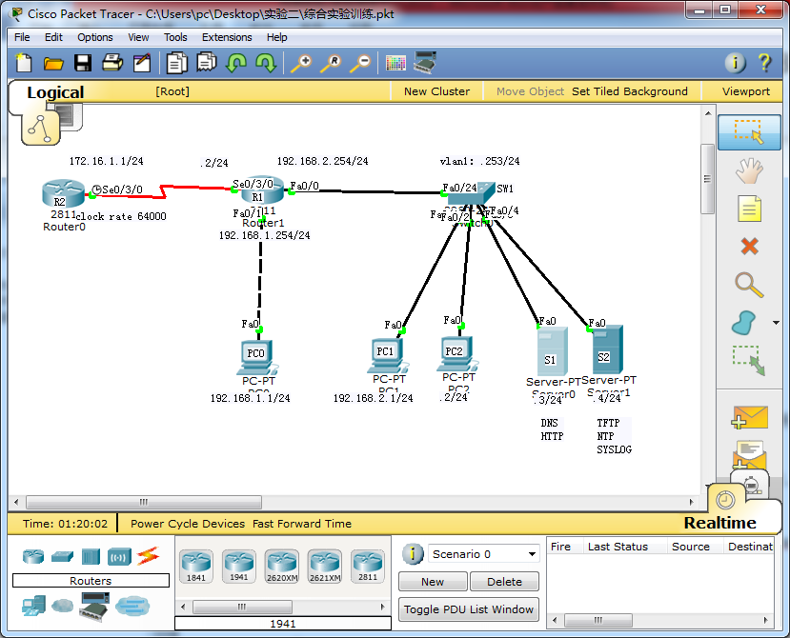

实验要求：

1：根据拓扑所示，配置设备用户名、DCE时钟、接口和PC地址等，确保所有直连网络的通信

2：关闭所有设备的域名解析、开启日志同步、关闭console口的配置超时、VTY的配置超时时间5分钟30秒

3：配置所有设备的特权加密密码：ciscoccna@；console密码：ciscoccnp#；vty(0-4)密码（SW1除外）：ciscoccie$；

所有password密码都需要加密

4：关闭连接PC端口的CDP。CDP是思科的私有协议，由于PC不是思科设备所以要关闭。

5：确保PC0可以远程管理SW1，可以使用下列用户名密码登陆：用户名ccna,密码ccna；用户名ccnp,密码ccnp；用户名ccie,密码ccie

6：通过TFTP服务器备份R1的启动文件，备份SW1的IOS

7：PC0可以访问WEB服务器，域名为www.wangluoshiyan.com

**步骤：**

**打开文件名为：综合实验训练.pkt的拓扑文件。**

**1：根据拓扑所示，配置设备用户名、DCE时钟、接口和PC地址等，确保所有直连网络的通信**

A．配置R2路由器

Router>en

Router#conf t

Enter configuration commands, one per line. End with CNTL/Z.

Router(config)#hostname R2

R2(config)#interface s0/3/0

R2(config-if)#ip address 172.16.1.1 255.255.255.0

R2(config-if)#clock rate 64000

R2(config-if)#no shutdown

B．配置R1路由器

Router>en

Router#conf t

Enter configuration commands, one per line. End with CNTL/Z.

Router(config)#hostname R1

R1(config)#interface s0/3/0

R1(config-if)#ip address 172.16.1.2 255.255.255.0

R1(config-if)#no shutdown

R1(config)#interface fa0/0

R1(config-if)#ip address 192.168.2.254 255.255.255.0

R1(config-if)#no shutdown

R1(config-if)#exit

R1(config)#interface fa0/1

R1(config-if)#ip address 192.168.1.254 255.255.255.0

R1(config-if)#no shutdown

c. 配置交换机：

Switch>en

Switch#conf t

Enter configuration commands, one per line. End with CNTL/Z.

Switch(config)#hostname SW1

SW1(config)#interface vlan 1

SW1(config-if)#ip address 192.168.2.253 255.255.255.0

SW1(config-if)#no shutdown

配置PC的IP地址、子网掩码和网关等

PC0: 192.168.1.1 255.255.255.0 192.168.1.254

PC1: 192.168.2.1 255.255.255.0 192.168.2.254

PC2: 192.168.2.2 255.255.255.0 192.168.2.254

HTTP: 192.168.2.3 255.255.255.0 192.168.2.254

TFTP: 192.168.2.4 255.255.255.0 192.168.2.254

请同学们配置完毕后测试所有直连网络的通信正常。

**2：关闭所有设备的域名解析、开启日志同步、关闭console口的配置超时、VTY的配置超时时间5分钟30秒**

R2>en

R2#conf t

Enter configuration commands, one per line. End with CNTL/Z.

R2(config)#line con 0

R2(config-line)#logg syn

R2(config-line)#exec-t 00

R2(config-line)#line vty 0 4

R2(config-line)#logg syn

R2(config-line)#exec-t 5 30

R2(config-line)#exit

R1>en

R1#conf t

Enter configuration commands, one per line. End with CNTL/Z.

R1(config)#no ip domain-lookup

R1(config)#line con 0

R1(config-line)#logging synchronous

R1(config-line)#no exec-t

R1(config-line)#line vty 0 4

R1(config-line)#logging synchronous

R1(config-line)#exec-t 5 30

SW1>en

SW1#conf t

Enter configuration commands, one per line. End with CNTL/Z.

SW1(config)#no ip domain-lookup

SW1(config)#line con 0

SW1(config-line)#logging synchronous

SW1(config-line)#exec-t 0 0

SW1(config-line)#line vty 0 4

SW1(config-line)#logging synchronous

SW1(config-line)#exec-t 5 30

**3：配置所有设备的特权加密密码：ciscoccna@；console密码：ciscoccnp#；vty(0-4)密码（SW1除外）：ciscoccie$；所有password密码都需要加密；。**

R2>en

R2#conf t

Enter configuration commands, one per line. End with CNTL/Z.

R2(config)#line con 0

R2(config-line)#logg syn

R2(config-line)#exec-t 00

R2(config-line)#line vty 0 4

R2(config-line)#logg syn

R2(config-line)#exec-t 5 30

R2(config-line)#exit

R2(config)#enable secret ciscoccna@

R2(config)#line con

R2(config)#line console 0

R2(config-line)#pass ciscoccnp#

R2(config-line)#login

R2(config-line)#line vty 0 4

R2(config-line)#pass ciscoccie$

R2(config-line)#login

R1(config)#enable secret ciscoccna@

R1(config)#line console 0

R1(config-line)#pass ciscoccnp#

R1(config-line)#login

R1(config-line)#line vty 0 4

R1(config-line)#pass ciscoccie$

R1(config-line)#login

SW1(config)#enable secret ciscoccna@

SW1 (config)#line console 0

SW1 (config-line)#pass ciscoccnp#

SW1 (config-line)#login

SW1 (config-line)#end

这条命令是把明文密码设置成加密密文。

SW1 #service password-encryption

**4：关闭连接PC端口的CDP(CDP是思科的私有协议，但是PC不是思科设备故要关闭)**

R1(config)#inter fa0/1

R1(config-if)#no cdp enable

SW1(config) #interface range fa0/1-4

SW1(config-if)#no cdp enable

**5：确保PC0可以远程管理SW1，可以使用下列用户名密码登陆：用户名ccna,密码ccna；用户名ccnp,密码ccnp；用户名ccie,密码ccie**

SW1#

SW1#conf t

Enter configuration commands, one per line. End with CNTL/Z.

SW1(config)#ip default-gateway 192.168.2.254

SW1(config)#username ccna pass

SW1(config)#username ccna password ccna

SW1(config)#username ccnp password ccnp

SW1(config)#username ccie password ccie

SW1(config)#line vty 0 4

SW1(config-line)#login local

**可以测试PC0 telnet 192.168.2.253**

输入用户名：ccna 密码：ccna

输入用户名：ccnp 密码：ccnp

输入用户名：ccne 密码：ccne可以实现远程登陆。

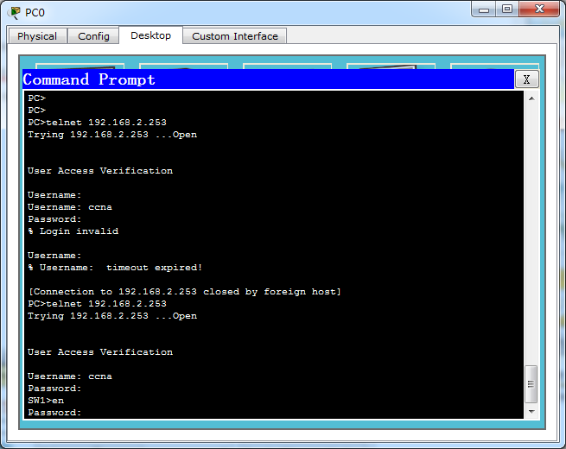

**6：通过TFTP服务器备份R1的启动文件，备份SW1的IOS**

R1#write

Building configuration...

[OK]

R1#copy startup-config tftp

Address or name of remote host []? 192.168.2.4

Destination filename [R1-confg]? R1-config

SW1#show flash:

SW1#copy flash: tftp:

**7：PC0可以访问WEB服务器，域名为**[**www.wangluoshiyan.com**](http://www.wangluoshiyan.com)

设置PC0的DNS：192.168.2.3。如下图所示。

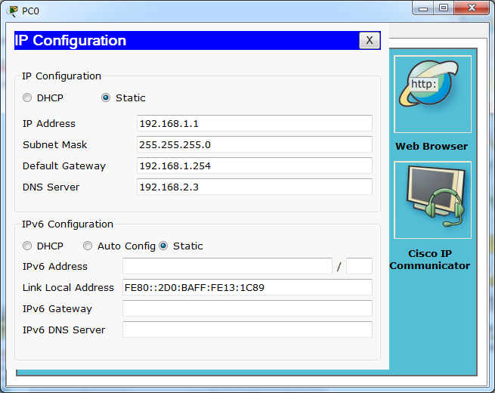

设置DNS服务器

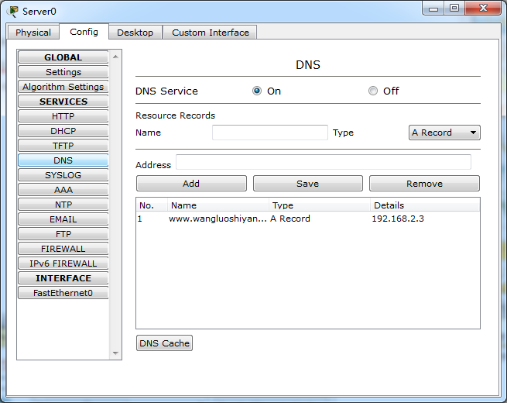

DNS Service:on

Name :www.wangluoshiyan.com

Address:192.168.2.3

单击：Add

**3、配置静态路由**

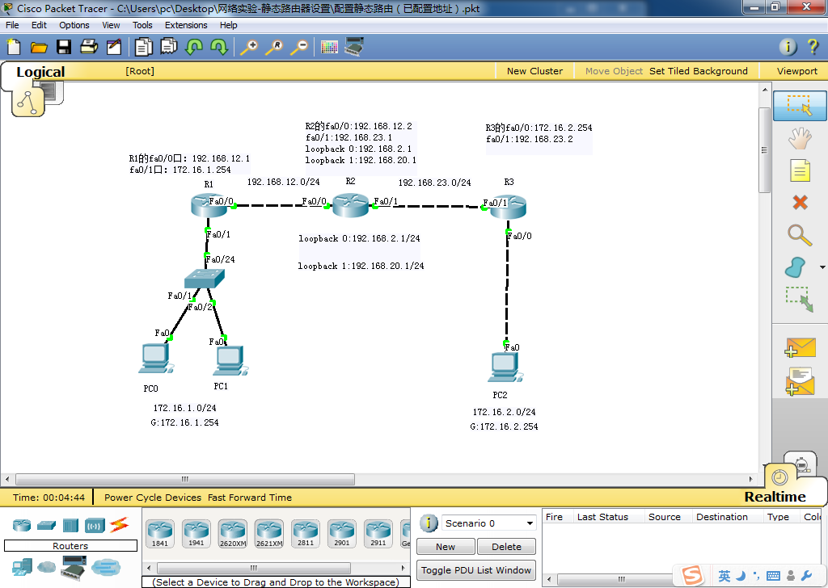

实验要求：

1. 学会配置静态路由协议；学会配置静态路由；
2. 理解静态路由两种写法：使用下一跳配置和出口配置；
3. 理解默认路由的含义

**实验步骤：**

打开文件名为静态路由器设置.pkt拓扑文件。

1. **根据拓扑所示，配置接口地址，PC地址和网关等（拓扑文件已配置）。**

R1:fa0/0口IP地址192.168.12.1； fa0/1口IP地址172.16.1.254

R2: fa0/0口IP地址192.168.12.2； fa0/1口IP地址172.16.23.1

Loopback 0 : 192.168.2.1

Loopback 1 : 192.168.20.1

R3 : fa0/0口IP地址192.16.2.2541； fa0/1口IP地址192.168.23.2

PC0 : IP地址172.16.1.1

PC1 : IP地址172.16.1.2

PC2 : IP地址172.16.2.2

1. **配置R2的环回口来模拟虚拟的PC。**

R2(config)#interface loopback ?

<0-2147483647> Loopback interface number

R2(config)#interface loopback 0

R2(config-if )#ip address 192.168.2.1 255.255.255.0

R2(config-if)#interface loopback 1

R2(config-if)#ip address 192.168.20.1 255.255.255.0

1. **查看接口状态，测试直连网络通讯**

测试直连网络是否通。例如：在R2上ping R1的fa0/0是否通。

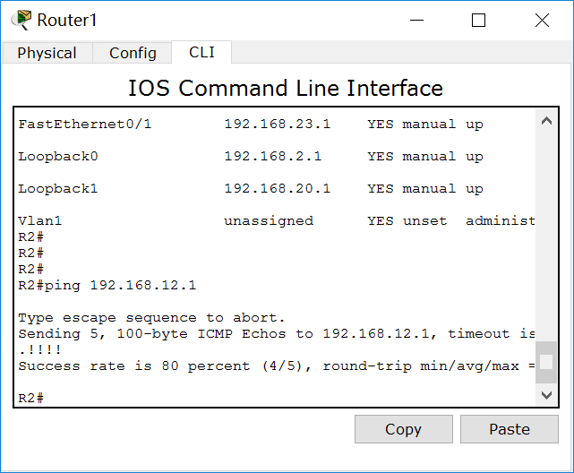

在配置静态路由器前测试PC0到PC2是未知网段，如下图所示：

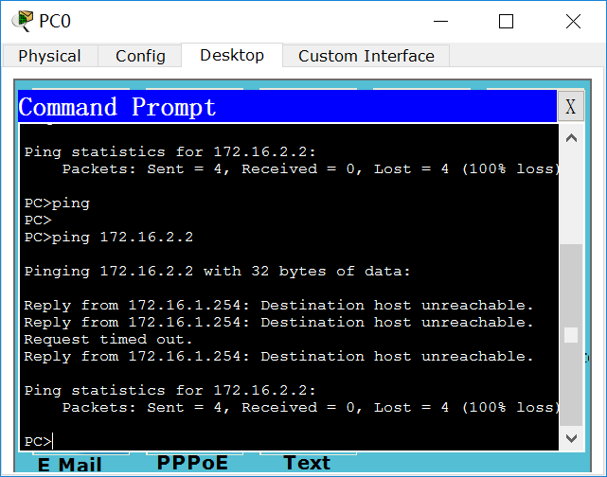

1. **配置静态路由：**

R1上使用下一跳配置方法配置路由：

使用命令：ip router 目标网段 子网掩码 下一跳（到目标网段经过的第一个网关）

R1上的非直连的网段有4个，分别罗列出来。

R1(config)#ip route 192.168.2.0 255.255.255.0 192.168.12.2

R1(config)#ip route 192.168.20.0 255.255.255.0 192.168.12.2

R1(config)#ip route 192.168.23.0 255.255.255.0 192.168.12.2

R1(config)#ip route 172.16.2.0 255.255.255.0 192.168.12.2

R2使用出口配置方法配置路由：

使用命令ip router 出口网段 子网掩码 本路由器接口。

R2有2个非直连的网段172.16.1.0和172.16.2.0分别对应R2的接口为fa0/0和fa0/1。

R2(config)#ip route 172.16.1.0 255.255.255.0 fa0/0

R2(config)#ip route 172.16.2.0 255.255.255.0 fa0/1

R3使用配置默认路由的方法设置路由：

所有要访问的网段用0.0.0.0 0.0.0.0代替，要访问所有非直连网段都交给192.168.23.1处理。

R3(config)#ip route 0.0.0.0 0.0.0.0 192.168.23.1

1. **查看路由表**

R1(config)#do show ip route

Codes: C - connected, S - static, I - IGRP, R - RIP, M - mobile, B - BGP

D - EIGRP, EX - EIGRP external, O - OSPF, IA - OSPF inter area

N1 - OSPF NSSA external type 1, N2 - OSPF NSSA external type 2

E1 - OSPF external type 1, E2 - OSPF external type 2, E - EGP

i - IS-IS, L1 - IS-IS level-1, L2 - IS-IS level-2, ia - IS-IS inter area

* - candidate default, U - per-user static route, o - ODR

P - periodic downloaded static route

Gateway of last resort is not set

172.16.0.0/24 is subnetted, 2 subnets

C 172.16.1.0 is directly connected, FastEthernet0/1

S 172.16.2.0 [1/0] via 192.168.12.2

S 192.168.2.0/24 [1/0] via 192.168.12.2

C 192.168.12.0/24 is directly connected, FastEthernet0/0

S 192.168.20.0/24 [1/0] via 192.168.12.2

S 192.168.23.0/24 [1/0] via 192.168.12.2

R2(config)#do show ip route

Codes: C - connected, S - static, I - IGRP, R - RIP, M - mobile, B - BGP

D - EIGRP, EX - EIGRP external, O - OSPF, IA - OSPF inter area

N1 - OSPF NSSA external type 1, N2 - OSPF NSSA external type 2

E1 - OSPF external type 1, E2 - OSPF external type 2, E - EGP

i - IS-IS, L1 - IS-IS level-1, L2 - IS-IS level-2, ia - IS-IS inter area

* - candidate default, U - per-user static route, o - ODR

P - periodic downloaded static route

Gateway of last resort is not set

172.16.0.0/24 is subnetted, 2 subnets

S 172.16.1.0 is directly connected, FastEthernet0/0

S 172.16.2.0 is directly connected, FastEthernet0/1

C 192.168.2.0/24 is directly connected, Loopback0

C 192.168.12.0/24 is directly connected, FastEthernet0/0

C 192.168.20.0/24 is directly connected, Loopback1

C 192.168.23.0/24 is directly connected, FastEthernet0/1

R3(config)#do show ip route

Codes: C - connected, S - static, I - IGRP, R - RIP, M - mobile, B - BGP

D - EIGRP, EX - EIGRP external, O - OSPF, IA - OSPF inter area

N1 - OSPF NSSA external type 1, N2 - OSPF NSSA external type 2

E1 - OSPF external type 1, E2 - OSPF external type 2, E - EGP

i - IS-IS, L1 - IS-IS level-1, L2 - IS-IS level-2, ia - IS-IS inter area

* - candidate default, U - per-user static route, o - ODR

P - periodic downloaded static route

Gateway of last resort is 192.168.23.1 to network 0.0.0.0

172.16.0.0/24 is subnetted, 1 subnets

C 172.16.2.0 is directly connected, FastEthernet0/0

C 192.168.23.0/24 is directly connected, FastEthernet0/1

S* 0.0.0.0/0 [1/0] via 192.168.23.1

1. **全网通信测试**

PC0：

Ping 172.16.2.2 (pc2)

Ping 192.168.2.1 (loopback0)

Ping 192.168.20.1 (loopback1)

PC3:

Ping 192.168.2.1 (loopback0)

Ping 192.168.20.1 (loopback1)

Ping 192.168.2.2 (pc2)