《高级网页设计I》

网页元素设计 项目报告

|  |  |
| --- | --- |
| 学 号：23201013001 姓 名：黄福祺 | |
| 班级 | 30 |

实施过程

1. 项目需求

[说明]

根据给定网页元素截图，完成基于HTML和CSS的网页元素设计。

选定的网页元素设计的截图分别如下：

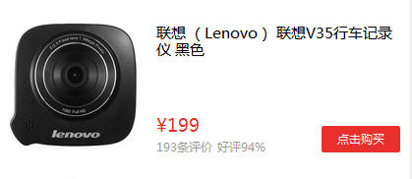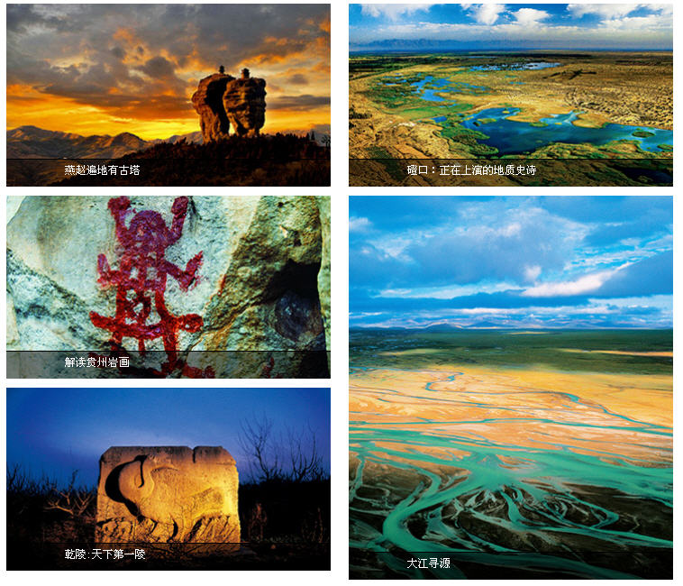

1. **项目代码**

**网页元素1代码：**

**<!DOCTYPE html>**

**<html lang="en">**

**<head>**

**<meta charset="UTF-8">**

**<meta name="viewport" content="width=device-width, initial-scale=1.0">**

**<title>Document</title>**

**<style>**

**#father {**

**width: 100%;**

**height: 100%;**

**display: flex;**

**flex-wrap: wrap;**

**justify-content: center;**

**align-items: center;**

**}**

**.button {**

**display: flex;**

**justify-content: center;**

**align-items: center;**

**width: 30px;**

**height: 25px;**

**margin: 5px;**

**border: 1px solid #000;**

**}**

**#father>div:first-child,**

**#father>div:nth-child(12) {**

**width: 60px;**

**}**

**#father>div:first-child {**

**background-color: rgb(3, 65, 115);**

**color: #fff;**

**}**

**#father>div:last-child {**

**width: 40px;**

**}**

**.button:hover {**

**background-color: rgb(3, 65, 115);**

**color: #fff;**

**}**

**</style>**

**</head>**

**<body>**

**<div id="father">**

**<div class="button"><span>上一页</span></div>**

**<div class="button"><span>1</span></div>**

**<div class="button"><span>2</span></div>**

**<div class="button"><span>3</span></div>**

**<div class="button"><span>4</span></div>**

**<div class="button"><span>5</span></div>**

**<div class="button"><span>6</span></div>**

**<div class="button"><span>7</span></div>**

**<div class="button"><span>8</span></div>**

**<div class="button"><span>9</span></div>**

**<div class="button"><span>10</span></div>**

**<div class="button"><span>下一页</span></div>**

**<div class="button"><span>>>|</span></div>**

**</div>**

**</body>**

**</html>**

**网页元素2代码：**

**<!DOCTYPE html>**

**<html lang="en">**

**<head>**

**<meta charset="UTF-8">**

**<meta name="viewport" content="width=device-width, initial-scale=1.0">**

**<title>Document</title>**

**<style>**

**#father {**

**width: 419px;**

**height: 182px;**

**}**

**#im>img {**

**float: left;**

**width: 125px;**

**height: 125px;**

**}**

**#wenzi {**

**float: left;**

**}**

**#title {**

**width: 240px;**

**height: 30px;**

**}**

**#price {**

**margin-top: 60px;**

**height: 15px;**

**width: 40px;**

**color: rgb(230, 45, 42);**

**}**

**#pingjia {**

**height: 10px;**

**width: 110px;**

**}**

**#pingjia>span {**

**font-size: 10px;**

**}**

**#goumai {**

**display: flex;**

**justify-content: center;**

**align-items: center;**

**color: #fff;**

**font-size: 15px;**

**margin-left: 160px;**

**margin-top: -15px;**

**width: 80px;**

**height: 25px;**

**background-color: rgb(230, 45, 42);**

**}**

**</style>**

**</head>**

**<body>**

**<div id="father">**

**<div id="im"><img src="img/1.jpg" alt=""></div>**

**<div id="wenzi">**

**<div id="title"><span>联想（Lenovo）联想V35行车记录仪黑色</span></div>**

**<div id="price"><span>¥199</span></div>**

**<div id="pingjia"><span>193条好评 好评94%</span></div>**

**<div id="goumai"><span>点击购买</span></div>**

**</div>**

**</div>**

**</body>**

**</html>**

**网页元素3代码：**

**<!DOCTYPE html>**

**<html lang="en">**

**<head>**

**<meta charset="UTF-8">**

**<meta name="viewport" content="width=device-width, initial-scale=1.0">**

**<title>Document</title>**

**<style>**

**#father {**

**width: 740px;**

**margin: 0;**

**padding: 0;**

**}**

**#left {**

**float: left;**

**}**

**#right {**

**margin-left: 20px;**

**float: right;**

**}**

**.wenzi {**

**width: 360px;**

**height: 30px;**

**margin-top: -34px;**

**color: #fff;**

**background-color: rgba(0, 0, 0, 0.5);**

**position: absolute;**

**display: flex;**

**justify-content: left;**

**align-items: center;**

**}**

**.wenzi>span {**

**margin-left: 50px;**

**font-size: 15px;**

**}**

**</style>**

**</head>**

**<body>**

**<div id="father">**

**<div id="left">**

**<div><img src="img/1.jpg" alt="">**

**<div class="wenzi"><span>燕赵遍地有古塔</span></div>**

**</div>**

**<div><img src="img/2.jpg" alt="">**

**<div class="wenzi"><span>解读贵州岩画</span></div>**

**</div>**

**<div><img src="img/3.jpg" alt="">**

**<div class="wenzi"><span>乾陵：天下第一陵</span></div>**

**</div>**

**</div>**

**<div id="right">**

**<div><img src="img/4.jpg" alt="">**

**<div class="wenzi"><span>磴口：正在上演的地址史诗</span></div>**

**</div>**

**<div><img src="img/5.jpg" alt="">**

**<div class="wenzi"><span>大江寻源</span></div>**

**</div>**

**</div>**

**</div>**

**</body>**

**</html>**

1. **测试与发布**

[说明]

网页元素1运行截图：

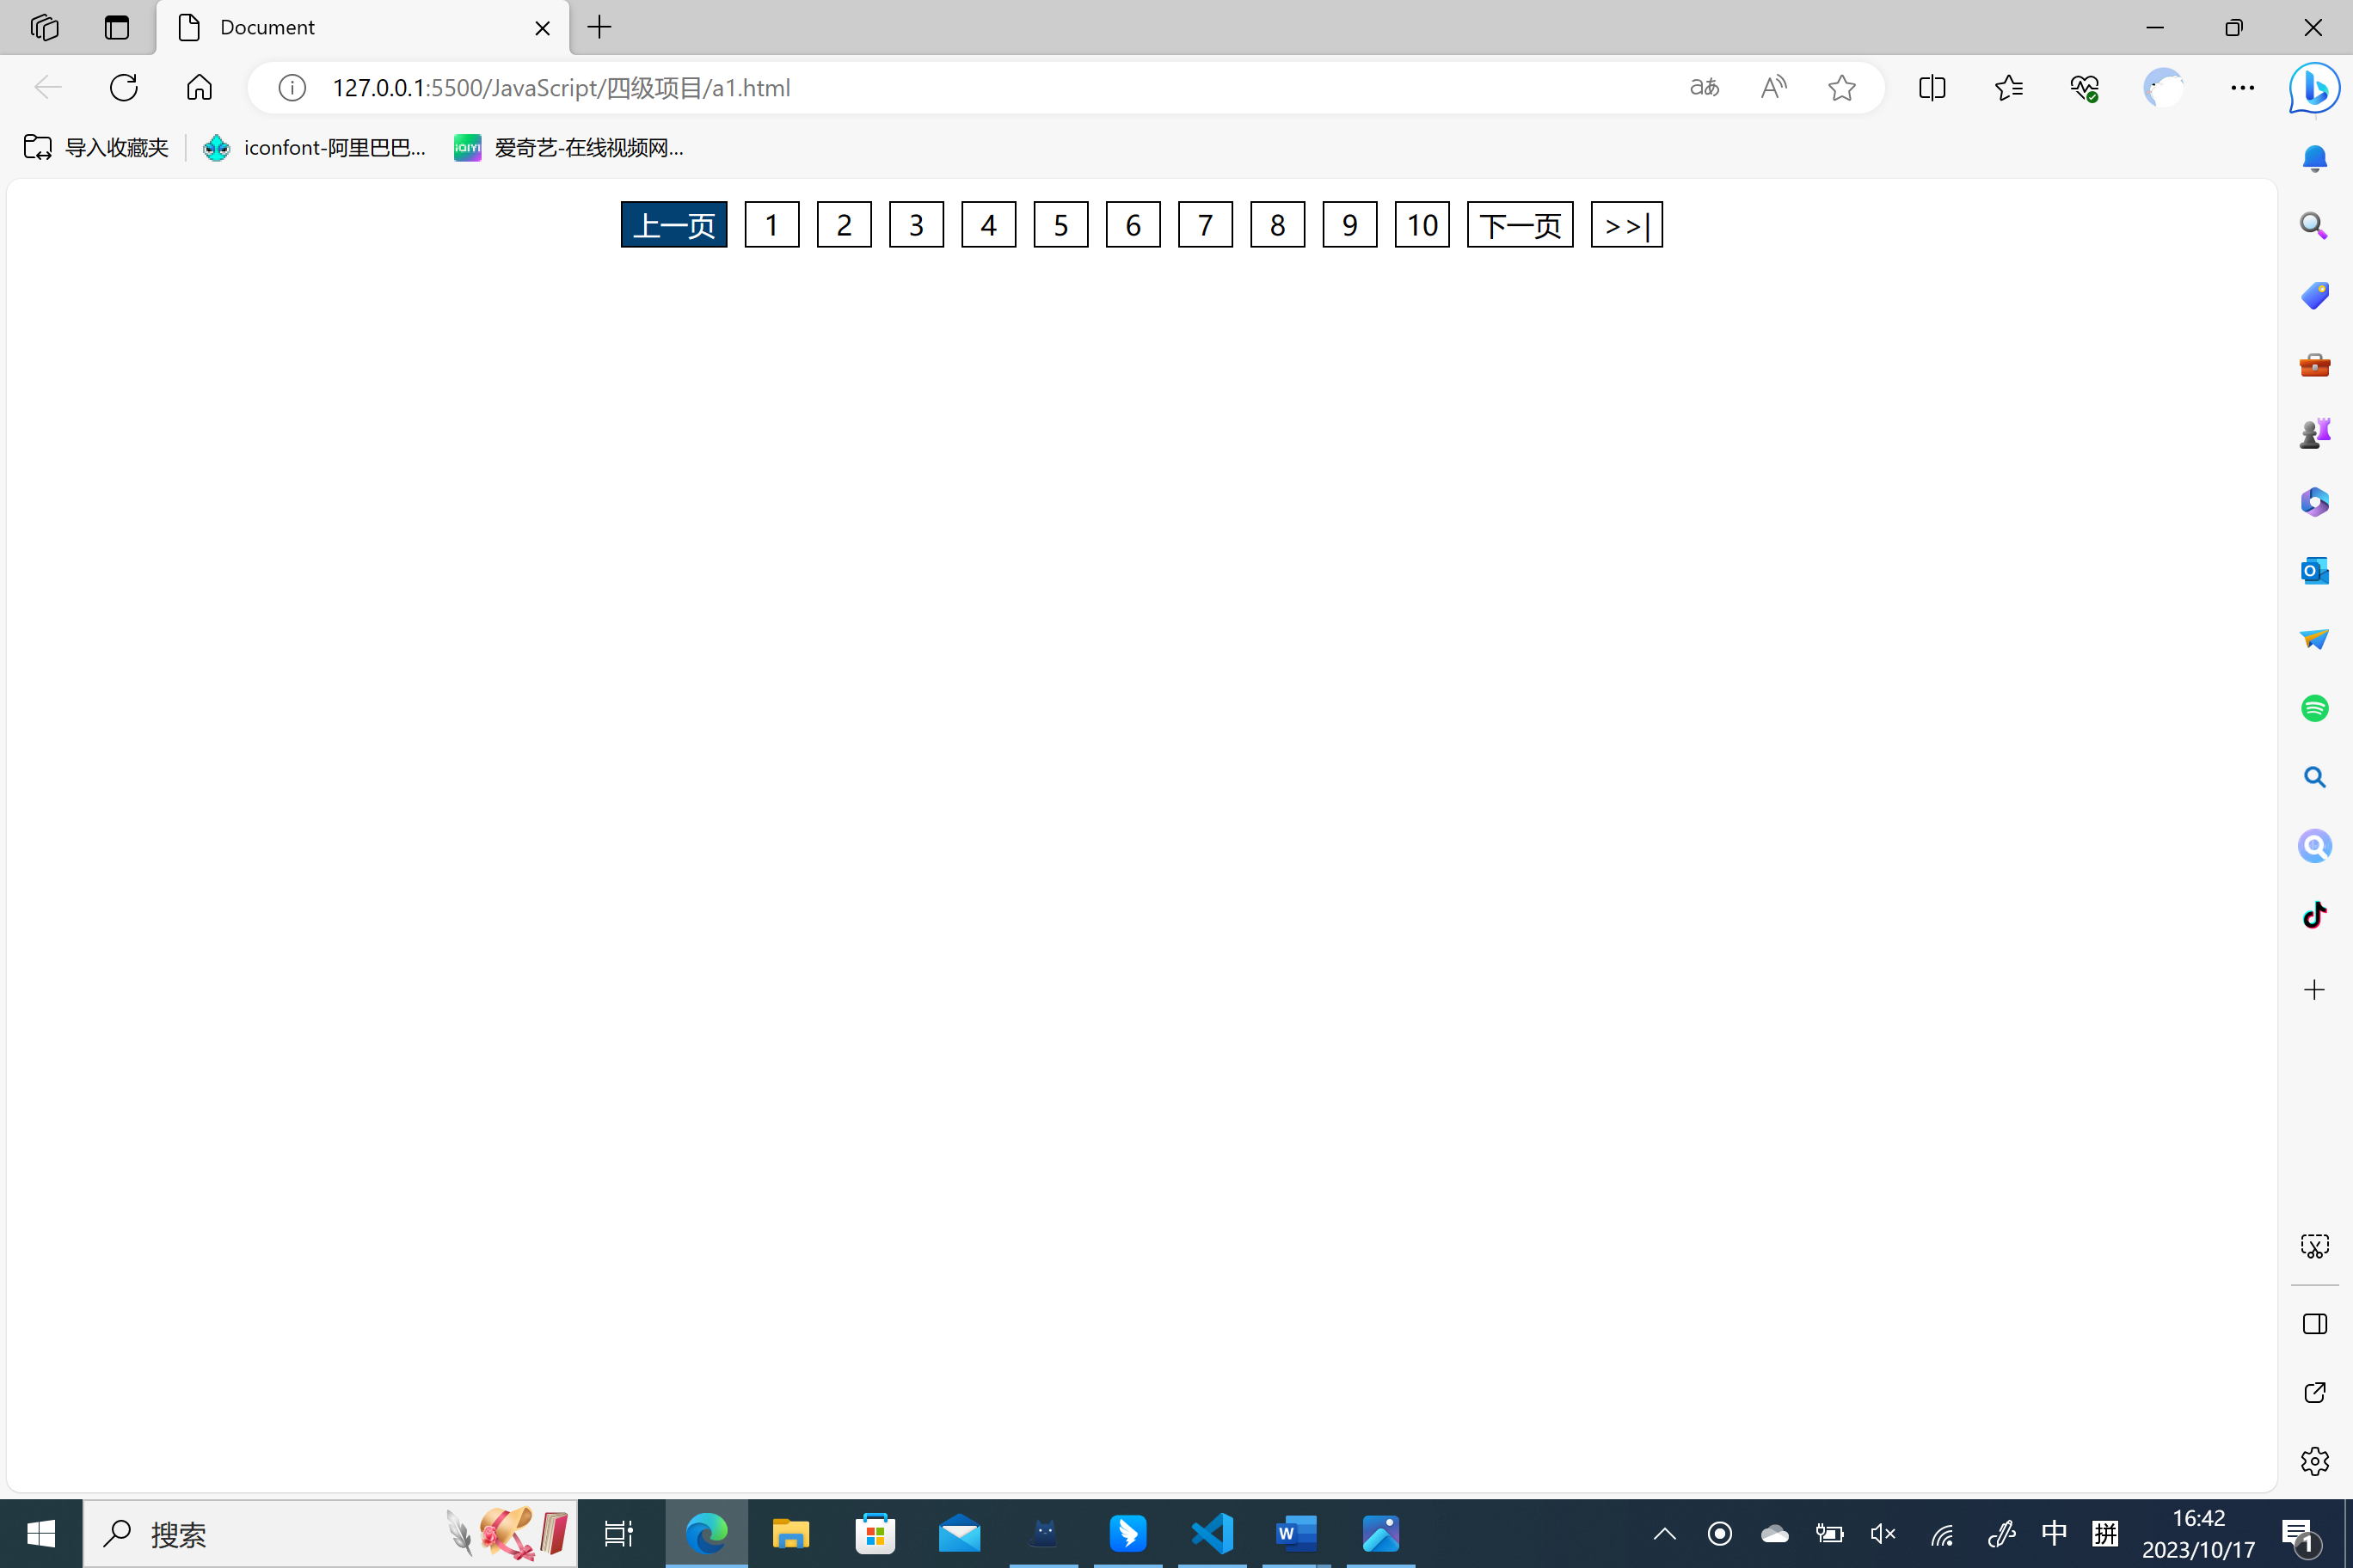

网页元素2运行截图：

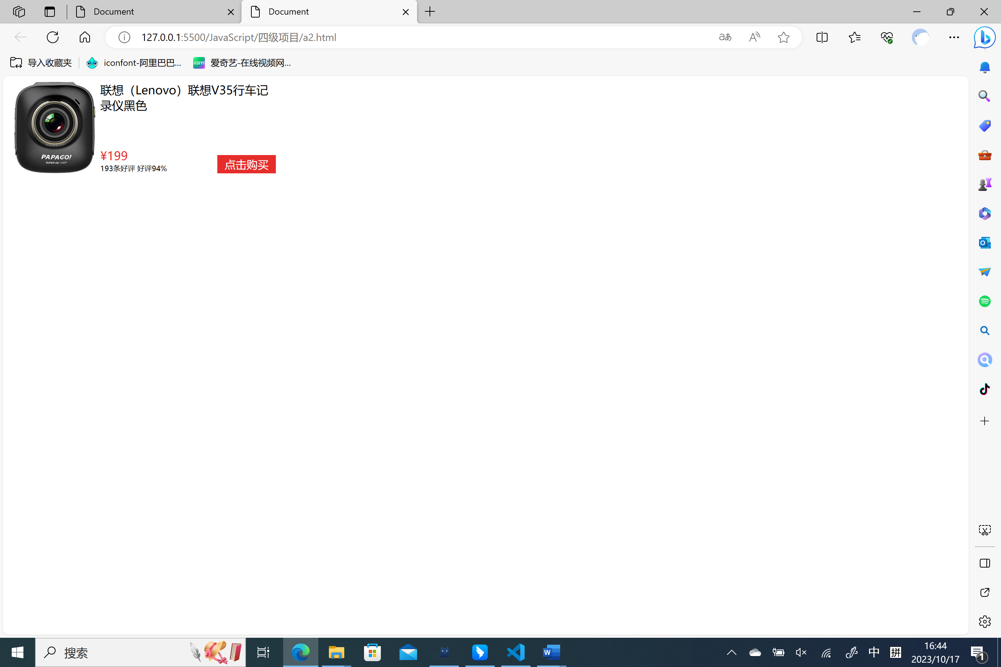

网页元素3运行截图：

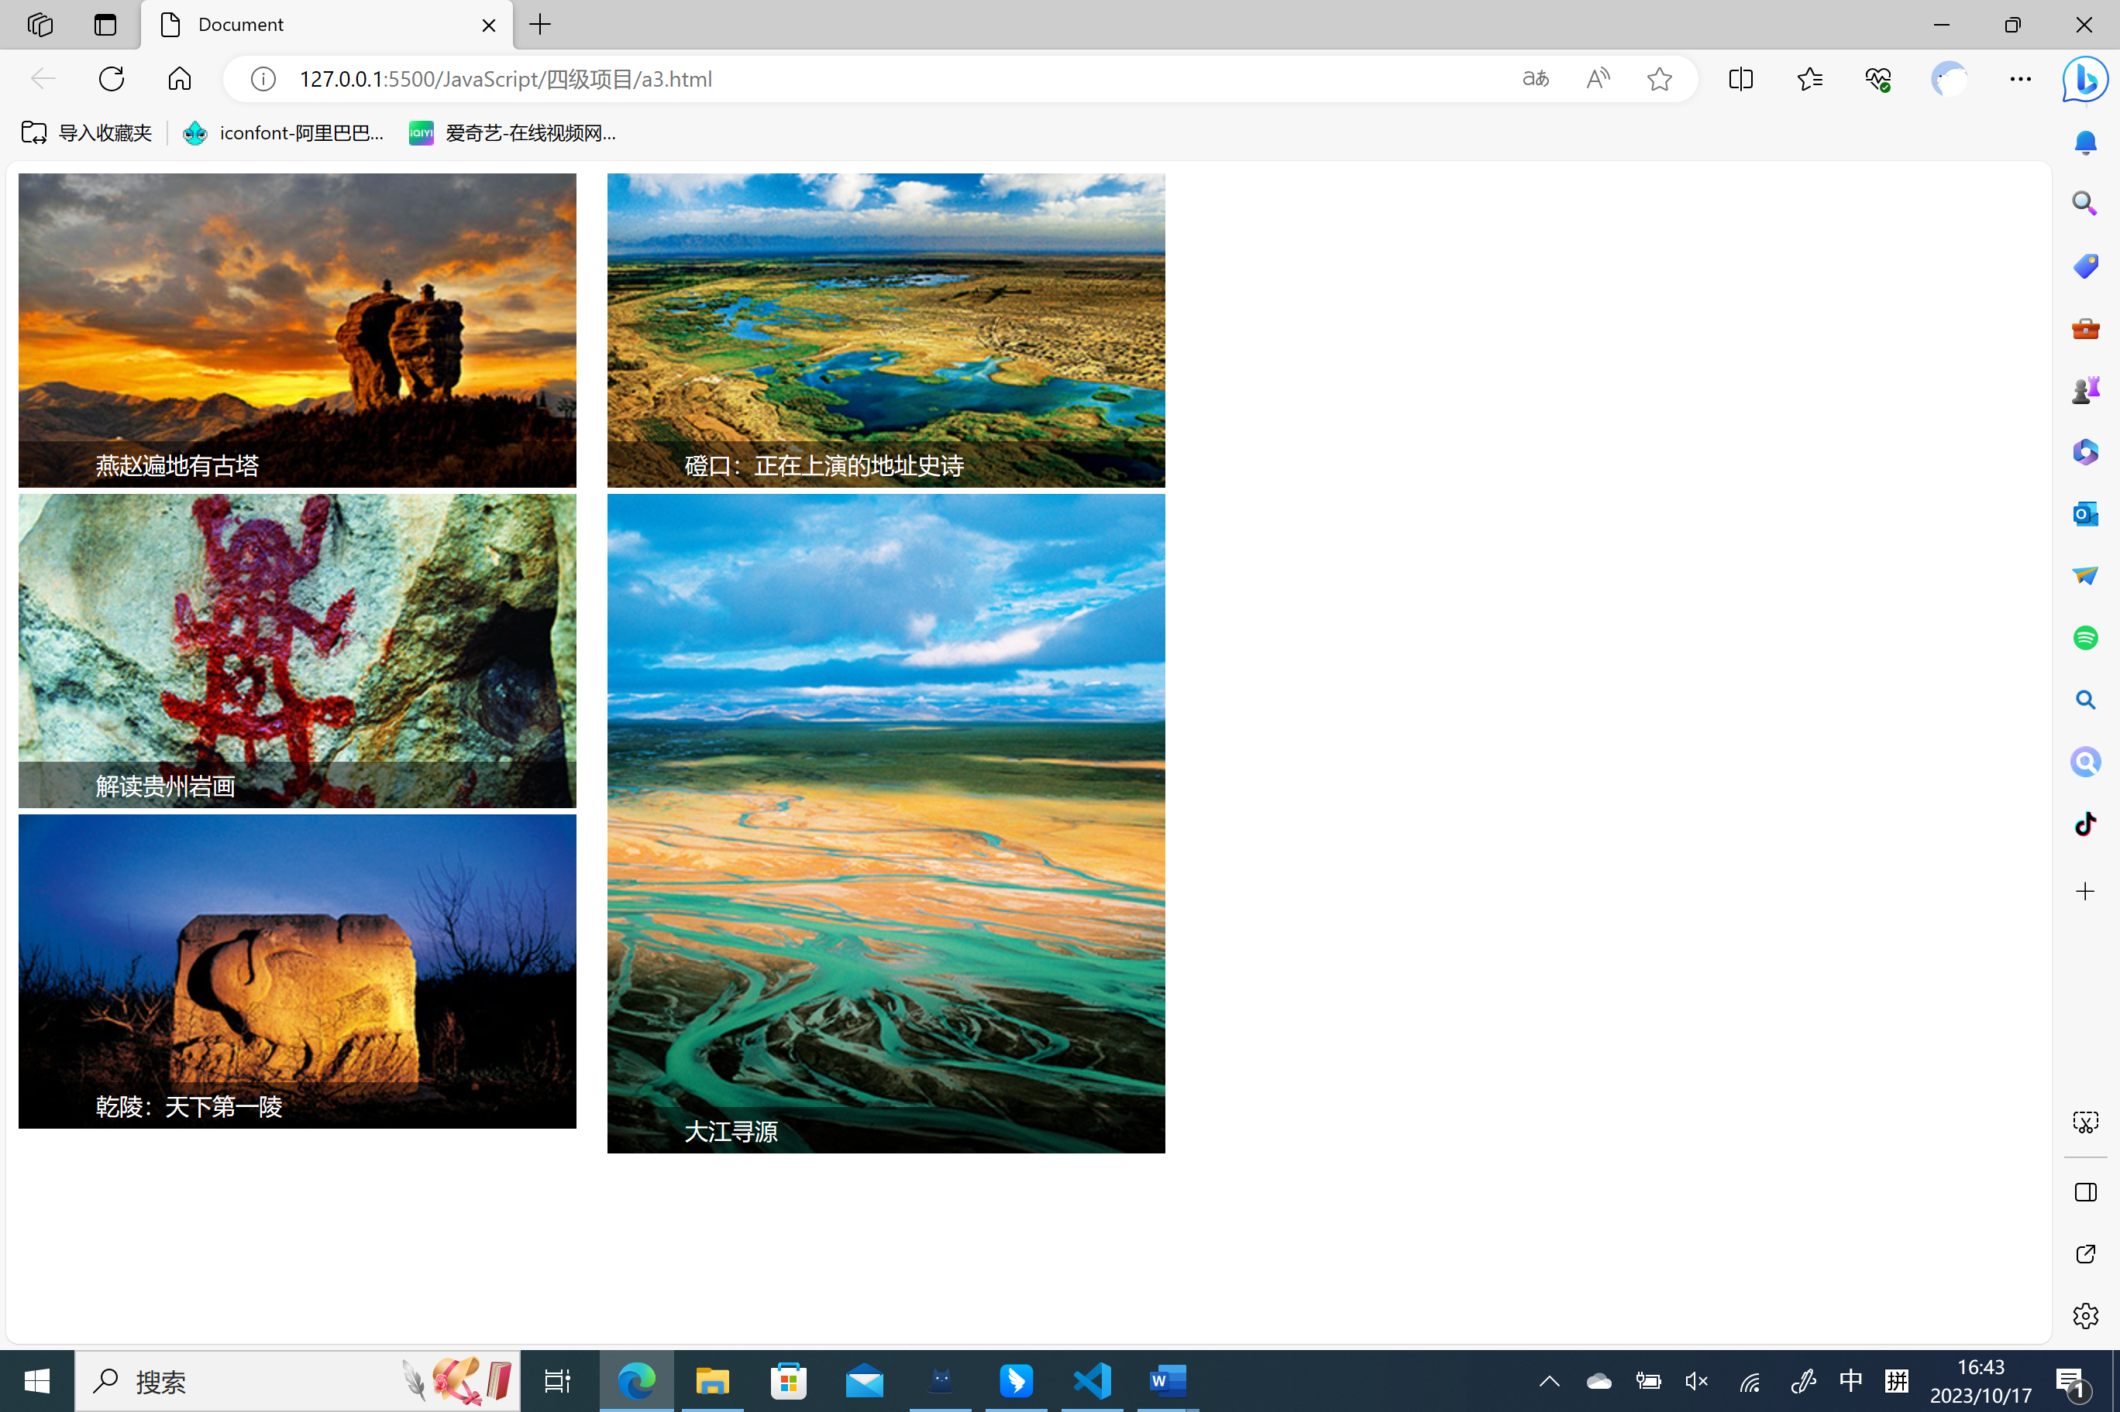

服务器端发布截图（如果有）：

项目总结

提交项目报告者对本次项目实施过程的所得与教训进行简单分析与描述，写出项目实施心得。

项目报告提交文件名：学号-姓名。

本次项目使我收获颇多，多亏了老师的悉心教导，使我更加深刻的了解了html的运行方式。