  Software Requirements & User Stories  Project III – CSCN72030 F25v2 | Abstract  This application inspires practical adoption of Promise Driven Development in both a personal and organizational settings.  Team Members  Salah Salame, Jonathan Taylor & Isaiah Andrews

Table of Contents
Product Overview 2
Description 3
Product Introduction 3
User and System Introduction 3
Product Requirements Definition 3
Description 4
System Requirements (From Project Documentation) 4
Functional Requirements 6
Non-Functional Requirements 9
Interface Requirements 12
Usability Requirements 14
Product Systems Diagrams 15
Architecture or System Block Diagram 16
Class Diagram(s) 16
Dataflow/Sequence Diagram(s) 17
User Login Sequence 18
Create A Product Promise 18
Add A Comment On A Stack Item 21
Assign a Moment to a Sprint 22
Export Project To JSON 23
Receive a Notification (When Mentioned in a Comment)Create a Bug/Rework Task from a Comment 24
Share A Project With Another User 25
User Stories – Product Backlog Draft 25
Initial Product Backlog 25
Acceptance Criteria by User Story 25
User Story 1: Student Interaction with tool. 25
Acceptance Criteria 25
Developer Voice (Technical Tasks) 25
User Story 2: Managing Promises with Moments 25
Acceptance Criteria 25
Developer Voice (Technical Tasks) 25
User Story N3: Professor Evaluating Promises 25
Acceptance Criteria 25
Developer Voice (Technical Tasks) 25
User Story N4: Software Professionals tool interaction and deployment. 25
Acceptance Criteria 25
Developer Voice (Technical Tasks) 25
Risk Register 25
Appendix 1 – Change Log 25

Product Overview

Description
Our PMO product will provide an accessible user interface for project management and team collaboration, ensuring compliance with the PMO architecture, and focus on security and containerization for inherent scalability. By developing this tool, we also look forward to keeping a close alignment with CISPM vision and ensure foundational steps can be taken for country-wide adoption of the promise model.
We aim to leverage this model by reducing manual coordination of labour and thus allowing for better management on planned tasks, allocated resources, and responsible parties; by effectively allowing for catalogue and interaction between the users and products and services being offered by the organization. Our aim is to create a flexible solution for teams of all sizes, independently of their motives, to effectively reach their goals and keep track of productivity and accountability.
Product Introduction
Our product aims to provide a flexible and intuitive user interface to allow for task management based on the promise model. Such a tool does not exist and could set the precedent for a foundation on how to tackle Process-Driven Development principles into practical and effective implementation strategies based on market requirements. It’s Open-Source nature would also allow from community-driven collaboration and continuous improvement over time.

User and System Introduction
We will leverage the latest technologies to create an efficient and portable solution which requires little to no manual interference. The tool will be written in ASP.NET Core, as a Single Page Application (SPA), with JavaScript being used to fetch data from the back-end server (using REST protocols), parse the data, then populate it into the client user interface.
This tool is designed for use in the education sector; students and professors will be able to gain first-hand experience in Promise-Driven Development (PDD) and allow for practical application of this model within both academic and professional responsibilities to ensure better time management and delivered outcomes.

Product Requirements Definition

Description
Insert description of your application and GUI

System Requirements (From Project Documentation)
Requirement Number | Description/Comments
REQ-SYS-001 | The software design shall consist of at least one (1) object per group member that manages a core feature of the PMO application (e.g., stack visualization, sprint management, notification system, sharing permissions, import/export, authentication integration). Each member of the group must be responsible for at least one such object.
REQ-SYS-002 | The project package shall consist of the software code base and a test suite of automated tests covering core functionality.
REQ-SYS-003 | The software design shall utilize the Repository, Service, Mapper, Controller pattern for the RESTful API, be developed using ASP.NET Core C# for the backend, and implement suitable design patterns to ensure future expansion of the product.
REQ-SYS-004 | The system shall allow users to create and manage the complete five-level Promise Stack: Product Promise, Epic, Journey, Flow, and Moment, with enforced parent-child relationships between levels.
REQ-SYS-005 | The system shall support classification of Moments as either Story (single persona) or Job (multi-persona coordination).
REQ-SYS-006 | The system shall persist all project data in a Microsoft SQL Server database to allow retrieval across sessions.
REQ-SYS-007 | The system shall support multiple users viewing and editing the same project simultaneously through standard HTTP requests. ASP.NET Core's built-in concurrency handling and database transaction management shall ensure data integrity during parallel CRUD operations.
REQ-SYS-008 | The system shall support user invitations via email with configurable permission levels (view, comment, edit).
REQ-SYS-009 | The system shall provide commenting functionality on all stack items, including @mentions to notify specific users.
REQ-SYS-010 | The system shall expose a RESTful API (built with ASP.NET Core) for all client-server interactions. The API shall follow standard HTTP methods and return JSON responses.
REQ-SYS-011 | The system shall include a dedicated authentication server (using ASP.NET Core Identity or similar) that issues JSON Web Tokens (JWT) for secure, stateless authentication.
REQ-SYS-012 | The frontend shall be implemented as a Single Page Application (SPA) using Vanilla JavaScript (no framework). The SPA shall communicate with the backend exclusively via the REST API using JWT for authorization and shall use the Fetch API for all HTTP requests.
REQ-SYS-013 | The system shall support sprint planning with configurable sprint durations (default 2 weeks) and maintain a backlog of unassigned Moments.
REQ-SYS-014 | The system shall allow users to assign owners to Promises, Moments, and tasks within Moments.
REQ-SYS-015 | The system shall provide status tracking for Moments (e.g., To Do, In Progress, Blocked, Done).
REQ-SYS-016 | The system shall support effort estimation using t-shirt sizing (XS, S, M, L, XL, XXL, XXXL).
REQ-SYS-017 | The system shall display total estimated effort for sprints and individual Promises.
REQ-SYS-018 | The system shall provide notification services including in-app notifications and email notifications for comments, feedback, deadline reminders, and sprint events.
REQ-SYS-019 | The system shall allow users to customize their notification preferences.
REQ-SYS-020 | The system shall support import and export of project data in JSON format via the REST API.
REQ-SYS-021 | A common Graphical User Interface (the SPA) shall be used to display the Promise Stack, sprint boards, and all collaboration features. This must be a web-based GUI.
REQ-SYS-022 | The system shall provide contextual help including tooltips for terminology, visual diagrams of the Promise Stack, and an interactive site walkthrough for new users.
REQ-SYS-023 | The software application shall support at least five concurrent users per project, enabling team collaboration.
REQ-SYS-024 | The software application shall provide role-based access control including view-only, comment, and edit permissions for individual users, teams, and link sharing.
REQ-SYS-025 | The system shall allow professors to view all student projects in their class and provide feedback.
REQ-SYS-026 | The system shall track which users have accessed shared projects and display this information to project owners.
REQ-SYS-027 | The system shall support creation of bug/rework tasks from comments, with assignable owners and status tracking.
REQ-SYS-028 | The software shall be containerized using Docker for portable execution across different computing environments. A Dockerfile and docker-compose.yml shall be provided to orchestrate the backend API, Microsoft SQL Server database, and the SPA (if served separately).
REQ-SYS-029 | The software shall provide a REST API that is documented (e.g., using Swagger/OpenAPI) for future integrations with external tools such as JIRA.
REQ-SYS-030 | The system shall validate all user inputs on both client and server sides and provide appropriate error messages for invalid operations.
REQ-SYS-031 | The system shall include automated tests (unit tests for backend, component tests for frontend) that verify core functionality including stack creation, collaboration features, and data persistence.
REQ-SYS-032 | The system shall be designed with extensibility in mind, allowing future addition of features like burndown charts, advanced reporting, and additional third-party integrations.
REQ-SYS-033 | The project shall use GitHub Actions for continuous integration and continuous deployment (CI/CD). The pipeline shall automatically run tests on each push and, upon successful merge to the main branch, build and deploy the application images to Docker Hub.

Functional Requirements
Requirement Number | Requirement Description | Supports Req’s IDs
REQ-FUN-001 | The system shall allow users to register for a new account using an email address and password. | REQ-SYS-011
REQ-FUN-002 | The system shall allow users to log in using their credentials and receive a JSON Web Token (JWT) for subsequent authenticated requests. | REQ-SYS-011
REQ-FUN-003 | The system shall allow authenticated users to create a new project with a name and optional description. | REQ-SYS-004
REQ-FUN-004 | The system shall allow users to create a Product Promise within a project, with a required statement field. | REQ-SYS-004
REQ-FUN-005 | The system shall allow users to create an Epic under a specific Product Promise. | REQ-SYS-004
REQ-FUN-006 | The system shall allow users to create a Journey under a specific Epic. | REQ-SYS-004
REQ-FUN-007 | The system shall allow users to create a Flow under a specific Journey. | REQ-SYS-004
REQ-FUN-008 | The system shall allow users to create a Moment under a specific Flow, with a statement and a type (Story or Job). | REQ-SYS-004, REQ-SYS-005
REQ-FUN-009 | The system shall enforce parent-child relationships: Epics belong to a Promise, Journeys to an Epic, Flows to a Journey, Moments to a Flow. | REQ-SYS-004
REQ-FUN-010 | The system shall display the Promise Stack in a hierarchical visual representation, allowing users to navigate up and down the levels. | REQ-SYS-021, REQ-SYS-022
REQ-FUN-011 | The system shall allow users to edit or update any existing stack item (Promise, Epic, Journey, Flow, Moment). | REQ-SYS-004
REQ-FUN-012 | The system shall allow users to delete stack items, with appropriate confirmation and cascade handling (e.g., warn if children exist). | REQ-SYS-004
REQ-FUN-013 | The system shall allow users to invite other users to a project via email, assigning a permission level (view, comment, edit). | REQ-SYS-008, REQ-SYS-024
REQ-FUN-014 | The system shall allow invited users to accept invitations and gain access to the project according to their assigned permissions. | REQ-SYS-008
REQ-FUN-015 | The system shall allow project owners to modify or revoke access permissions for any user. | REQ-SYS-024
REQ-FUN-016 | The system shall provide a link-sharing option with configurable permissions (view, comment, edit) for public or team access. | REQ-SYS-024
REQ-FUN-017 | The system shall allow users to add comments on any stack item, with support for plain text and @mentions of project members. | REQ-SYS-009
REQ-FUN-018 | The system shall send in-app notifications to mentioned users when a comment is posted. | REQ-SYS-018
REQ-FUN-019 | The system shall allow users to reply to comments, creating threaded discussions. | REQ-SYS-009
REQ-FUN-020 | The system shall allow users to assign an owner to a Promise, Moment, or task within a Moment. | REQ-SYS-014
REQ-FUN-021 | The system shall allow users to change the owner of any assignable item. | REQ-SYS-014
REQ-FUN-022 | The system shall display the owner’s name prominently on the item’s detail view. | REQ-SYS-014
REQ-FUN-023 | The system shall support sprint planning by allowing users to define sprints with configurable durations (default 2 weeks). | REQ-SYS-013
REQ-FUN-024 | The system shall allow users to add Moments to a sprint from the backlog. | REQ-SYS-013
REQ-FUN-025 | The system shall allow users to remove Moments from a sprint, moving them back to the backlog. | REQ-SYS-013
REQ-FUN-026 | The system shall maintain a backlog of all Moments not assigned to any sprint. | REQ-SYS-013
REQ-FUN-027 | The system shall allow users to set a status for Moments (e.g., To Do, In Progress, Blocked, Done). | REQ-SYS-015
REQ-FUN-028 | The system shall allow users to update the status of a Moment as work progresses. | REQ-SYS-015
REQ-FUN-029 | The system shall support effort estimation for Moments using t-shirt sizes (XS, S, M, L, XL, XXL, XXXL). | REQ-SYS-016
REQ-FUN-030 | The system shall calculate and display the total estimated effort for each sprint and for each Product Promise. | REQ-SYS-017
REQ-FUN-031 | The system shall provide a view of all Moments assigned to the current user (personal task list). | REQ-SYS-014
REQ-FUN-032 | The system shall allow users to create tasks (sub-items) within a Moment, each with its own description and owner. | REQ-SYS-014
REQ-FUN-033 | The system shall allow users to create bug/rework tasks from comments, capturing the issue and optionally assigning an owner. | REQ-SYS-027
REQ-FUN-034 | The system shall allow users to mark bug/rework tasks as resolved. | REQ-SYS-027
REQ-FUN-035 | The system shall send in-app and email notifications when a user is mentioned in a comment, when feedback is provided, or when a deadline approaches. | REQ-SYS-018
REQ-FUN-036 | The system shall allow users to customize their notification preferences (e.g., enable/disable email, digest frequency). | REQ-SYS-019
REQ-FUN-037 | The system shall display a countdown or days-remaining indicator for active sprints. | REQ-SYS-018
REQ-FUN-038 | The system shall send reminders to team members when a sprint is ending in 3 days. | REQ-SYS-018
REQ-FUN-039 | The system shall allow users to import project data from a JSON file, creating a new project or merging into an existing one. | REQ-SYS-020
REQ-FUN-040 | The system shall allow users to export the entire project stack (including all items, comments, assignments) to a JSON file. | REQ-SYS-020
REQ-FUN-041 | The system shall provide a help section with definitions of Promise Model terms, examples, and visual diagrams. | REQ-SYS-022
REQ-FUN-042 | The system shall display tooltips when users hover over terminology (Promise, Epic, Journey, Flow, Moment) throughout the interface. | REQ-SYS-022
REQ-FUN-043 | The system shall include an interactive site walkthrough (tutorial) for first-time users. | REQ-SYS-022
REQ-FUN-044 | The system shall allow professors to see a list of all student projects in their class and open any project for viewing or commenting. | REQ-SYS-025
REQ-FUN-045 | The system shall allow professors to leave feedback (comments) on student stacks, with optional grading annotations. | REQ-SYS-025
REQ-FUN-046 | The system shall track which users have accessed a shared project and display this information to the project owner. | REQ-SYS-026
REQ-FUN-047 | The system shall validate all user inputs on the client side (for immediate feedback) and on the server side (for security). | REQ-SYS-030
REQ-FUN-048 | The system shall provide clear error messages when an operation fails (e.g., duplicate name, invalid parent). | REQ-SYS-030
REQ-FUN-049 | The system shall allow users to view the parent chain of any stack item (e.g., see the Promise for a given Moment). | REQ-SYS-004
REQ-FUN-050 | The system shall allow users to view all children of a given stack item (e.g., all Moments under a Flow). | REQ-SYS-004
REQ-FUN-051 | The system shall support real-time updates of sprint boards via standard HTTP (page refresh). | REQ-SYS-007

Non-Functional Requirements
Requirement Number | Requirement Description | Supports Req’s IDs
REQ-NF-001 | Performance: The system shall load the main project dashboard within 3 seconds under 99% of the time under normal network conditions. | REQ-SYS-021
REQ-NF-002 | Performance: The REST API shall respond to standard CRUD requests in under 500ms for 95% of requests under normal load (5 requests a second). | REQ-SYS-010
REQ-NF-003 | Performance: The system shall support at least 20 concurrent users across multiple projects without significant degradation in response time. | REQ-SYS-023
REQ-NF-004 | Performance: Database queries for retrieving a full project stack (including all child items) shall execute in under 500 ms for projects with up to 100 Moments. | REQ-SYS-006
REQ-NF-005 | Security: All communication between the SPA and the backend API shall be encrypted using HTTPS/TLS. | REQ-SYS-010, REQ-SYS-011
REQ-NF-006 | Security: The system shall use JSON Web Tokens (JWT) for authentication; tokens shall expire after 8 hours. | REQ-SYS-011
REQ-NF-007 | Security: Passwords shall be stored using a strong hashing algorithm (e.g., bcrypt or PBKDF2) with a unique salt per user. | REQ-SYS-011
REQ-NF-008 | Security: The system shall validate all user inputs on the server side to prevent injection attacks, cross-site scripting (XSS), and other common vulnerabilities. | REQ-SYS-030
REQ-NF-009 | Security: Role-based access control shall be enforced on the server side for every API request; users may only access resources for which they have explicit permission. | REQ-SYS-024
REQ-NF-010 | Security: The authentication server shall implement rate limiting to prevent brute-force attacks on login endpoints. | REQ-SYS-011
REQ-NF-011 | Reliability: The system shall have 99% uptime during core business hours (8am–8pm) for the duration of the capstone demonstration period.
REQ-NF-012 | Reliability: In the event of a database connection failure, the API shall return a friendly error message and log the incident without crashing. | REQ-SYS-006
REQ-NF-013 | Reliability: Automated tests (unit and integration) shall achieve at least 70% code coverage for the backend and cover all critical paths (authentication, stack CRUD, sharing). | REQ-SYS-002, REQ-SYS-031
REQ-NF-014 | Usability: The SPA shall be responsive and usable on desktop, tablet, and mobile devices (minimum screen width 320px). | REQ-SYS-021
REQ-NF-015 | Usability: All user-facing error messages shall be written in plain language and suggest how to correct the issue (e.g., "Promise statement cannot be empty"). | REQ-SYS-030
REQ-NF-016 | Usability: The system shall provide visual feedback for all user actions (e.g., loading spinners, success confirmations, error toasts). | REQ-SYS-021
REQ-NF-017 | Usability: The Promise Stack visualization shall use clear visual hierarchy (indentation, colors, or connecting lines) to indicate parent-child relationships. | REQ-SYS-021, REQ-SYS-022
REQ-NF-018 | Usability: The interface shall be navigable via keyboard for users with mobility impairments, following WCAG 2.1 Level A guidelines. | REQ-SYS-021
REQ-NF-019 | Maintainability: The backend code shall follow the Repository, Service, Mapper, Controller pattern consistently across all features. | REQ-SYS-003
REQ-NF-020 | Maintainability: The codebase shall include inline comments for complex logic and follow consistent naming conventions as agreed by the team. | REQ-SYS-003
REQ-NF-021 | Maintainability: The Docker configuration (Dockerfile and docker-compose.yml) shall be version-controlled and reproducible across development, testing, and production environments. | REQ-SYS-028
REQ-NF-022 | Scalability: The database schema shall be designed with appropriate indexes on foreign keys and frequently queried fields (e.g., project ID, owner ID) to support growth. | REQ-SYS-006
REQ-NF-023 | Scalability: The architecture shall support horizontal scaling of the API layer by running multiple container instances behind a load balancer. | REQ-SYS-028
REQ-NF-024 | Compatibility: The SPA shall function correctly on the latest version of Chrome. | REQ-SYS-021
REQ-NF-025 | Compatibility: The REST API shall be compatible with the documented Swagger/OpenAPI specification; breaking changes shall be versioned (e.g., /api/v2/). | REQ-SYS-029
REQ-NF-026 | Data Integrity: The system shall use database transactions to ensure that related changes (e.g., moving a Moment to a new Flow) either complete fully or roll back entirely. | REQ-SYS-007
REQ-NF-027 | Data Integrity: The system shall prevent orphaned records (e.g., a Flow cannot exist without a parent Journey). Cascading deletes shall be handled carefully with user confirmation when needed. | REQ-SYS-004
REQ-NF-028 | Deployment: The CI/CD pipeline (GitHub Actions) shall automatically run all tests on every pull request and push to the main branch. | REQ-SYS-033
REQ-NF-029 | Observability: The API shall expose a health check endpoint (/health) for monitoring container status. | REQ-SYS-028
REQ-NF-030 | Deployment: Upon applications passing tests in main, their images will be posted to DockerHub. | REQ-SYS-033
REQ-NF-031 | Deployment: The production deployment shall be performed using a separate Docker Compose configuration (fetching from DockerHub, instead of building images locally). | REQ-SYS-033
REQ-NF-032 | Legal/Compliance: If user data includes any personal information (email addresses, names), the system shall comply with applicable privacy laws (e.g., PIPEDA for Canadian users). | REQ-SYS-008
REQ-NF-033 | Open Source: The complete source code shall be published under an open-source license (e.g., GPLv3) as required by the project sponsor (CISPM).
REQ-NF-034 | Documentation: A README.md shall be provided with setup instructions, technology stack summary, and contribution guidelines for future open-source contributors.

Interface Requirements
Requirement Number | Requirement Description | Supports Req’s IDs
REQ-INT-001 | REST API – Base: The system shall expose a RESTful API at /api that accepts and returns JSON. | REQ-SYS-010
REQ-INT-002 | REST API – Authentication: All API endpoints except for registration, login, and public health checks shall require a valid JWT in the Authorization header. | REQ-SYS-011
REQ-INT-003 | REST API – Error Handling: The API shall return standard HTTP status codes (200, 201, 400, 401, 403, 404, 500) with a consistent error response structure (e.g., { "error": "message", "details": {} }). | REQ-SYS-030
REQ-INT-004 | REST API – CORS: The API shall be configured to accept requests from the SPA origin (e.g., http://localhost or the deployed domain) using appropriate CORS headers. | REQ-SYS-010
REQ-INT-005 | REST API – Documentation: The API shall be documented using Swagger/OpenAPI, accessible at a dedicated endpoint (e.g., /swagger) when the application is running in development mode. | REQ-SYS-029
REQ-INT-006 | REST API – Health Check: The system shall provide a public health check endpoint (e.g., /health) that returns a 200 OK status to indicate the API is running. | REQ-SYS-028
REQ-INT-007 | SPA – Base: The Single Page Application (SPA) shall be served from the same origin as the API or from a separate container as configured in Docker Compose. | REQ-SYS-012
REQ-INT-008 | SPA – API Communication: The SPA shall communicate with the backend exclusively via the REST API using the Fetch API. All requests requiring authentication shall include the JWT in the Authorization header. | REQ-SYS-012
REQ-INT-009 | SPA – Routing: The SPA shall handle client-side routing. | REQ-SYS-021
REQ-INT-010 | SPA – State Management: The SPA shall maintain client-side state (e.g., current project, user session) using JavaScript objects and session storage or local storage for persistence where appropriate. | REQ-SYS-012
REQ-INT-011 | SPA – Real-time Updates: Since real-time push notifications are not implemented, the SPA shall refresh data as needed via standard Fetch API calls (e.g., on page load, after user actions, or with a manual refresh button). | REQ-SYS-007
REQ-INT-012 | Database – Connection: The backend API shall connect to Microsoft SQL Server using a connection string configured via environment variables (for security and portability). | REQ-SYS-006
REQ-INT-013 | Database – Schema: The database shall contain tables for Users, Projects, Promises, Epics, Journeys, Flows, Moments, Comments, Notifications, Permissions, Sprints, and Tasks, with appropriate foreign key relationships. | REQ-SYS-006
REQ-INT-014 | Database – Migrations: Entity Framework Core (or another migration tool) shall be used to manage database schema changes, with migrations checked into source control. | REQ-SYS-006
REQ-INT-015 | Authentication – JWT Issuance: The authentication server (ASP.NET Core Identity) shall issue JWTs upon successful login, containing user ID, roles, and permissions as claims. | REQ-SYS-011
REQ-INT-016 | Authentication – JWT Validation: The API shall validate incoming JWTs on each authenticated request, checking the signature, expiration, and issuer. | REQ-SYS-011
REQ-INT-017 | Authentication – Registration: The system shall provide an endpoint for new user registration, accepting email and password, and creating a new user record. | REQ-SYS-011
REQ-INT-018 | Authentication – Password Reset: The system may optionally provide a password reset flow via email. | REQ-SYS-011
REQ-INT-019 | Docker – Containerization: The backend API and SQL Server shall each run in separate Docker containers, orchestrated via Docker Compose. | REQ-SYS-028
REQ-INT-020 | Docker – Networking: The containers shall communicate over an internal Docker network; the API shall connect to SQL Server using the container name as the hostname. | REQ-SYS-028
REQ-INT-021 | Docker – Environment Variables: Sensitive configuration (database passwords, JWT secrets) shall be passed to containers via environment variables, not hardcoded. | REQ-SYS-028
REQ-INT-022 | Docker – Volumes: SQL Server data shall be persisted using Docker volumes to prevent data loss when containers are restarted. | REQ-SYS-028
REQ-INT-023 | Docker – SPA Serving: The SPA may be served either by a separate container (e.g., Nginx, or ASP.NET Core non-RESTFul API). | REQ-SYS-028
REQ-INT-024 | CI/CD – GitHub Actions: The GitHub Actions pipeline shall build the Docker images, run automated tests, and push images to a container registry (e.g., GitHub Container Registry). | REQ-SYS-033
REQ-INT-025 | CI/CD – Deployment: Upon successful build on the main branch, the pipeline shall deploy the application images to DockerHub using the HTTPS protocol. | REQ-SYS-033
REQ-INT-026 | External Integrations – Email: The system shall interface with an SMTP server (or a service like Gmail) for sending email notifications (invitations, deadline reminders). | REQ-SYS-018
REQ-INT-027 | Browser Storage – Cookie: The JWT will be held in a secure cookie. | REQ-SYS-011

Usability Requirements
Requirement Number | Requirement Description | Supports Req’s IDs
REQ-USE-001 | Learnability – First Use: The system shall provide an interactive site walkthrough (tutorial) for first-time users, highlighting key features such as creating a project, adding stack items, and sharing with teammates. | REQ-SYS-022
REQ-USE-002 | Learnability – Terminology Help: The system shall display tooltips when users hover over any Promise Model term (Promise, Epic, Journey, Flow, Moment, Story, Job) throughout the interface. | REQ-SYS-022
REQ-USE-003 | Learnability – Help Center: The system shall include a help section accessible from the main navigation, containing definitions, examples, and visual diagrams of the Promise Stack. | REQ-SYS-022
REQ-USE-004 | Learnability – Examples: The help section shall include real-world examples (e.g., Netflix, Uber) illustrating correct usage of each stack level. | REQ-SYS-022
REQ-USE-005 | Efficiency – Bulk Operations: Users shall be able to select multiple Moments and perform bulk operations (e.g., assign to sprint, change owner) where feasible. | REQ-SYS-013, REQ-SYS-014
REQ-USE-006 | Accessibility – Keyboard Only: All interactive elements shall be reachable and operable using the keyboard alone (Tab, Enter, Space, arrow keys) following WCAG 2.1 Level A guidelines. | REQ-SYS-021
REQ-USE-007 | Error Prevention – Input Validation: The system shall validate input in real-time (e.g., show a red border and error message when a required field is empty) to prevent submission of invalid data. | REQ-SYS-030
REQ-USE-008 | Satisfaction – Visual Feedback: After adding, editing or deleting a stack item a confirmation toast will be displayed. | REQ-SYS-021
REQ-USE-009 | Accessibility – Screen Reader: The SPA shall use semantic HTML and appropriate ARIA labels so that screen readers can correctly announce page structure and dynamic content changes. | REQ-SYS-021
REQ-USE-010 | Accessibility – Color Contrast: Text and background colors shall meet WCAG 2.1 AA contrast requirements (4.5:1 for normal text) to ensure readability for users with low vision. | REQ-SYS-021
REQ-USE-011 | Mobile Usability – Responsive Design: The SPA shall be fully usable on tablet and mobile devices (minimum width 320px), with touch targets at least 44×44 pixels. | REQ-SYS-021
REQ-USE-012 | User Control – Profile Management: Users shall be able to update their profile information (name, email, password) from a settings page. | REQ-SYS-011
REQ-SYS-013 | User Control – Notification Preferences: Users shall be able to easily find and adjust their notification settings (in-app, email, frequency) from a dedicated settings page. | REQ-SYS-019

Product Systems Diagrams

Architecture or System Block Diagram
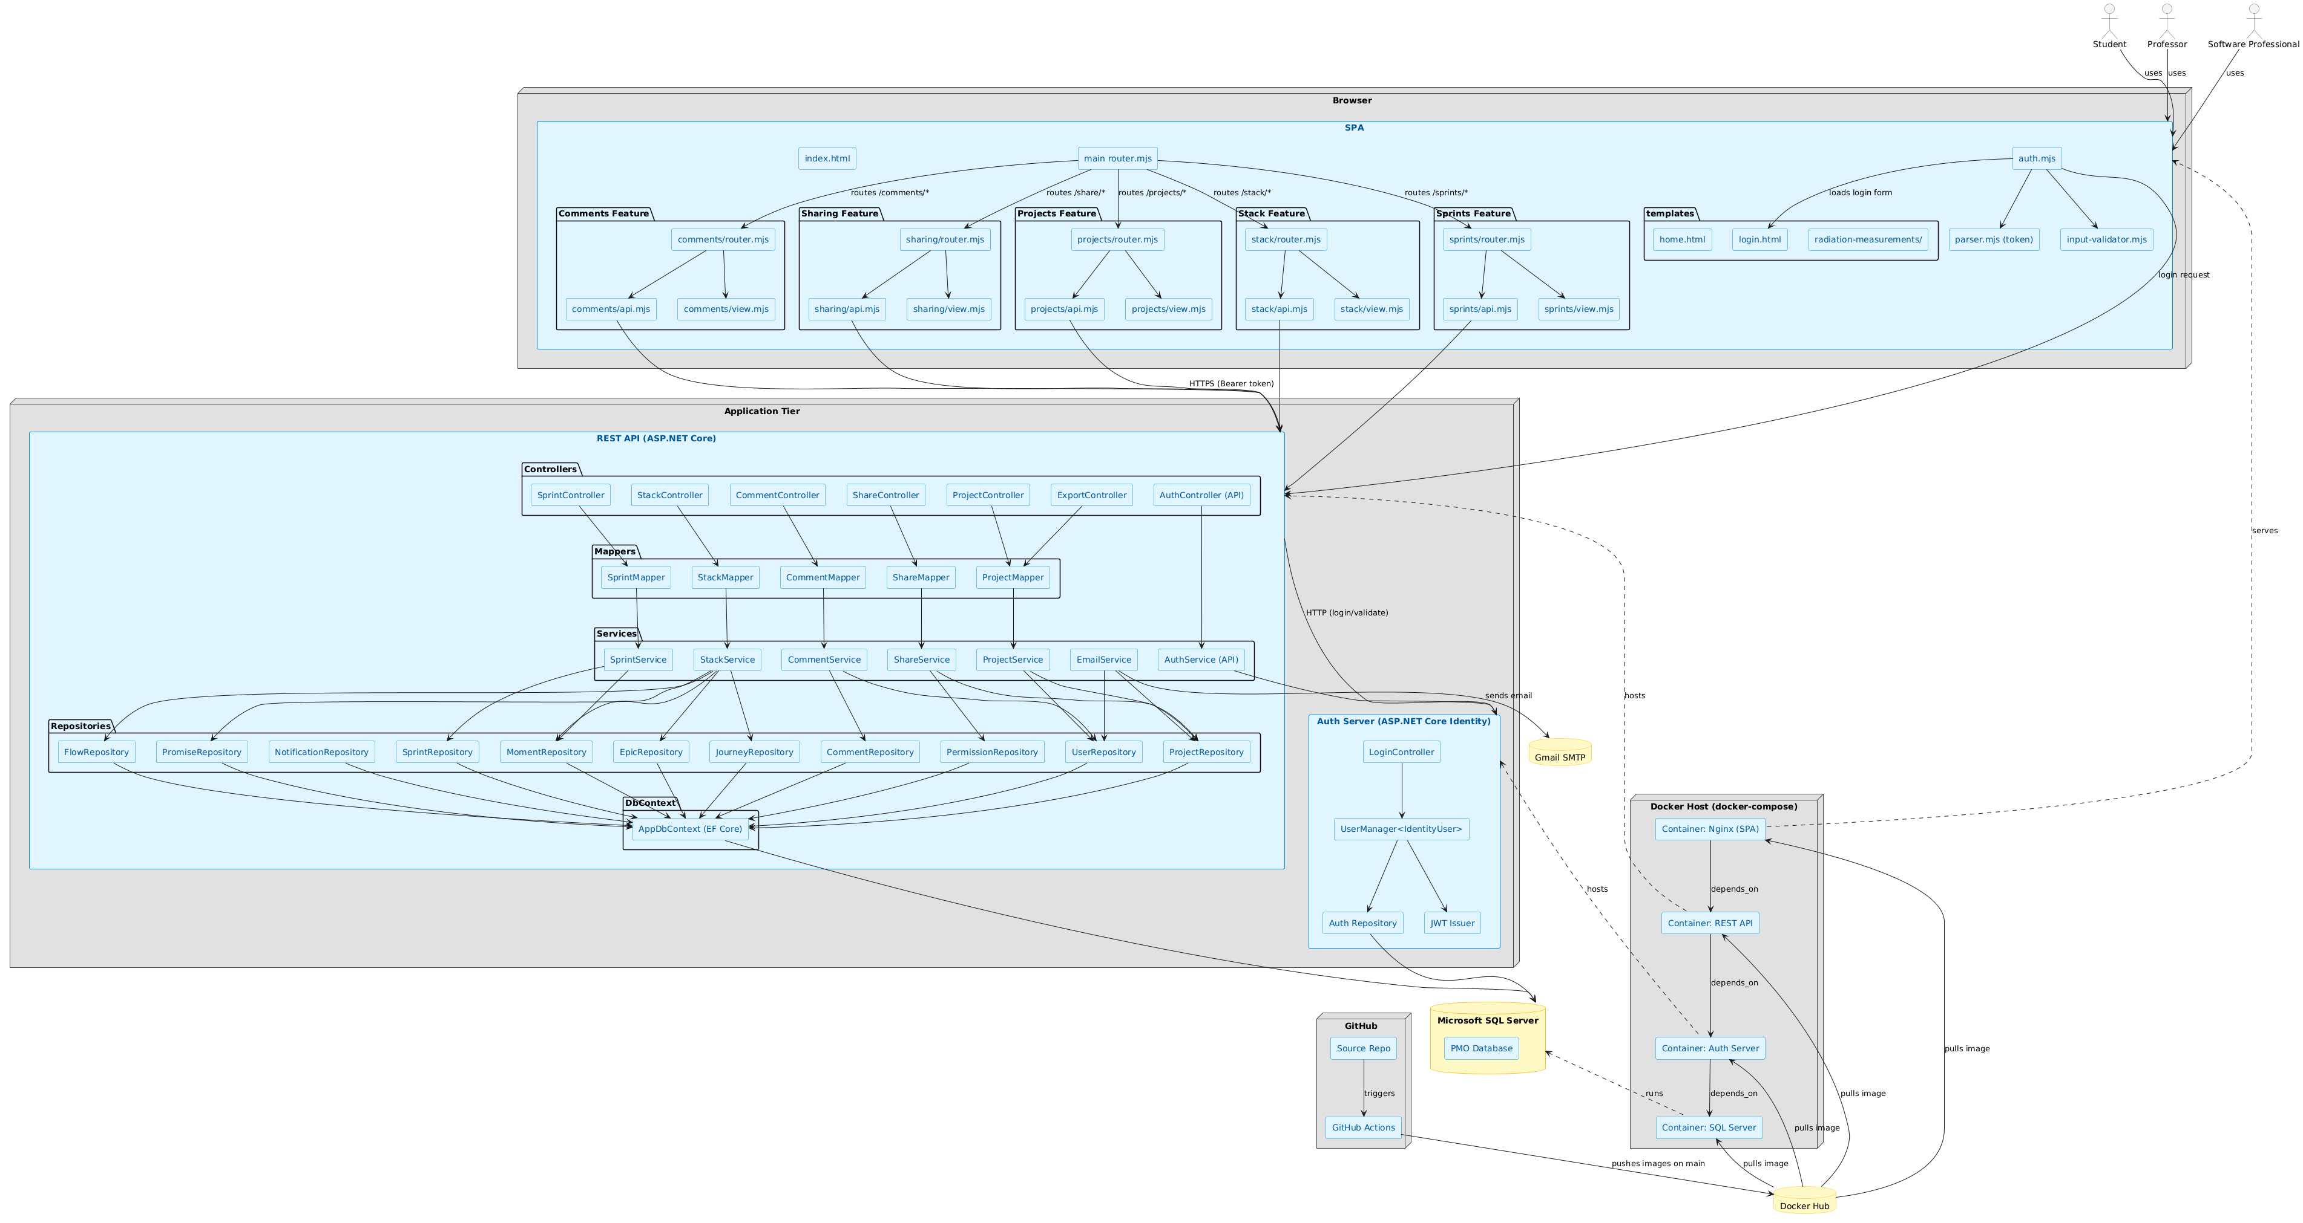

Class Diagram(s)
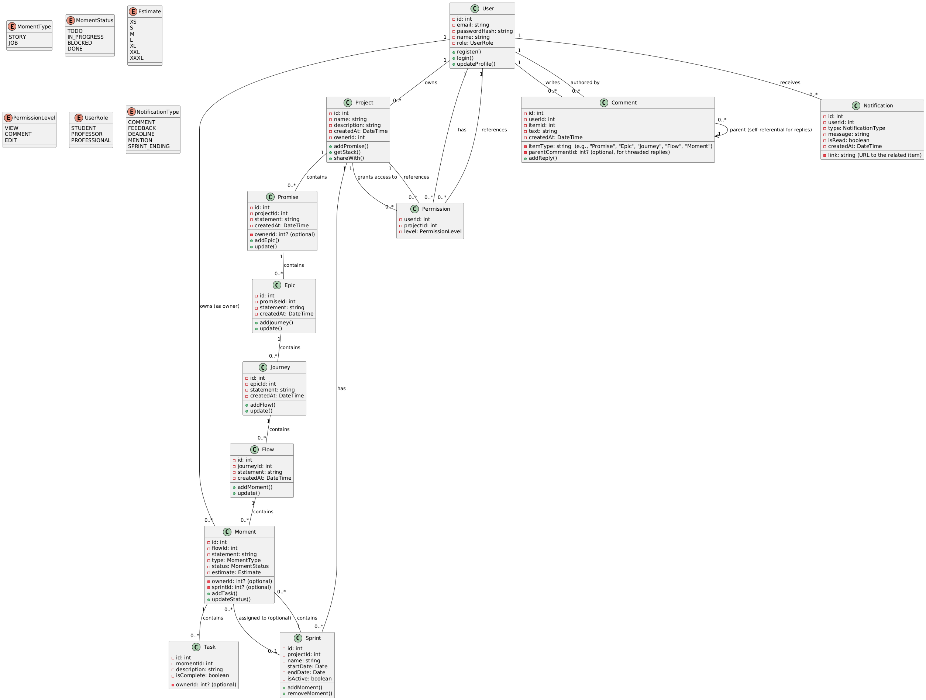

Dataflow/Sequence Diagram(s)

User Login Sequence
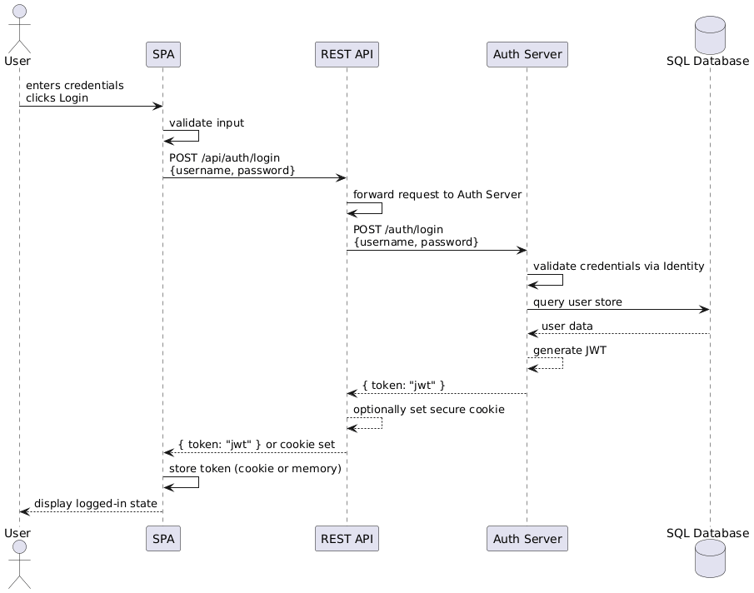

Create A Product Promise
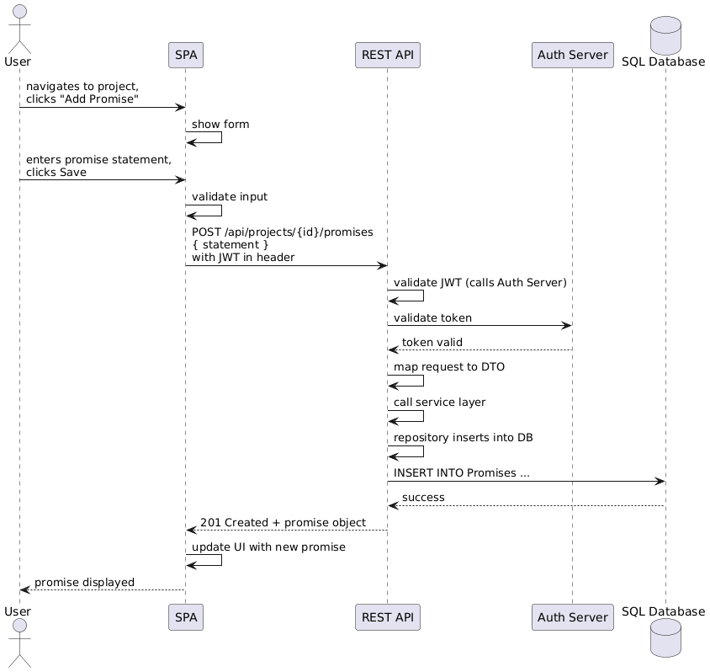

Add A Comment On A Stack Item
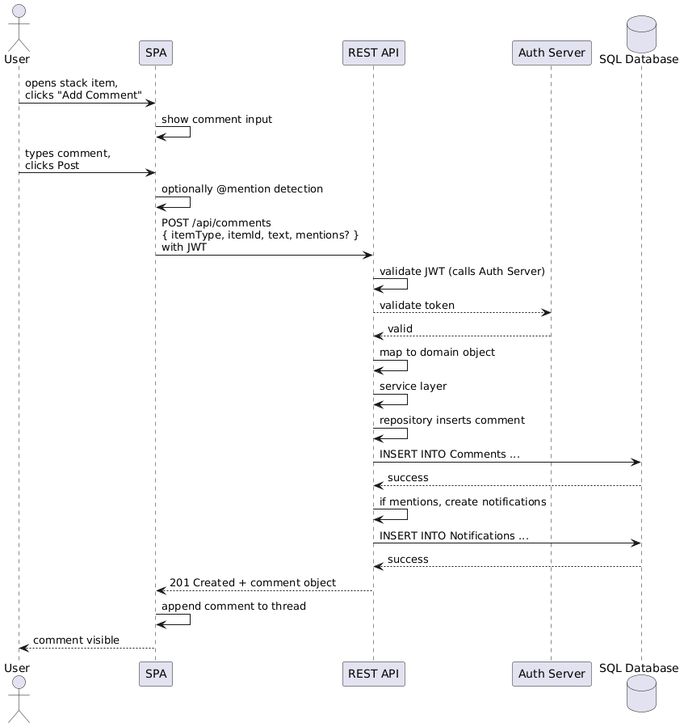

Assign a Moment to a Sprint
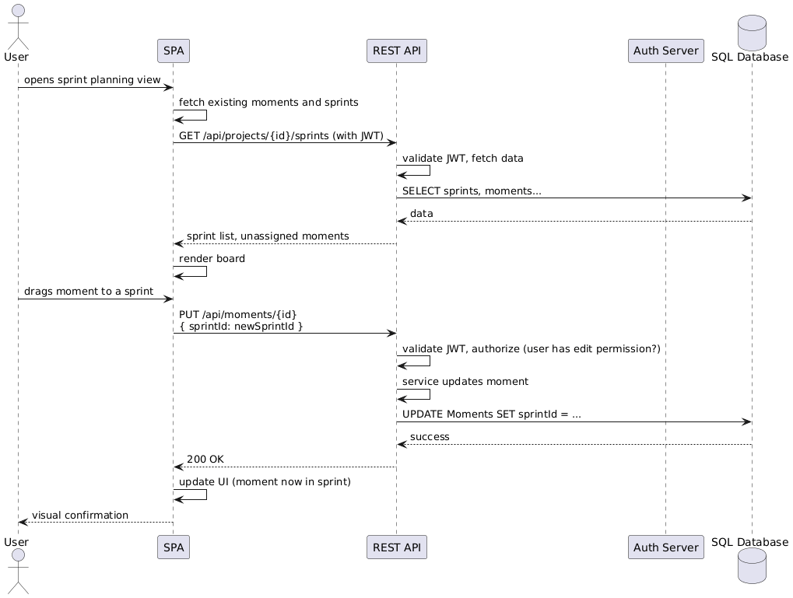

Export Project To JSON
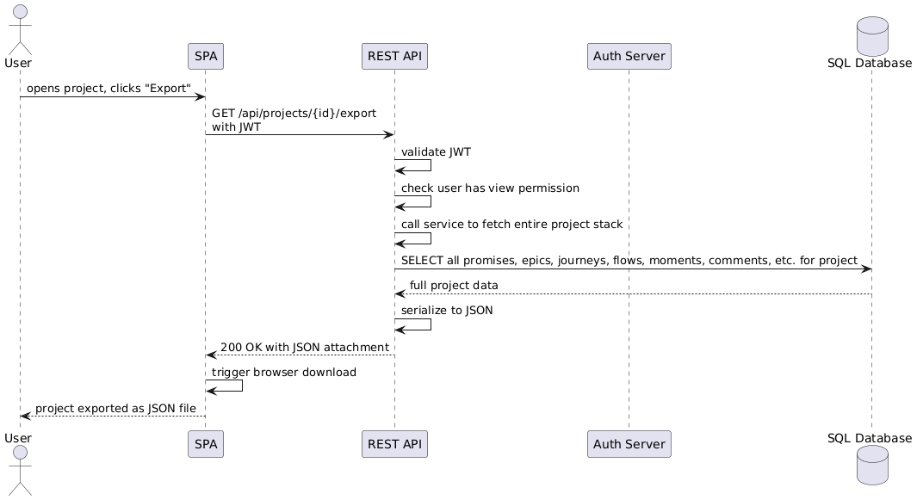

Receive a Notification (When Mentioned in a Comment)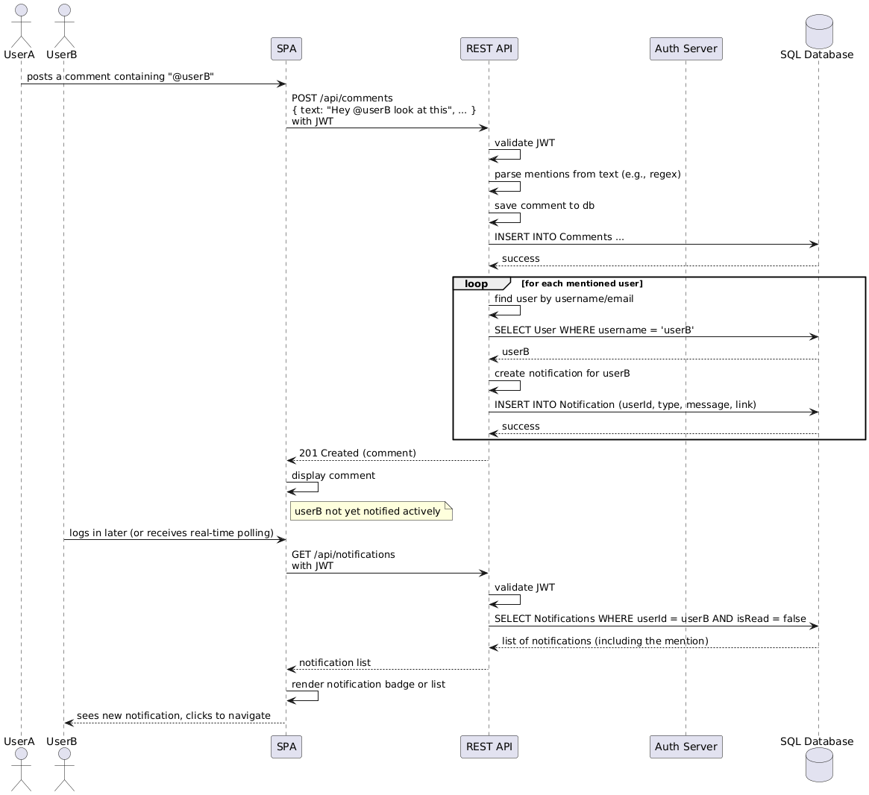
Create a Bug/Rework Task from a Comment
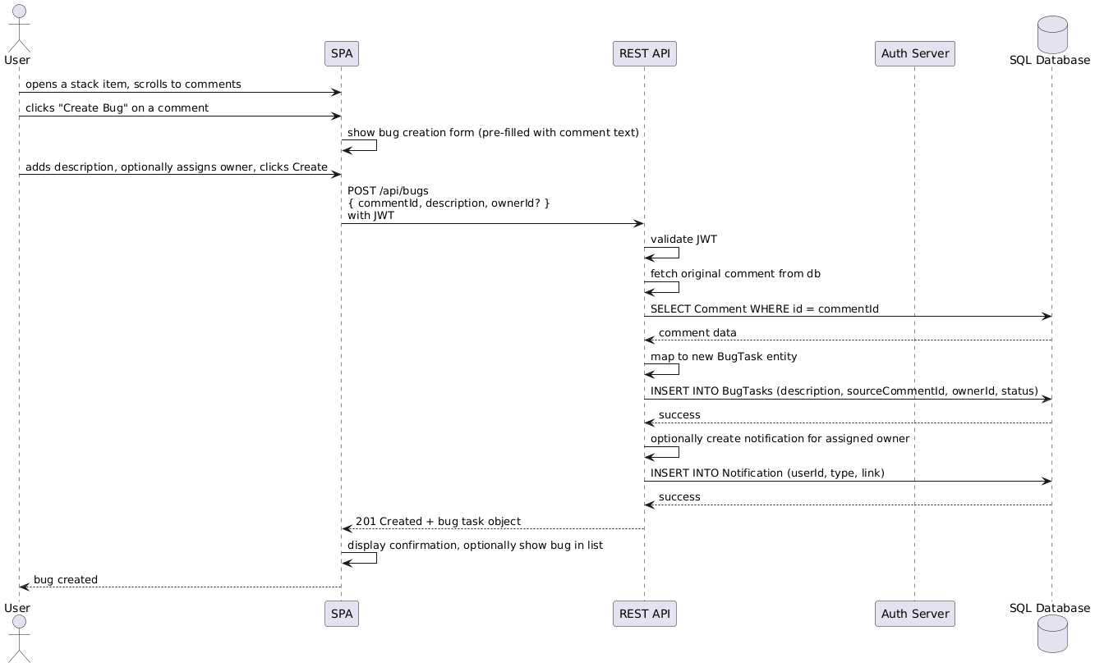

Share A Project With Another User

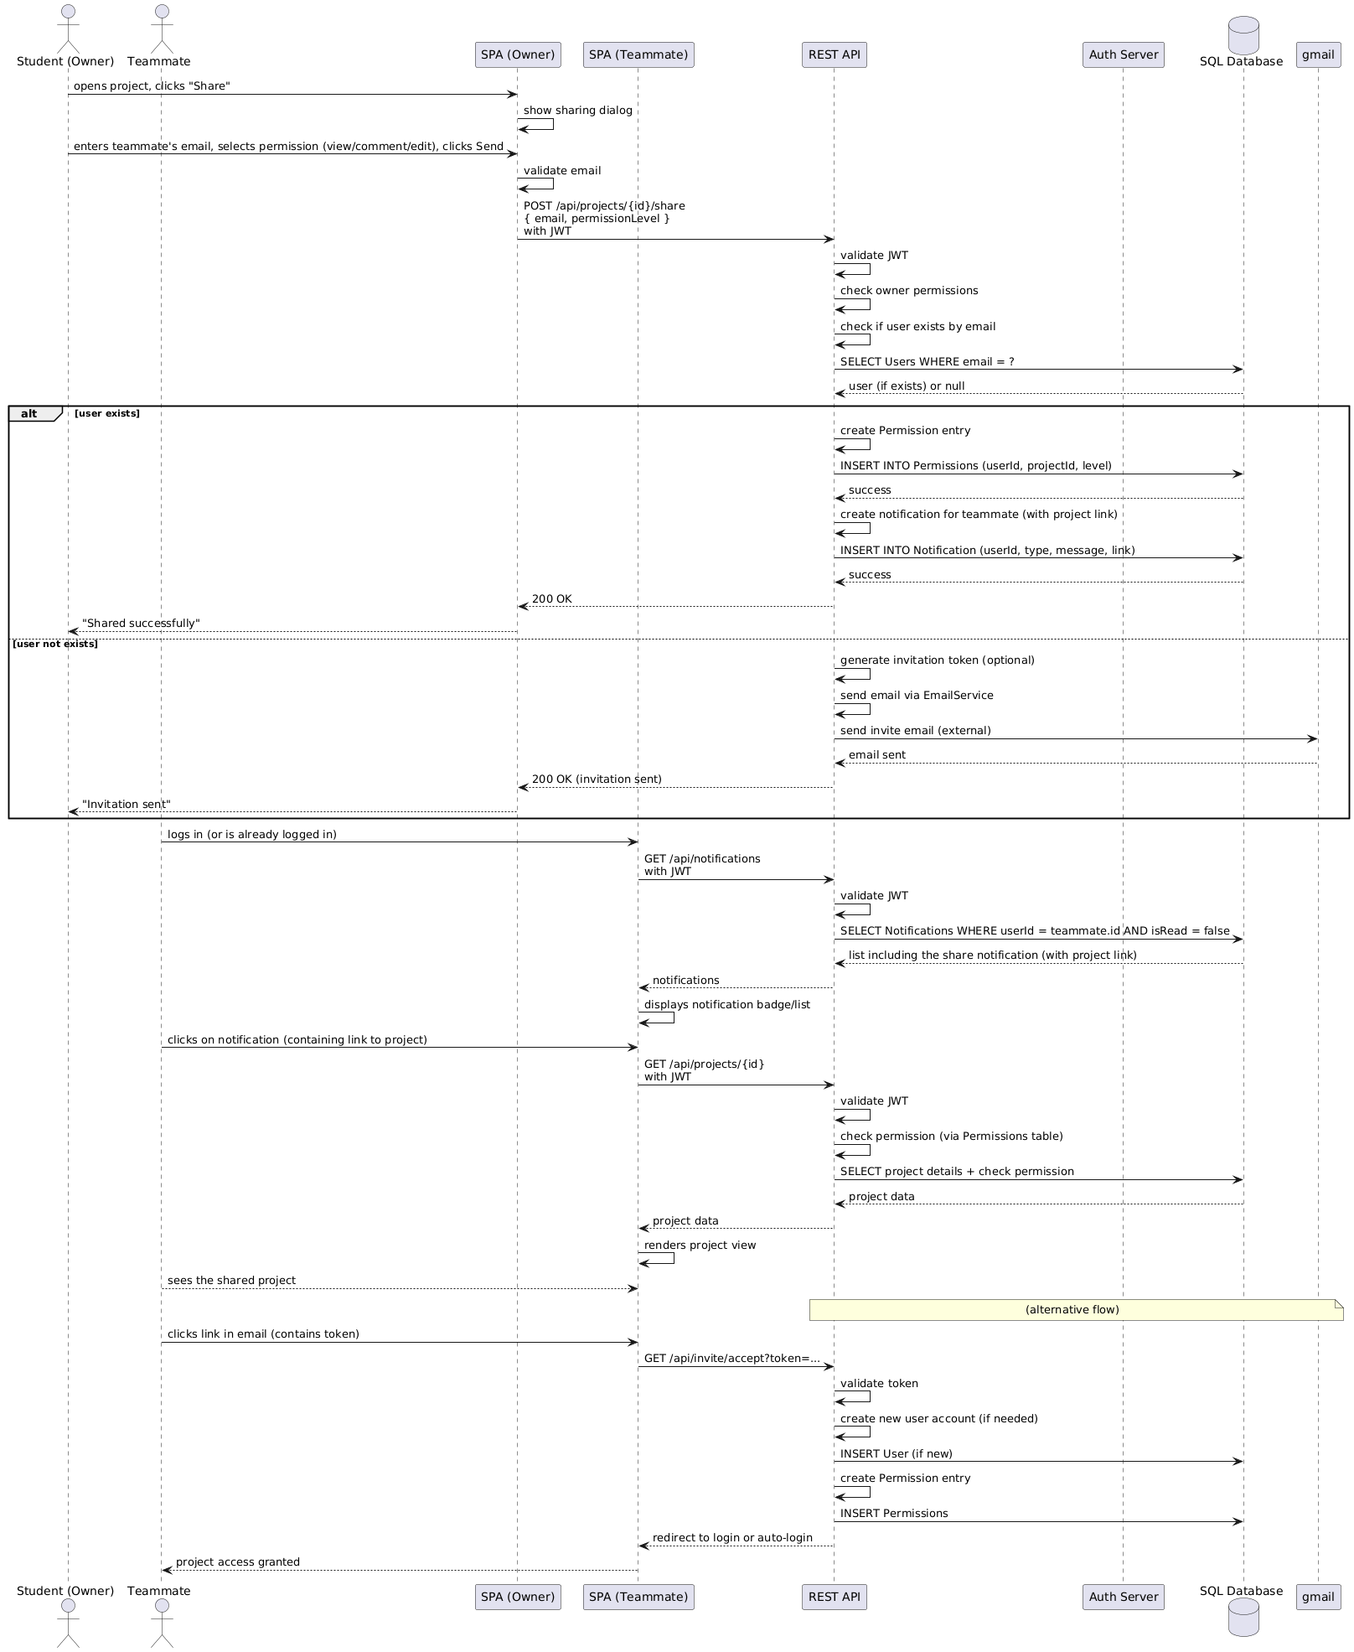

User Stories – Product Backlog Draft

Initial Product Backlog
ID | Story (short) | Priority | Points | Dependencies
US-1 | As a student, I would like to create promises so I can define the core principles behind my project. | High | 5 | N/A.
US-2 | As a student, I would like to add moments that define independent responsibilities needed to achieve the goals of my project. | High | 3 | US-1
US-3 | As a professor, I would like to have access to students’ promises and moments, to provide feedback and guidance when needed. | High | 5 | US-2.
US-4 | As a software professional, I would like to be able to install the required environment either for personal or organizational use, with proper documentation and little to no oversight. | High | 13 | N/A.

Acceptance Criteria by User Story

User Story 1: Student Interaction with tool.
As a student, I would like to create promises so I can define the core principles behind my project.

Acceptance Criteria
Scenario | Given | When | Then
Adding/Modifying Promises within User Interface | I am an authenticated student and have proper access to the software. | I click on “Add a Promise”, or mark moments as “Complete”. | The system should respond accordingly and update the interface based on my interaction.
Replying to Professor’s feedback from | I am an authenticated student who has received feedback from a professor for one of my promises. | I select the comment and decide to reply to the professor. | The system should display a text box, and a “submit” button. Allowing me to reflect on my performance.

Developer Voice (Technical Tasks)
- SQL tables must interact with back-end API for processing user requests (CRUD operations).
- The API must take requests from incoming clients and provide a response accordingly. Any response must be sent, even if was the result of an unsuccessful operation.
- Student and Professor SQL tables must be mapped to allow for back-and-forth CRUD operations.

User Story 2: Managing Promises with Moments
As a student, I would like to add moments that define independent responsibilities needed to achieve the goals of my project.

Acceptance Criteria
Scenario | Given | When | Then
Assigning moments to Promises hierarchically. | I am a student who is authenticated and have selected a promise to modify. | I create a new moment and assign it to a specific promise. | The system shall reflect the moment embedded within the promise in a hierarchical structure.
Modifying the status of a Moment. | I am an authenticated student and have selected a pertinent moment. | I select the moment and wish to change its status accordingly. | The system should display the currently set status for a moment and allow for further editing when required.

Developer Voice (Technical Tasks)
- SQL tables must interact with back-end API for processing user requests (CRUD operations).
- The API must take requests from incoming clients and provide a response accordingly. Any response must be sent, even if was the result of an unsuccessful operation.
User Story N3: Professor Evaluating Promises
As a professor, I would like to have access to students’ promises and moments, to provide feedback and guidance when needed.

Acceptance Criteria
Scenario | Given | When | Then
Evaluating a Promise | I am an authenticated professor and have selected a specific promise from any student. | I want to add comments and provide feedback based on my findings. | The system should display a text box with a “submit” button, allowing me to post feedback visible to the student.
Evaluate specific Moments | I am an authenticated professor and have selected a specific moment within a promise from any student. | I want to add comments and provide feedback based on my findings. | The system should display a text box and button to post feedback, making it visually clear which promise the specific moment belongs to.

Developer Voice (Technical Tasks)
- SQL tables must interact with back-end API for processing user requests (CRUD operations).
- The API must take requests from incoming clients and provide a response accordingly. Any response must be sent, even if was the result of an unsuccessful operation.
- Student and Professor SQL tables must be mapped to allow for back-and-forth CRUD operations.

User Story N4: Software Professionals tool interaction and deployment.
As a software professional, I would like to be able to install the required environment either for personal or organizational use , with proper documentation and little to no oversight.

Acceptance Criteria
Scenario | Given | When | Then
Deploying the PMO tool | I am a software professional that received the tool with required documentation. | I attempt to use the documentation and provided package to install the tool at the organization’s infrastructure, or for my personal use. | The documentation provided must be explicit to the point where I can install the tool without having to make any assumptions (ambiguity).
Using and interacting with the tool | I am a software professional who has deployed and registered for allowed use of the tool. | I attempt to use the tool. | All system components should be operational and easy to follow/navigate.

Developer Voice (Technical Tasks)
- Docker image should be pulled from Docker Hub and installed on the user’s machine.
- The created Docker containers must be automatically powered on upon installation.
- The tool shall be accessible through the user’s browser using their local IP (localhost) and the configured port number (1433 for SQL database, 9000 for SPA client, 8800 for API, 8060 for Auth).

Risk Register
Risk_ID | Risk | Category | Likelihood (L/M/H) | Impact (L/M/H) | Resulting Risk | Notes
Rsk-001 | Failure in compliance with specified security standards may result in unauthorized access to user data. | Sec | L | H | H | Mitigation: Non-functional testing will check for security validation of pertinent credentials prior to granting access to the system.
Rsk-002 | Internal API failure may result in unhandled exceptions within the user interface. | Dev | M | M | M | Mitigation: Use proper CI/CD pipelines and perform rigorous testing, accounting for edge cases and other scenarios.
Rsk-003 | Deleting a promise may result in mishandled hierarchical deletion of associated moments/journeys. | Dev/UX | M | H | M | Mitigation: Ensure proper relationship mapping within databases, leverage data structures and perform extensive testing.
Rsk-004 | The Docker image may fail to initialize one or more of the containers needed to start the PMO tool. | Dev | L | H | H | Mitigation: Ensure the docker-compose file is written properly. Else, should the issue stem from the user’s configuration, provide basic troubleshooting tips in documentation.

Appendix 1 – Change Log
Date | Version/Desc. | What Changed? (Summary)
March 2, 2026 | 1.0 Initial Draft for software documentation. | N/A Initial Release

