A

SUMMER RESEARCH INTERNSHIP

REPORT ON

# Power Electronics Devices in Transmission Line

DISCIPLINE OF ELECTRICAL ENGINEERING

INDIAN INSTITUTE OF TECHNOLOGY INDORE

JUNE 2024



|  |  |
| --- | --- |
| **Submitted by:** | **Guided by :** |
| Ankita Kumari | Dr. Lokesh Kr. Dewangan |

Assistant Professor,

Electrical Engineering

**ACKNOWLEDGEMENTS**

I would like to extend my heartfelt gratitude to Dr. Lokesh Kumar Dewangan for his invaluable mentorship and guidance throughout my internship at IIT Indore. His profound knowledge, insightful feedback, and constant support have been instrumental in shaping my understanding of power electronics devices in transmission lines. I am deeply appreciative of the time and effort he invested in guiding me through various challenges and ensuring my growth both academically and professionally. My sincere thanks also go to the entire faculty and staff of the Department of Electrical Engineering for providing a conducive learning environment and the necessary resources. This internship has been a remarkable learning experience, and I am grateful to all who contributed to making it successful.

Thank you.

Ankita Kumari

**LIST OF CONTENTS**

|  |  |  |
| --- | --- | --- |
| **TOPIC** | | **Page No.** |
| 1. Introduction | | 5 |
| 2. Basic Electrical Circuits  2.1 RL  2.2 RLC  2.3 Circuit with fixed resistance  2.4 Circuit with variable resistance(switch) | | 6  7  8  8-9 |
| 3. Basic Electronics Circuits  3.1 Simple circuit  3.2 Buck converter  3.3 Boost converter  3.4 Power quality analysis  3.5 Three phase PWM inverter | | 10  10-11  11-12  13-14  15-16 |
| 4. Transmission line, Bus Bar and Faults | | 17-22 |
| Conclusion |  | 23 |
| References |  | 24 |

**LIST OF FIGURES**

|  |  |  |
| --- | --- | --- |
| **Figure No.** | **Name Of Figure** | **Page No.** |
| 1. | RL Circuit | 6 |
| 2. | RLC Circuit | 7 |
| 3. | Simple Electrical circuit | 7 |
| 4. | Electrical circuit with switch | 8 |
| 5. | Simple Electronics circuit | 10 |
| 6. | Buck converter | 12 |
| 7. | Boost converter | 13 |
| 8. | Bridge Diode Rectifier | 14 |
| 9. | Inverter circuit | 15 |
| 10 | Bus Bar System | 16 |
| 11 | Transmission Line with Transformer | 17 |
| 12 | Transient Fault | 18 |
| 13 | Transmission Line | 19 |
| 14 | Transmission Line with FFT | 20 |
| 15 | Transmission Line with compensative capacitor | 21 |

**Introduction**

The field of power electronics is integral to modern electrical engineering, playing a pivotal role in the control and conversion of electric power across various applications. Power electronic devices are especially crucial in the transmission and distribution of electrical power, as they enhance efficiency, stability, and control. This report provides an in-depth exploration into the application and modelling of power electronic devices in transmission lines. During this study, various models were developed and implemented using PSCAD, a powerful software tool for power system analysis and design. This hands-on experience was invaluable in understanding the complexities and nuances of power electronics in real-world scenarios. One of the primary focuses was the design and analysis of various circuit combinations. By modelling these circuits, insights were gained into the behaviour of resistors, inductors, and capacitors in various configurations, which are fundamental to understanding power electronics. Additionally, the intricacies of transmission lines, a critical component in power distribution, were explored by designing and simulating different models to observe their performance under varying conditions. The study involves designing and analysing various circuit combinations, including RL and RLC circuits, simple power systems with fixed and variable resistors, and nine-bus bar systems. Special focus is given to the modelling of transmission lines, fault analysis, UG cables, and transformer integration. Additionally, the report covers the simulation of buck and boost converters, transient source fault analysis, and power systems with compensative capacitors. A significant portion of the work involved the "Simulation and Analysis of a Three-Phase PWM Inverter," providing insights into the behaviour and optimization of inverters in real-world applications. Through these designs, optimization of performance and stability in power electronic systems was achieved. By implementing these designs in PSCAD, their performance and efficiency were analysed, providing a deeper understanding of their operation and applications. This report details the various models and designs worked on, the methodologies employed, and the key learnings and outcomes of the work, providing a comprehensive understanding of power electronic devices in transmission lines.

# Basic Electrical Circuits

**2.1 RL circuit**

RL circuit consists of a resistor and inductor in series. An ammeter measures current, while a ground-connected voltmeter records voltage across the components, enabling detailed analysis of circuit behaviour and performance.

~~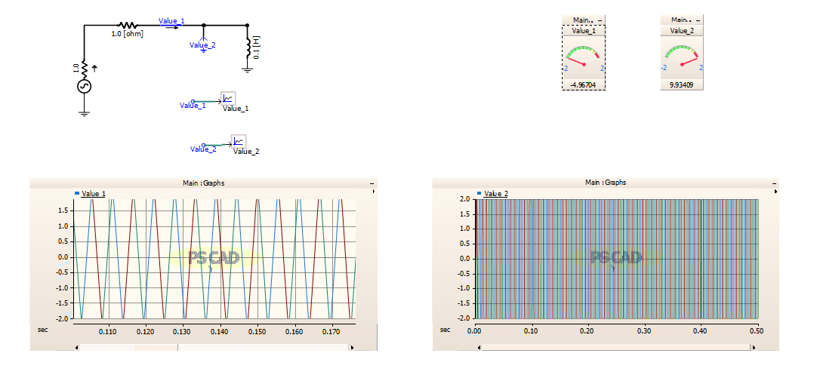~~

* Fig 1. RL Circuit
* Open PSCAD and create a new project.
* Add a resistor and an inductor in series.
* Connect an ammeter in series with the RL circuit.
* Add a voltmeter across the RL circuit, connecting one terminal to ground.
* Insert a graph to display voltmeter and ammeter values.
* Run the simulation.

**2.2 RLC circuit**

A normal RLC circuit can be modelled with an ammeter to measure current and a ground-connected voltmeter to measure voltage. This setup helps in analysing the circuit's dynamic response and electrical behaviour accurately.

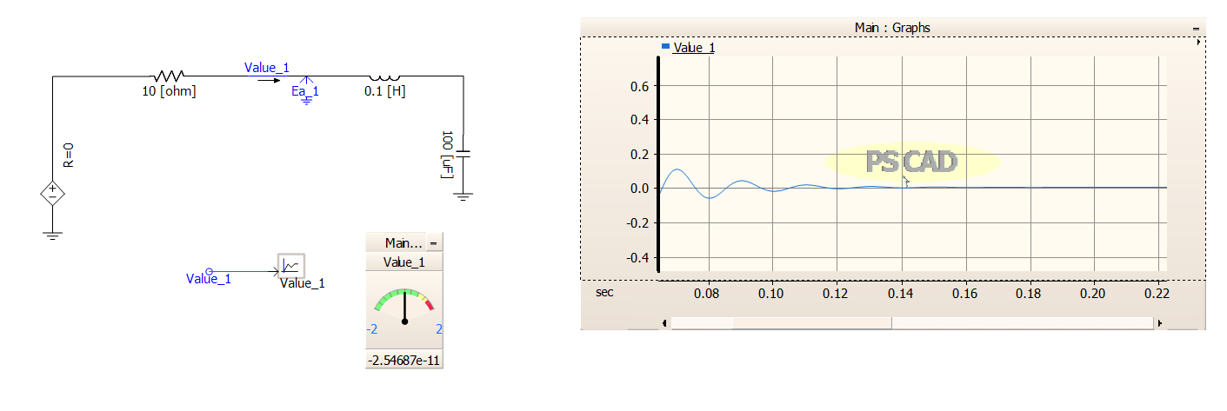

Fig 2. RLC circuit

**2.3 Electrical circuit (using 10ohm fixed resistor)**

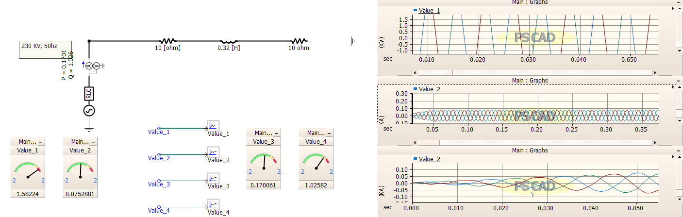

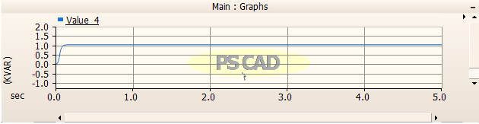

Fig 3. Simple Electrical circuit

**2.4 Electrical circuit using variable resistance (using switch)**

An Electrical circuit with a variable resistance controlled by a switch. This setup allows

dynamic adjustment of resistance values during simulation, enabling real-time analysis of system behaviour and performance under varying load condition.

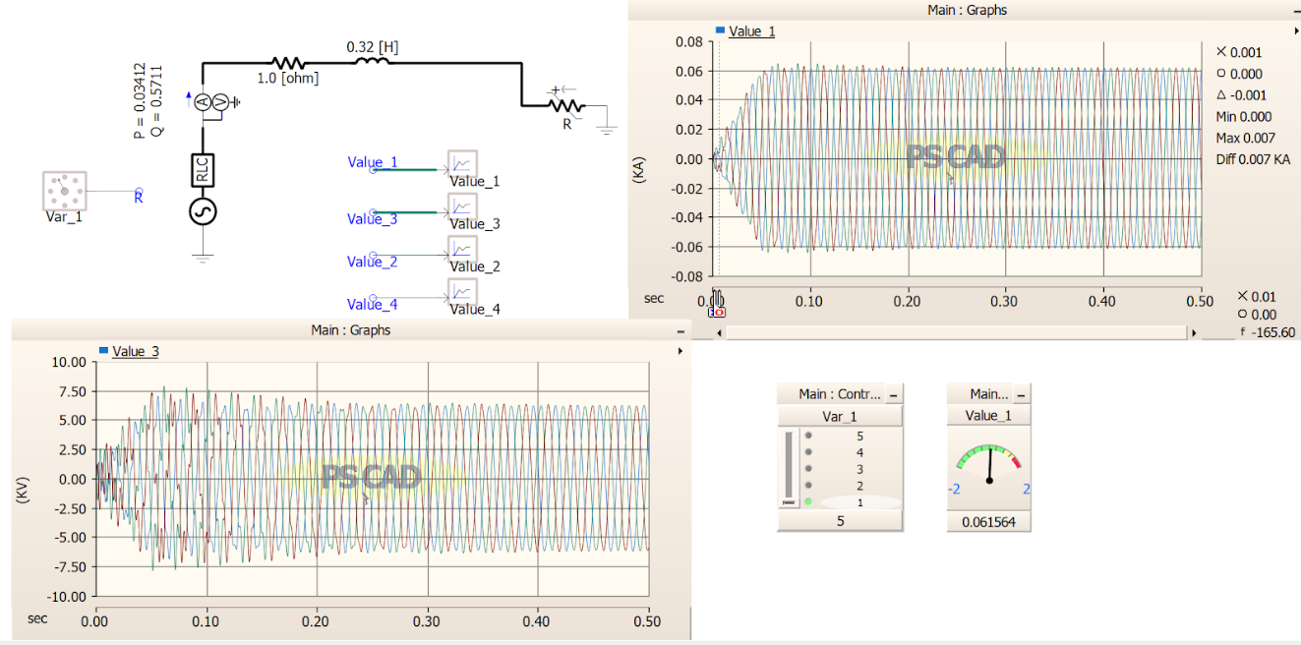

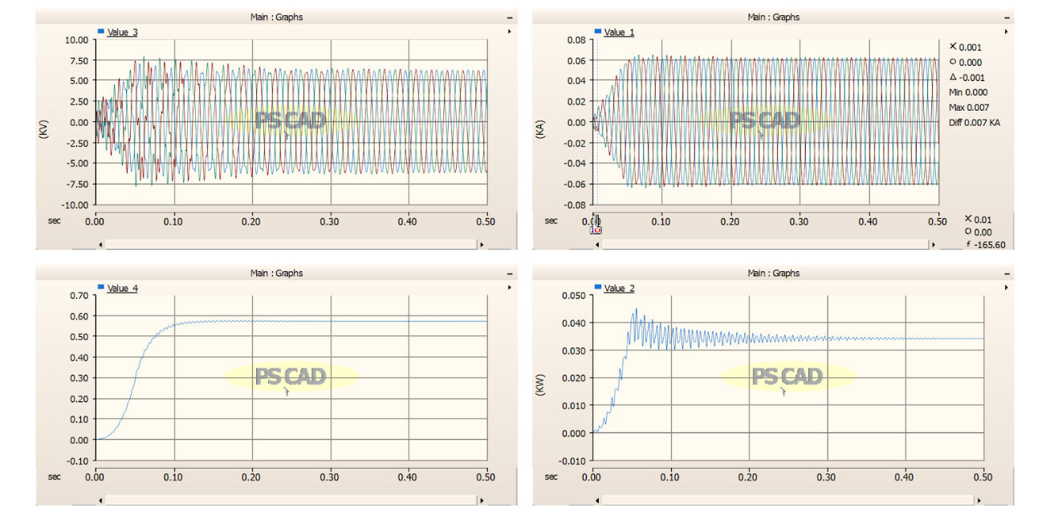

Fig 4. Electrical circuit with switch

• Connect a 3-phase voltage source (RLC source) to the circuit in PSCAD.

• Include a resistance and an inductor in series.

• Introduce a variable resistor controlled by a switch in parallel with the inductor.

• Measure active power using a multimeters across the resistor.

• Measure reactive power across the inductor.

**Power Electronics circuit**

Power electronics circuits in PSCAD simulate devices like boost and buck converters using components such as IGBTs and diodes. These circuits control voltage levels efficiently, crucial in renewable energy systems and motor drives, ensuring optimal energy transfer and regulation in diverse applications. Inverter circuits, like the three-phase PWM inverter simulated in PSCAD, convert DC power into AC power using IGBTs and diodes. hey generate adjustable AC voltages and frequencies suitable for motors and grid-connected renewable energy systems. This simulation analyzes waveform quality, efficiency, and control strategies critical for stable AC output, essential in industrial and residential applications for powering various loads with precise voltage and frequency control.

**3.1 Simple Electronics circuit**

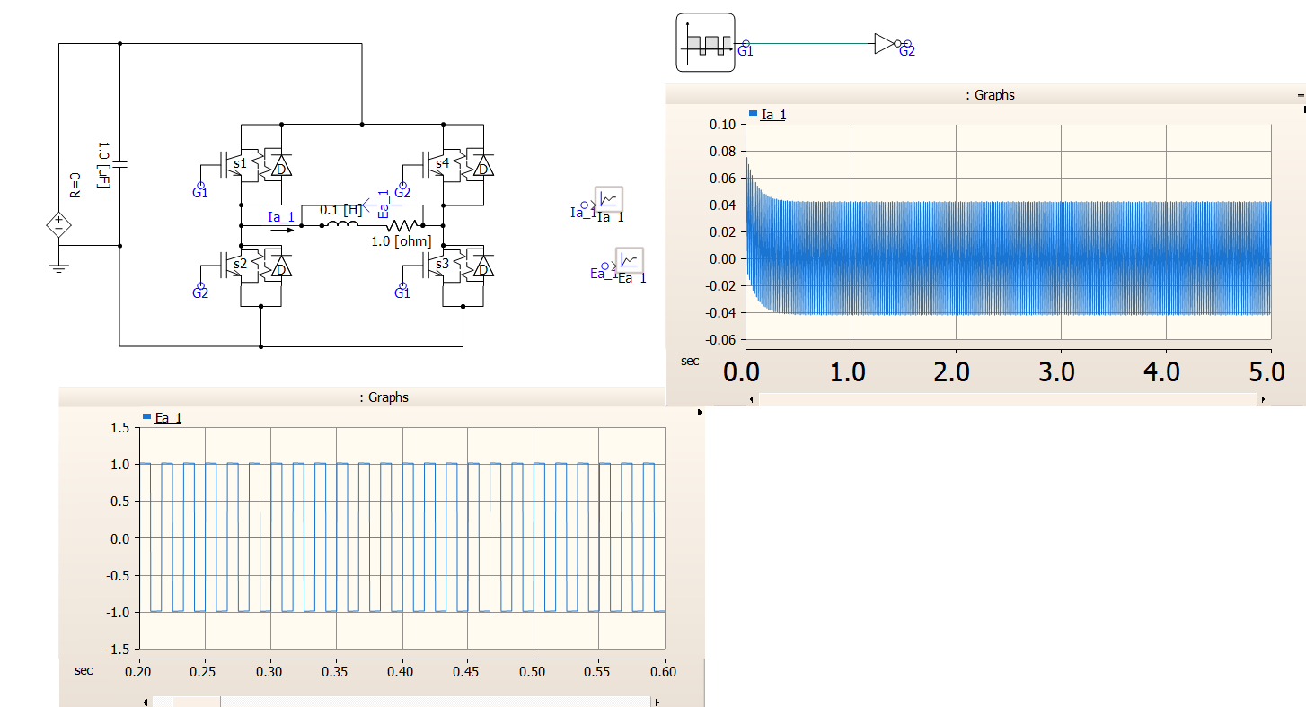

Fig 5: Simple circuit

**3.2  Modelling and Simulation of Buck Converter**

The modelling and simulation of a buck converter buck converter in PSCAD involves components like IGBTs for switching, diodes for rectification, resistors for load simulation, a voltage source, an ammeter for current measurement, a voltmeter for voltage monitoring, capacitors for smoothing, and an inductor for energy storage. This setup allows for the analysis of efficiency, voltage regulation, and transient responses critical in power electronics design and renewable energy systems. it is used to regulate voltage outputs efficiently by controlling the duty cycle of a switching transistor (often a MOSFET) and operates in continuous or discontinuous mode depending on the load. Buck converters are essential for applications where stable lower voltage levels are required, such as in battery-powered devices, power supplies, and LED drivers.

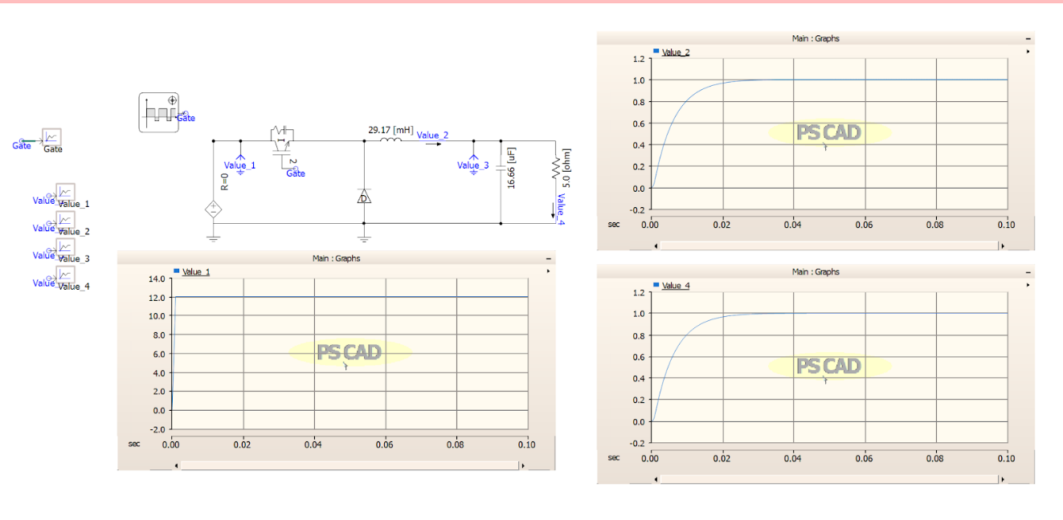

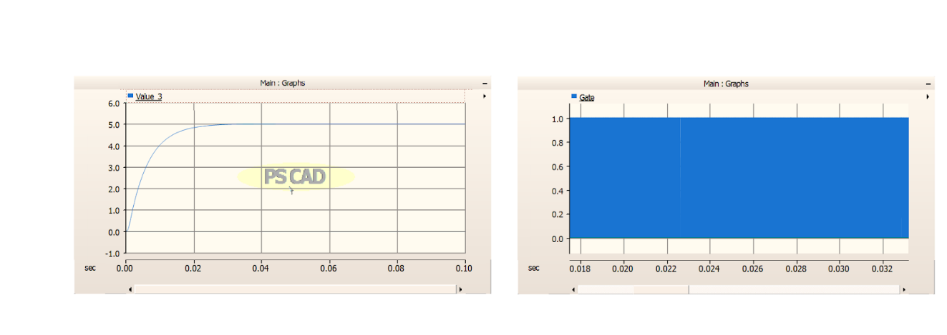

Fig 6. Buck converter

**3.3 Modelling and Simulation of Boost Converter**

The Boost Converter in modelling and simulation employs components like IGBTs for switching, diodes for rectification, resistors for current sensing, a voltage source for input, an ammeter for current measurement, a voltmeter for voltage monitoring, capacitors for smoothing, and inductors for energy storage. This setup allows for efficient voltage step-up operations, crucial in various power supply and renewable energy applications, ensuring effective simulation of power conversion processes in software like PSCAD. The Boost Converter in modelling and simulation employs components like IGBTs for switching, diodes for rectification, resistors for current sensing, a voltage source for input, an ammeter for current measurement, a voltmeter for voltage monitoring, capacitors for smoothing, and inductors for energy storage. This setup allows for efficient voltage step-up operations, crucial in various power supply and renewable energy applications, ensuring effective simulation of power conversion processes in software like PSCAD.

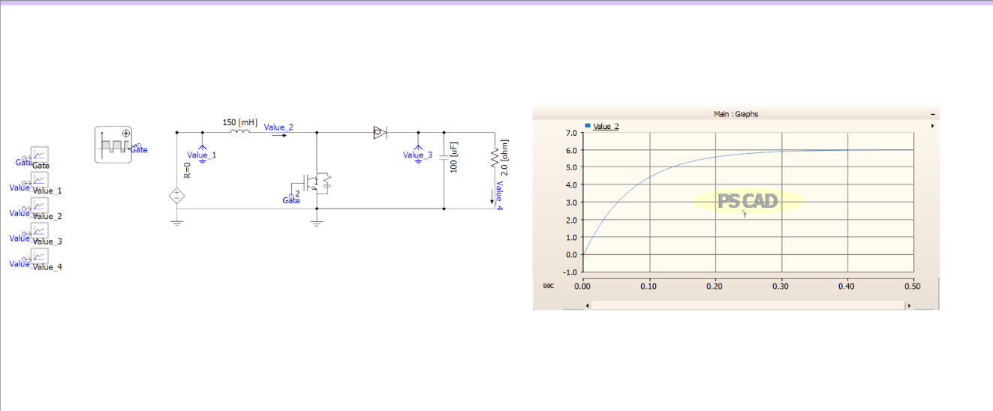

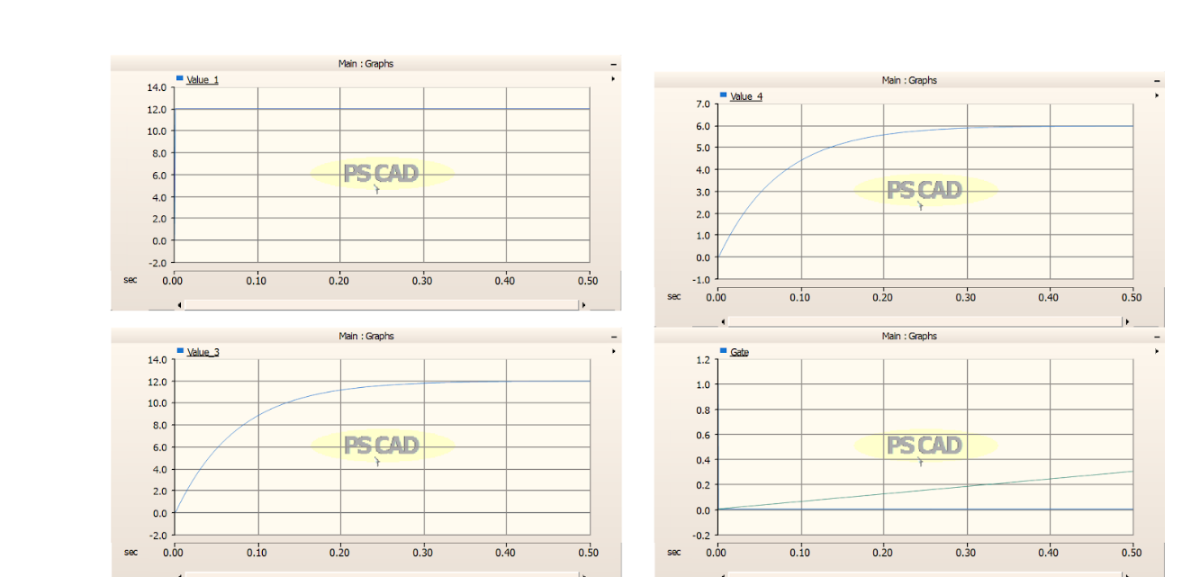

Fig 7. Boost Converter

**3.4 Power Quality Analysis of Simple Diode Bridge Rectifier**

Power quality analysis of a simple diode bridge rectifier involves assessing factors like total harmonic distortion (THD), ripple voltage, and efficiency. Diode bridges convert AC to pulsating DC, often causing harmonic distortion due to non-linear current draw. Analysis includes evaluating waveform distortion and designing filters to mitigate harmonics, crucial for reliable operation in power supply applications.

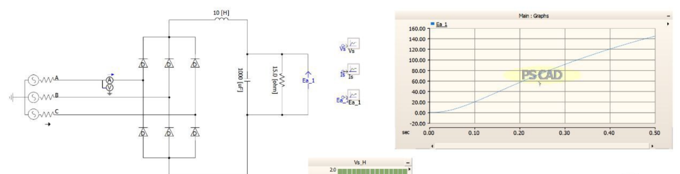

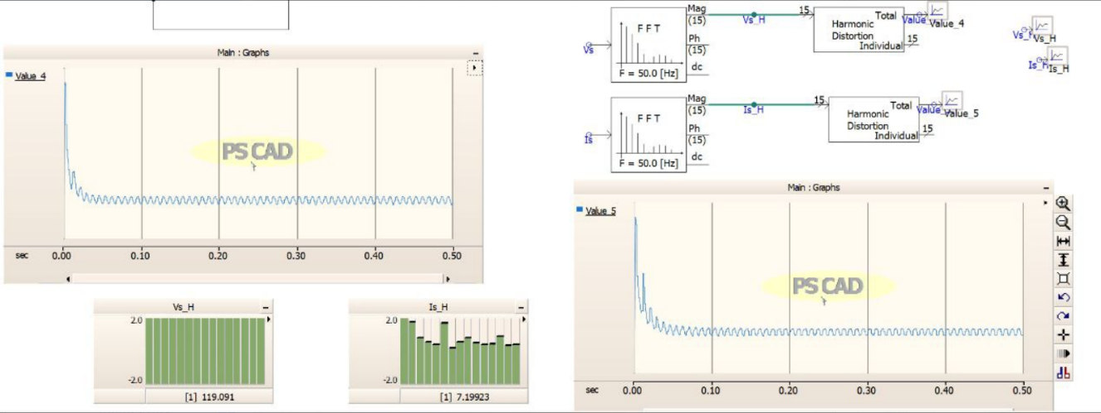

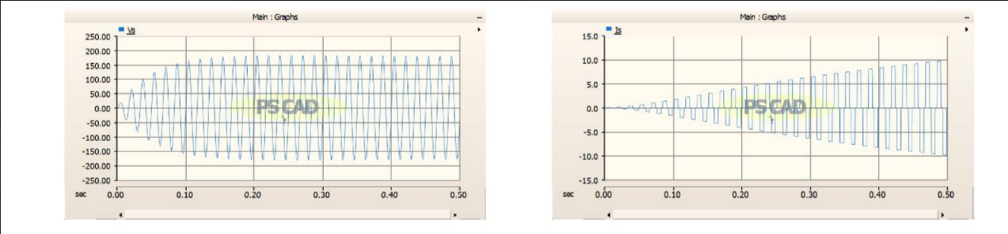

Fig 8. Bridge Diode Rectifier

**3.5 Simulation and Analysis of a Three-Phase PWM Inverter**

The simulation setup depicts a three-phase inverter controlled by PWM signals generated from a control circuit. It converts DC to AC, producing a sinusoidal output voltage (Eab) and drawing a corresponding DC current (Idc). This configuration in MATLAB Simulink facilitates analysis of inverter performance and validation of PWM control effectiveness through observed waveforms on measurement scopes and plotted graphs.

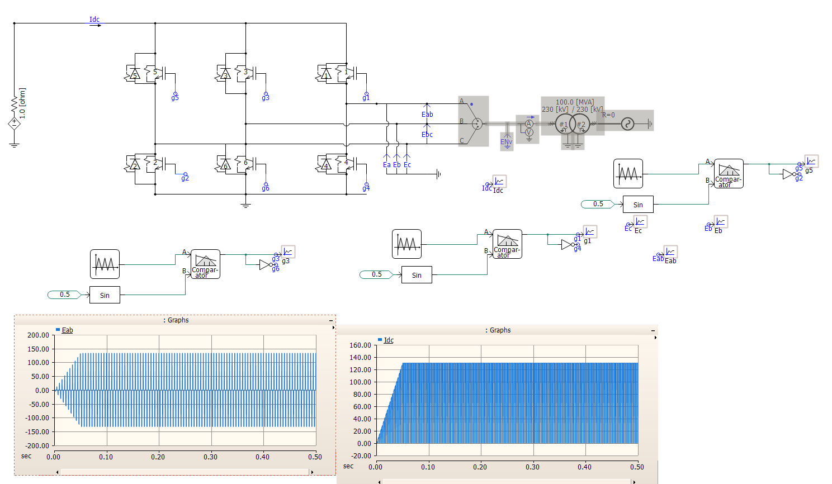

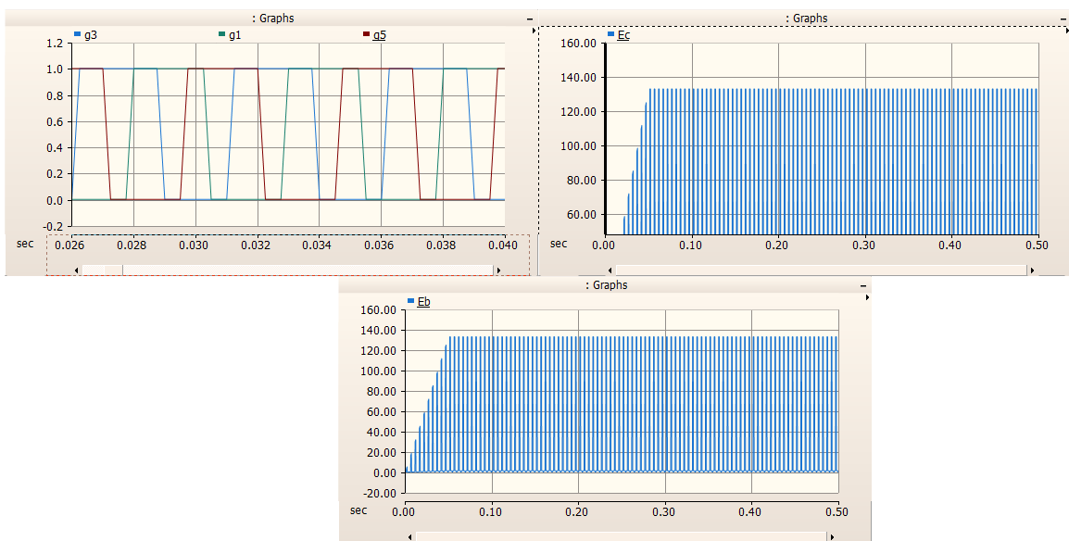

Fig 9. Inverter circuit

**Transmission line, Bus bar and Faults**

The Transmission lines serve as vital conduits for electricity, carrying power over long distances from generation plants to substations. Bus bars, typically in substations, distribute electricity to various networks. Faults in this infrastructure, such as short circuits or line breaks, can disrupt power flow, leading to outages or equipment damage. Mitigating faults involves protective measures like relays and circuit breakers, swiftly isolating faulty sections to maintain grid stability. Understanding these components and their interactions ensures reliable electricity distribution, supporting modern infrastructure and industries worldwide.

**4.1 Modelling of Nine Bus Bar System:**

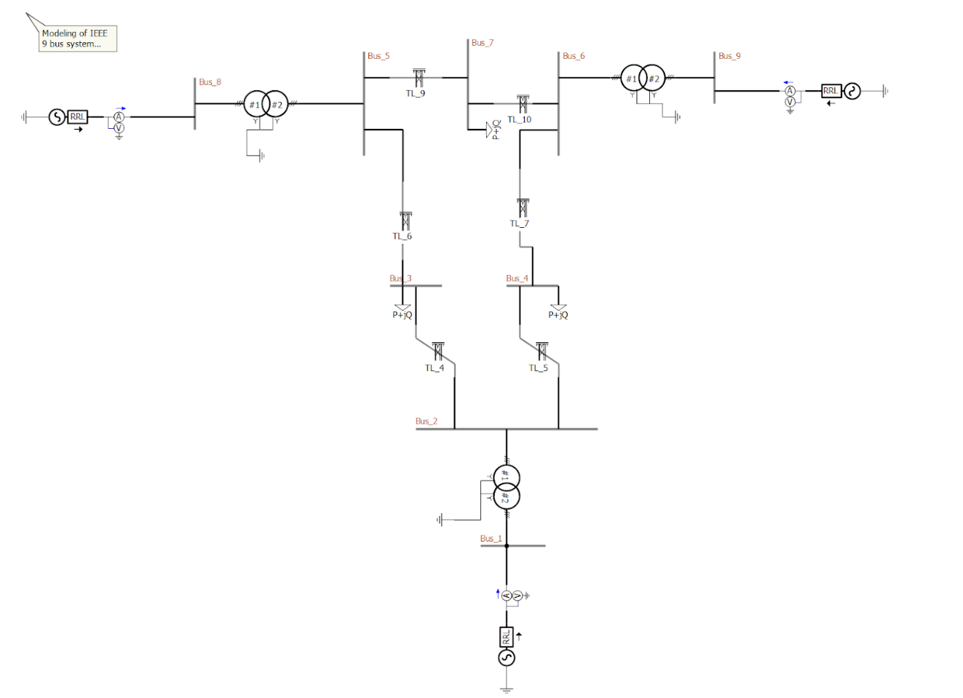

Fig 10. Bus Bar System

**4.2 Transmission line with Transformer**

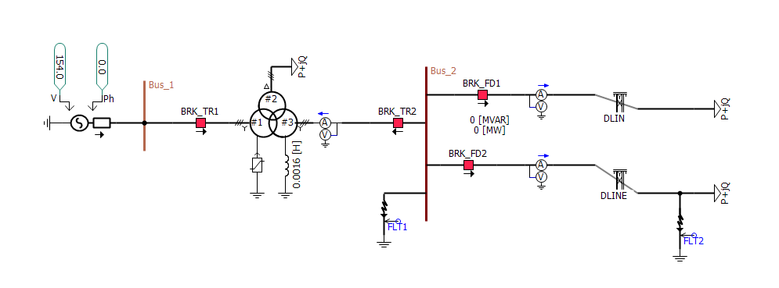

Fig 10. TL line with transformer

**4.3 Transient Source Fault Analysis:**

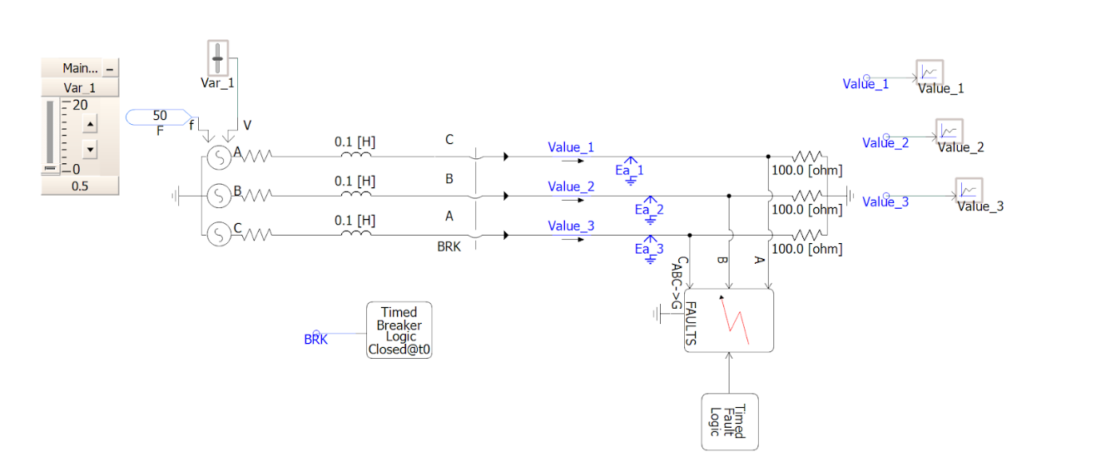

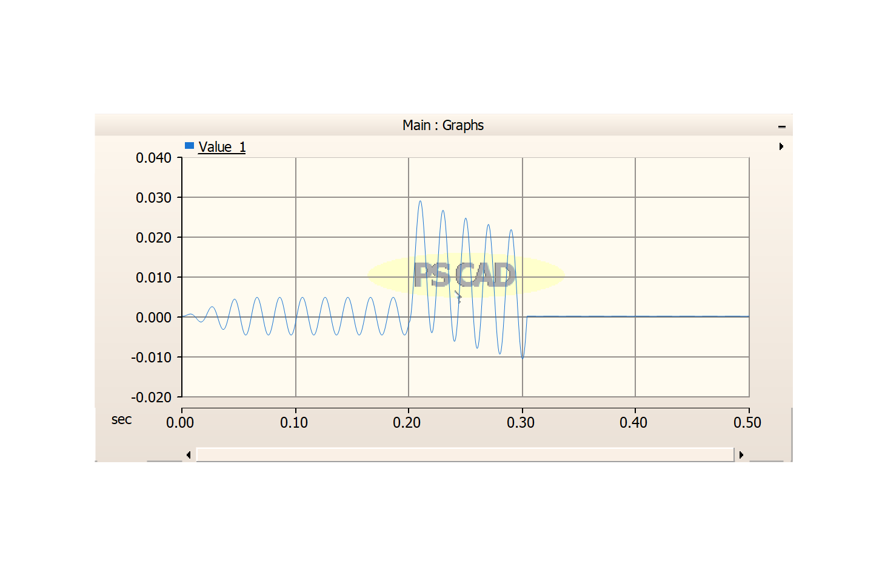

Fig 11.Transisent Fault

**4.3 Transmission Line**

In a series configuration of a transmission line, various components play critical roles. The cable itself acts as the conduit for electrical transmission, connected in series with protective devices like breakers to manage faults. A multimeter monitors electrical parameters, while a variable resistance adjusts line characteristics. An RLC source simulates impedance effects, crucial for power flow analysis. The bus bar distributes power at junctions, enhancing network reliability. Understanding and managing these interconnected elements are essential for maintaining operational integrity and swiftly addressing faults to ensure uninterrupted power supply.

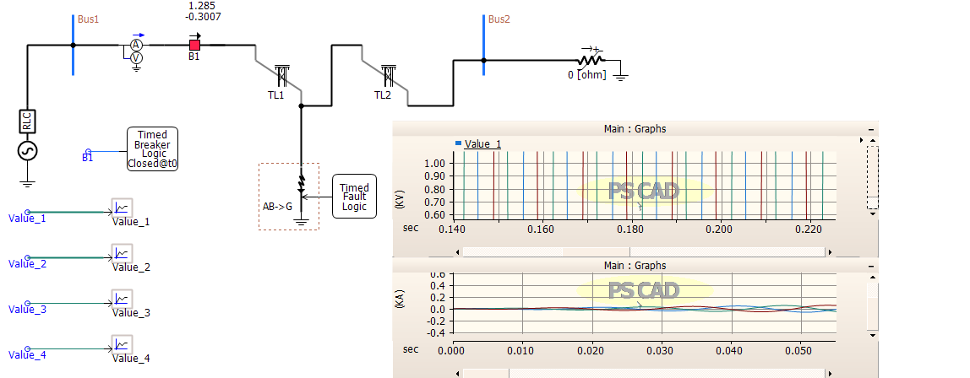

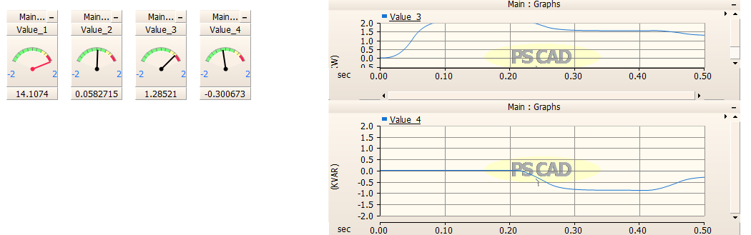

Fig 12.TL line

**4.3 Transmission Line Fault Analyser**

In a series configuration comprising a transmission line cable, breaker, fault, multimeter, RLC source, and bus bar, faults can disrupt power flow. The fault analyser identifies and isolates faults swiftly, ensuring grid stability and reliable electricity distribution. Understanding these components optimizes maintenance and troubleshooting in power systems. A transmission line cable with a breaker fault, multimeter, RLC source, and bus bar in series creates a PSCAD scenario. Adding a variable resistance complicates analysis. Utilizing an FFT analyser enhances fault detection by examining frequency components, aiding in accurate troubleshooting and maintenance.

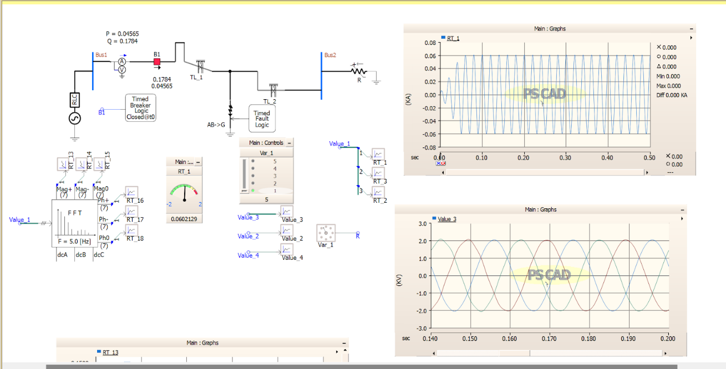

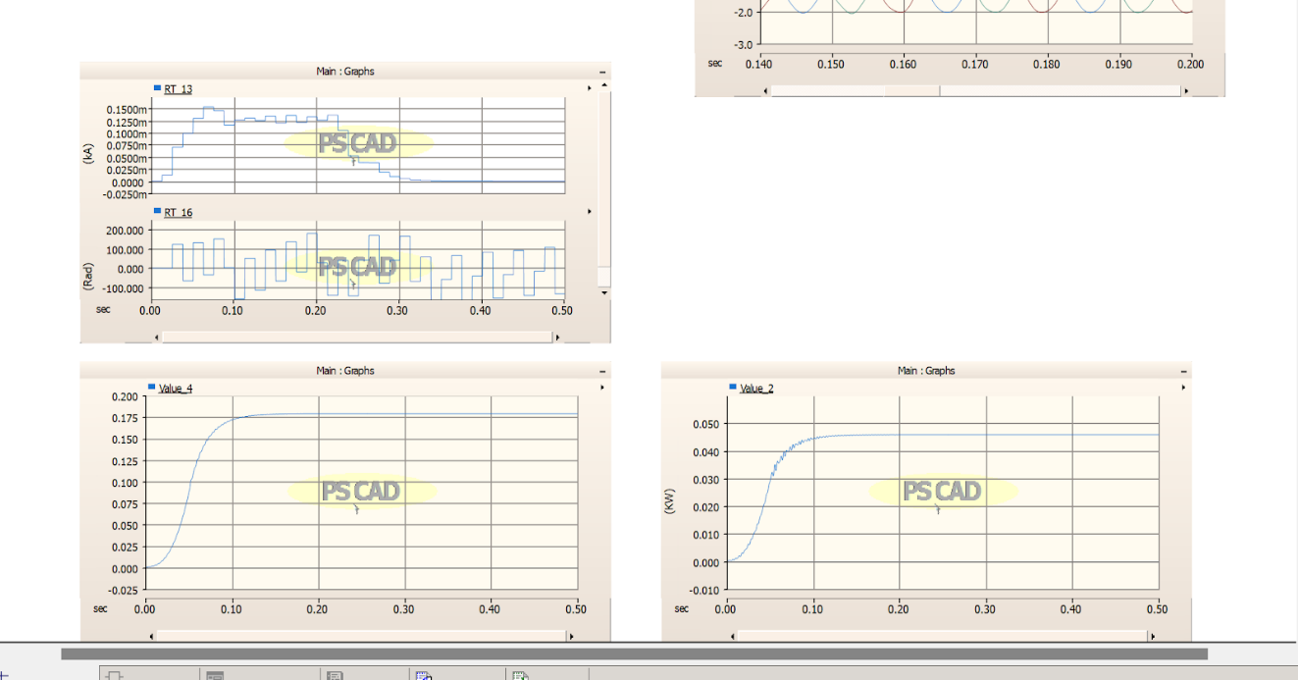

Fig 13.TL Line with FFT

**Transmission Line Using Compensative Capacitor**

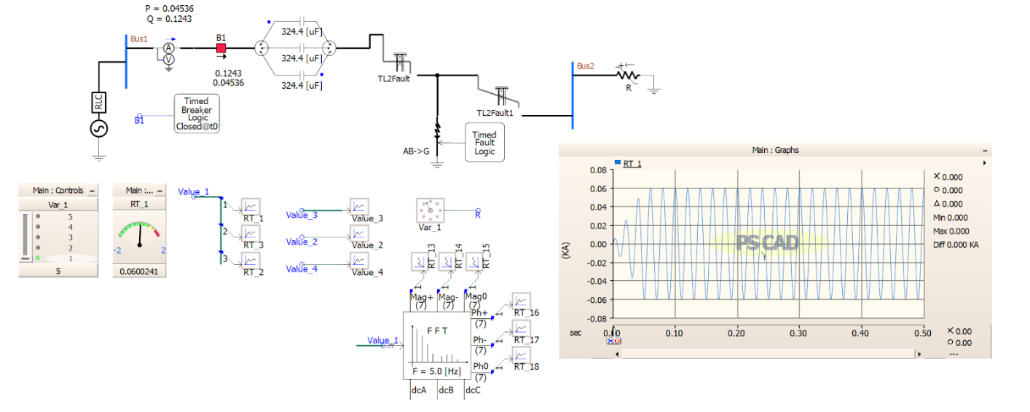

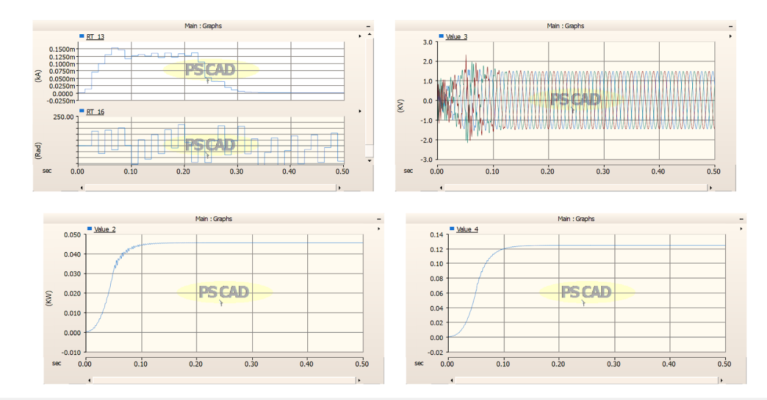

Fig 14. TL Line with compensative capacitor

**Conclusion**

During this research internship, various models of power electronic devices in transmission lines were designed and implemented. This report covers the development and analysis of inverter models, including half-bridge and full-bridge inverters, which are crucial for converting DC to AC power in applications such as renewable energy systems and uninterruptible power supplies.

A key project involved designing a three-phase converter with closed-loop control using phase-locked loop (PLL) technology, pulse-width modulation (PWM), and proportional-integral (PI) controllers. These components ensured stable and efficient power conversion and were vital in understanding advanced control mechanisms in power electronics.

The report also explores the modelling and analysis of various transmission lines, providing insights into the complexities of electrical power transmission and distribution. Extensive use of PSCAD for simulations and modelling was a critical aspect of this work, bridging the gap between theoretical knowledge and practical application.

Overall, the internship has significantly enhanced our understanding of power electronics in transmission lines, equipping us with essential skills and knowledge for future endeavours in this field. This experience underscored the importance of efficient design and precise control in power electronic systems, laying a solid foundation for continued research and professional development.

**References**

[1] Beerten, J., Cole, S., Belmans, R.: ‘Modeling of multi-terminal VSC HVDC systems with distributed DC voltage control’, IEEE Trans. Power Syst., 2014, 29, (1), pp. 34–42

[2] Prieto-Araujo, E., Bianchi, F.D., Junyent-Ferre, A., et al.: ‘Methodology for droop control dynamic analysis of multiterminal VSC-HVDC grids for offshore wind farms’, IEEE Trans. Power Deliv., 2011, 26, (4), pp. 2476–2485

[3] https://books.google.com/books?id=If_hxYcDnAUC&printsec=copyright

[4] Kundur, P.: ‘Power system stability and control’ (McGraw-Hill Inc., New York, 1993)

[5] <https://ieeexplore.ieee.org>

[6] <https://books.google.com/books/about/Power_System.html?id=KoFUJ5je-rUC>

[7] https://ieeexplore.ieee.org/document/8740645/