A Project Stage-I Report On
Multimodal Deepfake Detection and Explainable Analysis
Submitted in partial fulfillment of the requirements for the award of the degree of

BACHELOR OF TECHNOLOGY
in

COMPUTER SCIENCE AND ENGINEERING

from

JAWAHARLAL NEHRU TECHNOLOGICAL UNIVERSITY HYDERABAD

By
CHERUKURI MADHU (23C11A0584)

Under the guidance of
Mrs. G. UMA DEVI B. Tech.
Assistant Professor

DEPARTMENT OF COMPUTER SCIENCE & ENGINEERING

 | ANURAG ENGINEERING COLLEGE  (An Autonomous Institution)  (Affiliated to JNTUH, Hyderabad & Approved by AICTE, New Delhi)  Ananthagiri (V & M), Kodad, Suryapet (Dt.), Telangana -508206.  2026 – 27 | 
A Project Stage-I Report On
Multimodal Deepfake Detection and Explainable Analysis
Submitted in partial fulfillment of the requirements for the award of the degree of

BACHELOR OF TECHNOLOGY
in

COMPUTER SCIENCE AND ENGINEERING

from

JAWAHARLAL NEHRU TECHNOLOGICAL UNIVERSITY HYDERABAD

By
SK. MUKHEED HUSSAIN (23C11A0594)

Under the guidance of
Mrs. G. UMA DEVI B. Tech.
Assistant Professor

DEPARTMENT OF COMPUTER SCIENCE & ENGINEERING

ANURAG ENGINEERING COLLEGE
(An Autonomous Institution)
(Affiliated to JNTUH, Hyderabad & Approved by AICTE, New Delhi)
Ananthagiri (V & M), Kodad, Suryapet (Dt.), Telangana -508206.
2026 – 27
A Project Stage-I Report On
Multimodal Deepfake Detection and Explainable Analysis
Submitted in partial fulfillment of the requirements for the award of the degree of

BACHELOR OF TECHNOLOGY
in

COMPUTER SCIENCE AND ENGINEERING

from

JAWAHARLAL NEHRU TECHNOLOGICAL UNIVERSITY HYDERABAD

By
CHERUKURI MADHU (23C11A0584)
Sk. MUKHEED HUSSAIN (23C11A0594)
Under the guidance of
Mrs. UMA DEVI B.Tech.
Assistant Professor

DEPARTMENT OF COMPUTER SCIENCE & ENGINEERING

ANURAG ENGINEERING COLLEGE
(An Autonomous Institution)
(Affiliated to JNTUH, Hyderabad & Approved by AICTE, NewDelhi)
Ananthagiri (V & M), Kodad, Suryapet (Dt.), Telangana -508206.
2026 – 27
ANURAG ENGINEERING COLLEGE
(An Autonomous Institution)
(Affiliated to JNTUH, Hyderabad & Approved by AICTE, New Delhi)
Ananthagiri (V & M), Kodad, Suryapet (Dt), Telangana -508206.

DEPARTMENT OF COMPUTER SCIENCE AND ENGINEERING

CERTIFICATE

This is to certify that the project work entitled “Multimodal Deepfake Detection and Explainable Analysis” is a bonafide work done by “CHERUKURI MADHU (23C11A0584)” in the partial fulfillment for the award of Bachelor of Technology in Computer Science and Engineering from JNTUH, Hyderabad during the year 2026-27.
This work has not been submitted to any other university or institute or organization for the award of any degree or diploma.

Mrs. G. UMA DEVI  Supervisor |  | Dr. Ch. N Santhosh Kumar  H.O.D.
ANURAG ENGINEERING COLLEGE
(An Autonomous Institution)
(Affiliated to JNTUH, Hyderabad & Approved by AICTE, New Delhi)
Ananthagiri (V & M), Kodad, Suryapet (Dt), Telangana -508206.

DEPARTMENT OF COMPUTER SCIENCE AND ENGINEERING

CERTIFICATE

This is to certify that the project work entitled “Multimodal Deepfake Detection and Explainable Analysis” is a bonafide work done by “SK. MUKHEED HUSSAIN (23C11A0594)” in the partial fulfillment for the award of Bachelor of Technology in Computer Science and Engineering from JNTUH, Hyderabad during the year 2026-27.
This work has not been submitted to any other university or institute or organization for the award of any degree or diploma.

Mrs. G. UMA DEVI  Supervisor |  | Dr. Ch. N Santhosh Kumar  H.O.D.
ANURAG ENGINEERING COLLEGE
(An Autonomous Institution)
(Affiliated to JNTUH, Hyderabad & Approved by AICTE, New Delhi)
Ananthagiri (V & M), Kodad, Suryapet (Dt), Telangana -508206.

DEPARTMENT OF COMPUTER SCIENCE & ENGINEERING

CERTIFICATE

This is to certify that the project work entitled “Multimodal Deepfake Detection and Explainable Analysis” is a bona fide work done by “CHERUKURI MADHU (23C11A0584) and SK. MUKHEED HUSSAIN (23C11A0594),” in the partial fulfillment for the award of Bachelor of Technology in Computer Science and Engineering from JNTUH, Hyderabad during the year 2026-27.
This work has not been submitted to any other university or institute or organization for the award of any degree or diploma.

Mrs. G. UMA DEVI  Supervisor |  | Dr. Ch. N Santhosh Kumar  H.O.D.

DECLARATION

I, CHERUKURI MADHU (H.T. No.: 23C11A0584), IV B.Tech CSE I Semester, hereby declare that the Project Stage-I report titled “Multimodal Deepfake Detection and Explainable Analysis” is my original work carried out under the guidance of Mrs. G. UMA DEVI, Assistant Professor, Department of Computer Science and Engineering at ANURAG Engineering College, Ananthagiri (V&M), Kodad, Suryapet (Dt.), Telangana - 508206.
This report has not been submitted elsewhere. All sources are cited in References. I agree with the college academic integrity.

Date: 09-11-26 CHERUKURI MADHU
Place: Ananthagiri (V&M) 23C11A0584

DECLARATION

I, SK. MUKHEED HUSSAIN (H.T. No.: 23C11A0594), IV B.Tech CSE I Semester, hereby declare that the Project Stage-I report titled “Multimodal Deepfake Detection and Explainable Analysis” is my original work carried out under the guidance of Mrs. G. UMA DEVI, Assistant Professor, Department of Computer Science and Engineering at ANURAG Engineering College, Ananthagiri (V&M), Kodad, Suryapet (Dt.), Telangana - 508206.
This report has not been submitted elsewhere. All sources are cited in References. I agree with the college academic integrity.

Date: 09-11-26 SK. MUKHEED HUSSAIN
Place: Ananthagiri (V&M) 23C11A0594

DECLARATION

We, the undersigned IV B.Tech CSE I Semester students, hereby declare that the Project Stage-I report titled “Multimodal Deepfake Detection and Explainable Analysis” is our original work carried out under the guidance of Mrs. G. UMA DEVI, Assistant Professor, Department of Computer Science and Engineering at ANURAG Engineering College, Ananthagiri (V&M), Kodad, Suryapet (Dt.), Telangana - 508206.
This report has not been submitted elsewhere. All sources are cited in References. We agree with the college academic integrity.

CHERUKURI MADHU
23C11A0584

Date: 09-11-26 SK. MUKHEED HUSSAIN
Place: Ananthagiri (V&M) 23C11A0594

ACKNOWLEDGEMENTS

This report will certainly not be completed without due acknowledgement paid to all those who guided and supported me during this project work.
I express sincere thanks to my supervisor Mrs. G. UMA DEVI, for giving moral support, kind attention and valuable guidance throughout this project work.
It is my privilege to thank Dr. Ch. N Santhosh Kumar, Head of the Department, Department of Computer Science and Engineering, for his encouragement during the progress of this project work.
I am thankful to both Teaching and non-teaching staff members of Department of Computer Science and Engineering for their kind cooperation and all sorts of support in bringing out this project work successfully.
I derive great pleasure in expressing my sincere gratitude to the Principal Dr. T. Suresh Kumar for his timely suggestions, which helped me to complete this work successfully.
I also thank the Management of ANURAG Engineering College for providing the necessary facilities.
Finally, I am indebted to my parents and friends for their constant support and encouragement.

CHERUKURI MADHU
23C11A0584

ACKNOWLEDGEMENTS

This report will certainly not be completed without due acknowledgement paid to all those who guided and supported me during this project work.
I express sincere thanks to my supervisor Mrs. G. UMA DEVI, for giving moral support, kind attention and valuable guidance throughout this project work.
It is my privilege to thank Dr. Ch. N Santhosh Kumar, Head of the Department, Department of Computer Science and Engineering, for his encouragement during the progress of this project work.
I am thankful to both Teaching and non-teaching staff members of Department of Computer Science and Engineering for their kind cooperation and all sorts of support in bringing out this project work successfully.
I derive great pleasure in expressing my sincere gratitude to the Principal Dr. T. Suresh Kumar for his timely suggestions, which helped me to complete this work successfully.
I also thank the Management of ANURAG Engineering College for providing the necessary facilities.
Finally, I am indebted to my parents and friends for their constant support and encouragement.

SK. MUKHEED HUSSAIN
23C11A0594

ACKNOWLEDGEMENTS

This report will certainly not be completed without due acknowledgement paid to all those who helped me during this project work.
We express sincere thanks to my supervisor Mrs. G. UMA DEVI, for giving moral support, kind attention and valuable guidance throughout this project work.
It is our privilege to thank Dr. Ch. N Santhosh Kumar, Head of the Department, Department of Computer Science and Engineering for his encouragement during the progress of this project work.
We are thankful to both Teaching and non-teaching staff members of the Department of Computer Science and Engineering for their kind cooperation and all sorts of support in bringing out this project work successfully.
We derive great pleasure in expressing my sincere gratitude to the Principal Dr. T. Suresh Kumar for his timely suggestions, which helped us to complete this work successfully.
We also thank the Management of ANURAG Engineering College for providing the necessary facilities.
Finally, we are indebted to our parents and friends for their constant support and encouragement.

CHERUKURI MADHU
23C11A0584

SK. MUKHEED HUSSAIN
23C11A0594

MULTIMODAL DEEPFAKE DETECTION AND EXPLAINABLE ANALYSIS

CONTENTS
 | Abstract | i
 | List Of Figures | ii
 | List Of Tables | iii
 | List Of Acronyms | iv
1 | Introduction | 1-3
2 | Objectives | 4
3 | Literature Survey | 5-7
4 | Existing System | 8-9
5 | Problem Statement | 10
6 | Proposed System | 11-13
7 | System Architecture | 14-16
8 | Technologies Used | 17
9 | Software Requirements | 18
10 | Hardware Requirements | 19
11 | Front End Requirements | 20
12 | Back End Requirements | 21
13 | Modules | 22-25
14 | System Design | 26-33
15 | Conclusion and Future Enhancements | 34-35
 | References | 36

ABSTRACT
Deepfake technology uses artificial intelligence to generate or manipulate realistic video and audio content. Such media can threaten the reliability of digital communication and may be misused for impersonation, fraud, and spreading false information. The IEEE base paper, “Detection of Deepfake Media for Secure Communication Using Deep Learning,” describes a deepfake detection system based on the FakeAVCeleb dataset, OpenCV, Haar Cascade face detection, and a Deep Neural Network (DNN). Its future scope identifies the integration of audio and visual features as an opportunity to improve deepfake detection.
This project, Multimodal Deepfake Detection and Explainable Analysis, proposes an approach that analyzes both video and audio information. The video-processing branch extracts representative frames and detects facial regions, while the audio-processing branch extracts the audio track and prepares acoustic features. The outputs from both branches are combined using a multimodal fusion method to classify the input as Real or Fake. Explainable analysis is also intended to help users understand the prediction through available evidence, such as visual explanations or audio-video inconsistencies, when these features are supported by the implemented models.
The system will be evaluated using a held-out test dataset and appropriate performance measures, including accuracy, precision, recall, F1-score, confusion matrix, and ROC-AUC where applicable. Comparing video-only, audio-only, and multimodal results will help determine the contribution of combining the two modalities. The proposed system aims to support more informative deepfake analysis for secure digital communication. Its actual performance and limitations will be established through implementation and testing.

LIST OF FIGURES

Fig No. | Figure Description | Page No.
7.1 | Overall System Architecture | 14
7.2 | Multimodal Deepfake Detection Workflow | 15
13.1 | Video Preprocessing and Face Detection | 23
13.2 | Audio Extraction and Preprocessing | 23
13.3 | Video Classification Pipeline | 23
13.4 | Audio Classification Pipeline | 24
13.5 | Multimodal Feature Fusion Architecture | 24
14.1 | Use Case Diagram | 26
14.2 | Data Flow Diagram | 27
14.3 | Class Diagram | 28
14.4 | Activity Diagram | 29
14.5 | Sequence Diagram for Deepfake Detection | 30
14.6 | Collaboration Diagram | 31
14.7 | Explainable Analysis Output (Conceptual Layout) | 33

LIST OF TABLES

Table No. | Table Description | Page No.
3.1 | Literature Survey Comparison | 5
4.1 | Existing System and Its Limitations | 8
6.1 | Existing System vs. Proposed System | 12
8.1 | Technologies Used and Their Purposes | 17
9.1 | Software Requirements | 18
10.1 | Hardware Requirements | 19
11.1 | Frontend Components and Responsibilities | 20
12.1 | Backend Components and Responsibilities | 21
13.1 | Project Modules and Functions | 22
14.1 | Dataset Distribution and Class Labels | 31
14.2 | Evaluation Metrics | 32
14.3 | API Endpoints and Functions | 32

LIST OF ACRONYMS

AI | : | Artificial Intelligence
API | : | Application Programming Interface
AUC | : | Area Under the Curve
CNN | : | Convolutional Neural Network
CPU | : | Central Processing Unit
CSE | : | Computer Science and Engineering
CV | : | Computer Vision
DFD | : | Data Flow Diagram
DNN | : | Deep Neural Network
FPS | : | Frames Per Second
GAN | : | Generative Adversarial Network
GPU | : | Graphics Processing Unit
Grad-CAM | : | Gradient-weighted Class Activation Mapping

INTRODUCTION

INTRODUCTION

Background:
Deepfakes are synthetic or manipulated audio-visual media produced with deep learning techniques such as Generative Adversarial Networks (GANs). A deepfake can replace a person’s face, imitate facial movements, or clone a voice so convincingly that the result is difficult to distinguish from a genuine recording. As generation tools become easier to use, such media can undermine trust in digital communication and may be misused for impersonation, financial fraud, and the spread of false information.
Applications that depend on the authenticity of recorded media, including banking, social media, law enforcement, and media verification, therefore need dependable methods to examine whether a video or an audio clip has been manipulated. Machine Learning (ML) and Computer Vision (CV) techniques have been widely applied to this problem, and the works surveyed in [1]–[6] address visual, audio, and combined approaches to deepfake detection.

Motivation:
The IEEE base paper of this project [1] describes a deepfake detection system that uses the FakeAVCeleb dataset [7], OpenCV with Haar-cascade face detection, and a Deep Neural Network (DNN) for Real/Fake classification, together with a Flask-based web interface. In its Future Scope, the paper identifies several possible improvements: better handling of compressed and low-resolution videos, multimodal analysis by combining audio and visual features, optimization for mobile and edge devices, a more user-friendly interface, and continuous learning to adapt to new deepfake techniques.
The enhancement selected for this project is multimodal deepfake detection. A detector that studies only the face region can overlook evidence that is present in the audio track, and an audio-only detector ignores the visual evidence. The FakeAVCeleb dataset [7] is organized so that the video and the audio of a clip may each be real or manipulated, which makes it a suitable resource for studying both modalities together. Explainable analysis forms the second part of the project title: the system should help a user understand why an input was classified in a particular way, wherever the chosen model supports such an explanation.

Overview of the Project:
The project proposes a pipeline with two parallel branches followed by a fusion stage. In the video branch, frames are sampled from the input, faces are detected and cropped, and the face inputs are passed to a visual classifier. In the audio branch, the audio track is extracted, standardized, and converted into an acoustic representation such as a log-Mel spectrogram, which is passed to an audio classifier. A fusion component combines the available modality evidence to classify the input as Real or Fake. An explainable-analysis stage then presents the supporting evidence, such as a Grad-CAM heatmap [11] for a compatible visual model, together with the modality-level scores and warnings.

Scope of the Project:
The scope of the work is divided into three groups so that the report states clearly what is part of the core enhancement and what depends on implementation and testing.

Core Enhancement:
- Input validation and dataset inspection.
- Video frame extraction, face detection, and preprocessing.
- Audio extraction and preprocessing.
- Separate visual and audio inference branches.
- Multimodal fusion and a Real/Fake prediction with a clearly defined score.
- Evaluation comparing each single modality with the fused system.

Included When Implemented and Tested:
- Grad-CAM visualization for a compatible visual model.
- Audio-video synchronization analysis.
- A FastAPI backend and a web front end.
- Result history or downloadable reports.

Future Work:
- Robustness improvements for heavily compressed and low-resolution media.
- On-device, mobile, and edge deployment.
- Continuous or adaptive learning.
- Real-time streaming and browser extensions.
These future-work items are not assumed to be complete and will be reported as achievements only if they are implemented and evaluated.

Organization of the Report:
Chapter 2 lists the objectives of the project, and Chapter 3 reviews the base paper and related literature. Chapters 4 and 5 describe the existing system and define the problem, while Chapter 6 presents the proposed system. Chapter 7 explains the system architecture, Chapters 8 to 12 list the technologies and the software, hardware, front-end, and back-end requirements, and Chapter 13 describes the project modules. Chapter 14 presents the system design using UML diagrams, a data flow diagram, and design tables, and Chapter 15 gives the conclusion and future enhancements. The references follow in IEEE style.

OBJECTIVES

OBJECTIVES

Aim of the Project:
The aim of the project is to investigate whether combining video and audio evidence improves the classification of media as Real or Fake, and to present the result together with explainable evidence that helps users interpret the prediction.

Specific Objectives:
- Study the IEEE base paper [1] and identify multimodal audio-visual analysis as the selected future enhancement.
- Inspect the selected FakeAVCeleb dataset [7] and document its labels, structure, and usage conditions.
- Extract video frames and the associated audio track, and preprocess both for modelling.
- Develop a video-based classifier and evaluate it.
- Develop an audio-based classifier, provided the labels and audio samples support the task.
- Combine the outputs or learned features of both modalities using a documented fusion strategy.
- Compare video-only, audio-only, and fused-system performance on the same test split.
- Identify possible audio-video inconsistencies if a suitable method is implemented.
- Provide explainable analysis for the model outputs that support it.
- Document the evaluation results, limitations, and future improvements, and expose the analysis through a backend API and user interface if these are included in the final implementation.

LITERATURE SURVEY

LITERATURE SURVEY

Base Paper:
The base paper of this project is “Detection of Deepfake Media for Secure Communication Using Deep Learning” by Harishma R. and K. Sreelakshmi, presented at the 2025 9th International Conference on Computational System and Information Technology for Sustainable Solutions (CSITSS) [1]. The paper describes a DNN-based detector trained on the FakeAVCeleb dataset. Its preprocessing pipeline extracts video frames and uses OpenCV and Haar cascades to detect and crop faces. The DNN then performs Real/Fake classification, and a Flask web application supports user interaction. The evaluation discusses accuracy, precision, recall, F1-score, a confusion matrix, and ROC/AUC. The future-scope section of the paper motivates the combination of audio and visual features, which is the extension selected for this project.
This project will compare its audio-video approach against its own reproducible baseline and not against the figures reported in the paper.

Related Work:
The base paper lists several related works. They are summarized in Table 3.1 on the basis of their published titles; the original publications must be consulted before detailed claims about their methods or results are made in the final report.
Table 3.1: Literature Survey Comparison
Ref. | Work and Year | Focus (as indicated by the title) | Relevance to This Project
[1] | H. R. Harishma and K. Sreelakshmi, 2025 | DNN-based deepfake detection using FakeAVCeleb, OpenCV, and Haar-cascade face detection | Base paper; supplies the baseline and the future-scope motivation
[2] | A. Jadhav et al., 2024 | Deepfake detection in videos using a video vision transformer architecture | Shows a stronger visual-model direction for the video branch
[3] | T. S. Kulkarni et al., 2024 | Deep learning approaches for detecting deepfake content | General deep learning approaches for detecting deepfake content
[4] | M. Thanga Raj et al., 2023 | Review of deep fake and propaganda video and image detection, covering voice and facial manipulation | Overview covering both voice and facial manipulation
[5] | P. P. Chandran et al., 2024 | Multimodal forgery detection in videos using a tri-network model | Closest to the multimodal direction of this project
[6] | H. H. Kilinc and F. Kaledibi, 2023 | Audio deepfake detection using machine and deep learning | Supports the design of the audio branch

The vision-transformer work [2] indicates that stronger visual models than a plain DNN are available for the video branch. The study in [3] concerns deep learning approaches for detecting deepfake content in general, while the review in [4] covers both voice and facial manipulation and thereby supports the need to look beyond the face. The tri-network model in [5] is a multimodal forgery detector for videos and is therefore the closest reference for the direction of this project.

Supporting Techniques and Dataset:
- FakeAVCeleb [7]: an audio-video multimodal deepfake dataset in which the video and the audio of a clip may each be real or fake. Its documentation should be consulted for the exact labels, counts, and usage terms.
- Haar cascades [8]: a boosted cascade of simple features for object detection, used by the base paper for face detection and retained as the baseline detector.
- Xception [9] and EfficientNet [10]: convolutional architectures that are candidate video models if time and hardware permit.
- Grad-CAM [11]: a gradient-based localization method that produces a heatmap of the image regions influencing a CNN prediction.

Observations from the Survey:
The survey shows that deepfake detection has been studied for video, for audio, and for their combination, and that the base paper itself names multimodal analysis as a future direction. What remains for a student project is a reproducible comparison of video-only, audio-only, and fused models on one dataset and split, together with an explanation of the output. This is the gap addressed by the proposed system.

EXISTING SYSTEM

EXISTING SYSTEM

Overview:
According to the base paper [1] and the Stage-I review presentation, the existing system is a DNN-based deepfake detector that works mainly on facial and visual information. It is trained and evaluated on the FakeAVCeleb dataset [7], which contains real and synthetic audio-visual samples.

Working of the Existing System:
- Video frames are extracted from the input using OpenCV.
- Facial regions are detected with Haar-cascade classifiers [8].
- The detected face regions are resized and normalized.
- A DNN with dense layers, ReLU activations, dropout, batch normalization, and a SoftMax output classifies the input as Real or Fake, as described in the paper.
- A Flask-based interface accepts an uploaded video or webcam input.
- Detection performance is evaluated using accuracy, precision, recall, F1-score, a confusion matrix, and ROC/AUC.

Reported Evaluation:
The base paper reports its own experimental values, including an AUC close to 0.92 in its described evaluation. This is a result of the paper and not a result of this project. The project team will measure the performance of its own implementation independently and will not reuse the paper’s figures in its results.

Limitations of the Existing System:
The limitations identified in the project review are listed in Table 4.1. The selected enhancement addresses the first limitation directly; the remaining ones are research directions and are not claimed to be solved by adding multimodal analysis.

Table 4.1: Existing System and Its Limitations
Limitation | Description
Visual-only focus | The existing project mainly focuses on facial and visual information, so evidence in the audio track is not used.
Compression and low resolution | Compressed and low-resolution videos can be challenging for the detector.
Dataset and manipulation variation | Performance may vary across datasets and across manipulation methods.
Lack of explanation | The system does not clearly explain why an input is classified as Fake.
Evolving generation techniques | New deepfake-generation techniques may reduce performance over time.

PROBLEM STATEMENT

PROBLEM STATEMENT

Problem Definition:
A detector that relies mainly on visual information may miss useful clues in the audio track. Conversely, audio-only analysis may ignore visual evidence. A system is therefore needed to investigate whether combining video and audio information can improve Real/Fake classification and provide a more informative explanation of its prediction.

Key Challenges:
- Heterogeneous evidence: video frames and audio signals have different structure and must be preprocessed and modelled separately before their evidence can be combined.
- Missing or unusable modality: some inputs have no audio, or the audio cannot be extracted; the system must report this honestly instead of inventing a score.
- Fusion design: the way scores or features are normalized, weighted, and thresholded affects the result and must be tuned on validation data only.
- Explaining predictions: visual explanations such as Grad-CAM show influential regions but do not prove that the model’s reasoning is correct.
- Honest evaluation: results must come from an untouched test set, with leakage between related clips avoided where the metadata permits.

Research Questions:
The project is organized around the following questions, which will be answered by experiments: whether a fused model performs better than the video-only and the audio-only models on the same split; how the result changes when one modality is unavailable; and whether the explainable analysis gives useful evidence about the prediction.

PROPOSED SYSTEM

PROPOSED SYSTEM

Overview:
The proposed system is a multimodal deepfake detection pipeline that analyzes video frames and the associated audio track and combines the two kinds of evidence. The system is organized into the stages described below, and every stage reports its status so that the final result clearly shows which evidence was available.

Stages of the Proposed System:

Input and Validation:
The system accepts a supported audiovisual file, checks its format and size, and verifies that it can be decoded. Files that fail validation are rejected with a clear error message.

Video Preprocessing:
Frames are sampled from the video, faces are detected, the face regions are cropped and resized, and the inputs are prepared for the selected visual model. Haar cascades [8] provide the baseline detector; another detector may be compared if time permits.

Audio Preprocessing:
The audio track is extracted, converted to a standard format and sample rate, and transformed into the representation expected by the selected audio model, such as a log-Mel spectrogram.

Video Classification:
The visual model is run on the face inputs, and the frame-level outputs are aggregated into a video-level score using a documented method.

Audio Classification:
The audio model estimates whether the audio contains patterns associated with real or manipulated audio and returns an audio-level score.

Multimodal Fusion:
The video and audio scores or feature representations are combined using a selected and evaluated fusion strategy. Late fusion of scores is the starting point because it is easy to inspect; feature fusion is an experiment to be tried after each branch works independently.

Explainable Analysis:
Where supported, a Grad-CAM visualization [11] is produced for a compatible visual model. Audio-video synchronization evidence will be reported only if a method is implemented and validated. The visualization is described as a model-attention view and not as proof of manipulation.

Result Presentation:
The system displays the predicted label, a clearly defined score or confidence, the available modality results, the explanations, any warnings, and the processing status.

Handling Missing Modalities:
If a video has no audio, or audio extraction fails, the system marks the audio branch as unavailable rather than inventing a score, and the output is not described as a complete multimodal analysis. Likewise, if no face can be detected in the sampled frames, the video branch is reported as unavailable.

Existing System versus Proposed System:
Table 6.1 compares the base-paper system with the proposed system.
Table 6.1: Existing System vs. Proposed System
Aspect | Existing System (Base Paper) | Proposed System
Evidence used | Video frames (face regions) | Video frames and the audio track
Face detection | Haar cascade | Haar cascade baseline; another detector for comparison
Classifier | DNN | Video classifier and audio classifier
Decision | Single model output | Fusion of the available modality evidence
Explanation | Not clearly explained | Grad-CAM and modality-level evidence where supported
Missing modality | Not applicable | Branch marked unavailable; no score invented
Interface | Flask-based interface | Backend API and web interface, if implemented
Evaluation | Metrics reported in the paper | Video-only, audio-only, and fused models on one held-out test split

Privacy, Security, and Limitations:
- Only media that the user has permission to analyze should be processed, and private media must not be uploaded to a public repository.
- File content is validated, size and duration limits are imposed, and temporary files are handled safely and deleted according to a defined policy.
- A high model score is not a guarantee that a clip is fake, and a low score does not prove that it is real.
- Grad-CAM highlights influential regions but does not prove that the model’s reasoning is correct.
- Generalization to unseen manipulation methods must be tested rather than assumed.

SYSTEM ARCHITECTURE

SYSTEM ARCHITECTURE

Architectural Overview:
The architecture of the proposed system is shown in Fig. 7.1. An input audiovisual file is validated and then split into a video branch and an audio branch. The two branches produce independent scores that are combined by the multimodal fusion component. An optional synchronization analysis can add further evidence before the prediction and explainable evidence are returned to the backend API and the user interface.
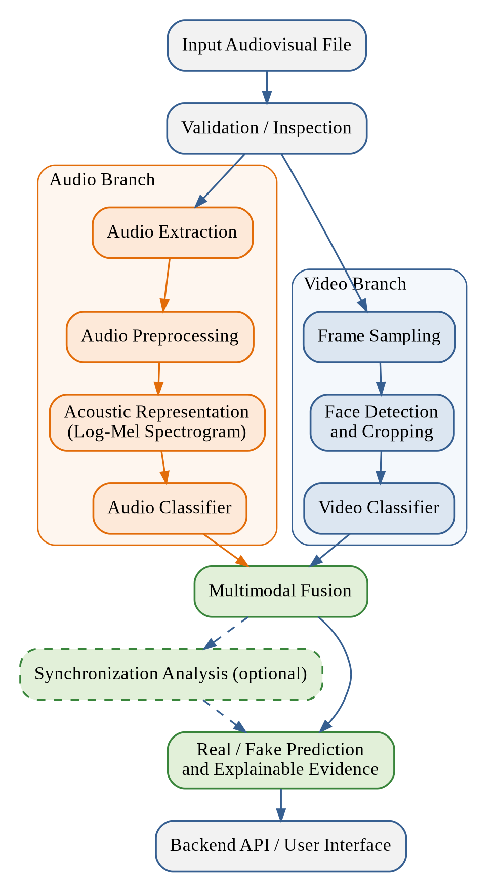
Figure 7.1: Overall System Architecture

Detection Workflow:
The workflow followed for every request is shown in Fig. 7.2. The file is first checked; an invalid file produces an error message. For a valid file, frames and the audio track are extracted and the two branches run. If no audio is found, the audio branch is marked unavailable and the remaining evidence is fused and clearly labelled.
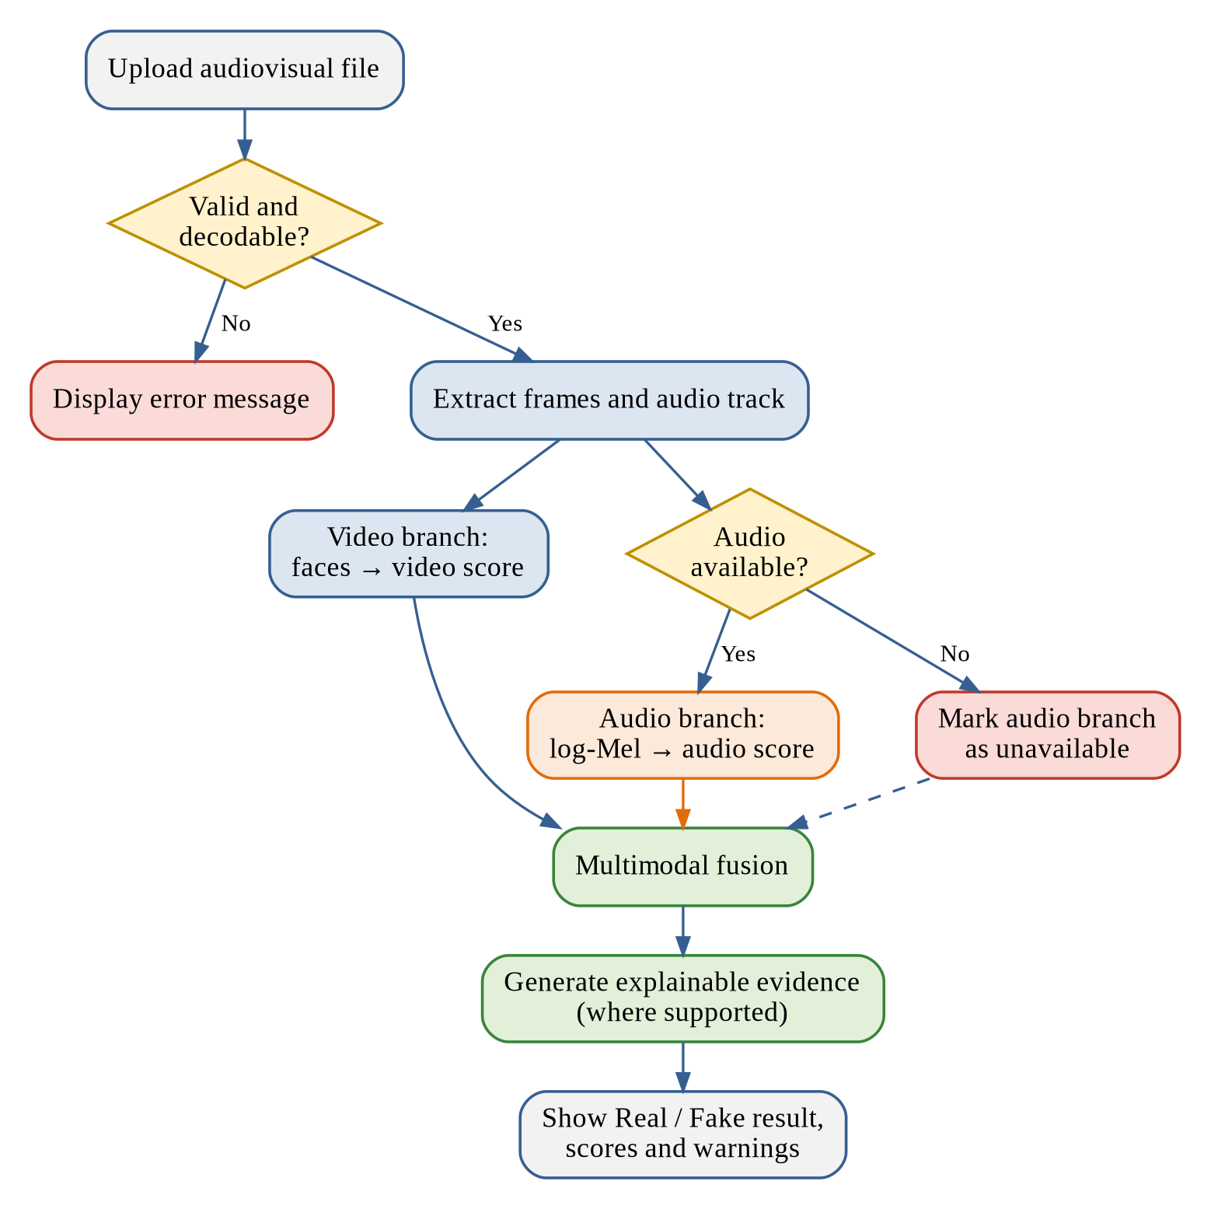
Figure 7.2: Multimodal Deepfake Detection Workflow

Component Description:
- Validation and inspection: checks format, size, duration, and decodability, and reports whether an audio track is present.
- Video branch: frame sampling, face detection and cropping, and the video classifier that returns a video-level score.
- Audio branch: audio extraction, preprocessing, acoustic representation, and the audio classifier that returns an audio-level score.
- Multimodal fusion: normalizes and combines the modality evidence and applies a decision threshold chosen on validation data.
- Synchronization analysis (optional): reports audio-video inconsistencies only if a tested method is implemented.
- Explainable analysis: produces Grad-CAM visualizations for a compatible visual model and presents modality-level evidence.
- Backend API and user interface: accept requests and present the prediction, scores, explanations, and warnings.

Design Considerations:
Each branch is designed to run and be evaluated independently so that the video-only and audio-only baselines can be measured on the same split as the fused model. The result structure carries an explicit status for each branch, and any confidence value is documented so that it is not mistaken for a probability of authenticity.

TECHNOLOGIES USED

TECHNOLOGIES USED

Technologies Reported in the Base Paper:
The base paper [1] reports the use of Python, TensorFlow/Keras, OpenCV, Haar-cascade XML, Flask, the FakeAVCeleb dataset, NumPy and Pandas, and Matplotlib and scikit-learn. These tools form the reference baseline for this project.

Technologies Proposed for the Multimodal Extension:
The technologies proposed for the extension are listed in Table 8.1. They are candidates; the final report will state which were actually used. The candidate video models correspond to [9] and [10], and the explainability technique to [11].
Table 8.1: Technologies Used and Their Purposes
Component | Candidate Technology | Purpose
Programming and data | Python, NumPy, Pandas | Data preparation, training, inference, and dataset metadata
Video decoding | OpenCV, FFmpeg | Read videos and sample frames
Face detection | Haar cascade baseline; MediaPipe or another detector for comparison | Locate face regions
Audio processing | Librosa or Torchaudio | Load audio and create acoustic features
Video model | DNN baseline of the base paper; XceptionNet or EfficientNet as candidates | Classify visual inputs
Audio model | CNN on log-Mel spectrograms; CNN-BiLSTM as an alternative | Classify audio inputs
Fusion | Late fusion first; feature fusion as an experiment | Combine modality evidence
Explainability | Grad-CAM for compatible CNN-based visual models | Visualize influential image regions
Backend | FastAPI (proposed) or Flask | Serve analysis requests
Frontend | React/Next.js or HTML/CSS/JavaScript | Upload and result interface
Evaluation | scikit-learn, Matplotlib | Metrics and plots

SOFTWARE REQUIREMENTS

SOFTWARE REQUIREMENTS

Initial Software Requirements:
The initial software requirements identified in the project review are given in Table 9.1.
Table 9.1: Software Requirements
Item | Requirement
Operating system | Windows or Linux
Programming language | Python
Development environment | Jupyter Notebook or VS Code
Visualization | Matplotlib
Version control | Git and GitHub
Web framework | Flask (listed in the review presentation); FastAPI as a possible alternative
Dataset | FakeAVCeleb

Additional Requirements:
Further requirements depend on the final implementation, for example FFmpeg for audio extraction, Librosa or Torchaudio for audio processing, and a deep learning framework for training. Compatible versions of all libraries will be installed in a virtual environment and recorded in a requirements file. FFmpeg may need a separate system installation.

HARDWARE REQUIREMENTS

HARDWARE REQUIREMENTS

Minimum Hardware Requirements:
The hardware requirements specified in the project review are given in Table 10.1.
Table 10.1: Hardware Requirements
Item | Requirement
Processor | Intel Core i5 or equivalent
RAM | Minimum 8 GB
Storage | Approximately 10–20 GB of free space
System | Laptop or desktop computer

Notes on Hardware:
Extracted frames and model weights may require more storage than the minimum stated above. Training time depends on the model, the dataset size, and the hardware, and a Graphics Processing Unit (GPU) may reduce it. The machine actually used for the experiments will be recorded in the final report, and real-time performance will not be claimed unless latency is measured.

FRONT END REQUIREMENTS

FRONT END REQUIREMENTS

Front End Components:
If a web front end is implemented, it should provide the components listed in Table 11.1. The base paper [1] describes a Flask interface; a separate React or Next.js front end is optional and will be reported as implemented only if it is built.
Table 11.1: Frontend Components and Responsibilities
Component | Responsibility
Introduction panel | Present the project introduction and its limitations
Upload control | Accept the media file and show the supported-file information
Validation and status | Show file validation and the processing status
Prediction display | Show the Real/Fake prediction and a clearly defined confidence or score
Modality scores | Show the video score and the audio score only when they are computed
Explainability viewer | Show the explainability visualization only when it is generated successfully
Error messages | Give clear messages for unsupported or corrupt files
Warning banner | State that model predictions may be wrong

BACK END REQUIREMENTS

BACK END REQUIREMENTS

Back End Components:
The backend is responsible for the tasks listed in Table 12.1.
Table 12.1: Backend Components and Responsibilities
Component | Responsibility
File validation | Validate uploaded files
Preprocessing | Extract and preprocess video and audio
Model loading | Load the selected video and audio models
Inference | Run both modality branches
Fusion | Apply the fusion method
Response builder | Return structured prediction and explanation fields
Failure handling | Handle missing modalities and processing failures
Logging | Log technical errors without unnecessarily exposing private media
Temporary files | Delete temporary files according to a defined policy

API Endpoints:
If FastAPI is used, the possible endpoints are those given in Table 14.3. Additional job and result endpoints are needed only if asynchronous processing or result storage is implemented. The project does not require a Structured Query Language (SQL) database unless results or users are stored.

MODULES

MODULES

Module Overview:
The project is divided into the nine modules summarized in Table 13.1. The modules follow the order of the pipeline, from the dataset to the evaluation.
Table 13.1: Project Modules and Functions
Module | Name | Function
Module 1 | Dataset Inspection | Inspect the dataset structure, labels, file integrity, and modality availability
Module 2 | Video Preprocessing | Decode videos, sample frames, detect faces, and prepare visual inputs
Module 3 | Audio Preprocessing | Extract audio and generate the selected acoustic representation
Module 4 | Video Classification | Train or load the video model and calculate a video-level score
Module 5 | Audio Classification | Train or load the audio model and calculate an audio-level score
Module 6 | Multimodal Fusion | Combine outputs or features from the two branches
Module 7 | Explainable Analysis | Generate supported visual explanations with appropriate caveats
Module 8 | API and Interface | Accept requests and show results if a user interface is implemented
Module 9 | Evaluation | Compare video-only, audio-only, and multimodal results on a held-out test set

Dataset Inspection (Module 1):
This module inspects the folders, file formats, labels, and available modalities of the FakeAVCeleb dataset [7]. It checks that the videos decode correctly, determines which files contain audio, and builds a metadata file that contains only verified information. The train, validation, and test splits are created here, taking care to avoid leakage between related clips or identities when the metadata permits, and the class balance and duplicates are checked.

Video Preprocessing (Module 2):
Videos are decoded, frames are sampled at a documented interval, and faces are detected and cropped as shown in Fig. 13.1. The crops are resized and normalized as required by the selected model. Corrupt files, frames without faces, and failed preprocessing are recorded.
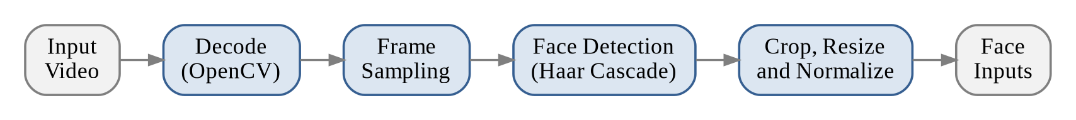
Figure 13.1: Video Preprocessing and Face Detection

Audio Preprocessing (Module 3):
The audio track is extracted with FFmpeg or an equivalent library, resampled consistently, and converted to a mono signal. The Short-Time Fourier Transform (STFT) is applied, and a Mel filter bank with a logarithmic scale produces the log-Mel spectrogram, as shown in Fig. 13.2. Mel-Frequency Cepstral Coefficients (MFCC) are an alternative representation. Files without audio are recorded so that the audio branch can be marked unavailable.
Figure 13.2: Audio Extraction and Preprocessing

Video Classification (Module 4):
The video classifier begins with a reproducible baseline that follows the DNN approach of the base paper [1], with the features actually received by the DNN verified. A stronger image model such as XceptionNet [9] or EfficientNet [10] is compared only if time and hardware permit. The pipeline is shown in Fig. 13.3; the method used to aggregate frame-level scores into a video-level score is defined and documented.
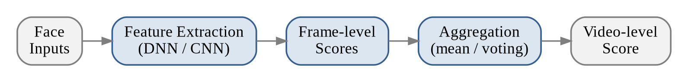
Figure 13.3: Video Classification Pipeline

Audio Classification (Module 5):
The audio classifier is a Convolutional Neural Network (CNN) trained on log-Mel spectrograms, with a CNN combined with a bidirectional Long Short-Term Memory (LSTM) layer as an alternative. The pipeline is shown in Fig. 13.4. The model is evaluated with the same split protocol as the video branch.
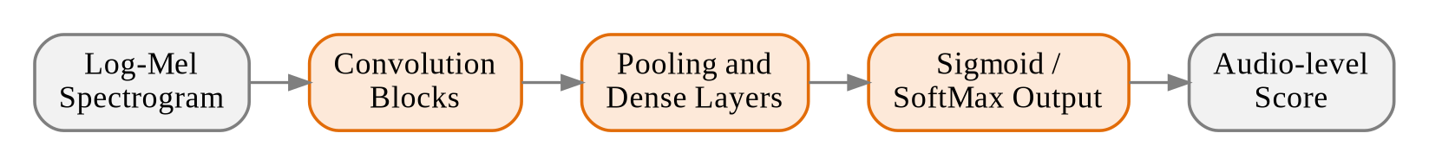
Figure 13.4: Audio Classification Pipeline

Multimodal Fusion (Module 6):
Fusion starts with late fusion of the video and audio scores because it is relatively easy to inspect. The scores are normalized and weighted, and any thresholds are tuned on validation data only. Feature fusion, in which the learned features of both branches are concatenated, is considered after each branch works independently. The architecture is shown in Fig. 13.5, and every fused model is compared against the two single-modality baselines.
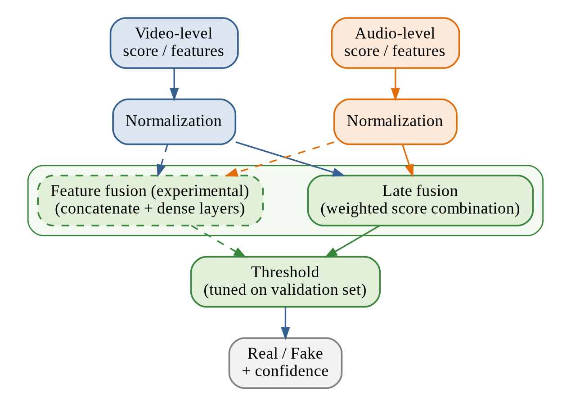
Figure 13.5: Multimodal Feature Fusion Architecture

Explainable Analysis (Module 7):
Grad-CAM [11] is applied only to a compatible visual model, and its output is labelled as a model-attention visualization and not as proof of manipulation. The module also reports the modality-level scores. Audio-video synchronization detection is claimed only if a tested method actually computes it.

API and Interface (Module 8):
This module exposes the pipeline through a backend API and, if included, a web interface. It validates uploads, runs the pipeline, and returns the structured result described in Chapter 14. A branch that did not run is returned as unavailable and not as a number.

Evaluation (Module 9):
The video-only baseline, the audio-only model, and the fused model are evaluated on the same held-out test split. The metrics, the processing time, and the memory use are reported, and the dataset version, the split method, the class balance, the model checkpoint, the threshold, and the hardware are documented.

SYSTEM DESIGN

SYSTEM DESIGN

Design Overview:
This chapter presents the design of the system using Unified Modeling Language (UML) diagrams, namely the use case, class, activity, sequence, and collaboration diagrams, together with a data flow diagram and the design tables. The designs describe the proposed system and will be refined as the implementation progresses.

Use Case Diagram:
The use case diagram in Fig. 14.1 shows two actors. The User uploads an audiovisual file, runs the analysis, and views the prediction, the modality scores, and the explainable analysis. Validating the file, extracting the frames and the audio, and fusing the evidence are included functions of the analysis. The explainable analysis extends the display of the prediction because it is produced only when the model supports it. The Researcher or Administrator prepares the dataset, trains the models, evaluates and compares them, and configures the fusion strategy.
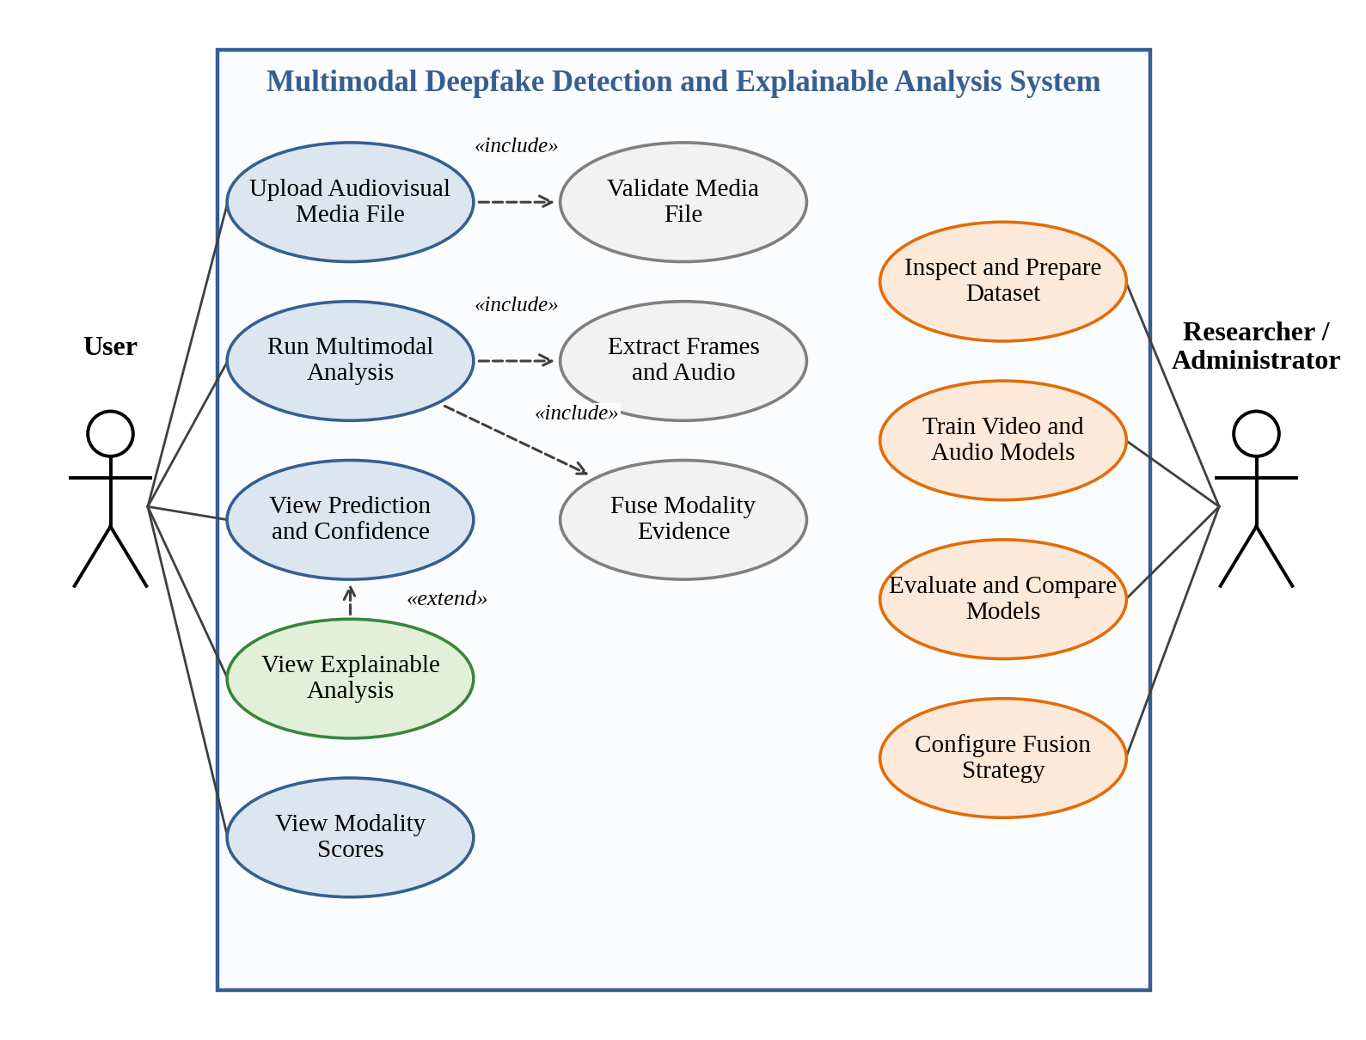
Figure 14.1: Use Case Diagram

Data Flow Diagram:
The level-1 data flow diagram in Fig. 14.2 shows how data moves through the system. The user supplies a media file to the validation process, which stores the validated file in a temporary media store or returns an error message. The video and audio streams are preprocessed separately and classified using the trained model weights. The two scores are fused, and the explanation and presentation process returns the result to the user.
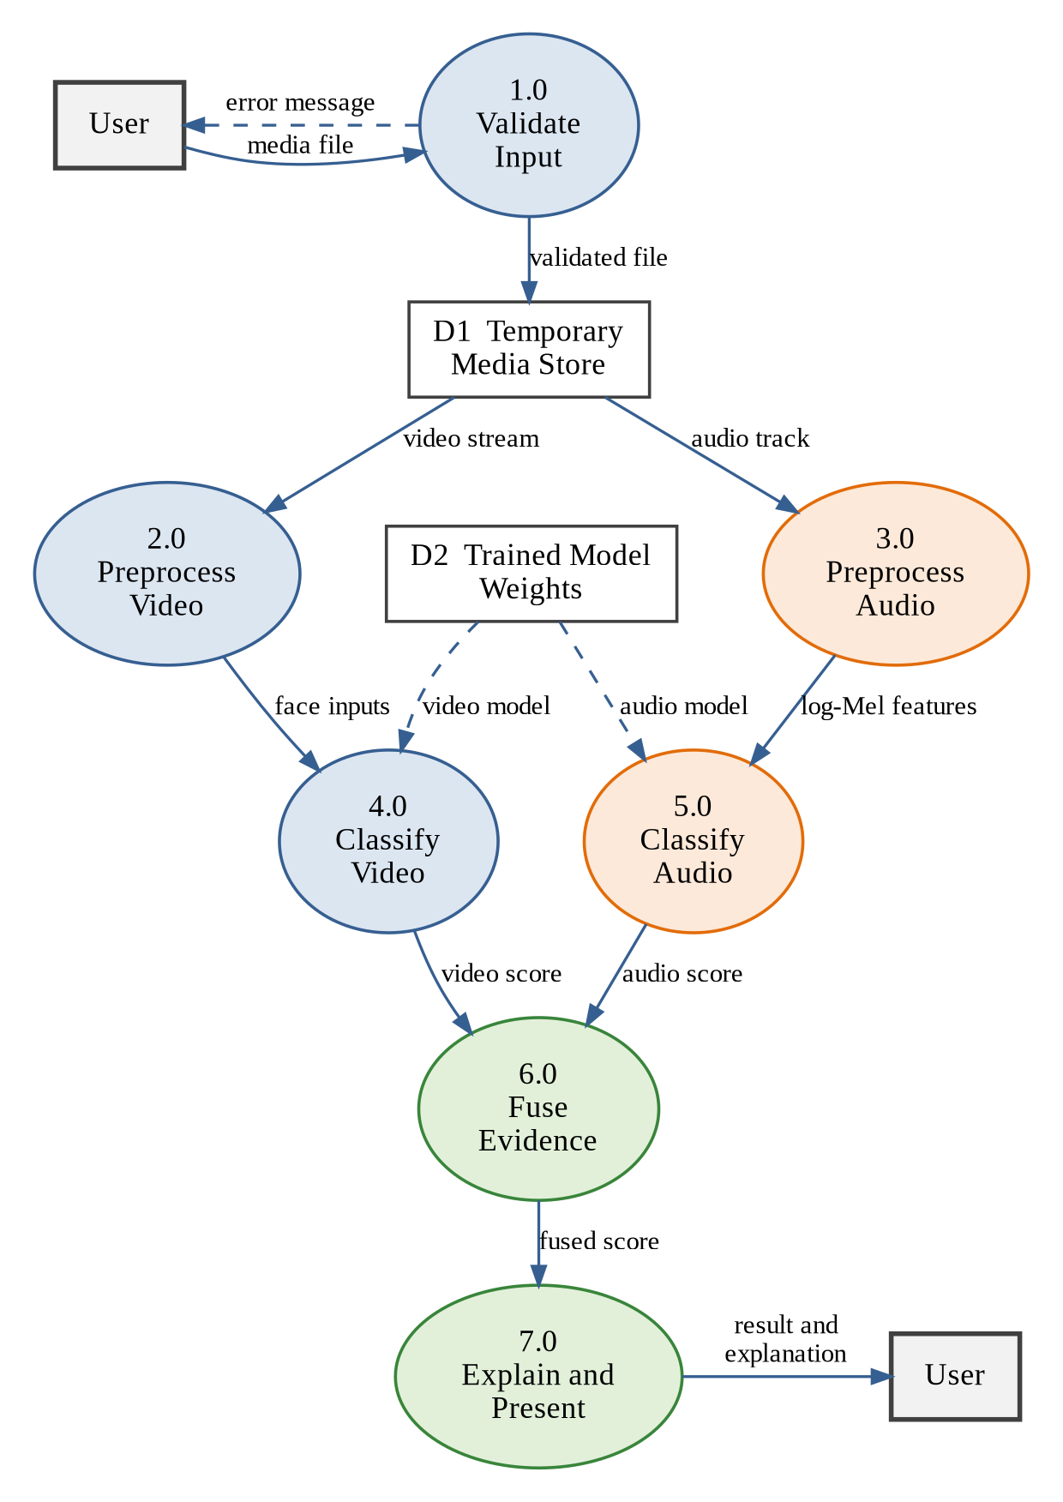
Figure 14.2: Data Flow Diagram

Class Diagram:
The class diagram in Fig. 14.3 shows the main classes. The APIController uses the DetectionPipeline, which is composed of the InputValidator, the VideoPreprocessor, the AudioPreprocessor, the FusionModule, and the ExplainabilityModule, and creates a DetectionResult. The VideoClassifier and the AudioClassifier are specializations of the abstract ModalityClassifier, which defines the common loadModel and predict operations.
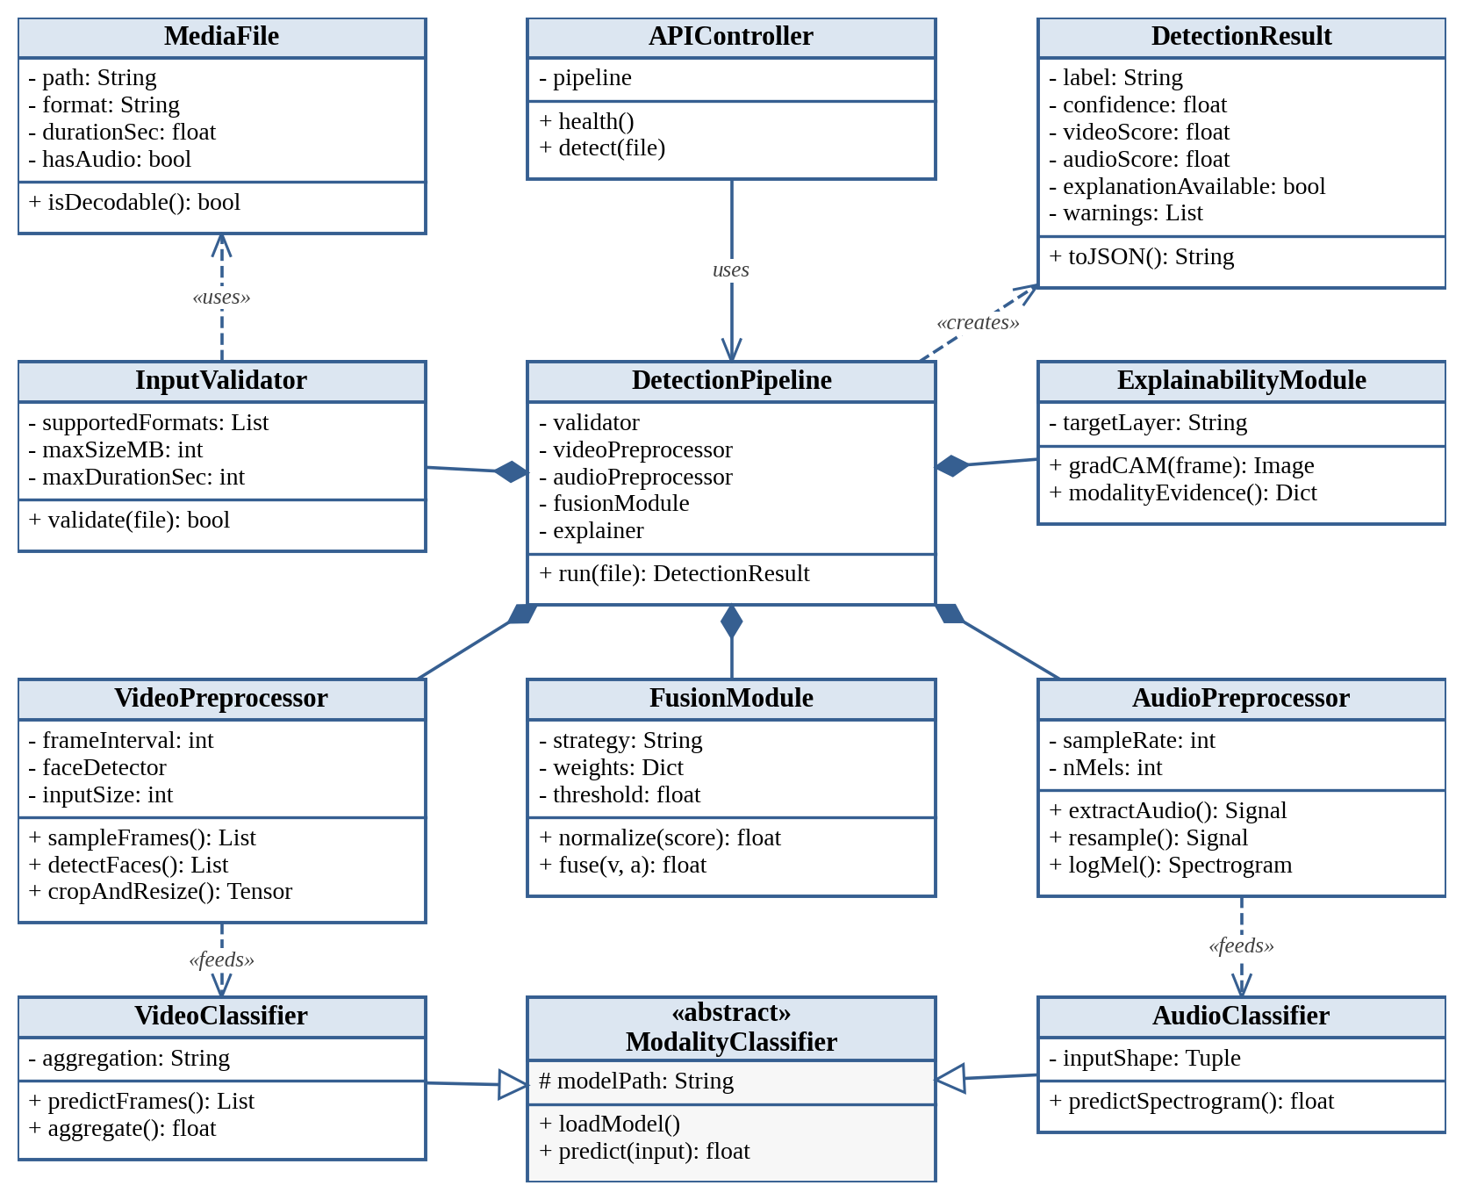
Figure 14.3: Class Diagram

Activity Diagram:
The activity diagram in Fig. 14.4 describes the flow of activities for one request. After a file is uploaded and validated, the video and audio activities run in parallel and join before fusion. When no audio is found, the audio branch is marked unavailable and the flow continues with the remaining evidence.
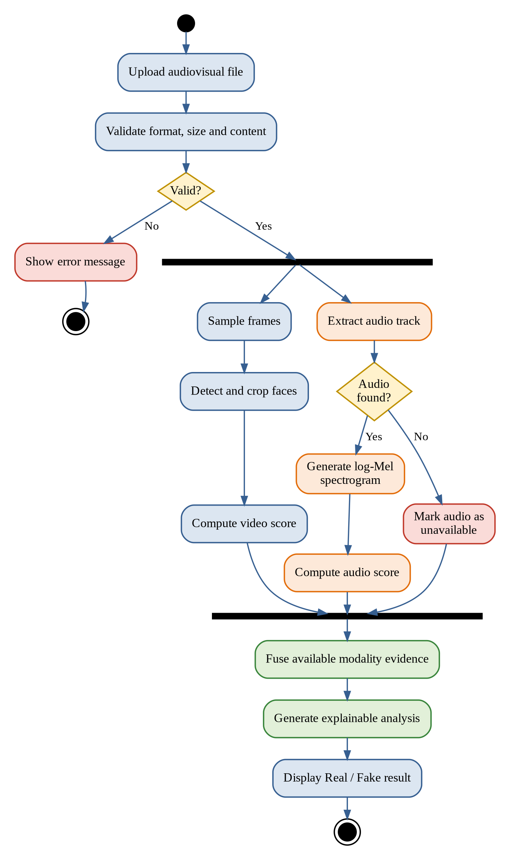
Figure 14.4: Activity Diagram

Sequence Diagram:
The sequence diagram in Fig. 14.5 shows the order of the messages exchanged between the user, the web interface, the backend API, the preprocessor, the video and audio models, and the fusion and explainer components. The backend API coordinates the process and returns the JSON result to the interface, which displays it to the user.
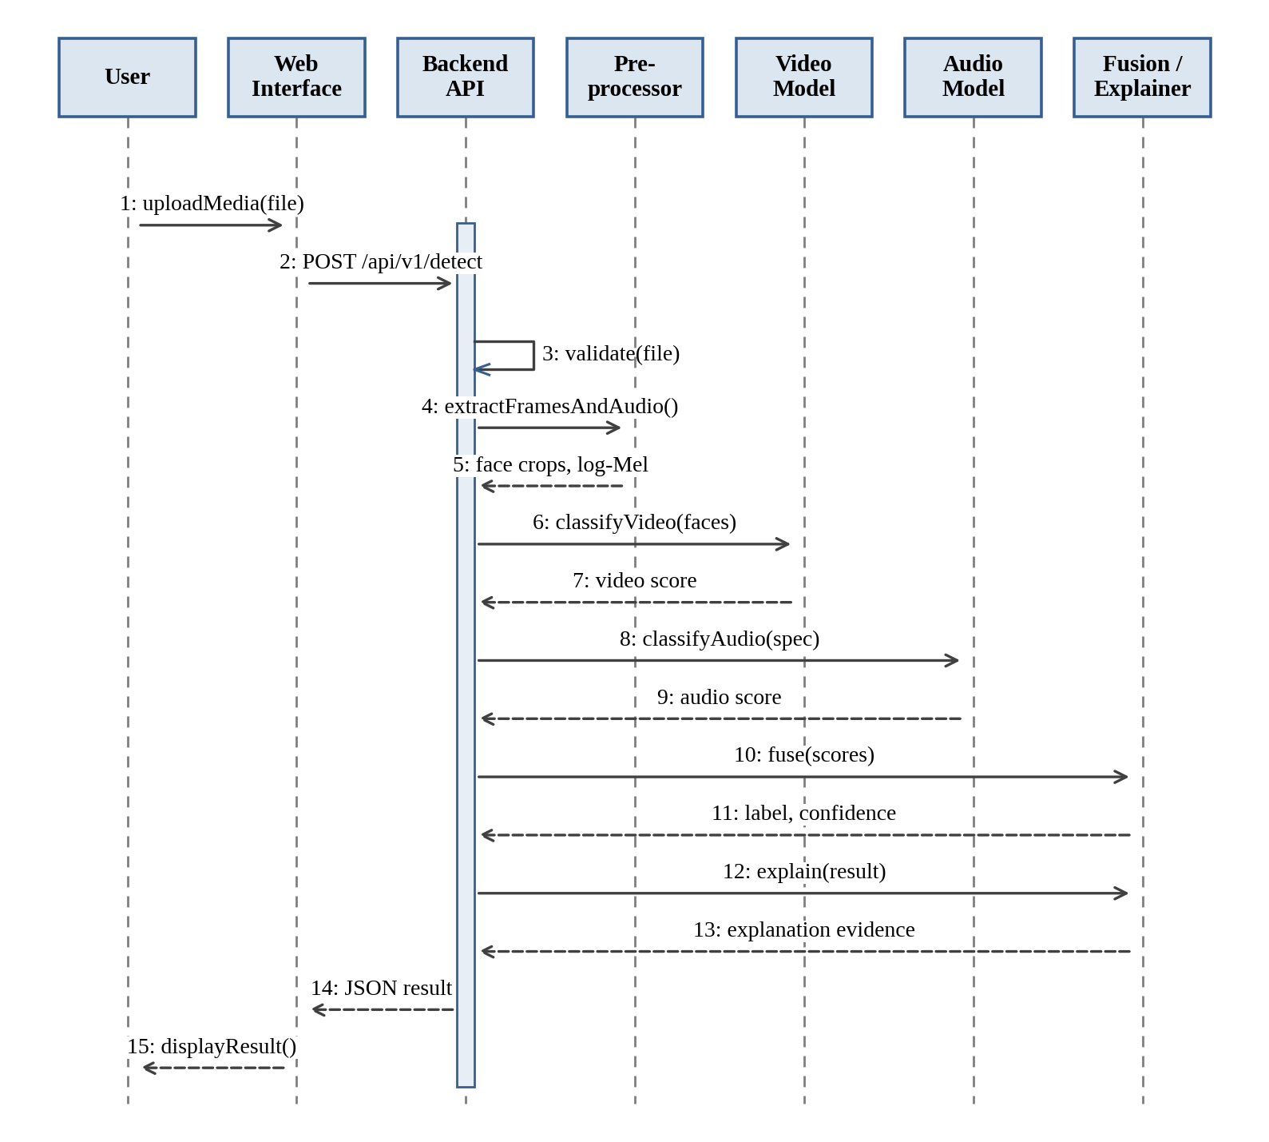
Figure 14.5: Sequence Diagram for Deepfake Detection

Collaboration Diagram:
The collaboration diagram in Fig. 14.6 shows the same interaction as the sequence diagram but emphasizes the links between objects. The numbers indicate the order of the messages: the APIController is the central object that exchanges messages with the InputValidator, the Preprocessor, the VideoClassifier, the AudioClassifier, the FusionModule, and the ExplainabilityModule.
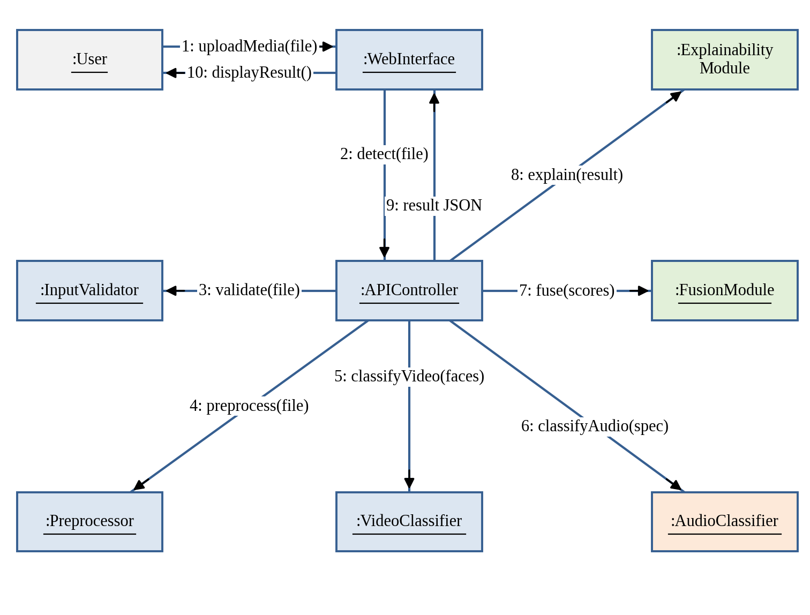
Figure 14.6: Collaboration Diagram

Dataset Distribution and Class Labels:
The FakeAVCeleb dataset [7] allows the video and the audio of a clip to be real or fake independently. Table 14.1 gives the proposed mapping to the binary labels. The sample counts will be recorded after the dataset inspection and are not stated here.
Table 14.1: Dataset Distribution and Class Labels
Category | Video | Audio | Proposed Label | Number of Samples
Real video, real audio | Real | Real | Real | To be recorded after inspection
Real video, fake audio | Real | Fake | Fake | To be recorded after inspection
Fake video, real audio | Fake | Real | Fake | To be recorded after inspection
Fake video, fake audio | Fake | Fake | Fake | To be recorded after inspection

Evaluation Metrics:
The metrics used to compare the video-only, audio-only, and fused models are defined in Table 14.2, where TP, TN, FP, and FN are the numbers of true positives, true negatives, false positives, and false negatives. Robustness results are reported only if experiments on compressed or low-resolution media are performed.
Table 14.2: Evaluation Metrics
Metric | Definition | Purpose
Accuracy | (TP + TN) / (TP + TN + FP + FN) | Overall fraction of correct predictions
Precision | TP / (TP + FP) | Reliability of the predictions of the positive class
Recall | TP / (TP + FN) | Fraction of positive samples detected
F1-score | 2 × Precision × Recall / (Precision + Recall) | Balance between precision and recall
Confusion matrix | Counts of TP, TN, FP, and FN | Shows the types of errors
ROC-AUC | Area under the ROC curve | Threshold-independent ranking quality, where suitable scores exist
Processing time and memory | Measured on the recorded hardware | Practical cost of inference

API Endpoints and Response:
The endpoints of the optional backend API are given in Table 14.3. The detection endpoint returns a structured result containing the status, the prediction, the confidence, the video score, the audio score, an indicator of whether an explanation is available, and a list of warnings. A branch that did not run is returned as unavailable, the meaning of the confidence field is documented, and no placeholder value is ever hard-coded as a model result.
Table 14.3: API Endpoints and Functions
Method | Endpoint | Function
GET | /health | API health check
POST | /api/v1/detect | Upload media and request analysis
GET | /api/v1/jobs/{job_id} | Check asynchronous processing status, if implemented

Explainable Analysis Output:
The planned layout of the result screen is shown in Fig. 14.7. It presents the selected frame, the Grad-CAM overlay when it is available, the prediction, the confidence, and the modality evidence, followed by a warning that the output is an estimate. The figure is a layout only; the actual screens will replace it after the interface is implemented and tested.
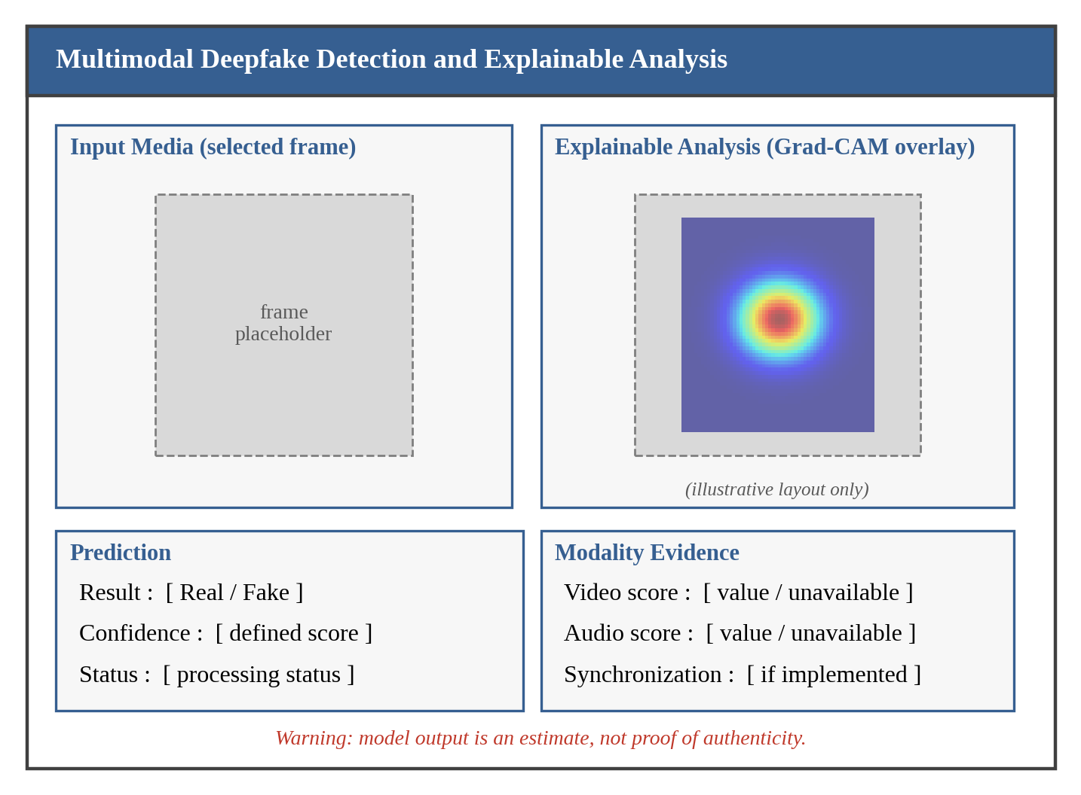
Figure 14.7: Explainable Analysis Output (Conceptual Layout)

CONCLUSION AND FUTURE ENHANCEMENTS

CONCLUSION AND FUTURE ENHANCEMENTS

Conclusion:
This report presents the Stage-I proposal for Multimodal Deepfake Detection and Explainable Analysis. Starting from the base paper [1], which identifies the integration of audio and visual features as future scope, the project proposes a pipeline with separate video and audio branches, a multimodal fusion stage, and an explainable-analysis stage. The report has described the objectives, the existing system and its limitations, the proposed system, the architecture, the requirements, the modules, and the UML designs. The performance of the system and its limitations will be established through implementation and testing, and a prediction of the system will always be an estimate and not definitive proof that media is authentic or manipulated.

Planned Implementation Tasks:
- Verify the dataset source, version, labels, and usage terms.
- Create the metadata inventory and the data splits.
- Implement video preprocessing and audio extraction and preprocessing.
- Train and evaluate the video-only baseline and the audio-only model.
- Implement the fusion method and compare the three model variants.
- Add and validate explainability, if included.
- Build and test the API and the interface, if included.
- Record the actual metrics and limitations, and update the figures and tables of the report.

Future Enhancements:
After the multimodal baseline is working, the following enhancements can be studied. They remain future work unless they are separately implemented and evaluated.
- Testing on compressed and low-resolution videos and evaluating generalization across datasets.
- Optimizing the models for mobile and edge devices and building a more responsive user interface.

REFERENCES
[1] H. R. Harishma and K. Sreelakshmi, “Detection of deepfake media for secure communication using deep learning,” in Proc. 2025 9th Int. Conf. Comput. Syst. Inf. Technol. Sustain. Solutions (CSITSS), 2025, doi: 10.1109/CSITSS67709.2025.11295707.
[2] A. Jadhav, D. Narale, R. Kore, U. Shisode, and A. Kulange, “Unmasking the illusion: A novel approach for detecting deep fakes using video vision transformer architecture,” in Proc. 2024 Asian Conf. Intell. Technol. (ACOIT), 2024, doi: 10.1109/ACOIT62457.2024.10939366.
[3] T. S. Kulkarni, D. K. Vishwakarma, and V. Ranga, “AI vs. AI: Deep learning approaches for detecting deepfake content,” in Proc. 2024 1st Int. Conf. Adv. Comput., Commun. Netw. (ICAC2N), 2024, doi: 10.1109/ICAC2N63387.2024.10895362.
[4] M. Thanga Raj et al., “A review on the detection of deep fake and propaganda videos and images-based voice and facial manipulation using AI techniques,” in Proc. 2023 2nd Int. Conf. Autom., Comput. Renew. Syst. (ICACRS), 2023, doi: 10.1109/ICACRS58579.2023.10405046.
[5] P. P. Chandran, S. Sriram, and C. Babu, “Multimodal forgery detection in videos using a tri-network model,” in Proc. 2024 10th Int. Conf. Adv. Comput. Commun. Syst. (ICACCS), 2024, doi: 10.1109/ICACCS60874.2024.10717044.
[6] H. H. Kilinc and F. Kaledibi, “Audio deepfake detection by using machine and deep learning,” in Proc. 2023 10th Int. Conf. Wireless Netw. Mobile Commun. (WINCOM), 2023, doi: 10.1109/WINCOM59760.2023.10323004.
[7] H. Khalid, S. Tariq, M. Kim, and S. S. Woo, “FakeAVCeleb: A novel audio-video multimodal deepfake dataset,” in Proc. 35th Conf. Neural Inf. Process. Syst. (NeurIPS) Datasets Benchmarks Track, 2021.
[8] P. Viola and M. Jones, “Rapid object detection using a boosted cascade of simple features,” in Proc. IEEE Comput. Soc. Conf. Comput. Vis. Pattern Recognit. (CVPR), Kauai, HI, USA, 2001, pp. I-511–I-518.
[9] F. Chollet, “Xception: Deep learning with depthwise separable convolutions,” in Proc. IEEE Conf. Comput. Vis. Pattern Recognit. (CVPR), Honolulu, HI, USA, 2017, pp. 1251–1258.
[10] M. Tan and Q. V. Le, “EfficientNet: Rethinking model scaling for convolutional neural networks,” in Proc. 36th Int. Conf. Mach. Learn. (ICML), Long Beach, CA, USA, 2019, pp. 6105–6114.
[11] R. R. Selvaraju et al., “Grad-CAM: Visual explanations from deep networks via gradient-based localization,” in Proc. IEEE Int. Conf. Comput. Vis. (ICCV), Venice, Italy, 2017, pp. 618–626.

