1. Log in

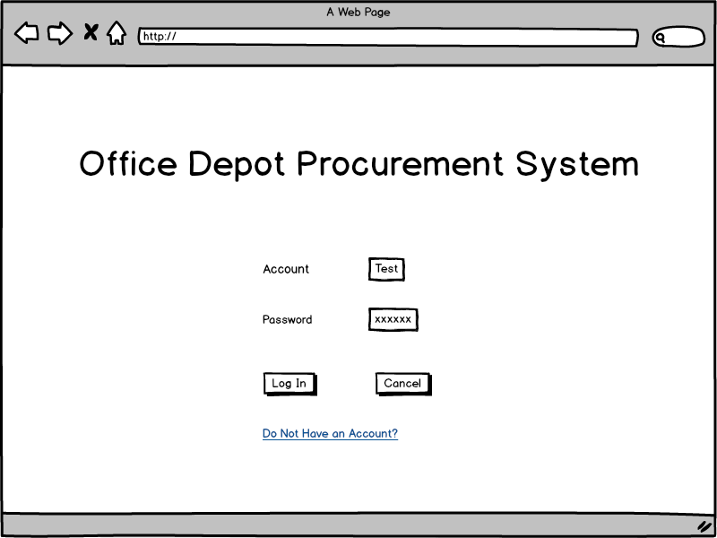

Request: login

Data:

F -> B: {account:Test, password:XXXXXX}

B -> F: {authSuccess:true/false, userID:XXXXXX}

1. Register（Requestor）

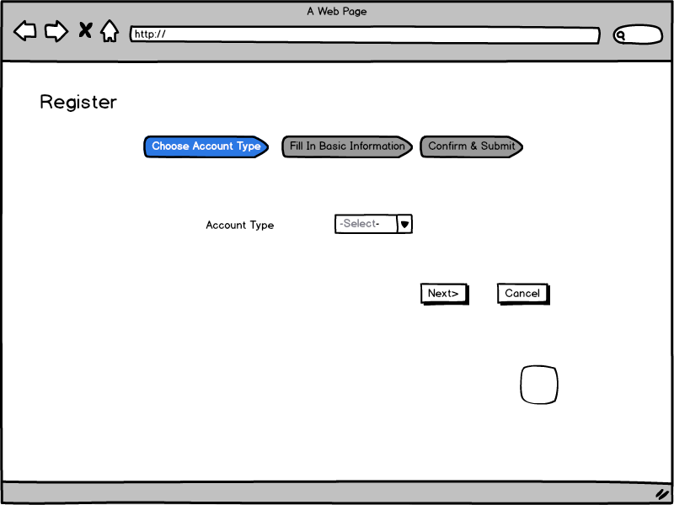

Request: getRegisterRoles

Data:

B->F: [{roleId:2, roleName: Requestor},

{roleId:4, roleName: Supplier}]

F: Click ‘next’

Request: createUser

Data:

F->B: {roleId:XXX}

B: Service: creating new user

B->F: {userId: XXXX}

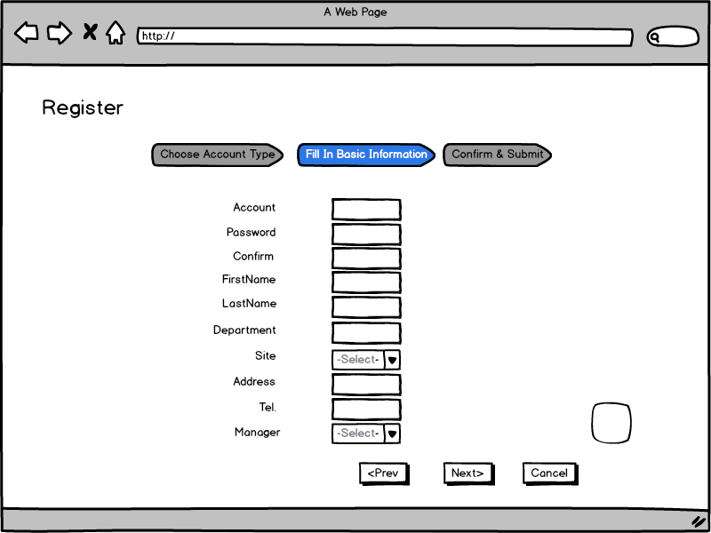

B->F:

blanks: [{displayName: Account, isText: true, map: null},

{displayName: Password, isText: true, map: null},

{displayName: Confirm, isText, true, map: null},

{displayName: First Name, isText: true, map: null},

{displayName: Last Name, isText: true, map: null},

{displayName: Department, isText: true, map: null},

{displayName: Site, isText: false, map: sites},

{displayName: Address, isText: true, map: null},

{displayName: Tel., isText:true, map: null},

{displayName: Manager, isText: false, map: managers}],

Sites: {“US Redwood”: 1, “CN SH: 2”, “CN BJ”: 3…},

Managers：{“Eunhei Jang”: 2, “Jeffrey Meredith”: 3}

F->B

{“Account”: XXX, “Password”: XXX, “Confirm”: XXX, “First Name”: XXX, “Last Name”: XXX, “Department”: XXX, “Site”: ”CN SH”, “Address”: XXX, “Tel.”: XXX, “Manager”:3, “ManagerName”: “Jeffrey Meredith”}

注：Site返回字符串.

F: Click next

Request: getConfirmInfo

Data:

B->F:[{displayName: “Name”, value: “Qingyi Meng”}, {displayName: Department, value: APM}, …]

注：这里的Save按键去掉吧。

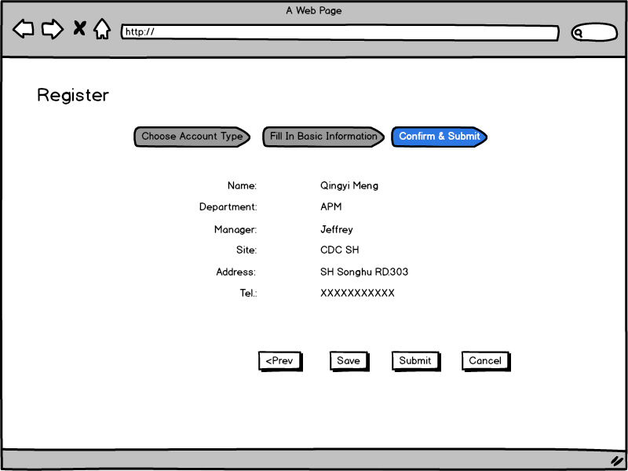

F: Click submit

Reuqest: submitAccount

F->B: {userID: XXX}

1. Register（Supplier）

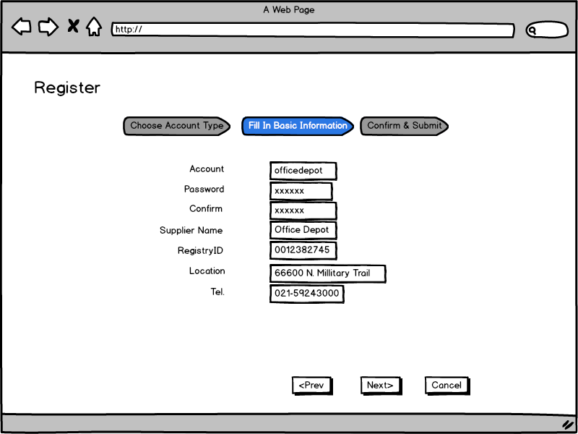

总体类似于Requestor注册的数据传输

1. Catalog

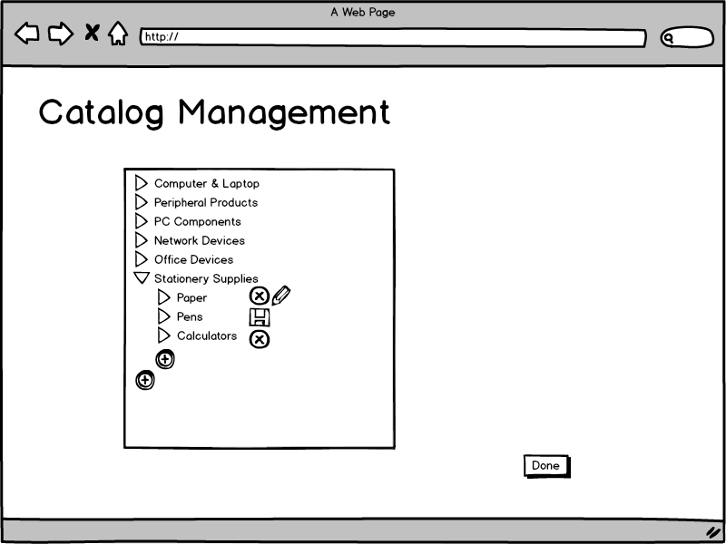

Request: showCatalog

Data:

B -> F:

[[root: {id: 1, name: “Computer & Laptop”, root: 0}, subCatalog: [{id: 7, name: “XXX”, root: 1]],

[root: {id: 2, name: “Peripheral Products”, root: 0}, subCatalog: [{id: n, name: “YYY”, root: 2]],

……

]

F: Click Add

Request: addCatalog

Data

F->B: {root: m1, name: “ZZZ”}

B->F: {catalogID: m2}

F: Click Delete

Request: deleteCatalog

Data:

F->B: {id: m3}

B->F: {success: true/false}

F: Click Update:

Request: updateCatalog

Data:

F->B: {id: m4, newName: “RRR”}

1. Homepage:

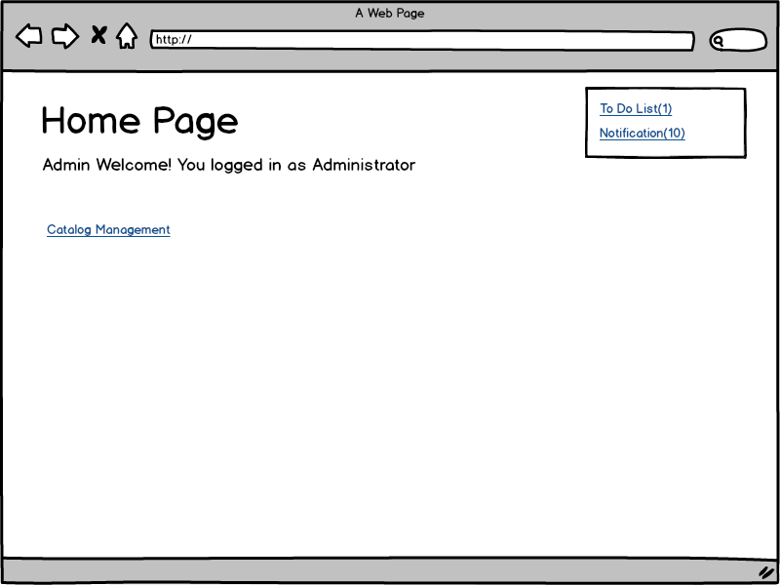

(接第一张图的Login)

Request: showHomepage

B -> F:

{userID: m1, username: “XXX”, userRole: m2, notificationNum: m3, toDoListNum: m4}

Click on “To Do List”:

F->B: Request: checkToDoList?userID=m1

B->F:

1）Manager:

[

{listType: “Account To-Do”,

list: [

{toDoListItemID: m1, typeID: m2, ownerID: m3, ownerName: “XXX”, assigneeID: m4, orderID: null, account: “AAA”, firstName: “BBB”, lastName: “CCC”, status: “DDD”, actions: [“Approve”, “Refuse”]},

…,

]},

{listType: “Order To-Do”,

list: [

{toDoListItemID: m1, typeID: m2, ownerID: m3, ownerName: “XXX”, assigneeID: m4, orderID: m5, totalPrice: “YYY”, justification: “ZZZ”, submitDate: “xxxx-xx-xx”, actions: [“Details”, “Approve”, “Refuse”]},

…,

]}

]

2）Administrator：

[

{listType: “Account To-Do”,

list: [

{toDoListItemID: m1, typeID: m2, ownerID: m3, ownerName: “XXX”, assigneeID: m4, orderID: null, account: “AAA”, supplieName: “BBB”, status: “CCC”, actions: [“Approve”, “Refuse”]},

…,

]}]

3）Supplier：

[

{listType: “Order To-Do”,

list: [

{toDoListItemID: m1, typeID: m2, ownerID: m3, ownerName: “XXX”, assigneeID: m4, orderID: m5, totalPrice: “YYY”, submitDate: “xxxx-xx-xx”, actions: [“Details”, “Process/Complete”]},

…,

]}]

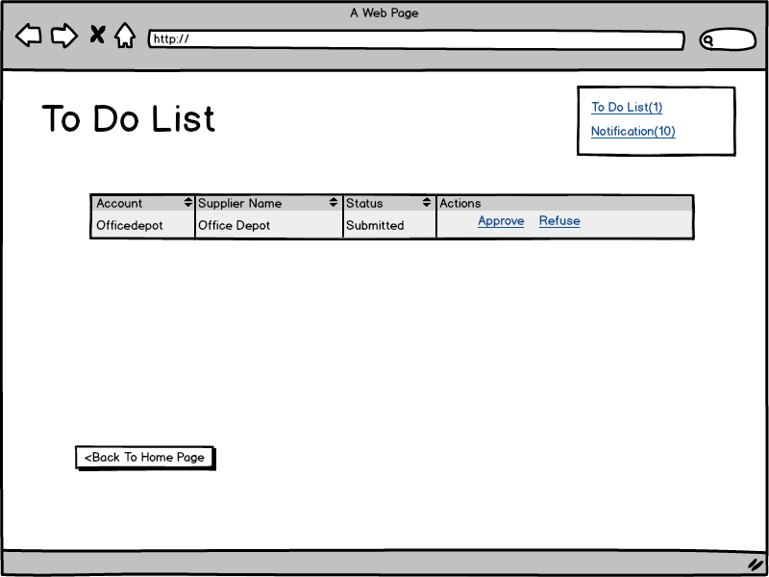

上图为Admin的To Do List

F: Click Approve/Refuse:

Request: updateAccountStatus

Data:

F -> B:

{userID: m1, action: Approve/Refuse}

B -> F:

{success: true/false}

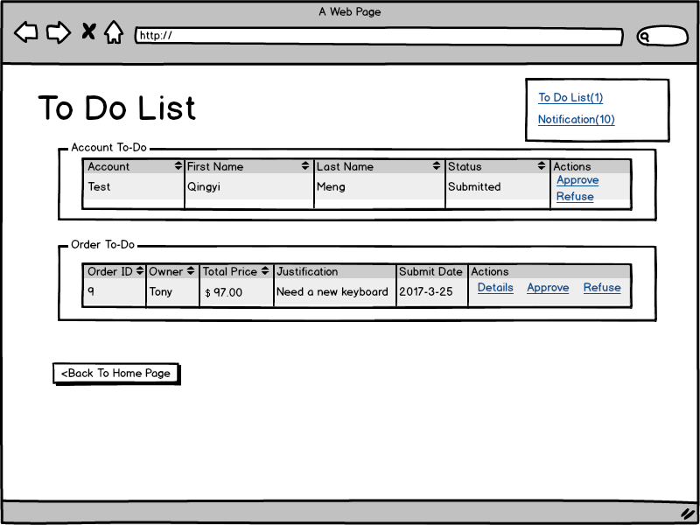

上图为Manager的To Do List:

F: Click Approve/Refuse:

Request: updateAccountStatus

Data:

F -> B:

{userID: m1, action: Approve/Refuse}

B -> F:

{success: true/false}

F: Click Details:

Request: showOrderDetails

Data:

F -> B:

{orderID: m1}

B -> F:

{orderID: m1, orderType: “AAA”, totalPrice: “BBB”, Status: “CCC”, createTimeValue: “xxxx-xx-xx”, ……} (如下图所示)

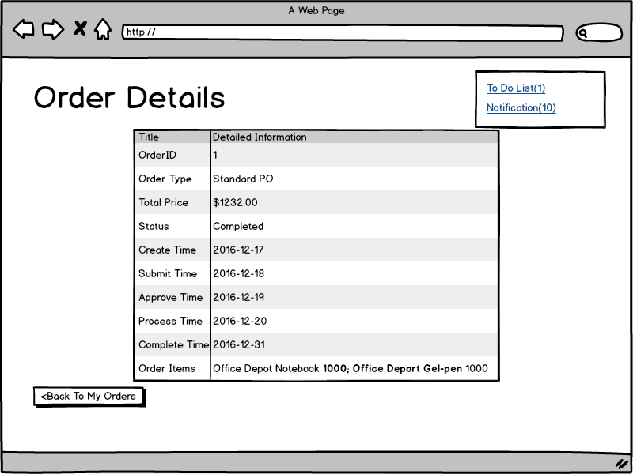

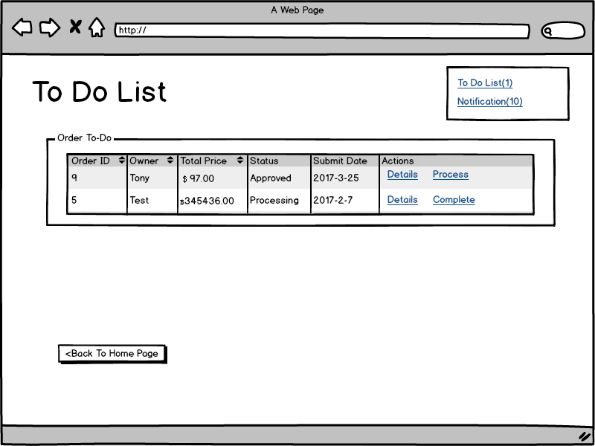

上图为Supplier的To Do List:

F: Click Process/Complete:

Request: updateOrderStatus

Data:

F -> B:

{userID: m1, action: Process/Complete }

B -> F:

{success: true/false}

F: Click Details:

Request: showOrderDetails

Data:

F -> B:

{orderID: m1}

B -> F:

{orderID: m1, orderType: “AAA”, totalPrice: “BBB”, Status: “CCC”, createTimeValue: “xxxx-xx-xx”, ……} (与Manager类似)

1. Notification:

F: Click Notification

Request: getUnreadNotification

Data:

F -> B: {userID: m1}

B -> F: [{notificationID: m1, notificationMessage: “AAA”, notificationTime:”xxxx-xx-xx”},

……,

]

Request: updateNotification

Data:

F -> B: [{notificationID: m1}, {notificationID: m2},…,]

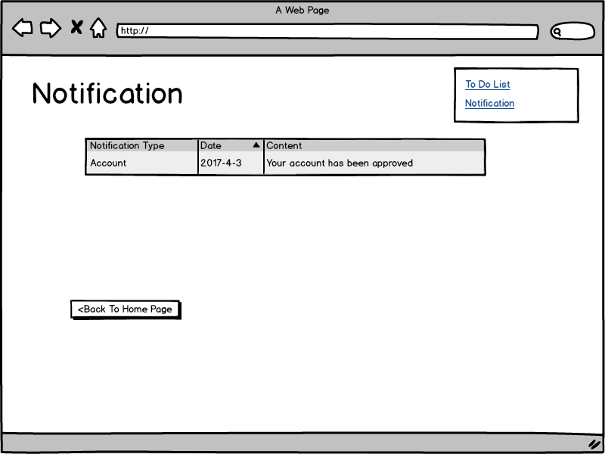

1. Account Management
2. Administrator：

F: Click ‘Account Management’

Request: getAllAccounts

Data:

F -> B: {roleType: Supplier}

B -> F:

[

{userID: null, account: “AAA”, supplieName: “BBB”, status: “CCC”, actions: [“Approve”, “Refuse”]},

…,

]

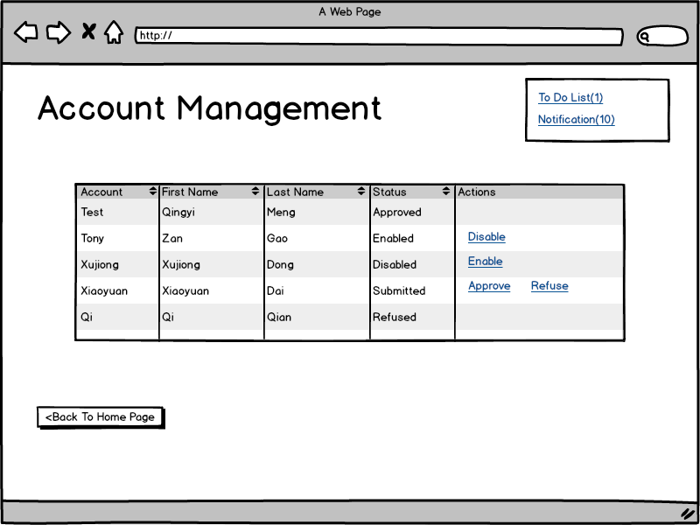

注：上图原型Table有误，请参考Admin的To Do List中的表格

F: Click Approve/Refuse/Enable/Disable:

Request: updateAccountStatus

Data:

F -> B:

{userID: m1, action: Approve/Refuse/Enable/Disable }

B -> F:

{success: true/false}

1. Manager：

F: Click ‘Account Management’

Request: getAllAccounts

Data:

F -> B: {managerID: m1} (m1即为当前manager用户的userID)

B -> F:

[

{userID: m2, account: “AAA”, firstName: “BBB”, lastName: “CCC”, status: “DDD”, actions: [“Approve”, “Refuse”]},

…,

]



F: Click Approve/Refuse/Enable/Disable:

Request: updateAccountStatus

Data:

F -> B:

{managerID: m1, userID: m2, action: Approve/Refuse/Enable/Disable }

B -> F:

{success: true/false}

1. My Order

F: Click My Order from Homepage:

Request: getAllOrders

Data:

F -> B: {userID: m1}

B -> F:

[

{orderID: m5, type: “AAA”, totalPrice: “BBB”, createTime: “xxxx-xx-xx”, status: “CCC”, actions: [“Details”, “Refuse”]},

…,

]

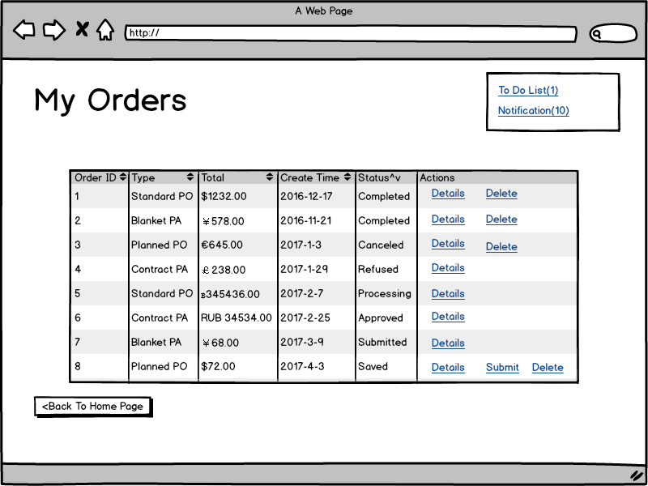

F: Click Details

Request: getOrderDetail

Data:

F -> B: {orderID: m1}

B -> F:

{orderID: m1, orderType: “AAA”, totalPrice: “BBB”, Status: “CCC”, createTimeValue: “xxxx-xx-xx”, ……} (如下图所示)



1. Office Depot Procurement:

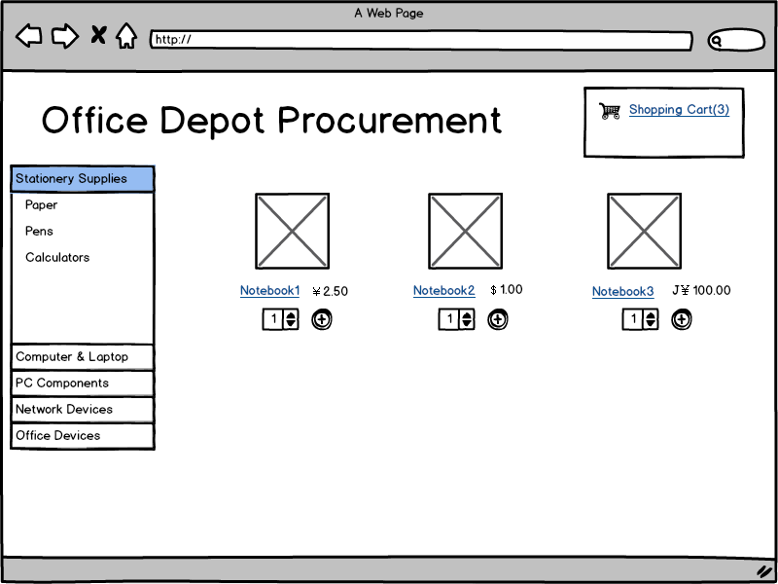

B->F:

[[root: {id: 1, name: “Computer & Laptop”, root: 0}, subCatalog: [{id: 7, name: “XXX”, root: 1]],

[root: {id: 2, name: “Peripheral Products”, root: 0}, subCatalog: [{id: n, name: “YYY”, root: 2]],

……

]

F: Click one Catalog item

Request: getOfficeDepotByCatalog

Data:

F -> B: {catalogID: m1}

B -> F:

[{officeDepotID: m1, officeDepotPrice: m2, currencyID: m3, currencySymble:”A”, picDir: “xxxxx”},

……,

]

F: Click Buy

Request: checkOut

Data:

B -> F:

{orderType: {“Standard PO”: 1, “Blanket PA“: 2,…},

currency: {” RMB”: 1, “USD”: 2…}}

F: Click Submit

Request: createOrder

Data:

F -> B:

{userID: m1, orderType: m2, cuccencyID: m3, orderItems:[{officeDepotID: n1, amount: n2}, {officeDepotID n3, amount: n4}…]}

B -> F:

{orderID: m1, orderType: “AAA”, totalPrice: “BBB”, Status: “CCC”, createTimeValue: “xxxx-xx-xx”, ……} (如下图所示)

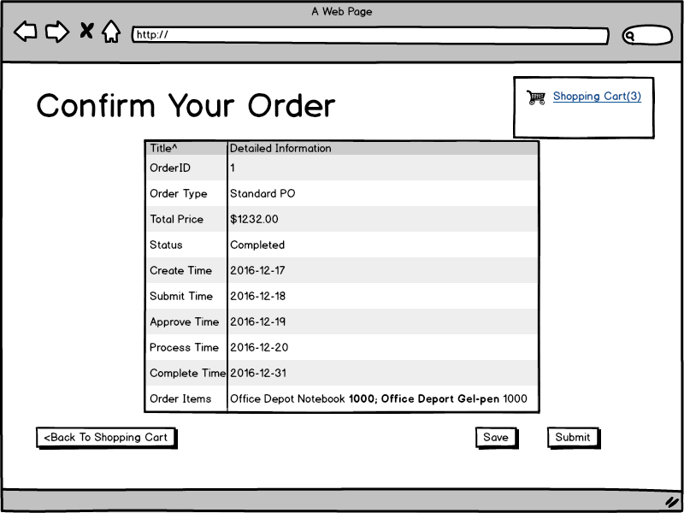

1. Office Depot Management

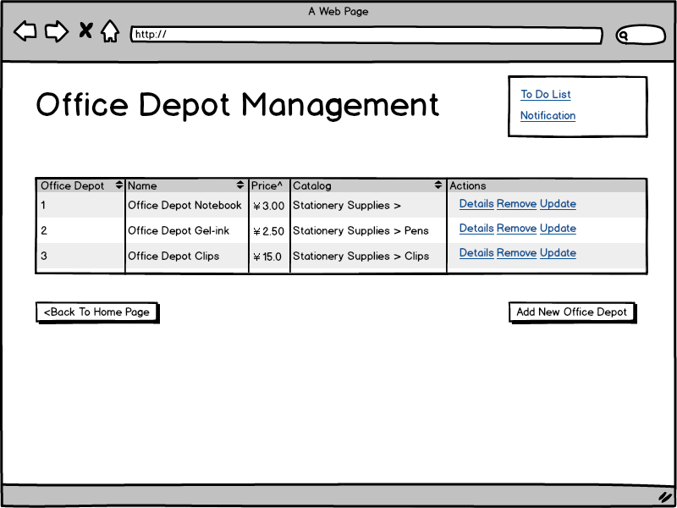

F: Click “Office Depot Management” from Homepage

Request: getAllOfficeDepot

Data:

F->B: {supplierID: m1}（m1即为当前userID）

B->F:

[

{officeDepotID: m1, name: “AAA”, Price: “BBB”, Catalog: “CCC”, actions: [Details, Remove, Update]},

……

]

F: Click “Details”

Request: getOfficeDepotDetails

F -> B: {officeDepotID: m1}

B -> F: {SKU: [{skuName: “AAA”, skuValue: “BBB”}, …]}

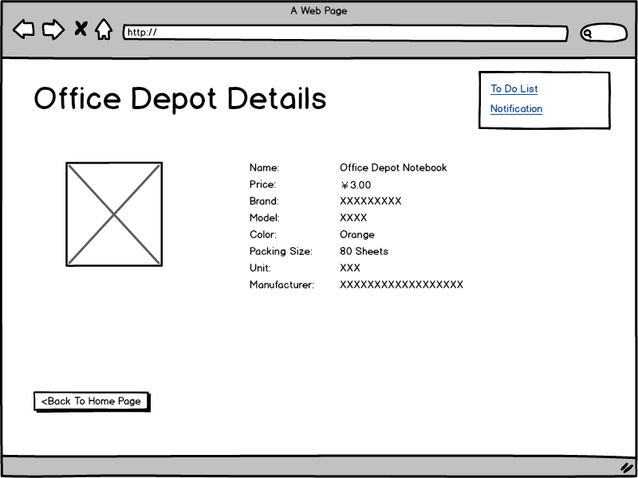

F: Click “Remove”:

Request: deleteOfficeDepot

F -> B: {officeDepotID: m1}

B -> F: {success: true/false}

F: Click “Add New Office Depot”

Request getAddOfficeDepotFillingForm

Data:

B -> F:

{catalog:

[[root: {id: 1, name: “Computer & Laptop”, root: 0}, subCatalog: [{id: 7, name: “XXX”, root: 1]],

[root: {id: 2, name: “Peripheral Products”, root: 0}, subCatalog: [{id: n, name: “YYY”, root: 2]],

……

],

mandatorySKU: [{skuID:m1, dispalyName: “Name”, isText: true, map: null}, { skuID:m2, displayName: “Price”, isText: true, map: “currency”}, …],

optionalSKU: [{skuID:m3, displayName: “Usage”, isText: true, map: null},…]

}

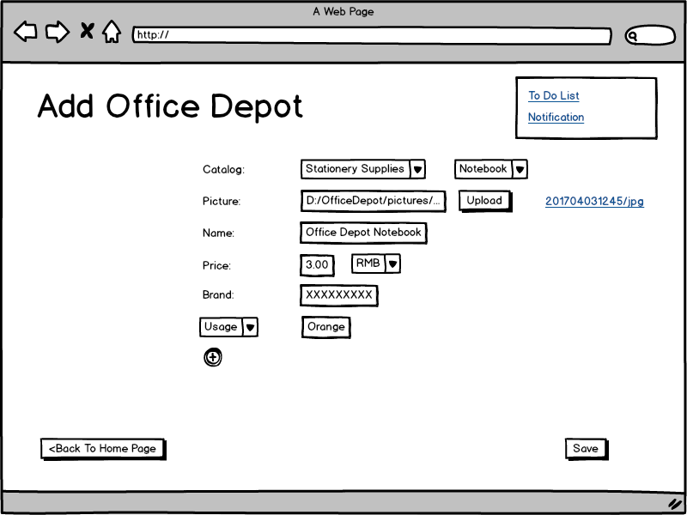

F: Click “Save”

Request: addOfficeDepot

Data:

F -> B:

{catalogID: m1,

supplierID: p

SKU: [{skuType: m1, value: n1}, { skuType:m2, value: n2}, …],

currencyID: q

}

B -> F:

{officeDepot: m1}

Back

F: Click “Update”

Request: getUpdateOfficeDepotFillingForm

Data:

F -> B:

{officeDepotID: m1}

B -> F:

{mandatorySKU: [{skuID:m1, dispalyName: “Name”, isText: true, map: null, value: “AAA”}, { skuID:m2, displayName: “Price”, isText: true, map: “currency”, value: “BBB”}, …],

optionalSKU: [{skuID:m3, displayName: “Usage”, isText: true, map: null, value: “CCC”},…],

currencyID: n1

}

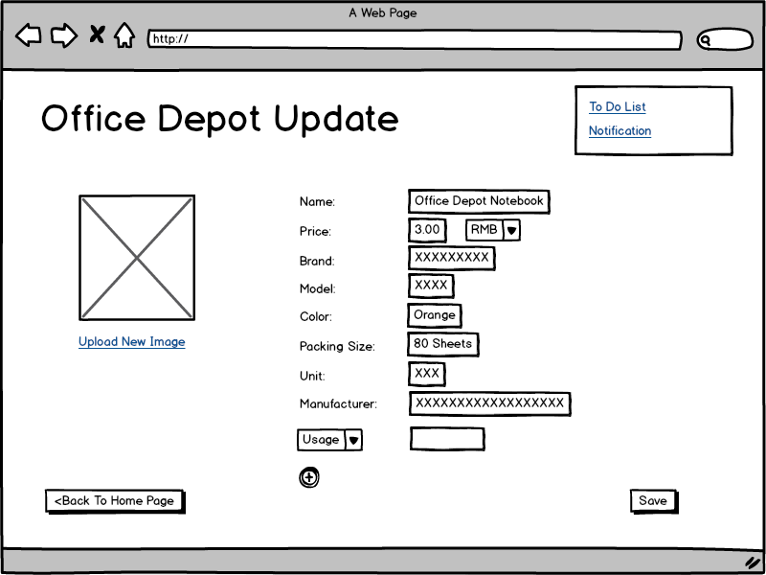

F: Click “Save”

F -> B:

{

SKU: [{skuID, m1, value: n1}, { skuID:m2, value: n2}, …],

currencyID: q

}