Rockbuster Stealth LLC

Data Dictionary

02/11/2021

Table of Contents

1. Rockbuster Stealth LLC……………………………………………………………. 3

2. Payment…………...………………………………………………………..………. 4

3. Payment Tables

3.1 - Payment……………………………………………………………………5

3.2 - Rental………………………………………………………………………6

3.3 - Customer……………………………………………………………..……7

3.4 - Store ……………………………………………………………….……8

3.5 – Staff ………………………………………………………………….….…9

3.6 - Address …………………………………………………………………10

3.7 - City…………………………………………………………………………11

3.8 – Country……………………………………………………………………12

4. Inventory………………………………………………………………………………13

5. Inventory Tables

5.1 – Film_Category………………………………………………….....………14

5.2 - Category……………………………………………………………………15

5.3 - Film………………………………………………………………….………16

5.4 – Film_Actor………………………………………………………….………17

5.5 - Inventory…………………………………………………………...….……18

5.6 – Actor….……………………………………………………………….……19

5.7 - Language…………………………………………………………..….……20

Rockbuster Stealth LLC

Rockbuster Stealth LLC is a movie rental company that used to have stores around the world. Facing stiff competition from streaming services such as Netflix and Amazon Prime, the Rockbuster Stealth management team is planning to use its existing movie licenses to launch an online video rental service in order to stay competitive.

Rockbuster’s database includes film inventory, film attributes, customer information and payment information.

You can download Rockbusters database here: [Rockbuster Database](http://www.postgresqltutorial.com/wp-content/uploads/2019/05/dvdrental.zip)

Payment

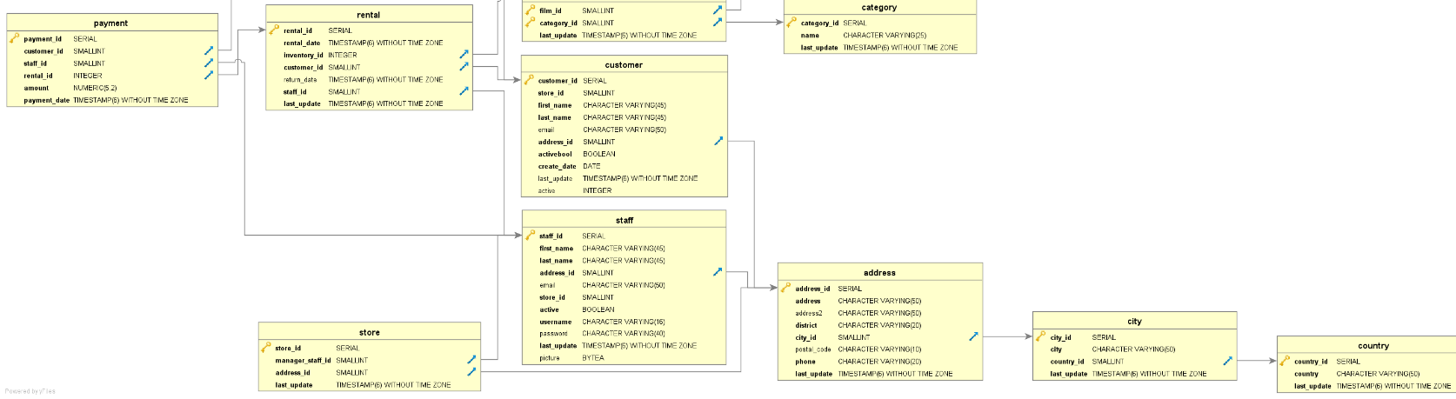

3 . Payment Tables

**3.1 –Table: Payment**

**Columns**

|  |  |  |  |
| --- | --- | --- | --- |
|  | **Name** | **Data Type** | **Description** |
|  | payment_id | SERIAL | Primary key for payment records. Identity increment for payment |
|  | customer_id | SMALLINT | Identity increment for customers |
|  | staff_id | SMALLINT | Identity increment for staff |
|  | rental_id | INTEGER | Identity increment for film rental |
|  | amount | NUMERIC(5,2) | Monetary amount of payment |
|  | payment_date | TIMESTAMP(6) WITHOUT TIME ZONE | Date/time of payment |

**Links To**

|  |
| --- |
| **Table** |
| Customer |
| Rental |
| Staff |

**Links From**

|  |
| --- |
| **Table** |
| N/A |

**Unique Keys**

|  |  |  |
| --- | --- | --- |
|  | **Column** | **Description** |
|  | payment_id | Primary Key |

**3.2 –Table: Rental**

**Columns**

|  |  |  |  |
| --- | --- | --- | --- |
|  |  | | |
|  | **Name** | **Data Type** | **Description** |
|  | Rental_id | SERIAL | Primary key for rental records. Identity increment for rental |
|  | Rental_date | TIMESTAMP(6) WITHOUT TIME ZONE | Date/time of rental |
|  | Inventory_id | INTEGER | Identity increment for inventory |
|  | Customer_id | SMALLINT | Identity increment for customer |
|  | Return_date | TIMESTAMP(6) WITHOUT TIME ZONE | Date/time of return |
|  | Staff_id | SMALLINT | Identity increment for staff |
|  | Last_update | TIMESTAMP(6) WITHOUT TIME ZONE | Date/time rental last updated |

**Links To**

|  |
| --- |
| **Table** |
| Customer |
| Inventory |
| Staff |

**Links From**

|  |
| --- |
| **Table** |
| Payment |

**Unique Keys**

|  |  |  |
| --- | --- | --- |
|  | **Column** | **Description** |
|  | rental_id | Primary Key |

**3.3 –Table: Customer**

**Columns**

|  |  |  |  |
| --- | --- | --- | --- |
|  | **Name** | **Data Type** | **Description** |
|  | Customer_id | SERIAL | Primary key for customer records. Identity increment for customer |
|  | Store_id | SMALLINT | Identity increment for store |
|  | First_name | CHARACTER VARYING(45) | Customer’s first name |
|  | Last_name | CHARACTER VARYING(45) | Customer’s last name |
|  | Email | CHARACTER VARYING(45) | Customer’s email |
|  | Address_id | SMALLINT | Identity increment for customer’s address |
|  | Activebool | BOOLEAN | True or False confirming whether customer active or not in system |
|  | Create_date | DATE | Date/time customer created in system |
|  | Last_update | TIMESTAMP(6) WITHOUT TIME ZONE | Date/time customer’s profile last updated |
|  | active | INTEGER | 0 or 1 integer for whether customer is active or not |

**Links To**

|  |
| --- |
| **Table** |
| Address |

**Links From**

|  |
| --- |
| **Table** |
| Payment |
| Rental |

**Unique Keys**

|  |  |  |
| --- | --- | --- |
|  | **Column** | **Description** |
|  | customer_id | Primary Key |

**3.4 –Table: Store**

**Columns**

|  |  |  |  |
| --- | --- | --- | --- |
|  | **Name** | **Data Type** | **Description** |
|  | store_id | SERIAL | Primary key for store records. Identity increment for store |
|  | manager_staff_id | SMALLINT | Identity increment for manager & staff at store |
|  | address_id | SMALLINT | Identity increment for store’s address |
|  | last_update | TIMESTAMP(6) WITHOUT TIME ZONE | Date/time store last updated |

**Links To**

|  |
| --- |
| **Table** |
| Address |
| Staff |

**Links From**

|  |
| --- |
| **Table** |
| N/A |

**Unique Keys**

|  |  |  |
| --- | --- | --- |
|  | **Column** | **Description** |
|  | store_id | Primary Key |

**3.5 –Table: Staff**

**Columns**

|  |  |  |  |
| --- | --- | --- | --- |
|  | **Name** | **Data Type** | **Description** |
|  | staff_id | SERIAL | Primary key for staff records. Identity increment for staff |
|  | First_name | CHARACTER VARYING(45) | Staff’s first name |
|  | Last_name | CHARACTER VARYING(45) | Staff’s last name |
|  | Address_id | SMALLINT | Identity increment for Staff’s address |
|  | Email | CHARACTER VARYING(50) | Staff’s email |
|  | Store_id | SMALLINT | Identity increment for store where staff is employed |
|  | Active | BOOLEAN | True or False confirming whether staff active or not in system |
|  | Username | CHARACTER VARYING(40) | Staff’s username |
|  | password | CHARACTER VARYING(40) | Staff’s password |
|  | Last_update | TIMESTAMP(6) WITHOUT TIME ZONE | Date/time Staff’s profile last updated |
|  | Picture | BYTEA | Staff’s picture |

**Links To**

|  |
| --- |
| **Table** |
| Address |

**Links From**

|  |
| --- |
| **Table** |
| Payment |
| Store |
| Rental |

**Unique Keys**

|  |  |  |
| --- | --- | --- |
|  | **Column** | **Description** |
|  | Staff_id | Primary Key |

**3.6 –Table: Address**

**Columns**

|  |  |  |  |
| --- | --- | --- | --- |
|  | **Name** | **Data Type** | **Description** |
|  | address_id | SERIAL | Primary key for address records. Identity increment for address |
|  | address | CHARACTER VARYING(50) | First line of address |
|  | Address2 | CHARACTER VARYING(50) | Second line of address |
|  | District | CHARACTER VARYING(20) | Address district |
|  | City_id | SMALLINT | Address city |
|  | Postal_code | CHARACTER VARYING(10) | Address postal code |
|  | phone | CHARACTER VARYING(20) | Phone number of staff |
|  | Last_update | TIMESTAMP(6) WITHOUT TIME ZONE | Date/time address profile last updated |

**Links To**

|  |
| --- |
| **Table** |
| City |

**Links From**

|  |
| --- |
| **Table** |
| Staff |
| Store |
| Customer |

**Unique Keys**

|  |  |  |
| --- | --- | --- |
|  | **Column** | **Description** |
|  | address_id | Primary Key |

**3.7 –Table: City**

**Columns**

|  |  |  |  |
| --- | --- | --- | --- |
|  | **Name** | **Data Type** | **Description** |
|  | city_id | SERIAL | Primary key for city records. Identity increment for city |
|  | city | CHARACTER VARYING(50) | Name of city |
|  | Country_id | SMALLINT | Identity increment for country |
|  | last_update | TIMESTAMP(6) WITHOUT TIME ZONE | Date/time city last updated |

**Links To**

|  |
| --- |
| **Table** |
| Country |

**Links From**

|  |
| --- |
| **Table** |
| Address |

**Unique Keys**

|  |  |  |
| --- | --- | --- |
|  | **Column** | **Description** |
|  | city_id | Primary Key |

**3.8 –Table: Country**

**Columns**

|  |  |  |  |
| --- | --- | --- | --- |
|  | **Name** | **Data Type** | **Description** |
|  | country_id | SERIAL | Primary key for country records. Identity increment for country |
|  | Country | CHARACTER VARYING(50) | Name of country |
|  | last_update | TIMESTAMP(6) WITHOUT TIME ZONE | Date/time country last updated |

**Links To**

|  |
| --- |
| **Table** |
| N/A |

**Links From**

|  |
| --- |
| **Table** |
| City |

**Unique Keys**

|  |  |  |
| --- | --- | --- |
|  | **Column** | **Description** |
|  | country_id | Primary Key |

Inventory

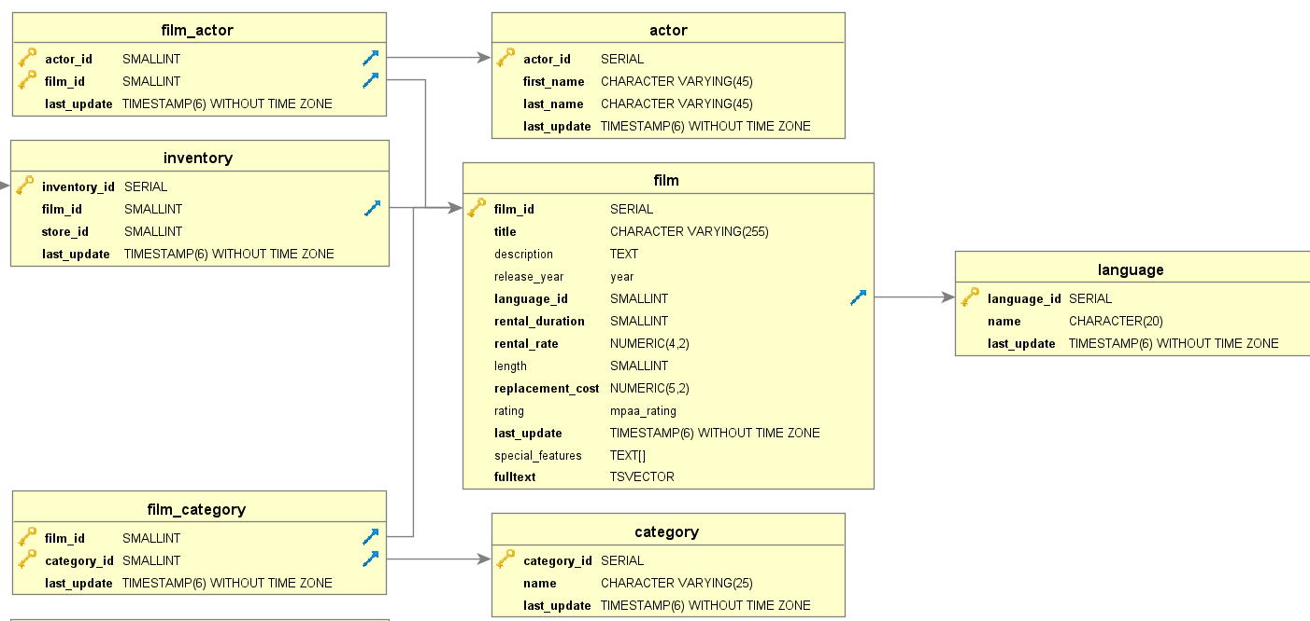

5 . Inventory Tables

**5.1 –Table: Film_Category**

**Columns**

|  |  |  |  |
| --- | --- | --- | --- |
|  | **Name** | **Data Type** | **Description** |
|  | film_id | SERIAL | Primary key for film records. Identity increment for film |
|  | category_id | SMALLINT | Candidate key for film records. Identity increment for film category |
|  | last_update | SERIAL | Date/time film last updated |

**Links To**

|  |
| --- |
| **Table** |
| Category |
| Film |

**Links From**

|  |
| --- |
| **Table** |
| N/A |

**Unique Keys**

|  |  |  |
| --- | --- | --- |
|  | **Column** | **Description** |
|  | film_id | Primary Key |
|  | Category_id | Candidate Key |

**5.2 –Table: Category**

**Columns**

|  |  |  |  |
| --- | --- | --- | --- |
|  | **Name** | **Data Type** | **Description** |
|  | category_id | SERIAL | Primary key for category records. Identity increment for category |
|  | name | CHARACTER(25) | Name of category (genre of film) |
|  | last_update | TIMESTAMP(6) WITHOUT TIME ZONE | Date/time category last updated |

**Links To**

|  |
| --- |
| **Table** |
| N/A |

**Links From**

|  |
| --- |
| **Table** |
| Film_Category |

**Unique Keys**

|  |  |  |
| --- | --- | --- |
|  | **Column** | **Description** |
|  | category_id | Primary Key |

**5.3 –Table: Film**

**Columns**

|  |  |  |  |
| --- | --- | --- | --- |
|  | **Name** | **Data Type** | **Description** |
|  | film_id | SERIAL | Primary key for film records. Identity increment for film |
|  | title | CHARACTER VARYING(255) | Title of film |
|  | description | TEXT | Description of film |
|  | Release_year | year | Release year of film |
|  | Language_id | SMALLINT | Language of film |
|  | Rental_duration | SMALLINT | Rental duration of film |
|  | Rental_rate | NUMERIC(4,2) | Rental rate of film |
|  | length | SMALLINT | Length of film |
|  | Replacement_cost | NUMERIC(5,2) | Replacement cost of film |
|  | rating | Mpaa_rating | Rating of film |
|  | Last_update | TIMESTAMP(6) WITHOUT TIME ZONE | Date/time film’s profile last updated |
|  | Special_features | TEXT[] | Description of what special features are included (Trailers, Behind the scenes, etc…) |
|  | fulltext | TSVECTOR | Summary of text describing film |

**Links To**

|  |
| --- |
| **Table** |
| Language |

**Links From**

|  |
| --- |
| **Table** |
| Film_Category |
| Inventory |
| Film_Actor |

**Unique Keys**

|  |  |  |
| --- | --- | --- |
|  | **Column** | **Description** |
|  | Film_id | Primary Key |

**5.4 –Table: Film_Actor**

**Columns**

|  |  |  |  |
| --- | --- | --- | --- |
|  | **Name** | **Data Type** | **Description** |
|  | actor_id | SMALLINT | Primary key for actor records. Identity increment for actor |
|  | film_id | SMALLINT | Candidate key for actor records. Identity increment for film category |
|  | last_update | TIMESTAMP(6) WITHOUT TIME ZONE | Date/time actor last updated |

**Links To**

|  |
| --- |
| **Table** |
| Actor |
| Film |

**Links From**

|  |
| --- |
| **Table** |
| N/A |

**Unique Keys**

|  |  |  |
| --- | --- | --- |
|  | **Column** | **Description** |
|  | actor_id | Primary Key |
|  | film_id | Candidate Key |

**5.5 –Table: Inventory**

**Columns**

|  |  |  |  |
| --- | --- | --- | --- |
|  | **Name** | **Data Type** | **Description** |
|  | inventory_id | SERIAL | Primary key for inventory records. Identity increment for inventory |
|  | Film_id | SMALLINT | Identity increment for film |
|  | Store_id | SMALLINT | Identity increment for store |
|  | last_update | TIMESTAMP(6) WITHOUT TIME ZONE | Date/time inventory last updated |

**Links To**

|  |
| --- |
| **Table** |
| Film |

**Links From**

|  |
| --- |
| **Table** |
| Rental |

**Unique Keys**

|  |  |  |
| --- | --- | --- |
|  | **Column** | **Description** |
|  | inventory_id | Primary Key |

**5.6 –Table: Actor**

**Columns**

|  |  |  |  |
| --- | --- | --- | --- |
|  | **Name** | **Data Type** | **Description** |
|  | actor_id | SERIAL | Primary key for actor records. Identity increment for actor |
|  | First_name | CHARACTER VARYING(45) | Actor’s first name |
|  | Last_name | CHARACTER VARYING(45) | Actor’s last name |
|  | last_update | TIMESTAMP(6) WITHOUT TIME ZONE | Date/time actor last updated |

**Links To**

|  |
| --- |
| **Table** |
| N/A |

**Links From**

|  |
| --- |
| **Table** |
| Film_Actor |

**Unique Keys**

|  |  |  |
| --- | --- | --- |
|  | **Column** | **Description** |
|  | actor_id | Primary Key |

**5.7 –Table: Language**

**Columns**

|  |  |  |  |
| --- | --- | --- | --- |
|  | **Name** | **Data Type** | **Description** |
|  | language_id | SERIAL | Primary key for language records. Identity increment for language |
|  | name | CHARACTER(20) | Name of language |
|  | last_update | TIMESTAMP(6) WITHOUT TIME ZONE | Date/time language last updated |

**Links To**

|  |
| --- |
| **Table** |
| N/A |

**Links From**

|  |
| --- |
| **Table** |
| Film |

**Unique Keys**

|  |  |  |
| --- | --- | --- |
|  | **Column** | **Description** |
|  | language_id | Primary Key |