**Django Chat App**

**Problem Statement:** Develop a basic chat application that allows users to send and receive messages in real-time using sockets or a simple web interface.

**1. Introduction:**

The "Django Chat App" project is a real-time chat application developed using Django, Django Channels, and WebSockets. The application allows users to join chat rooms, exchange messages in real-time, and navigate through different rooms. This report provides an analysis of the project structure, code, and potential improvements.

**2. Project Overview:**

The project leverages Django for the backend, Django Channels for handling WebSockets, and Bootstrap for the frontend. Users can log in, join chat rooms, and participate in real-time conversations. The project focuses on demonstrating the integration of WebSockets with Django for dynamic and interactive features.

**3. Project Structure and Settings:**

* Settings:

The project uses a standard Django settings file with some potential improvements, such as handling SECRET_KEY more securely.

Considerations for production environments, like specifying allowed hosts, should be addressed.

* Routing:

URL routing follows a straightforward pattern using path functions. Considerations for URL patterns are well-defined.

* Database:

The project currently uses the default SQLite database. For production, consider transitioning to a more robust database like PostgreSQL.

**4. Django Views and Templates:**

Views:

The views in the project are functional and straightforward. Consider using Django's class-based views for more structured and reusable code.

Templates:

Templates are well-structured, and the use of Bootstrap enhances the visual appeal of the application.

**5. WebSocket and Channels:**

The WebSocket consumer is well-implemented, handling connections, disconnections, and message exchanges effectively.

Ensure user input is validated and sanitized in the WebSocket consumer to prevent potential security vulnerabilities.

**6. Code and Security:**

Implement Django's security middleware to enhance the overall security of the application.

Validate and sanitize user input, especially when handling messages in the WebSocket consumer.

**7. Potential Improvements:**

Separation of Concerns:

Consider organizing the Django app with a clearer separation of concerns. Group related components into dedicated directories, such as creating a consumers directory for WebSocket consumers.

Use of Django Channels:

Verify the necessity of the channels and daphne packages. Ensure compatibility with the Django version used in the project.

Form Validation:

Implement form validation to ensure the security of user input.

**8. Conclusion:**

The "Django Chat App" project successfully demonstrates the integration of Django, Django Channels, and WebSockets to create a real-time chat application. The project is suitable for learning about dynamic and interactive features in web development.

**9. Future Enhancements:**

Explore using a more robust database, such as PostgreSQL, for production deployment.

Consider adding user authentication features, user profiles, and additional chat functionalities to enhance the user experience.

**10. References:**

Django Documentation: https://docs.djangoproject.com/

Django Channels Documentation: https://channels.readthedocs.io/

Bootstrap Documentation: <https://getbootstrap.com/>

OUTPUT:

* Django admin page with proper login:

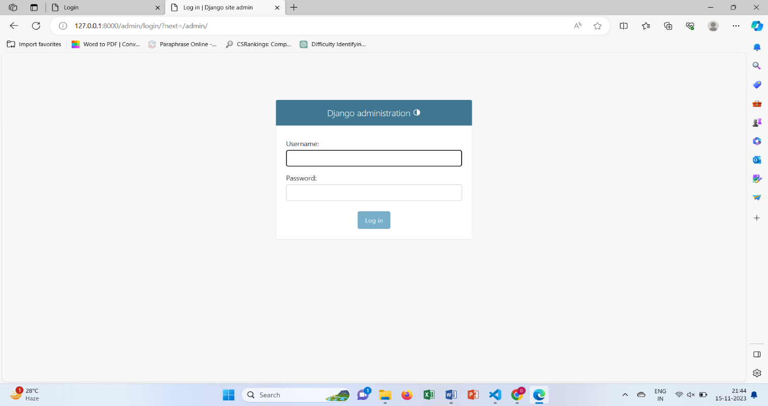

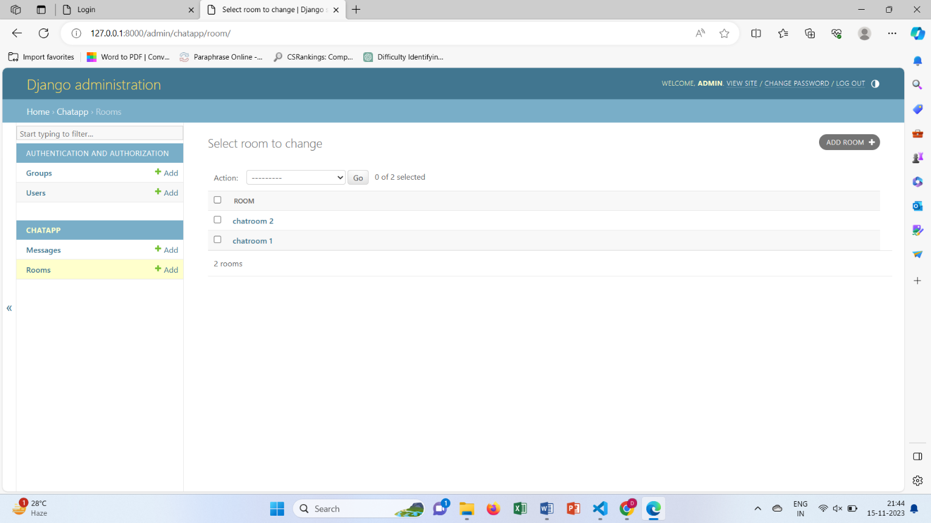

* Admin group, messages, users and message chat rooms:

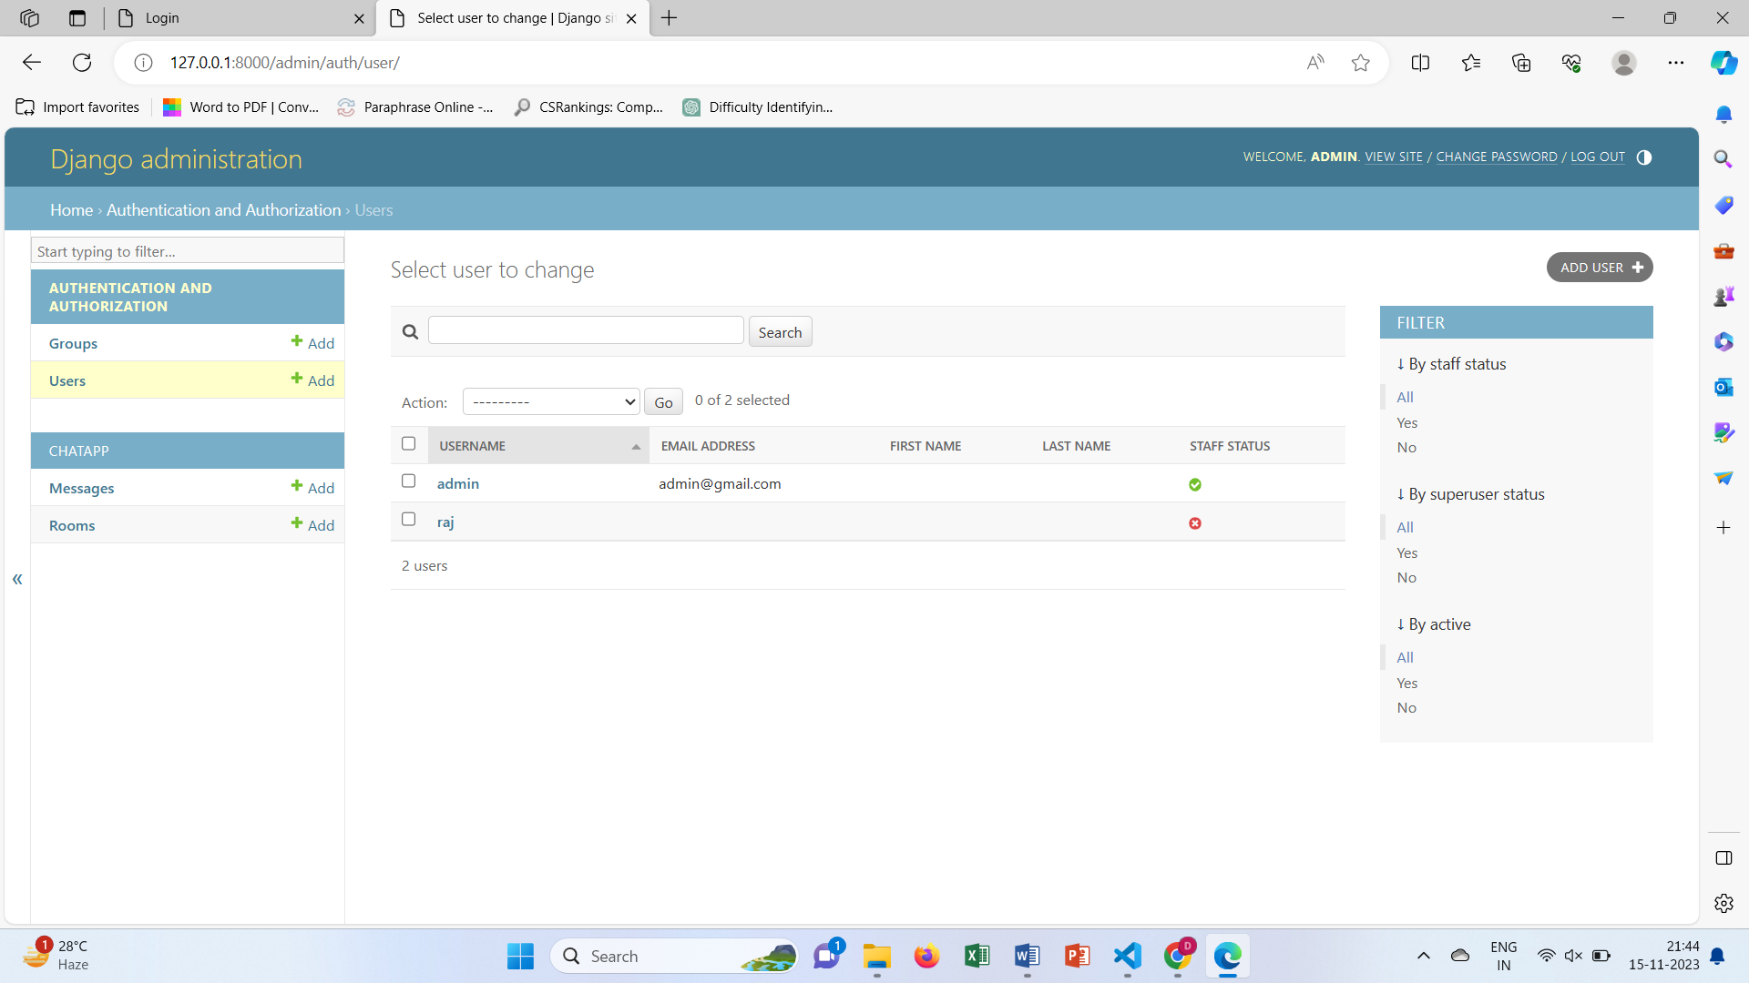

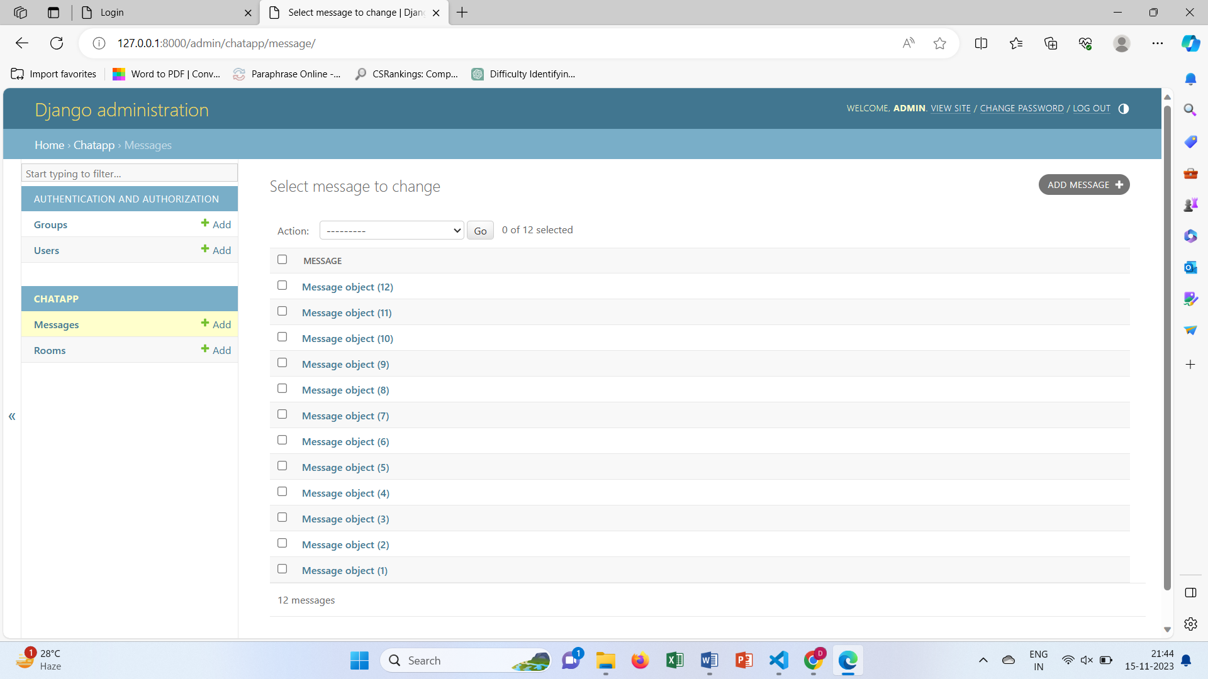

* Login page for chat application:

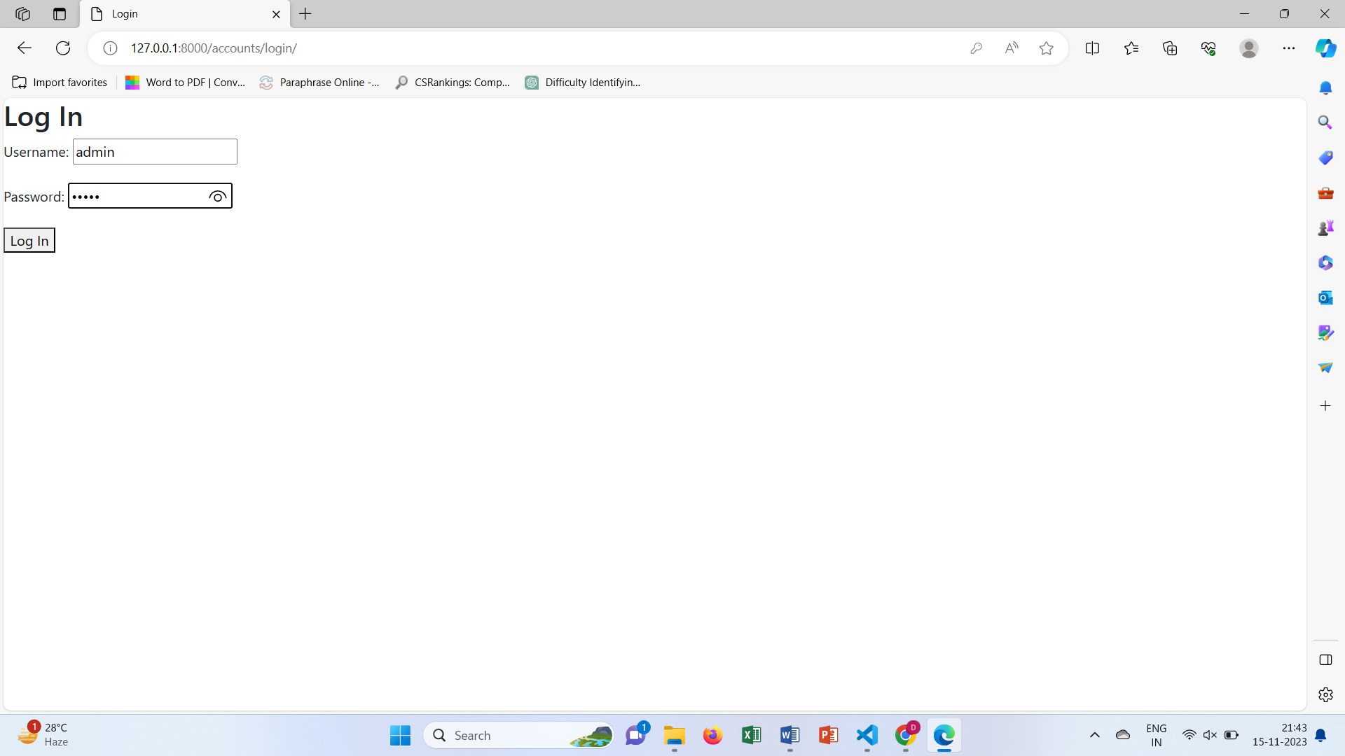

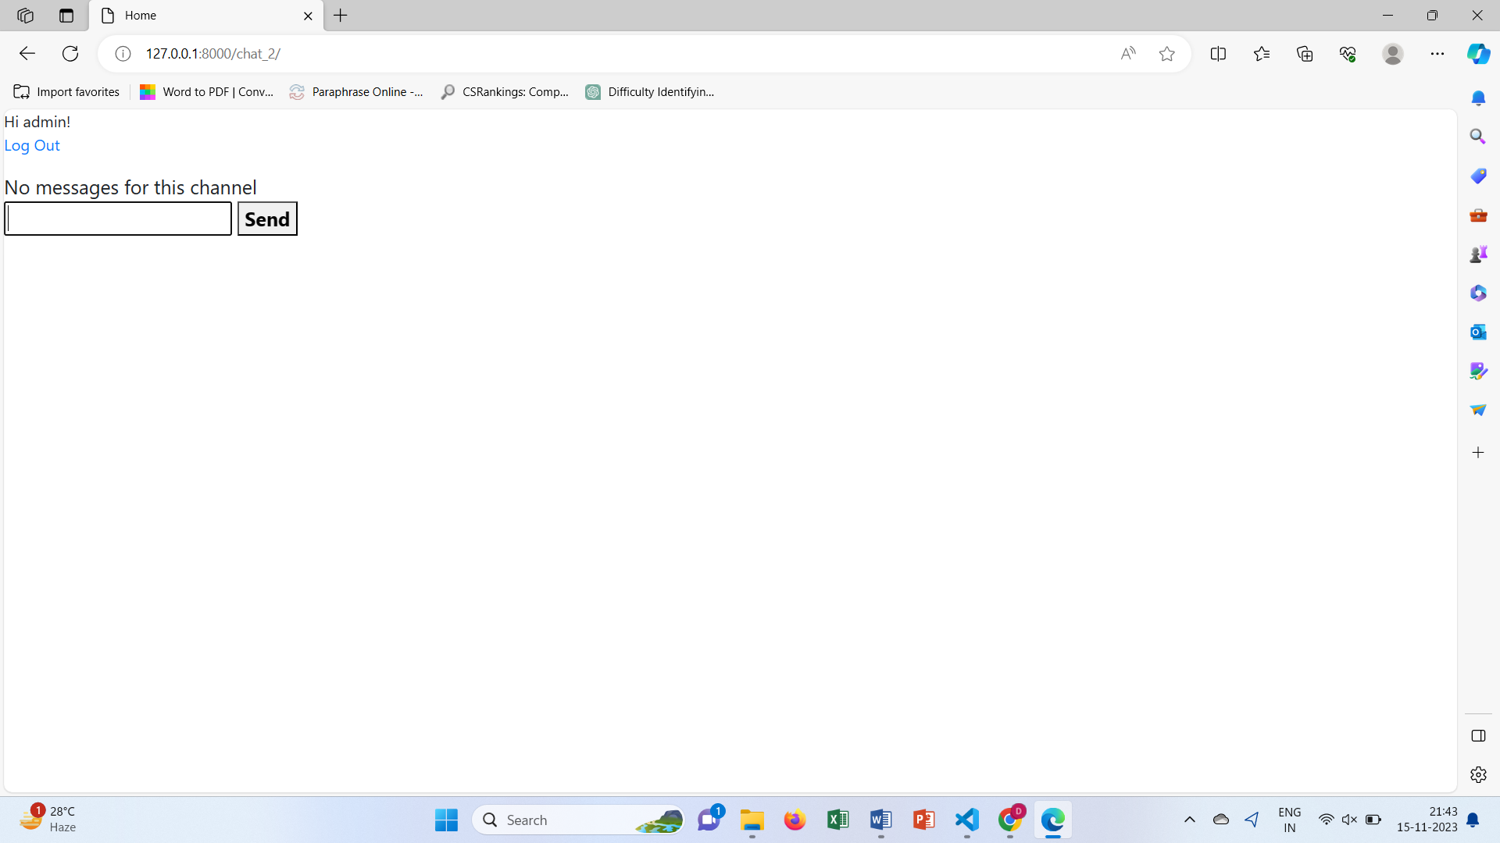

* Display of chatrooms:

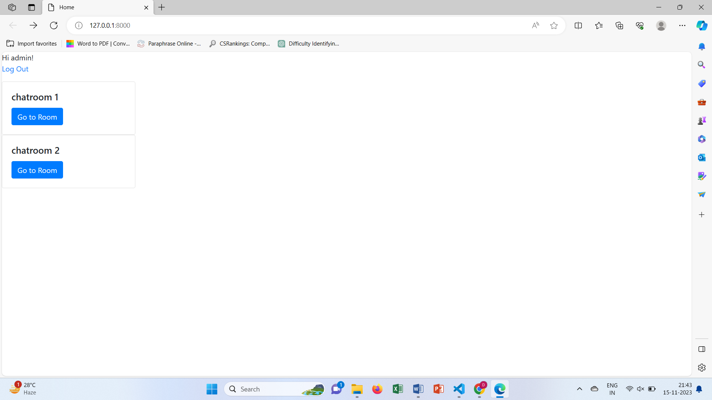

* Display of all messages sent between two users:

