**Instructions**

Run “Kovalchuk.WeatherChecker.py” to Run an application.

This app can help you to check some parameters of the weather in the Lviv.

Here are tasks, which this app can do:

0) Analyze json file structure and show data example.

1) Print value by specific key.

2) Print max value by key.

3) Print average value by key.

4) Print dates with given value by key.

5) Print dates with value bigger then given by key.

6) Calculate amount of each character in the results file, which you can recheck later.

Example of application in work:

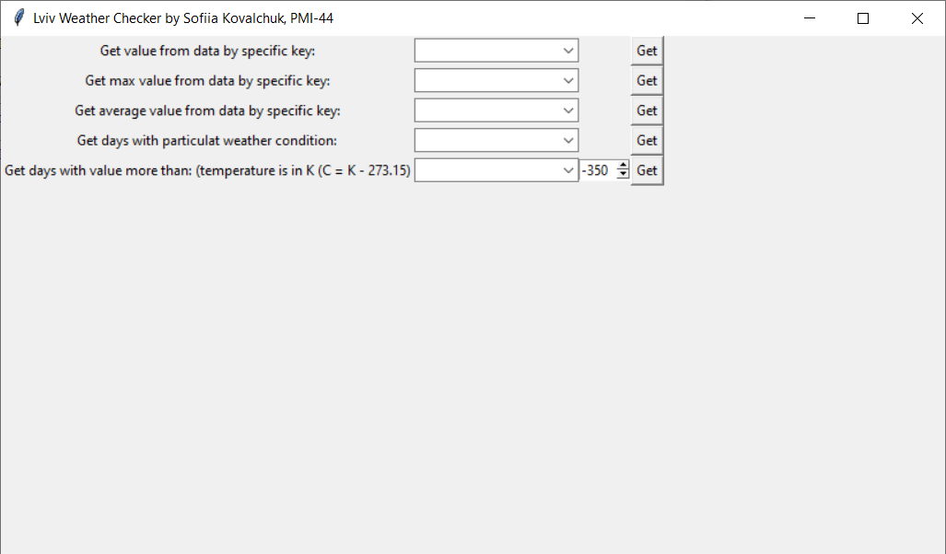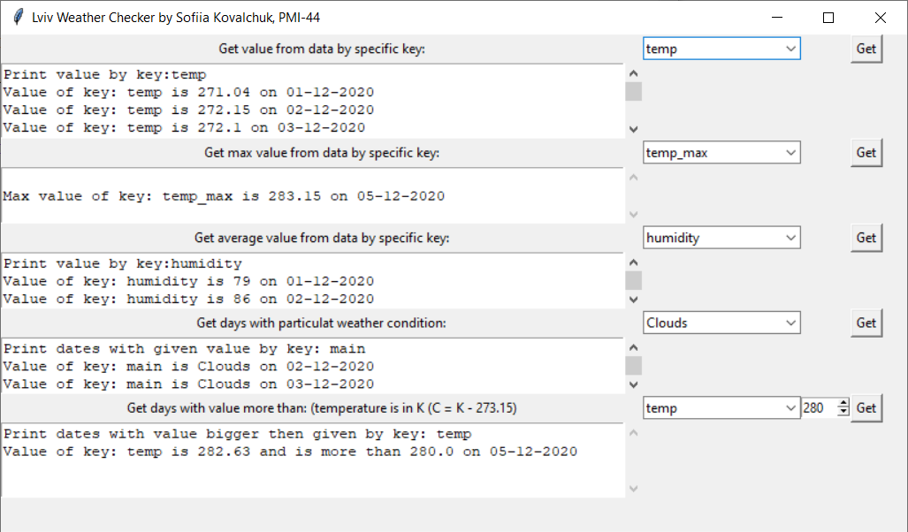

Weather API URL, which I used: <http://api.openweathermap.org/data/2.5/weather?q=Lviv&appid=1952efb4a7da640d955fd67682858a7f>

Programmed using Python Tkinter by Sofiia Kovalchuk, PMI-44 as last task of the course “Python Application Programming”.