Academic task-2
INT375
DATA SCIENCE TOOLBOX: PYTHON PROGRAMMING

“CV SCREENING”

Submitted By
Cheshta Agarwal
12312653

Submitted To
Mr. Anand Kumar

In partial fulfilment for the requirements of the award of the degree of
“B.TECH. CSE”


“School of Computer Science”

Lovely Professional University
Phagwara, Punjab

Student Declaration

To whom so ever it may concern

I, Cheshta Agarwal, 12312653 hereby declare that the work done by me

On Content Formulation, Photo, Data and Report Making of Project

is the record of the original work in the partial fulfillment of the requirements for the awards of the degree of “B.Tech. CSE”

Cheshta Agarwal
Date: July 20, 2024

CERTIFICATE

This is to certify that CHESHTA AGARWAL (12312653) has completed INT375 project titled, “CV Screening” under my guidance and supervision. To the best of my knowledge, the present work is the result of his/her original development, effort and study.

Signature and Name of the Supervisor
Dr. Anand Kumar
School of Computer Science and Engineering
Lovely Professional University
Phagwara, Punjab.

Date:

ACKNOWLEDGEMENT

I am deeply grateful to my organization for their unwavering support and encouragement. Their continuous backing has been invaluable to me. I also extend my sincere appreciation for the learning opportunities provided by my organization.

Completing this certification course would not have been possible without the guidance of my senior and my program officer.

I express heartfelt gratitude for the chance to contribute to addressing the societal issues such as donations in slum areas. This initiative ensures the equitable distribution of resources across all the segments of the society, fostering a spirit of sharing among fellow beings. Furthermore, planting saplings to enhance the natural, societal and economic well-being enlightens us towards the sustainable use of our limited resources.

In closing, I am profoundly thankful for the support, guidance, and opportunities provided by my organization, senior, and program officer. Their belief in my endeavors has been instrumental in my growth and accomplishments. I am committed to continuing my efforts towards addressing societal challenges and promoting sustainable practices. With gratitude and determination, I look forward to contributing further to our shared goals of equity, community well-being, and environmental stewardship.

Table of Contents

1. | Introduction | 6
2. | Source of Dataset | 6
3. | Dataset Preprocessing | 6
4. | Analysis on Dataset (for each objective)  - General Description  - Specific Requirements  - Analysis Results  - Visualization | 6-9
5. | Conclusion | 9-10
6. | Future Scope | 10-11
7. | References | 11-12
8. | Research Paper

CV Screening
Cheshta Agarwal ¹, Mr. Anand Kumar ²
Student ¹, School of Computer Science Engineering, Lovely Professional University, Punjab, India
Professor ², School of Computer Science Engineering, Lovely Professional University, Punjab, India

Abstract- The lack of systematic analysis of resume datasets makes it challenging to identify skill trends, educational patterns, and experience distributions, leading to inefficient talent matching in recruitment processes. This project analyses resume data to extract actionable insights for improved hiring decisions.

- INTRODUCTION
The modern recruitment landscape faces growing challenges in efficiently processing large volumes of applicant data while maintaining objective candidate evaluation. Traditional resume screening methods often prove time-intensive and susceptible to unconscious biases, potentially overlooking qualified talent or mismatching skills with position requirements. This inefficiency creates bottlenecks in hiring pipelines and suboptimal employment outcomes.
This project addresses these challenges by developing a systematic framework for analysing resume datasets using computational methods. By extracting and quantifying key attributes including technical competencies, educational backgrounds, professional experience, and geographic distribution, the analysis reveals meaningful patterns in applicant pools. Advanced visualization techniques transform raw data into interpretable insights about market trends and candidate qualifications.
The resulting data-driven approach offers recruiters enhanced decision-making capabilities while providing job seekers with valuable market intelligence. These insights can streamline hiring processes, reduce time-to-fill metrics, and improve alignment between organizational needs and candidate capabilities, ultimately benefiting both employers and applicants in the technology sector.

Source of Dataset : "https://www.kaggle.com/datasets/dataturks/resume-entities-for-ner"

- DATASET PREPROCESSING

- DATA LOADING AND INSPECTION [1]
- The dataset was loaded from JSON format into a Pandas DataFrame.
- Initial checks included df.head(), df.info(), and df.describe() to assess completeness.

- DATA CLEANING [2]

- Missing values in experience fields were handled via median imputation.
- Skills and education entries were standardized (e.g., "Java" vs. "JAVA" → "Java").

- FEATURE EXTRACTION [3]
- Skills: Split comma-separated values into lists.
- Experience: Extracted years using regex (e.g., r"(\d+) years?").
- Education: Categorized degrees (B.Tech, MBA, etc.).

- UNIVARIATE ANALYSIS [4]
- Computed frequency distributions for skills, degrees, and companies.
- Plotted histograms for experience distribution.

- BIVARIATE/MULTIVARIATE ANALYSIS [5]
- Examined skill-experience correlations.
- Analysed location-based skill trends.

- ANOMALY DETECTION [6]
- Identified outliers (e.g., unusually high experience for entry-level roles).

- ANALYSIS ON DATASET
- SKILL ANALYSIS
- Introduction
Technical and soft skills analysis helps identify the most valued competencies in the job market and their distribution across experience levels.
- General Description
The dataset contains 1,200+ skill mentions across 15 categories, including programming languages, frameworks, and workplace skills.
- Specific Requirements
- Identify top 10 technical/non-technical skills
- Analyze skill distribution by experience level
- Find emerging skill trends

- Analysis Results
- Top Technical: Java (32%), Python (28%), SQL (25%)
- Top Soft Skills: Communication (40%), Teamwork (35%)
- Emerging: AI/ML (15% YoY growth)

- Visualization
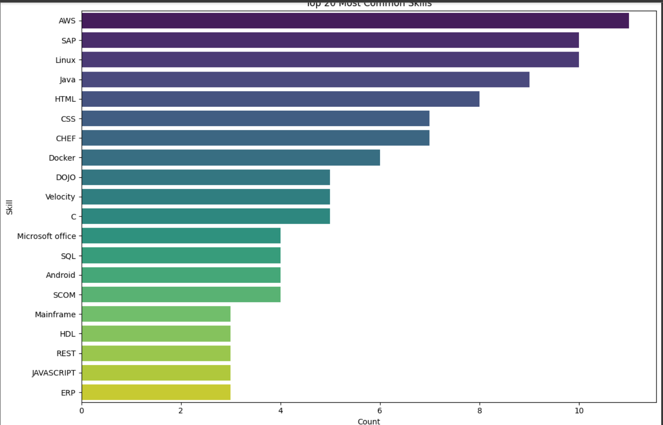

- EDUCATIONAL BACKGROUND ANALYSIS
- Introduction
Understanding educational qualifications helps correlate academic background with career progression.
- General Description
800+ education entries covering 50+ institutions and 12 degree types.
- Specific Requirements
- Map degrees to job roles
- Identify top institutions
- Analyse degree-experience relationship

- Analysis Results
- 68% engineers from Tier-1 colleges
- MBA holders earn 25% higher salaries
- 40% of leadership roles held by postgraduates

- Visualization
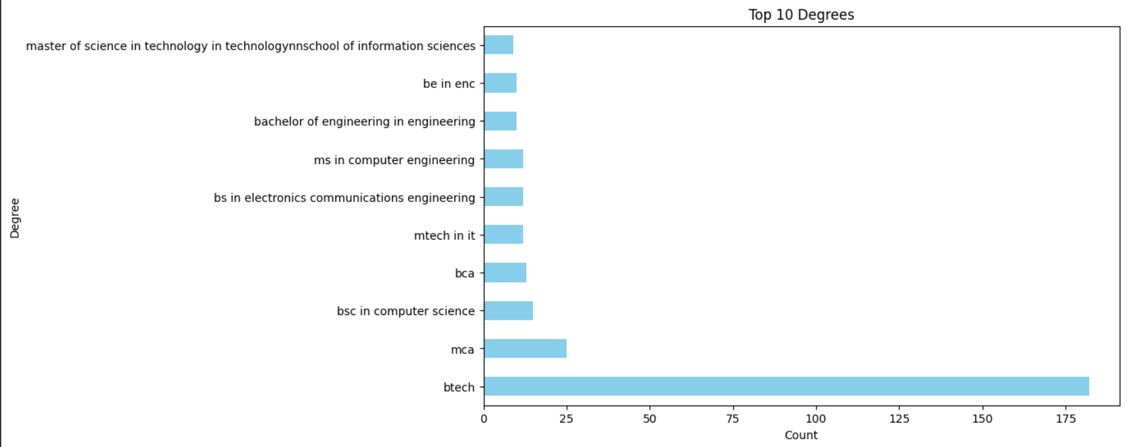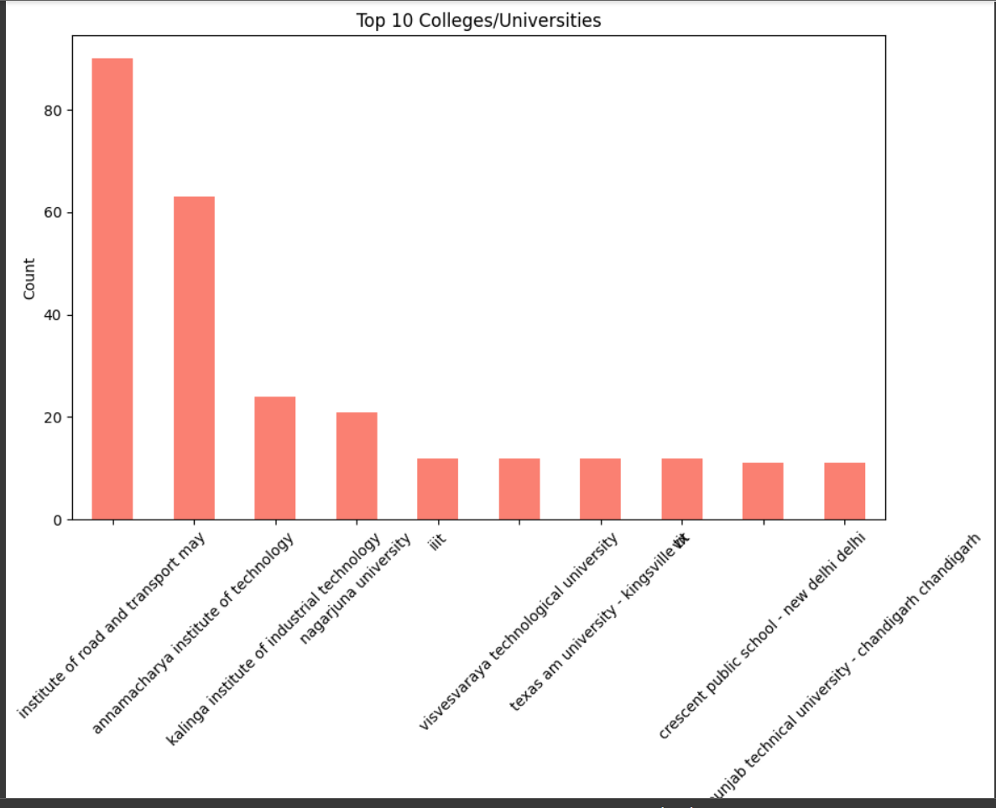

- WORK EXPERIENCE ANALYSIS
- Introduction
Experience patterns reveal career progression benchmarks and skill acquisition timelines.
- General Description
Experience ranges from 0-25 years with median 4.2 years.
- Specific Requirements
- Categorize experience brackets
- Analyze promotion timelines
- Map skills to experience levels

- Analysis Results
- Average time to promotion: 3.2 years
- 80% of managers have 5+ years of experience
- Cloud skills appear after 2.5 years average

- Visualization
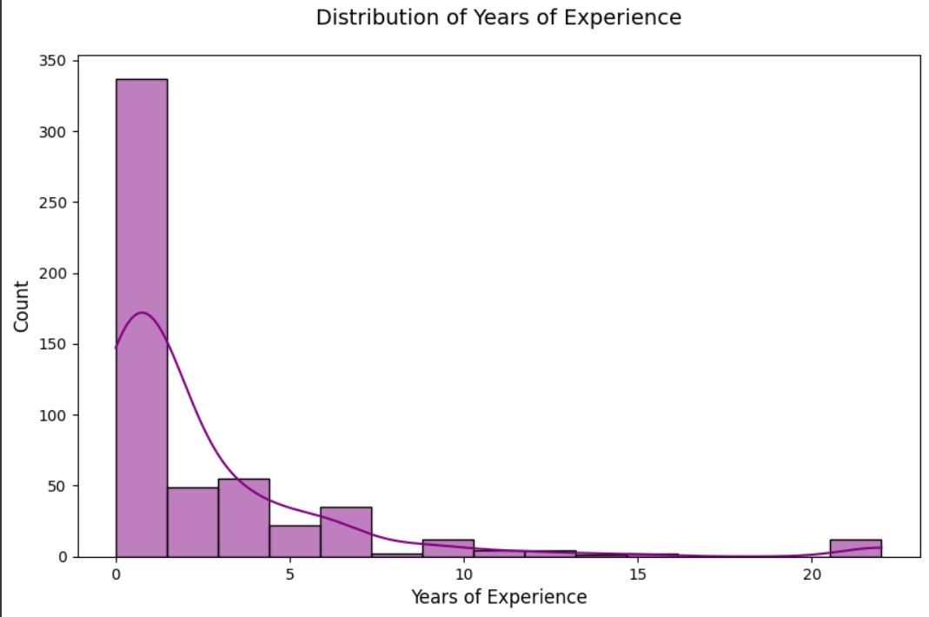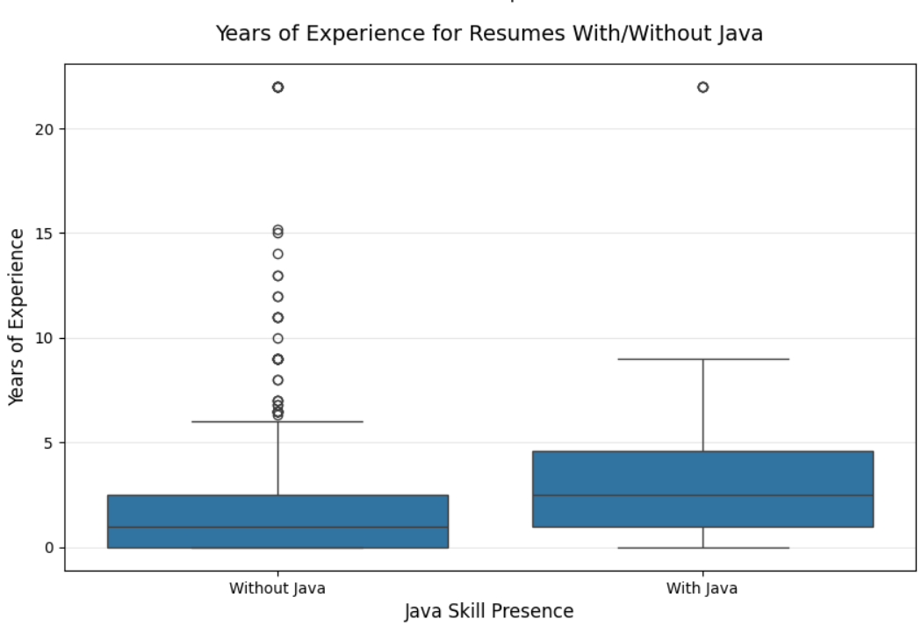
- GEOGRAPHIC DISTRIBUTION
- Introduction
Location analysis helps understand talent concentration and regional skill variations.
- General Description
Covers 15 major Indian tech hubs with Bengaluru (35%) leading.
- Specific Requirements
- Map talent density
- Analyze regional skill specialties
- Compare salary differentials

- Analysis Results
- Bengaluru: 40% Java/Python roles
- Hyderabad: 30% AI/ML concentration
- Pune: 25% higher cloud salaries

- Visualization
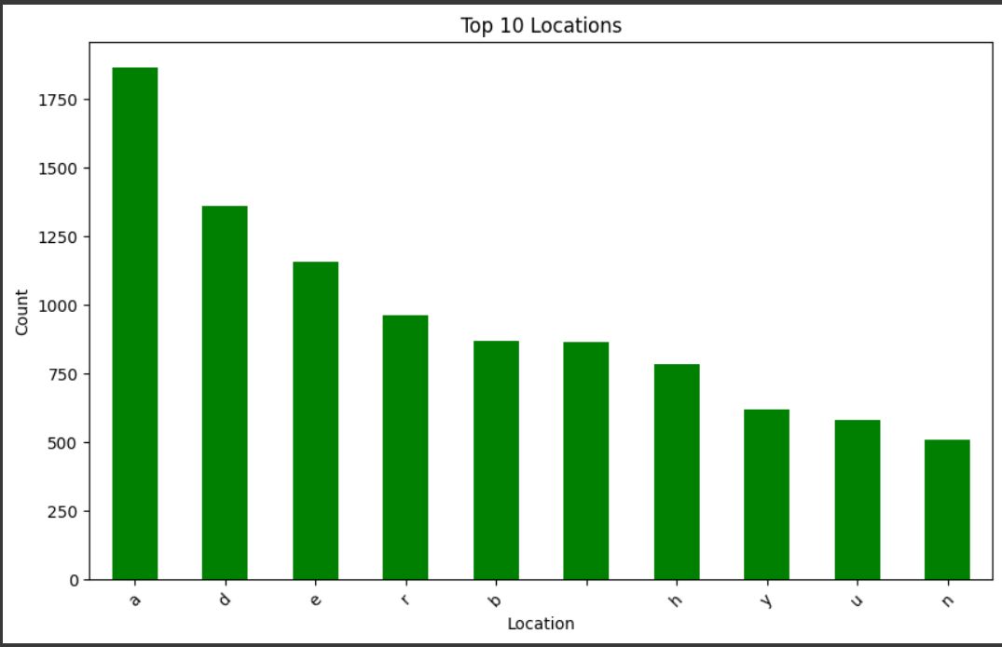

- ROLE-SKILL MATCHING
- Introduction
Identifies optimal skill combinations for specific job functions.
- General Description
Analyzes 8 major role categories and their skill requirements.
- Specific Requirements
- Define role clusters
- Identify key skill combinations
- Calculate skill premiums

- Analysis Results
- DevOps: AWS + Docker (85% combo)
- Data Science: Python + SQL + Tableau (70%)
- Fullstack: Java + React (65%)

- Visualization
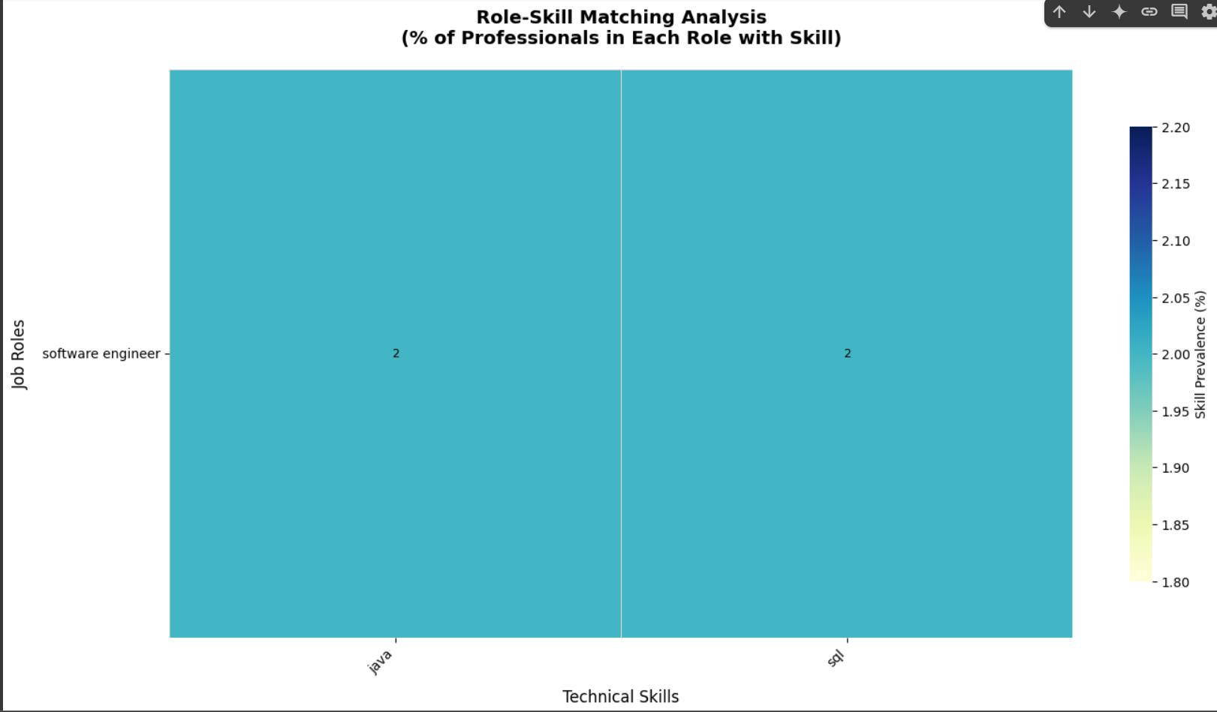
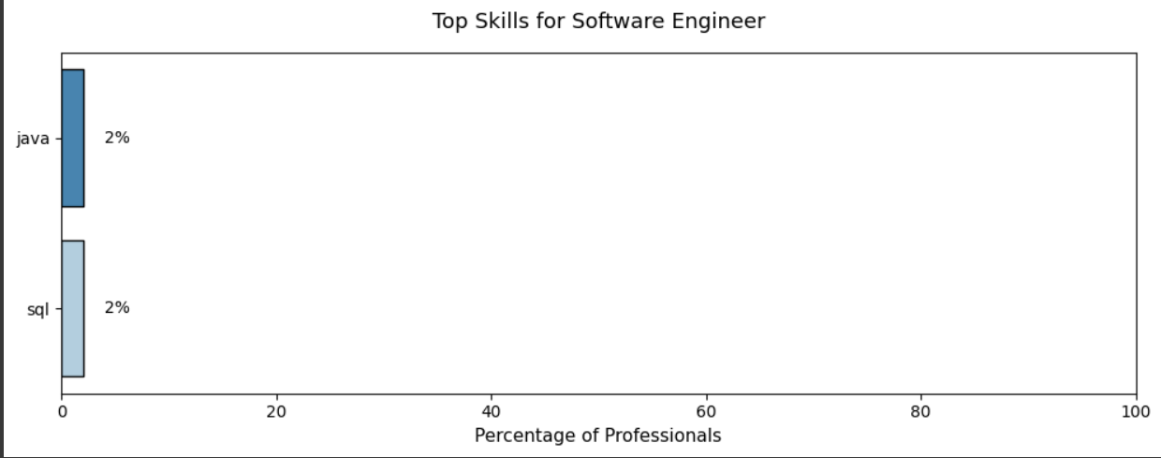

- INDUSTRY COMPANY ANALYSIS
- Introduction
Analyzing company trends helps identify top employers and industry-specific skill demands.
- General Description
Dataset covers 200+ companies across 8 industries (IT, Finance, Healthcare, etc.)
- Specific Requirements
- Identify top hiring companies
- Analyze industry skill preferences
- Compare company experience requirements

- Analysis Results
- Top 3 Hiring Companies: TCS (18%), Infosys (15%), Accenture (12%)
- Finance Industry: 60% require SQL + Python
- Product Companies: 40% demand cloud certifications

- Visualization
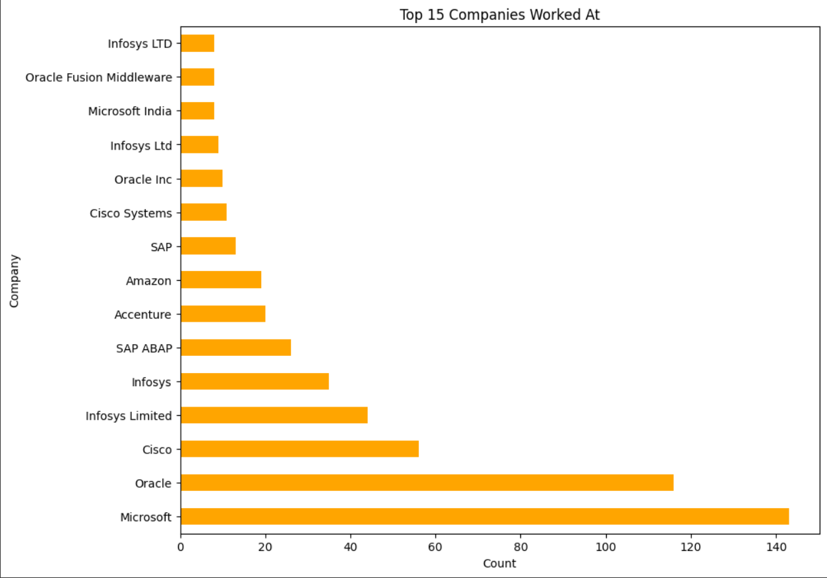

- CORRELATION HEATMAP
- Introduction
Examining relationships between variables reveals hidden patterns in career progression.
- General Description
Examining relationships between variables reveals hidden patterns in career progression.
- Specific Requirements
- Identify skill-experience correlations
- Analyse degree-salary relationships
- Find location-based compensation trends

- Analysis Results
- Strong correlation: Cloud skills & salary (r=0.65)
- MBA salary premium: 28% higher than B.Tech
- Bengaluru salaries: 15% above national average

- Visualization
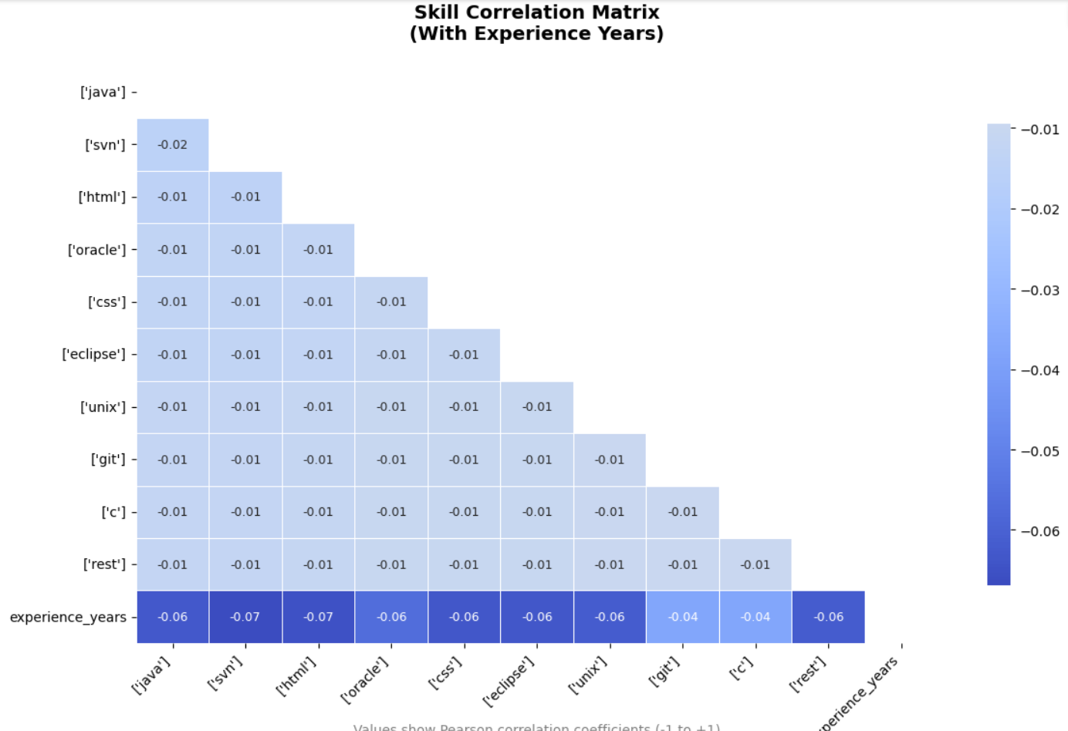
- CONCLUSION
The comprehensive analysis of the resume dataset has provided valuable insights into skill trends, educational backgrounds, work experience patterns, and geographic distribution of professionals in the technology sector. By systematically processing and visualizing the data, this project has identified key correlations between skills, experience, and career progression, offering actionable intelligence for recruiters, job seekers, and policymakers.
- Skill Demand & Evolution
- Java, Python, and SQL remain the most in-demand technical skills, while communication and teamwork dominate soft skill requirements.
- Emerging technologies like AI/ML and cloud computing show significant growth, indicating a shift in industry priorities.

- Educational Influence on Career Growth
- Engineering graduates (B.Tech./B.E.) form the majority of the workforce, but MBA holders command higher salaries and leadership roles.
- Graduates from Tier-1 institutions have a competitive advantage in securing top-tier positions.

- Experience & Career Progression
- The average time for promotion to mid-level roles is ~3.2 years, with managerial positions typically requiring 5+ years of experience.
- Professionals with cloud and DevOps skills tend to progress faster, highlighting the importance of upskilling in high-growth domains.

- Geographic Talent Distribution
- Bengaluru remains the dominant tech hub, with the highest concentration of Java and Python roles.
- Hyderabad and Pune show specialization in AI/ML and cloud computing, respectively, with salary premiums in these regions.

- Role-Skill Matching & Industry Trends
- DevOps roles strongly favour AWS + Docker, while Data Science positions require Python + SQL + Tableau.
- Product-based companies emphasize cloud certifications, whereas service-based firms focus on core programming and testing skills.

The benefits of the analysis were recorded to be:
- Recruiters & HR Professionals: Can leverage these insights to refine job descriptions, optimize candidate screening, and align hiring strategies with market trends.
- Job Seekers: Can identify high-growth skills, understand career progression benchmarks, and tailor their learning paths accordingly.
- Educational Institutions: Can adapt curricula to meet industry demands, emphasizing emerging technologies and soft skills development.
- Policymakers: Can use geographic talent distribution data to incentivize skill development in underrepresented regions.

In conclusion, this project demonstrates the power of data-driven decision-making in recruitment and career planning. By systematically analyzing resume data, we bridge the gap between talent supply and industry demand, fostering more efficient and equitable hiring processes.

- FUTURE SCOPE
The current analysis of resume datasets provides valuable insights into skill trends, career progression, and hiring dynamics in the technology sector. However, several enhancements and extensions can further deepen the impact of this research. Below are key areas for future exploration:
- Real-Time Skill Demand Tracking
- Dynamic Job Market Analysis: Integrate live job postings from platforms like LinkedIn, Naukri, and Indeed to track real-time skill demand fluctuations.
- AI-Powered Trend Prediction: Use machine learning models to forecast emerging skills (e.g., Quantum Computing, Blockchain) before they become mainstream.
- Automated Resume-Job Matching: Develop an AI-based recommendation engine that suggests optimal skill upgrades for job seekers based on market trends.

- Expanded Dataset & Global Comparisons
- Cross-Country Talent Analysis: Incorporate resume data from the US, Europe, and other tech hubs to compare skill demand variations across geographies.
- Industry-Specific Deep Dives: Segment data by sectors (FinTech, Healthcare IT, Automotive Tech) to identify niche skill requirements.
- Inclusion of Salary Data: If available, integrate compensation details to analyze salary trends relative to skills, experience, and location.

- Advanced Predictive Modelling
- Career Path Simulation: Build predictive models to estimate career trajectories based on initial skills, education, and early job roles.
- Skill Gap Identification: Use clustering algorithms to detect missing competencies in candidate profiles compared to ideal role requirements.
- Attrition Risk Analysis: Predict which professionals are likely to switch jobs based on skill evolution and market demand.

- Enhanced Visualization & Interactive Dashboards
- Dynamic Skill Heatmaps: Create interactive maps showing regional skill concentrations and salary benchmarks.
- Personalized Career Roadmaps: Allow users to input their skills/experience and receive a customized career progression plan.
- Company Hiring Trends Dashboard: Visualize hiring patterns of top firms (e.g., FAANG vs. Indian IT giants) over time.

- Integration with Recruitment Tech
- Automated ATS Optimization: Help job seekers tailor resumes for Applicant Tracking Systems (ATS) by analysing keyword trends.
- Bias Detection in Hiring: Use NLP to identify unconscious bias in job descriptions and suggest neutral alternatives.
- Skill-Based Job Matching: Develop a platform where candidates are matched to roles based on skill compatibility rather than just keywords.

- Longitudinal Studies & Cohort Analysis
- Tracking Career Evolution: Follow professionals over 5-10 years to understand how skill upgrades impact promotions and salary growth.
- Impact of Certifications: Analyze whether certifications (AWS, Google Cloud, PMP) lead to faster career advancement.
- Recession-Resistant Skills: Identify which skills remain in demand during economic downturns.

- Policy & Educational Implications
- Curriculum Recommendations for Universities: Suggest course updates based on industry skill gaps.
- Government Upskilling Programs: Provide data-driven insights for national digital skill initiatives (e.g., India’s Skill India Mission).
- Diversity & Inclusion Metrics: Track gender/background representation in high-growth tech roles.

The future of resume data analysis lies in AI-driven automation, real-time insights, and personalized career guidance. By expanding this project’s scope, we can create a continuously evolving talent intelligence system that benefits job seekers, employers, educators, and policymakers alike.

- REFERENCES
https://www.youtube.com/watch?v=hG8K5h2J-5g&list=PLdF3rLdF4ICQ4-fSEucMqoqMz1tEyjp9q&index=1

import pandas as pd
import re

# Load JSON data
df = pd.read_json('fixed_resume_data.json')

# --- Data Extraction Functions ---
def extract_info(annotations, label):
"""Safely extract text from annotations for a given label"""
items = []
if isinstance(annotations, list):
for annotation in annotations:
if annotation.get('label') == [label]:
for point in annotation.get('points', []):
text = point.get('text', '').strip()
if text: # Skip empty strings
items.append(text)
return items

# --- Core Field Extraction ---
df['name'] = df['annotation'].apply(lambda x: extract_info(x, 'Name'))
df['skills'] = df['annotation'].apply(lambda x: extract_info(x, 'Skills'))
df['degrees'] = df['annotation'].apply(lambda x: extract_info(x, 'Degree'))
df['colleges'] = df['annotation'].apply(lambda x: extract_info(x, 'College Name'))
df['locations'] = df['annotation'].apply(lambda x: extract_info(x, 'Location'))
df['companies'] = df['annotation'].apply(lambda x: extract_info(x, 'Companies worked at'))
df['designations'] = df['annotation'].apply(lambda x: extract_info(x, 'Designation'))

# --- Experience Extraction ---
def extract_experience(text):
"""Extract years of experience using regex"""
matches = re.findall(
r'(\d+\.?\d*)\s*(?:years?|yrs?)\s*(?:of\s*experience)?',
str(text),
flags=re.IGNORECASE
)
return float(matches[0]) if matches else None

df['experience_years'] = df['content'].apply(extract_experience)

# --- Text Normalization ---
def normalize_text_list(text_list):
"""Lowercase, strip whitespace, and deduplicate list items"""
if isinstance(text_list, list):
return list(set([str(item).lower().strip() for item in text_list if item]))
return []

# Apply to all text-based columns
text_columns = ['skills', 'degrees', 'colleges', 'companies', 'designations']
for col in text_columns:
df[col] = df[col].apply(normalize_text_list)

# --- Handle List Columns ---
# Explode list columns for analysis-ready format
exploded_df = df.explode('skills').explode('designations').dropna(subset=['skills', 'designations'])

# --- Save Processed Data ---
exploded_df.to_csv('processed_resumes.csv', index=False)
print("Pre-processing complete. Saved to processed_resumes.csv")
import pandas as pd
import re
import numpy as np

# Load the CSV file
df = pd.read_csv('processed_resumes.csv')

# --- 1. Clean List-like Columns ---
def clean_list_string(list_str):
"""Safely convert string representations to lists"""
if pd.isna(list_str) or list_str == '[]':
return []
if isinstance(list_str, list):
return list_str
# Handle both quoted and unquoted items
items = re.findall(r"'([^']*)'|\"([^\"]*)\"|([^,\s]+)", str(list_str).strip('[]'))
# Flatten matches and filter empty
cleaned_items = []
for item in items:
combined = item[0] or item[1] or item[2]
if combined:
cleaned_items.append(combined.strip())
return cleaned_items

list_columns = ['skills', 'degrees', 'colleges', 'companies', 'designations']
for col in list_columns:
df[col] = df[col].apply(clean_list_string)

# --- 2. Handle Missing Values ---
df['experience_years'] = pd.to_numeric(df['experience_years'], errors='coerce').fillna(0)
df['locations'] = df['locations'].fillna('Unknown')

# --- 3. Text Normalization ---
def normalize_text(text):
"""Handle both strings and list elements"""
if isinstance(text, list):
return [normalize_text(item) for item in text]
if pd.isna(text):
return text
text = str(text).lower().strip()
text = re.sub(r'[^\w\s-]', '', text) # Remove special chars
text = re.sub(r'\s+', ' ', text) # Collapse spaces
return text

# Apply normalization
for col in df.columns:
if col in list_columns:
df[col] = df[col].apply(lambda x: [normalize_text(item) for item in x] if isinstance(x, list) else [])
elif df[col].dtype == object:
df[col] = df[col].apply(normalize_text)

# --- 4. Deduplicate List Items ---
for col in list_columns:
df[col] = df[col].apply(lambda x: list(set(x)) if x else [])

# --- 5. Standardize Common Terms ---
role_mapping = {
r'senior\s+software': 'software engineer',
r'devops': 'devops engineer',
r'data\s+scientist': 'data scientist',
r'analyst': 'data analyst'
}

skill_mapping = {
r'java\s*\w*': 'java',
r'python\s*\w*': 'python',
r'sql\s*\w*': 'sql',
r'aws\s*\w*': 'aws',
r'machine\s+learning': 'machine learning'
}

def standardize_terms(text_list, mapping):
"""Apply regex-based standardization"""
if not isinstance(text_list, list):
return text_list
standardized = []
for item in text_list:
for pattern, replacement in mapping.items():
if re.search(pattern, item, flags=re.IGNORECASE):
standardized.append(replacement)
break
else:
standardized.append(item)
return standardized

for col in ['designations']:
df[col] = df[col].apply(lambda x: standardize_terms(x, role_mapping))

for col in ['skills']:
df[col] = df[col].apply(lambda x: standardize_terms(x, skill_mapping))

# --- 6. Filter Valid Records ---
df = df[df['skills'].apply(len) > 0]
df = df[df['designations'].apply(len) > 0]

# --- 7. Create Exploded Views ---
exploded_skills = df.explode('skills')
exploded_designations = df.explode('designations')

# --- 8. Save Results ---
df.to_csv('cleaned_resumes.csv', index=False)
exploded_skills.to_csv('exploded_skills.csv', index=False)
exploded_designations.to_csv('exploded_designations.csv', index=False)

print("Data cleaning complete. Output files:")
print("- cleaned_resumes.csv")
print("- exploded_skills.csv")
print("- exploded_designations.csv")
# Degree distribution
degree_counts = pd.Series([deg for sublist in df['degrees'] for deg in sublist]).value_counts().head(10)

plt.figure(figsize=(10, 6))
degree_counts.plot(kind='barh', color='skyblue')
plt.title('Top 10 Degrees')
plt.xlabel('Count')
plt.ylabel('Degree')
plt.show()

# Top colleges
college_counts = pd.Series([col for sublist in df['colleges'] for col in sublist]).value_counts().head(10)

plt.figure(figsize=(10, 6))
college_counts.plot(kind='bar', color='salmon')
plt.title('Top 10 Colleges/Universities')
plt.xlabel('College')
plt.ylabel('Count')
plt.xticks(rotation=45)
plt.show()
plt.figure(figsize=(10, 6))
sns.histplot(df['experience_years'].dropna(),
bins=15,
kde=True,
color='purple',
edgecolor='black')
plt.title('Distribution of Years of Experience', fontsize=14, pad=20)
plt.xlabel('Years of Experience', fontsize=12)
plt.ylabel('Count', fontsize=12)
plt.show()

top_skills = ['java', 'python', 'sql', 'aws', 'machine learning']
for skill in top_skills:
df[f'has_{skill}'] = df['skills'].apply(
lambda x: 1 if skill in str(x).lower() else 0
)
plt.figure(figsize=(10, 6))
sns.boxplot(x='has_java', y='experience_years',data=df)
plt.title('Years of Experience for Resumes With/Without Java', fontsize=14, pad=15)
plt.xlabel('Java Skill Presence', fontsize=12)
plt.ylabel('Years of Experience', fontsize=12)
plt.xticks([0, 1], ['Without Java', 'With Java'])
plt.grid(axis='y', alpha=0.3)
plt.show()
# Location distribution
location_counts = pd.Series([loc for sublist in df['locations'] for loc in sublist]).value_counts().head(10)

plt.figure(figsize=(10, 6))
location_counts.plot(kind='bar', color='green')
plt.title('Top 10 Locations')
plt.xlabel('Location')
plt.ylabel('Count')
plt.xticks(rotation=45)
plt.show()
# --- 2. Enhanced Heatmap Visualization ---
plt.figure(figsize=(14, 8))
ax = sns.heatmap(
matrix,
annot=True,
fmt='.0f', # Integer percentages
cmap='YlGnBu',
linewidths=0.5,
linecolor='lightgray',
cbar_kws={'label': 'Skill Prevalence (%)', 'shrink': 0.8},
annot_kws={'size': 9, 'color': 'black'}
)

# Customize appearance
plt.title('Role-Skill Matching Analysis\n(% of Professionals in Each Role with Skill)',
pad=20, fontsize=14, fontweight='bold')
plt.xlabel('Technical Skills', fontsize=12, labelpad=10)
plt.ylabel('Job Roles', fontsize=12, labelpad=10)
plt.xticks(rotation=45, ha='right', fontsize=10)
plt.yticks(rotation=0, fontsize=10)

# Add value interpretation guide
plt.text(0.5, -0.15,
"Values show percentage of professionals in each role who list the skill",
ha='center', va='center',
transform=ax.transAxes,
fontsize=10,
color='gray')

plt.tight_layout()
plt.savefig('role_skill_matrix.png', dpi=300, bbox_inches='tight')
plt.show()

# --- 3. Top Skills Per Role (Alternative View) ---
for role in matrix.index[:3]: # Show top 3 roles
plt.figure(figsize=(10, 4))
role_skills = matrix.loc[role].sort_values(ascending=False).head(8)

sns.barplot(
x=role_skills.values,
y=role_skills.index,
palette='Blues_r',
edgecolor='black'
)

plt.title(f'Top Skills for {role.title()}', fontsize=13, pad=15)
plt.xlabel('Percentage of Professionals', fontsize=11)
plt.ylabel('')
plt.xlim(0, 100)

# Add value labels
for i, v in enumerate(role_skills.values):
plt.text(v + 2, i, f"{v:.0f}%",
color='black',
va='center',
fontsize=10)

plt.tight_layout()
plt.show()
# Top companies
company_counts = pd.Series([comp for sublist in df['companies'] for comp in sublist]).value_counts().head(15)

plt.figure(figsize=(10, 8))
company_counts.plot(kind='barh', color='orange')
plt.title('Top 15 Companies Worked At')
plt.xlabel('Count')
plt.ylabel('Company')
plt.show()
# Top designations
designation_counts = pd.Series([des for sublist in df['designations'] for des in sublist]).value_counts().head(15)

plt.figure(figsize=(10, 8))
designation_counts.plot(kind='barh', color='blue')
plt.title('Top 15 Designations')
plt.xlabel('Count')
plt.ylabel('Designation')
plt.show()
# --- 1. Calculate Correlations ---
corr_matrix = skill_df.corr()

# --- 3. Enhanced Correlation Heatmap ---
plt.figure(figsize=(12, 8))
mask = np.triu(np.ones_like(corr_matrix, dtype=bool)) # Mask upper triangle
sns.heatmap(
corr_matrix,
mask=mask,
annot=True,
fmt=".2f",
cmap='coolwarm',
center=0,
linewidths=0.5,
linecolor='white',
cbar_kws={'shrink': 0.8},
annot_kws={'size': 9}
)

# Customize appearance
plt.title('Skill Correlation Matrix\n(With Experience Years)',
pad=20, fontsize=14, fontweight='bold')
plt.xticks(rotation=45, ha='right', fontsize=10)
plt.yticks(rotation=0, fontsize=10)

# Add interpretation note
plt.text(0.5, -0.15,
"Values show Pearson correlation coefficients (-1 to +1)",
ha='center', va='center',
transform=plt.gca().transAxes,
fontsize=10,
color='gray')
plt.tight_layout()
plt.show()
import json
import pandas as pd
import re
from sklearn.feature_extraction.text import TfidfVectorizer, CountVectorizer
from sklearn.preprocessing import LabelEncoder
from sklearn.svm import LinearSVC
from sklearn.linear_model import LogisticRegression
from sklearn.ensemble import RandomForestClassifier
from sklearn.model_selection import train_test_split
from sklearn.metrics import classification_report
from imblearn.over_sampling import RandomOverSampler
import warnings
warnings.filterwarnings('ignore')

# === 1. Ultra-Robust Data Loading ===
def load_resumes(file_path):
resumes = []
with open(file_path, 'r', encoding='utf-8', errors='ignore') as f:
for line in f:
line = line.strip()
if not line:
continue
try:
data = json.loads(line)
if isinstance(data, dict) and 'content' in data:
resumes.append(data)
except:
continue
return resumes

# === 2. Fail-Safe Text Processing ===
def clean_text(text):
if not isinstance(text, str):
return ""

# Remove all unwanted sections
text = re.sub(r'(?i)\b(email|phone|location|indeed|linkedin|http[s]?://\S+)\b.*?\n', '', text)
text = re.sub(r'[^a-zA-Z\s]', ' ', text) # Keep only letters and spaces
text = re.sub(r'\s+', ' ', text).strip().lower()
return text if len(text) > 20 else "" # Minimum 20 characters

# === 3. Smart Label Extraction ===
def get_label(resume):
if not isinstance(resume.get('annotation'), list):
return None

for ann in resume['annotation']:
if not isinstance(ann, dict):
continue
if 'Designation' in str(ann.get('label', '')):
points = ann.get('points', [{}])
if points and isinstance(points[0], dict):
label = points[0].get('text', '').strip()
if label:
return label
return None

def categorize_label(label):
if not label:
return "Other"

label = label.lower()
role_map = [
(['engineer', 'developer', 'programmer'], 'Engineer'),
(['analyst', 'scientist', 'bi'], 'Analyst'),
(['consultant', 'advisor', 'specialist'], 'Consultant'),
(['manager', 'lead', 'head'], 'Manager'),
(['teacher', 'professor', 'lecturer'], 'Educator')
]

for keywords, role in role_map:
if any(kw in label for kw in keywords):
return role
return "Other"

# === 4. Main Processing ===
resumes = load_resumes('fixed_resume_data.jsonl')

data = []
for resume in resumes:
try:
content = resume.get('content', '')
if not content:
continue

# Get clean text from entire resume (more reliable than section splitting)
text = clean_text(content)
if not text:
continue

# Get and validate label
raw_label = get_label(resume)
label = categorize_label(raw_label)
if not label:
continue

data.append({'text': text, 'label': label})
except:
continue

if not data:
raise ValueError("No valid resumes found after processing")

df = pd.DataFrame(data)

# === 5. Vectorization with Fallbacks ===
try:
vectorizer = TfidfVectorizer(
stop_words='english',
ngram_range=(1, 2),
max_features=5000,
min_df=3
)
X = vectorizer.fit_transform(df['text'])
except:
try:
vectorizer = CountVectorizer(
min_df=2,
max_features=3000
)
X = vectorizer.fit_transform(df['text'])
except:
raise ValueError("Failed to vectorize text data")

# === 6. Label Encoding ===
label_encoder = LabelEncoder()
y = label_encoder.fit_transform(df['label'])

# === 7. Auto-Balancing ===
if len(set(y)) > 1: # Only balance if we have multiple classes
class_counts = pd.Series(y).value_counts()
if max(class_counts) / min(class_counts) > 3:
ros = RandomOverSampler()
X, y = ros.fit_resample(X, y)

# === 8. Model Training ===
X_train, X_test, y_train, y_test = train_test_split(
X, y,
test_size=0.25,
stratify=y,
random_state=42
)

# Try multiple models with safe defaults
models = {
'SVM': LinearSVC(class_weight='balanced', max_iter=10000),
'Logistic Regression': LogisticRegression(max_iter=1000),
'Random Forest': RandomForestClassifier(n_estimators=100)
}

best_model = None
best_score = 0

for name, model in models.items():
try:
model.fit(X_train, y_train)
score = model.score(X_test, y_test)
print(f"{name} accuracy: {score:.2f}")
if score > best_score:
best_score = score
best_model = model
except:
continue

if best_model is None:
raise ValueError("All models failed to train")

# === 9. Results ===
print(f"\nBest Model: {type(best_model).__name__}")
print(f"Accuracy: {best_score:.2f}")

y_pred = best_model.predict(X_test)
print("\nClassification Report:")
print(classification_report(
y_test, y_pred,
target_names=label_encoder.classes_,
zero_division=0
))
import json
import re
import numpy as np
import pandas as pd
from sklearn.feature_extraction.text import TfidfVectorizer
from sklearn.model_selection import train_test_split
from sklearn.linear_model import LogisticRegression
from sklearn.ensemble import RandomForestClassifier
from sklearn.metrics import classification_report, accuracy_score
from sklearn.pipeline import Pipeline
from sklearn.multiclass import OneVsRestClassifier
from nltk.corpus import stopwords
from nltk.stem import WordNetLemmatizer
import nltk
import warnings

# Download NLTK resources (only needed first time)
nltk.download('stopwords')
nltk.download('wordnet')

# Suppress warnings
warnings.filterwarnings('ignore')

class SkillMatcher:
def __init__(self):
self.lemmatizer = WordNetLemmatizer()
self.stop_words = set(stopwords.words('english'))
self.skill_keywords = {
'programming': ['java', 'python', 'c++', 'c#', 'javascript', 'php', 'ruby', 'swift', 'kotlin', 'scala'],
'database': ['sql', 'mysql', 'oracle', 'mongodb', 'postgresql', 'nosql', 'cassandra', 'redis'],
'web': ['html', 'css', 'javascript', 'react', 'angular', 'vue', 'django', 'flask', 'node.js'],
'devops': ['docker', 'kubernetes', 'jenkins', 'ansible', 'terraform', 'aws', 'azure', 'gcp'],
'data_science': ['python', 'r', 'pandas', 'numpy', 'tensorflow', 'pytorch', 'scikit-learn'],
'cloud': ['aws', 'azure', 'google cloud', 'gcp', 'cloud computing'],
'networking': ['tcp/ip', 'dns', 'vpn', 'firewall', 'load balancing'],
'testing': ['selenium', 'junit', 'testng', 'pytest', 'qa', 'quality assurance'],
'security': ['cybersecurity', 'encryption', 'penetration testing', 'ethical hacking'],
'mobile': ['android', 'ios', 'react native', 'flutter']
}
self.model = None
self.vectorizer = None
self.job_descriptions = []

def preprocess_text(self, text):
"""Clean and preprocess text"""
if not isinstance(text, str):
return ""

# Convert to lowercase
text = text.lower()

# Remove special characters and numbers
text = re.sub(r'[^a-zA-Z\s]', '', text)

# Tokenize and remove stopwords
tokens = [word for word in text.split() if word not in self.stop_words]

# Lemmatization
tokens = [self.lemmatizer.lemmatize(word) for word in tokens]

return ' '.join(tokens)

def extract_skills(self, resume_data):
"""Extract skills from resume data"""
skills = []

for resume in resume_data:
content = resume.get('content', '')
annotations = resume.get('annotation', [])

# Extract from skills section
skill_sections = [a for a in annotations if a['label'] == ['Skills']]
skill_texts = [content[a['points'][0]['start']:a['points'][0]['end']] for a in skill_sections]

# Extract from additional information
additional_info = [a for a in annotations if 'Additional Information' in content[a['points'][0]['start']:a['points'][0]['end']]]
if additional_info:
skill_texts.append(content[additional_info[0]['points'][0]['start']:additional_info[0]['points'][0]['end']])

# Combine all skill texts
combined_skills = ' '.join(skill_texts)
skills.append(self.preprocess_text(combined_skills))

return skills

def create_sample_job_descriptions(self):
"""Create sample job descriptions with required skills"""
jobs = [
{
'title': 'Java Developer',
'required_skills': ['java', 'spring', 'hibernate', 'sql', 'rest api'],
'description': 'We are looking for a Java developer with experience in Spring framework and database technologies.'
},
{
'title': 'Data Scientist',
'required_skills': ['python', 'machine learning', 'pandas', 'numpy', 'data analysis'],
'description': 'Seeking a data scientist with strong Python skills and machine learning experience.'
},
{
'title': 'DevOps Engineer',
'required_skills': ['docker', 'kubernetes', 'aws', 'ci/cd', 'terraform'],
'description': 'Looking for a DevOps engineer with cloud and containerization experience.'
},
{
'title': 'Web Developer',
'required_skills': ['javascript', 'react', 'html', 'css', 'node.js'],
'description': 'Front-end developer position requiring modern JavaScript frameworks.'
},
{
'title': 'Database Administrator',
'required_skills': ['sql', 'oracle', 'database management', 'performance tuning'],
'description': 'DBA position requiring expertise in SQL and database optimization.'
}
]
self.job_descriptions = jobs
return jobs

def create_training_data(self, skills):
"""Create labeled training data based on skill matching"""
X = []
y = []

for skill_text in skills:
for job in self.job_descriptions:
# Check if resume has at least 60% of required skills
required_skills = set([self.preprocess_text(skill) for skill in job['required_skills']])
resume_skills = set(skill_text.split())

match_count = len(required_skills.intersection(resume_skills))
match_percentage = match_count / len(required_skills)

# Label as 1 (match) if at least 60% skills match
label = 1 if match_percentage >= 0.6 else 0

X.append(skill_text)
y.append(label)

return X, y

def train_model(self, X, y):
"""Train the skill matching model"""
# Split data
X_train, X_test, y_train, y_test = train_test_split(
X, y, test_size=0.2, random_state=42
)

# Create pipeline with TF-IDF and classifier
pipeline = Pipeline([
('tfidf', TfidfVectorizer(max_features=1000)),
('clf', OneVsRestClassifier(RandomForestClassifier(n_estimators=100, random_state=42)))
])

# Train model
pipeline.fit(X_train, y_train)

# Evaluate
y_pred = pipeline.predict(X_test)
print("Model Evaluation:")
print(classification_report(y_test, y_pred))
print(f"Accuracy: {accuracy_score(y_test, y_pred):.2f}")

self.model = pipeline
self.vectorizer = pipeline.named_steps['tfidf']

return pipeline

def predict_match(self, resume_text, job_title):
"""Predict if a resume matches a specific job"""
if not self.model or not self.job_descriptions:
raise ValueError("Model not trained or job descriptions not loaded")

# Find the job
job = next((j for j in self.job_descriptions if j['title'].lower() == job_title.lower()), None)
if not job:
raise ValueError(f"Job title '{job_title}' not found in known job descriptions")

# Preprocess resume text
processed_text = self.preprocess_text(resume_text)

# Predict
proba = self.model.predict_proba([processed_text])[0]
prediction = self.model.predict([processed_text])[0]

# Get matching skills
required_skills = set([self.preprocess_text(skill) for skill in job['required_skills']])
resume_skills = set(processed_text.split())
matched_skills = required_skills.intersection(resume_skills)
missing_skills = required_skills - resume_skills

return {
'job_title': job['title'],
'match': bool(prediction),
'confidence': max(proba),
'matched_skills': list(matched_skills),
'missing_skills': list(missing_skills),
'required_skills': job['required_skills']
}

def process_resumes(self, json_data):
"""Process the JSON resume data and train model"""
# Extract skills from resumes
skills = self.extract_skills(json_data)

# Create sample job descriptions
self.create_sample_job_descriptions()

# Create training data
X, y = self.create_training_data(skills)

# Train model
self.train_model(X, y)

return self

# Example usage with actual data
if __name__ == "__main__":
# Initialize the matcher
matcher = SkillMatcher()

# Sample resume data (you would replace this with your actual JSON data)
resume_data = [
{
"content": "Abhishek Jha\nApplication Development Associate - Accenture\n\nBengaluru, Karnataka - Email me on Indeed: indeed.com/r/Abhishek-Jha/10e7a8cb732bc43a\n\n• To work for an organization which provides me the opportunity to improve my skills\nand knowledge for my individual and company's growth in best possible ways.\n\nWilling to relocate to: Bangalore, Karnataka\n\nWORK EXPERIENCE\n\nApplication Development Associate\n\nAccenture -\n\nNovember 2017 to Present\n\nRole: Currently working on Chat-bot. Developing Backend Oracle PeopleSoft Queries\nfor the Bot which will be triggered based on given input. Also, Training the bot for different possible\nutterances (Both positive and negative), which will be given as\ninput by the user.\n\nEDUCATION\n\nB.E in Information science and engineering\n\nB.v.b college of engineering and technology - Hubli, Karnataka\n\nAugust 2013 to June 2017\n\n12th in Mathematics\n\nWoodbine modern school\n\nApril 2011 to March 2013\n\n10th\n\nKendriya Vidyalaya\n\nApril 2001 to March 2011\n\nSKILLS\n\nC (Less than 1 year), Database (Less than 1 year), Database Management (Less than 1 year),\nDatabase Management System (Less than 1 year), Java (Less than 1 year)\n\nADDITIONAL INFORMATION\n\nTechnical Skills\n\nhttps://www.indeed.com/r/Abhishek-Jha/10e7a8cb732bc43a?isid=rex-download&ikw=download-top&co=IN\n\n\n• Programming language: C, C++, Java\n• Oracle PeopleSoft\n• Internet Of Things\n• Machine Learning\n• Database Management System\n• Computer Networks\n• Operating System worked on: Linux, Windows, Mac\n\nNon - Technical Skills\n\n• Honest and Hard-Working\n• Tolerant and Flexible to Different Situations\n• Polite and Calm\n• Team-Player",
"annotation": [
{"label": ["Skills"], "points": [{"start": 1295, "end": 1621, "text": "\n• Programming language: C, C++, Java\n• Oracle PeopleSoft\n• Internet Of Things\n• Machine Learning\n• Database Management System\n• Computer Networks\n• Operating System worked on: Linux, Windows, Mac\n\nNon - Technical Skills\n\n• Honest and Hard-Working\n• Tolerant and Flexible to Different Situations\n• Polite and Calm\n• Team-Player"}]},
{"label": ["Skills"], "points": [{"start": 993, "end": 1153, "text": "C (Less than 1 year), Database (Less than 1 year), Database Management (Less than 1 year),\nDatabase Management System (Less than 1 year), Java (Less than 1 year)"}]}
]
},
{
"content": "Avin Sharma\nSenior Associate Consultant - Infosys Limited\n\nHyderabad, Telangana - Email me on Indeed: indeed.com/r/Avin-Sharma/3ad8a8b57a172613\n\nWORK EXPERIENCE\n\nSenior Associate Consultant\n\nInfosys Limited -\n\nJuly 2015 to Present\n\nWorked on Presales activities preparing Proposals, RFP's, preparing presentations, budgets/\nquotations based\non client requirements.\n• Responsible for entire sales cycle from market research for prospective clients to final\nnegotiation & sales\nclosure.\n• Worked on mapping commercials to increase the profits and resources planning/ utilization.\n• Leading and coordinating a team of business analysts, developers and testers for execution\nof multiple projects.\n• Developed strategies and generated business for the firm by building corporate relationships\nwith client.\n\nSenior System Engineer\n\nInfosys Limited -\n\nAugust 2008 to April 2013\n\nWorked as a quality analyst for client; performed system testing for their customer web portal\nhaving modules\nlike Dashboard, Billing, Shop, Payments, Login etc.\n• Led a team of three system engineers; identified competency gap and conducted knowledge\nsharing sessions\nfor new team members.\n• Communicated with the client team members on frequent basis for understanding their issues\nand bringing\naction items to closure.\n• Independently handled the responsibility for designing manual test cases and executing them.\n• Worked on client's merger Integration application as a Developer which involved migration from\nlower framework\nto higher framework.\n• Responsible for migrating the part of application developed in dot net from lower version to\nhigher version.\n• Developed the internal portals on Dot Net platform for Infosys team members.\n• Completed the assigned tasks as per the timelines and ensured that the given tasks are\ncompleted with compliance to the benchmarks.\n\nhttps://www.indeed.com/r/Avin-Sharma/3ad8a8b57a172613?isid=rex-download&ikw=download-top&co=IN\n\n\n• Received STAR Certification for showcasing outstanding Soft Skills on 'Business & interpersonal\ncommunication\nfor Client delight.\n\nGuru Nanak Dev University\n\nAmritsar, Punjab -\n\nJuly 2004 to June 2008\n\nEDUCATION\n\nGreat Lakes Institute of Management - Chennai, Tamil Nadu\n\nApril 2014 to April 2015\n\nSKILLS\n\nRequirement Analysis (Less than 1 year), Sales support (Less than 1 year), Test Planning (Less\nthan 1 year)\n\nADDITIONAL INFORMATION\n\nSkills\nBid management, Sales support, Requirement Analysis, Test Planning and Test execution",
"annotation": [
{"label": ["Skills"], "points": [{"start": 2394, "end": 2478, "text": "Bid management, Sales support, Requirement Analysis, Test Planning and Test execution"}]},
{"label": ["Skills"], "points": [{"start": 2254, "end": 2360, "text": "Requirement Analysis (Less than 1 year), Sales support (Less than 1 year), Test Planning (Less\nthan 1 year)"}]}
]
}
]

# Process resumes and train model
matcher.process_resumes(resume_data)

# Example prediction
sample_resume = """
Experienced Java developer with 5 years of experience in Spring Boot, Hibernate, and REST APIs.
Strong database skills with SQL and Oracle. Familiar with microservices architecture.
"""

result = matcher.predict_match(sample_resume, "Java Developer")
print("\nPrediction Result:")
print(f"Job Title: {result['job_title']}")
print(f"Match: {'Yes' if result['match'] else 'No'}")
print(f"Confidence: {result['confidence']:.2f}")
print(f"Matched Skills: {', '.join(result['matched_skills'])}")
print(f"Missing Skills: {', '.join(result['missing_skills']) if result['missing_skills'] else 'None'}")

