**EXPONENTIAL SMOOTHING**

A popular forecasting method in business is exponential smoothing. Its adaptability, simplicity in automation, low cost, and high performance are the main reasons for its popularity. Simple exponential smoothing is similar to the moving average, except that instead of taking a simple average over the m most recent values, we take a weighted average of all past values so that the weights decrease exponentially into the past. The decay rate of the observation weights is set by the smoothing parameter of the model α (0 < α < 1) and called the **exponential smoothing constant**.

The idea is to give more weight to recent information, but previous information should not be completely ignored. Similar to the moving average, simple exponential smoothing can be used for forecasting, but the main assumption is that the series stays at the same level (that is, the local mean of the series is constant) over time, and therefore, this method is suitable for series with neither trend nor seasonal components. As mentioned earlier, such a series can be obtained by removing trend and/or seasonality from the original time series and then applying exponential smoothing to the series of residuals (which are assumed to contain no trend or seasonality). If y1 ,y2 ...,yt are the observations of a time series, then the smoothed value at time t is given by



We can also write, the above expression as:



where α is called the exponential smoothing constant and lies between 0 and 1. It controls the rate at which weights decrease. This method consists of the following steps:

**Step 1:** We take the first given value as the first smoothed value, i.e.,



**Step 2:** We compute the second smoothed value using the first smoothed value. We compute the second smoothed value as:



**Step 3:** We repeat this process until all data are exhausted. We compute the tth smoothed value as follows:



The popular choice of the smoother constant is α = 0.2. For this, we assign a weight of 0.2 on the most recent observation and a weight of 1 − 0.2 = 0.8 on the most recent forecast value.

Let us look at an example which helps you to understand how to compute exponentially smooth values.

**Example 3:** Consider the data of the number of fire insurance claims received by an insurance company given in Example 1. Smooth the given time series data using smoothing factors 0.2, 0.4 and 0.8. Compute and compare the forecast errors produced by using the different exponential smoothing constants.

**Solution:** In the exponential smoother method, we take the first smooth(forecast) value as the first given value, i.e.,



We can compute the forecast error as



We can compute the second smoothed value using the first smoothed value and α = 0.2 as



We can compute the forecast error as



Similarly, you can compute the rest values in the same manner and also for α = 0.4 and 0.8

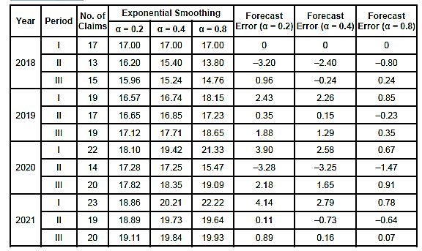

From the above table, we observe that as we increase the value of the smoother constant then the forecast error decreases. We now demonstrate the impact of the smoothing factor α using the time series graph as shown below

From the above figure, we observed that as we increase the smoothing constant α, the series is smoother. Therefore, α plays the same role in exponential smoothing as m in the moving average.

After understanding the exponential smoothing and forecast technique, we now discuss the merits and demerits of this method.

**Merits**

1. It is very simple in concept and very easy to understand.
2. The primary merit of the exponential method over the moving average is that there is no loss of information (data values) as in the case of the moving average.
3. If we forecast using the moving averages method, then m prior values are required. If we have to forecast many values, then this is time-consuming. Whereas the exponential method uses only two pieces of data.

**Demerits**

1. The method is not flexible in the sense that if some figures are added to the data, then we have to do all calculations again.
2. This method gives good results in the absence of seasonal or cyclical variations. As a result, forecasts are not accurate when data with cyclical or seasonal variations are present.

After understanding the exponential smoothing method, you may be interested in doing the same yourself.

|  |
| --- |
| **EXERCISE**  The annual expenditure levels (in millions) to promote products and services for the financial services sector such as banks, insurance, investments, etc. from 2015 to 2022 are shown in the following table:    Use exponential smoothing to obtain filtered values by taking α = 0.5, α = 0.7, α = 0.9 and calculate the forecast errors. Also, plot the original and smoothed values. |

**ESTIMATION OF TREND COMPONENT USING METHOD OF LEAST SQUARES**

There are several ways to determine trend effects in time series data and one of the more prominent is the method of least squares. This method is one of the most common methods for identifying and quantifying the relationship between a dependent variable and single or multiple independent variables. It can also be used to fit a trend. We can also use fitted trend for forecasting. To create a trend model that captures a time series with a global trend, the dependent/ response/output variable (Y) is set as the time series measurement or some function of it, and the independent/predictor variable (X) is set as a time period. In this method, we fit a curve in such a way that the squares of the forecast errors should be minimum.

Many possible trends can be explored with time series data. In this section, we examine only the linear model, the quadratic model and the exponential model because they are the easiest to understand and simplest to compute. Because seasonal effects can confound trend analysis, it is assumed here that no seasonal effects occur in the time series data, or they were removed prior to determining the trend.

A linear trend means that the values of the series increase or decrease linearly in time, whereas an exponential trend captures an exponential increase or decrease.

**Linear Trend**

When the values of the time series increase or decrease linearly with time then we use linear trend.

In the simplest case, the linear

trend model allows for a linear relationship between the forecast variable Y and a single predictor variable time t. In this case, the linear trend line equation is as follows:



The coefficients β0 and β1 denote the intercept and the slope of the trend line, respectively. The intercept β0 represents the predicted value of Y when t = 0 and the slope represents the average predicted change in Y resulting from a one-unit change in t.

We can estimate the values of the constants β0 and β1using the following normal equations:

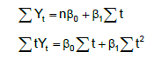

where n is the number of observations in the given time series. We obtain the values of ΣYt , Σt, Σt2 and ΣtYt from the given time series data and solve these normal equations for the values of β0 and β1

Generally, the time t is given in years, therefore, to calculate the values of Σt, ΣtYt and Σt2 manually becomes very cumbersome. Therefore, to simplify the calculations, we may make the following transformations in t:

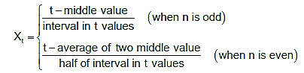

Therefore, the normal equations become:

The fitted trend line for estimating or forecasting the trend values is given as follows:



After that, we put the value of Xt in terms of t to find the final trend line. Let us take an example to understand how to fit a linear trend line for real-life time series data.

**Example 4:** The sales director of a real estate company wants to study the general direction (trend) of future housing sales. For that, he/she recorded the number of houses sold from 2010 to 2018 as given in the following table:



* 1. Construct a simple trend line for the house sales data for the real estate company.
  2. Find the trend values for the given data and find forecast errors.
  3. Plot the given data with trend values.
  4. Use the trend line of best fit to estimate the level of house sales for the year 2022.

**Solution:** The linear trend line equation is given by



Since n (number of years) = 9 is odd and the middle value is 2014, therefore, we make the following transformation in time t as Xt = t – 2014. Therefore, the normal equations for estimating the constants are:



In the following table, we calculate the values of:

Therefore, we find the values of 0 1 β and β using the normal equations as

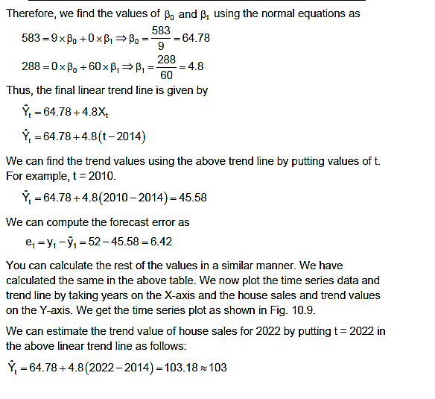

Thus, the final linear trend line is given by



We can find the trend values using the above trend line by putting values of t. For example, t = 2010.

We can compute the forecast error as

You can calculate the rest of the values in a similar manner. We have calculated the same in the above table. We now plot the time series data and trend line by taking years on the X-axis and the house sales and trend values on the Y-axis. We get the time series plot as shown below.

We can estimate the trend value of house sales for 2022 by putting t = 2022 in the above linear trend line as follows:

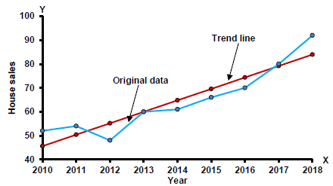

**Quadratic Trend**

Sometimes the trend is not linear and shows some curvature. The simplest curvilinear form is a second-degree polynomial. In this case, the quadratic trend equation is given below:



We proceed same as in the case of the trend line, the normal equations for estimating β0 , β1 and β2 after the transform of the data are given as follows:

**Example 5:** Fit a quadratic trend equation for the house sales data of the real estate company given in Example 4. Also

* 1. Find forecast errors.
  2. Plot the given data with trend values.
  3. Use the quadratic trend equation, to estimate the level of house sales for year 2022.

**Solution:** The quadratic trend equation is given as



Proceeding in the same way as in the case of Example 4, we make the transform Xt = t − 2014, then the normal equations are given as:

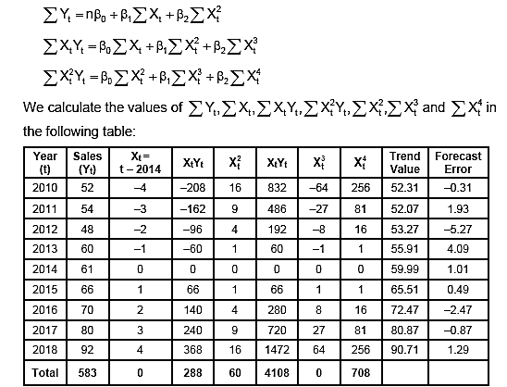

By putting the values from the table in the normal equations, we get

After solving the above equation for 0 1 2 β , β and β get the estimate of these as



Thus, the final quadratic trend equation is given by



After putting the value of t X in terms of t, we get the desired quadratic trend equation as follows:



We can find the trend values using the above quadratic trend equation by putting t values. For example, for t = 2010.



We can compute the forecast error as



You can calculate the rest of the values in a similar manner. We have calculated the same in the table.

We can estimate the trend value of house sales for 2022 by putting t = 2022 in the above linear trend line as follows:



We now plot the time series data and trend line by taking years on the X-axis and the house sales and trend values on the Y-axis. We get the time series plot as shown

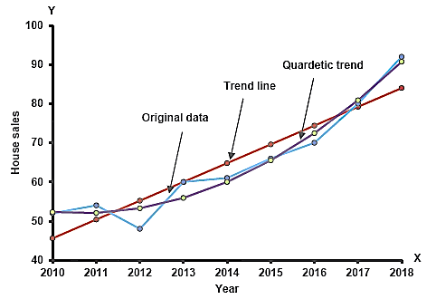

If we compare the forecast errors that occurred in both linear and quadratic form, then we observe that these are less in quadratic in comparison to the linear so we can say that the quadratic trend fits better than linear on the number of houses sold by the company.

|  |
| --- |
| **EXERCISE**  The following table gives the gross domestic product (GDP) in 100 million for a certain country from 2010 to 2020:     1. Fit a trend line for GDP data and find trend values with the help of trendline. 2. Find forecast errors. 3. Use best-fit trend model to predict the country’s GDP for 2022. |