Chris Messmann

12/1/20

IT FDN 110 A Au20: Foundations of Programming: Python

Assignment 07

Enter Assignment 07 github link here!

Assignment 07: Create Error Handling (Try-except) & Pickling Demo

**Introduction**

Assignment 07 are some simple examples of the ‘try-except’ block and pickling works. The program presents the user with a menu of 3 options: (1.) Run Error Handling Demo; (2.) Run Pickling Demo (3.) Exit Program. The ‘try-except’ demo shows how shows the user an example of a custom ‘try-except’ and another example of a built-in IO ‘try-except’ block. The program itself utilizes a similar structure of classes and functions as was done in Assignment06.

Figure 1a-1g are snapshots of the Python code. Figure 2 is a snapshot of the program working in the command window. Figure 3 is a snapshot of the program working out of the shell window. Figure 4 is a snapshot of the text document where the user information is retrieved and recorded.

Figure 1a (Python code-Error Handling Demo 1)

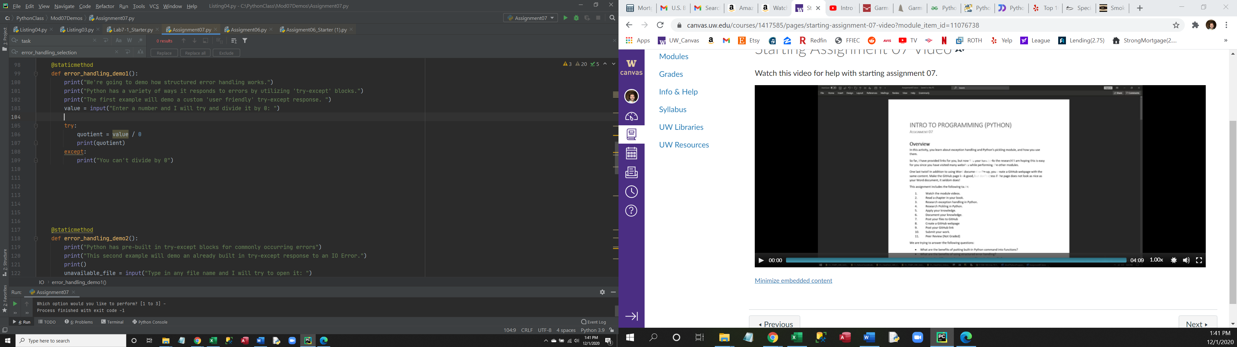

Figure 1b (Python code-Error Handling Demo 2)

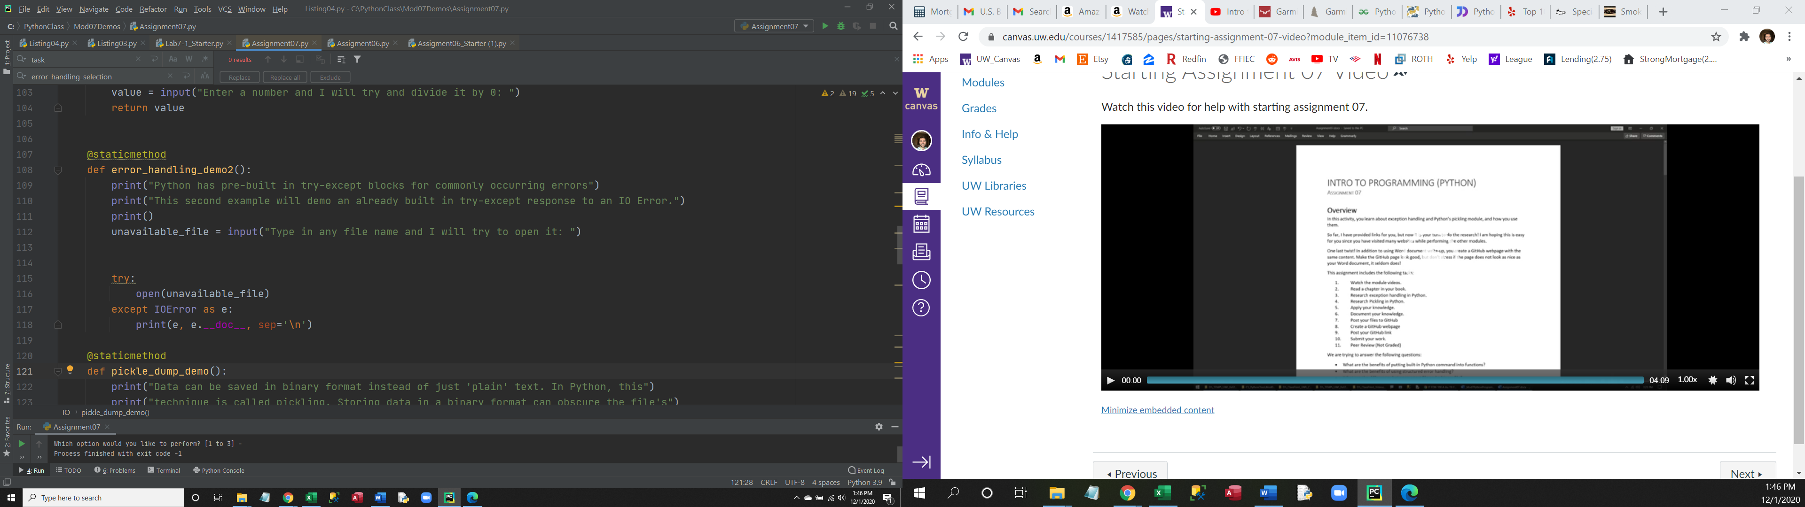

Figure 1c (Python code-Pickling Demo)

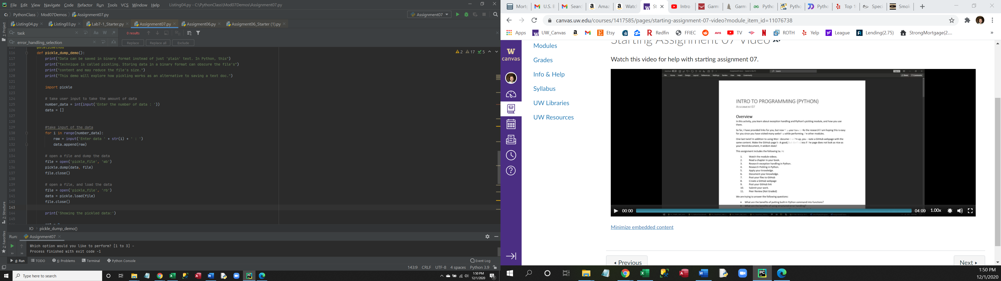

2a (Command window)

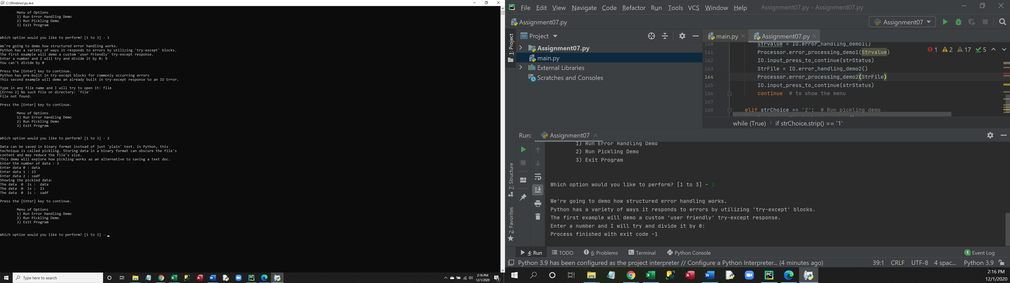

Figure 3 (Shell window)

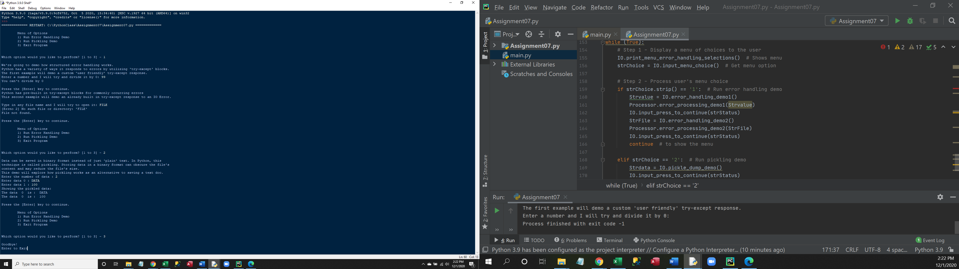

Figure 4 (pickle_file.dat document)

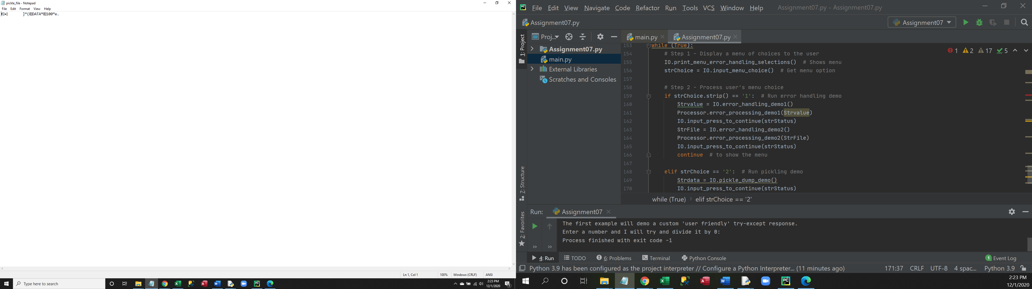

**Summary**

In summary Assignment 07 walks a user through a couple of demonstrations of the ‘try-except’ block and one demo of the pickle function. The program utilizes class and functions to controls the overall flow of the program.