Chris Messmann

12/8/20

IT FDN 110 A Au20: Foundations of Programming: Python

Assignment 08

Assignment 08: Class, Fields, Attributes, Properties, and Methods

**Introduction**

Assignment 08 is like Assignment 06 in that the program shows menu to user, collects and saves a list of information to a text file. Instead of using dictionaries to hold and pass information collected by the user this program utilizes a list of product objects.

Figure 1a-1g are snapshots of the Python code. Figure 2 is a snapshot of the program working in the command window. Figure 3 is a snapshot of the program working out of the shell window. Figure 4 is a snapshot of the text document where the user information is retrieved and recorded.

Figure 1a (Python code)

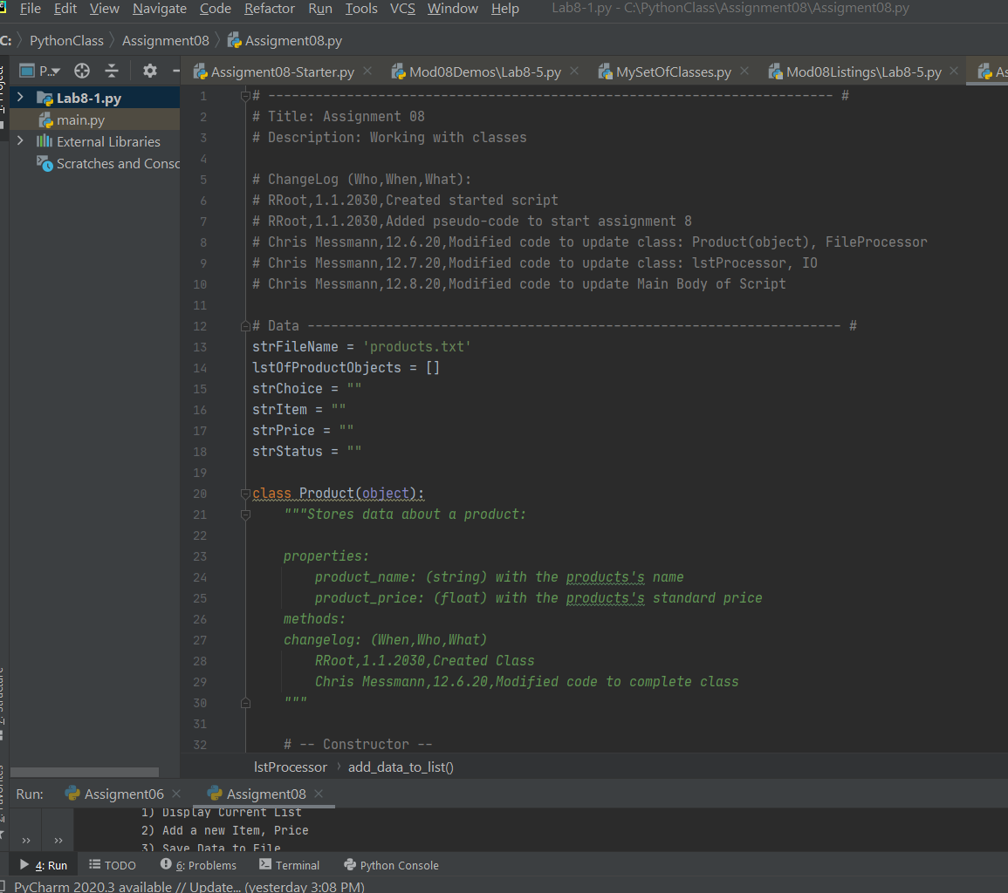

Figure 1b (Python code)

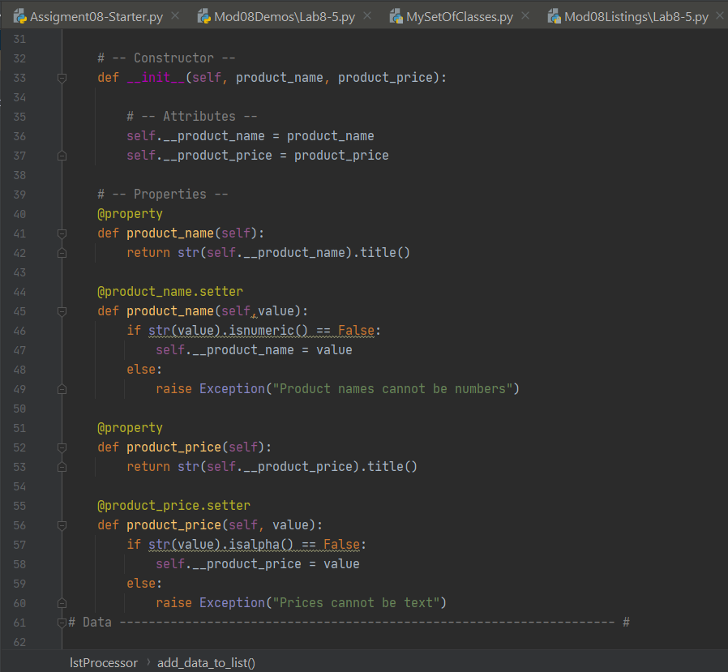

Figure 1c (Python code)

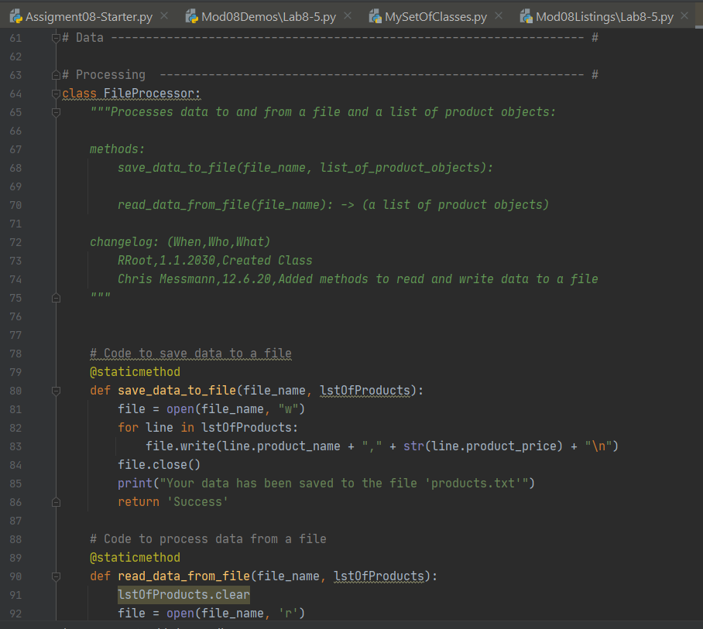

Figure 1d (Python code)

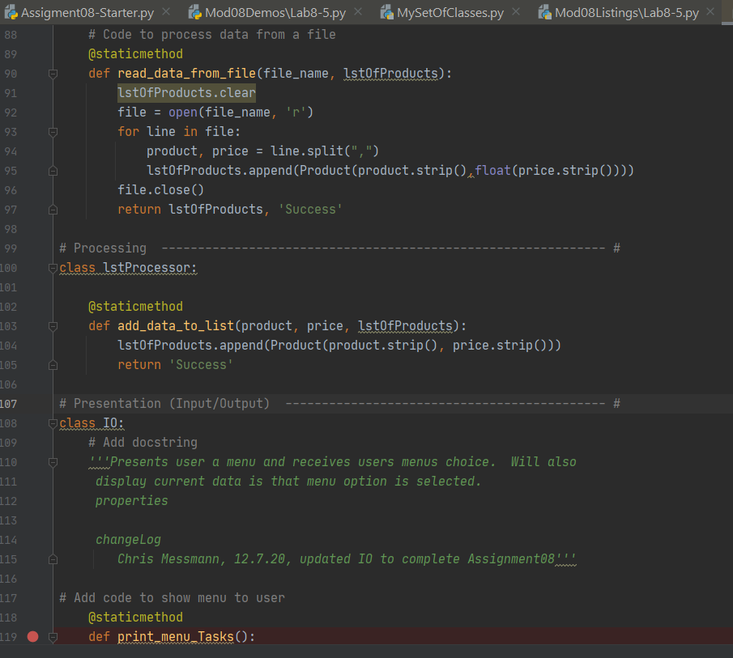

Figure 1e (Python code)

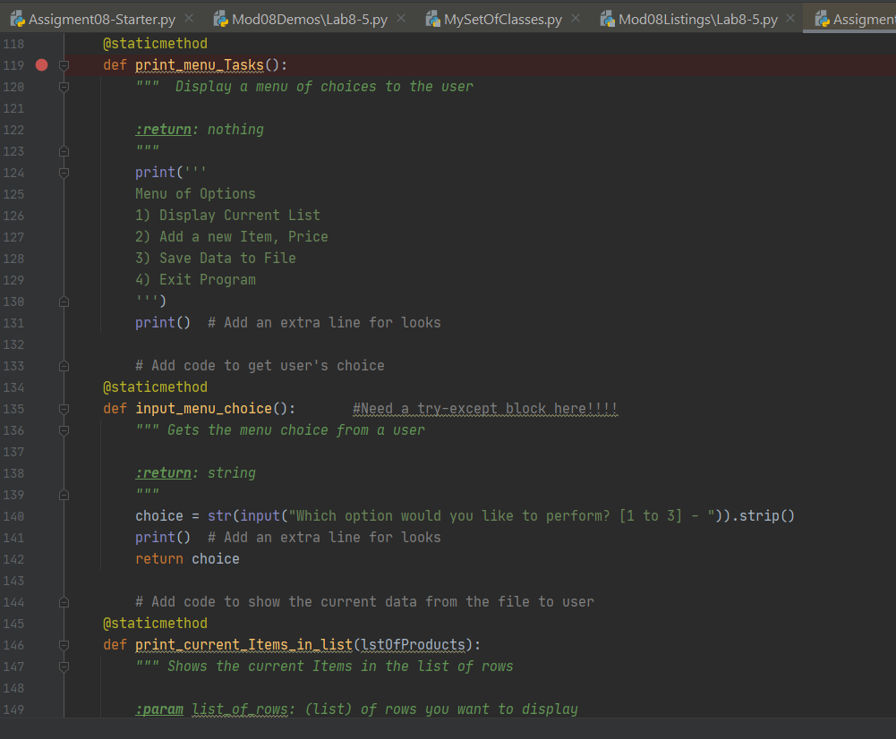

Figure 1f (Pthon code)

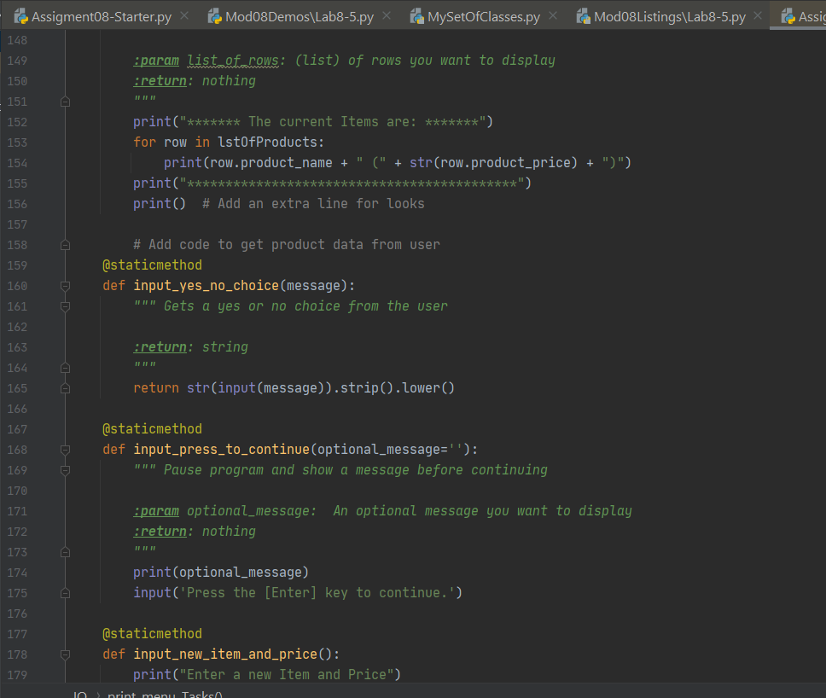

Figure 1g (Python code)

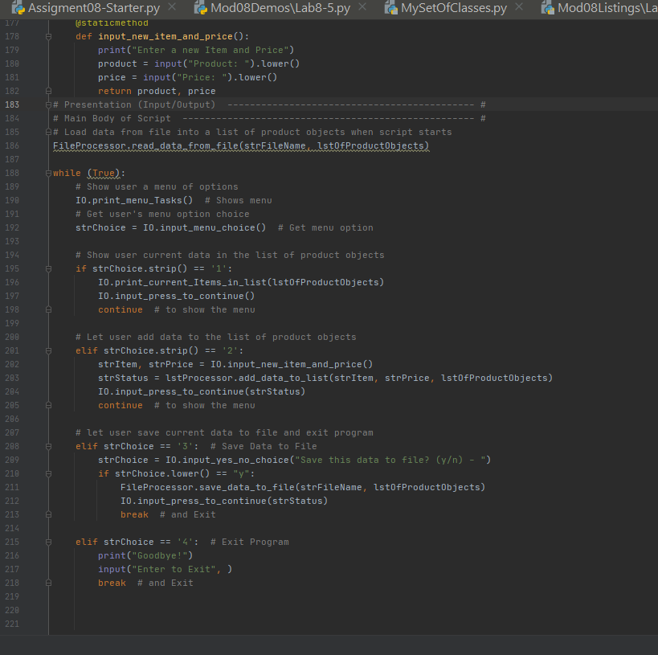

Figure 2 (Command window)

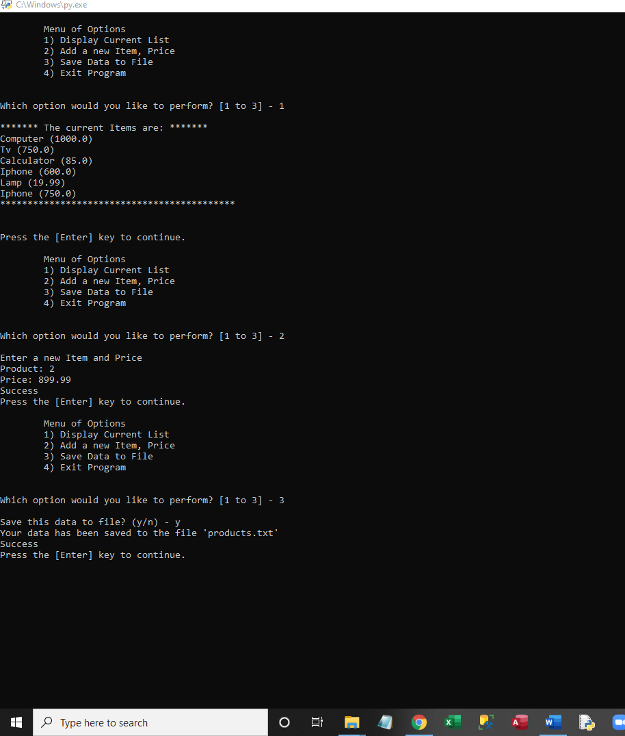

Figure 3 (Shell window)

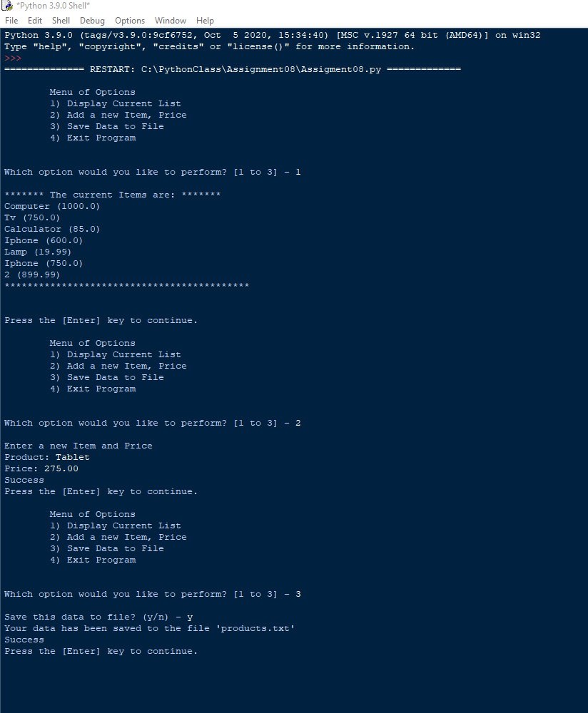

Figure 4 (products.txt Text document)

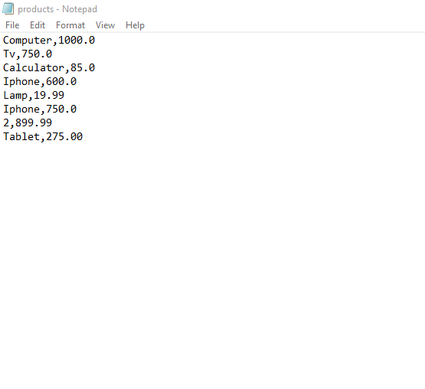

**Summary**

In summary Assignment 08 is a revision of Assignment06 where a user is presented with a menu of options on how to manage a list of products and their respective prices. New functionality for Assignment08 utilizes class, attributes, properties, and methods to enable a list of product objects to move information into and out of the program. Similar to previous assignments (A05 and A06) the program makes use of a text file stored locally to save and reload information the user has entered through the program (product.txt).