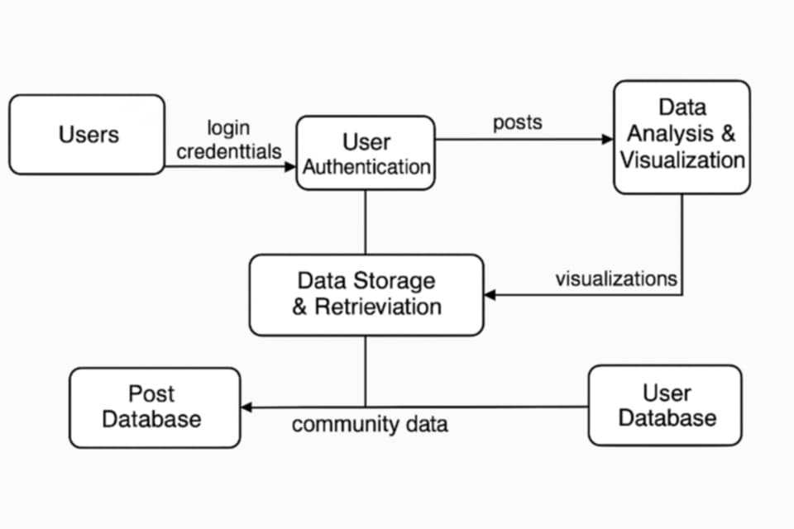

**Data Flow Diagram of Echoes of Today System**

This DFD represents how data flows through the Echoes of Today System, showing how users interact with the system, and how data is processed, stored, and visualized.

**External Entity:**

Users: The main external actor who interacts with the system by providing input (credentials, posts, community actions) and receiving output (visualizations, notifications).

**Processes:**

* User Authentication: Handles login and registration using credentials from users.
* Post Management: Allows users to create, edit, and delete journal entries or blog posts.
* Data Storage & Retrieval: Manages how data (posts, user info, community data) is stored and fetched from databases.
* Data Analysis & Visualization: Analyzes user and post data to generate meaningful visual outputs like mood trends.

**Data Stores:**

* User Database: Stores user profiles and credentials.
* Post Database: Holds journal entries and blog posts.
* Community Database: Contains data related to user communities and their interactions.

**Data Flows:**

Credentials flow from Users to Authentication, Posts move from Post Management to Data Storage, Community data is stored and retrieved for analysis, and Visualizations are sent back to Users as feedback.