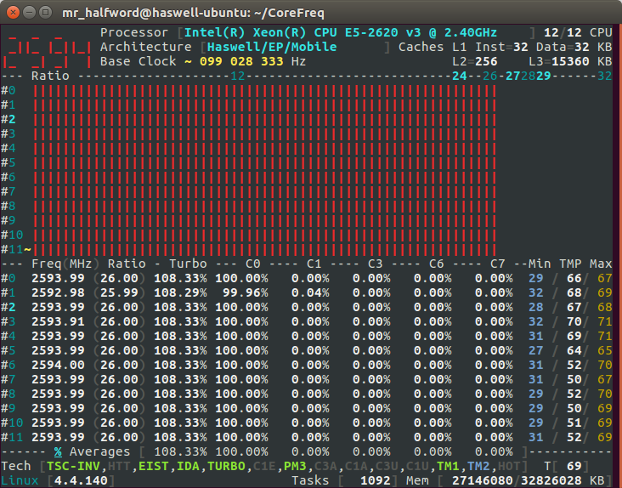1. Runtime Power Management and Turbo mode enabled in BIOS, Intel pstate driver enabled, AVX on cores 0-5 and SSE on cores 6-11

With these power settings:

\* The AVX threads are running at 4.2 IPC.

\* The SSE threads are running at 1.5 IPC.

From a disassembly each inner loop in the AVX thread contains:

- 9 vmovaps AVX instructions

- 10 vfmadd132ps FMA instructions

- 3 loop control instructions

2. Runtime Power Management and Turbo mode enabled in BIOS , Intel pstate driver enabled, SSE on cores 0-5 and AVX on cores 6-11

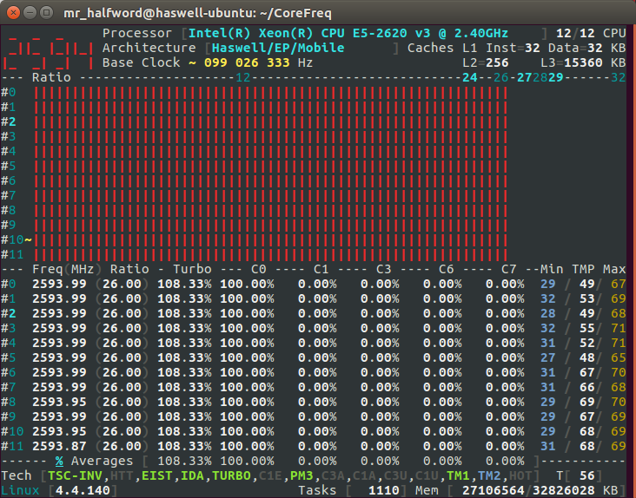

3. Runtime Power Management and Turbo mode disable in BIOS, Intel pstate driver disabled, AVX on cores 0-5 and SSE on cores 6-11:

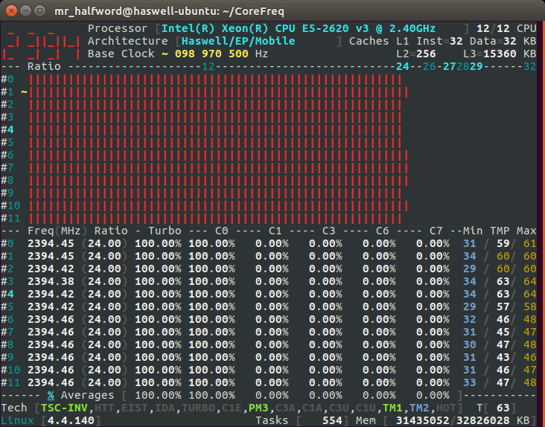

4. Runtime Power Management and Turbo mode disable in BIOS, Intel pstate driver disabled, SSE on cores 0-5 and AVX on cores 6-11:

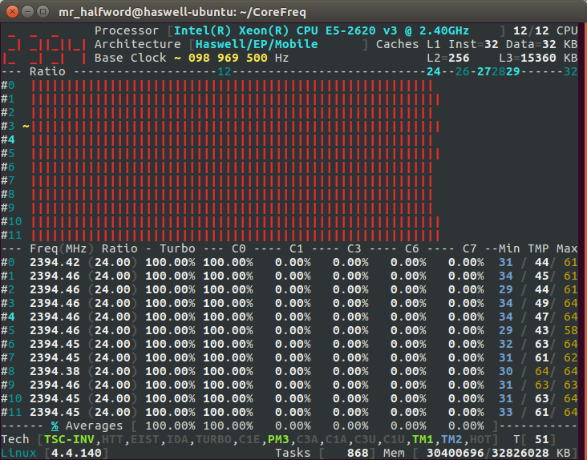

Note that when the runtime power management is disabled in the BIOS and Kernel that /proc/cpuinfo reports a fixed frequency of “2394.394” at all times. When the cores are not busy, CoreFreq shows the cores spend ~99.8% of their time in the C6 state.