**VATek**

**SDK2 I2C Guideline**

**Date : 20181205**

1. **VATEK I2C Command Buffer**

VATEK 於標準I2C流程上，格外定義了一段由9 個位元組組成的command buffer，其結構如下表，目的為了擴充VATEK I2C可處理的命令彈性。使用者每次的I2C溝通，皆必須由此段記憶體完成暫存器存取與寫入動作。

每筆I2C的溝通，使用者必需將欲存取/寫入的內容寫入Command buffer，最後才將C0寫入，觸發晶片執行收到的Command。

VATEK I2C Command Buffer :

1. SRAM address(P0) : 標示欲存取command buffer(SRAM)的起始位址，

範圍0x00~0x07

1. Register value(D0~D3) : 欲寫入暫存器的值
2. Register address(A0~A2) : 欲存取的暫存器位址
3. VATEK I2C command(C0) : VATEK I2C 命令(read/write memory : 0x05 / 0x07，read/write reg：0x04 / 0x06)

**(Note : ADDRESS 與 DATA為Little endian排序)**

|  |  |
| --- | --- |
| P0 | Point the position(SRAM address) of buffer |

|  |  |
| --- | --- |
| **SRAM Address** | **Context** |
| 0x00 : D0 | DATA [ 7 : 0 ] |
| 0x01 : D1 | DATA [ 15 : 8 ] |
| 0x02 : D2 | DATA [ 23 : 16 ] |
| 0x03 : D3 | DATA [ 31 : 24 ] |
| 0x04 : A0 | ADDRESS[ 7 : 0 ] |
| 0x05 : A1 | ADDRESS[ 15 : 8 ] |
| 0x06 : A2 | ADDRESS[ 23 : 16 ] |
| 0x07 : C0 | COMMAND:  VBTI2C_REG_READ_TAG 0x04  VBTI2C_REG_WRITE_TAG 0x06  VBTI2C_MEM_READ_TAG 0x05  VBTI2C_MEM_WRITE_TAG 0x07 |

1. I2C command structure

#### **VATEK I2C MEM command – READ (0x05)**

READ命令的溝通動作分為兩階段 :

Step 1 - 寫入欲讀取的暫存器位址與命令

Step 2 - 讀出暫存器位址的值，詳細操作如下圖:

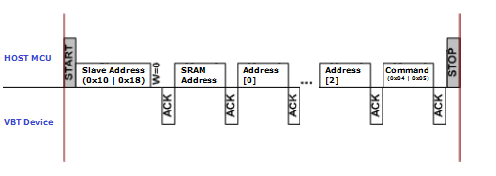

1. VATEK I2C Command – READ (Send Command)
2. HOST MCU Send Start Signal.
3. HOST MCU Send Slave Write Address (0x10 / 0x18) + W/R bit.
4. HOST MCU Send SRAM Address (0x04).
5. HOST MCU Send Register Address. (3 Bytes Length)
6. HOST MCU Send the READ Memory(0x05) Command.
7. HOST MCU Send Stop Signal.

第二階段 : 從VATEK I2C command buffer取出記憶體位址的值，如下圖 :

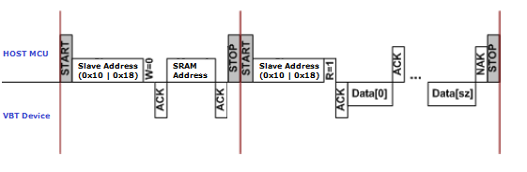

1. VATEK I2C Command– READ (Get Data)
2. HOST MCU Send Start Signal.
3. HOST MCU Send Slave Write Address (0x10 | 0x18) + W/R bit.
4. HOST MCU Send SRAM Address (0x00).
5. HOST MCU Send Stop Signal. (Switch SRAM Address To 0x00)
6. HOST MCU Send Start Signal.
7. HOST MCU Send Slave Read Address (0x10 | 0x18) + W/R bit.
8. HOST MCU Read Data. (4 Bytes).
9. HOST MCU Send Stop Signal.

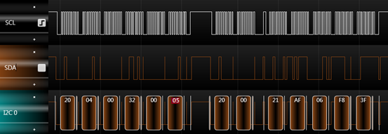

1. VATEK I2C Command– READ Time Flow

ADDRESS-0x003200

SRAM address

(ADDRESS)-0x04

(DATA)-0x00

I2C Slave Address

(Write)-0x20

(Read)-0x21

Command- READ - 0x05

DATA - 0x3FF806AF

### VATEK I2C MEM command – WRITE (0x07)

寫入暫存器與記憶體的操作流程，如下圖 :

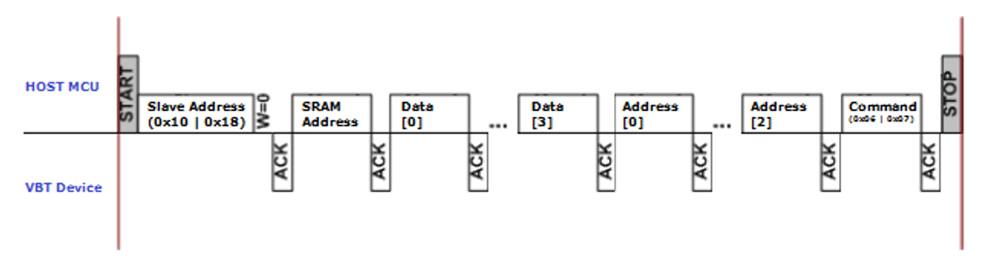

1. VATEK I2C Command– WRITE(Send Command)
2. HOST MCU Send Start Signal.
3. HOST MCU Send Slave Write Address (0x10 | 0x18) + W/R bit .
4. HOST MCU Send SRAM Address (0x00).
5. HOST MCU Write Data. (4 Bytes)
6. HOST MCU Write Current Access Address. (3 Byes)
7. HOST MCU Send the WRITE Memory(0x07) Command.
8. HOST MCU Send Stop Signal.

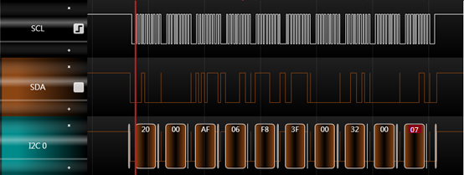

SRAM address

(DATA)-0x00

Command WRITE-0x07

I2C Slave Address-0x20

ADDRESS-0x003200

DATA-0x3FF806AF

1. VATEK I2C Command– WRITE time flow