INDEX

1. System Process 2

1.1 Process Overview 2

1.3 Process of chip (internal HDMI) 3

1.4 Process of chip (external HDMI) 5

2. Status Registers (BASE) 7

2.1 System Status 7

2.2 Broadcast Status 8

2.3 HDMI Status 9

3.AV Control Registers (Stream Registers) 12

3.1 Registers for Video Input Settings 12

3.2 Registers for AV Encoder Settings 14

4. MUXER register 16

4.1 Mux Related Settings 16

5. Broadcast Related Registers 17

5.1 General Settings 17

## 1. System Process

### 1.1 Process Overview

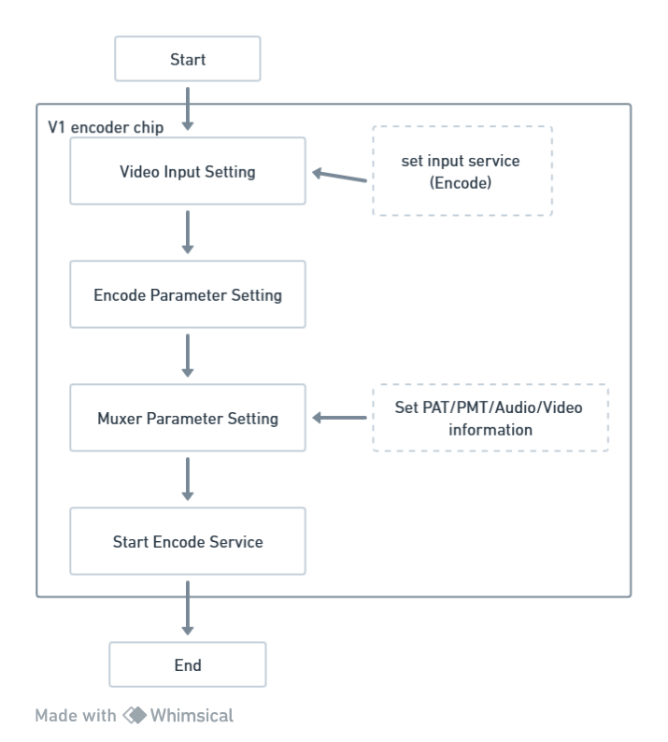

### 1.3 Process of chip (internal HDMI)

To using VI internal HDMI mode, you don’t need to set PHY information at the front end, V1 chip will detect the input source.

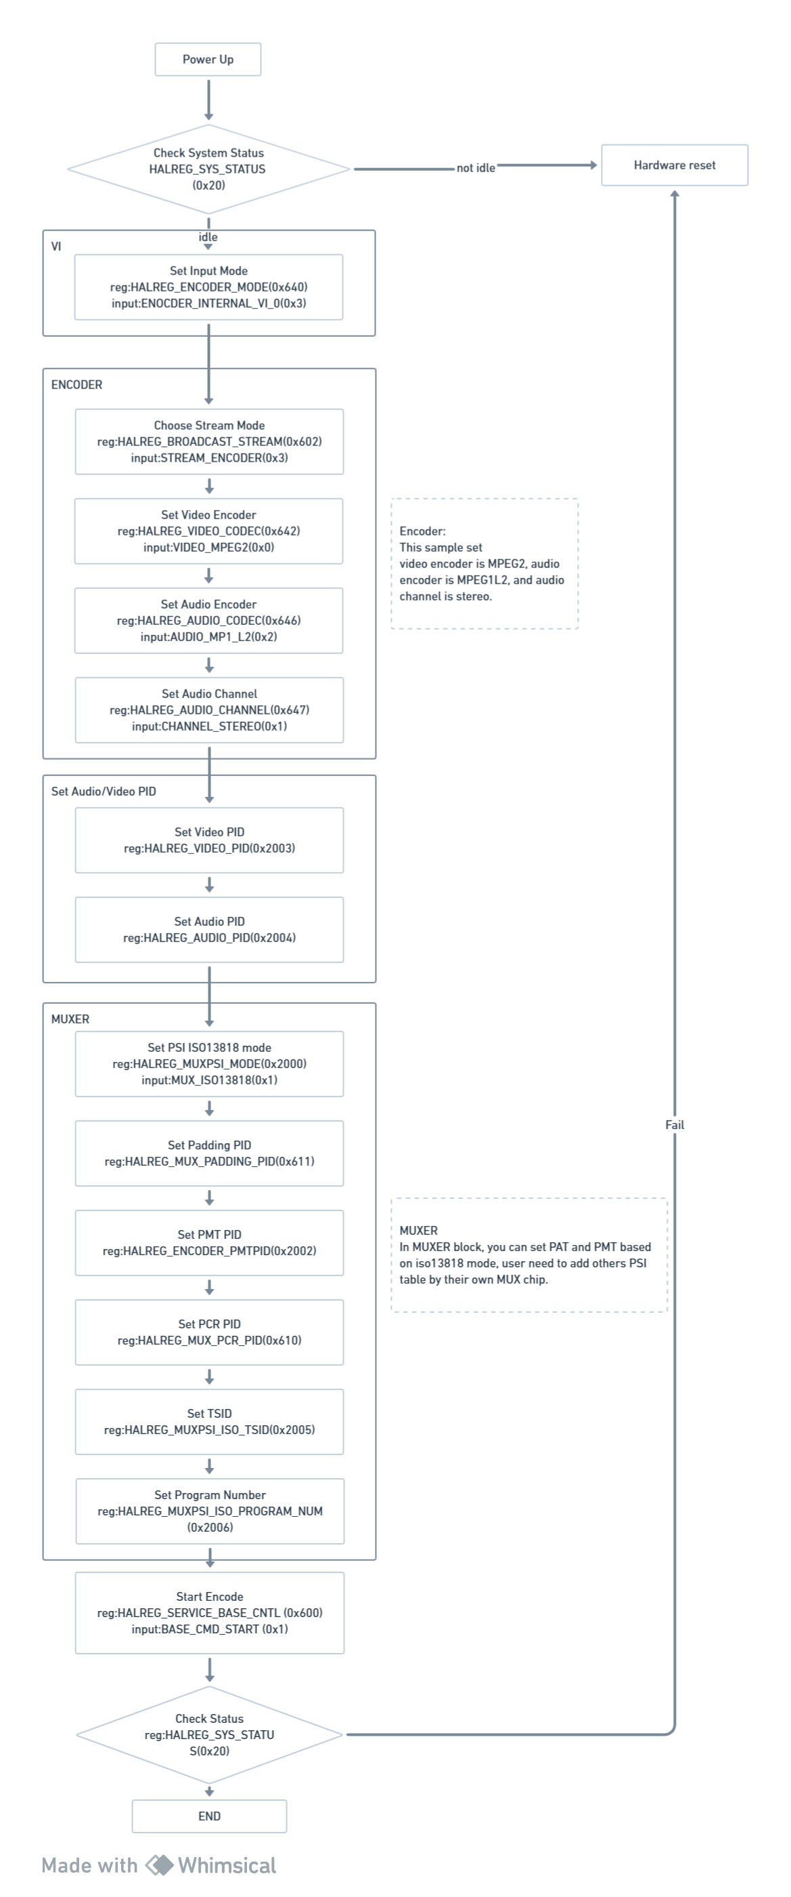

Next page



### 1.4 Process of chip (external HDMI)

To using VI external HDMI mode, user need to set PHY information at the front end.

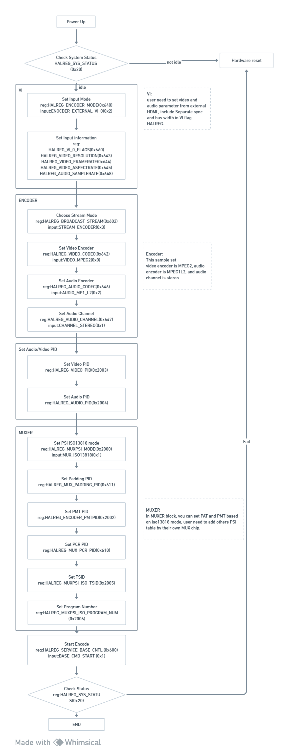

Next page

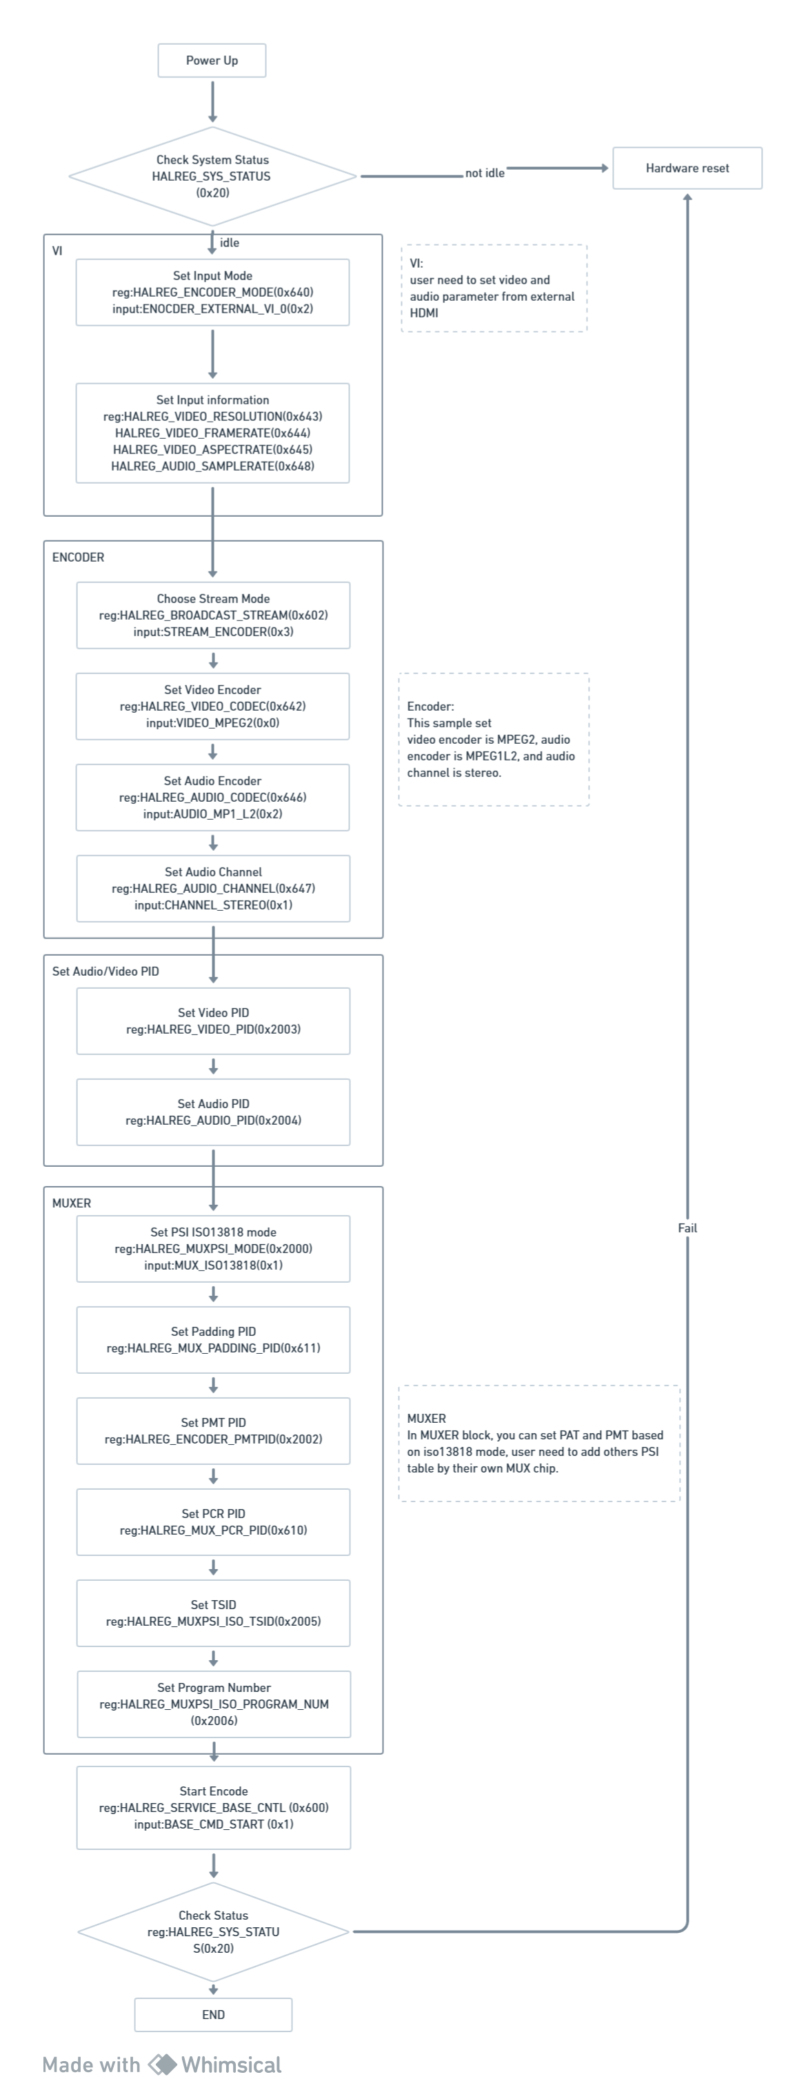

## **2. Status Registers (BASE)**

### 2.1 System Status

**0x20 - HALREG_SYS_STATUS_0:** System Status Register 0

|  |  |  |  |
| --- | --- | --- | --- |
| **Bit #** | **Type** | **Value** | **Name** |
| 0~31 | R | 0xFF000001 | SYS_STATUS_IDLE: |
| R | 0xFF000002 | SYS_STATUS_RUN: |
| R | 0xFF000085 | SYS_STATUS_LOADER_FAIL |
| R | 0xFF000086 | SYS_STATUS_SERVICE_FAIL |
| R | 0xFF000088 | SYS_STATUS_EXCEPTION_FAIL |
| R | 0xFF00008E | SYS_STATUS_BADSTATUS |
| R | 0xFF00008F | SYS_STATUS_UNKNOWN_FAIL |

**0x23 - HALREG_SYS_ERRCODE:** System Error Code Register

|  |  |  |  |
| --- | --- | --- | --- |
| **Bit #** | **Type** | **Value** | **Name** |
| 0~31 | R | 0x80000001 | SYS_ERRCODE_INIT |
| R | 0x80010001 | LOADER_ERRCODE_NOAPP |
| R | 0x80010002 | LOADER_ERRCODE_CRC32 |
| R | 0x80010003 | LOADER_ERRCODE_HW |
| R | 0x80020001 | SERVICE_INIT_FAIL |

**0x24 - HALREG_CHIP_ID:** CHIP ID Register

|  |  |  |  |
| --- | --- | --- | --- |
| **Bit #** | **Type** | **Value** | **Name** |
| 0~31 | R | 0x00010100 | HAL_CHIPID_A1 |
| R | 0x00010300 | HAL_CHIPID_A3 |
| R | 0x00020100 | HAL_CHIPID_B1 |
| R | 0x00020200 | HAL_CHIPID_B2 |
| R | 0x00020201 | HAL_CHIPID_B2_PLUS |
| R | 0x00020300 | HAL_CHIPID_B3 |
| R | 0x00020301 | HAL_CHIPID_B3_PLUS |
| R | 0x00040300 | HAL_CHIPID_E1 |

**0x25 - HALREG_FW_VER:** Firmware Version Register

|  |  |  |  |
| --- | --- | --- | --- |
| **Bit #** | **Type** | **Value** | **Name** |
| 0~31 | R |  |  |

**0x26 - HALREG_SERVICE_MODE:** Service Mode Register

|  |  |  |  |
| --- | --- | --- | --- |
| **Bit #** | **Type** | **Value** | **Name** |
| 0~31 | R | 0xFF000001 | SERVICE_TAG_RESCUE |
| R | 0xF8000001 | SERVICE_TAG_BROADCAST |
| R | 0xF8000002 | SERVICE_TAG_TRANSFORM |
| R | 0xF8000003 | SERVICE_TAG_ENCODE |

**0x28 - HALREG_INPUT_SUPPORT:** Media Source Register

|  |  |  |  |
| --- | --- | --- | --- |
| **Bit #** | **Type** | **Value** | **Name** |
| 0 | R | 0x00000001 | INPUT_EN_TEST |
| 1-2 |  | Reserved |  |
| 3 | R | 0x00000008 | INPUT_EN_ENC |
| 4 | R | 0x00000010 | VENC_EN_MPEG2 |
| 5 | R | 0x00000020 | VENC_EN_H264 |
| 7 |  | Reserved |  |
| 8 | R | 0x00000100 | VENC_EN_FULLHD |
| 9~11 |  | Reserved | -- |
| 12 | R | 0x00001000 | AENC_EN_MP1_L2 |
| 13 | R | 0x00002000 | AENC_EN_AAC_LC_ADTS |
| 14 | R | 0x00004000 | AENC_EN_AC_3 |
| 15 | R | 0x00008000 | AENC_EN_AAC_LC_LATM |
| 22~31 |  | Reserved |  |

**0x29 - HALREG_OUTPUT_SUPPORT:** Output Mode Register

|  |  |  |  |
| --- | --- | --- | --- |
| **Bit #** | **Type** | **Value** | **Name** |
| 2 | R | 0x00000004 | OUTPUT_EN_TS |
| 3~31 |  | Reserved |  |

**0x1040 - HALREG_HDMI_VIN_VIC:** Input video information VIC

|  |  |  |  |
| --- | --- | --- | --- |
| **Bit #** | **Type** | **Value** | **Name** |
| 0 | R | 0x0000FFFF | VIC_MASK |
| 1~31 |  | Reserved |  |

### 2.2 Broadcast Status

**0x620 - HALREG_BCINFO_STREAM:** Enable stream mode

|  |  |  |  |
| --- | --- | --- | --- |
| **Bit #** | **Type** | **Value** | **Name** |
| 3~31 | R |  |  |

**0x621 - HALREG_BCINFO_OUTPUT:** Enable output mode

|  |  |  |  |
| --- | --- | --- | --- |
| **Bit #** | **Type** | **Value** | **Name** |
| 1~31 | R |  |  |

**0x623 - HALREG_BCINFO_MUXRATE:** Show output bitrate of MUX

|  |  |  |  |
| --- | --- | --- | --- |
| **Bit #** | **Type** | **Value** | **Name** |
| 0~31 | R |  |  |

**0x624 - HALREG_BCINFO_STATUS:** Broadcast Status Register

|  |  |  |  |
| --- | --- | --- | --- |
| **Bit #** | **Type** | **Value** | **Name** |
| 0~1 | R | 0x00000000 | BCSTATUS_IDLE |
| R | 0x00000001 | BCSTATUS_WAIT_SOURCE |
| R | 0x00000002 | BCSTATUS_BROADCAST |
| R | 0x00000003 | BCSTATUS_FINISH |
| 2~31 |  | Reserved |  |
| 32 | R | 0x80000000 | BCSTATUS_FAIL_UNKNOWN |
| R | 0x80000001 | BCSTATUS_FAIL_SOURCE |
| R | 0x80000002 | BCSTATUS_FAIL_TIMEOUT |
| R | 0x80000003 | BCSTATUS_FAIL_CODECDROP |
| R | 0x80000004 | BCSTATUS_FAIL_BUFFER |
| R | 0x80000005 | BCSTATUS_FAIL_MUXER |
| R | 0x80000006 | BCSTATUS_FAIL_ENCODE |
| R | 0x80000007 | BCSTATUS_FAIL_MEDIA |
| R | 0x80000008 | BCSTATUS_FAIL_DEMUX |

**0x625 - HALREG_BCINFO_CURRATE:** Show real bitrate of MUX

|  |  |  |  |
| --- | --- | --- | --- |
| **Bit #** | **Type** | **Value** | **Name** |
| 0~31 | R |  |  |

**0x626 - HALREG_BCINFO_DATARATE:** Show PES bitrate.

|  |  |  |  |
| --- | --- | --- | --- |
| **Bit #** | **Type** | **Value** | **Name** |
| 0~31 | R |  |  |

**0x627 - HALREG_BCINFO_QUERYBUF:** Show buffer length.

|  |  |  |  |
| --- | --- | --- | --- |
| **Bit #** | **Type** | **Value** | **Name** |
| 0~31 | R |  |  |

### 2.3 HDMI Status

**0x1020 – HALREG_HDMI_STATUS:** internal HDMI status

|  |  |  |  |
| --- | --- | --- | --- |
| **Bit #** | **Type** | **Value** | **Name** |
| 0 | R | 0x00000001 | HDMI_CONNECT |
| 1 | R | 0x00000002 | HDMI_HPD_EN |
| 3 | R | 0x00000003 | HDMI_DE_VLD |

**0x1022 - HALREG_HDMI_VIDEO_STS:** input video VIC change tag

|  |  |  |  |
| --- | --- | --- | --- |
| **Bit #** | **Type** | **Value** | **Name** |
| 0 | R | 0x00000001 | VIDEO_VIC_CHG |

**0x1024 - HALREG_HDMI_AUDIO_STS:** input audio sample frequency change tag

|  |  |  |  |
| --- | --- | --- | --- |
| **Bit #** | **Type** | **Value** | **Name** |
| 0 | R | 0x00000001 | AUDIO_SF_CHG |

**0x1040 - HALREG_HDMI_VIDEO_INFO:** HDMI information

|  |  |  |  |
| --- | --- | --- | --- |
| **Bit #** | **Type** | **Value** | **Name** |
| 0 | R | 0x0000FFFF | HDMI_VID_VIC_MASK |
| 1 | R | 0x00010000 | HDMI_HDCP_AI |
| 2 | R | 0x00020000 | HDMI_HDCP_DP |

**0x1041 - HALREG_VID_VIC_RESOLUTION:** get input source resolution

|  |  |  |  |
| --- | --- | --- | --- |
| **Bit #** | **Type** | **Value** | **Name** |
| 0 | R | 0x00000000 | HDMI_VID_RESOLUTION_480I |
| 1 | R | 0x00000001 | HDMI_VID_RESOLUTION_480P |
| 2 | R | 0x00000002 | HDMI_VID_RESOLUTION_576I |
| 3 | R | 0x00000003 | HDMI_VID_RESOLUTION_576P |
| 4 | R | 0x00000004 | HDMI_VID_RESOLUTION_720P |
| 5 | R | 0x00000005 | HDMI_VID_RESOLUTION_1080I |
| 6 | R | 0x00000006 | HDMI_VID_RESOLUTION_1080P |

**0x1042 - HALREG_VID_FRAMERATE:** get input source frame rate

|  |  |  |  |
| --- | --- | --- | --- |
| **Bit #** | **Type** | **Value** | **Name** |
| 0 | R | 0x00000000 | HDMI_VID_FR_23_97 |
| 1 | R | 0x00000001 | HDMI_VID_FR_24 |
| 2 | R | 0x00000002 | HDMI_VID_FR_25 |
| 3 | R | 0x00000003 | HDMI_VID_FR_29_97 |
| 4 | R | 0x00000004 | HDMI_VID_FR_30 |
| 5 | R | 0x00000005 | HDMI_VID_FR_50 |
| 6 | R | 0x00000006 | HDMI_VID_FR_59_94 |
| 7 | R | 0x00000007 | HDMI_VID_FR_60 |

**0x1043 - HALREG_HDMI_VID_ASPECTRATE:** get input source aspect rate

|  |  |  |  |
| --- | --- | --- | --- |
| **Bit #** | **Type** | **Value** | **Name** |
| 0 | R | 0x00000000 | HDMI_VID_ASPECTRATE_4_3 |
| 1 | R | 0x00000001 | HDMI_VID_ASPECTRATE_16_9 |

**0x1045 - HALREG_HDMI_VID_HACT:** get H active from input.

|  |  |  |  |
| --- | --- | --- | --- |
| **Bit #** | **Type** | **Value** | **Name** |
| 0~31 | R |  |  |

**0x1046 - HALREG_HDMI_VID_HFB:** get H blank from input.

|  |  |  |  |
| --- | --- | --- | --- |
| **Bit #** | **Type** | **Value** | **Name** |
| 0~31 | R |  |  |

**0x1047 - HALREG_HDMI_VID_HPLS:** get H pulse from input.

|  |  |  |  |
| --- | --- | --- | --- |
| **Bit #** | **Type** | **Value** | **Name** |
| 0~31 | R |  |  |

**0x1048 - HALREG_HDMI_VID_HBB:** get H back bank from input.

|  |  |  |  |
| --- | --- | --- | --- |
| **Bit #** | **Type** | **Value** | **Name** |
| 0~31 | R |  |  |

**0x1049 - HALREG_HDMI_VID_VACT:** get V active from input.

|  |  |  |  |
| --- | --- | --- | --- |
| **Bit #** | **Type** | **Value** | **Name** |
| 0~31 | R |  |  |

**0x104A - HALREG_HDMI_VID_VFB:** get V front blank from input.

|  |  |  |  |
| --- | --- | --- | --- |
| **Bit #** | **Type** | **Value** | **Name** |
| 0~31 | R |  |  |

**0x104B - HALREG_HDMI_VID_VPLS:** get V pulse from input.

|  |  |  |  |
| --- | --- | --- | --- |
| **Bit #** | **Type** | **Value** | **Name** |
| 0~31 | R |  |  |

**0x104C - HALREG_HDMI_VID_VBB:** get V back blank from input.

|  |  |  |  |
| --- | --- | --- | --- |
| **Bit #** | **Type** | **Value** | **Name** |
| 0~31 | R |  |  |

**0x1060 - HALREG_HDMI_AUD_SAMPLERATE:** get audio sample rate from input.

|  |  |  |  |
| --- | --- | --- | --- |
| **Bit #** | **Type** | **Value** | **Name** |
| 0 | R | 0x00000000 | HDMI_AUD_SR_32KHZ |
| 1 | R | 0x00000001 | HDMI_AUD_SR_44_1KHZ |
| 2 | R | 0x00000002 | HDMI_AUD_SR_48KHZ |

## 3.AV Control Registers (Stream Registers)

### 3.1 Registers for Video Input Settings

**0x643 - HALREG_VIDEO_RESOLUTION:** Video Encoder resolution

|  |  |  |  |
| --- | --- | --- | --- |
| **Bit #** | **Type** | **Value** | **Name** |
| 0~2 | W | 0x00000000 | RESOLUTION_480I |
| W | 0x00000001 | RESOLUTION_480P |
| W | 0x00000002 | RESOLUTION_576I |
| W | 0x00000003 | RESOLUTION_576P |
| W | 0x00000004 | RESOLUTION_720P |
| W | 0x00000005 | RESOLUTION_1080I |
| W | 0x00000006 | RESOLUTION_1080P |
| 3~31 |  | Reserved |  |

**0x644 - HALREG_VIDEO_FRAMERATE:** Video Encoder framerate

|  |  |  |  |
| --- | --- | --- | --- |
| **Bit #** | **Type** | **Value** | **Name** |
| 0~2 | W | 0x00000000 | FRAMERATE_23_97 |
| W | 0x00000001 | FRAMERATE_24 |
| W | 0x00000002 | FRAMERATE_25 |
| W | 0x00000003 | FRAMERATE_29_97 |
| W | 0x00000004 | FRAMERATE_30 |
| W | 0x00000005 | FRAMERATE_50 |
| W | 0x00000006 | FRAMERATE_59_94 |
| W | 0x00000007 | FRAMERATE_60 |
| 3~31 |  | Reserved |  |

**0x645 - HALREG_VIDEO_ASPECTRATE:** Video Encoder aspect rate

|  |  |  |  |
| --- | --- | --- | --- |
| **Bit #** | **Type** | **Value** | **Name** |
| 0 | W | 0x00000000 | ASPECTRATE_4_3 |
| W | 0x00000001 | ASPECTRATE_16_9 |
| 1~31 |  | Reserved |  |

**0x647 - HALREG_AUDIO_CHANNEL:** Audio Encode Mode Select Register

|  |  |  |  |
| --- | --- | --- | --- |
| **Bit #** | **Type** | **Value** | **Name** |
| 0~2 | W | 0x00000000 | CHANNEL_MUTE |
| W | 0x00000001 | CHANNEL_STEREO |
| W | 0x00000002 | CHANNEL_MONO_L |
| W | 0x00000003 | CHANNEL_MONO_R |
| W | 0x00000004 | CHANNEL_STEREO_MONO_L |
| W | 0x00000005 | CHANNEL_STEREO_MONO_R |
| 3~31 |  | Reserved | -- |

**0x648 - HALREG_AUDIO_SAMPLERATE:** Audio Sample Rate Register

|  |  |  |  |
| --- | --- | --- | --- |
| **Bit #** | **Type** | **Value** | **Name** |
| 0~1 | W | 0x00000000 | SAMPLERATE_32KHZ |
| W | 0x00000001 | SAMPLERATE_44_1KHZ |
| W | 0x00000002 | SAMPLERATE_48KHZ |
| 3~31 |  | Reserved |  |

**0x64A - HALREG_SCALER_RESOLUTION:** Video Encoder scale down resolution

|  |  |  |  |
| --- | --- | --- | --- |
| **Bit #** | **Type** | **Value** | **Name** |
| 0~2 | W | 0x00000000 | RESOLUTION_480I |
| W | 0x00000001 | RESOLUTION_480P |
| W | 0x00000002 | RESOLUTION_576I |
| W | 0x00000003 | RESOLUTION_576P |
| W | 0x00000004 | RESOLUTION_720P |
| W | 0x00000005 | RESOLUTION_1080I |
| W | 0x00000006 | RESOLUTION_1080P |
| 3~31 |  | Reserved |  |

**0x660 - HALREG_VI_0_FLAGS:** Video Interface Setup Register

|  |  |  |  |
| --- | --- | --- | --- |
| **Bit #** | **Type** | **Value** | **Name** |
| 0~3 |  | Reserved |  |
| 4 | W | 0x00000010 | VI_BUSWIDTH_16 |
| 5 |  | Reserved | -- |
| 6 | W | 0x00000040 | VI_SEPARATED_SYNC |
| 7~8 |  | Reserved | -- |
| 9 | W | 0x00000200 | VI_CLK_INVERSE |
| 10~11 |  | Reserved | -- |
| 12 | W | 0x00001000 | VI_VSYNC_INVERSE |
| 13~15 |  | Reserved |  |
| 16 | W | 0x00010000 | VI_DOWN_SCALER |
| 17~23 |  | Reserved | -- |
| 24 | W | 0x01000000 | VI_FIELDID_SIGNAL |
| 25~27 |  | Reserved |  |
| 28 | W | 0x10000000 | VI_EXT_HALF_FPS |
| 29 | W | 0x20000000 | VI_FIELD_INVERSE |

**Description**

VI_BUSWIDTH_16：setting output base on PHY, default is 0. 0 is 8-bits data; 1 is 16-bits data.

VI_SEPARATED_SYNC：setting output base on PHY, default is 0。0 is Embedded Sync; 1 is Separated Sync.

VI_CLK_INVERSE：setting output base on PHY, default is 0. 0 is trigger at rising edge; 1 is trigger at falling edge.

VI_VSYNC_INVERSE：setting output base on PHY, default is 0. 0 is Negative Polarity; 1 is Positive Polarity。

VI_DOWN_SCALER：if user want to scaler down resolution, enable this flag and use 0x64A register to set down scale resolution.

VI_FIELDID_SIGNAL：setting output base on PHY, default is 0. 0 is using Field ID pin; 1 is detecting Field ID from timing.

VI_EXT_HALF_FPS：minus half frame rate from input. 0 is disable; 1 is enable.

VI_FIELD_INVERSE：setting output base on PHY, default is 0. 0 is top field first; 1 is bottom field first.

**0x661 - HALREG_VI_0_PIXELCLOCK:** Video Input Pixel Clock Register

|  |  |  |  |
| --- | --- | --- | --- |
| **Bit #** | **Type** | **Value** | **Name** |
| 0~31 | W |  |  |

### 3.2 Registers for AV Encoder Settings

**0x602 - HALREG_BROADCAST_STREAM:** Setting stream mode

|  |  |  |  |
| --- | --- | --- | --- |
| **Bit #** | **Type** | **Value** | **Name** |
| 0 | W | 0x00000003 | STREAM_ENCODER |
| 1~31 |  | Reserved | -- |

**0x640 - HALREG_ENCODER_MODE:** Encoder Mode Control Register

|  |  |  |  |
| --- | --- | --- | --- |
| **Bit #** | **Type** | **Value** | **Name** |
| 0 | W | 0x00000000 | ENCMOD_COLORBAR (not yet) |
| 1 | W | 0x00000001 | ENCMOD_BOOTLOGO (not yet) |
| 2 | W | 0x00000002 | ENCODER_EXTERNAL_VI_0 |
| 3 | W | 0x00000003 | ENOCDER_INTERNAL_VI_0 |
| 4~31 |  | Reserved | -- |

**0x641 - HALREG_ENCODER_FLAGS:** Encoder Mode Switch Register

|  |  |  |  |
| --- | --- | --- | --- |
| **Bit #** | **Type** | **Value** | **Name** |
| 0 | W | 0x00000001 | ENC_EN_INTERLACED |
| 1 |  | Reserved |  |
| 2 | W | 0x00000004 | ENC_EN_PROGRESSIVE_2_I |
| 3~31 |  | Reserved | -- |

**Description**

ENC_EN_INTERLACED：chip will transform interlaced field to progressive frame without enable this flag from input source.

ENC_EN_PROGRESSIVE_2_I：change progressive format to interlaced format and output interlaced format, 0 is disable, 1 is enable.

**0x642 - HALREG_VIDEO_CODEC:** Encoder format

|  |  |  |  |
| --- | --- | --- | --- |
| **Bit #** | **Type** | **Value** | **Name** |
| 0~1 | W | 0x00000000 | VIDEO_MPEG2 |
| W | 0x00000001 | VIDEO_H264 |
| 2~31 |  | Reserved |  |

**0x646 - HALREG_AUDIO_CODEC:** Audio Encoder format

|  |  |  |  |
| --- | --- | --- | --- |
| **Bit #** | **Type** | **Value** | **Name** |
| 0~1 | W | 0x00000000 | AUDIO_MP1_L2 |
| W | 0x00000001 | AUDIO_AAC_LC_ADTS |
| W | 0x00000002 | AUDIO_AC_3 |
| W | 0x00000003 | AUDIO_AAC_LC_LATM |
| 2~31 |  | Reserved |  |

**0x650 - HALREG_QUALITY_RCMODE:** rate control mode selects.

|  |  |  |  |
| --- | --- | --- | --- |
| **Bit #** | **Type** | **Value** | **Name** |
| 0 | W | 0x00000001 | QUALITY_RC_VBR |
| 2 | W | 0x00000004 | QUALITY_LB_RTVBR |
| 3~31 |  | Reserved |  |

**Description**

QUALITY_RC_VBR：normal setting.

QUALITY_LB_RTVBR：suggest to use this mode when in low bitrate.

**0x2002 - HALREG_ENCODER_PMTPID:** set PMT PID

|  |  |  |  |
| --- | --- | --- | --- |
| **Bit #** | **Type** | **Value** | **Name** |
| 0~31 | W |  |  |

**0x2003 - HALREG_VIDEO_PID:** PID of video PES

|  |  |  |  |
| --- | --- | --- | --- |
| **Bit #** | **Type** | **Value** | **Name** |
| 0~31 | W |  |  |

**0x2004 - HALREG_AUDIO_PID:** PID of audio PES

|  |  |  |  |
| --- | --- | --- | --- |
| **Bit #** | **Type** | **Value** | **Name** |
| 0~31 | W |  |  |

## 4. MUXER register

### 4.1 Mux Related Settings

**0x610 - HALREG_MUX_PCR_PID:** PID of PCR

|  |  |  |  |
| --- | --- | --- | --- |
| **Bit #** | **Type** | **Value** | **Name** |
| 0~31 | W |  |  |

**0x611 - HALREG_MUX_PADDING_PID:** PID of padding buffer

|  |  |  |  |
| --- | --- | --- | --- |
| **Bit #** | **Type** | **Value** | **Name** |
| 0~31 | W |  |  |

**0x612 - HALREG_MUX_BITRATE:** TSIF output bitrate

|  |  |  |  |
| --- | --- | --- | --- |
| **Bit #** | **Type** | **Value** | **Name** |
| 0~31 | W |  |  |

**0x2000 - HALREG_MUXPSI_MODE:** Produce mode of PSI

|  |  |  |  |
| --- | --- | --- | --- |
| **Bit #** | **Type** | **Value** | **Name** |
| 0~2 | W | 0x00000001 | MUX_ISO13818 |
| 3~31 |  | Reserved |  |

## 5. Broadcast Related Registers

### 5.1 General Settings

**0x600 - HALREG_SERVICE_BASE_CNTL:** Broadcast Control Register

|  |  |  |  |
| --- | --- | --- | --- |
| **Bit #** | **Type** | **Value** | **Name** |
| 0 | W | 0x00000001 | BASE_CMD_START |
| 1~31 |  | Reserved | -- |