

Developing and Deploying Intelligent Chat Bots

Objectives

Objectives

When your bot application is having issues, where do you start?

Application Insight Analytics is powerful to identify trends and identify root cause of problems that users maybe having. Application Insights is designed for developers to help continuously improve the availability, performance and usability of the app. The Agile way of developing bots is to iterate something fast and then use telemetry to track insights.

The aim of this lab is to demonstrate how to add Application Insights to your bot and monitor your bot application health in real time.

Prerequisites / Setup

For this lab, you will need

1. A working Bot Project in Visual Studio

Add Application Insights

Check if “Application Insights Telemetry” is already added to your project by right clicking on the project in *Solution Explorer* as shown below. If you see *Configure Application Insights…*, Application Insights is already added to your project and you can skip to the next section (Configure Application Insights).

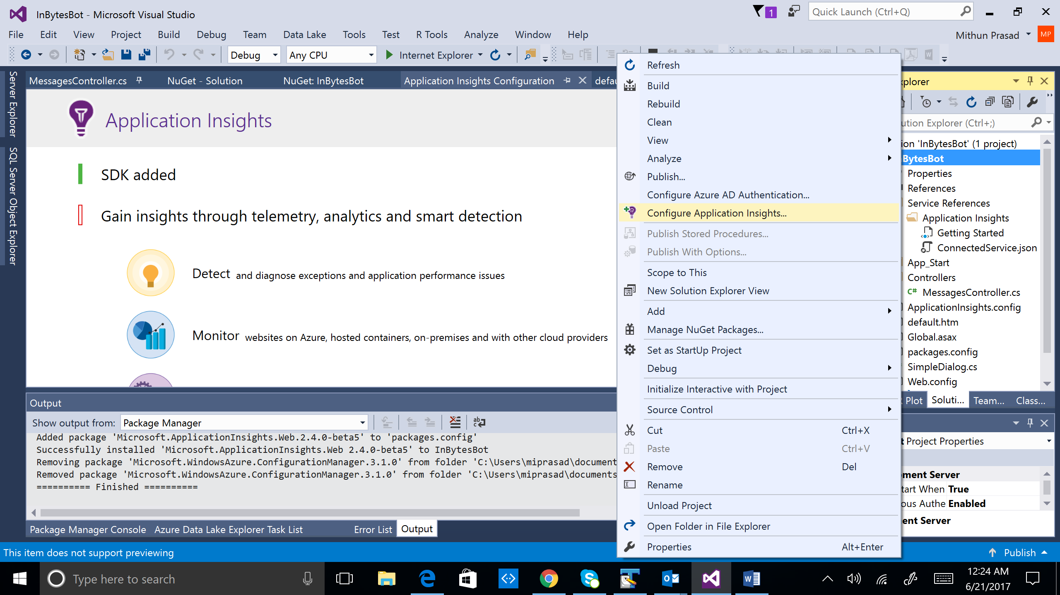

If *Configure Application Insights…* is not visible in your project, it needs to be added by following the below steps:

1. Right click on the project in *Solution Explorer* and select *Add*->*Application Insights Telemetry…*

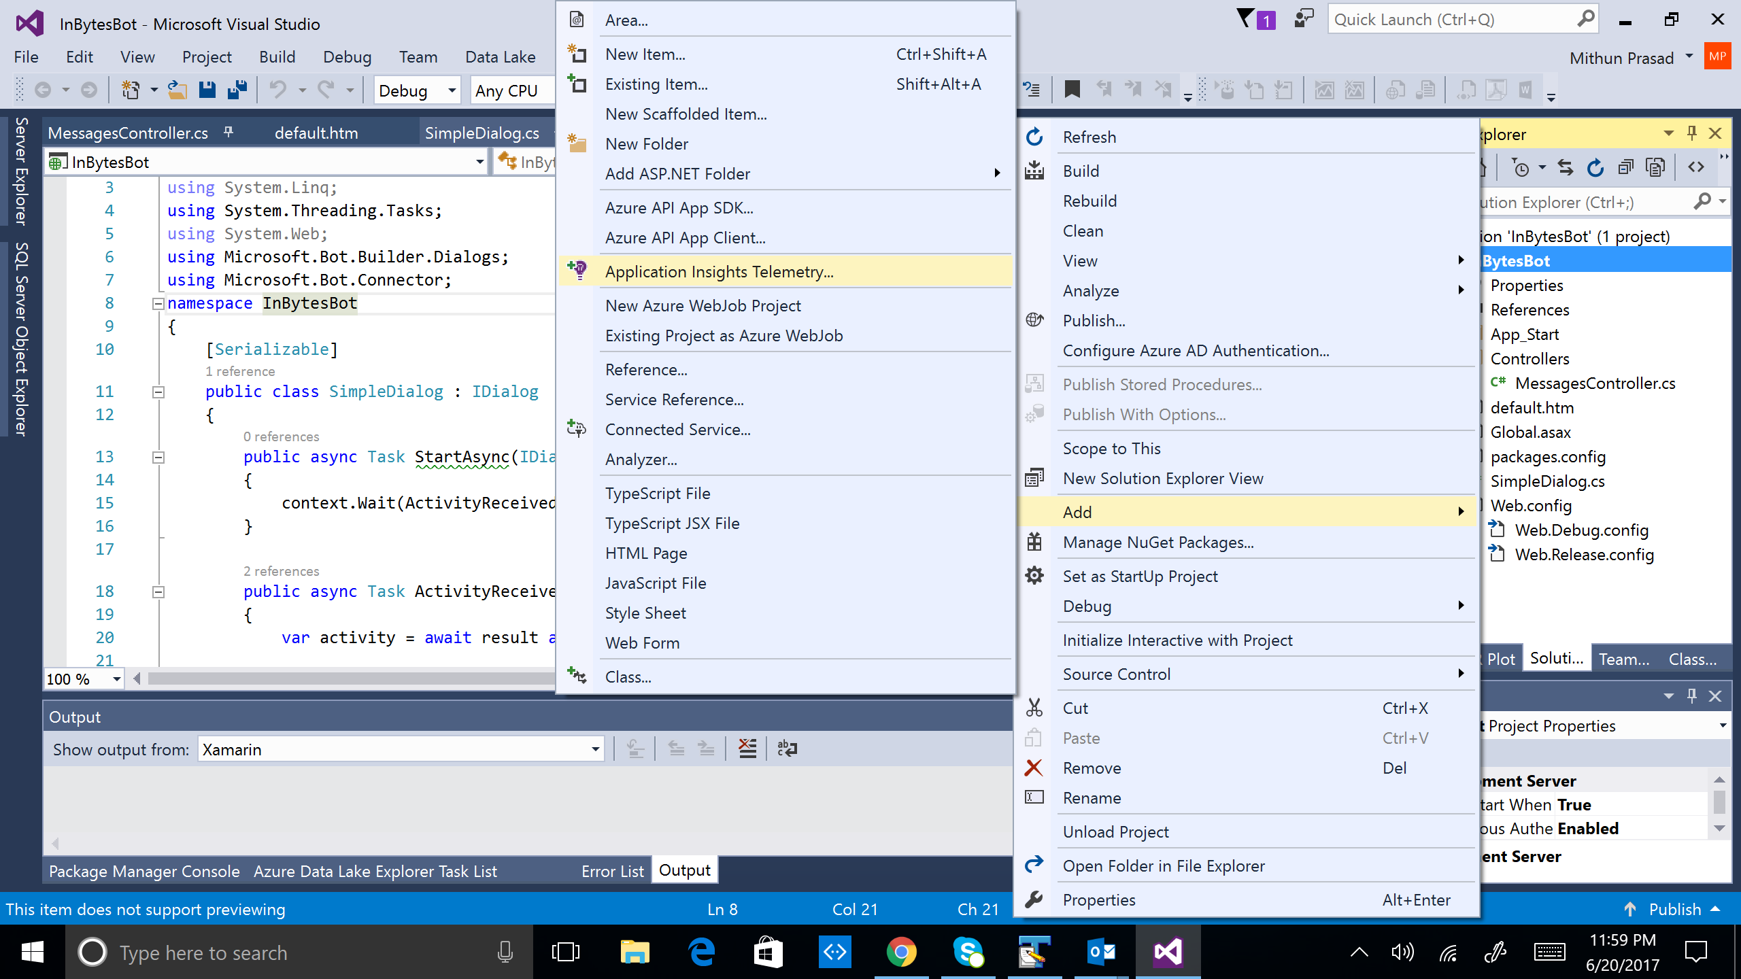

1. Select *Start Free*

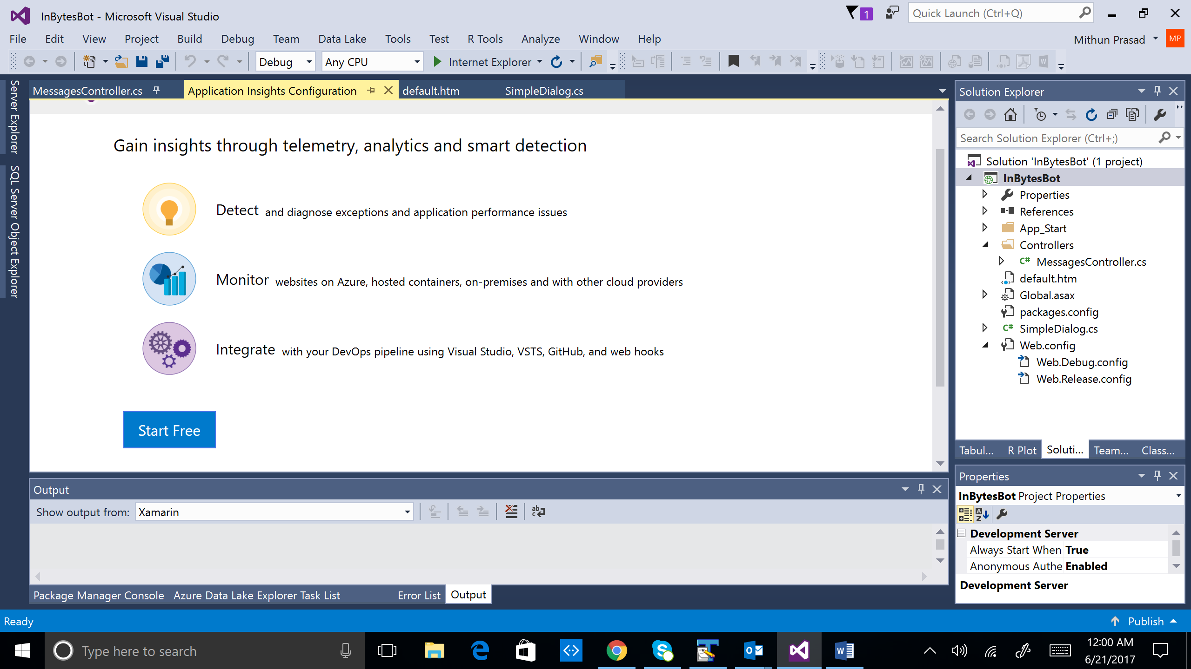

1. In the next page, enter Subscription and Resource information. Leave all other selections default.

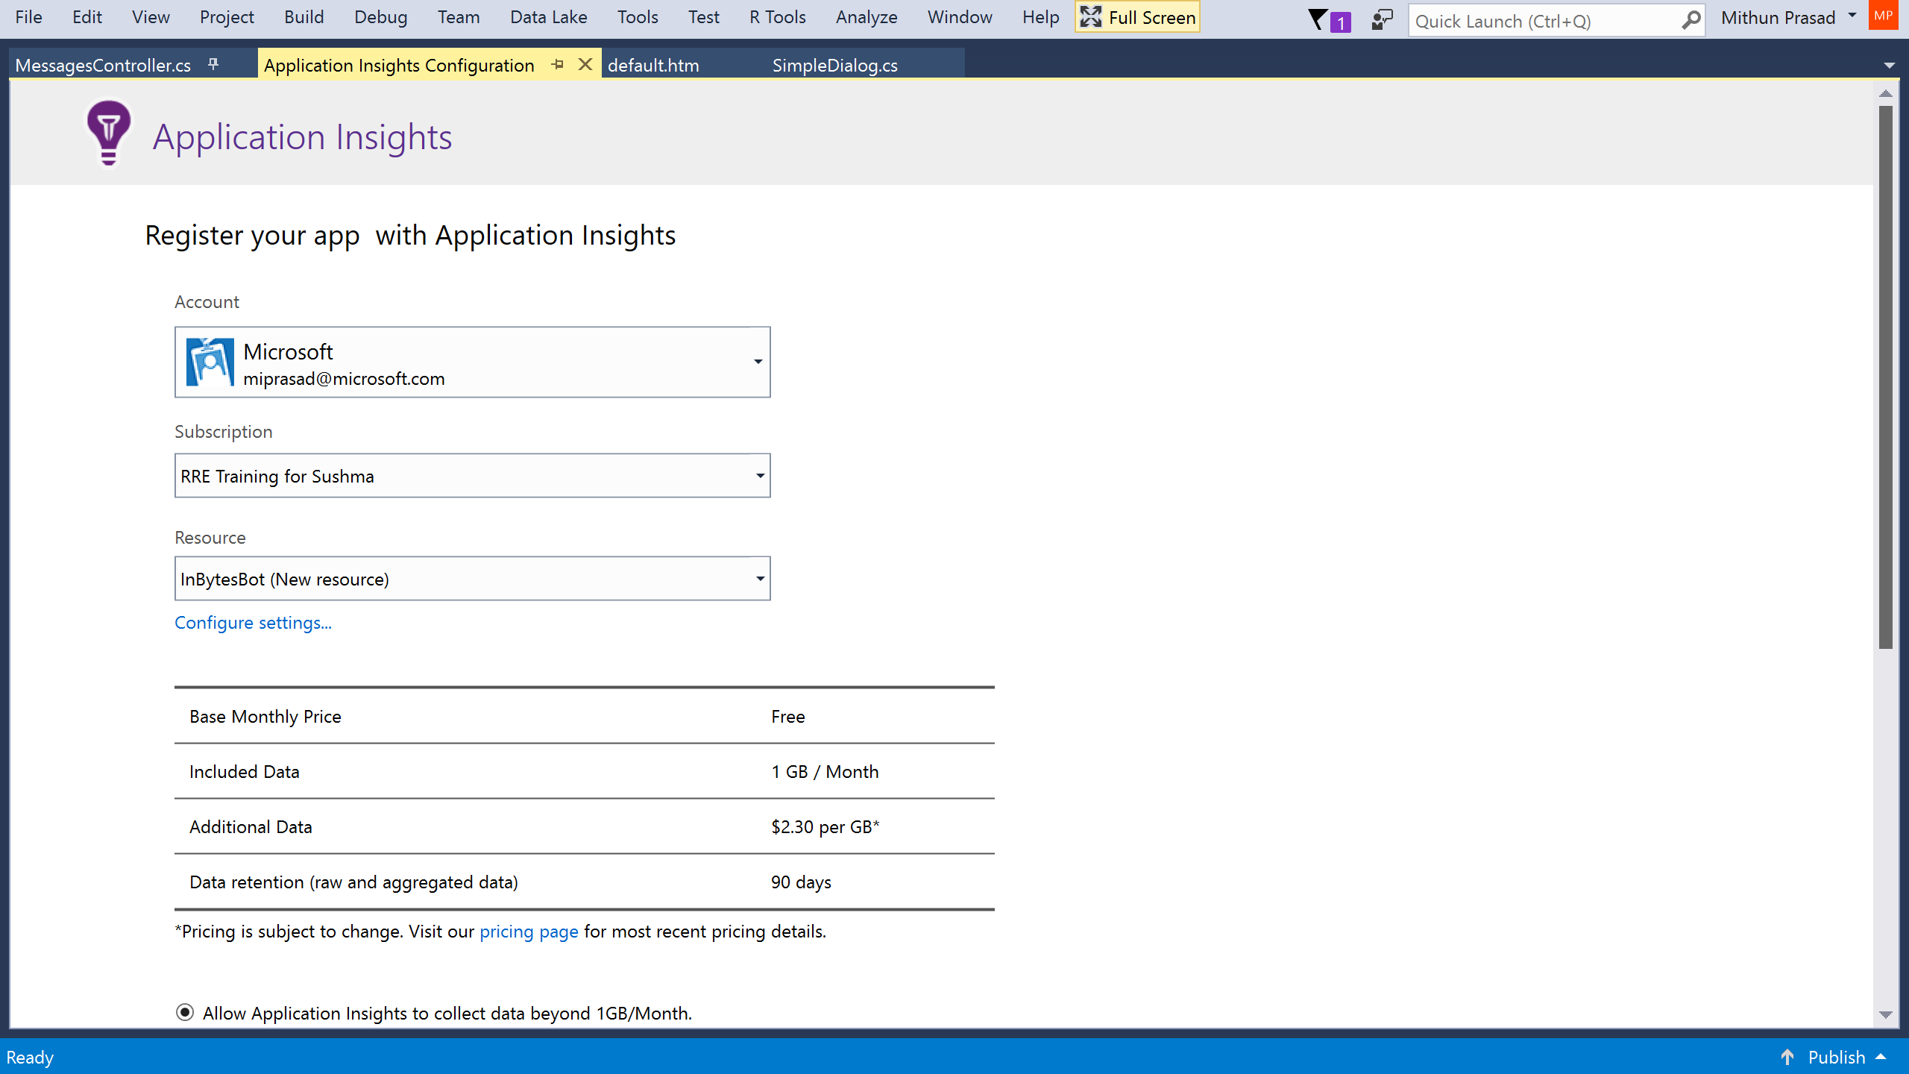

1. In the next tab, you will see progress of Application Insights added to the project.

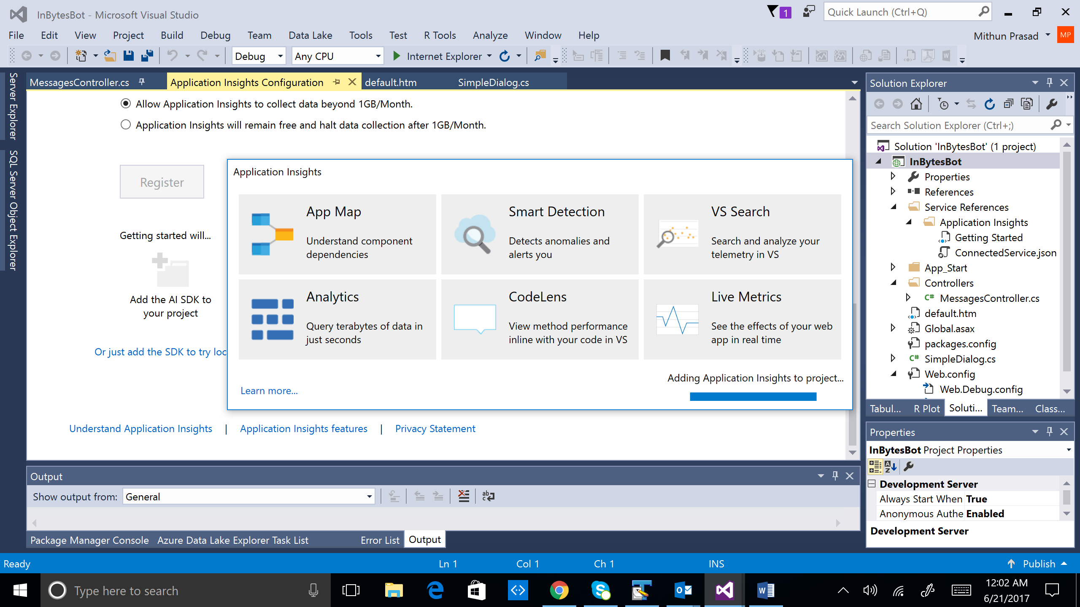

\*\*\* If you find errors with adding Application Insights to project, follow the instructions in Appendix A. It is quite likely that you have components that need to be updated.

1. The below image indicates that Application Insights have been configured successfully.

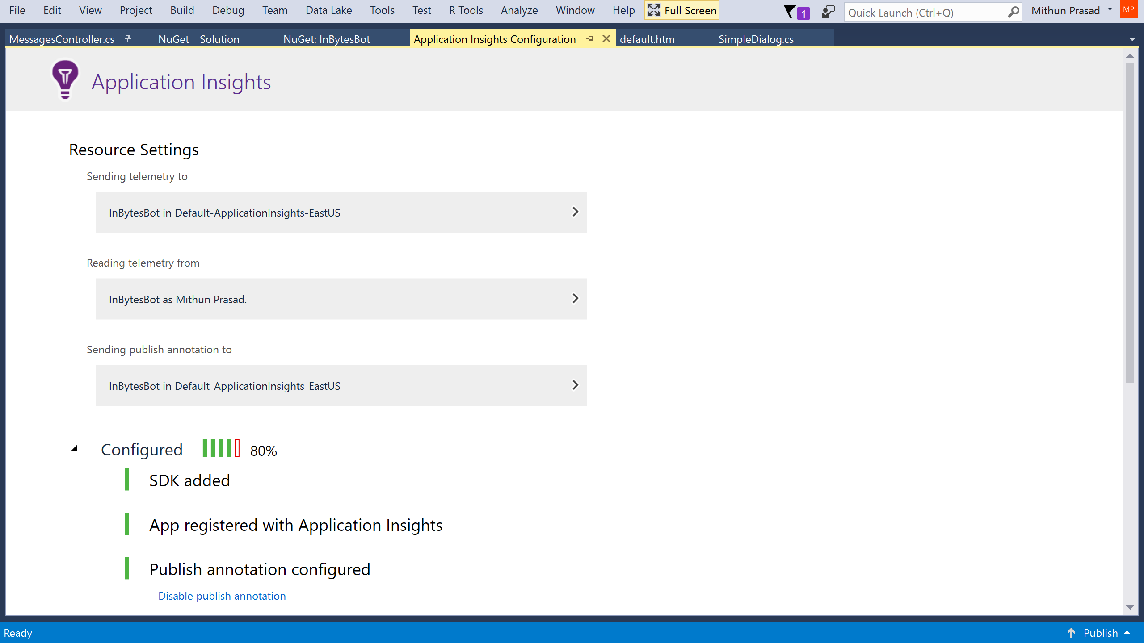

Configure Application Insights

On right-clicking the project in Solution Explorer, if you see *Configure Application Insights…*, you will not need to perform the last section steps. Ensure you see the below Configuration page to confirm that the Application Insights are configured.



1. Right click on the project in Solution Explorer and select *Application Insights* -> *Open Application Insights Portal*. This will take you to the portal.

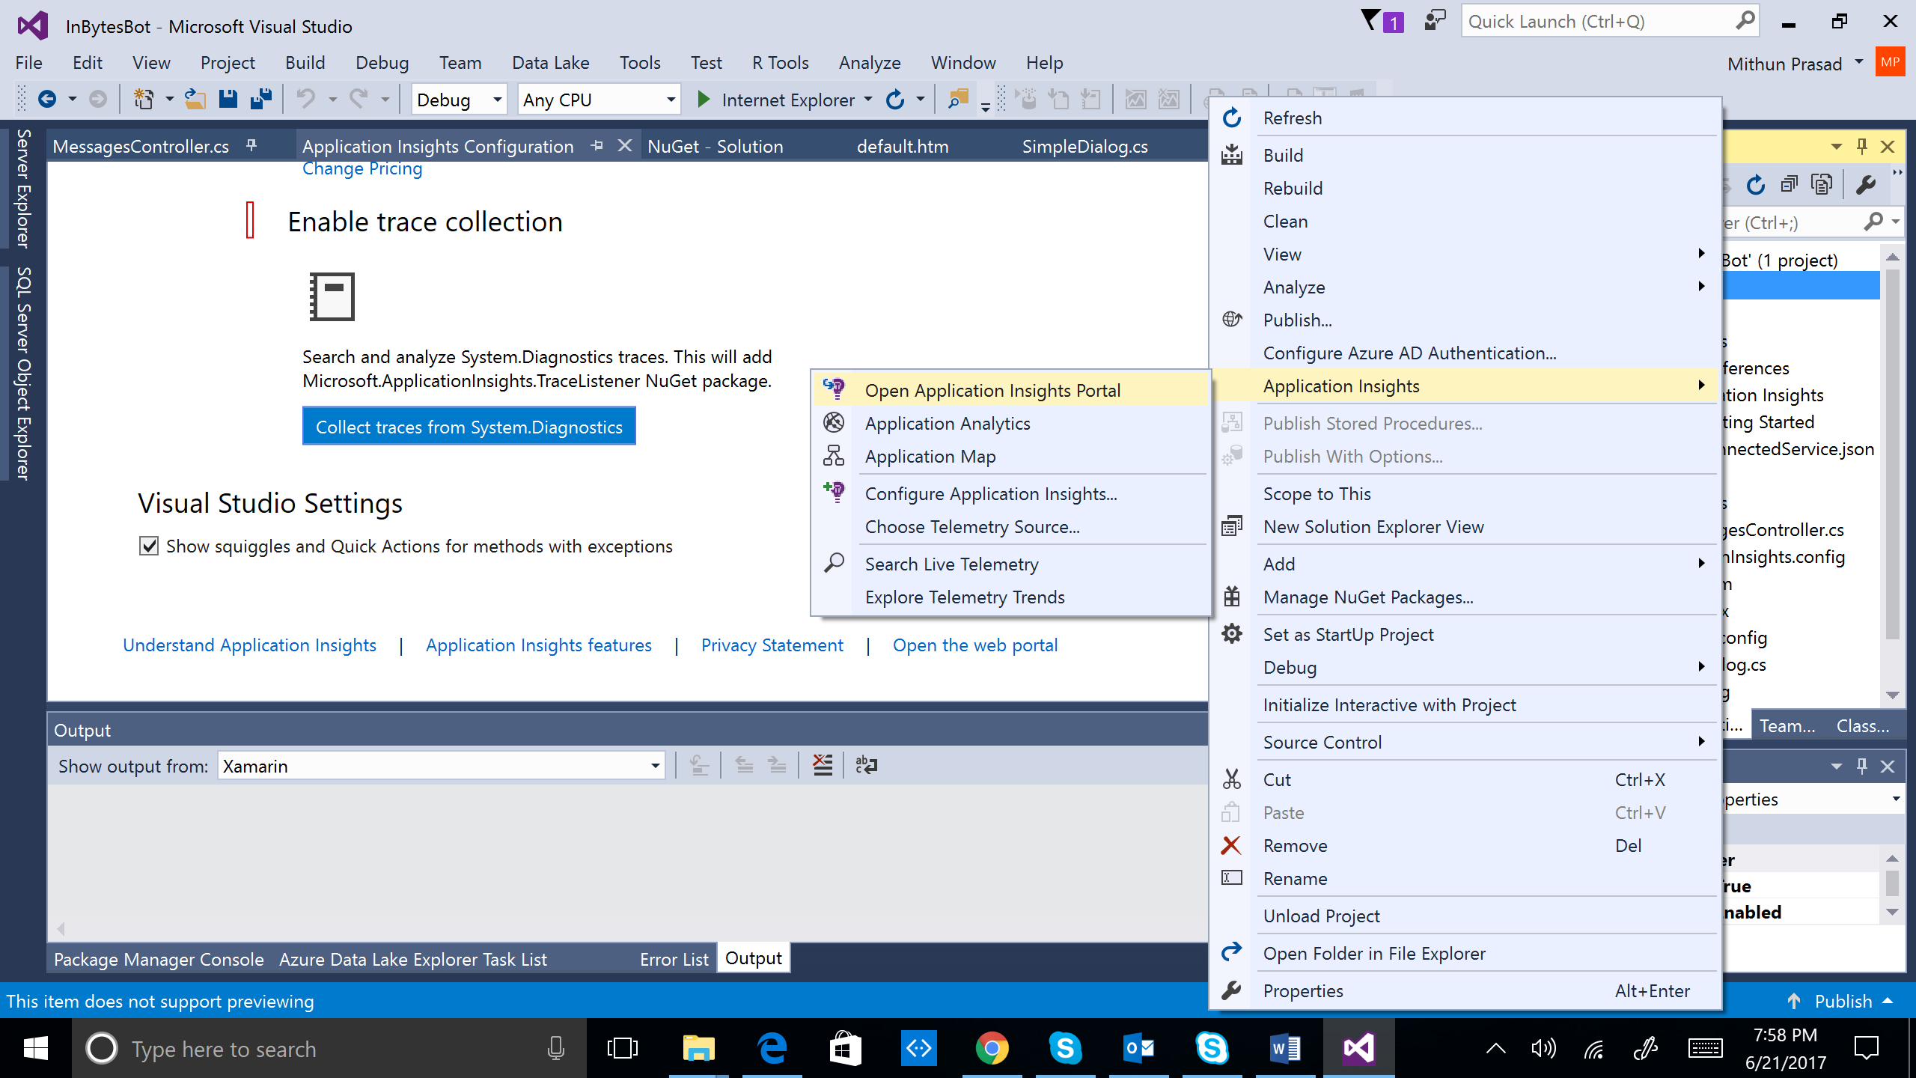

2. The Application Insights blade for the Bot application would look as follows. Select *Properties* and copy the *INSTRUMENTATION KEY*.

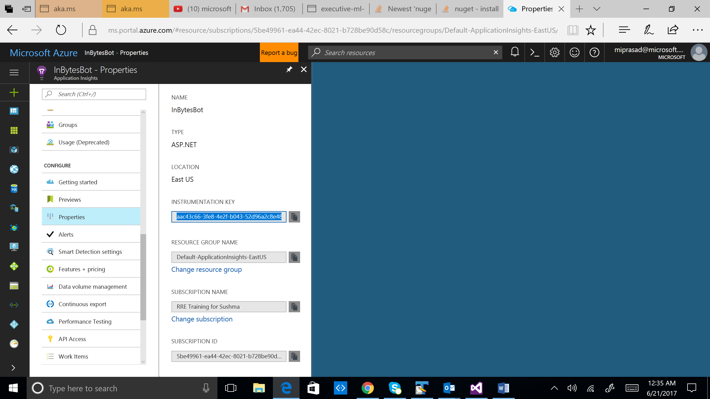

3. The key will need to be copied to your existing bot from My Bots section - <https://dev.botframework.com/>

Click Edit and scroll to the end as illustrated in the image below. You will find the Instrumentation Key text box. Update the key and save.

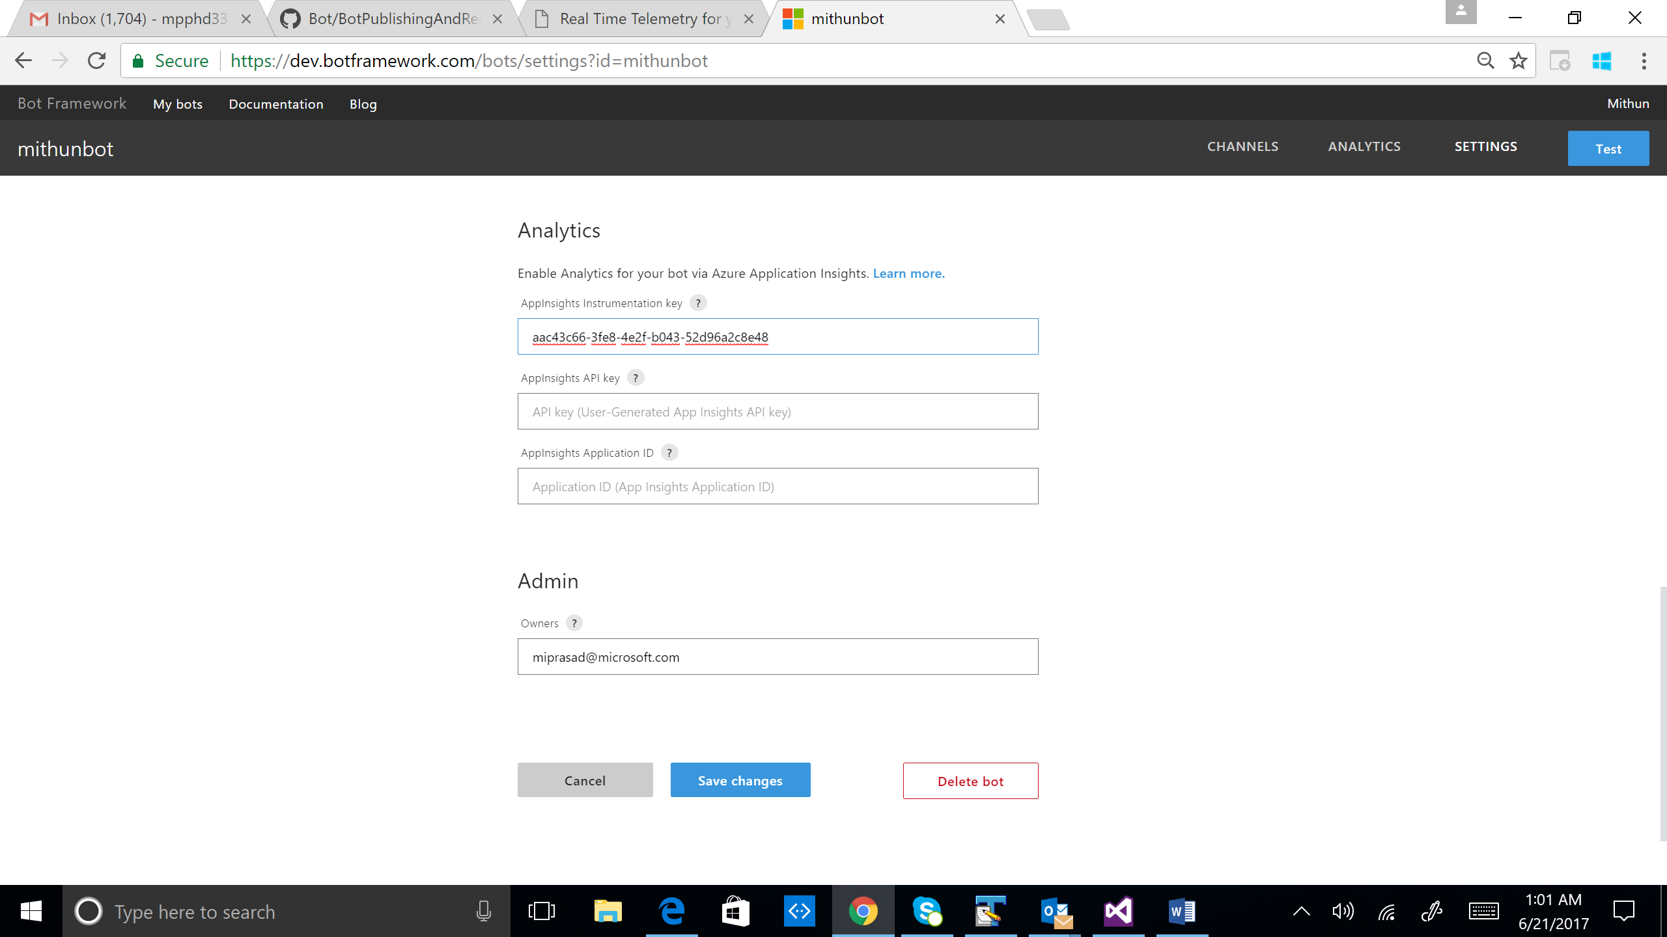

Metrics

In the Application Insights blade for the Bot application, select *Metrics Explorer*. In the *Chart details*, select metrics to add for monitoring. For example, select *Server response time* to monitor this metric.

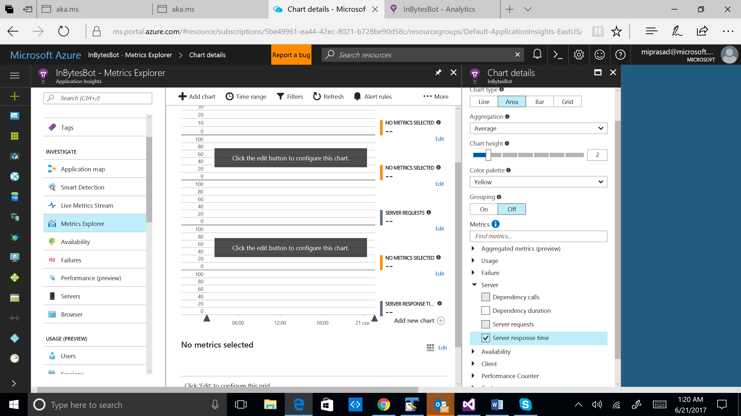

Over time, you should start receiving telemetry data in your Application Insights portal.

Appendix A

Add Application Insights

When adding Application Insights, if you see the below error, it’s because the package Microsoft.ApplicationInsights.Web has not been installed.

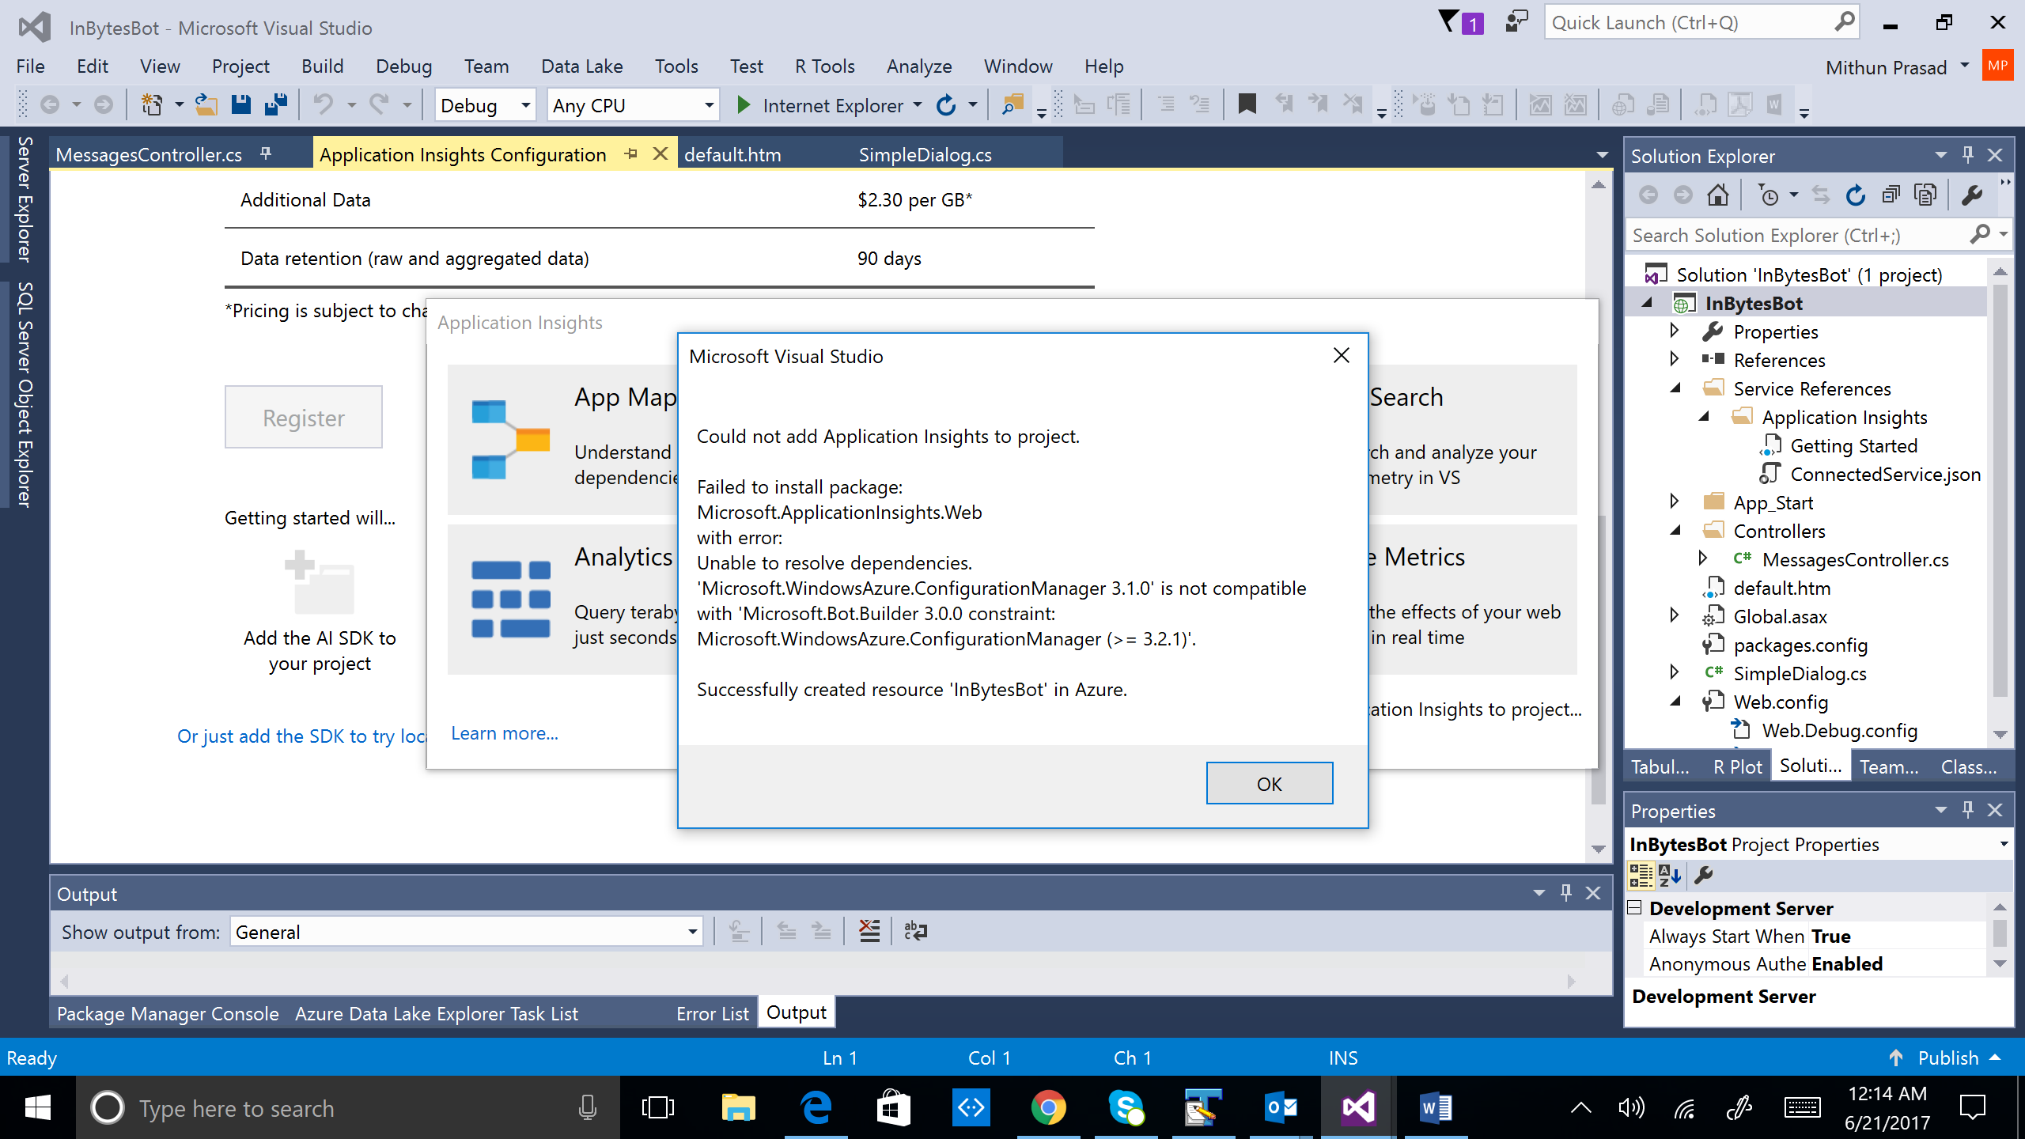

1. Right click on the Solution in the Solution Explorer and select *Manage NuGet Packages for Solution…*
2. Search for ApplicationInsights in the Browse window and Install Microsoft.ApplicationInsights.Web

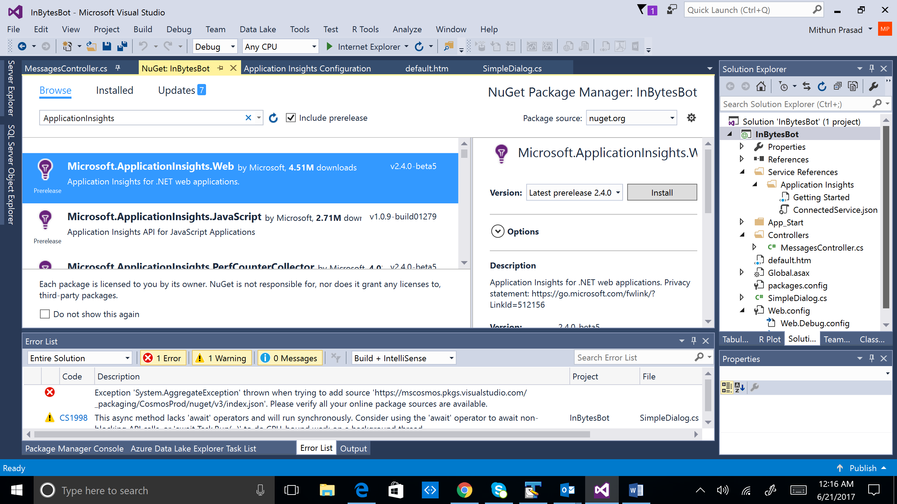

3. If the above error occurs, change the *Package Manger Settings* as shown below.

