PCA and FLD for Analyzing Human Faces

Chufeng Hu | UID: 504687715 | huchufeng@g.ucla.edu

This project’s object is to compare two types of representations for dimension reduction: PCA and FLD. The data contains 177 human faces (88 males, 85 females, 4 unknown), and is divided in to training set and test set in both methods.

## ASM and AAM model for face reconstruction

(1). Using PCA to find first k eigen-faces in the training set, and use them to reconstruct test set faces.

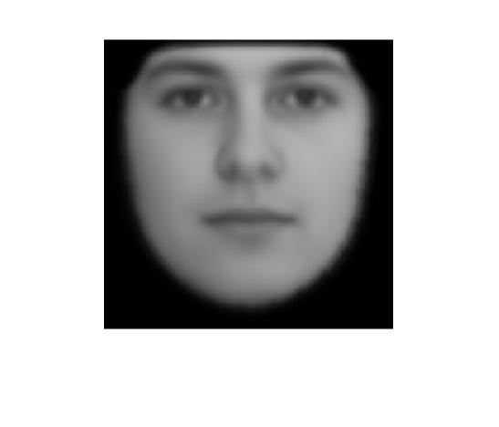

Figure

Figure 1 shows the mean face of the faces in training set, the face is mutual sex and balanced in appearance.

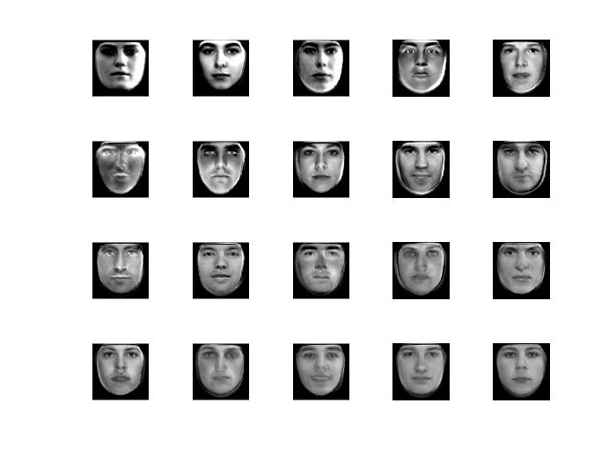

Figure

Figure 2 shows the first 20 eigen-faces in training set. Each eigen-face is calculated by their corresponding eigen-vector multiplied a factor $δ$ and add the mean face. Compared with the mean face, eigen-faces control the face structure like light, width, length, the depth of eyes, etc.

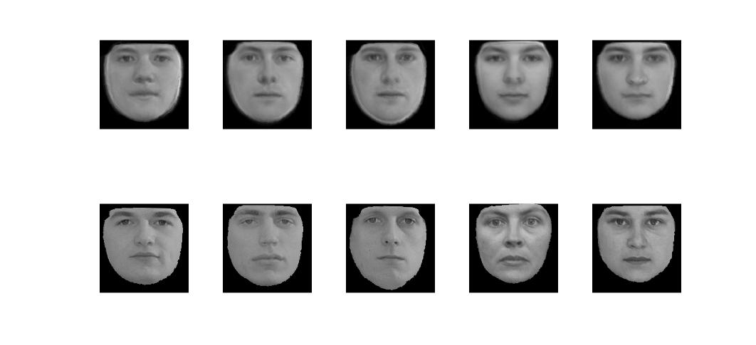

Figure

Figure 3 compares the reconstructed faces with the original faces. We can see that all faces’ appearance has been smoothed. (first row are reconstructed faces; the second row are original ones).

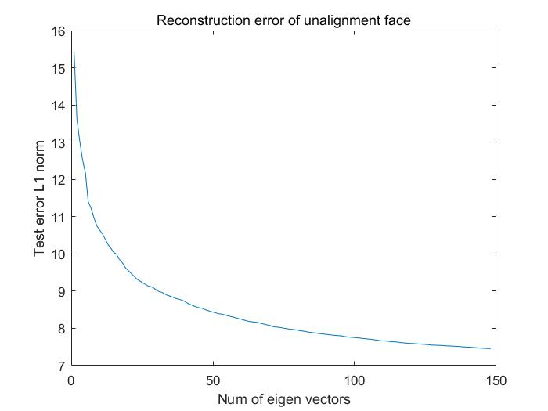

Figure

Using first K eigen-faces to reconstruct faces in testing set. The error is measured by L1 norm of the difference per pixel, and averaged by testing images. As the number of eigen-face increasing, the test error decreases.

(2). Find mean landmark and first 5 eigen landmarks in training faces.

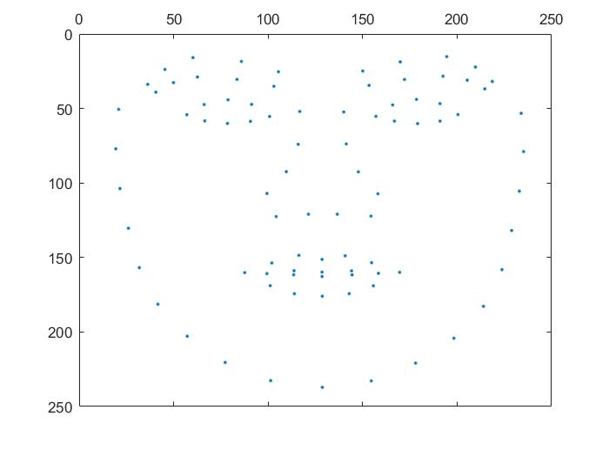

Figure

Figure 4 shows the mean landmark of the training faces, the geometry is balanced and every part of the face (i.e. eyes, nose, mouth) is well defined.

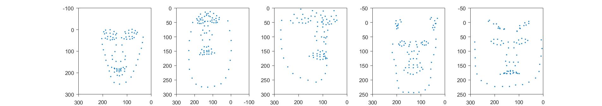

Figure

Figure 5 shows the first 5 eigen landmarks in the training set. Every landmark represents a geometric feature of the face. For example, the first eigen landmark controls the width of the face.

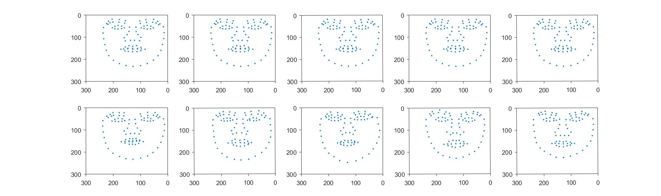

Figure

Figure 7 compares the difference between the reconstructed test faces, the second row are original ones.

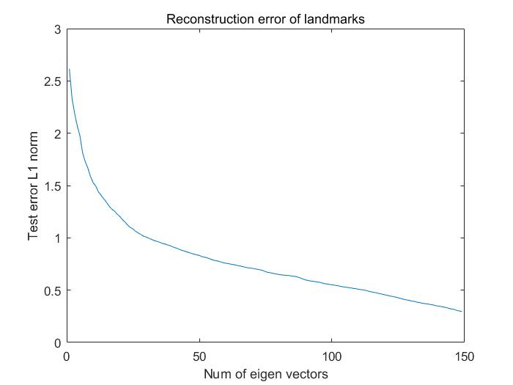

Figure

The test error of the reconstructed landmarks decreases as we using more eigen vectors to represent the test face.

(3). Combining two steps above, use top 10 eigen vectors to reconstruct landmarks and use top k eigen vectors to reconstruct appearance.

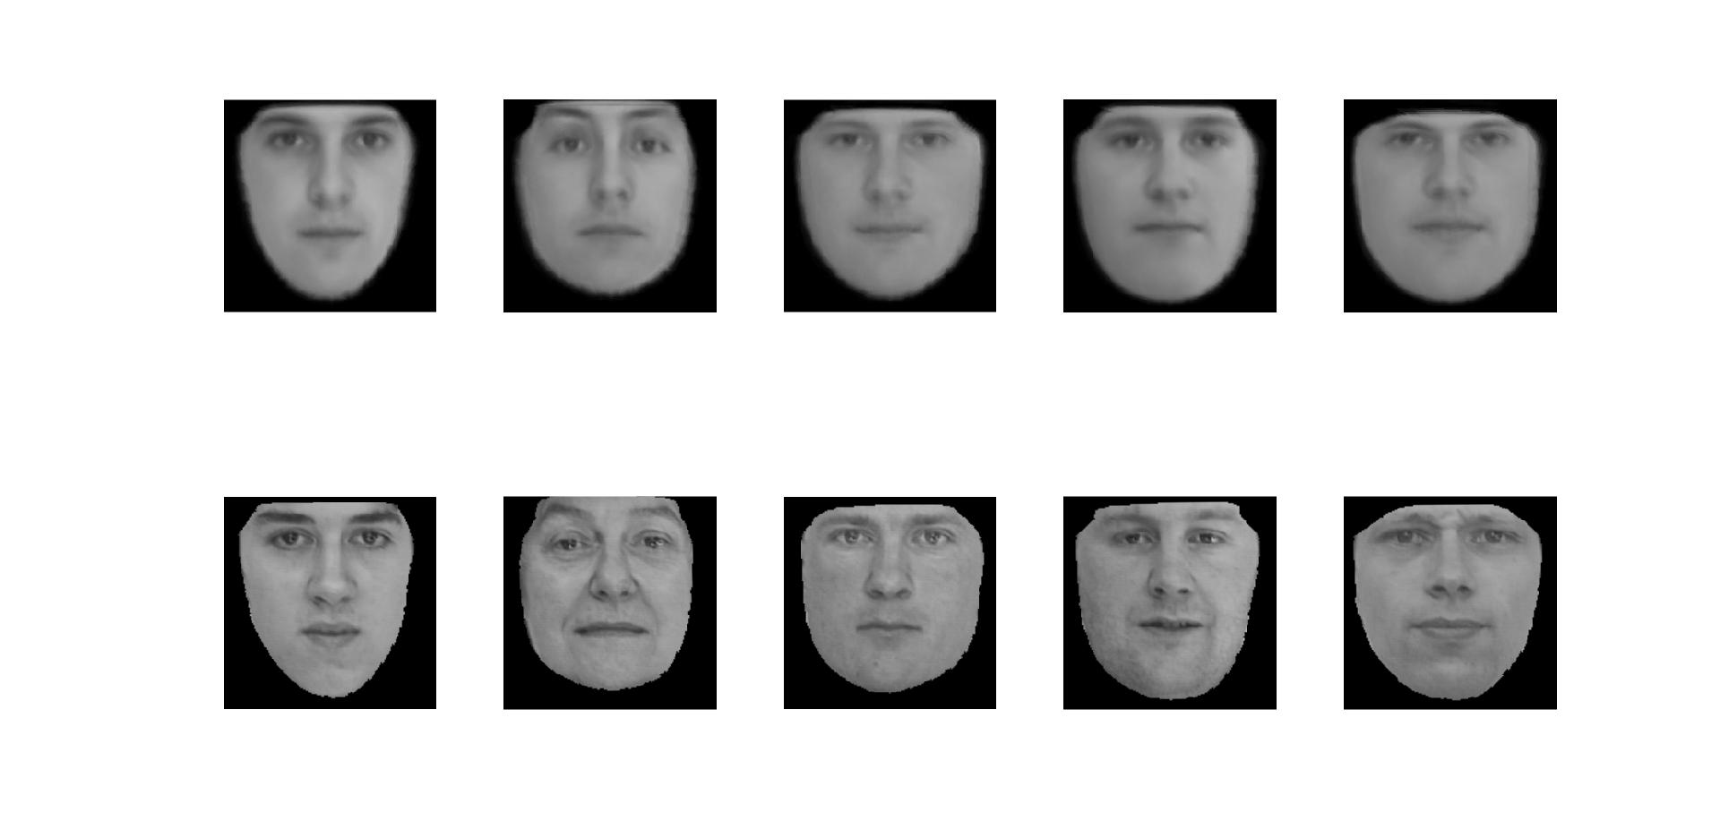

Figure

Figure 9 compares the reconstructed faces with original faces, the second row are original ones. Different from the step 1, both their appearance and geometric features have been smoothed. And since we loss appearance and geometric information, the test error would be higher than the two steps above.

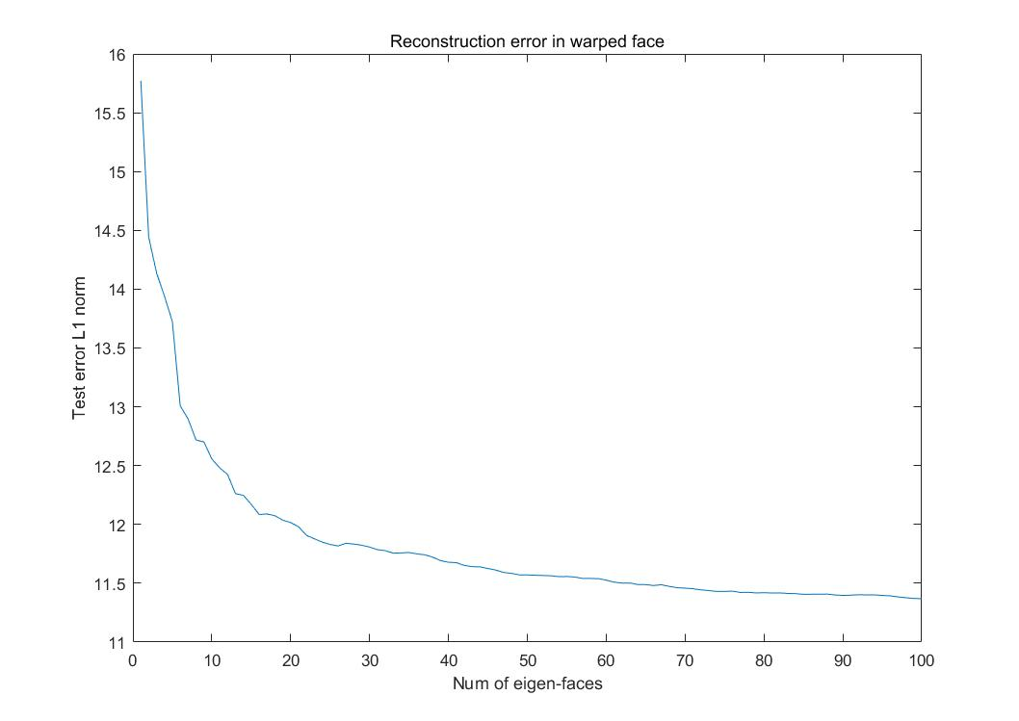

Figure

Figure 10 shows the test error in L1 norm per pixel against the number of eigen-faces k.

(4). Now with eigen-faces and eigen-landmarks, we can synthesize random faces by sampling the eigen vectors.

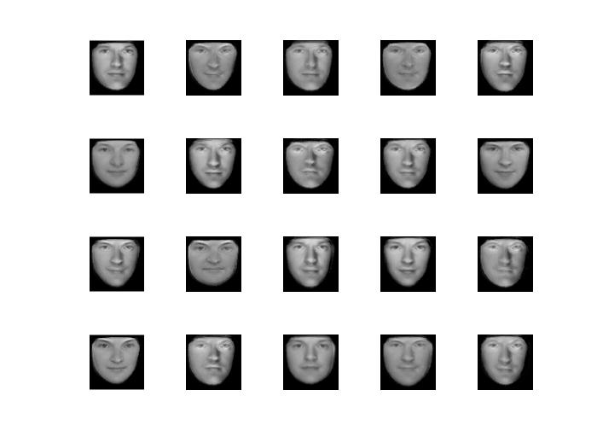

Figure

Figure 11 shows the 20 random faces sampling from a uniform distribution.

## Fisher faces for gender discrimination

In this part, using fisher faces to discriminate faces into male and female. By applying the fisher linear projection, face’s gender feature can be represented in a few dimensions.

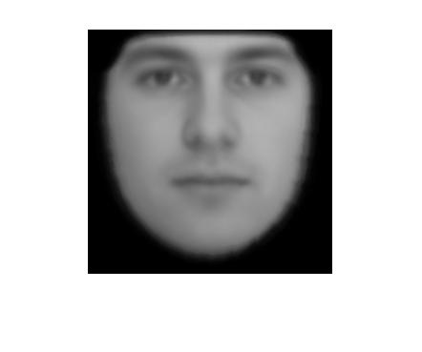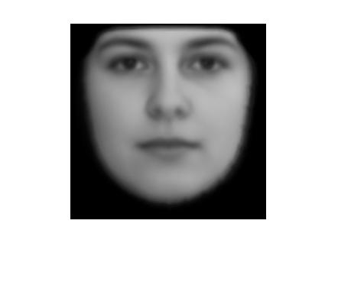

Figure

Figure 12 shows the mean face of male and female in training set. There’re geometric and appearance differences between them.

(5). Find fisher face to distinguish male from female. In this projection, all faces are projected on a 1-dimension space.

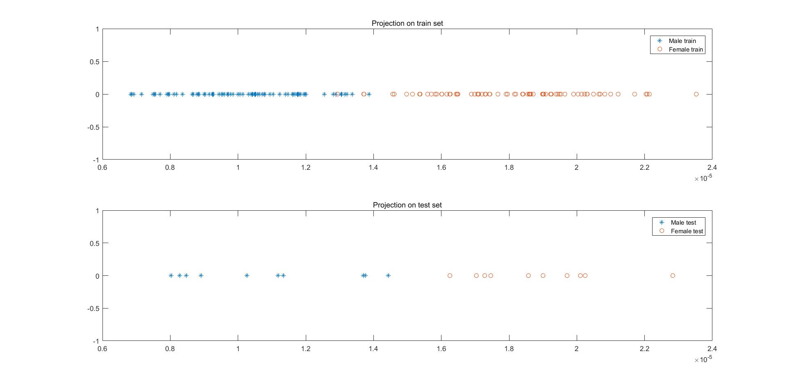

Figure

Figure 12 shows the projection on training set and testing set. The fisher projection is calculated by the training set then applied on the testing set. Each points represents a male or female face.

(6). Using 2-dimension to discriminate male and female faces. First find Fisher faces for the geometric shape, then aligning all faces to the mean position, and find Fisher face for the appearance.

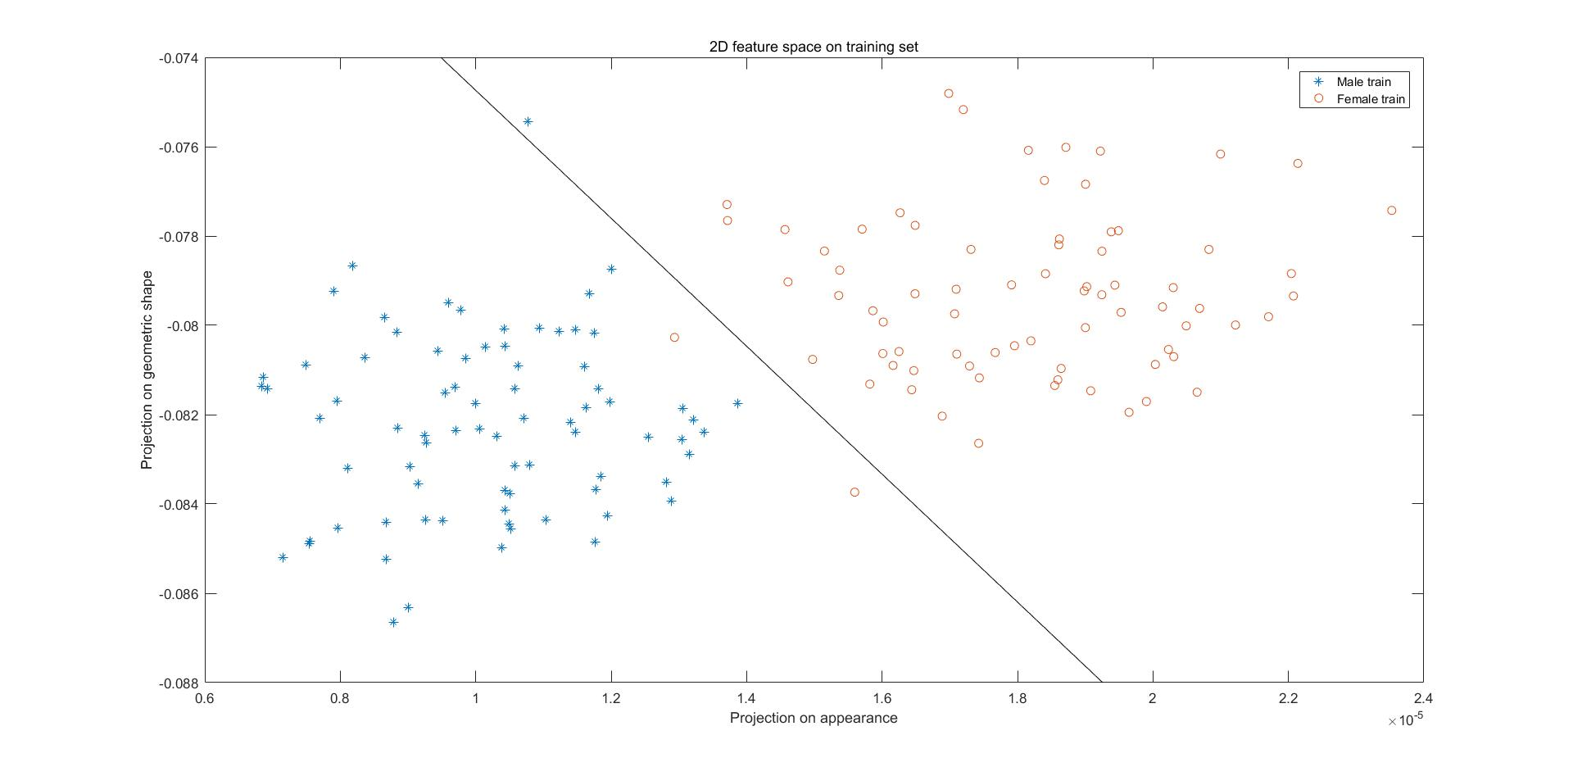

Figure

Figure 13 shows the Fisher faces in 2-dimensions in training faces.

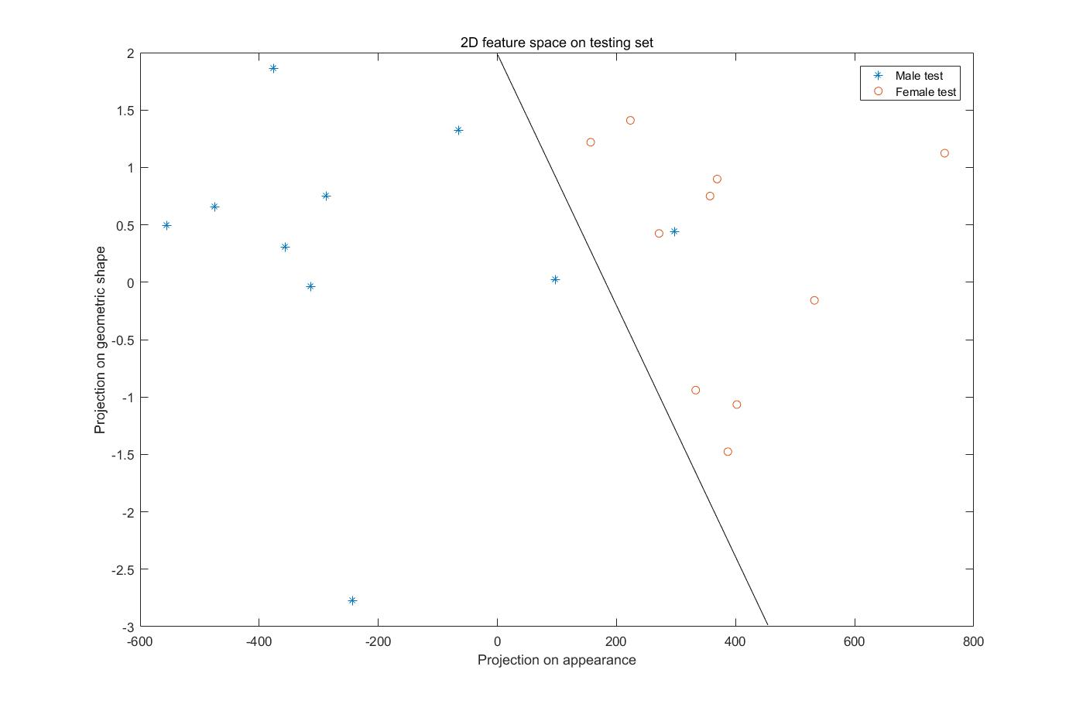

Figure

Figure 14 shows the Fisher faces in testing set, there are only one test face are miss classified by the Fisher discrimination.

## Conclusion

In this project, we use PCA and Fisher faces to represent high dimensional data by very few features. PCA can help us find and understand the main features or structures of human face(data), since each eigen vector can represent orthogonal dimensions of the data space, we can also use them to generate arbitrary human faces. Fisher faces can help us discriminate faces(data) in high dimension space on low dimensions, where data are more easily to be interpreted. By setting appropriate threshold in the low dimensional space, one can classify the high dimensional data into different labels. To optimize the threshold, we can use Cross-Validation.