**How To Configure The Smart Account**

1. Import the ‘config’ private key into Scatter

**5KFjDvq33nnsGLL9kJ1jNxzMRcWoQBE65ecpfCeDySyEJwctnpX**

2. Give this key a new name. I will use **smartaccount@config**

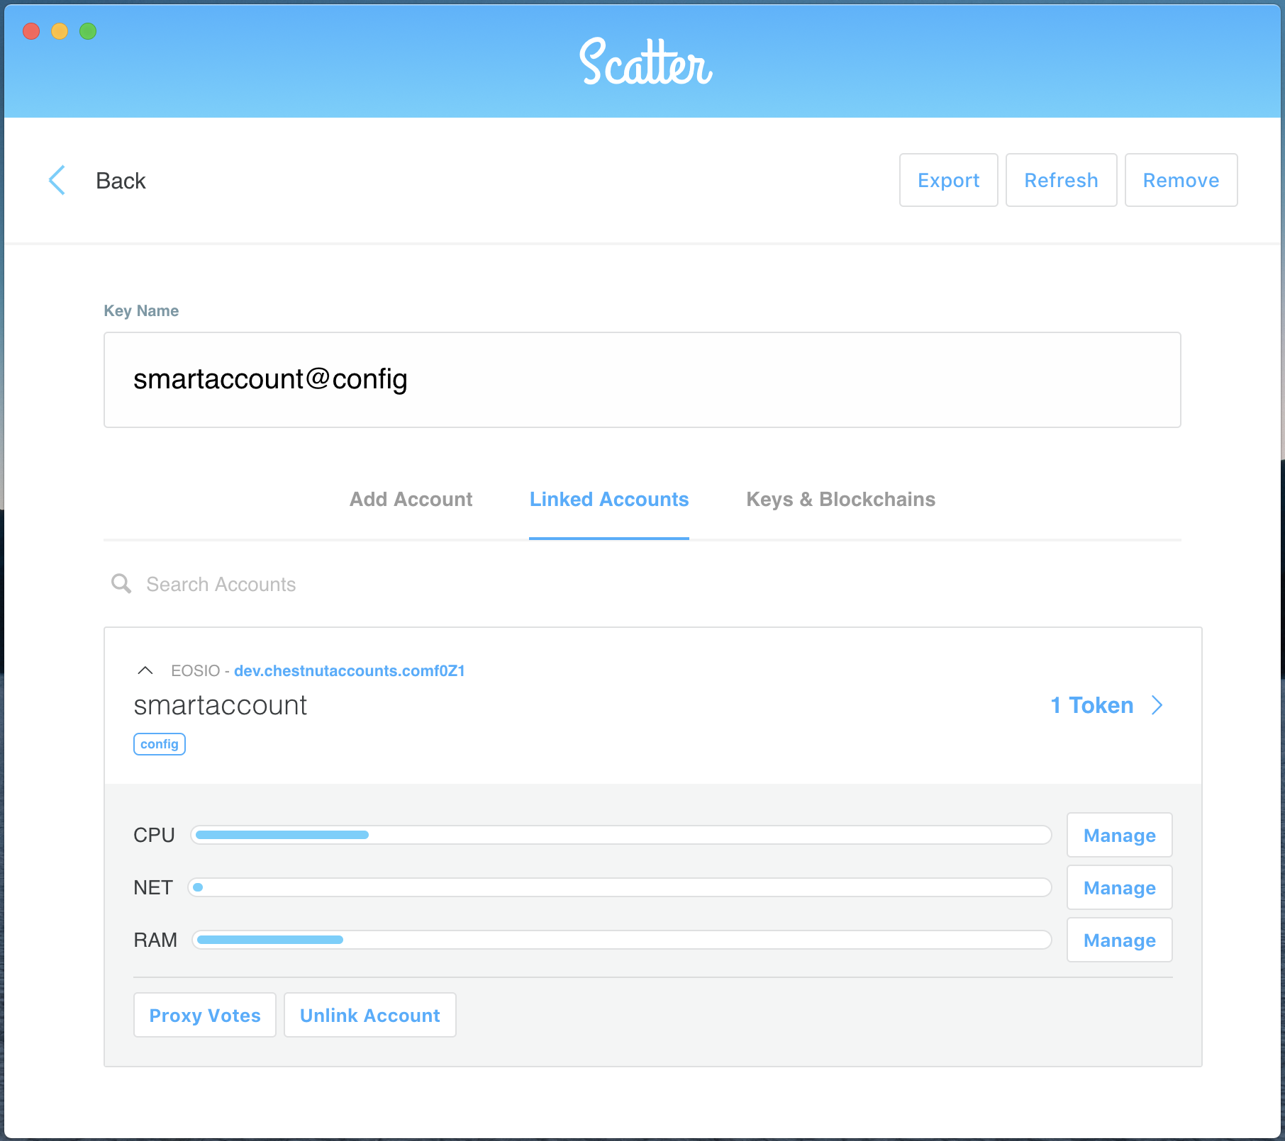

3. Click the **Back** button at the top left

4. Go to your favorite Jungle Testnet block explorer, log in with Scatter, search for the **chestnutacnt** account and then click on **Contract**

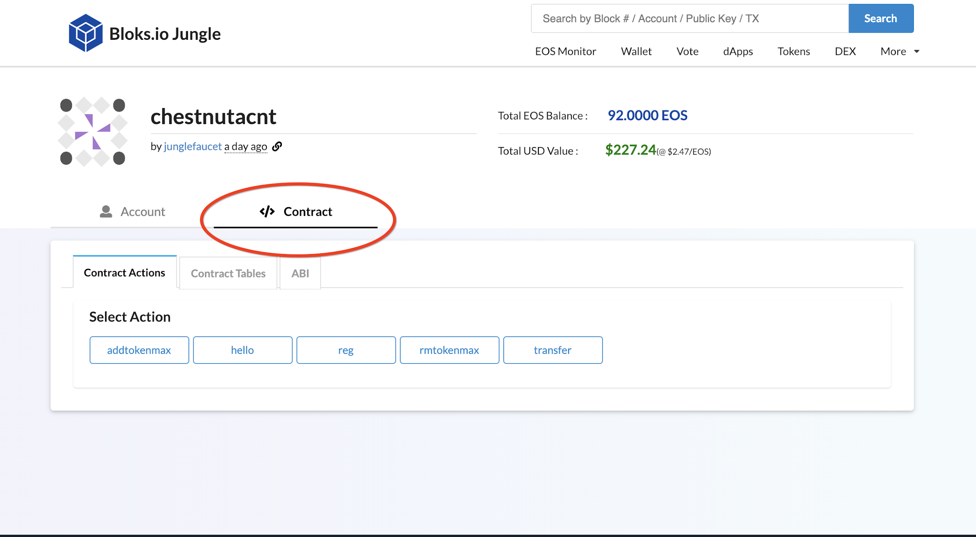

6. Click on the action **addtokenmax** and enter the information about the maximum token you wish to transfer at a single time.

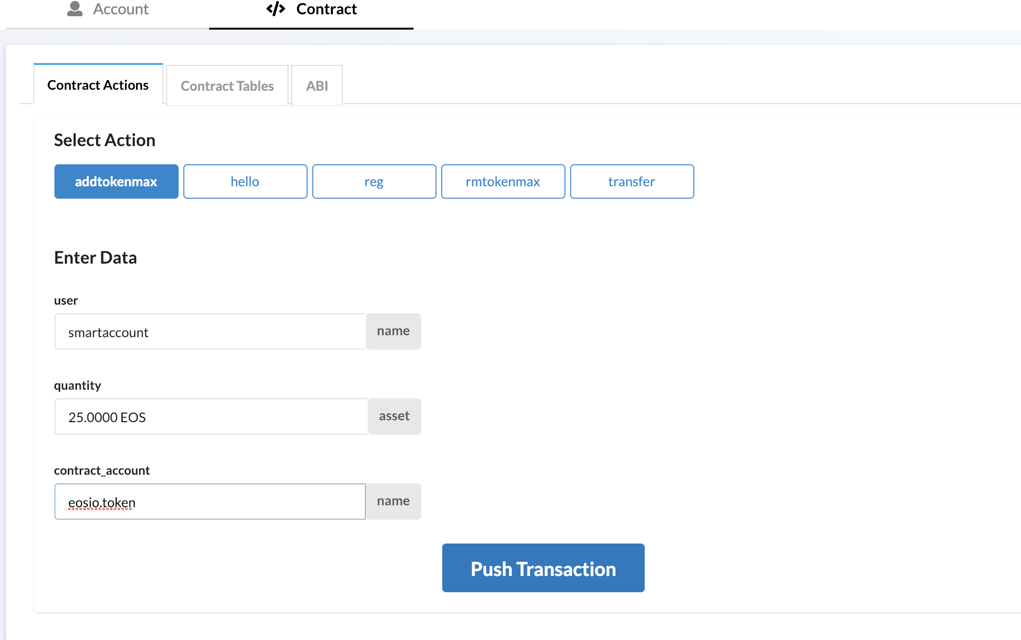

7. Click on **Push Transaction** and Allow with Scatter

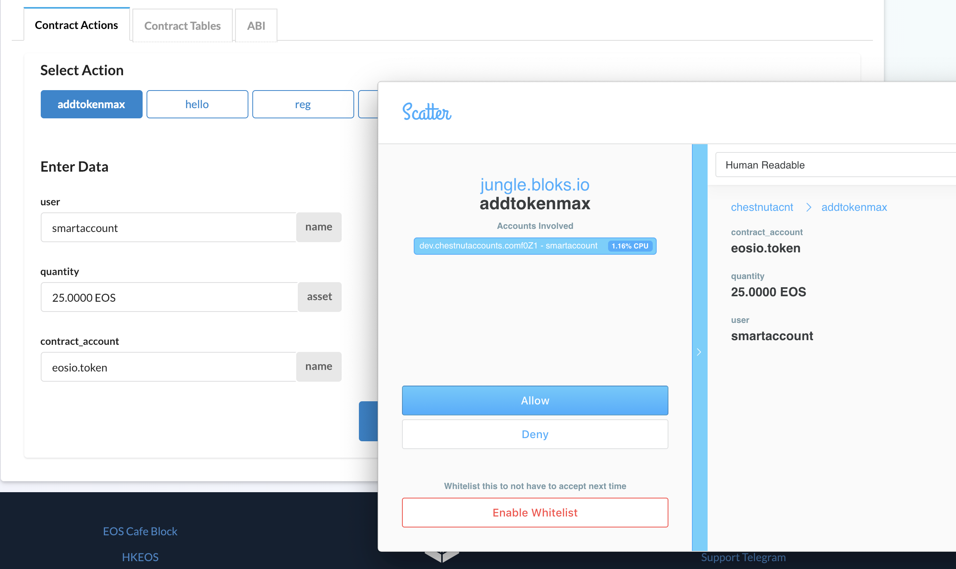

8. The transaction should succeed (you can remove this limit with the **rmtokenmax** action)

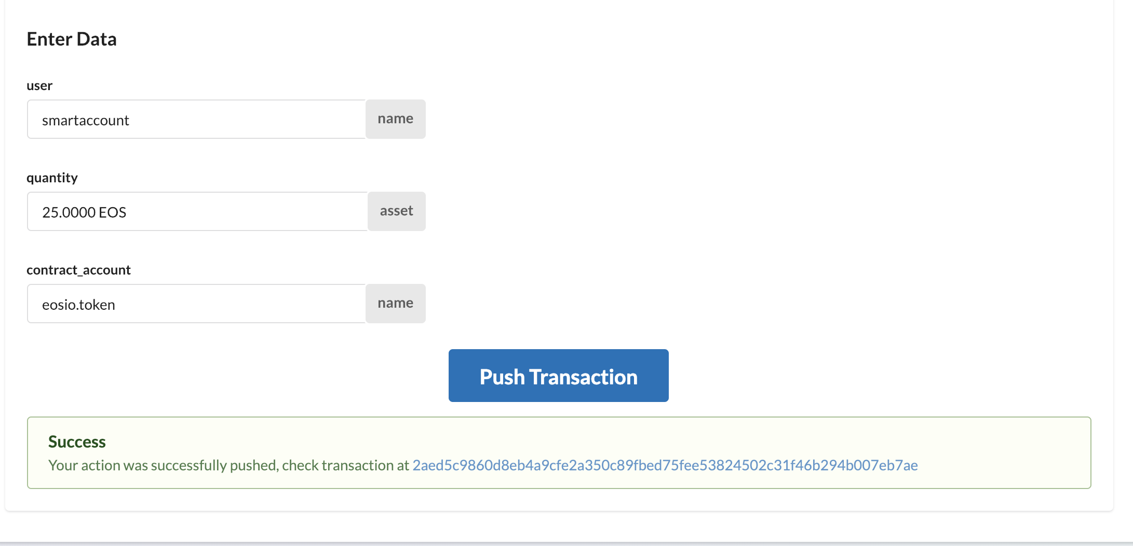

9. Remove the key from Scatter once you are done with the configuration

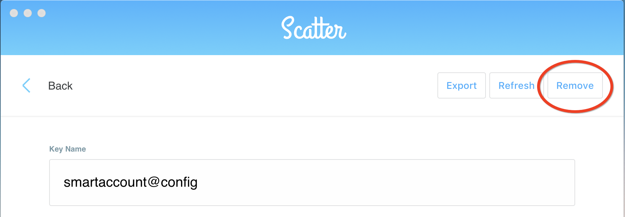

10. Confirm

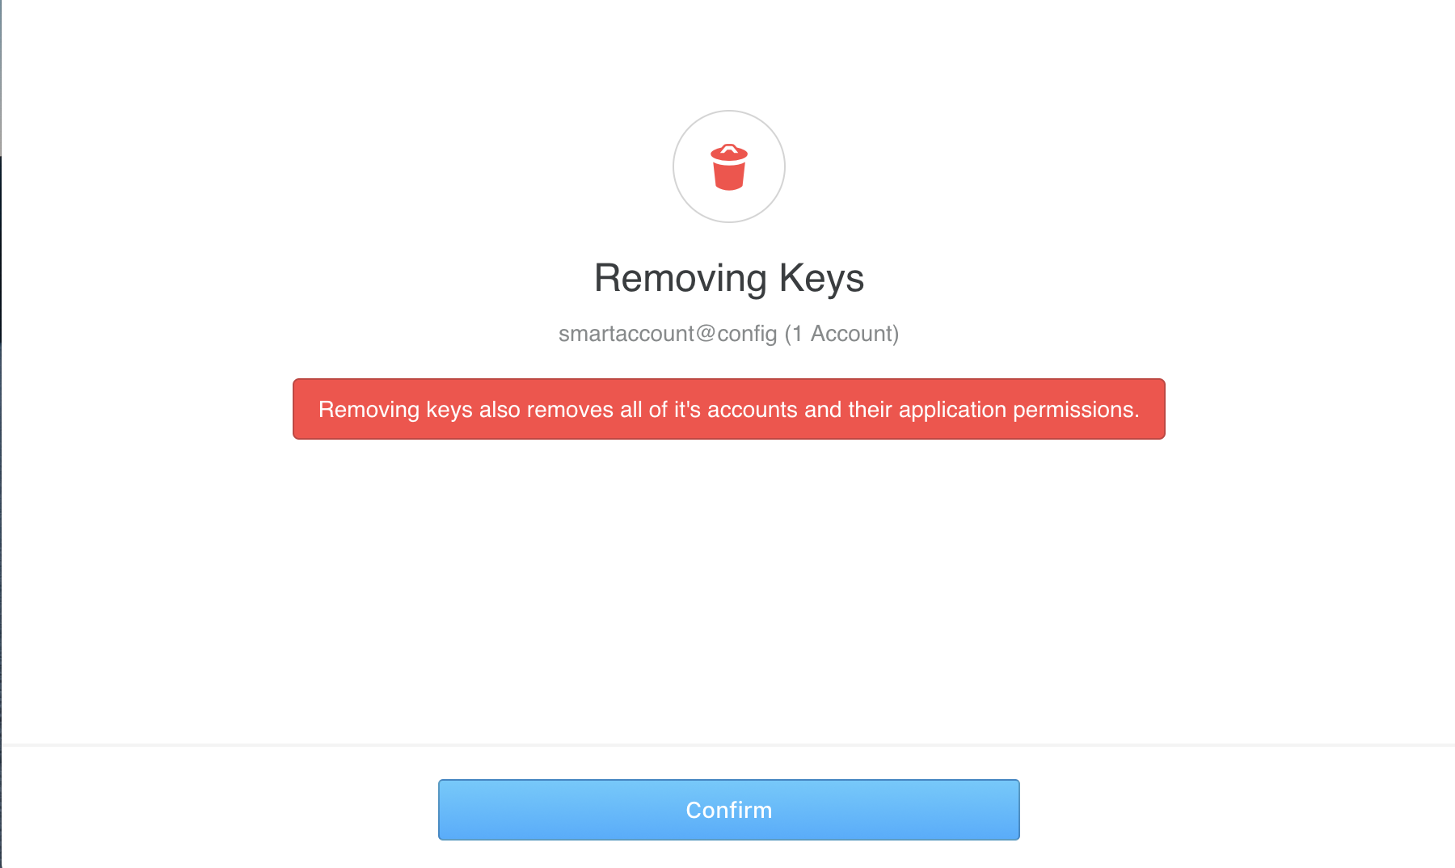

**How To Use The Smart Account**

1. Import this private key into Scatter

**5JpPzWK9RFtdKzJneWuQYyFrcQWVCF8FT5dUYWoaaUNs4VeGNy5**

2. Give this key a new name. I will use **smartaccount@chestnut**

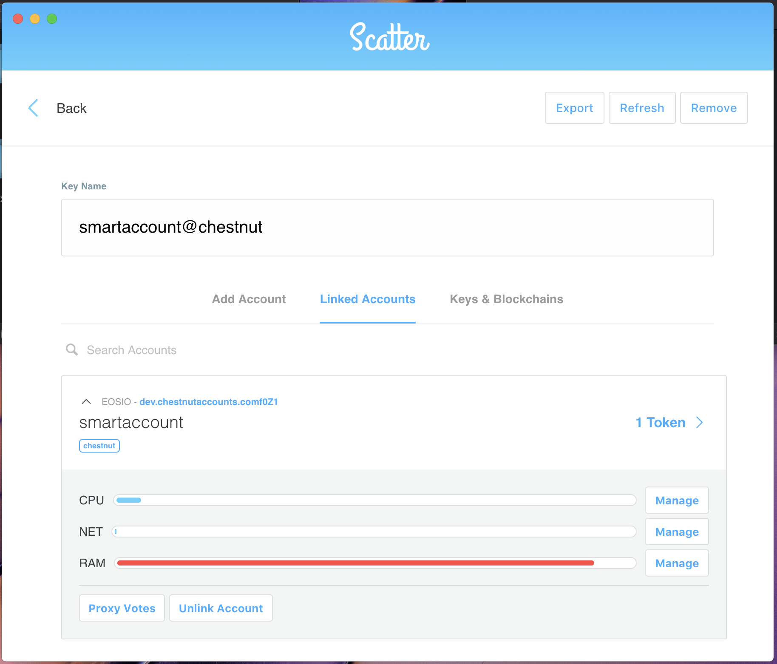

3. Click the **Back** button at the top left

4. Now click on **Send** tokens at the top right

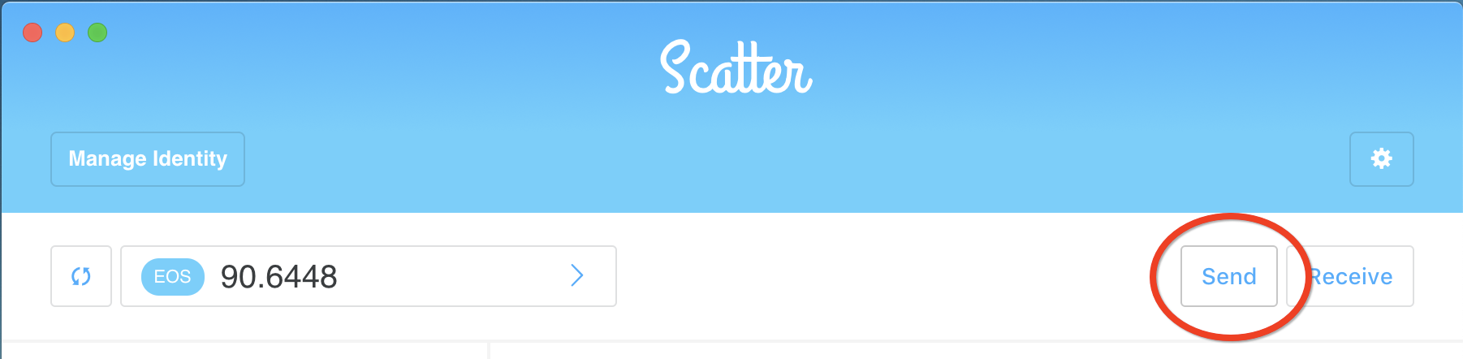

5. Click on **smartaccount** at the bottom of the page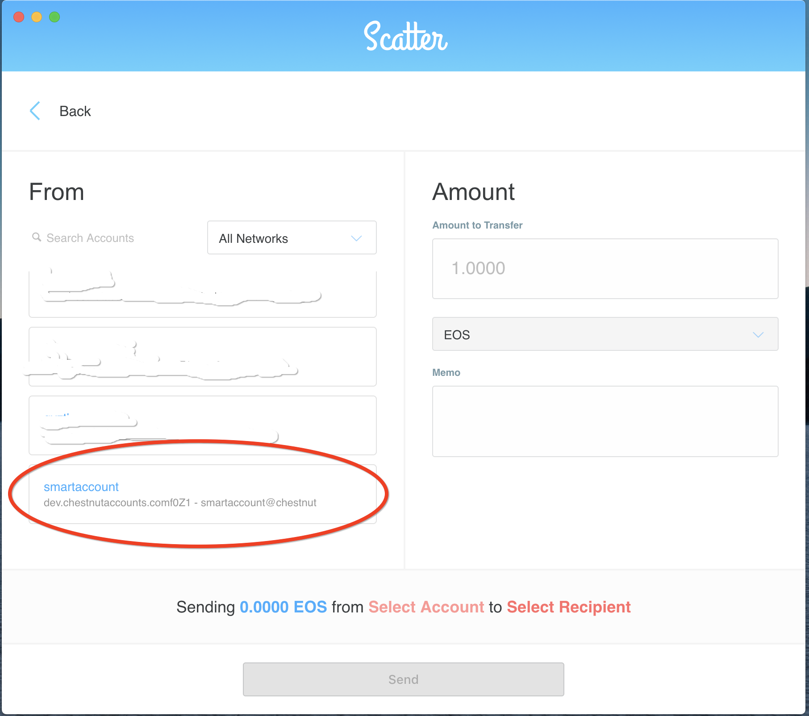

6. Click the drop-down arrow at the right of the EOS token to add the chestnut smart contract

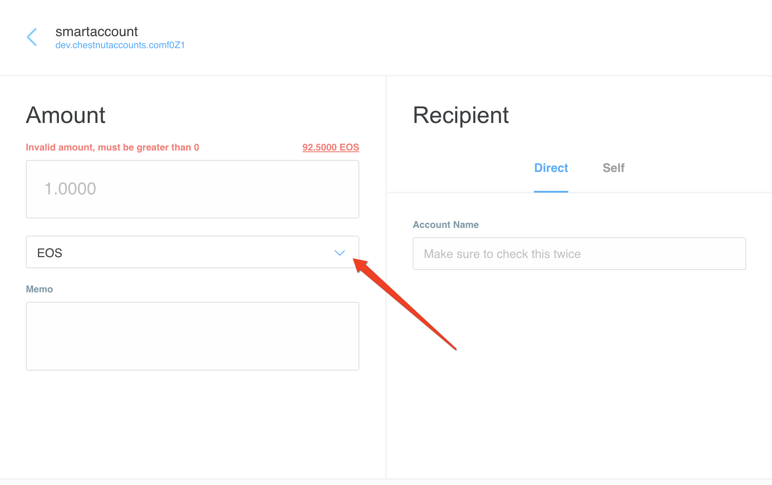

7. Click **Custom Token**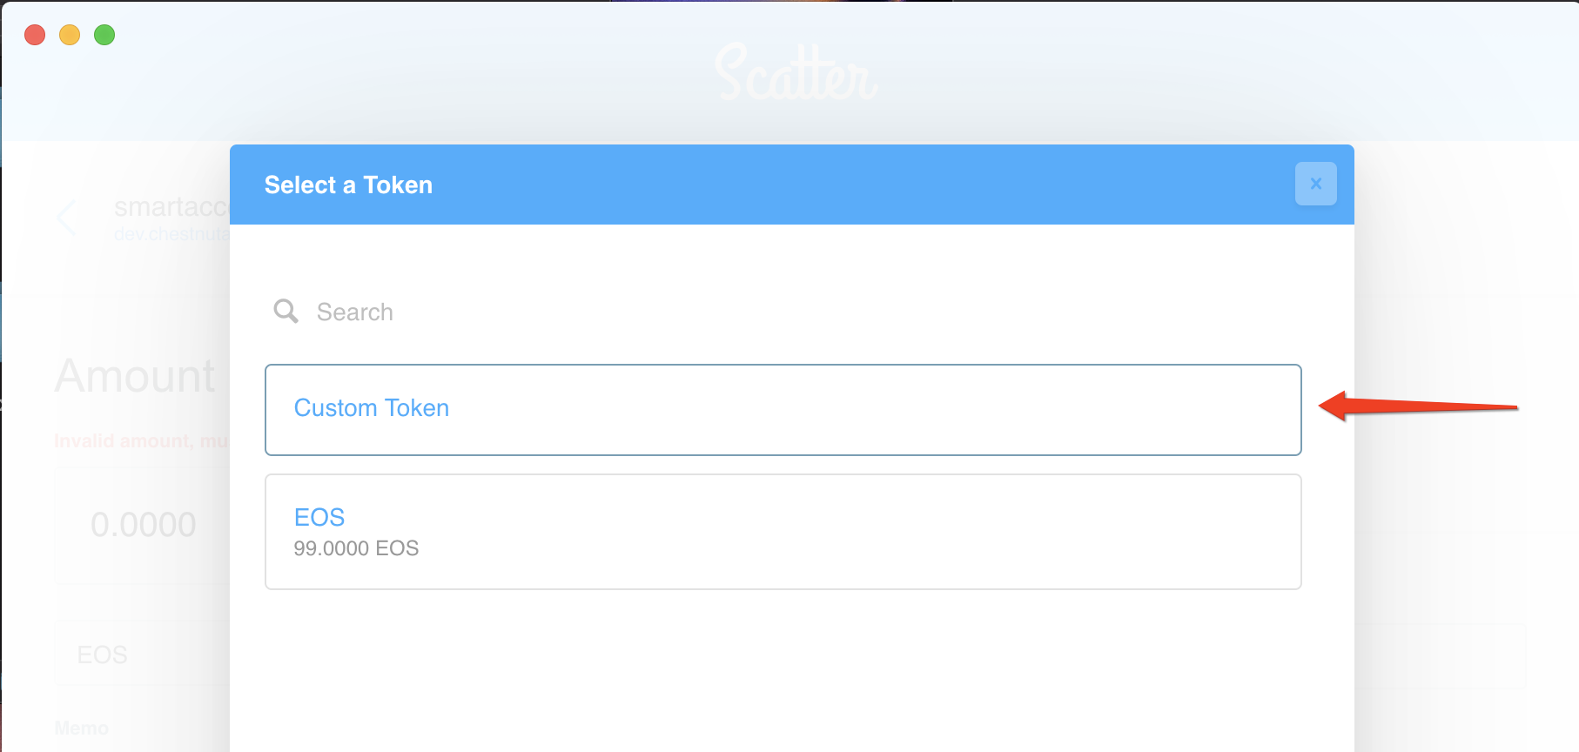

8. Fill out the custom token input fields as follows

Use **chestnutacnt** for the contract name

Use **EOS** for the token name

Use **4** decimal places

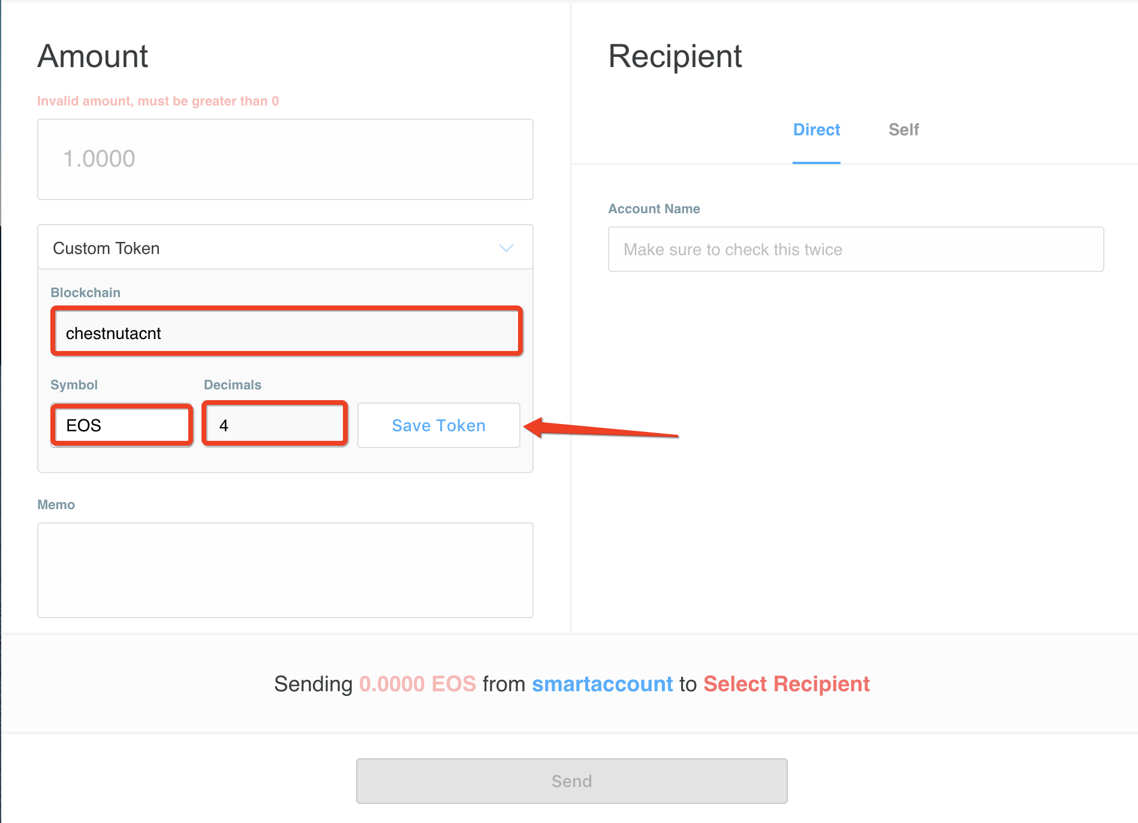

9. Press **Save Token**

10. Now attempt to send greater than **25.0000 EOS** and it will not work, anything less will work

For example, this shows a failure transfer of 25.0001 EOS to my other test account jacktestacnt

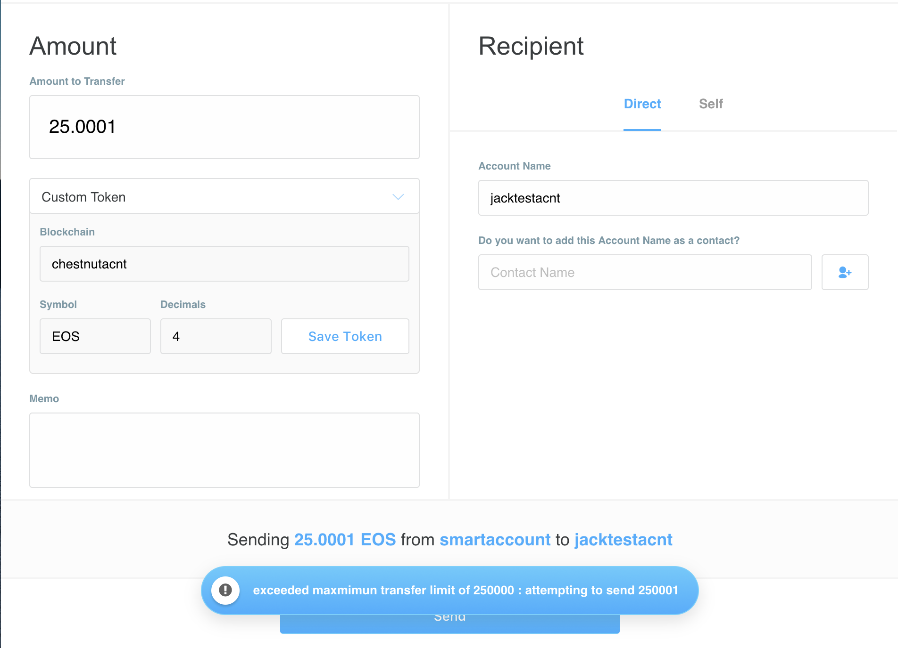

Scatter shows an error message at the bottom showing an attempt to send 250001 (EOS satoshi value)

**Appendix**

How to remove a token transfer limit (jungle.bloks.io)

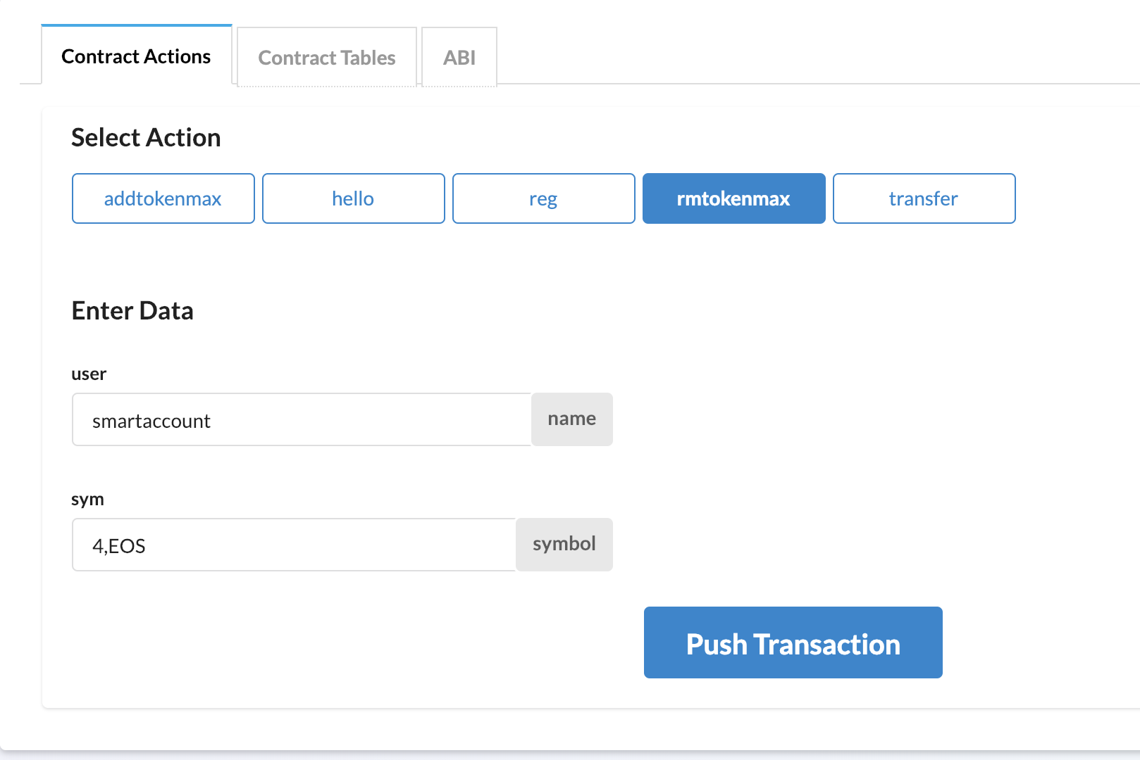

How to view all tokens added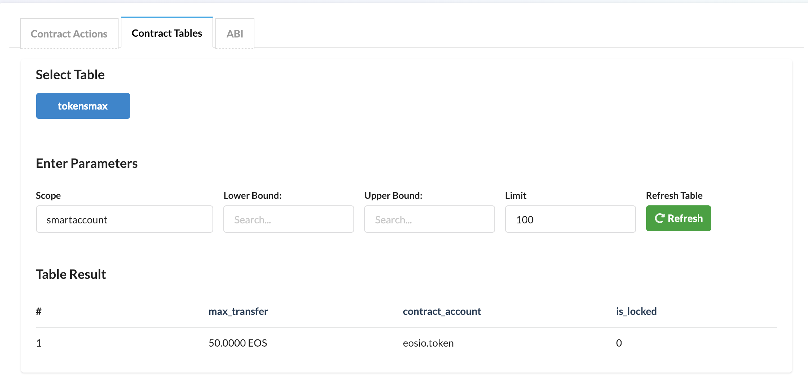

Wallet used: Scatter ( <https://get-scatter.com/> )

Block Explorer used: jungle.bloks.io