Title Page
CSP LEARNING PORTAL: A WEB-BASED STUDENT INFORMATION AND LEARNING MATERIALS SYSTEM

A project study presented to the faculty of
South East Asian Institute of Technology
College of Information and Communication Technology

In partial Fulfillment
of the requirement for the subject
ITELEC5: System Integration and Architecture 2

By:
Barreto, Frank Reed E.
Esnardo, Joshua L.
Flores, Chester John D.
Gonzales, Clark Justine M.
Lanotan, Victorina R.
Panes, Sheryn Mel
Tuliao, Andre A.

April 2026

Business Continuity Plan
End-User | Feature | Icon | Objective
Student,  Pharmacy Staff | Online Medicine Catalog |  | To be able to design a feature that displays an organized catalog of available medicines online.
Table 1.1: Business Continuity Plan

Functions of the Proposed System



Figure 1.1: Venn Diagram of SSCMS, Online Pharmacy, and ClinicRx

Business Continuity Plan Design
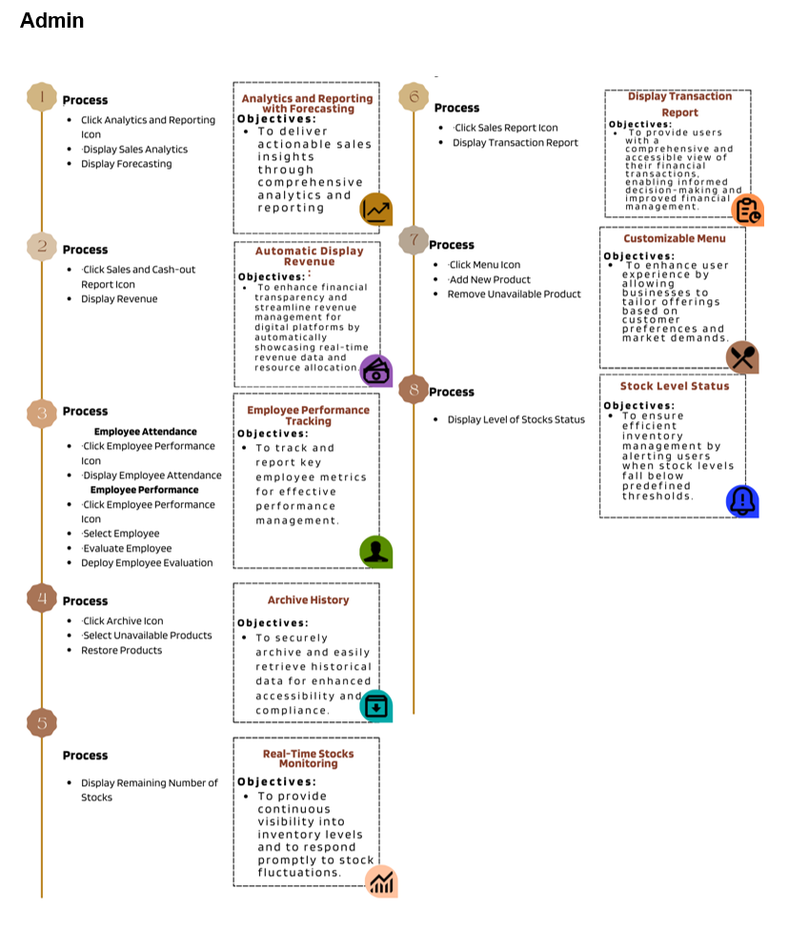
Figure 1.2 BCP of Customer

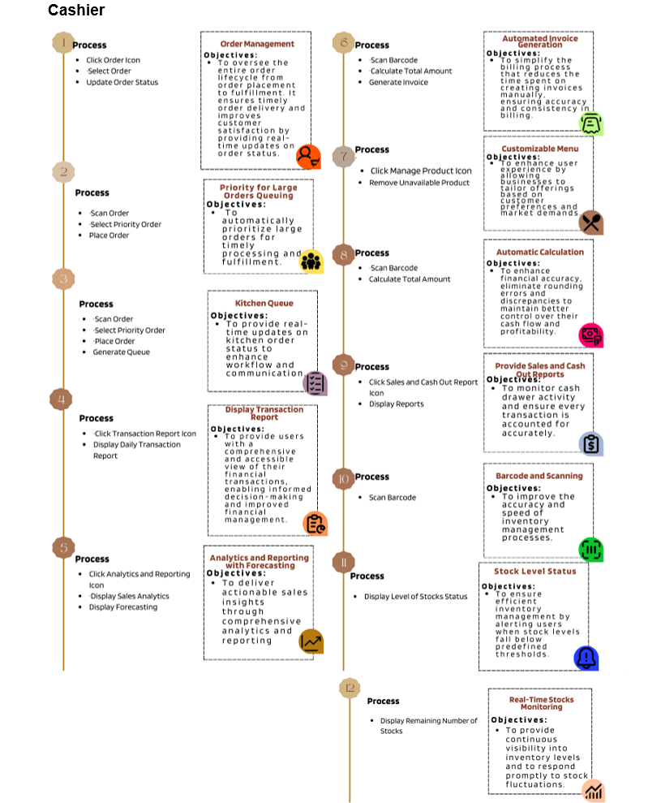

Figure 1.2 BCP of Customer

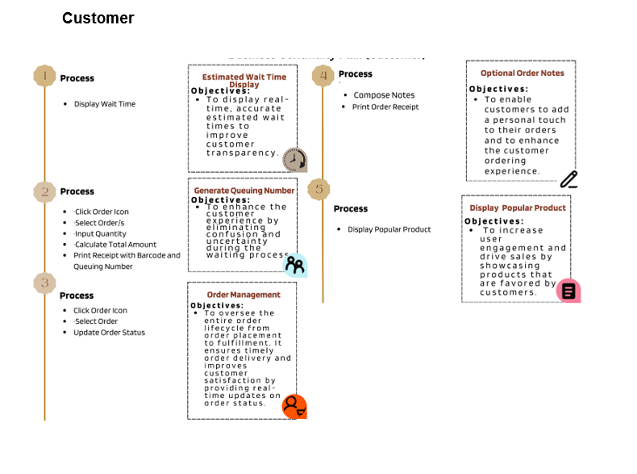

Figure 1.2 BCP of Customer

Widgets
Label Widgets
Dialog Boxes
Push Button
Combo Boxes

Commercial off the Shelf (COTS)
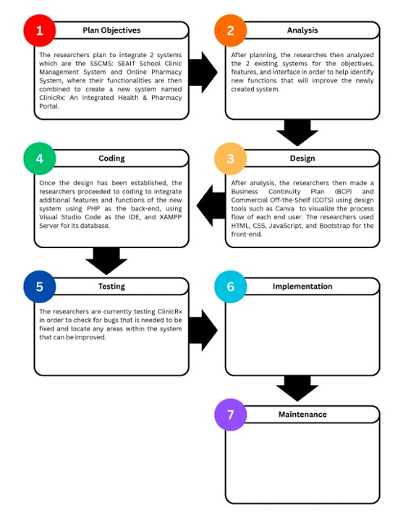

Figure 4.2: Commercial of the Shelf (COTS)

Gantt Chart

Figure 4.3 Gantt Chart

Budget Cost and Hardware Specification

Table 1.1: Budget Cost and Hardware Specification

Business Cost Analysis
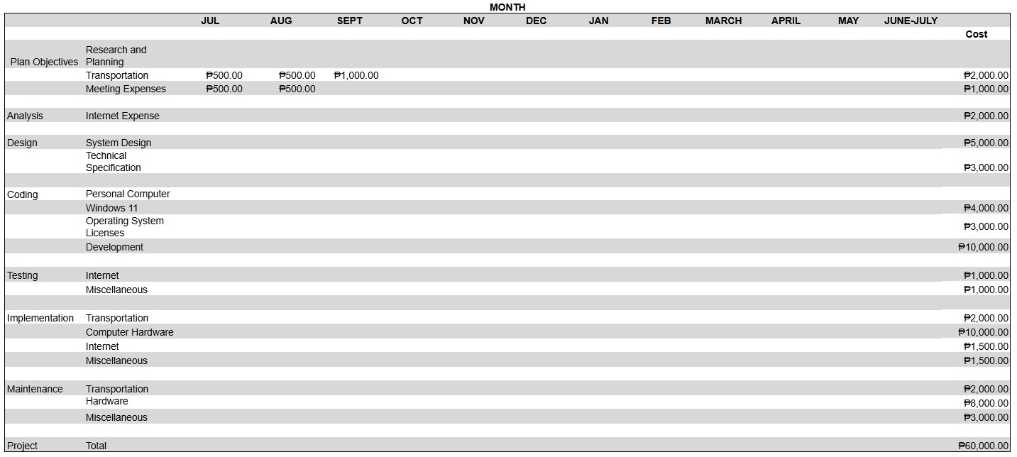

Table 1.1: Business Cost Analysis

