# SCM Sample Assignment: Implementing Git Basics

## 1. Repository Setup and Initial Commit

Steps:

1. Create a GitHub Repository:  
 - Navigate to GitHub and log in.  
 - Click on the "+" icon and select "New Repository."  
 - Name the repository, add a description, and create it as a public or private repository.

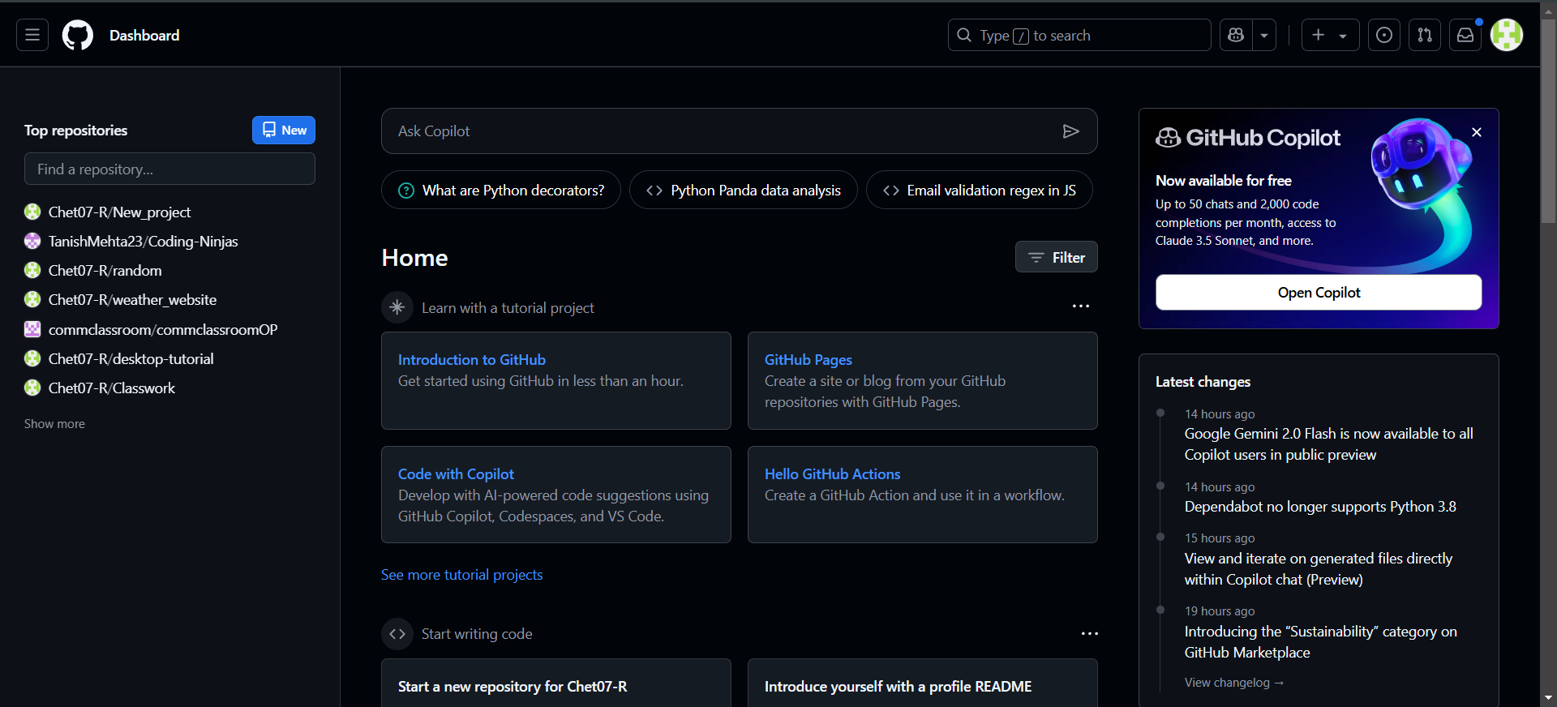

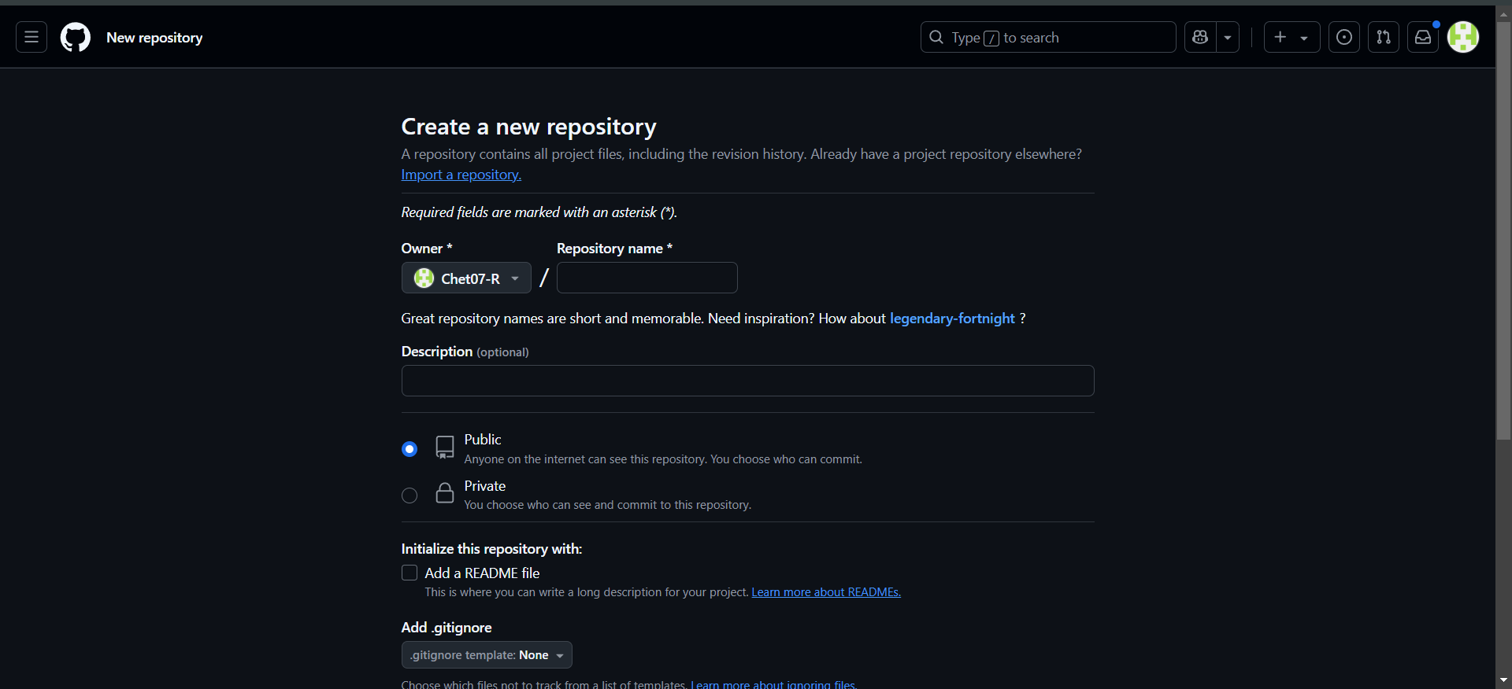

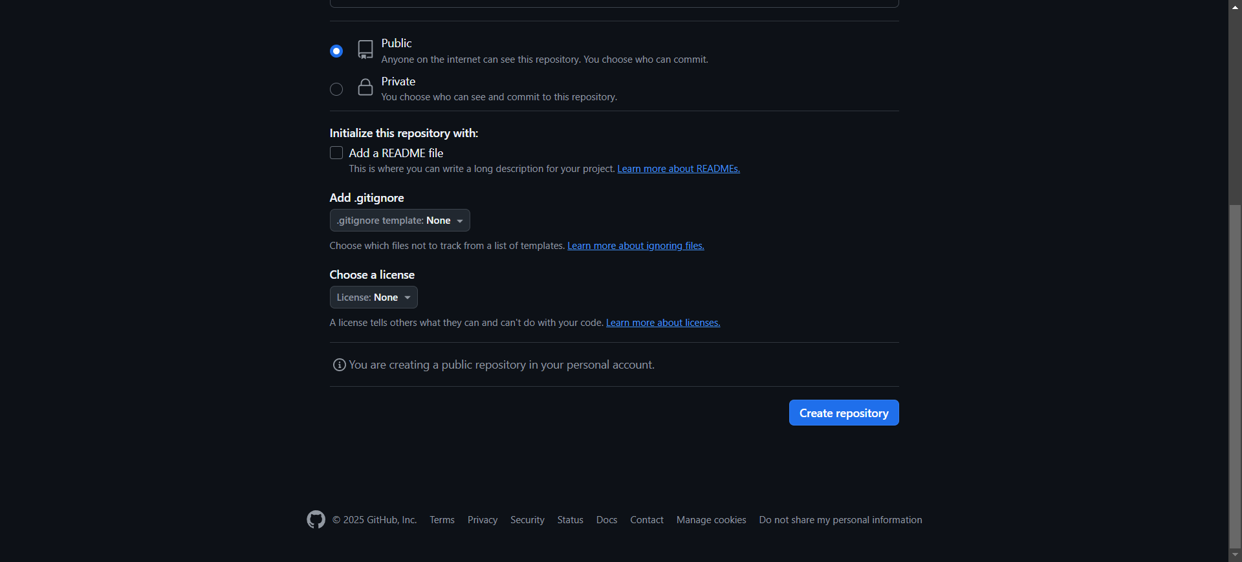

2. Clone the Repository Locally:

git clone <classwork>  
 cd <classwork>

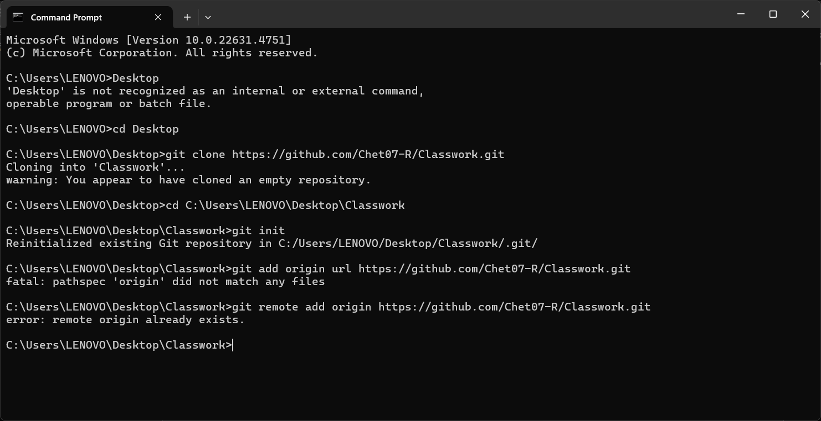

3. Initialize and Create an Initial Commit:

echo "text file" > project_overview.txt  
 git add project_overview.txt  
 git commit -m "Initial commit "  
 git push origin main

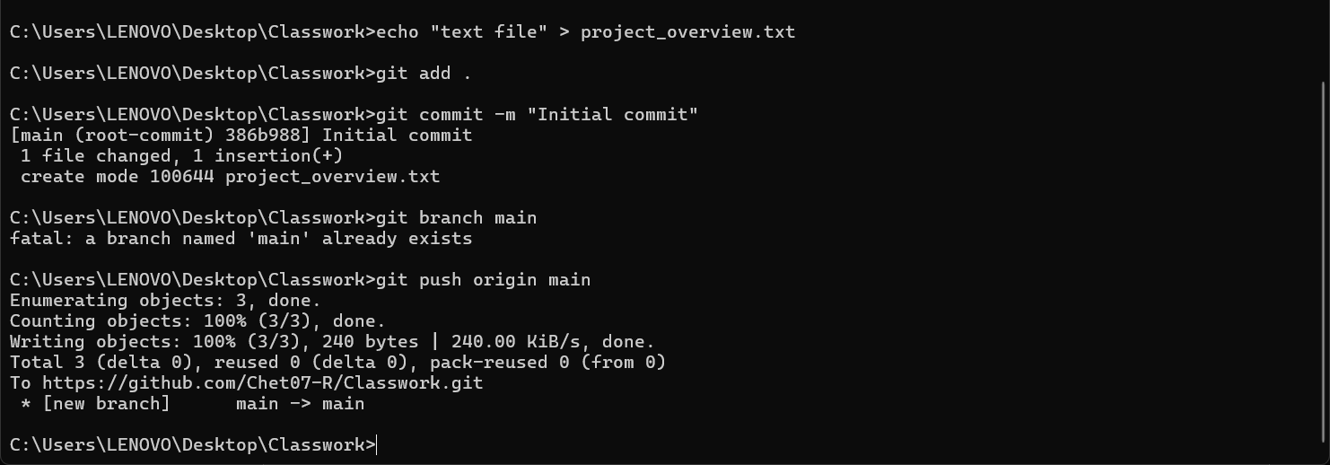

## 2. Branch Creation and Updates

Steps:

1. Create a New Branch:

git branch feature-update

git checkout feature-update

2. Add a Feature Details File:

echo . > feature_details.txt  
 git add .  
 git commit -m "new features"  
 git push origin feature-update

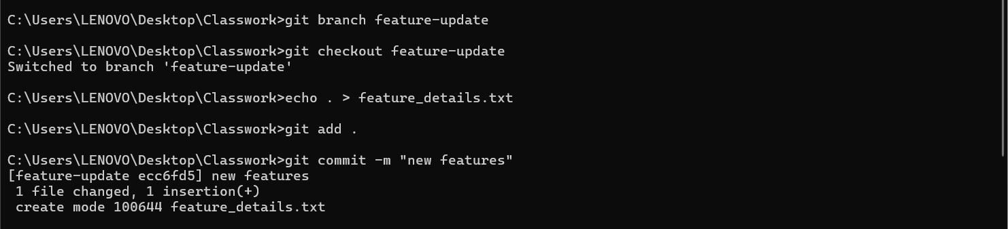

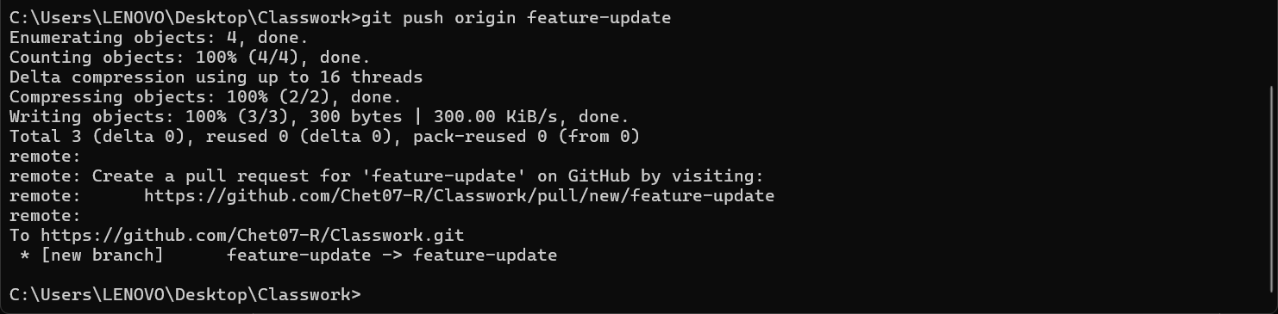

## 3. Merge and Conflict Resolution

Steps:

1. Modify the `feature_details.txt` file in the `main` branch:

git checkout main  
 echo "Modified content in main branch." > feature_details.txt  
 git commit -am "Updated feature_details.txt in main branch"  
 git push origin main

2. Attempt to Merge feature-update into Main:

git checkout main  
 git merge feature-update

3. Resolve the Conflict:

- Open `feature_details.txt`, manually edit the conflicting lines.  
 - Save the file, then run:  
 git add feature_details.txt  
 git commit -m "Resolved merge conflict in feature_details.txt"  
 git push origin main

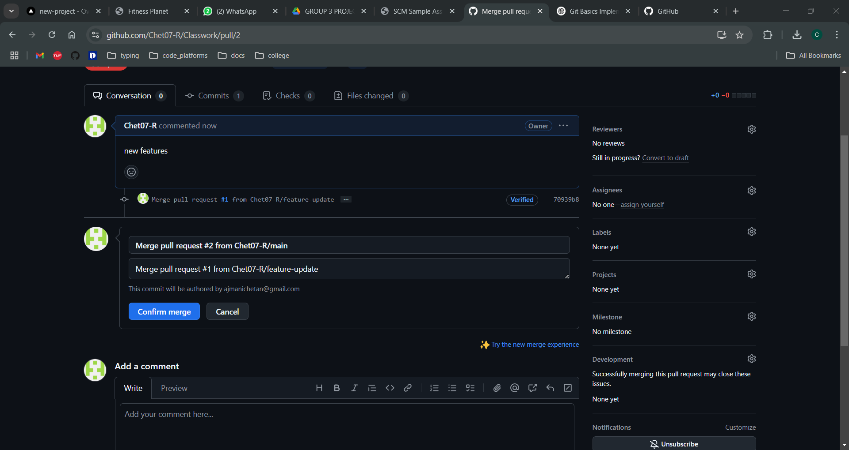

## 4. Repository Audit

Commands and Outputs:

1. Check Repository Status:

git status

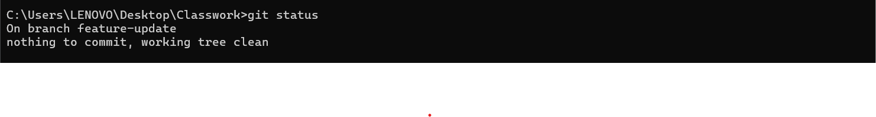

2. Review Commit History:

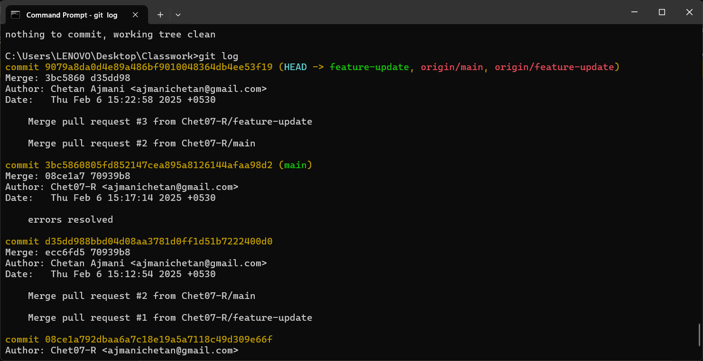 git log

## Conclusion

This document outlines the key Git operations performed, including repository setup, branch management, merging, conflict resolution, and repository auditing. The included screenshots provide visual evidence of the steps executed.