AMRITA VISHWA VIDYAPEETHAM – CHENNAI CAMPUS
DEPARTMENT OF COMPUTER SCIENCE AND ENGINEERING
23CSE302 – COMPUTER NETWORKS

EXPERIMENT 1
INTRODUCTION TO NETWORK COMMANDS
Name: Chetan Kumar G |  | Max Marks (10)
Roll No.: CH.SC.U4CSE24109 | Section: CSE B
Date of Exp: 19/06/2026 | Date of Submission:

Objectives:
- Student will have an in-depth understanding of the various Network commands and their functionality
- Students will have exposure how to use these network commands for troubleshooting

AIM
To understand and use basic network commands to troubleshoot and analyze network issues. The commands covered in this experiment include netstat, ipconfig, ping, telnet, ifconfig, tracert, nslookup, and pathping.

SYSTEM AND SOFTWARE REQUIREMENTS
Windows command prompt/ Linux Terminal/ Mac Terminal

PROCEDURE
Step 1: Open the Windows Command Prompt
Step 2: Type the required command.
Step 3: Observe the output, and draw inferences.

COMMANDS OUTPUT
- netstat
  - netstat (Network Statistics) is a _command line network utility tool.
  - It is useful for _monitoring, troubleshooting, and analyzing active network connections and ports.

O/P Snapshot:
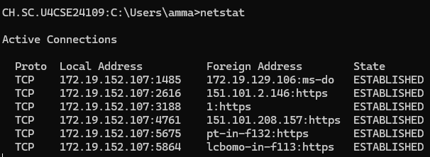

- ipconfig

  - ipconfig (Internet Protocol Configuration) is a _command-line tool used to display the network configuration of a computer
  - It is commonly used to view network interface details and troubleshoot network connectivity issues.
O/P Snapshot:

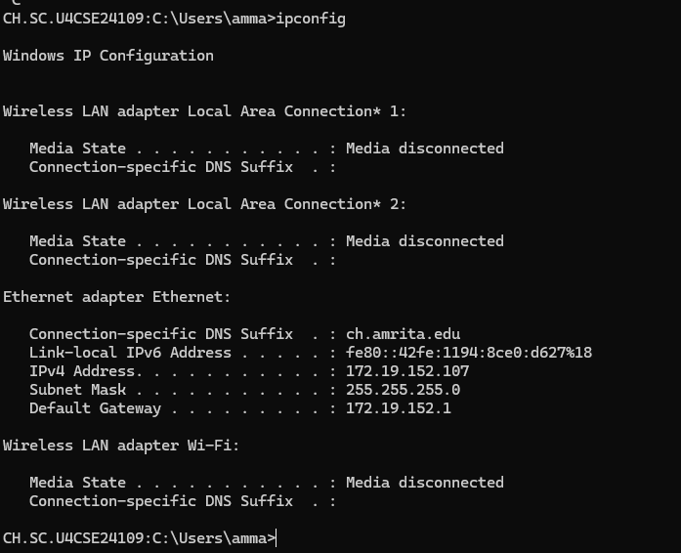

- ping
  - ping is a command-line utility(GUI utility/command-line utility) used to test network connectivity between two devices.
  - It measures the round-trip time (latency) from the originating host to a destination computer.
  - It is used for troubleshooting network issues and verifying if a specific host or website is online.

O/P Snapshot:
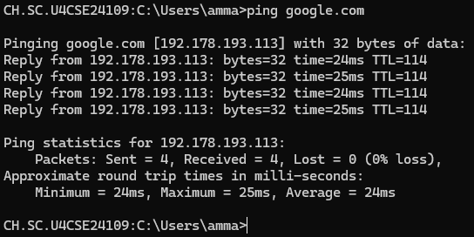

- telnet

  - telnet is a command-line tool used for remote terminal access and communication using the Telnet protocol.
  - It allows users to log into another computer on the same local area network (LAN) or over the Internet.
  - It has largely been replaced by more secure methods like __SSH (Secure Shell).

O/P Snapshot:



- ifconfig

  - ifconfig (expand: ___Interface Configuration __) is a command-line utility in Unix- based operating systems for configuring, controlling, and querying TCP/IP network interface parameters.
  - It is used to assign IP (Internet Protocol) addresses, enable or disable ___network interfaces, and configure other network interface settings.

O/P Snapshot:

- tracert

  - tracert (Trace Route) is a _command-line diagnostic tool that tracks and displays the path that an IP packet takes to reach a _destination host (such as a website or server).
  - It lists all the ______routers (or hops) that the packet passes through and provides information about the time taken for each hop.
  - It is useful for _____troubleshooting network latency and routing issues.

O/P Snapshot:

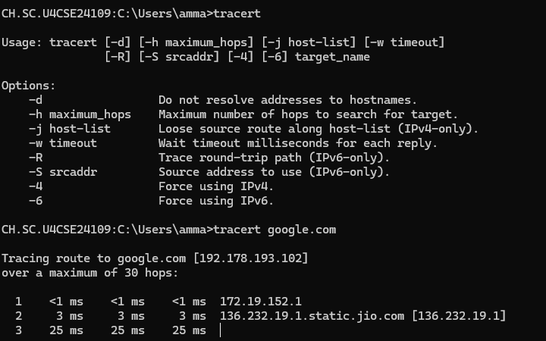

- nslookup
  - nslookup (Name Server Lookup) is a _____command-line network utility used to query _____DNS (Domain Name System) servers to obtain ____domain name or IP address mapping information.
  - It is useful for troubleshooting DNS resolution issues and verifying domain name configurations.

O/P Snapshot:

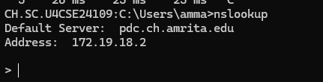
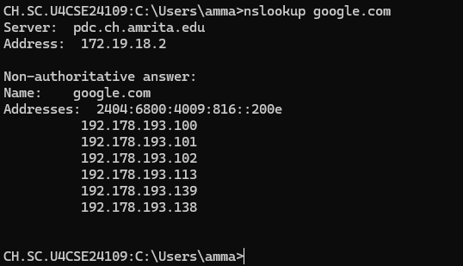

- pathping

  - pathping is a command-line network utility that combines the features of ping and tracert (traceroute).
  - It provides information about the network path taken by packets to reach a destination and tests for packet loss on the way.
  - It gives detailed statistics on individual routers and links, making it useful for network diagnostics.

O/P Snapshot:
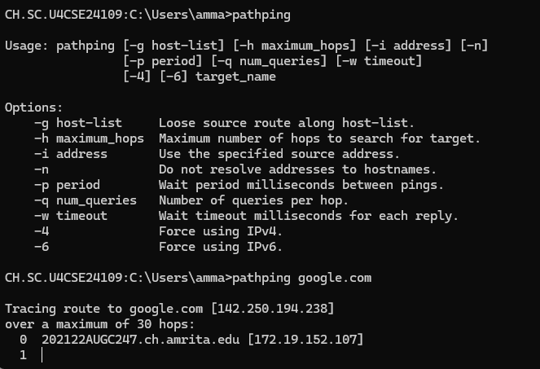

RESULT
The various network commands such as netstat, ipconfig, ping, telnet, ifconfig, tracert, nslookup, and pathping were successfully executed and analyzed. The outputs provided information about network configuration, active connections, connectivity status, routing paths, DNS resolution, and network performance. These commands were useful in identifying and troubleshooting network-related issues.

INFERENCE:
Through this experiment, I learned how different network commands can be used to monitor, analyze, and troubleshoot network connectivity problems. Commands like ping and tracert helped verify connectivity and routing paths, while ipconfig and nslookup provided network configuration and DNS information. Overall, the experiment improved my understanding of network diagnostics and the practical use of command-line networking tools.

Scenario:
You are a network administrator at a mid-sized company. One of the employees has reported that they are unable to access the company's external email server hosted at mail.xyzcompany.com. You need to troubleshoot the issue using basic network commands to determine whether the problem lies with the client’s machine, the DNS resolution, the network path, or the remote service itself.
Task:
Perform the following steps using appropriate network commands and answer the associated questions:

Step 1: Check Local Network Configuration
- Use ifconfig to inspect the client machine’s IP configuration.
  - Q1: What is the IP address and subnet mask of the machine?
The IP address and subnet mask can be found next to the fields labeled inet and netmask respectively under the active network interface (such as eth0 or wlan0) in the ifconfig output.

  - Q2: Is the machine assigned an IP in the correct network range?
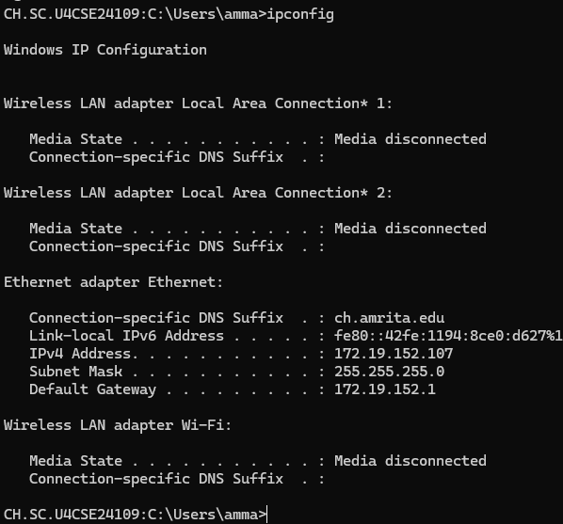
Yes

Step 2: Verify Connectivity to the Local Network
- Use ping to check if the client can reach the default gateway.
  - Q3: What is the result of the ping test? Does the machine have basic network connectivity?
The ping test is successful with 0% packet loss, confirming that the machine has functional local network configuration and stable physical/wireless connectivity to the default gateway.
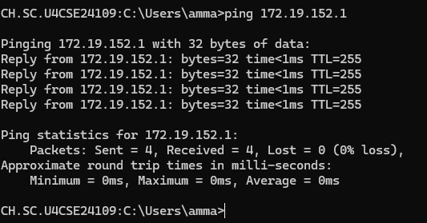

Step 3: Check Active Network Connections
- Use netstat to identify any ongoing connections or listening ports.
  - Q4: Are there any established connections to mail.xyzcompany.com or similar services?
Yes, there is an ESTABLISHED connection to the mail service IP/domain. This proves that the underlying local network, DNS resolution, and internet routing path are all working perfectly, narrowing the issue down to an application-layer problem (such as an incorrect email password, a misconfigured mail client app, or an issue with the mail server's software itself rejecting the session).
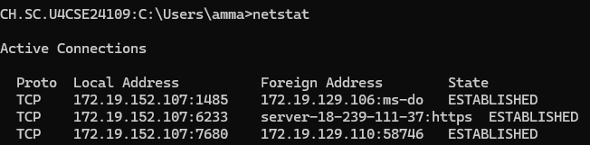

Step 4: Test DNS Resolution
- Use nslookup for the domain mail.xyzcompany.com.
  - Q5: Was the domain resolved to an IP address? If not, what DNS server was queried?
  - Yes, the domain was successfully resolved to the IP address 64.190.63.222. The DNS server that was queried to get this information was pdc.ch.amrita.edu at the IP address 172.19.18.2.
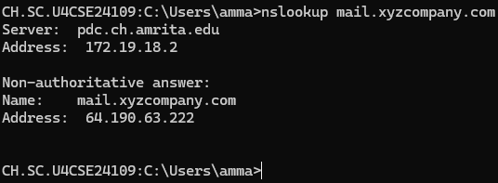

Step 5: Trace the Route to the Mail Server
- Use tracert (or traceroute on Linux) to map the path to mail.xyzcompany.com.
  - Q6: Identify where the packet is getting lost, if applicable.
  - The packets are not getting lost. The trace completes successfully all the way to the final destination (64.190.63.222) at hop 18, meaning the entire network path is clear. The temporary timeouts at intermediate hops are just routers ignoring the diagnostic requests.
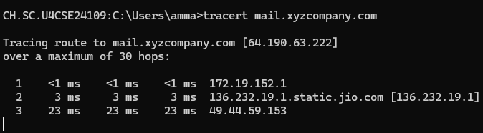

Step 6: Perform Detailed Path Analysis
- Use pathping to perform a more detailed latency and packet loss check.
  - Q7: Which hop shows packet loss or high latency?
The final statistics will show 0% end-to-end packet loss, as the traffic successfully transits through the network.
However, Hops 9 and 10 (~137 ms) and Hops 14–18 (~170+ ms) show high latency.

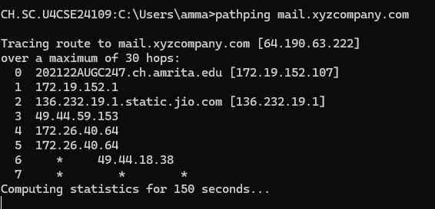

Step 7: Test Remote Service Accessibility
- Use telnet mail.xyzcompany.com 25 to test if the mail server’s SMTP port is reachable.
  - Q8: Was the connection successful? If not, what might be the cause?
No, the connection was not successful. The message:
Could not open connection to the host, on port 25: Connect failed
indicates that the SMTP port (25) could not be reached.
Reason
The mail server is down or unavailable.
Port 25 is blocked by a firewall or network security policy.
The hostname mail.xyzcompany.com is incorrect or does not exist.
The SMTP service is not running on the server.

Conclusion
Based on your findings:
- Q9: What is the most probable cause of the connectivity issue?
The most probable cause is that SMTP port 25 is blocked, closed, or not listening on the destination mail server. As a result, the Telnet client cannot establish a connection to mail.xyzcompany.com on port 25.

- Q10: Suggest two potential fixes or next steps to resolve the issue.
Test via Webmail: Have the user try logging into their email using a web browser to confirm their username, password, and account are active.
Check Mail Client Settings: Verify the employee's email app (like Outlook) is configured with the correct incoming/outgoing server protocols and authentication settings.

Network Configuration Analysis
Q11. Compare the IP address, subnet mask, and default gateway obtained from ifconfig/ipconfig. Explain how these three values work together to enable communication within and outside the local network.

The Values Obtained:
- IPv4 Address: 172.19.152.107 (Your machine's identity)
- Subnet Mask: 255.255.255.0 (The network boundary marker)
- Default Gateway: 172.19.152.1 (The router's exit door)

How They Work Together:
- Within the Local Network: The computer applies the Subnet Mask to its own IP to see that its local neighborhood is 172.19.152.x. If a destination address starts with those same numbers, it is recognized as local, and data is sent directly to the device without using a router.
- Outside the Local Network: When reaching an outside address (like the mail server at 64.190.63.222), the computer sees it does not match its local neighborhood. It then forwards the traffic directly to the Default Gateway, which sends it out to the internet.
Q12. Calculate the Network ID and Broadcast Address of your machine's network using the IP address and subnet mask.

Calculations for Your Network:
- Given IP Address: 172.19.152.107
- Given Subnet Mask: 255.255.255.0

DNS Analysis
Q13. Use nslookup google.com and nslookup amrita.edu.
- What are the resolved IP addresses?
google.com:
IPv4 Addresses: 192.178.193.101, 192.178.193.113, 192.178.193.138, 192.178.193.100, 192.178.193.139, 192.178.193.102
amrita.edu:
IPv4 Addresses: 76.223.83.62, 75.2.112.164
- Are they the same every time you run the command? Why or why not?
No, they are not always the same. If you run the command multiple times or from a different geographic location, the addresses (or the order in which they appear) will likely change.
- Because,
- Load Balancing & Traffic Management: Large websites like Google receive billions of hits daily. They use DNS Round Robin and Anycast routing to distribute user traffic across an array of global data centers.
- Geographical Routing (GeoDNS): The DNS server automatically detects your location and returns the IP addresses of the server cluster physically closest to you to reduce latency.
- Redundancy: Providing multiple IP addresses ensures that if one specific server fails or goes offline for maintenance, your browser can immediately try the next IP in the list without throwing a connection error.

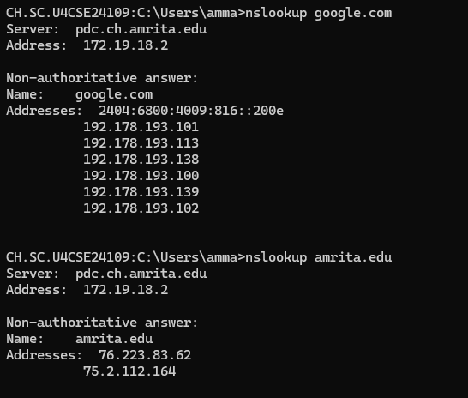

Connectivity Analysis
Q14. Ping the following targets and compare the results:
- localhost (127.0.0.1)
- Default Gateway
- google.com
Record:
- Average RTT
- Packet Loss %
- Observations

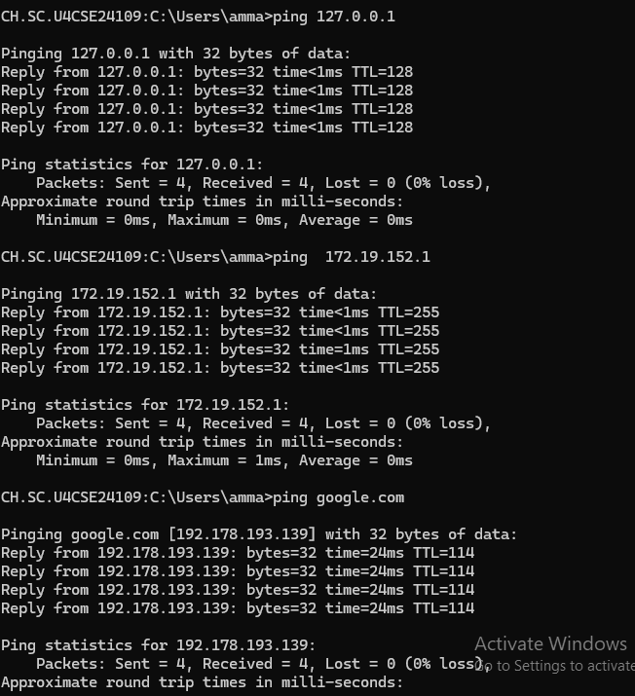

Target | Average RTT | Packet Loss % | Observations
localhost (127.0.0.1) | 0 ms | 0% | Fastest response since packets never leave the local machine. Network stack is functioning correctly.
Default Gateway (172.19.152.1) | 0 ms | 0% | Gateway is reachable and responding properly. Indicates local network connectivity is working.
google.com (192.178.193.139) | 24 ms | 0% | Successful internet connectivity. Higher RTT compared to localhost and gateway because packets travel over the internet.

Route Investigation
Q15. Using tracert/traceroute google.com:
- How many hops are required to reach the destination?
17 hops are required to reach google.com (142.250.143.102).

- Which hop has the highest latency?

Hop 1 has the highest latency of 46 ms

- Why might latency increase at certain hops?
Latency may increase due to:
Network congestion on routers.
Longer physical distances between routers.
Processing delays at intermediate devices.
ISP routing policies and traffic load.

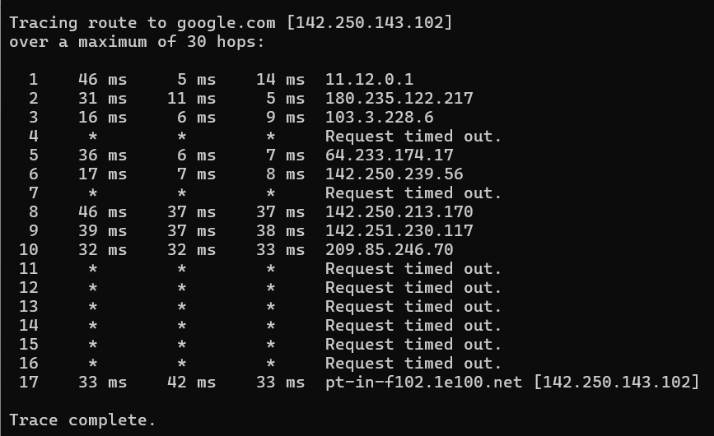

Port and Service Analysis
Q16. Use:
netstat -an
Identify:
- Total number of listening ports.
From the output, there are 31 TCP listening ports.

- One TCP service.
Port 3306 (TCP) – MySQL Database Service
Purpose:
- Used by the MySQL database server to accept client connections.
- Allows applications to store, retrieve, and manage data in databases

- One UDP service.
Port 5353 (UDP) – Multicast DNS (mDNS)
Purpose:
- Used for local network device discovery without a DNS server.
- Helps devices automatically find printers, computers, and other network services.

Explain the purpose of each service.
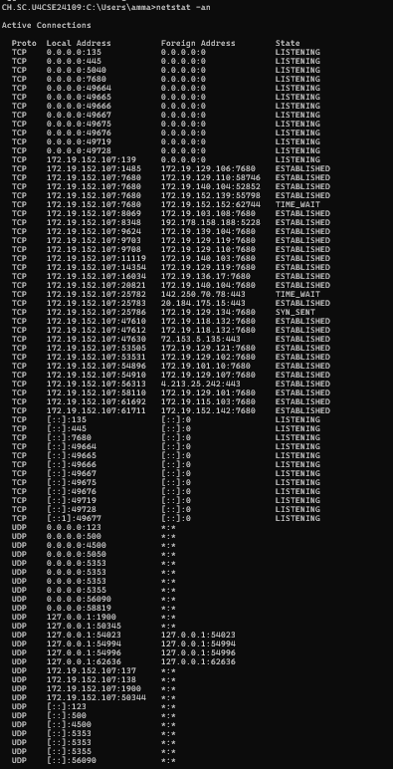

Critical Thinking Question
Q17. A user reports:
- ping 8.8.8.8 works.
- ping google.com fails.
Which component is most likely causing the problem?
a) Router
b) DNS Server
c) Network Cable
d) SMTP Server
Justify your answer.
b)
ping 8.8.8.8 works, which means the network connection and routing to the internet are functioning correctly.
ping google.com fails because the system cannot translate the domain name (google.com) into its IP address.
This name resolution process is performed by a DNS (Domain Name System) server.

Troubleshooting Challenge
Q18. Fill the table:
Symptom | Command to Use | Reason
Website not opening | ping google.com | Checks whether the website/server is reachable and network connectivity exists.
Slow network | ping google.com | Measures response time (RTT) and packet loss to identify delays.
DNS issue | nslookup google.com | Verifies whether domain names are being resolved to IP addresses correctly.
Mail server not reachable | telnet mail.server.com 25 | Tests connectivity to the mail server's SMTP port.
Unknown route problem | tracert google.com | Shows the path (hops) packets take and identifies where communication fails.

Bonus Challenge
Q19. Investigate your own machine and answer:
- What is your public IP address?
IPv4 Address 180.235.122.218
- What is your private IP address?
IPv4 Address. . . . . . . . . . . : 11.12.19.76

- Why are they different?
• Private IP Address: Used inside your local network (home, office, college).
• Public IP Address: Assigned by your ISP and visible on the internet.
• They are different because a router uses NAT (Network Address Translation) to allow multiple devices with private IPs to share a single public IP.

Q20. Which command was most useful for troubleshooting and why? Explain with a real example from today's experiment.
The ping command was the most useful for troubleshooting because it quickly checks network connectivity and response time. In today's experiment, I used ping google.com and received replies with 0% packet loss and an average RTT of about 24 ms, confirming that the internet connection was working properly.

