AMRITA VISHWA VIDYAPEETHAM – CHENNAI CAMPUS
DEPARTMENT OF COMPUTER SCIENCE AND ENGINEERING
23CSE302 – COMPUTER NETWORKS

EXPERIMENT 3
IMPLEMENTATION OF SIMPLE CLIENT- SERVER FILE TRANSFER PROTOCOL USING JAVA AND CISCO PACKET TRACER
Name: Chetan Kumar G |  | Max Marks (10)
Roll No.: CH.SC.U4CSE24109 | Section: CSE-B
Date of Exp: 05/07/2026 | Date of Submission: 05/07/2026

OBJECTIVES:
  - Students will have exposure to FTP using Java
  - Students will have an understanding how ﬁle transfer can be simulated between client and FTP server in Cisco Packet Tracer using FTP protocol

A. Implementation of Simple Client-Server File Transfer
Protocol in Java

AIM
To implement a basic File Transfer Protocol (FTP) using socket programming in Java, where a server sends a file to a client upon connection.

SYSTEM AND SOFTWARE REQUIREMENTS
Software – VS Code
Libraries – java.io.* and java.net.*

PROCEDURE

- Server
  - Import Required Libraries:
    - Import the java.io.* and java.net.* libraries.
  - Create the Server Socket:
    - Use the ServerSocket class to create a server socket on port 8000.
  - Accept Client Connections:
    - Use the accept() method to listen for and accept client connection requests.
  - Read and Send File:
    - Use a FileInputStream to read the file specified in the command line arguments.
    - Use an OutputStreamWriter to send the file data to the client.
  - Close Connections:
    - Close the socket and file input stream after the file transfer is complete.

Client

  - Import Required Libraries:
    - Import the java.io.* and java.net.* libraries.

  - Create the Client Socket:
    - Use the Socket class to create a client socket and connect to the server at the local host on port 8000.
  - Receive and Write File:
    - Use a FileOutputStream to write the received file data to a file specified in the command line arguments.
    - Use an InputStreamReader to read the file data sent by the server.
  - Close Connections:
    - Close the socket and file output stream after the file transfer is complete.

JAVA CODE

- Server

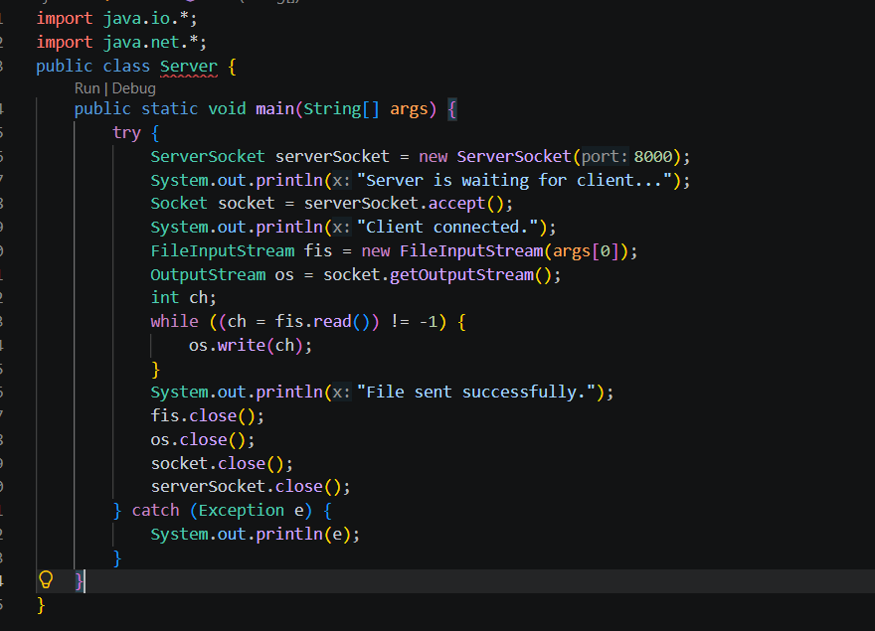

Client

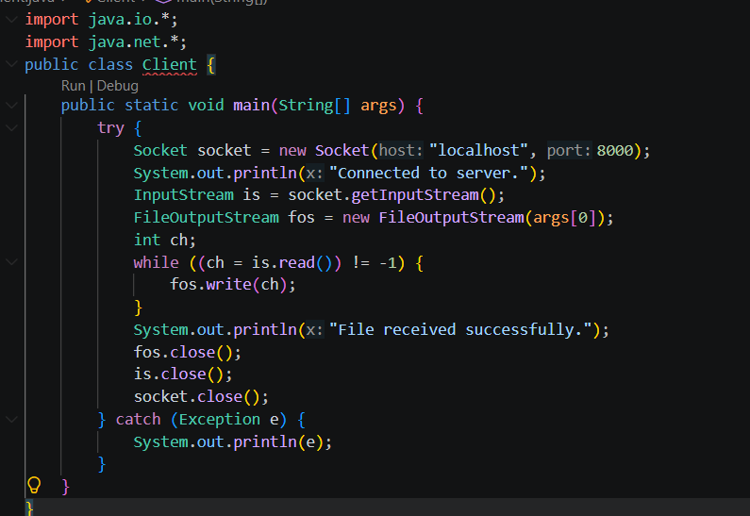

OUTPUT SNAPSHOT

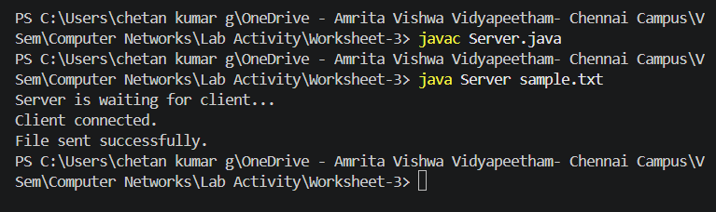

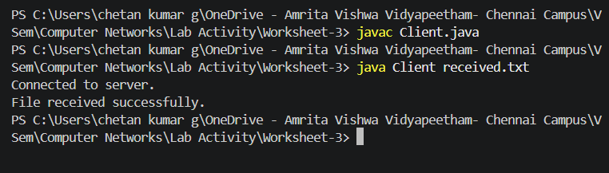

RESULT

The File Transfer Protocol (FTP) was successfully implemented using Java socket programming. The server established a connection with the client on port 8000 and transmitted the specified file. The client successfully received the file and stored it in the destination location without any data loss.

INFERENCE

- Socket programming enables reliable communication between a server and a client over a network.
- A ServerSocket listens for incoming client requests, while a Socket establishes the connection.
- File data can be transferred efficiently using Java input and output streams (FileInputStream and FileOutputStream).
- This experiment demonstrates the basic working principle of the File Transfer Protocol (FTP) and client-server communication in Java.

B. IMPLEMENTATION OF FTP USING CISCO PACKET TRACER

AIM
To implement a File Transfer Protocol (FTP) using Cisco Packet Tracer to transfer files between a client and a server within a simulated network environment.

SYSTEM AND SOFTWARE REQUIREMENTS
Software – Cisco Packet Tracer

Components used:
  - End Devices
    - PC-PT
    - Server -PT
  - Network Devices
    - Router 2911
- Switch 2950-24
  - Connections
    - Copper Straight-Through
    - Console Cable

PROCEDURE
To implement a File Transfer Protocol (FTP) using Cisco Packet Tracer to transfer files between a client and a server, follow these steps:

Step 1: Open Cisco Packet Tracer
1) Launch Cisco Packet Tracer on your computer.

Step 2: Add Devices to the Workspace
- Add two PCs:
  - Click on the "End Devices" icon in the bottom left corner.
  - Select "PC" and drag two PCs into the workspace.

- Add a server:
  - Click on the "End Devices" icon in the bottom left corner.
  - Select "Server" and drag a server into the workspace.
- Add a Switch:
  - Click on the "Switches" icon in the bottom left corner.
  - Select a switch (2950-24) and drag it into the workspace.
- Add a Router:
  - Click on the "Routers" icon in the bottom left corner.
  - Select a router (2911) and drag it into the workspace.

Step 3: Connect the Devices

- Select the Connection Tool:
  - Click on the "Connections" icon (lightning bolt) in bottom left corner.
- Connect the PCs to the Switch:
  - Click on a PC and then click on the switch to connect them with a copper straight-through cable.
  - Repeat the process for the second PC.
- Connect the Switch to the Router:
  - Click on the switch and then click on the router to connect them with a copper straight-through cable.
- Connect the Router to the Server:
  - Click on the router and then click on the Server to connect them with a copper straight-through cable.
- Connect a PC to the Router:
  - Click on the PC and then click on the router to connect them with a console cable.

Step 4: Configure IP Addresses:

- Configure the first PC (Faculty PC):
  - Open the Faculty PC, click on Desktop, select IP Configuration
  - Choose Static to manually enter the following,

IPv4 Address: 192.168.1.2
Subnet Mask: 255.255.255.0

Default Gateway: 192.168.1.1

- Configure the second PC (Student PC):
  - Open the Student PC, click on Desktop, select IP Configuration
  - Choose Static to manually enter the following,

IPv4 Address: 192.168.1.3
Subnet Mask: 255.255.255.0

Default Gateway: 192.168.1.1
- Configure the router (AVV Chennai Router):
  - On the router, go to the Config tab and select the GigabitEthernet0/0 interface for LAN interface. Under IP Configuration, manually enter the following,

IPv4 Address: 192.168.1.1
Subnet Mask: 255.255.255.0
  - On the router, go to the Config tab and select the GigabitEthernet0/1 interface for WAN interface. Under IP Configuration, manually enter the following,

IPv4 Address: 10.0.0.1
Subnet Mask: 255.0.0.0
- Configure the server (Amritapuri File Server):
  - Open the Amritapuri File Server, click on Desktop, select IP Configuration
  - Choose Static to manually enter the following,

IPv4 Address: 10.0.0.2
Subnet Mask: 255.0.0.0

Default Gateway: 10.0.0.1

Step 5: FTP Server Configuration

- On the Amritapuri File Server, go to the Services tab and select FTP.
- Ensure the FTP service is turned ON.
- Under User Setup, add a new user with the following details:

Username: Amrita

Password: amma@123

- Enable the following permissions, Read write and Load (RWL)

Step 6: Testing Connectivity

- Ping the Amritapuri File Server from the Faculty PC and Student PC to ensure network connectivity.
- Example: To check the network connectivity of Faculty PC,
  - Open the Faculty PC, click on Desktop, select command prompt and enter the following
  - To test the network connectivity between the Faculty PC and the Student PC: Ping 192.168.1.3
  - To test the network connectivity between the Faculty PC and the LAN interface of the 2911 Chennai Router: Ping 192.168.1.3
  - To test the network connectivity between the Faculty PC and the WAN interface of the 2911 Chennai Router: Ping 10.0.0.1
  - To test the network connectivity between the Faculty PC and the Amritapuri File Server on the WAN network: Ping 10.0.0.2

Step 7: FTP Client Configuration- Upload a file from Faculty PC

- On the Faculty PC, navigate to the Desktop tab and open the Text Editor.
- Create a new text file, add the desired content, and save the file with the name `msg.txt`.
- Navigate to the Desktop tab and open the Command Prompt:
  - To initiates an FTP connection from the Faculty PC to the Amritapuri File Server enter: ftp 10.0.0.2
  - Enter the valid FTP credentials to log in to the FTP server.

Username: Amrita Password: amma@123
  - To list the contents of the current directory on the FTP server enter:

ftp>dir
  - To upload a file named msg.txt from the Faculty PC to the current directory on the FTP server enter: ftp>put msg.txt

Step 8: FTP Client Configuration- Download the file in Student PC

- On the Student PC, navigate to the Desktop tab and open the Command Prompt:
  - To initiates an FTP connection from the Faculty PC to the Amritapuri File Server enter: ftp 10.0.0.2
  - Enter the valid FTP credentials to log in to the FTP server.

Username: Amrita Password: amma@123
  - To download the file named msg.txt from the FTP server to the Student PC's current directory enter: ftp>get msg.txt
  - To terminate the FTP session and returns the user to the command prompt enter: ftp>quit
  - To list the contents of the current directory on the Student PC again to verify that msg.txt has been successfully downloaded from the FTP server enter: dir
By following these steps, we can successfully implement a File Transfer Protocol (FTP) using Cisco Packet Tracer to transfer files between a client and a server.

NETWORK TOPOLOGY DIAGRAM

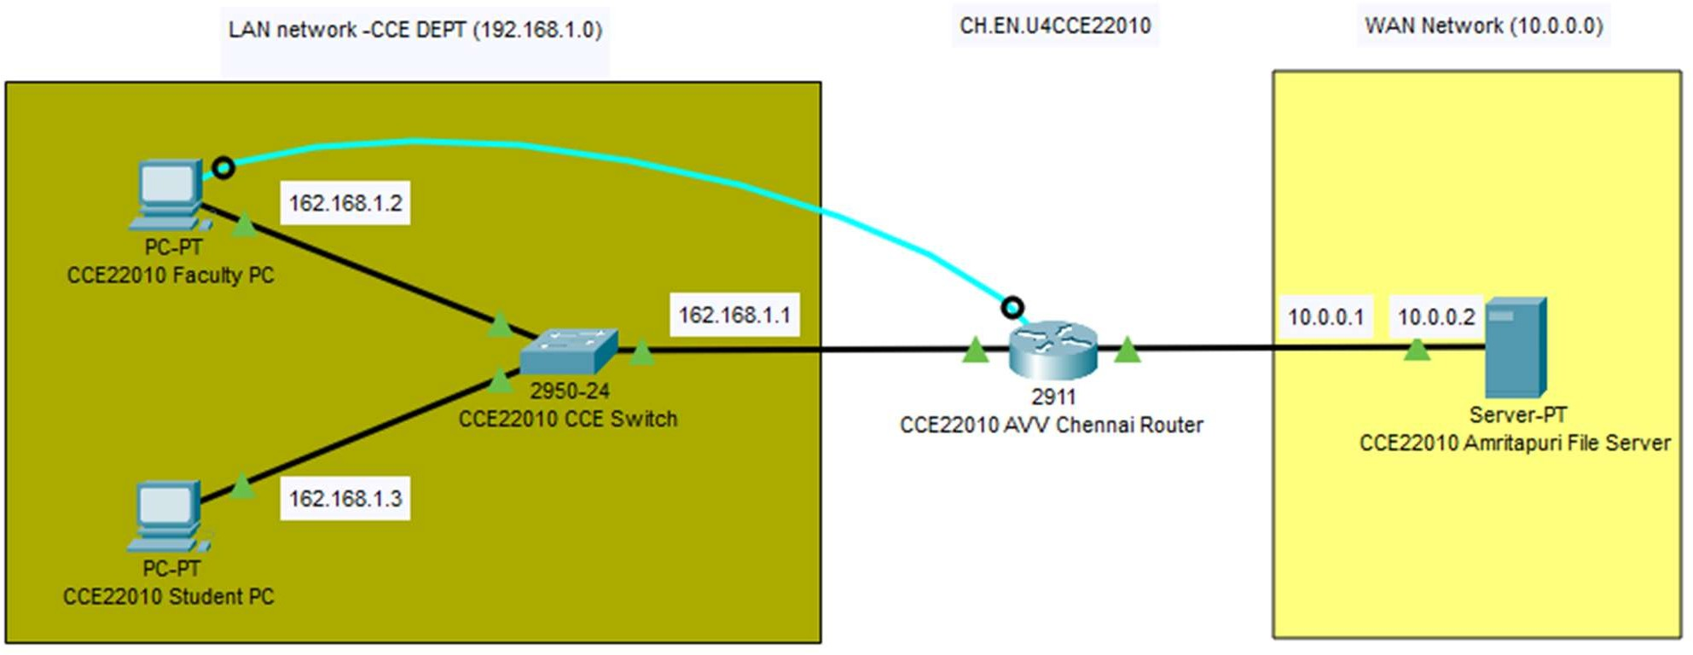

OUTPUT

Network Connectivity test of Faculty PC with other devices:

  - Faculty PC and Student PC:

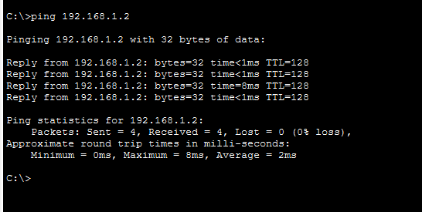
  - Faculty PC and LAN interface of the 2911 Chennai Router:

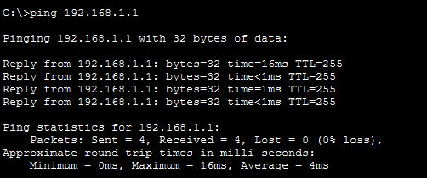

  - Faculty PC and the WAN interface of the 2911 Chennai Router:
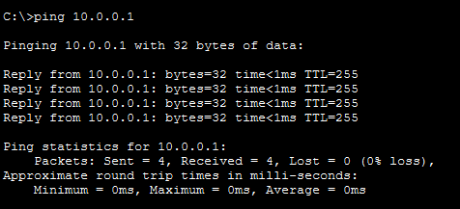

  - Faculty PC and the Amritapuri File Server on the WAN network:

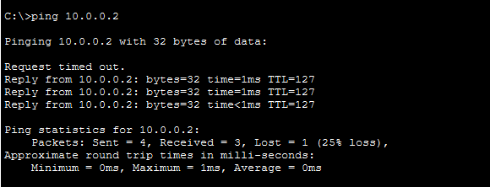

FTP Client Configuration: Uploading a file from Faculty PC

  - Creating a file name named “msg.txt:
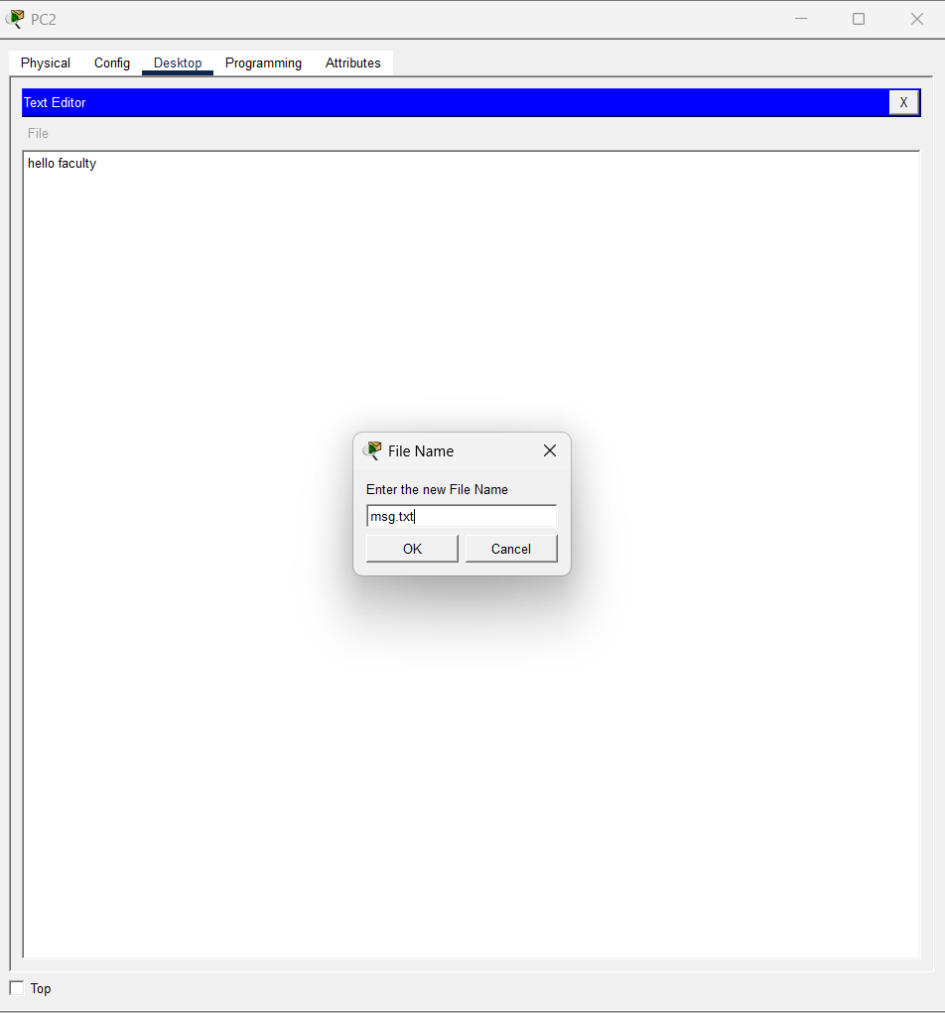
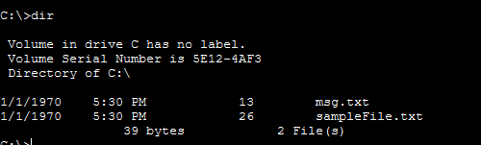

  - Initiate connection to FTP and login:
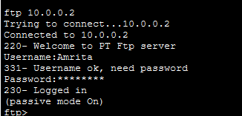

  - List the contents of the current directory on the FTP server:
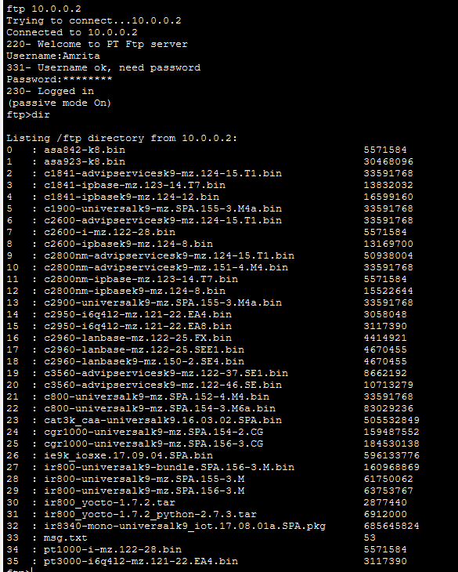

  - Upload the msg.txt file in FTP directory and exit:

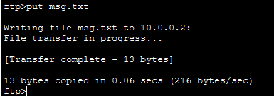

FTP Client Configuration: Downloading a file from Student PC

  - Initiate connection to FTP and login:
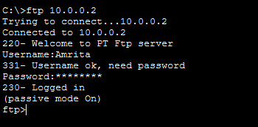

  - Download the file named msg.txt from the FTP server to the Student PC:
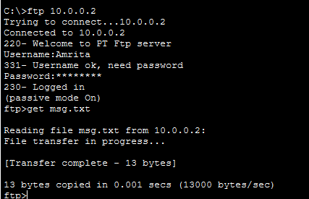

  - List the contents of the current directory on the Student PC:

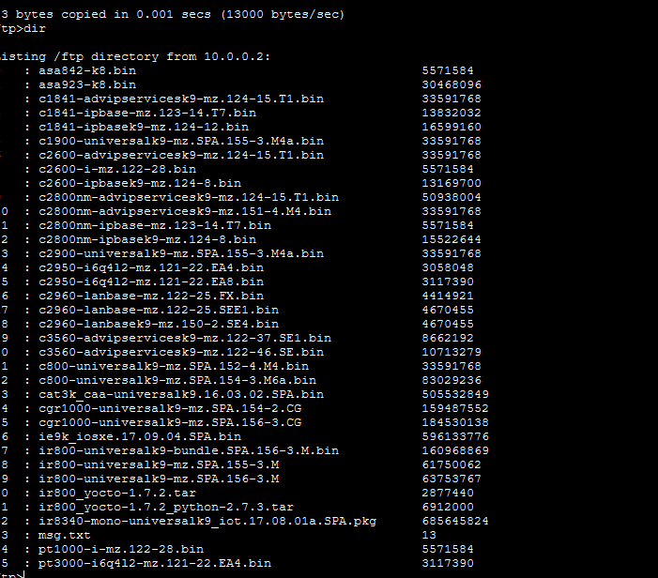

RESULT
- Successful FTP connection from client PC’s
- Successful File transfer between client PC’s through FTP protocol

INFERENCE
The experiment demonstrated the working of the File Transfer Protocol (FTP) in a simulated network environment. Proper IP addressing, routing, and FTP server configuration enabled reliable file sharing between different hosts. The activity provided practical knowledge of FTP authentication, file upload/download operations, and network connectivity testing using Cisco Packet Tracer.

Lab Scenario: Secure Document Sharing in a Corporate Environment

Scenario Title: “Designing a File Sharing System for Secure Inter-Department Communication”

Background:
Your company, CyberWave Pvt. Ltd., has multiple departments working in different parts of the campus. The management has instructed the IT team to enable secure and efficient file sharing between client systems and a centralized document server. This must be done in two phases:

Part A: Java-Based File Transfer System

Task:
You are tasked with developing a basic file transfer protocol using Java socket programming. The goal is to:
- Allow a client to connect to the file server.
- Request a file by name.
- Download the file if it exists on the server.
- Handle the case where the requested file is not found.

Requirements:
- Create a Java server application that:
  - Listens on a port.
  - Waits for a client to request a file.
  - Sends the file if available, or returns an error message.
- Create a Java client application that:
  - Connects to the server.
  - Requests a specific file.
  - Downloads and saves the file locally.

Q1: What file did you request from the server, and what was the size of the transferred file?

Q2: Show and explain how your client handles a "file not found" situation.

Part B: FTP Network Simulation in Cisco Packet Tracer

Task:
Now simulate the same environment using Cisco Packet Tracer by setting up:
- An FTP server (using the server module in Packet Tracer).
- At least two client PCs from different network segments.
- Proper IP addressing, routing (if required), and FTP service configuration.
Each client PC should be able to:
- Connect to the FTP server.
- Upload and download files.

Requirements:
- Configure the FTP server with login credentials and file permissions.
- Test the upload of a file from PC1 and download the same file from PC2.

Q3: What was the IP configuration of the FTP server and clients?

Q4: Demonstrate successful upload and download by showing relevant screenshots and logs.

Q5 (Challenge): What network issues (e.g., incorrect routing, firewall settings) might prevent FTP communication, and how did you resolve them?

Viva Questions:

Question | Company
How does file transfer happen using sockets? | Infosys, Wipro
What happens if the file doesn’t exist on the server? | TCS, Dell
How do you simulate this system in Packet Tracer? | Cisco
What are some limitations of FTP? | Palo Alto, IBM

