DEPARTMENT OF COMPUTER SCIENCE AND ENGINEERING
AMRITA SCHOOL OF COMPUTING
AMRITA VISHWA VIDYAPEETHAM – CHENNAI CAMPUS
23CSE302 – COMPUTER NETWORKS

EXPERIMENT 6

ROUTING
Name: Chetan Kumar G |  | Max Marks (10)
Roll No.: CH.SC.U4CSE24109 | Section: CSE B
Date of Exp: 17-08-2026 | Date of Submission: 17-08-2026

OBJECTIVES:
- Students will gain an indepth experience on the need for routing.
- Students will understand the types of routing

STATIC ROUTING BETWEEN TWO LAN NETWORKS

AIM
To configure a static router in a network using Cisco Packet Tracer, enabling communication between different network segments by manually setting static routes to direct traffic efficiently.

SYSTEM AND SOFTWARE REQUIREMENTS
Software – Cisco Packet Tracer Components used:
- End Devices
  - 4 PC-PT
- Network Devices
- 2 Switch 2950-24
  - 2 Routers 2911
- Connections
  - Copper Straight-Through
  - Copper Cross- Over

PROCEDURE
To configure a static router in a network using Cisco Packet Tracer, follow the given steps:

Step 1: Open Cisco Packet Tracer
1) Launch Cisco Packet Tracer on your computer.

Step 2: Add Devices to the Workspace
- Add four PCs:
  - Click on the "End Devices" icon in the bottom left corner.
  - Select "PC" and drag four PCs into the workspace.
- Add two Switches:
  - Click on the "Switches" icon under Network devices in the bottom left corner.
  - Select a switch (2950-24) and drag 2 switches into the workspace.
- Add two Routers:
  - Click on "Routers" icon under Network devices in the bottom left corner.
  - Select a router (2950-24) and drag 2 routers into the workspace.

Step 3: Connect the Devices
- Select the Connection Tool:
  - Click on the "Connections" icon (lightning bolt) in bottom left corner.
- Connect the PCs to the Switch:
  - Click on a PC and then click on the switch to connect them with a copper straight-through cable, follow the same for another PC.
  - Connect the remaining two PCs with the other switch using the same method.
- Connect the Switch to the Router:
  - Click on the switch and then click on the Router to connect them with a copper straight-through cable (connect Switch0 to Router0's GigabitEthernet0/0 interface).
  - Repeat for the other switch and router (connect Switch1 to Router1's GigabitEthernet0/1 interface).
- Connect the two Routers:
  - Click on a router and then click on the other router to connect them with a copper Cross-Over cable (connect Router0's GigabitEthernet 0/1 interface to Router1's GigabitEthernet0/0 interface).

Step 4: Configure IP Addresses

LAN Network-1 with network address 192.168.1.0/24
- Configure the PC0:
  - Open the PC, navigate to Config, and Edit the FastEthernet0 tab.
  - Choose Static to manually enter the following,

IPv4 Address: 192.168.1.2
Subnet Mask: 255.255.255.0

Default Gateway: 192.168.1.1
- Configure the PC1:
  - Open the PC, navigate to Config, and Edit the FastEthernet0 tab.
  - Choose Static to manually enter the following,

IPv4 Address: 192.168.1.3
Subnet Mask: 255.255.255.0

Default Gateway: 192.168.1.1

- Configure the Router0:
  - Click on the router and navigate to the Config tab.
  - Select the interface connected to the switch (GigabitEthernet0/0).
  - Set the IP address and subnet mask:

IP Address: 192.168.1.1
Subnet Mask: 255.255.255.0
  - Check the box for "Port Status" to bring the interface up.

LAN Network-2 with network address 192.168.2.0/24
- Configure the PC2:
  - Open the PC, navigate to Config, and Edit the FastEthernet0 tab.
  - Choose Static to manually enter the following,

IPv4 Address: 192.168.2.2
Subnet Mask: 255.255.255.0

Default Gateway: 192.168.2.1
- Configure the PC3:
  - Open the PC, navigate to Config, and Edit the FastEthernet0 tab.
  - Choose Static to manually enter the following,

IPv4 Address: 192.168.2.3
Subnet Mask: 255.255.255.0

Default Gateway: 192.168.2.1
- Configure the Router1:
  - Click on the router and navigate to the Config tab.
  - Select the interface connected to the PC (GigabitEthernet0/1).
  - Set the IP address and subnet mask:

IP Address: 192.168.2.1
Subnet Mask: 255.255.255.0
  - Check the box for "Port Status" to bring the interface up.

WAN Network-2 with network address 10.0.0.0/24
- Configure Router1:
  - Click on the router and navigate to the Config tab.

  - Select the interface connected to the Router1 (GigabitEthernet0/1).
  - Set the IP address and subnet mask:

IP Address: 10.0.0.1
Subnet Mask: 255.0.0.0
  - Check the box for "Port Status" to bring the interface up.
- Configure the Router1:
  - Click on the router and navigate to the Config tab.
  - Select the interface connected to the Router0 (GigabitEthernet0/0).
  - Set the IP address and subnet mask:

IP Address: 10.0.0.1
Subnet Mask: 255.0.0.0
  - Check the box for "Port Status" to bring the interface up.

Step 5: Configure the Static Routes using either of the 2 methods: Through Command Line Interface:
- Router0
  - Select the router, navigate to CLI
  - Enter privileged EXEC mode by typing:

enable
  - Enter global configuration mode by typing:

configure terminal
  - Configure IP route of the network:

ip route 192.168.2.0 255.255.255.0 10.0.0.2
  - Exit configuration mode

End
- Router1
  - Select the router, navigate to CLI
  - Enter privileged EXEC mode by typing:

enable
  - Enter global configuration mode by typing:

configure terminal
  - Configure IP route of the network:

ip route 192.168.1.0 255.255.255.0 10.0.0.1
  - Exit configuration mode

end

Through Graphical User Interface:

Router0
  - Select the router, navigate to Config tab.
  - Select Static under Routing and enter the following:

Network: 192.168.2.0
Mask: 255.255.255.0

Next Hop: 10.0.0.2
  - Click on add.

Router0
  - Select the router, navigate to Config tab.
  - Select Static under Routing and enter the following:

Network: 192.168.1.0
Mask: 255.255.255.0

Next Hop: 10.0.0.1
  - Click on add.

Step 6: Verify the connectivity between the two LAN Networks:
- Ping Test from PC0 to PC2:
  - On PC0, navigate to the Desktop tab and open the Command Prompt.
  - Enter the command ping 192.168.2.2 and observe the responses.
- Ping Test from PC3 to PC1:
  - On PC1, navigate to the Desktop tab and open the Command Prompt.
  - Enter the command ping 192.168.1.3 and observe the responses.

NETWORK TOPOLOGY DIAGRAM

OUTPUT

- Configure IP Address of the PCs
PC0
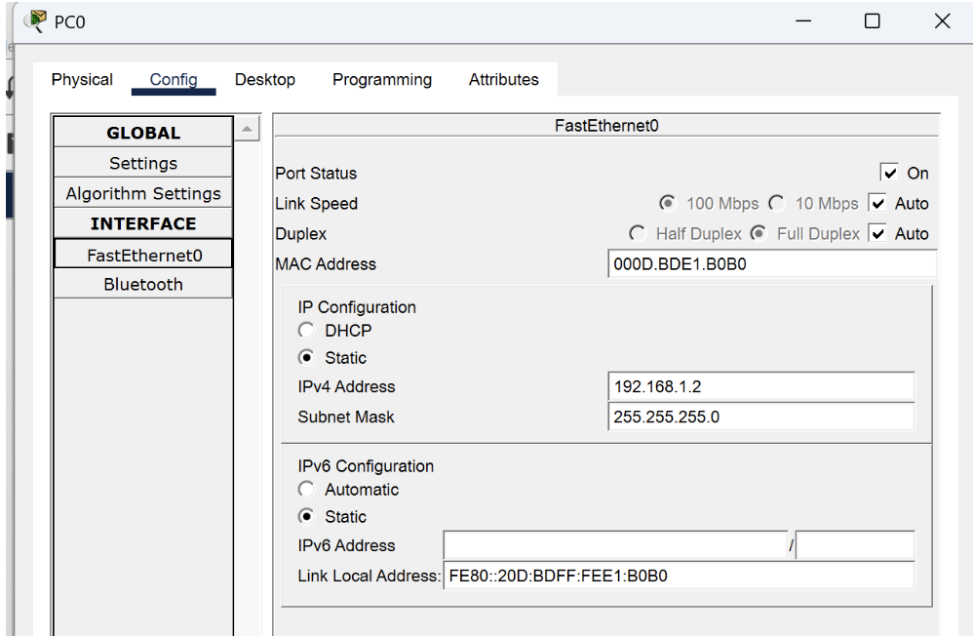PC1
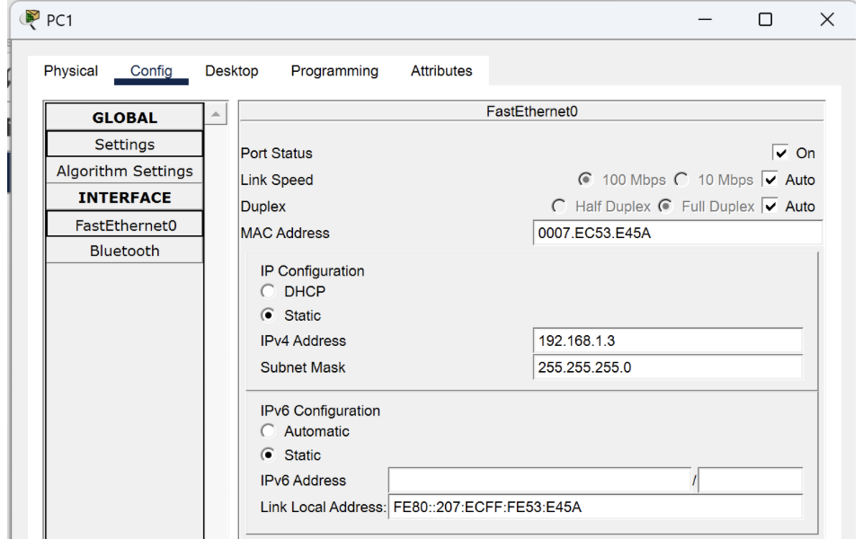
PC2
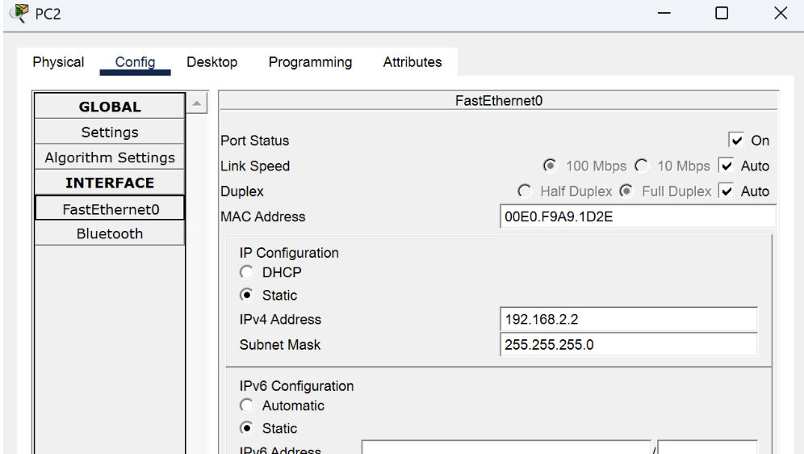
PC3
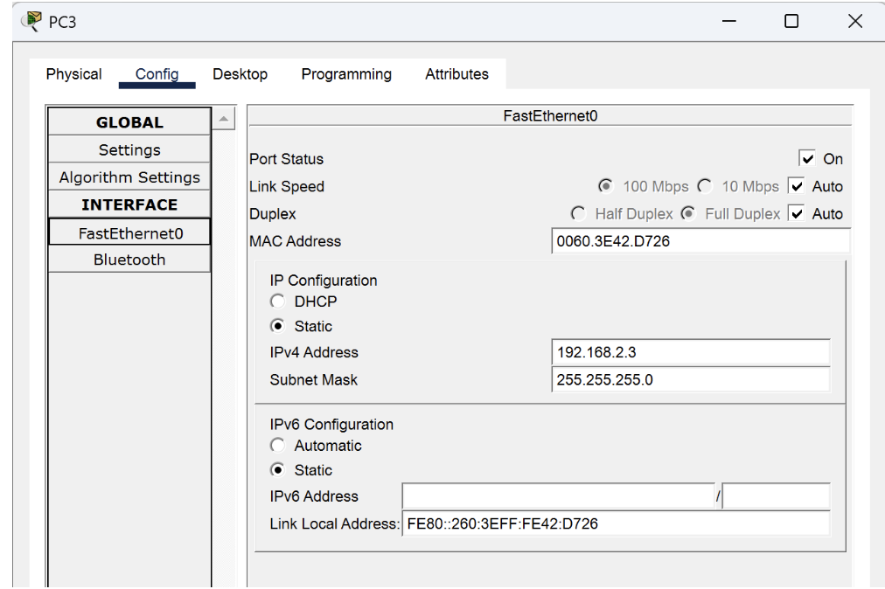
- Configure IP Address of Router0

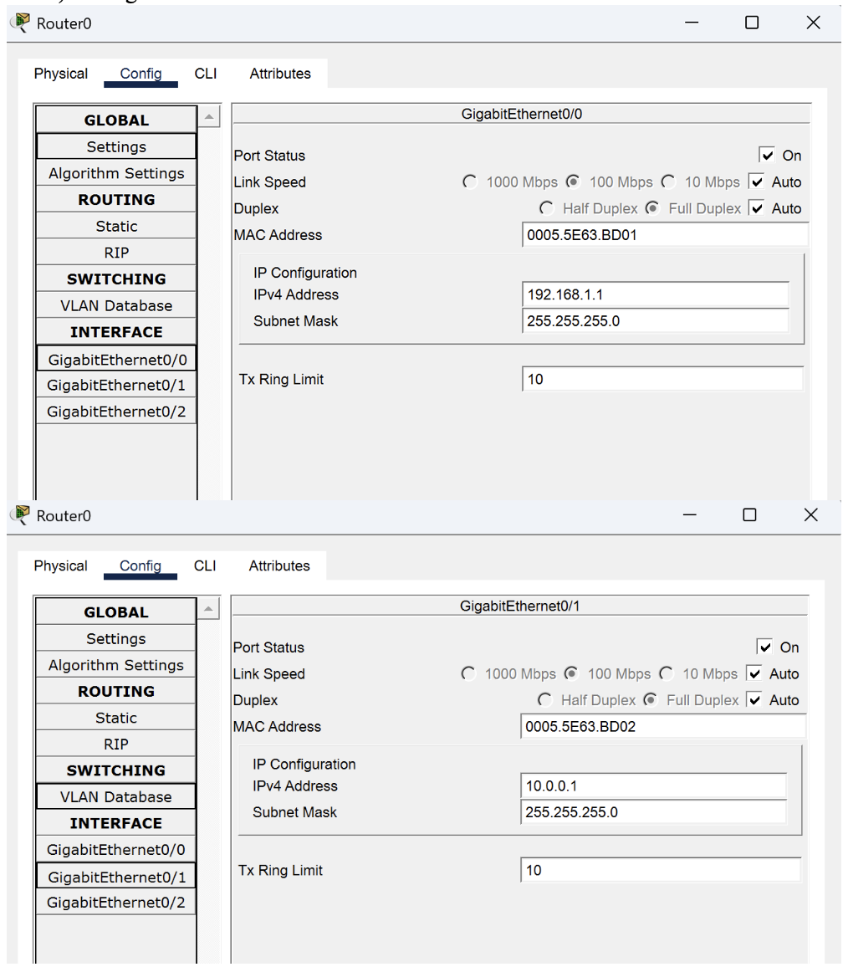

- Configure IP Address of Router1
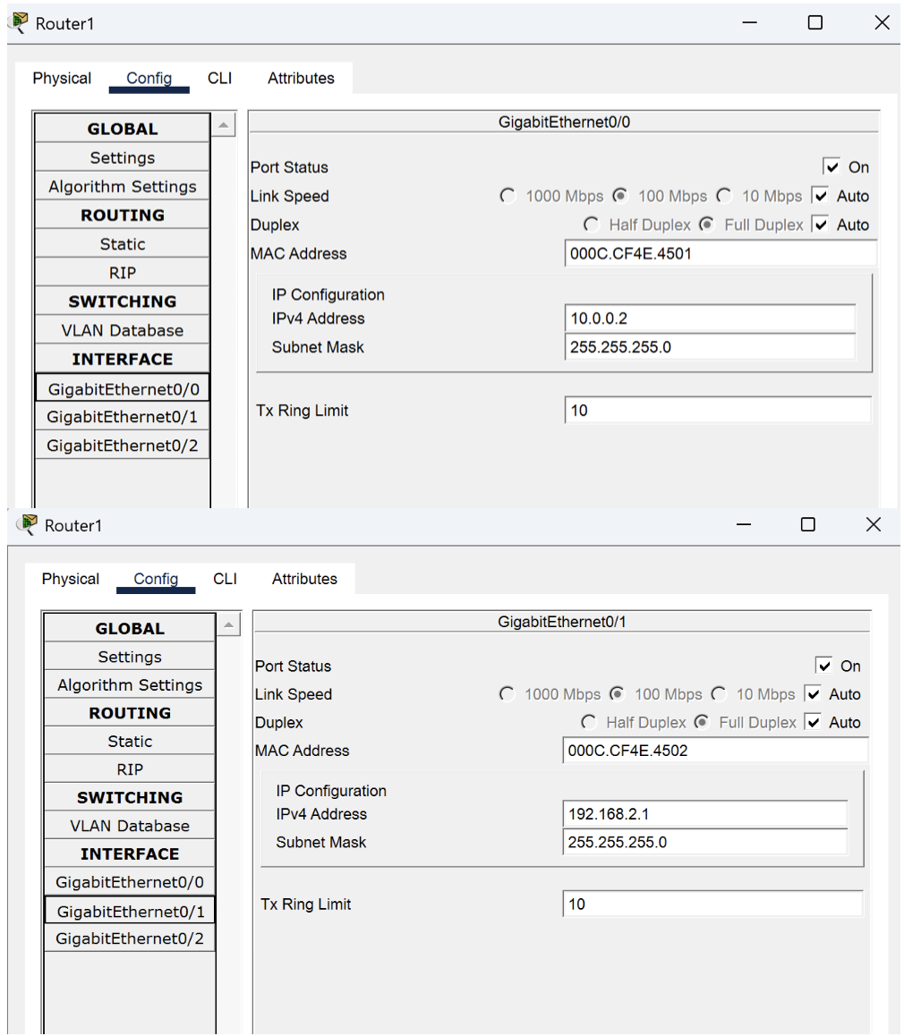

- Static Routing Configuration through CLI
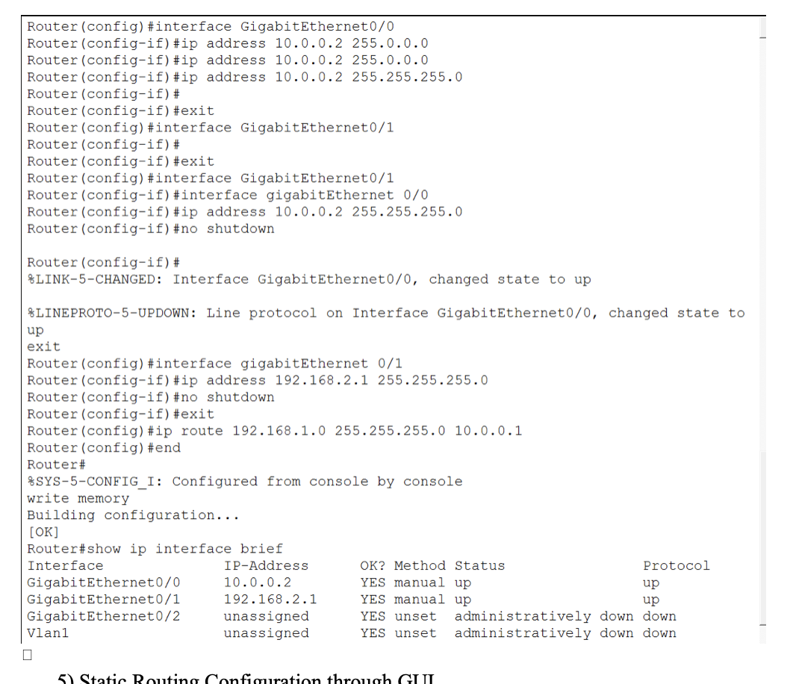

- Static Routing Configuration through GUI
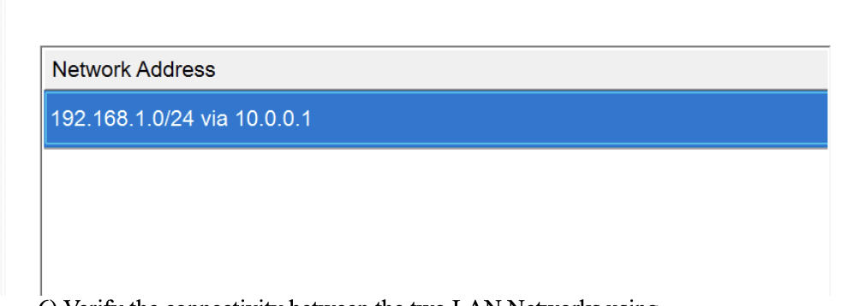

- Verify the connectivity between the two LAN Networks using Ping command

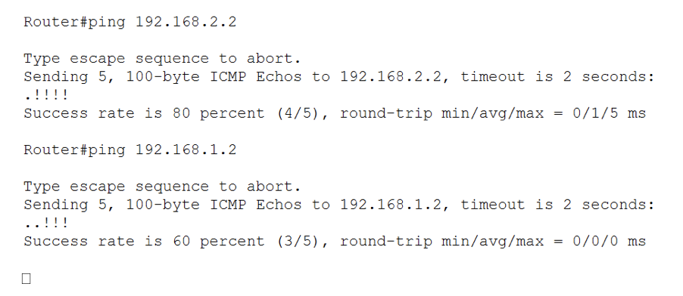

RESULT
After configuring static routes on both routers, PCs in LAN Network 1 should be able to communicate with PCs in LAN Network 2. Successful ping responses between the PCs confirm proper routing and connectivity.
The network connectivity can also be verified by sending packets from PC0 to PC2 in real-time simulation of the Cisco packet tracer,

INFERENCE
Static routing was successfully configured between the two LAN networks. By manually defining routes on both routers, communication between the two different network segments was established. The successful ping responses confirmed that the routers correctly forwarded packets between the LAN networks.

DEFAULT ROUTING BETWEEN TWO LAN NETWORKS

AIM
To configure a default router in a network using Cisco Packet Tracer, enabling communication between different network segments by manually setting default routes to direct traffic efficiently.

SYSTEM AND SOFTWARE REQUIREMENTS
Software – Cisco Packet Tracer Components used:
- End Devices
  - 4 PC-PT
- Network Devices
- 2 Switch 2950-24
  - 2 Routers 2911
- Connections
  - Copper Straight-Through
  - Copper Cross- Over

PROCEDURE:
To configure a default router in a network using Cisco Packet Tracer, follow the given steps:

Step 1: Open Cisco Packet Tracer
1) Launch Cisco Packet Tracer on your computer.

Step 2: Add Devices to the Workspace
- Add four PCs:
  - Click on the "End Devices" icon in the bottom left corner.
  - Select "PC" and drag four PCs into the workspace.
- Add two Switches:
  - Click on the "Switches" icon under Network devices in the bottom left corner.
  - Select a switch (2950-24) and drag 2 switches into the workspace.
- Add two Routers:
  - Click on the "Routers" icon under Network devices in the bottom left corner.
  - Select a router (2950-24) and drag 2 routers into the workspace.

Step 3: Connect the Devices
- Select the Connection Tool:
  - Click on the "Connections" icon (lightning bolt) in bottom left corner.
- Connect the PCs to the Switch:
  - Click on a PC and then click on the switch to connect them with a copper straight-through cable, follow the same for another PC.
  - Connect the remaining two PCs with the other switch using the same method.
- Connect the Switch to the Router:
  - Click on the switch and then click on the Router to connect them with a copper straight-through cable (connect Switch0 to Router2's GigabitEthernet0/0 interface).
  - Repeat for the other switch and router (connect Switch1 to Router3's GigabitEthernet0/0 interface).
- Connect the two Routers:
  - Click on a router and then click on the other router to connect them with a copper Cross-Over cable (connect Router2's GigabitEthernet 0/1 interface to Router3's GigabitEthernet0/1 interface).

Step 4: Configure IP Addresses

LAN Network-1 with network address 192.168.1.0/24
- Configure the PC0:
  - Open the PC, navigate to Config, and Edit the FastEthernet0 tab.
  - Choose Static to manually enter the following,

IPv4 Address: 192.168.1.2
Subnet Mask: 255.255.255.0

Default Gateway: 192.168.1.1
- Configure the PC1:
  - Open the PC, navigate to Config, and Edit the FastEthernet0 tab.
  - Choose Static to manually enter the following,

IPv4 Address: 192.168.1.3
Subnet Mask: 255.255.255.0

Default Gateway: 192.168.1.1

- Configure the Router2:
  - Click on the router and navigate to the Config tab.
  - Select the interface connected to the switch (GigabitEthernet0/0).
  - Set the IP address and subnet mask:

IP Address: 192.168.1.1
Subnet Mask: 255.255.255.0
  - Check the box for "Port Status" to bring the interface up.

LAN Network-2 with network address 192.168.2.0/24
- Configure the PC2:
  - Open the PC, navigate to Config, and Edit the FastEthernet0 tab.
  - Choose Static to manually enter the following,

IPv4 Address: 192.168.2.2
Subnet Mask: 255.255.255.0

Default Gateway: 192.168.2.1
- Configure the PC3:
  - Open the PC, navigate to Config, and Edit the FastEthernet0 tab.
  - Choose Static to manually enter the following,

IPv4 Address: 192.168.2.3
Subnet Mask: 255.255.255.0

Default Gateway: 192.168.2.1
- Configure the Router3:
  - Click on the router and navigate to the Config tab.
  - Select the interface connected to the PC (GigabitEthernet0/0).
  - Set the IP address and subnet mask:

IP Address: 192.168.2.1
Subnet Mask: 255.255.255.0
  - Check the box for "Port Status" to bring the interface up.

WAN Network-2 with network address 10.0.0.0/24
- Configure Router1:
  - Click on the router and navigate to the Config tab.

  - Select the interface connected to the Router1 (GigabitEthernet0/1).
  - Set the IP address and subnet mask:

IP Address: 10.0.0.1
Subnet Mask: 255.0.0.0
  - Check the box for "Port Status" to bring the interface up.
- Configure the Router1:
  - Click on the router and navigate to the Config tab.
  - Select the interface connected to the Router0 (GigabitEthernet0/0).
  - Set the IP address and subnet mask:

IP Address: 10.0.0.1
Subnet Mask: 255.0.0.0
  - Check the box for "Port Status" to bring the interface up.

Step 5: Configure the default Routes using either of the 2 methods: Through Command Line Interface:
- Router2
  - Select the router, navigate to CLI
  - Enter privileged EXEC mode by typing:

enable
  - Enter global configuration mode by typing:

configure terminal
  - Configure IP route of the network:

ip route 0.0.0.0 0.0.0.0.0 10.0.0.2
  - Exit configuration mode

End
- Router3
  - Select the router, navigate to CLI
  - Enter privileged EXEC mode by typing:

enable
  - Enter global configuration mode by typing:

configure terminal
  - Configure IP route of the network:

ip route 0.0.0.0 0.0.0.0 10.0.0.1
  - Exit configuration mode

end

Through Graphical User Interface:

Router2
  - Select the router, navigate to Config tab.
  - Select Static under Routing and enter the following:

Network: 0.0.0.0
Mask: 0.0.0.0

Next Hop: 10.0.0.2
  - Click on add.

Router3
  - Select the router, navigate to Config tab.
  - Select Static under Routing and enter the following:

Network: 0.0.0.0
Mask: 0.0.0.0

Next Hop: 10.0.0.1
  - Click on add.

Step 6: Verify the connectivity between the two LAN Networks:
- Ping Test from PC0 to PC2:
  - On PC0, navigate to the Desktop tab and open the Command Prompt.
  - Enter the command ping 192.168.2.2 and observe the responses.
- Ping Test from PC3 to PC1:
  - On PC1, navigate to the Desktop tab and open the Command Prompt.
  - Enter the command ping 192.168.1.3 and observe the responses.

NETWORK TOPOLOGY DIAGRAM

OUTPUT

- Configure IP Address of the PCs
PC0
PC1

PC2

PC3


- Configure IP Address of Router0



- Configure IP Address of Router1


- Static Routing Configuration through CLI

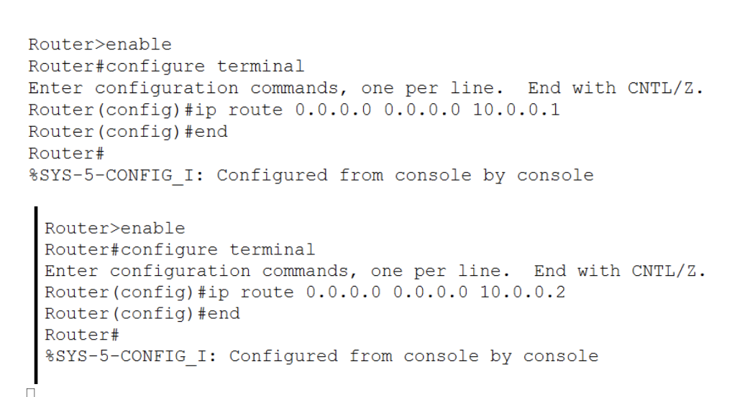
- Static Routing Configuration through GUI

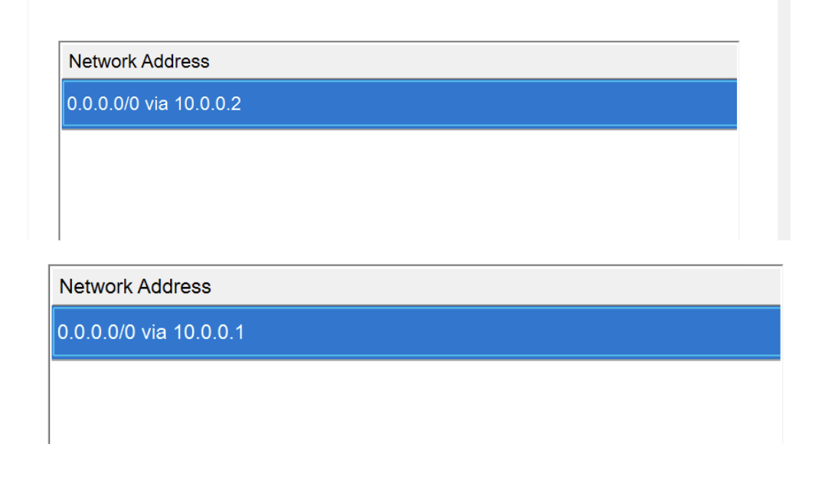

- Verify the connectivity between the two LAN Networks using Ping command

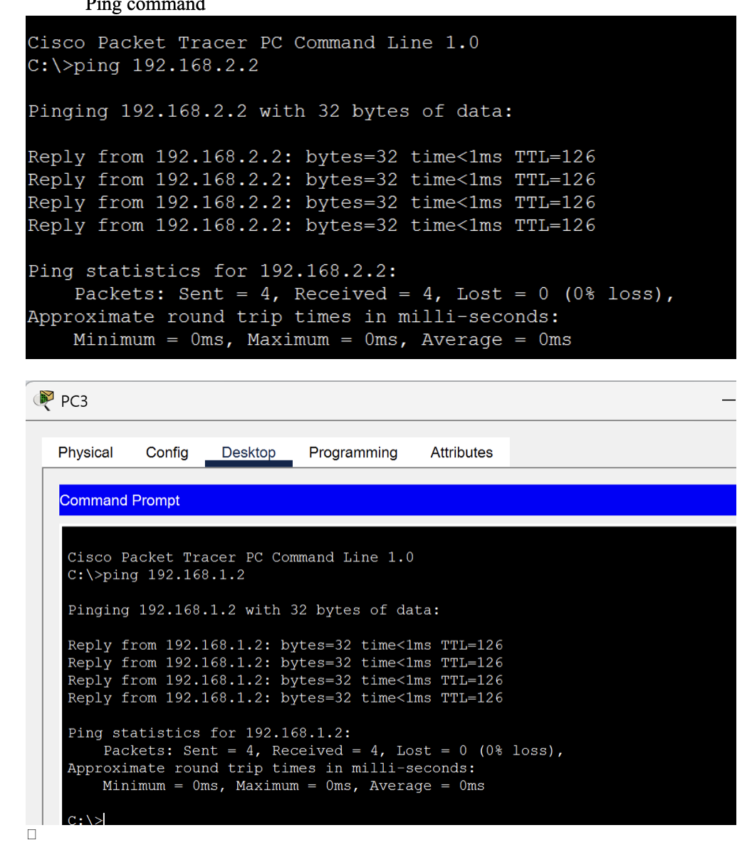

RESULT
After configuring static routes on both routers, PCs in LAN Network 1 should be able to communicate with PCs in LAN Network 2. Successful ping responses between the PCs confirm proper routing and connectivity.
The network connectivity can also be verified by sending packets from PC0 to PC2 in real-time simulation of the Cisco packet tracer,

INFERENCE
Default routing was successfully configured between the two LAN networks. By configuring default routes on both routers, packets destined for the other LAN were forwarded through the appropriate next-hop router. Successful ping responses confirmed proper routing and connectivity between the two LAN networks.

DYNAMIC ROUTING BETWEEN TWO LAN NETWORKS

AIM
To configure a dynamic router in a network using Cisco Packet Tracer, enabling communication between different network segments by manually setting dynamic routes to direct traffic efficiently.

SYSTEM AND SOFTWARE REQUIREMENTS
Software – Cisco Packet Tracer Components used:
- End Devices
  - 2 PC-PT
- Network Devices
- 2 Switch 2950-24
  - 3 Router-PT
- Connections
  - Copper Straight-Through
  - Serial DTE

PROCEDURE
To configure a static router in a network using Cisco Packet Tracer, follow the given steps:

Step 1: Open Cisco Packet Tracer
1) Launch Cisco Packet Tracer on your computer.

Step 2: Add Devices to the Workspace
- Add two PCs:
  - Click on the "End Devices" icon in the bottom left corner.
  - Select "PC" and drag two PCs into the workspace.
- Add two Switches:
  - Click on the "Switches" icon under Network devices in the bottom left corner.
  - Select a switch (2950-24) and drag 2 switches into the workspace.
- Add three Routers:
  - Click on the "Routers" icon under Network devices in the bottom left corner.
  - Select a router (Router-PT) and drag 2 routers into the workspace.

Step 3: Connect the Devices

- Select the Connection Tool:
  - Click on the "Connections" icon (lightning bolt) in bottom left corner.
- Connect the PCs to the Switch:
  - Click on a PC and then click on the switch to connect them with a copper straight-through cable, follow the same for the other PC and switch.
- Connect the Switch to the Router:
  - Click on the switch and then click on the Router to connect them with a copper straight-through cable (connect Switch2 to Router7's FastEthernet0/0 interface).
  - Repeat for the other switch and router (connect Switch3 to Router8's FastEthernet0/0 interface).
- Connect the Routers:
  - Click on Router7 and then click on the Router8 to connect them with a Serial DTE cable (connect Router7's Serial3/0 interface to Router8's Serial3/0 interface).
  - Click on Router7 and then click on the Router9 to connect them with a Serial DTE cable (connect Router7's Serial2/0 interface to Router9's Serial2/0 interface).
  - Click on Router9 and then click on the Router8 to connect them with a Serial DTE cable (connect Router9's Serial3/0 interface to Router8's Serial2/0 interface).

Step 4: Configure IP Addresses

Network-1 with network address 192.168.1.0/24
- Configure the PC:
  - Open the PC, navigate to Config, and Edit the FastEthernet0 tab.
  - Choose Static to manually enter the following,

IPv4 Address: 192.168.1.2
Subnet Mask: 255.255.255.0

Default Gateway: 192.168.1.1

- Configure the Router7:
  - Click on the router and navigate to the Config tab.
  - Select the interface connected to the switch (FastEthernet0/0).
  - Set the IP address and subnet mask:

IP Address: 192.168.1.1
Subnet Mask: 255.255.255.0
  - Check the box for "Port Status" to bring the interface up.

Network-2 with network address 155.165.1.0/24
- Configure the PC:
  - Open the PC, navigate to Config, and Edit the FastEthernet0 tab.
  - Choose Static to manually enter the following,

IPv4 Address: 155.165.1.2
Subnet Mask: 255.255.255.0

Default Gateway: 155.165.1.1
- Configure the Router8:
  - Click on the router and navigate to the Config tab.
  - Select the interface connected to the switch (FastEthernet0/0).
  - Set the IP address and subnet mask:

IP Address: 155.165.1.1
Subnet Mask: 255.255.255.0
  - Check the box for "Port Status" to bring the interface up.

- Configure the Router9:
  - Click on the router and navigate to the Config tab.
  - Select the interface connected to the Router7 (Serial2/0).
  - Set the IP address and subnet mask:

IP Address: 10.0.0.2
Subnet Mask: 255.0.0.0
  - Check the box for "Port Status" to bring the interface up.

Network-4 with network address 30.0.0.0/24
- Configure the Router9:
  - Click on the router and navigate to the Config tab.
  - Select the interface connected to the Router8 (Serial3/0).
  - Set the IP address and subnet mask:

IP Address: 30.0.0.1
Subnet Mask: 255.0.0.0
  - Check the box for "Port Status" to bring the interface up.
- Configure the Router8:
  - Click on the router and navigate to the Config tab.
  - Select the interface connected to the Router9 (Serial2/0).
  - Set the IP address and subnet mask:

IP Address: 30.0.0.2
Subnet Mask: 255.0.0.0
  - Check the box for "Port Status" to bring the interface up.

Network-5 with network address 20.0.0.0/24
- Configure the Router7:

Click on the router and navigate to the Config tab. Select the interface connected to the Router8 (Serial3/0). Set the IP address and subnet mask:
IP Address: 20.0.0.1
Subnet Mask: 255.0.0.0
Check the box for "Port Status" to bring the interface up.

- Configure the Router8:
  - Click on the router and navigate to the Config tab.
  - Select the interface connected to the Router7 (Serial3/0).
  - Set the IP address and subnet mask:

IP Address: 20.0.0.2
Subnet Mask: 255.0.0.0
  - Check the box for "Port Status" to bring the interface up.

Step 5: Configure the Dynamic Routes through Command Line Interface:

- Router7
  - Select the router, navigate to CLI
  - Enter privileged EXEC mode by typing:

enable
  - Enter global configuration mode by typing:

configure terminal
  - Start OSPF process with ID 1.

router ospf 1
  - Assign network 192.168.1.0/16 to OSPF area 0

network 192.168.1.0 0.0.0.255 area 0
  - Assign network 10.0.0.0/8 to OSPF area 0

network 10.0.0.0 0.255.255.255 area 0
  - Assign network 20.0.0.0/8 to OSPF area 0.

network 20.0.0.0 0.255.255.255 area 0
  - Exit OSPF router configuration mode.

exit
- Router9
  - Select the router, navigate to CLI
  - Enter privileged EXEC mode by typing:

enable
  - Enter global configuration mode by typing:

configure terminal
  - Start OSPF process with ID 1.

router ospf 1
  - Assign network 10.0.0.0/8 to OSPF area 0

network 10.0.0.0 0.255.255.255 area 0
  - Assign network 30.0.0.0/8 to OSPF area 0.

network 30.0.0.0 0.255.255.255 area 0

  - Exit OSPF router configuration mode.

Exit

- Router8

  - Select the router, navigate to CLI
  - Enter privileged EXEC mode by typing:

enable
  - Enter global configuration mode by typing:

configure terminal
  - Start OSPF process with ID 1.

router ospf 1
  - Assign network 155.165.1.0/16 to OSPF area 0

network 155.165.1.0 0.0.255.255 area 0
  - Assign network 20.0.0.0/8 to OSPF area 0

network 20.0.0.0 0.255.255.255 area 0
  - Assign network 30.0.0.0/8 to OSPF area 0.

network 30.0.0.0 0.255.255.255 area 0
  - Exit OSPF router configuration mode.

exit

Step 6: Verify the connectivity between the Networks:
    - Ping Test from PC4 to PC5:
      - On PC4, navigate to the Desktop tab and open the Command Prompt.
      - Enter the command ping 155.165.1.2 and observe the responses.

NETWORK TOPOLOGY DIAGRAM

OUTPUT

- Configure IP Address of the PCs

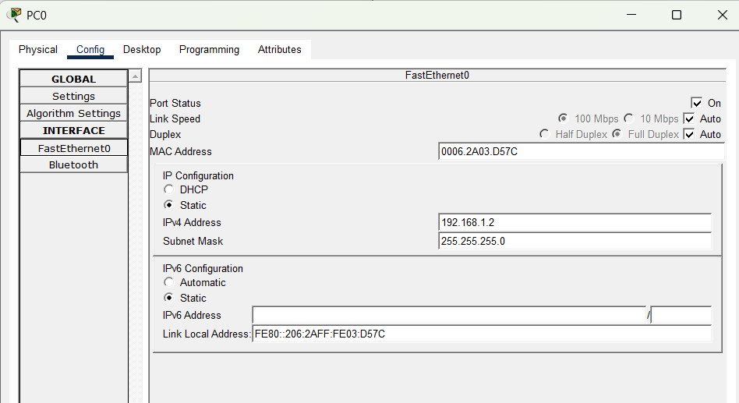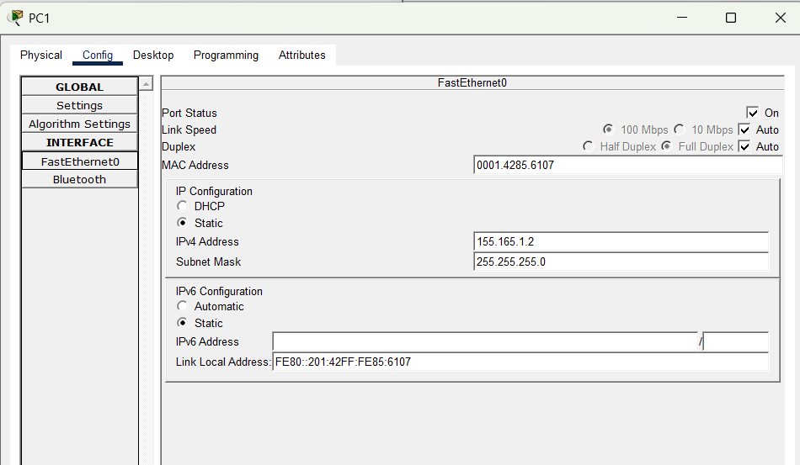

  - Configure IP Address of Router7

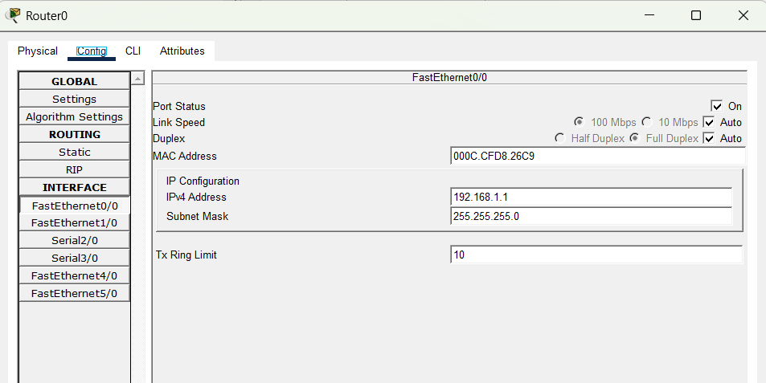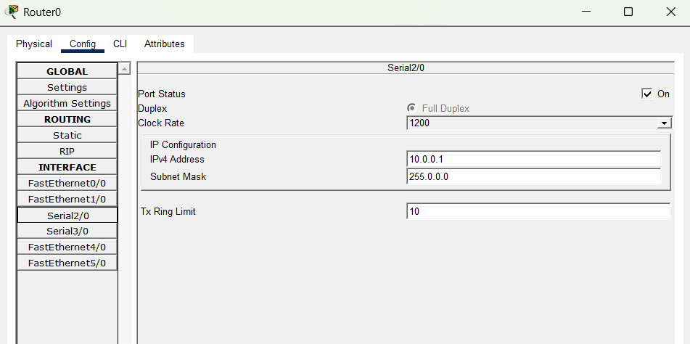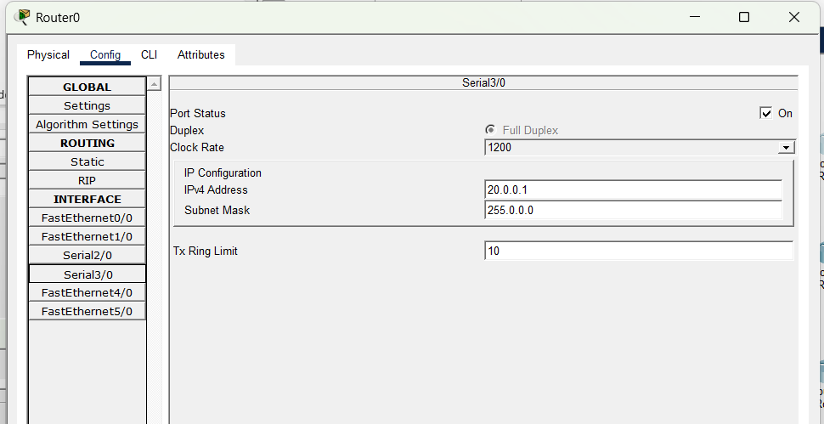

  - Configure IP Address of Router8

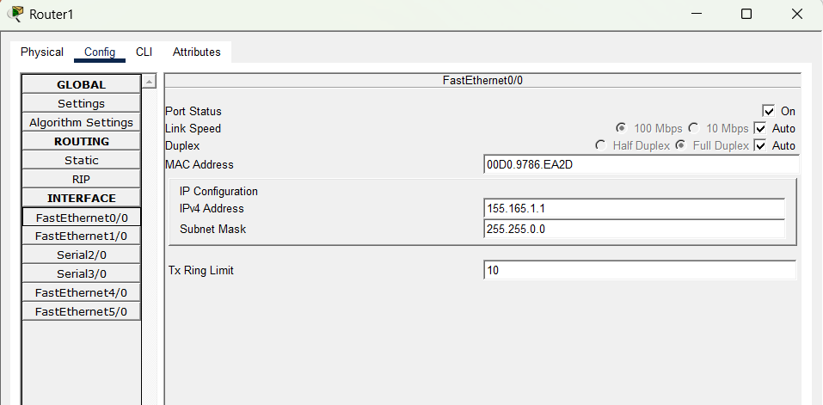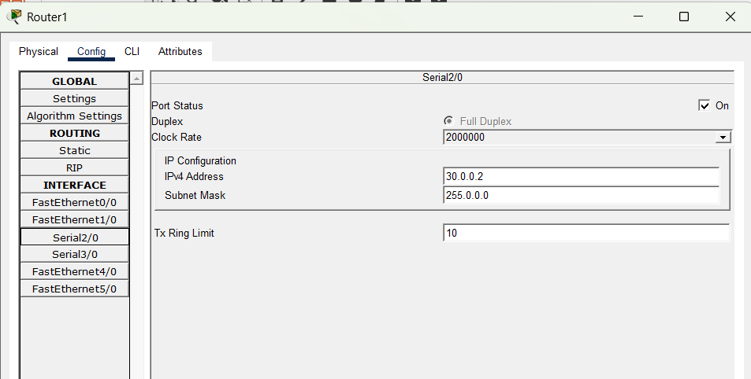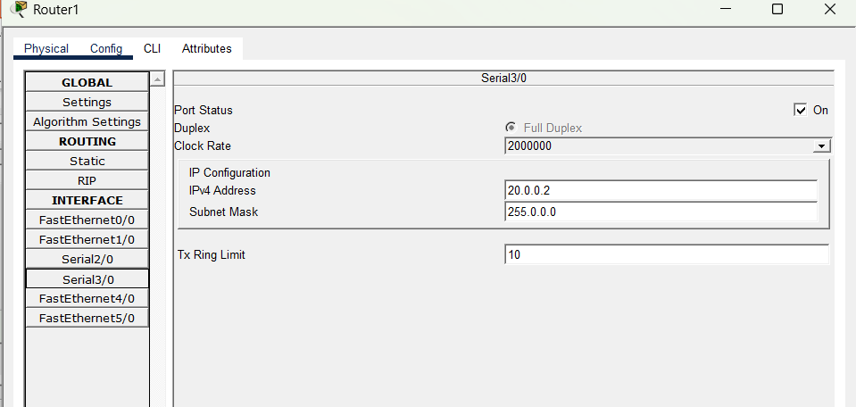

  - Configure IP Address of Router9

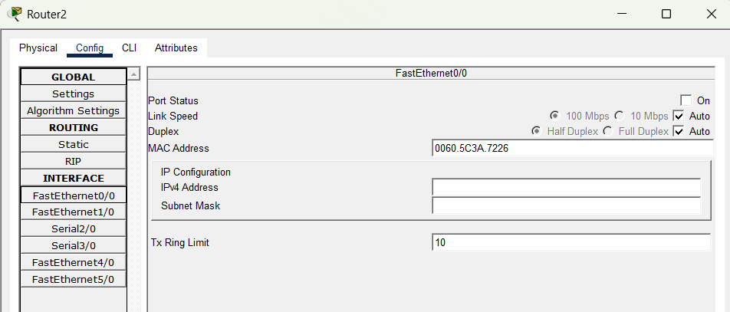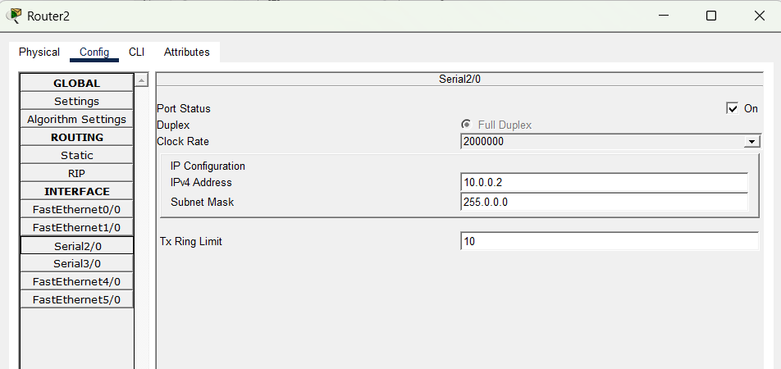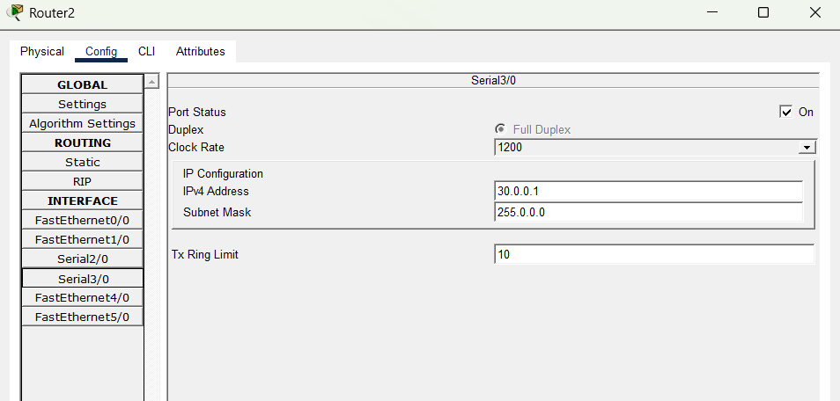
  - Dynamic Routing Configuration through CLI

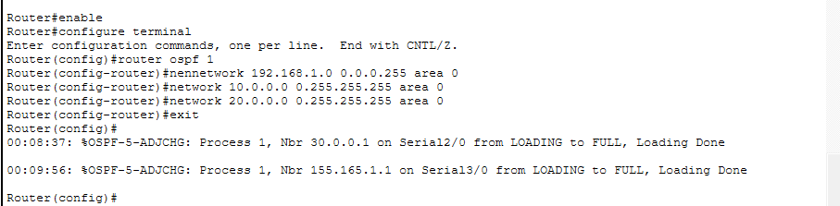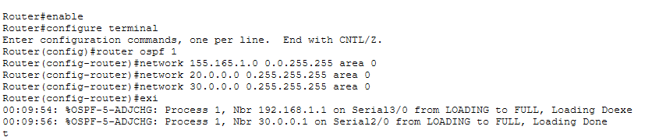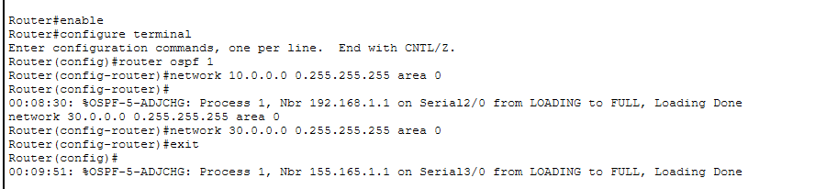

  - Verify the connectivity between the Networks using Ping command

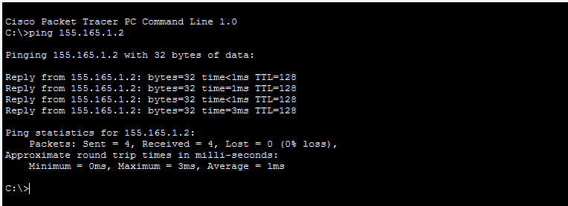

RESULT
After configuring dynamic routes on all three routers, PCs in Network 1 should be able to communicate with PCs in Network 2. Successful ping responses between the PCs confirm proper routing and connectivity.
The network connectivity can also be verified by sending packets from PC4 to PC5 in real-time simulation of the Cisco packet tracer,

INFERENCE

Dynamic routing using OSPF was successfully configured between the three routers. The routers exchanged routing information automatically, established OSPF neighbor relationships, and enabled communication between the two LAN networks. Successful ping responses between PC4 and PC5 confirmed proper connectivity

