

DEPARTMENT OF COMPUTER SCIENCE AND ENGINEERING

23CSE304 Embedded Systems Laboratory

Activity Sheet #10

Activity Name: Interrupt Programming

Name of Student: | Chetan Kumar G
Registration No.: | CH.SC.U4CSE24109
Activity Date: | 02|10|2026
Submission Date: | 02|10|2026

Assessment Rubrics:

Component | Maximum Marks | Marks Allotted
Program | 3
Output | 4
Viva | 2
Timely Submission | 1
Total | 10

Faculty In-charge

Write an embedded C program for ARM architecture to drive Interrupt module. Debug and verify the program using IDE on a development computer system.

PROGRAM:
#include <LPC21xx.H>

#define LED 0x00000001

int main(void)
{
PINSEL0 = 0x00000000;
IO0DIR = LED;
IO0CLR = LED; // LED starts OFF

PINSEL1 |= 0x00000001; // P0.16 as EINT0

EXTMODE = 0x01; // Edge-triggered
EXTPOLAR = 0x01; // Rising edge
EXTINT = 0x01; // Clear any stale flag

while(1)
{
if (EXTINT & 0x01) // Button press detected
{
IO0PIN ^= LED; // Toggle LED state
EXTINT = 0x01; // Clear flag

while(EXTINT & 0x01); // (safety) wait if flag re-sets immediately
}
}
}

OUTPUT WINDOW:

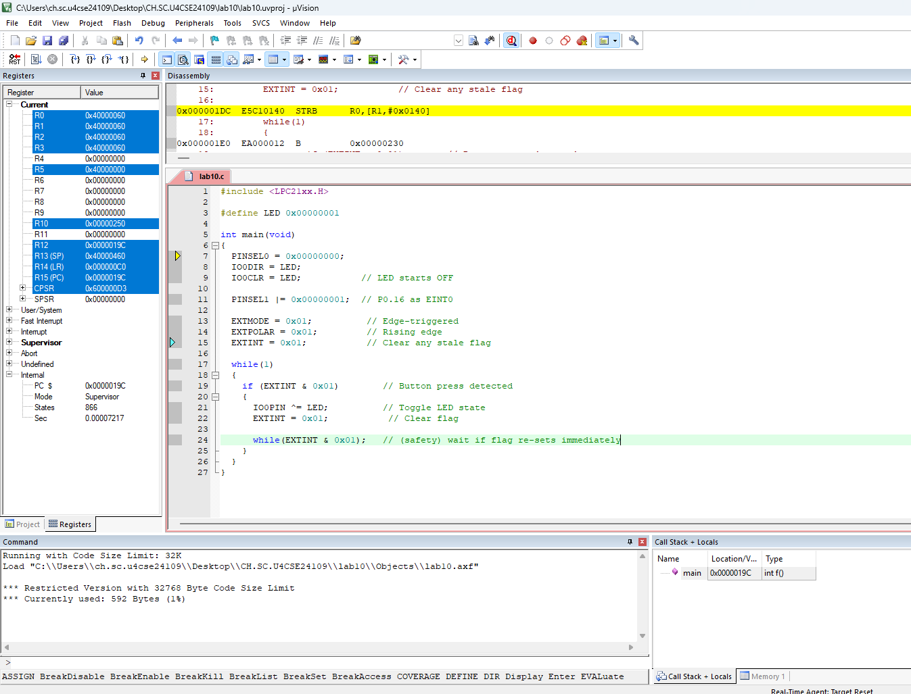

OUTPUT:
