

DEPARTMENT OF COMPUTER SCIENCE AND ENGINEERING

23CSE304 Embedded Systems Laboratory

Activity Sheet #11

Activity Name: UART Programming

Name of Student: | Chetan Kumar G
Registration No.: | CH.SC.U4CSE24109
Activity Date: | 02|10|2026
Submission Date: | 02|10|2026

Assessment Rubrics:

Component | Maximum Marks | Marks Allotted
Program | 3
Output | 4
Viva | 2
Timely Submission | 1
Total | 10

Faculty In-charge

Write an embedded C program for ARM architecture to drive UART module. Debug and verify the program using IDE on a development computer system.

PROGRAM:
#include <LPC21xx.H>

void delay(unsigned int t)
{
unsigned int i;
for(i=0; i<t; i++);
}
void UART0_Init(void)
{
PINSEL0 |= 0x00000005; // P0.0 = TXD0, P0.1 = RXD0

U0LCR = 0x83; // 8 bits, 1 stop, no parity, DLAB=1
U0DLL = 16; // Baud rate divisor (9600 baud @ 2.5MHz PCLK)
U0DLM = 0;
U0LCR = 0x03; // DLAB=0, 8-bit mode
}
void UART0_SendChar(unsigned char ch)
{
U0THR = ch;
while(!(U0LSR & 0x20)); // Wait until THR empty
}
void UART0_SendString(char *str)
{
while(*str)
{
UART0_SendChar(*str);
str++;
}
}

int main(void)
{
UART0_Init();

while(1)
{
UART0_SendString("Hello, im chetan\r\n");
delay(1000000);
}
}

OUTPUT WINDOW:

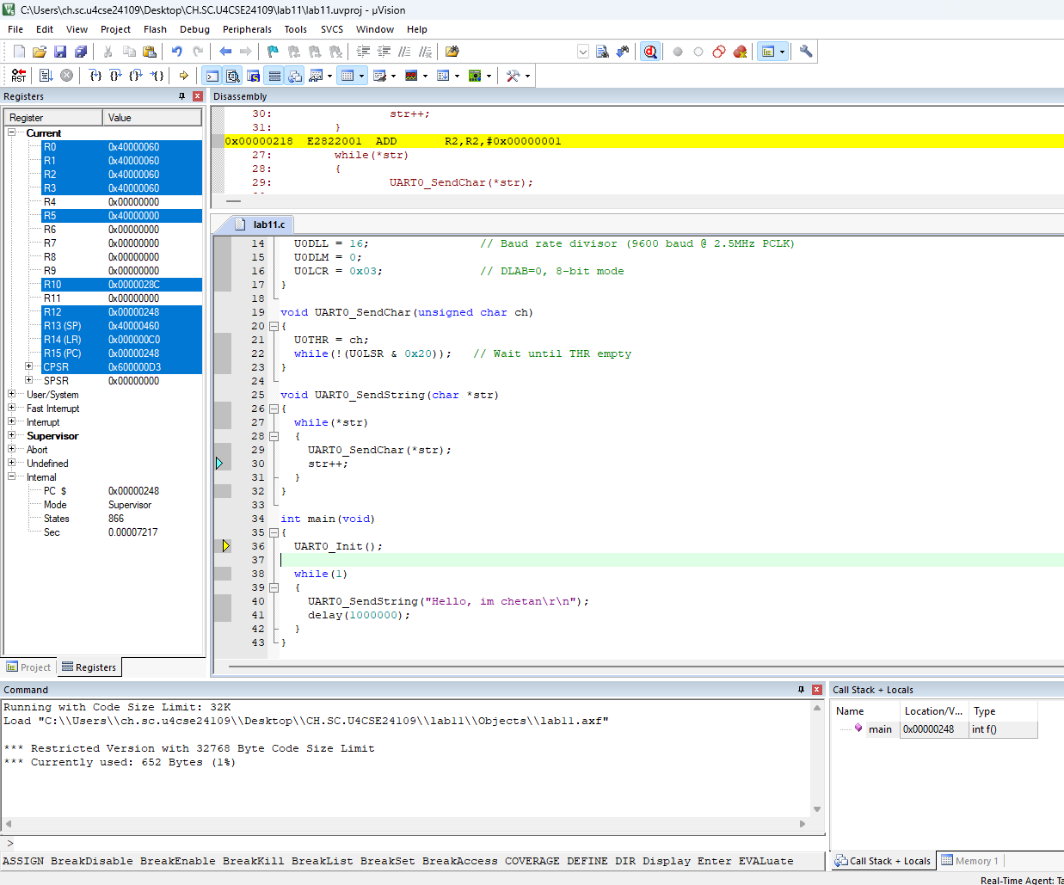

OUTPUT:
